Fig. S1. Frequency distributions of Cd contents in roots and shoots, and the translocation factor across 506 accessions.
(A) Frequency distribution of Cd content in roots. (B) Frequency distribution of Cd contents in shoots. (C) Frequency distribution of the translocation factor. Curves indicate the fitted lines of the distribution.

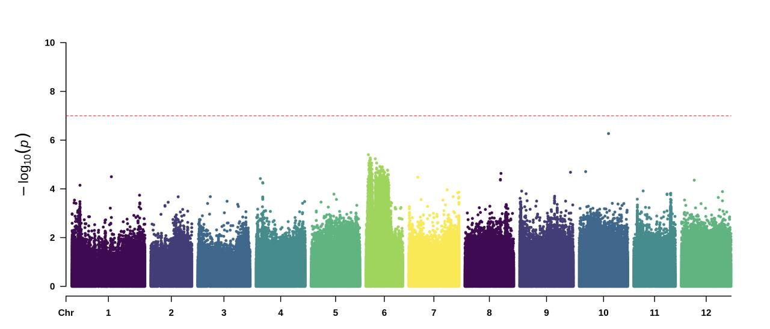
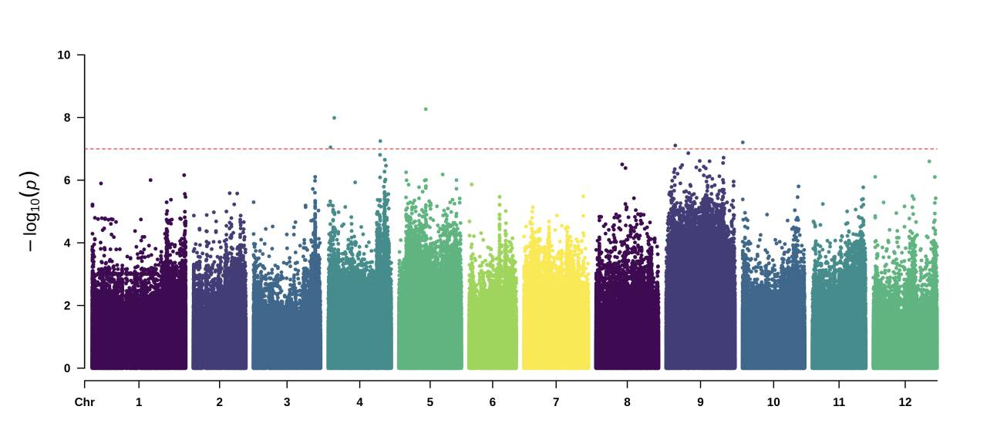
Fig. S2. GWAS of Cd content in tomato roots and translocation factor.
(A) Manhattan plot for GWAS of Cd content in roots on chromosomes 1-12. (B) Manhattan plot for GWAS of translocation factor on chromosomes 1-12. The horizontal line shows the Bonferroni-adjusted significance threshold (P = 1.0 × 10⁻⁷).

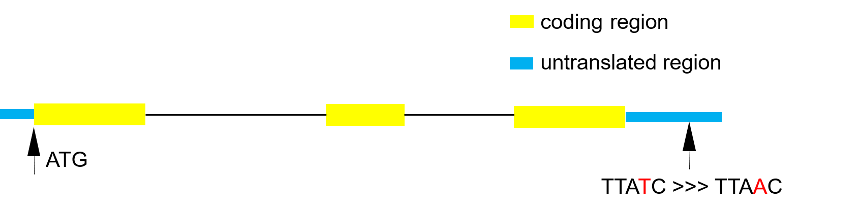
Fig. S3. Structure of SlF3’H and location of SNP3-A.
The SlF3'H consists of a 5’UTR (the left blue-highlighted section), three exons (the yellow sections), two introns (the straight-line sections), and a 3' UTR (the right blue-highlighted section). SNP3-A, one of the significant SNPs identified in the genome-wide association study (marked in red), is located within the 3’UTR of the SlF3’H.

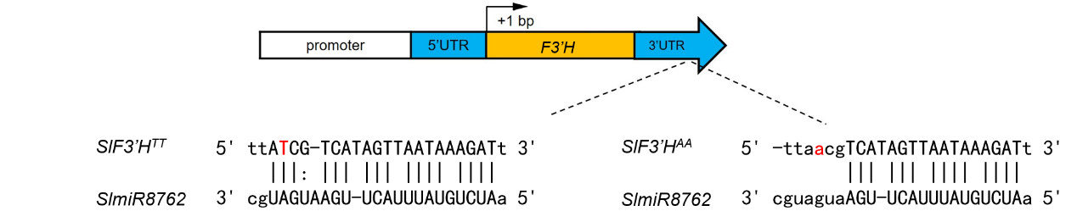
Fig. S4. The putative binding of miR8762 to the two genotypes of the SlF3'H gene.
miR8762 was predicted to bind to the 3’UTR of SlF3’H using tools (http://www.bioinformatics.com.cn/). Variations in the 3’UTR of SlF3’H can diminish the binding affinity of SlmiR8762. Vertical solid lines represent complete complementarity between miR8762 and the 3’UTR bases, while the vertical dashed line indicates partial complementarity.


Fig. S5. Overexpression and CRISPR/Cas9-mediated knockout of SlF3'H.
(A) Relative expression of SlF3'H in the overexpression lines. (B) Mutations generated in SlF3'H by CRISPR/Cas9 using two independent single-guide RNA (sgRNA1 and sgRNA2). Sequences of the SlF3'H in wild-type (TS-222), and mutant tomato plants SlF3'H-CR#1 and SlF3'H-CR#2 are shown. The sgRNA-targeted sequences are underlined, and the protospacer adjacent motif (PAM) sequences are highlighted blue. Deletions are indicated by dashed lines. The red arrow indicates the position of the start codon. (C) Cd content in the shoots of wild type TS-222 and SlF3'H-CR lines. (D) cDNA sequence alignment between the SlF3’H-CR lines and the wild-type TS-222. (E and F) Amino acid sequence alignments of F3’H between the SlF3’H-CR#1 (E) and #2 (F) lines and the wild-type TS-222. (G-I) The secondary structures of the F3’H peptide chain in the wild-type TS-222 and the SlF3’H-CR#1 (H) and #2 (I) lines were predicted using the Protter tools (http://wlab.ethz.ch/protter/start/). (J) The protein levels of F3'H in the SlF3'H-CR lines compared to the wild-type TS-222.


Fig. S6. RNA-seq analysis of SlF3’H-OE and SlF3’H-CR lines compared with TS-222.
(A and B) Gene ontology (GO) term enrichment analysis of differentially expressed genes (DEGs) in SlF3’H-OE (A) and SlF3’H-CR (B) lines. (C and D) KEGG enrichment analysis of DEGs in SlF3’H-OE (C) and SlF3’H-CR (D) lines. (E) Relative expression levels of genes involved in cell wall and chelating pathways in the SlF3’H-OE lines. (F) Relative expression levels of genes associated with ion transport in the SlF3’H-CR lines.


Fig. S7. Relative expression of AtCYP75B1, OsCYP75B2 and OsCYP75B4 in overexpressing lines.
(A) Relative expression of AtCYP75B1 in the Arabidopsis thaliana overexpression lines. (B) Relative expression of OsCYP75B2 in the rice overexpression lines. (C) Relative expression of OsCYP75B4 in the rice overexpression lines.

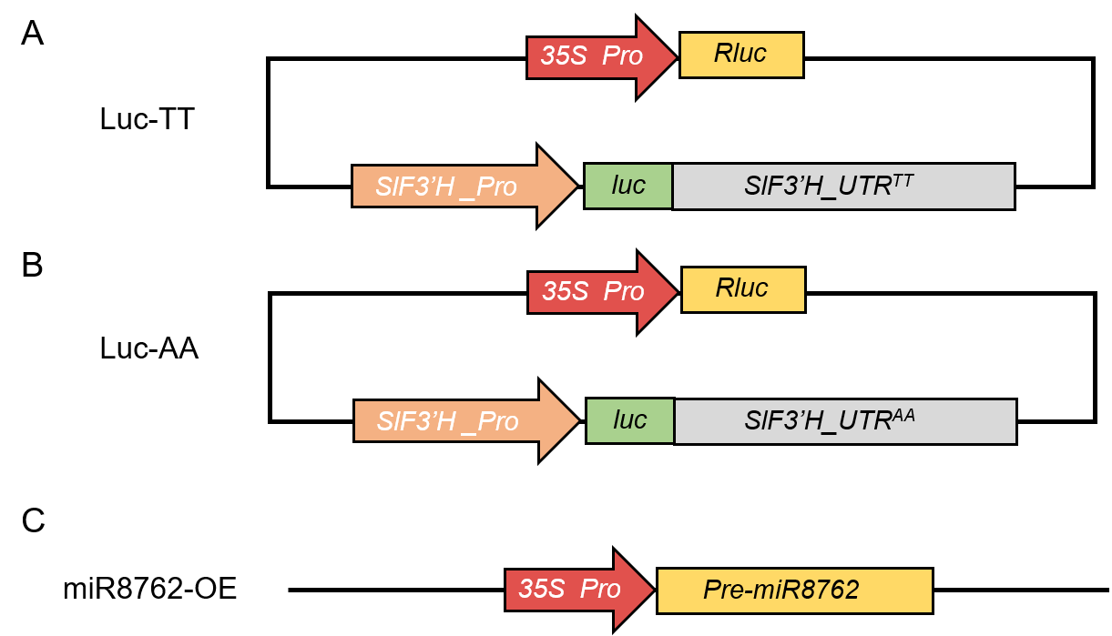
Fig. S8. Schematic representation of the constructs used for the dual luciferase reporter assay.
(A and B) Schematic representation of the constructs fused to the 3’ UTR^{TT} (A) and 3’ UTR^{AA} (B) of SlF3’H. The red and orange bars indicate the 35S and SlF3’H promoters, respectively. The green and yellow bars indicate the coding sequences of firefly luciferase (luc) and Renilla luciferase (Rluc), respectively. The gray bars indicate the two types of 3’UTR for SlF3’H. (C) Schematic representation of the overexpression construct 35Spro: Pre-miR8762. The red bar indicates the 35S promoter. The yellow bar indicates the precursor sequence of miR8762.

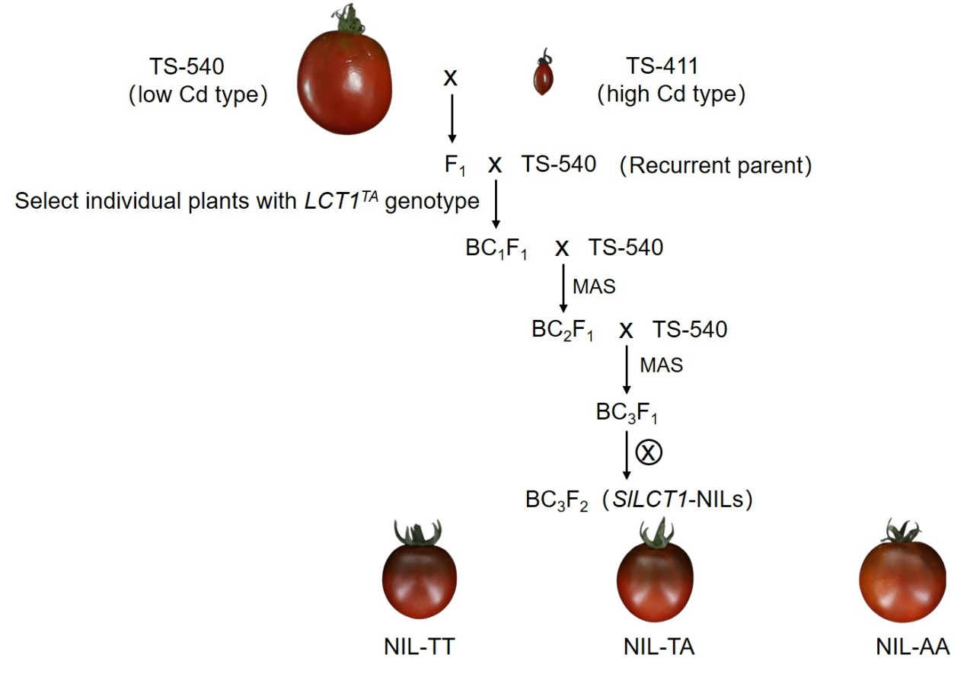
Fig. S9. Development of near-isogenic lines for LCT1.
The generation of near-isogenic lines for LCT1 by crossing the low-Cd tomato TS-540 with the high-Cd tomato TS-411, followed by continuous backcrossing using TS-540 as the recurrent parent. Throughout this process, CAPS molecular marker, designed based on the lead SNP in the 3’ UTR of LCT1, was utilized to select individuals with the LCT1^{TA} genotype.


Fig. S10. Co-selection of nicotinic acid and succinyladenosine with fruit weight.
(A and B) Relative contents of nicotinic acid (A) and succinyladenosine (B) in three groups of 442 tomato accessions. The red solid line represents the median, while the black dashed lines represent the first and third quartiles. (C and D) Ratios of nucleotide diversity (π) surrounding the fw11.3 and GWAS-identified lead SNPs for nicotinic acid and succinyladenosine between PIM and CER accessions (C) and between CER and BIG (D) accessions on chromosome 11. The red horizontal dashed line indicates the top 5% threshold for the entire genome. The location of fw11.3 and the lead SNPs for nicotinic acid and succinyladenosine on chromosome 11 is marked by the red arrow. Source data are from Zhu et al (2018).

Supplementary Tables
Table S1. 506 tomato accessions used in this study.
See supplementary files.

Table S2. The Cd content in roots and shoots, and translocation factors of 506 accessions.
See supplementary files.

Table S3. The candidate genes of LCT1.
Lead SNPs | P | Location | Genes | SNP effect | Gene description
64869851 | 9.09E-11 | Promoter | Solyc03g115010.1 | none | Transcription factor, TCP
64769236 | 9.93E-09 | Promoter | Solyc03g114890.2 | none | COBRA-like protein
64837546 | 4.74E-09 | Promoter | Solyc03g114980.2 | none | Unknown Protein
64922295 | 3.23E-08 | Promoter | Solyc03g115120.1 | none | Heat shock protein
65007638 | 2.18E-08 | Promoter | Solyc03g115220.2 | none | Flavonoid 3’hydroxylase, F3’H
65004108 | 2.51E-08 | Exon | Solyc03g115220.2 | synonymous | Flavonoid 3’hydroxylase, F3’H
65001793 | 3.48E-09 | 3'UTR | Solyc03g115220.2 | miR8762 | Flavonoid 3’hydroxylase, F3’H
65033600 | 4.35E-08 | Promoter | Solyc03g115240.2 | none | RNA polymerase-associated protein LEO1
65020764 | 5.20E-08 | Intron | Solyc03g115240.2 | none | RNA polymerase-associated protein LEO1
65033769 | 7.00E-08 | Promoter | Solyc03g115240.2 | none | RNA polymerase-associated protein LEO1
65034246 | 9.59E-08 | Promoter | Solyc03g115240.2 | none | RNA polymerase-associated protein LEO1
65034247 | 9.59E-08 | Promoter | Solyc03g115240.2 | none | RNA polymerase-associated protein LEO1
65052687 | 2.00E-08 | Intron | Solyc03g115250.2 | none | Genomic DNA chromosome 5 P1 clone MXM12
65054727 | 3.02E-08 | Intron | Solyc03g115250.2 | none | Genomic DNA chromosome 5 P1 clone MXM12
65052631 | 3.67E-08 | Intron | Solyc03g115250.2 | none | Genomic DNA chromosome 5 P1 clone MXM12
65069482 | 8.78E-08 | Intron | Solyc03g115290.2 | none | Unknown Protein
64978528 | 2.54E-09 | Intergenic
64766273 | 3.76E-09 | Intergenic
64871576 | 7.46E-09 | Intergenic
64978968 | 7.78E-09 | Intergenic
65038615 | 8.17E-09 | Intergenic
64899693 | 1.11E-08 | Intergenic
64968796 | 1.18E-08 | Intergenic
64862318 | 1.23E-08 | Intergenic
64924410 | 2.10E-08 | Intergenic
65038616 | 2.91E-08 | Intergenic
65036339 | 4.19E-08 | Intergenic
The gene denoted in red, SlF3’H, selected based on SNP effects and gene annotations, is designated for further functional studies.

Table S4. The QTLs associated with fruit weight.
Locus | gene ID | Year | Author | Article
fw11.3 | Solyc11g071940 | 2017 | Mu, et al. | Fruit weight is controlled by Cell Size Regulator encoding a novel protein that is expressed in maturing tomato fruits
fascinated | Solyc11g071810 | 2008 | Cong, et al. | Regulatory change in YABBY-like transcription factor led to evolution of extreme fruit size during tomato domestication
fw3.2 | Solyc03g114940 | 2013 | Chakrabart, et al. | A cytochrome P450 regulates a domestication trait in cultivated tomato
lc | Solyc02g083940 | 2011 | Munos, et al. | Increase in tomato locule number is controlled by  two single-nucleotide polymorphisms located near WUSCHEL
fw2.2 | Solyc02g090730 | 2000 | Frary, et al. | fw2.2: a quantitative trait locus key to the evolution of tomato fruit size
GBP1 | Solyc10g008950 | 2020 | Musseau, et al. | The tomato guanylate-binding protein SlGBP1  enables fruit tissue differentiation by maintaining  endopolyploid cells in a non-proliferative state
CLV3 | Solyc11g071380 | 2015 | Xu, et al. | A cascade of arabinosyltransferases controls shoot meristem size in tomato
ENO | Solyc03g117230 | 2020 | Yuste-Lisbona, et al. | ENO regulates tomato fruit size through the floral meristem development network
GRAS2(fw7.3） | Solyc07g063940 | 2018 | Li, et al. | Silencing GRAS2 reduces fruit weight in tomato

Table S5. List of primers used in this study.
Abbreviation | Primer sequence (5′-3′) | Purpose
F3'H-OE-FW | CATTTGGAGAGGACACGCTCGAGATGGCTATATTTTTCTTAATACTATACACTA | vector construction for plant transfromation
F3'H-OE-RV | TCTCATTAAAGCAGGACTCTAGATCACCCACCGTATACTTGGG | vector construction for plant transfromation
AtCYP75B1-OE-Fw① | CATTTGGAGAGGACACGCTCGAGATGGCAACTCTATTTCTCACAA | vector construction for plant transfromation
AtCYP75B1-OE-Rv① | TCTCATTAAAGCAGGACTCTAGATTAACCCGACCCGAGTC | vector construction for plant transfromation
OsCYP75B2-OE-FW | TGCAGGTCGACTCTAGAGGATCCATGGACGTTGTGCCTCTCCC | vector construction for plant transfromation
OsCYP75B2-OE-RV | TCGAGCTGGTCAGAGCTCGGTACCTTATACTCCATAAGCCGATGGAAG | vector construction for plant transfromation
OsCYP75B4-FW | TGCAGGTCGACTCTAGAGGATCCATGGAGGTCGCCGCCAT | vector construction for plant transfromation
OsCYP75B4-RV | TCGAGCTGGTCAGAGCTCGGTACCTTATGCAATATTGTAAGCGGATGG | vector construction for plant transfromation
OsCYP75B2-Q-FW | GAATATGCGCTGGCCTTAGTTG | qRT-PCR
OsCYP75B2-Q-RV | GTCTCCACCGATTTCTGACCTT | qRT-PCR
OsCYP75B4-Q-FW | ACACGGAAATCAAGGCCCTTAT | qRT-PCR
OsCYP75B4-Q-RV | CCCACAACAACATCTAGCTCCT | qRT-PCR
AtCYP75B1-Q-FW | TCAGGAGCTAAACACATGGCAT | qRT-PCR
AtCYP75B1-Q-RV | CTCGTCCTAGAGCGTTGACTAC | qRT-PCR
Os-Qactin-FW | TGAAGATCAAGGTGGTGGCAC | qRT-PCR
Os-Qactin-RV | TGCTGGACCCGACTCATCATA | qRT-PCR
At-Qactin-FW | GTTCCAGCCCTCGTTTGTG | qRT-PCR
At-Qactin-RV | CAAGTGCTGTGATTTCTTTGCTC | qRT-PCR
F3'H-Q-Fw | CCATGTCCGACAGGAAGAAGTCAG | qRT-PCR
F3'H-Q-Rv | CATCACACGCGCAAGTGCATTC | qRT-PCR
Q-actin-FW | GTCCTCTTCCAGCCATCCA | qRT-PCR
Q-actin-RV | ACCACTGAGCACAATGTTACCG | qRT-PCR
F3'Hpro-LUC-Fw | GACCATGATTACGAATTGAGCTCCTTACTTCACAATACCTCATGTG | Dual Luciferase Reporter Assay
F3'Hpro-LUC-Rv | TTTTTGGCGTCTTCCATGAATTCAAGAGAGAGTGGGACCATGT | Dual Luciferase Reporter Assay
F3'H-UTR-Fw | GAAAGATCGCCGTGTAACCCGGGACAGCCGAATAAGCAGATGA | Dual Luciferase Reporter Assay
F3'H-UTR-Rv | AGCTGGTCACCAATTCACACGTGAATTGAAAAGCAGAGCGACA | Dual Luciferase Reporter Assay
F3'H-YFP-Fw | ATATGGGATCTACTAGTGAATTCATGGCTATATTTTTCTTAATACTATAC | Subcellular localization
F3'H-YFP-Rv | TCGAGCCCGGGGGTACCGTCGACCCCACCGTATACTTGGG | Subcellular localization
F3'Hpro-gus-Fw① | TGCATCCAACGCGTTGGGAGCTCCTTACTTCACAATACCTCATGTG | GUS reporter construction
F3'Hpro-gus-Rv① | GCCTTCGCCATTCTAGACTCGAGAAGAGAGAGTGGGACCATGT | GUS reporter construction
F3'H-caps-Fw1 | ATACGGTGGGTGAACAGC | Molecular marker assisted selection
F3'H-caps-Rv1 | AAAGCAGAGCGACAATTACTA | Molecular marker assisted selection

References and Notes
1. X. Liang, S. L. Yang, Z. C. Lou, A. Ali, The impact of Japan's discharge of nuclear-contaminated water on aquaculture production, trade, and food security in China and Japan. Sustainability 16, 1285 (2024). doi: 10.3390/su16031285.
2. I. Thornton, Impacts of mining on the environment; Some local, regional and global issues. Appl. Geochem. 11, 355-361 (1996). doi: 10.1016/0883-2927(95)00064-x.
3. H. Gui, Q. C. Yang, X. Y. Lu, H. L. Wang, Q. B. Gu, J. D. Martín, Spatial distribution, contamination characteristics and ecological-health risk assessment of toxic heavy metals in soils near a smelting area. Environ. Res. 222, 115328 (2023). doi: 10.1016/j.envres.2023.115328.
4. Y. S. Xu, S. H. Xiang, X. Y. Zhang, H. J. Zhou, H. M. Zhang, High-performance pseudocapacitive removal of cadmium via synergistic valence conversion in perovskite-type FeMnO₃. J. Hazard. Mater. 439, 129575 (2022). doi: 10.1016/j.jhazmat.2022.129575.
5. S. Soni, A. B. Jha, R. S. Dubey, P. Sharma, Mitigating cadmium accumulation and toxicity in plants: The promising role of nanoparticles. Sci. Total Environ. 912, 168826 (2024). doi: 10.1016/j.scitotenv.2023.168826.
6. T. Inaba, E. Kobayashi, Y. Suwazono, M. Uetani, M. Oishi, H. Nakagawa, K. Nogawa, Estimation of cumulative cadmium intake causing Itai-itai disease. Toxicol. Lett. 159, 192-201 (2005). doi: 10.1016/j.toxlet.2005.05.011.
7. M. Peana, A. Pelucelli, C. T. Chasapis, S. P. Perlepes, V. Bekiari, S. Medici, M. A. Zoroddu, Biological effects of human exposure to environmental cadmium. Biomolecules 13, 36 (2023). doi: 10.3390/biom13010036.
8. M. Viuda-Martos, E. Sanchez-Zapata, E. Sayas-Barberá, E. Sendra, J. A. Pérez-Alvarez, J. Fernández-López, Tomato and tomato byproducts. Human health benefits of lycopene and its application to meat products: A review. Crit. Rev. Food Sci. Nutr. 54, 1032-1049 (2014). doi: 10.1080/10408398.2011.623799.
9. C. M. Bai, C. E. Wu, L. L. Ma, A. Z. Fu, Y. Y. Zheng, J. W. Han, C. B. Li, S. Z. Yuan, S. F. Zheng, L. P. Gao, X. H. Zhang, Q. Wang, D. M. Meng, J. H. Zuo, Transcriptomics and metabolomics analyses provide insights into postharvest ripening and senescence of tomato fruit under low temperature. Hortic. Plant J. 9, 109-121 (2023). doi: 10.1016/j.hpj.2021.09.001.
10. D. Tieman, G. T. Zhu, M. F. R. Resende, T. Lin, M. Taylor, B. Zhang, H. Ikeda, Z. Y. Liu, J. Fisher, I. Zemach, A. J. Monforte, D. Zamir, A. Granell, M. Kirst, S. Huang, H. Klee, C. Nguyen, D. Bies, J. L. Rambla, K. S. O. Beltran, A chemical genetic roadmap to improved tomato flavor. Science 355, 391-394 (2017). doi: 10.1126/science.aal1556.
11. Z. Wang, Y. C. Hong, G. T. Zhu, Y. M. Li, Q. F. Niu, J. J. Yao, K. Hua, J. J. Bai, Y. F. Zhu, H. Z. Shi, S. W. Huang, J. K. Zhu, Loss of salt tolerance during tomato domestication conferred by variation in a Na⁺/K⁺ transporter. Embo J. 39, e103256 (2020). doi: 10.15252/embj.2019103256.
12. M. J. L. Morton, M. Awlia, N. Al-Tamimi, S. Saade, Y. Pailles, S. Negrao, M. Tester, Salt stress under the scalpel - dissecting the genetics of salt tolerance. Plant J. 97, 148-163 (2019). doi: 10.1111/tpj.14189.
13. Z. L. Guo, H. R. Cao, J. Zhao, S. Bai, W. T. Peng, J. Li, L. L. Sun, L. Y. Chen, Z. H. Lin, C. Shi, Q. Yang, Y. Q. Yang, X. R. Wang, J. Tian, Z. C. Chen, H. Liao, A natural uORF variant confers phosphorus acquisition diversity in soybean. Nat. Commun. 13, 3796 (2022). doi: 10.1038/s41467-022-31555-2.
14. M. Yang, K. Lu, F. J. Zhao, W. B. Xie, P. Ramakrishna, G. Y. Wang, Q. Q. Du, L. M. Liang, C. J. Sun, H. Zhao, Z. Y. Zhang, Z. H. Liu, J. J. Tian, X. Y. Huang, W. S. Wang, H. X. Dong, J. T. Hu, L. C. Ming, Y. Z. Xing, G. W. Wang, J. H. Xiao, D. E. Salt, X. M. Lian, Genome-wide association studies reveal the genetic basis of ionomic variation in rice. Plant Cell 30, 2720-2740 (2018). doi: 10.1105/tpc.18.00375.
15. B. Escalante, D. Erlij, J. R. Falck, J. C. McGiff, Effect of cytochrome-P450 arachidonate metabolites on ion-transport in rabbit kidney loop of henle. Science 251, 799-802 (1991). doi: 10.1126/science.1846705.
16. J. Vriens, H. Watanabe, A. Janssens, G. Droogmans, T. Voets, B. Nilius, Cell swelling, heat, and chemical agonists use distinct pathways for the activation of the cation channel TRPV4. Proc. Natl. Acad. Sci. U. S. A. 101, 396-401 (2004). doi: 10.1073/pnas.0303329101.
17. H. L. Yan, W. X. Xu, J. Y. Xie, Y. W. Gao, L. L. Wu, L. Sun, L. Feng, X. Chen, T. Zhang, C. H. Dai, T. Li, X. N. Lin, Z. Y. Zhang, X. Q. Wang, F. M. Li, X. Y. Zhu, J. J. Li, Z. C. Li, C. Y. Chen, M. Ma, H. L. Zhang, Z. Y. He, Variation of a major facilitator superfamily gene contributes to differential cadmium accumulation between rice subspecies. Nat. Commun. 10, 2562 (2019). doi: 10.1038/s41467-019-10544-y.
18. S. Bagga, J. Bracht, S. Hunter, K. Massirer, J. Holtz, R. Eachus, A. E. Pasquinelli, Regulation by let-7 and lin-4 miRNAs results in target mRNA degradation. Cell 122, 553-563 (2005). doi: 10.1016/j.cell.2005.07.031.
19. L. Fattore, R. Mancini, M. Acunzo, G. Romano, A. Laganà, M. E. Pisanu, D. Malpicci, G. Madonna, D. Mallardo, M. Capone, F. Fulciniti, L. Mazzucchelli, G. Botti, C. M. Croce, P. A. Ascierto, G. Ciliberto, miR-579-3p controls melanoma progression and resistance to target therapy. Proc. Natl. Acad. Sci. U. S. A. 113, E5005-E5013 (2016). doi: 10.1073/pnas.1607753113.
20. B. Harr, M. Kauer, C. Schlötterer, Hitchhiking mapping: A population-based fine-mapping strategy for adaptive mutations in Drosophila melanogaster. Proc. Natl. Acad. Sci. U. S. A. 99, 12949-12954 (2002). doi: 10.1073/pnas.202336899.
21. J. Maynard-Smith, J. Haigh, Hitch-hiking effect of a favorable gene. Genet. Res. 23, 23-35 (1974). doi: 10.1017/s0016672300014634.
22. T. Lin, G. T. Zhu, J. H. Zhang, X. Y. Xu, Q. H. Yu, Z. Zheng, Z. H. Zhang, Y. Y. Lun, S. Li, X. X. Wang, Z. J. Huang, J. M. Li, C. Z. Zhang, T. T. Wang, Y. Y. Zhang, A. X. Wang, Y. C. Zhang, K. Lin, C. Y. Li, G. S. Xiong, Y. B. Xue, A. Mazzucato, M. Causse, Z. J. Fei, J. J. Giovannoni, R. T. Chetelat, D. Zamir, T. Städler, J. F. Li, Z. B. Ye, Y. C. Du, S. W. Huang, Genomic analyses provide insights into the history of tomato breeding. Nature Genet. 46, 1220-1226 (2014). doi: 10.1038/ng.3117.
23. M. Chakrabarti, N. Zhang, C. Sauvage, S. Muños, J. Blanca, J. Cañizares, M. J. Diez, R. Schneider, M. Mazourek, J. McClead, M. Causse, E. van der Knaap, A cytochrome P450 regulates a domestication trait in cultivated tomato. Proc. Natl. Acad. Sci. U. S. A. 110, 17125-17130 (2013). doi: 10.1073/pnas.1307313110.
24. X. M. Ji, B. D. Dong, B. Shiran, M. J. Talbot, J. E. Edlington, T. Hughes, R. G. White, F. Gubler, R. Dolferus, Control of abscisic acid catabolism and abscisic acid homeostasis is important for reproductive stage stress tolerance in cereals. Plant Physiol. 156, 647-662 (2011). doi: 10.1104/pp.111.176164.
25. C. F. Su, Y. C. Wang, T. H. Hsieh, C. A. Lu, T. H. Tseng, S. M. Yu, A novel MYBS3-dependent pathway confers cold tolerance in rice. Plant Physiol. 153, 145-158 (2010). doi: 10.1104/pp.110.153015.
26. H. Yu, T. Lin, X. B. Meng, H. L. Du, J. K. Zhang, G. F. Liu, M. J. Chen, Y. H. Jing, L. Q. Kou, X. X. Li, Q. Gao, Y. Liang, X. D. Liu, Z. L. Fan, Y. T. Liang, Z. K. Cheng, M. S. Chen, Z. X. Tian, Y. H. Wang, C. C. Chu, J. R. Zuo, J. M. Wan, Q. Qian, B. Han, A. Zuccolo, R. Wing, C. X. Gao, C. Z. Liang, J. Y. Li, A route to de novo domestication of wild allotetraploid rice. Cell 184, 1156-1170 (2021). doi: 10.1016/j.cell.2021.01.013.
27. J. Zeng, C. L. Zhou, Z. M. He, Y. Wang, L. L. Xu, G. D. Chen, W. Zhu, Y. H. Zhou, H. Y. Kang, Disomic substitution of 3D chromosome with its homoeologue 3E in tetraploid Thinopyrum Elongatum enhances wheat seedlings tolerance to salt stress. Int. J. Mol. Sci. 24, 1609 (2023). doi: 10.3390/ijms24021609.
28. L. Z. Chen, L. Duan, M. H. Sun, Z. Yang, H. Y. Li, K. M. Hu, H. Yang, L. Liu, Current trends and insights on EMS mutagenesis application to studies on plant abiotic stress tolerance and development. Front. Plant Sci. 13, 1052569 (2023). doi: 10.3389/fpls.2022.1052569.
29. G. T. Zhu, S. C. Wang, Z. J. Huang, S. B. Zhang, Q. G. Liao, C. Z. Zhang, T. Lin, M. Qin, M. Peng, C. K. Yang, X. Cao, X. Han, X. X. Wang, E. van der Knaap, Z. H. Zhang, X. Cui, H. Klee, A. R. Fernie, J. Luo, S. W. Huang, Rewiring of the fruit metabolome in tomato breeding. Cell 172, 249-261 (2018). doi: 10.1016/j.cell.2017.12.019.
30. J. Ye, X. Wang, W. Q. Wang, H. Y. Yu, G. Ai, C. X. Li, P. Y. Sun, X. Y. Wang, H. X. Li, B. Ouyang, J. H. Zhang, Y. Y. Zhang, H. Y. Han, J. J. Giovannoni, Z. J. Fei, Z. B. Ye, Genome-wide association study reveals the genetic architecture of 27 agronomic traits in tomato. Plant Physiol. 186, 2078-2092 (2021). doi: 10.1093/plphys/kiab230.
31. F. Rastmanesh, F. Moore, B. Keshavarzi, Speciation and phytoavailability of heavy metals in contaminated soils in sarcheshmeh area, Kerman Province, Iran. Bull. Environ. Contam. Toxicol. 85, 515-519 (2010). doi: 10.1007/s00128-010-0149-z.
32. B. Ouyang, Y. H. Chen, H. X. Li, C. J. Qian, S. L. Huang, Z. B. Ye, Transformation of tomatoes with osmotin and chitinase genes and their resistance to Fusarium wilt. J. Horticult. Sci. Biotechnol. 80, 517-522 (2005). doi: 10.1080/14620316.2005.11511971.
33. S. B. Zhang, Z. C. Jiao, L. Liu, K. T. Wang, D. Y. Zhong, S. B. Li, T. T. Zhao, X. Y. Xu, X. Cui, Enhancer-promoter interaction of SELF PRUNING 5G shapes photoperiod adaptation. Plant Physiol. 178, 1631-1642 (2018). doi: 10.1104/pp.18.01137.
34. Y. Zhang, R. H. Ming, M. Khan, Y. Wang, B. Dahro, W. Xiao, C. L. Li, J. H. Liu, ERF9 of Poncirus trifoliata (L.) Raf. undergoes feedback regulation by ethylene and modulates cold tolerance via regulating a glutathione S-transferase U17 gene. Plant Biotechnol. J. 20, 183-200 (2022). doi: 10.1111/pbi.13705.
35. J. Z. Zang, V. Kriechbaumer, P. W. Wang, Plant cytoskeletons and the endoplasmic reticulum network organization. J. Plant Physiol. 264, 7 (2021). doi: 10.1016/j.jplph.2021.153473.
36. L. L. Shang, J. W. Song, H. Y. Yu, X. Wang, C. Y. Yu, Y. Wang, F. M. Li, Y. G. Lu, T. T. Wang, B. Ouyang, J. H. Zhang, R. M. Larkin, Z. B. Ye, Y. Y. Zhang, A mutation in a C₂H₂-type zinc finger transcription factor contributed to the transition toward self-pollination in cultivated tomato. Plant Cell 33, 3293-3308 (2021). doi: 10.1093/plcell/koab201.

