Supplementary Information

Apoptotic body based biomimetic hybrid nanovesicles to attenuate cytokine storms for sepsis treatment
Hongbing Lan^{1,2,†}, Zhanhao Zhou^{3,†}, Qian Hu², Qi Xie², Xiaonan Li², Tianyi Tian², Yi Wang², Conglian Yang², Li Kong², Dehao Fu^{4,}*, Yuanyuan Guo^{3,5,}*, Zhiping Zhang ^{2,6,}*
¹Department of Pharmacy, Nanxishan Hospital of Guangxi Zhuang Autonomous Region, Guilin 541002, China.
²Tongji School of Pharmacy, Huazhong University of Science and Technology, Wuhan 430030, China.
³Liyuan Hospital, Tongji Medical College, Huazhong University of Science and Technology, Wuhan 430030, China
⁴Department of Orthopaedics, Shanghai Jiaotong University Affiliated Shanghai Sixth People's Hospital, Shanghai, 200025, China.
⁵Hubei Key Laboratory of Metabolic Abnormalities and Vascular Aging, Huazhong University of Science and Technology, Wuhan, 430077, China
⁶National Engineering Research Center for Nanomedicine, Huazhong University of Science and Technology, Wuhan 430030, China.
†These authors contributed equally to this work.
*Corresponding author.
Zhiping Zhang - Tongji School of Pharmacy, Huazhong University of Science and Technology, Wuhan 430030, China. Email: zhipingzhang@mail.hust.edu.cn;
Yuanyuan Guo - Liyuan Hospital, Tongji Medical College, Huazhong University of Science and Technology, Wuhan 430030, China Email: yuanyuanguo@hust.edu.cn;
Dehao Fu - Department of Orthopaedics, Shanghai Jiaotong University Affiliated Shanghai Sixth People's Hospital, Shanghai, 200025, China. Email: fudehao@sjtu.edu.cn.

Fig. S1 The stability of AB, LIP and L-AB in phosphate buffer containing 10% FBS. (A) Size. (B) PDI.
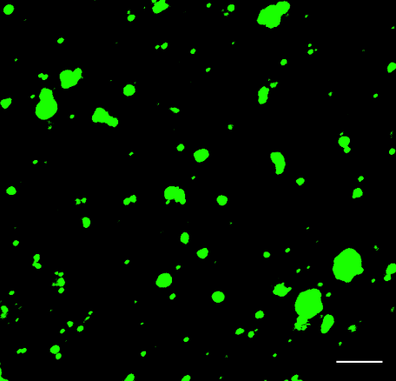
Fig. S2 The Annexin V staining of AB. Scale bars = 5 μm.

Fig. S3 Cell viability of RAW 276 after incubating with LIP, AB, or L-AB for 24 h.
Fig. S4 Dex encapsulation efficiency by L-AB (n = 3).

Fig. S5 Organ weights after LPS induction. (A)Spleen; (B) Lung.

Fig. S6 Supplementary data of the biodistribution study. (A) The quantitative analysis for the fluorescence signal in the blood; (B) The fluorescence image in the blood. (n = 3).

Fig. S7 The localization of DiD@AB, DiD@LIP, and DiD@L-AB within the spleen, immunofluorescence analysis of spleen sections stained with F4/80. The sections were visualized using blue (DAPI), green (F4/80), and red (DiD) fluorescence, scale bar = 20 μm.

Fig. S8 The level of proinflammatory cytokines IL-12p70 in serum (n = 5). Data are displayed as mean ± SD. ***P < 0.001.

Fig. S9 Quantification results of CD86⁺ cells as a percentage of the total macrophages population after various treatments (n = 5). Data are displayed as mean ± SD. ***P < 0.001.

