Supplementary (S)
Table S1: Predictor variables used for the species distribution modelling of barking deer in Indian Himalaya Region, India
Sl. No | Variables | Code | Unit | Data | Source
I. Bio climatic
1 | Annual Mean Temperature | Bio1 | Celsius
2 | Mean Diurnal Range (Mean of monthly (max temp - min temp) | Bio2 | Celsius
3 | Isothermality (BIO2/BIO7) (×100) | Bio3 | Celsius
4 | Temperature Seasonality (standard deviation ×100) | Bio4 | Celsius
5 | Max Temperature of Warmest Month | Bio6 | Celsius
6 | Min Temperature of Coldest Month | Bio6 | Celsius
7 | Temperature Annual Range (BIO5-BIO6) | Bio7 | Celsius
8 | Mean Temperature of Wettest Quarter | Bio8 | Celsius
9 | Mean Temperature of Driest Quarter | Bio9 | Celsius
10 | Mean Temperature of Warmest Quarter | Bio10 | Celsius
11 | Mean Temperature of Coldest Quarter | Bio11 | Celsius
12 | Annual Precipitation | Bio12 | mm
13 | Precipitation of Wettest Month | Bio13 | mm
14 | Precipitation of Driest Month | Bio14 | mm
15 | Precipitation Seasonality (Coefficient of Variation) | Bio15 | %
16 | Precipitation of Wettest Quarter | Bio16 | mm
17 | Precipitation of Driest Quarter | Bio17 | mm
18 | Precipitation of Warmest Quarter | Bio18 | mm
19 | Precipitation of Coldest Quarter | Bio19 | mm
II. Topographic variables
20 | Aspect | Aspect | Radian | SRTM | https://earthexplorer.usgs.gov/
21 | Elevation (m) | Elevation | Meter
22 | Slope | Slope | Radian
23 | Ruggedness | Ruggedness | Radian
24 | Drainage | DW | Euclidean distance | DIVA GIS | (https://www.diva-gis.org/gdata)
III. Anthropogenic variables
25 | Human Influence Index | HII | Continuous | SEDAC | NASA
26 | Distance to Road | Road | Euclidean distance | DIVA GIS | (https://www.diva-gis.org/gdata)
IV. Land use land cover type
27 | Barren | Barren | Focal statistics (proportion) |  | https://earthexplorer.usgs.gov
28 | Cropland | Crop | Focal statistics (proportion) |  | https://earthexplorer.usgs.gov
29 | Forest | Forest | Focal statistics (proportion) |  | https://earthexplorer.usgs.gov
30 | Grasslands | Grass | Focal statistics (proportion) |  | https://earthexplorer.usgs.gov
31 | Impervious | Impervious | Focal statistics (proportion) |  | https://earthexplorer.usgs.gov
32 | Shrub | Shrub | Focal statistics (proportion) |  | https://earthexplorer.usgs.gov
33 | Snowice | Snowice | Focal statistics (proportion) |  | https://earthexplorer.usgs.gov
34 | Urban green space | Urban green | Focal statistics (proportion) |  | https://earthexplorer.usgs.gov
35 | water | Water | Focal statistics (proportion) |  | https://earthexplorer.usgs.gov
36 | Wetland | Wetland | Focal statistics (proportion) |  | https://earthexplorer.usgs.gov

Table S2: Variance Inflation Factor (VIF) value of the variables used to predict the habitat suitability map of barking deer in three biogeographic provinces of Indian Himalayan Region viz., Eastern Himalaya (EH), Central Himalaya (CH) and Western Himalaya (WH) and overall Indian Himalayan Region (IHR)
Sl No | Predictor | CH | EH | WH | Overall IHR
1 | Bio2 | 2.2 | 2.4 | 1.8 | 1.9
2 | Bio3 | 2.2 | 2.3 | - | -
3 | Bio8 | - | - | 1.9 | 3.2
4 | Bio14 | 1.8 | 3.5 | 2.0 | 1.8
5 | Bio15 | 1.6 | 1.7 | 1.7 | 2.1
6 | Aspect | 1.0 | - | - | -
7 | Elevation | - | 6.5 | - | -
8 | Slope | 1.5 | 1.5 | - | 1.3
9 | Ruggedness | 1.1 | - | - | -
10 | Drainage | 1.5 | 1.1 | - | 1.6
11 | Road | 1.4 | 1.1 | 1.2 | 1.3
12 | Hii | - | 2.0 | - | 2.0
13 | Barren | - | - | 1.6 | 1.4
14 | crop | - | - | - | 2.1
15 | Forest | 1.6 | 1.9 | 1.1 | 9.4
16 | Grass | - | - | 1.2 | 1.2
17 | Snow | - | - | 1.4 | 1.8
Table S3: Secondary occurrence locations of Barking deer collected from published literature are used for the species distribution modelling in Indian Himalaya Region, India
Sl No | Reference | State
1 | Aditya S, Kushwaha SPS (2010). Refining logistic regression models for wildlife habitat suitability modeling—A case study with muntjak and goral in the Central Himalayas, India. Ecol Model 222. 1354–1366. | Uttarakhand
2 | Ahmad K, Khan JA (2011). Status of mammals with special reference to Muntjac (Muntiacus muntjak) in Khulgarh Watershed area of Kumaon Himalayas. Tigerpaper 38(1) 15-19. | Uttarakhand
3 | Anwaruddin C (2010). Mammals and birds in Dihang-Dibang Biosphere Reserve, Arunachal Pradesh. Tigerpaper 37(4), pp.1-4. | Arunachal Pradesh
4 | Bahuguna NC, Mallick JK, (2004). Ungulates of West Bengal and its adjoining areas including Sikkim, Bhutan and Bangladesh. Ungulates of India, ENVIS Bulletin: Wildlife and Protected Areas, 7(1), pp.219-238. | West Bengal
5 | Bhattacharjee S (2006). Monitoring leopard (Panthera pardus) and its prey in different human-leopard conflict zones (high, medium and low), Pauri Garhwal, Uttaranchal. Forest Research Institute. Wildlife Institute of India, Dehradun, India. | Uttarakhand
6 | Biswas B, Ghose RK (1982). Progress report of the World Wildlife Fund-India and Zoological Survey of India collaborative project on the 'Status survey of the Lesser cats in eastern India'. Report No. 1, 52. | Sikkim
7 | Biswas B, Ghose RK, Ghosal DK (1985). Progress report of the World Wildlife Fund-India and Zoological Survey of India collaborative project on the 'Status survey of the Lesser cats in eastern India'. Report No. 2, 60. | Sikkim
8 | Biswas GG, Das D, Mukhopadhyay A (1999). Richness of mammalian species in the higher elevations of Neora Valley National Park. Zoos’ Print Journal 14(4) 10–12. https://doi.org/10.11609/JoTT.ZPJ.14.4.10-2. | West Bengal
9 | Chakraborty S, Sen AK (1991). Mammals of the Mehao Wildlife Sanctuary (Dibang Valley district, Arunachal Pradesh) with remarks on their status. Records of the Zoological Survey of India, pp.263-285. | Arunachal Pradesh
10 | Chattopadhyay S, Saha SS, Ghosh MK, Aggarwal VC (2006). Mammalia. In: Alfred, J.R.B. (eds.). Fauna of Sikkim (Part 1) Vertebrates, State Fauna Series 9, pp. 37–76. Director, Zoological Survey of India, Kolkata, 214pp. | Sikkim
11 | Choudhury A (2014). On the Occurrence of Dark-Coloured Indian or Red Muntjac Muntiacus muntjak Zimmermann in Sikkim-Darjeeling Areas with a Recent Sighting from West Sikkim, India. J Bombay Nat Hist Soc 111(1) 43-44. | Sikkim
12 | Dalgilesh G (1906). Notes and observations on mammals collected and observed in the Darjeeling District. J Bombay Nat Hist Soc 17(1) 122–127. | West Bengal
13 | Datta A, Anand MO, Naniwadekar R (2008). Empty forests: Large carnivore and prey abundance in Namdapha National Park, north-east India. Biol Conserv 141(5), pp.1429-1435. | Uttarakhand
14 | Gabb, H.B. (1945). Two Clouded Leopards. J Bombay Nat Hist Soc 20(2): 58–61. | West Bengal
15 | Gaston AJ, Garson PJ, Hunter JrML (1983). The status and conservation of forest wildlife in Himachal Pradesh, Western Himalayas. Biol Conserv 27(4), pp.291-314. | Himachal Pradesh
16 | Ghose, R.K. (1984). Ecological observation on the Neora Valley, Darjeeling District, West Bengal. J Bengal Nat Hist Soc 3(2), 84–98. | West Bengal
17 | Ilyas O, Khan JA (2003). Food habits of barking deer (Muntiacus muntjak) and goral (Naemorhedus goral) in Binsar Wildlife Sanctuary, India. Mammalia 67(4) 521-532. | Uttarakhand
18 | Joshi R (2016). Mammalian fauna of Rajaji National Park, India: a review on ecological observations and checklist. Check List, 12(3), pp.1892-1892. | Uttarakhand
19 | Khan DN, Faiza A (2011). Impact of hunting on large mammal densities in the West Indian Himalaya. Indian For 137(10), pp.1141-1146. | Himachal Pradesh
20 | Kumar S, Sahi DN (2009). Mammalian diversity and management plan for Jasrota Wildlife Sanctuary, Kathua (J&K). Tigerpaper 36, pp.18-23. | Jammu and Kashmir
21 | Kushwaha SPS, Khan A, Habib B, Quadri A, Singh A (2004). Evaluation of sambar and muntjak habitats using geostatistical modelling. Curr Sci pp.1390-1400. | Uttarakhand
22 | Lepcha TW, Chandy T, Rao CS, Tamang NW, Subba N, Sathyakumar S, Ramesh K, Bhattacharya T, Maheshwari A, Arunkumar A (2017). Wildlife Population Estimation for all Protected Areas of Sikkim 2016-2017, Department of Forests, Environment and Wildlife Management, Government of Sikkim, Gangtok, 72pp. | Sikkim
23 | Mallick JK (2012). Mammals of Kalimpong Hills, Darjeeling District, West Bengal, India. J. Threat. Taxa. 4(12) 3103–3136. https://doi.org/10.11609/JoTT.o2418.3103-36. | West Bengal
24 | Mallick JK, (2019). An updated checklist of the mammals of West Bengal. JNBR 8(2), pp.37-123. | West Bengal
25 | Mishra C, Datta A, Madhusudan MD (2004). The high altitude wildlife of Western Arunachal Pradesh: a survey report. Nature Conservation Foundation, International Snow Leopard Trust, and Wildlife Conservation Society (India Program), Mysore, India. Technical report, (8). | Arunachal Pradesh
26 | Mishra C, Johnsingh AJT (1996). On habitat selection by the goral Nemorhaedus goral bedfordi (Bovidae, Artiodactyla). J. Zool. 240(3), pp.573-580. | Himachal Pradesh
27 | Nath R (1978). Gamugul Siya-Behi Sanctuary, Himachal Pradesh. Cheetal. 20(1) 41-43. | Himachal Pradesh
28 | Orus Ilyas, J.A Khan and Afifullah Khan (2003). Status, abundancea and factor governing distribution of ungulates in Kumaon Himalaya, India. Int J eco Env sci 29.123:130. | Uttarakhand
29 | Prasad S, Chellam R, Krishnaswamy J, Goyal SP (2004). Frugivory Of Phyllanthus Emblica At Rajaji National Park, Northwest India. Curr Sci Vol. 87, No. 9. | Uttarakhand
30 | Ranade SP, Prakash V (2015). Coprophagy by Barking Deer Muntiacus vaginalis (Mammalia: Cetartiodactyla: Cervidae) in Buxa Tiger Reserve, West Bengal, India. J Threat Taxa 7(11), pp.7825-7826. | West Bengal
31 | Saha, J. C. (1955). Annual Report of The Bengal Natural History Society and Natural History Museum, Darjeeling for the year ending March 31, 1955. J Bengal Nat Hist Soc 17(1) 123–126. | West Bengal
32 | Sathyakumar S, Bashir T, Bhattacharya T, Poudyal K (2011). Assessing mammal distribution and abundance in intricate eastern Himalayan habitats of Khangchendzonga, Sikkim, India. Mammalia 75(3) 257–268. https://doi.org/10.1515/MAMM.2011.023. | Sikkim
33 | Sathyakumar S, Bhattacharya T, Bashir T, Poudyal K, (2013). Developing Spatial Database on the Mammal Distributions and Monitoring Programme for Large Carnivores, Prey Populations, and their Habitats in Khangchendzonga Biosphere Reserve. Project Final Report. Wildlife Institute of India, Dehradun. | Sikkim
34 | Sharma T, Ganguli-Lachungpa U (2003). Status, distribution and management of mountain ungulates in Sikkim. In: Sathyakumar, S. and Bhatnagar, Y.V. (Eds.) ENVIS BULLETIN: Wildlife and Protected Areas. Mountain Ungulates. Vol. (1) 38-49 ENVIS Bulletin: Wildlife and Protected Areas. 38-49 pp. | Sikkim
35 | Thapa A, Pradhan PK, Joshi BD, Mukherjee T, Thakur M, Chandra K, Sharma LK (2021). Non-protected areas demanding equitable conservation strategies as of protected areas in the Central Himalayan region. PloS one 16(8), p.e0255082. | West Bengal
36 | Vijayan L, Bhupathy S, Kuma, A, Thapa J, Acharya BK, Chettri B, Riphung S, (2004). An Ecological Study of Mammals, Birds, Herpetofauna and Butterflies in Teesta Basin, Sikkim: Report of Phase II, 123pp. | Sikkim
37 | Vinod TR, Sathyakumar S, (1999). Ecology and conservation of mountain ungulates in great Himalayan national park, western Himalaya. An ecological study of the conservation of biodiversity and biotic pressures in the Great Himalayan National Park Conservation Area—an eco development approach. FREEP-GHNP, 3(10). | Himachal Pradesh
38 | Wroughton RC (1916). Bombay Natural History Societies Mammal Survey of India, Burma and Ceylon. Report No. 23. Sikkim and Bengal Terai. J Bombay Nat Hist Soc 24. 256-493.a. | West Bengal

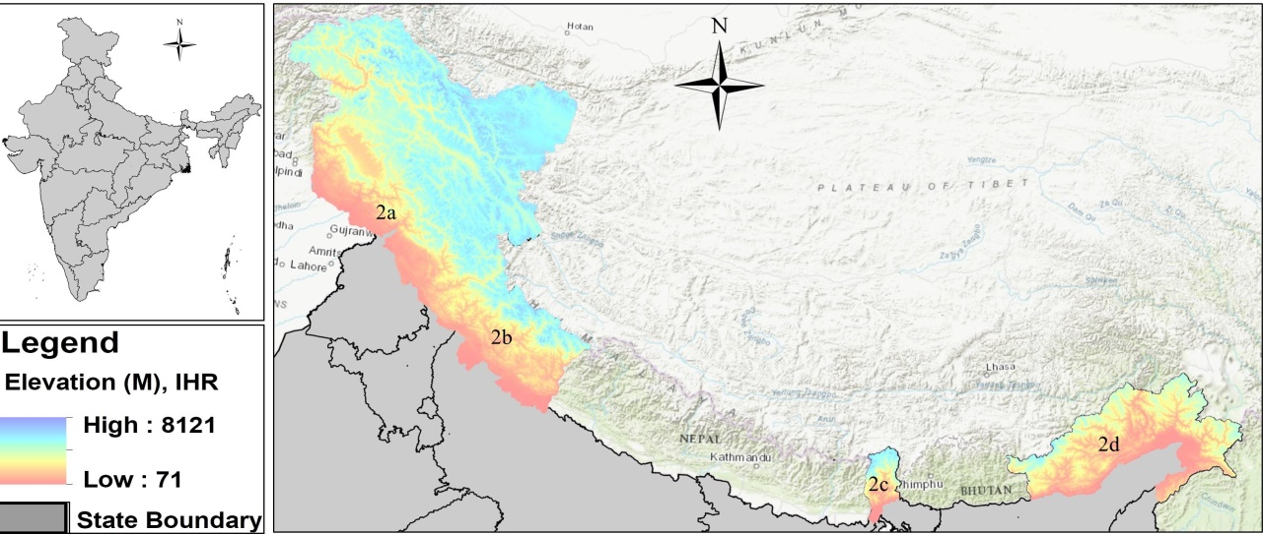
Figure S1: Map of India showing biogeographic provinces of Indian Himalayan Region (2a: North West Himalaya; 2b: Western Himalaya; 2c: Central Himalaya and 2d: Eastern Himalaya)

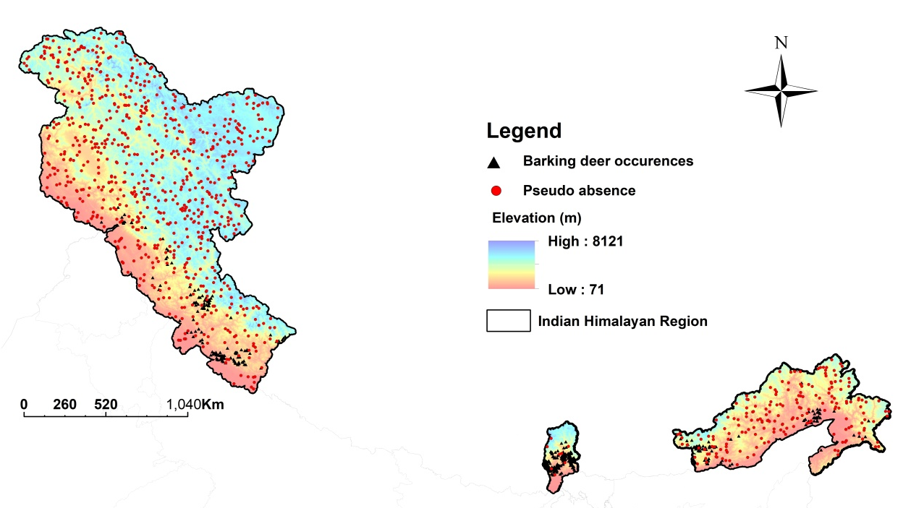
Figure S2: Indian Himalayan Region with elevation range and black triangle showing barking deer occurrence and red dot represent pseudo-absences.

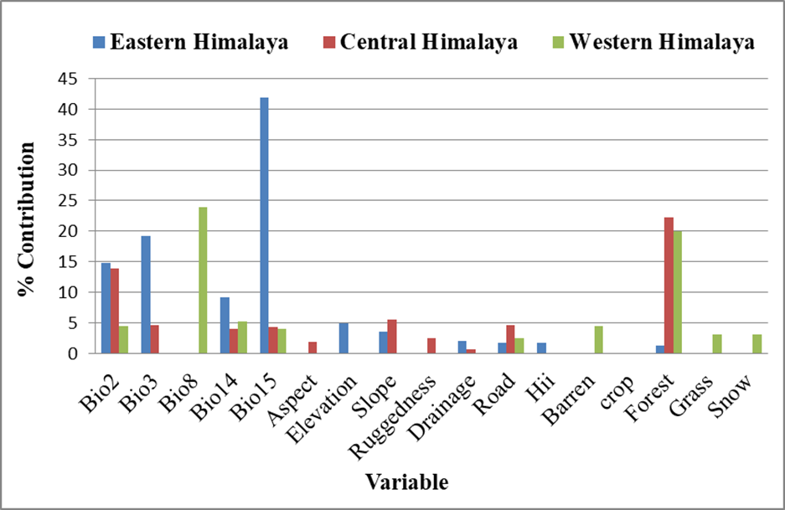
Figure S3. Variable importance based on its percentage of contribution was used to predict habitat suitability map of barking deer in three biogeographic provinces viz., Eastern, Central and Western Himalaya, Indian Himalayan Region.
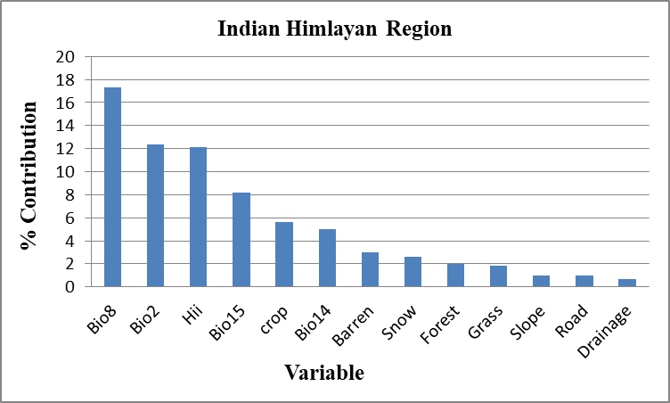
Figure S4: Variable importance based on its percentage of contribution was used to predict habitat suitability map of barking deer in overall Indian Himalayan Region
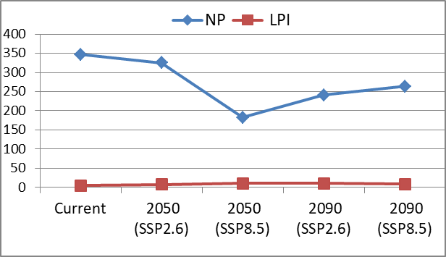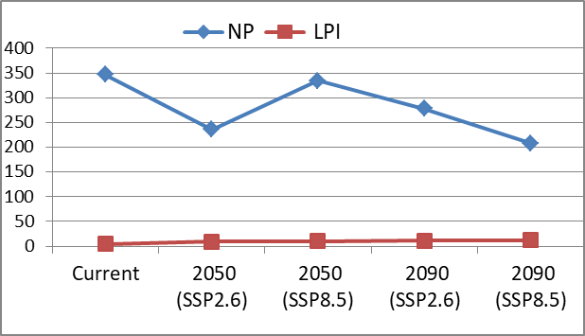
(b)
(a)
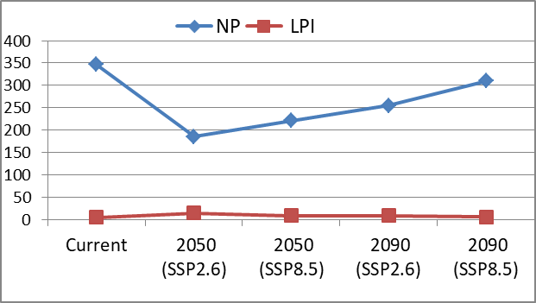
(c)
Figure S5: Patch metrics represented by Number of Patches (NP) and Largest Patch Index (LPI) of suitable habitat for barking deer in Western Himalaya (a) combined future climate and land use change scenarios (M1), (b) future climate change only (M2) scenarios and (c) future land use change only scenarios (M3).
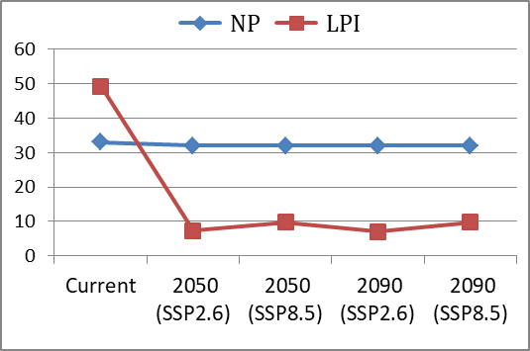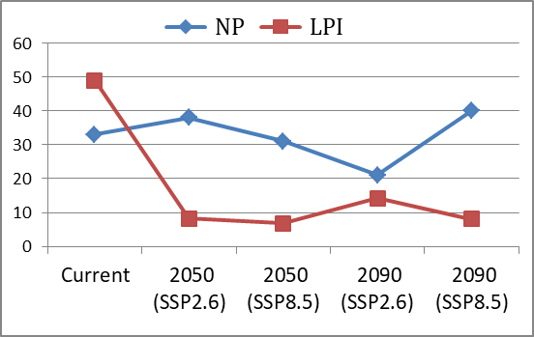
(b)
(a)

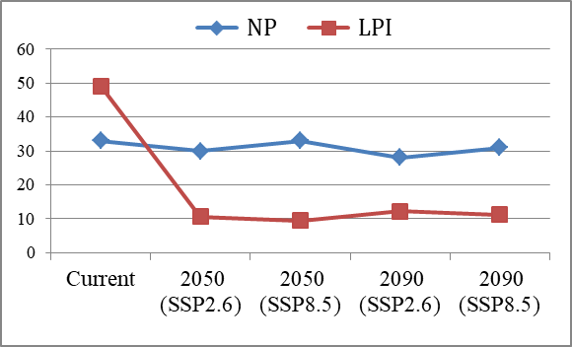
(c)
Figure S6: Patch metrics represented by Number of Patches (NP) and Largest Patch Index (LPI) of suitable habitat for barking deer in Central Himalaya (a) combined future climate and land use change scenarios (M1), (b) future climate change only (M2) scenarios and (c) future land use change only scenarios (M3).
(b)
(a)
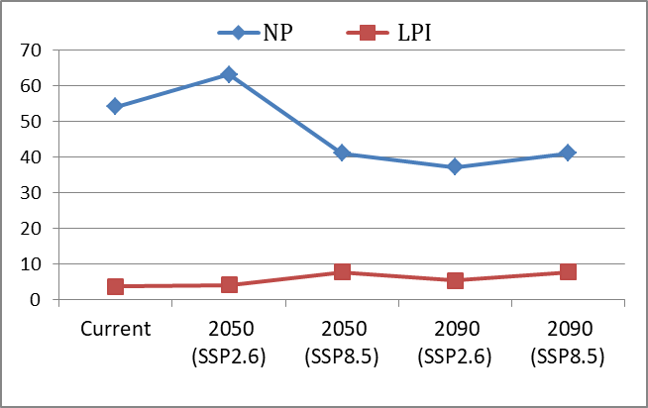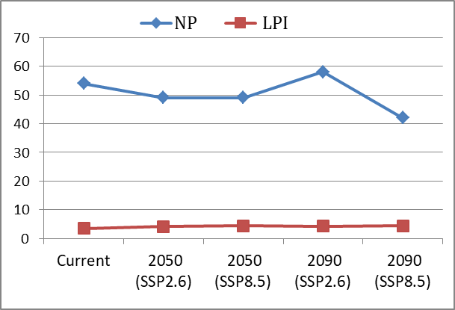
(c)
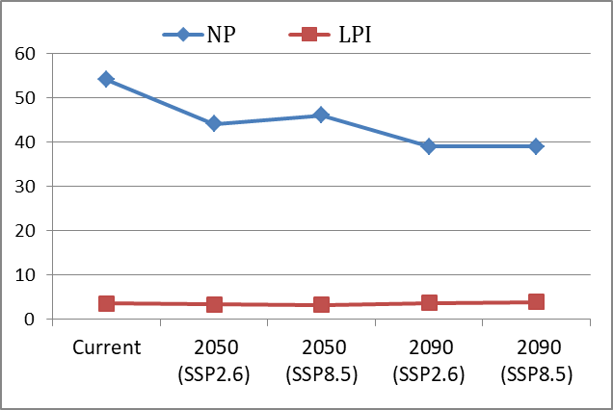
Figure S7: Patch metrics represented by Number of Patches (NP) and Largest Patch Index (LPI) of suitable habitat for barking deer in Eastern Himalaya (a) combined future climate and land use change scenarios (M1), (b) future climate change only (M2) scenarios and (c) future land use change only scenarios (M3).

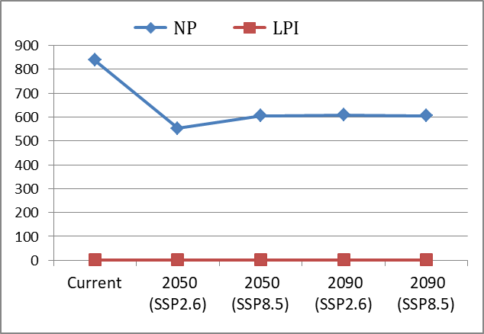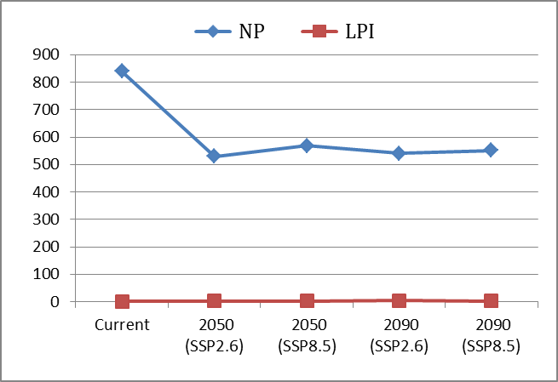
(b)
(a)
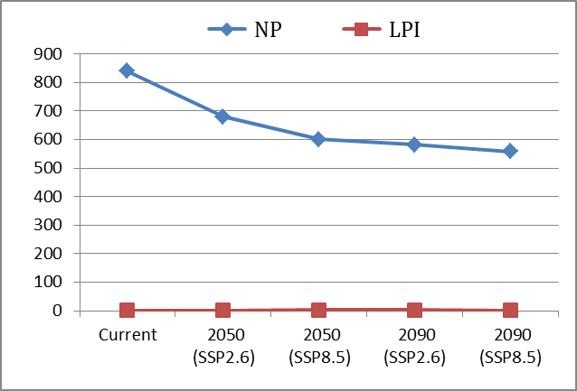
(c)
Figure S8: Patch metrics represented by Number of Patches (NP) and Largest Patch Index (LPI) of suitable habitat for barking deer in overall Indian Himalayan Region, (a) combined future climate and land use change scenarios (M1), (b) future climate change only scenarios (M2) and (c) future land use change only scenarios (M3).

