Spatial and temporal distribution characteristics and source apportionment of biogenic elements using APCS-MLR model in the main inlet tributary of Danjiangkou Reservoir

Yihang Wuª, Qianzhu Zhang^{a*}, Yuan Luo^{b}, Ke Jinª, Qian He^{b}, Yang Luª

ª Chongqing Branch, Changjiang River Scientific Research Institute, Chongqing 400026, China
^{b} College of River and Ocean Engineering, Chongqing Jiaotong University, Chongqing 400074, China

Supplementary Material

Pages =7
Figures = 1
Tables = 3

*Corresponding authors.
E-mail address: qianzhuzhang@163.com

Table S1. Relative weights and normalization factors of 11 parameters
Variable | Relative weight (P_{i}) | Normalization factor (C_{i})
Variable | Relative weight (P_{i}) | 100 | 90 | 80 | 70 | 60 | 50 | 40 | 30 | 20 | 10 | 0
pH | 1 | 7 | 7–8 | 8–8.5 | 8.5–9 | 6.5–7 | 6–6.5,  9-9.5 | 5–6,  9.5-10 | 4–5,  10-11 | 3–4,  11-12 | 2–3,  12-13 | 1–2,  13-14
WT(℃) | 1 | 16-21 | 15-16,  21-22 | 14-15,  22-24 | 12-14,  24-26 | 10-12,  26-28 | 5-10,  28-30 | 0-5,  30-32 | -2-0,  32-36 | -4~-2,  36-40 | -6~-4,  40-45 | >45, <−6
EC(μs/cm) | 2 | <750 | <1000 | <1250 | <1500 | <2000 | <2500 | <3000 | <5000 | <8000 | ≤12000 | >12000
DO(mg/L) | 4 | ≥7.5 | >7 | >6.5 | >6 | >5 | >4 | >3.5 | >3 | >2 | ≥1 | <1
Ca²⁺(mg/L) | 1 | <10 | <50 | <100 | <150 | <200 | <300 | <400 | <500 | <600 | ≤1000 | >1000
Mg²⁺(mg/L) | 1 | <10 | <25 | <50 | <75 | <100 | <150 | <200 | <250 | <300 | ≤500 | >500
Cl⁻(mg/L) | 1 | <25 | <50 | <100 | <150 | <200 | <300 | <500 | <700 | <1000 | ≤1500 | >1500
SO₄²⁻(mg/L) | 2 | <25 | <50 | <75 | <100 | <150 | <250 | <400 | <600 | <1000 | ≤1500 | >1500
TP(mg/L) | 1 | <0.01 | <0.02 | <0.05 | <0.1 | <0.15 | <0.2 | <0.25 | <0.3 | <0.35 | ≤0.4 | >0.4
TN(mg/L) | 2 | <0.1 | 0.1-0.2 | 0.2-0.35 | 0.35-0.5 | 0.5-0.75 | 0.75-1 | 1-1.25 | 1.25-1.5 | 1.5-1.75 | 1.75-2 | >2
TDS(mg/L) | 2 | <100 | <500 | <750 | <1000 | <1500 | <2000 | <3000 | <5000 | <10000 | ≤20000 | >20000

Table S2 Concentrations of biogenic elements in other rivers
Country | Region | River | DIC/(mg/L) | DOC/(mg/L) | TN/(mg/L) | TP/(mg/L) | DSi/(mg/L) | Reference
China | Beijing | Chaobai River |  | 30.60 |  |  |  | Wang et al., 2023a
China | Danjiangkou Reservoir Basin | Han River |  |  |  | 0.04 |  | Chen et al., 2015
China | Danjiangkou Reservoir Basin | Tian River |  |  |  | 0.05 |  | Chen et al., 2015
China | Danjiangkou Reservoir Basin | Jiang River |  |  |  | 0.81 |  | Chen et al., 2015
China | Danjiangkou Reservoir Basin | Shending River |  |  |  | 0.80 |  | Chen et al., 2015
China | Danjiangkou Reservoir Basin | Si River |  |  |  | 0.65 |  | Chen et al., 2015
China | Danjiangkou Reservoir Basin | Jian River |  |  |  | 0.12 |  | Chen et al., 2015
China | Danjiangkou Reservoir Basin | Lang River |  |  |  | 0.17 |  | Chen et al., 2015
China | Danjiangkou Reservoir Basin | Laoguan River |  |  |  | 0.09 |  | Chen et al., 2015
China | Danjiangkou Reservoir Basin | Tao River |  |  |  | 0.02 |  | Chen et al., 2015
China | Danjiangkou Reservoir Basin | Dan River |  |  |  | 0.07 |  | Chen et al., 2015
China | Fujian Province | Jiulong River | 19.32 |  |  |  |  | Yin et al., 2020
China | Anhui Province | Lake Chaohu |  |  | 3.95 | 0.27 |  | Yang et al., 2020
China |  | Yellow River |  | 2.92 |  |  |  | Wen et al., 2021
China | Qinghai-Tibet Plateau | Bailong River | 38.50 | 1.40 |  |  |  | Wang et al., 2023b
China | Chongqing and Guizhou Province | Qijiang |  | 1.52 |  |  |  | Ni and Li, 2022
China | Southwest China | Furong River | 24.82 | 2.94 |  |  |  | Ni et al., 2023
China | Southwest China | Pengxi River | 21.42 | 3.60 |  |  |  | Ni et al., 2023
China |  | Tuo River |  |  |  |  | 12.70 | Chen et al., 2024a
China |  | Dadu River |  |  |  |  | 11.60 | Chen et al., 2024a
China | Hubei Province | Xiangxi River |  |  |  |  | 6.38 | Huang et al., 2019
China | Chongqing | Taohuaxi River |  | 5.67 |  |  |  | Chen and Li, 2021
China | Chongqing | Puli River |  | 4.02 |  |  |  | Chen and Li, 2021
China | Zhejiang Province | Wen-Rui Tang River |  | 2.70 | 3.77 | 0.23 |  | Chen et al., 2024b
China | Zhejiang Province | Qiduyuan River |  |  | 0.16~2.28 | 0.001~0.113 |  | Wang et al., 2025
China |  | Lancang River |  |  | 0.47 |  |  | Li et al., 2022
China |  | the Upper Yellow River |  |  | 1.55 |  |  | Li et al., 2022
China |  | Three River Headwater Region |  |  | 1.06 |  |  | Li et al., 2022
China | Hubei Province and Henan Province | Danjiangkou Resevoir |  |  | 1.44 | 0.02 |  | Xiao et al., 2023
China |  | Changjiang River |  |  | 2.02 | 0.10 | 3.87 | Liang and Xian, 2018
China |  | Huanghe(Lijin) |  |  |  |  | 3.24 | Liang and Xian, 2018
China | Guangdong Province | Zhujiang |  |  | 2.30 | 0.10 | 3.78 | Liang and Xian, 2018
China | Sichuan Province | Laixi River |  |  | 3.74 | 0.19 |  | Ren et al., 2023
China | Liaoning Province | Taizi River |  |  | 3.75 | 0.19 |  | Wang et al., 2017
China |  | Changjiang |  |  |  |  | 8.58 | Zhang et al., 2020
China | Hubei Province | Baota River |  |  |  |  | 4.13 | Zhang et al., 2008
China | Hubei Province | Quxi River |  |  |  |  | 9.17 | Zhang et al., 2008
China | Hubei Province | Three Gorges Dam |  |  |  |  | 5.43 | Yu et al., 2022
China | Fujian Province | Minjiang River |  |  |  |  | 5.30 | Liu et al., 2023
China | Jiangsu Province | Changjiang River |  |  |  |  | 2.8 | Ran et al., 2016
China |  | Pearl River |  | 4.0-16.4 |  |  |  | Bao et al., 2015
America | South Florida | Kissimmee River |  |  |  | 0.13 |  | Gholizadeh et al., 2016
America |  | Caloosahatchee River |  |  |  | 0.13 |  | Gholizadeh et al., 2016
America |  | Miami cannal |  |  |  | 0.04 |  | Gholizadeh et al., 2016
America |  | Mississippi |  | 2.8-8.0 | 1.97 | 0.12 | 2.38 | Bao et al., 2015; Liang and Xian, 2018
America | California | Skokomish River |  | 0.7 |  |  |  | Bao et al., 2015
America | Alaska | Yukon River |  | 7.6 |  |  |  | Bao et al., 2015
India |  | Kali | 11.80 | 1.20 |  |  | 4.70 | Nishitha et al., 2021
India |  | Sharavati | 7.60 | 1.60 |  |  | 2.70 | Nishitha et al., 2021
India |  | Sita-Swarna | 17.00 | 3.10 |  |  | 5.80 | Nishitha et al., 2021
Poland |  | Głuszynka river |  |  | 3.76 | 0.36 |  | Janicka et al., 2022
Poland | Łod´ ´z Voivodeship | Bzura River |  | 16.50 |  |  |  | Wieczorek et al., 2024
Thailand |  | Mun River |  | 9.00 |  |  | 1.7~9.9 | Liu et al., 2019
La Paz Bolivia |  | Amazon River |  | 4.1 |  |  |  | Bao et al., 2015
Republic of Congo |  | Congo River |  | 10.7 |  |  |  | Bao et al., 2015
Russia |  | Lena River |  | 11.4 |  |  |  | Bao et al., 2015
Russia |  | Kolyma River |  | 6.6 |  |  |  | Bao et al., 2015
Canada |  | Mackenzie River |  | 4.4 |  |  |  | Bao et al., 2015
Russia |  | Yenisei River |  | 8.8 |  |  |  | Bao et al., 2015

Table S3 The parameters selection results of the WQI_{min} models from the stepwise multiple linear
Models | Parameters included | F | Adjusted R² | P | RMSE | MAE
1 | TN | 58.451 | 0.530 | <0.001 | 2.59 | 2.07
2 | TN, WT | 110.154 | 0.811 | <0.001 | 1.63 | 1.29
3 | TN, WT, TP | 87.588 | 0.836 | <0.001 | 1.50 | 1.18
4 | TN, WT, TP, SO₄²⁻ | 73.523 | 0.850 | <0.001 | 1.42 | 1.05

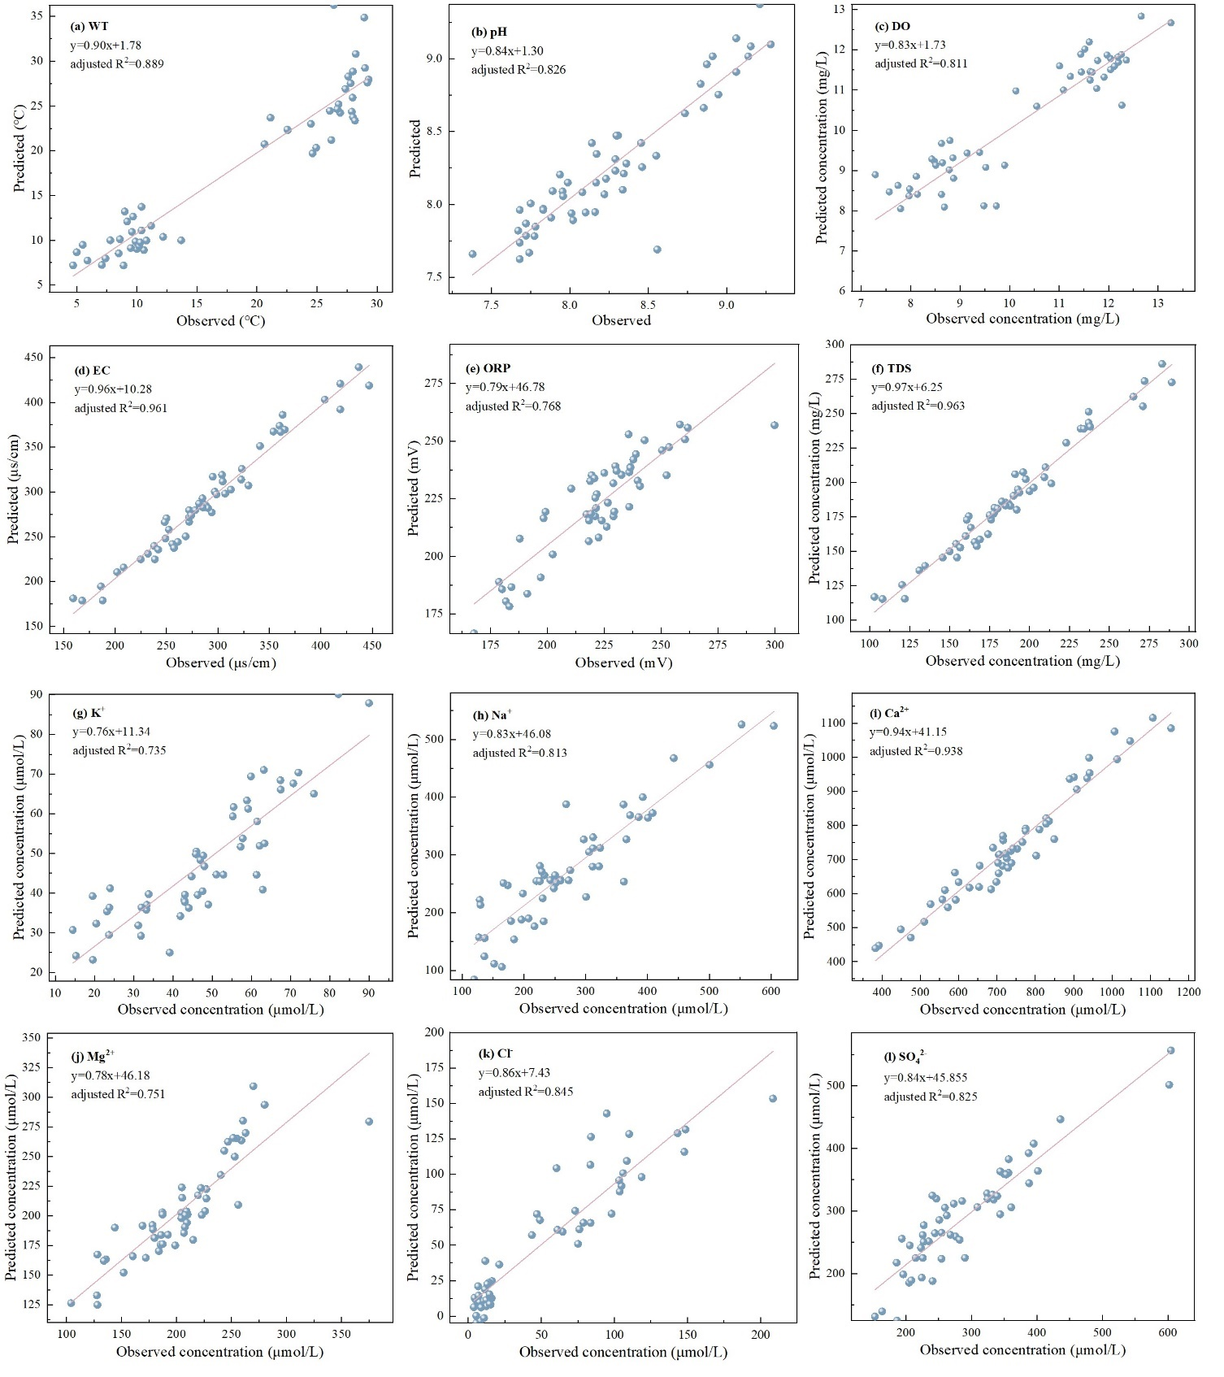
Fig.S1 Scatter plots of observed and predicted concentrations of water quality parameters
Reference:
Bao, H.Y., Wu, Y., Zhang, J. 2015. Spatial and temporal variation of dissolved organic matter in the Changjiang: Fluvial transport and flux estimation. Journal of Geophysical Research: Biogeosciences, 120(9), 1870-1886.
Chen, P., Li, L., Zhang, H.B. 2015. Spatio-Temporal Variations and Source Apportionment of Water Pollution in Danjiangkou Reservoir Basin, Central China. Water, 7(6), 2591-2611.
Chen, Z., Li, S., 2021. Seasonal variation of DOM spectral characteristics of rivers with different urbanization levels in the three gorges reservoir area. Environmental Science. 42, 195–203 (in Chinese).
Chen, X.M., Liang, L.W., Fu, S.J., et al. 2024a. Distribution characteristics of reactive silicon in six water bodies in the Yangtze River Basin in China. Environmental Research, 249, 118424.
Chen, W.L., Zhang, X.H., Wu, N.T., et al. 2024b. Sources and transformations of riverine nitrogen across a coastal-plain river network of eastern China: New insights from multiple stable isotopes. Science of the Total Environment, 924, 171671.
Gholizadeh, M.H., Melesse, A., Reddi, L., et al. 2016. Water quality assessment and apportionment of pollution sources using APCS-MLR and PMF receptor modeling techniques in three major rivers of South Florida. Science of the Total Environment, 566, 1552-1567.
Huang, Y.B., Mi, W.J., Hu, Z.Y., et al. 2019. Effects of the Three Gorges Dam on spatiotemporal distribution of silicon in the tributary: evidence from the Xiangxi River. Environmental Science and Pollution Research, 26(5), 4645-4653.
Janicka, E., Kanclerz, J., Wiatrowska, K., et al. 2022. Variability of Nitrogen and Phosphorus Content and Their Forms in Waters of a River-Lake System. Frontiers in Environmental Science, 10, 874754.
Li, Y., Li, B.L., Yuan, Y.C., et al. 2022. Trends in total nitrogen concentrations in the Three Rivers Headwater Region. Science of the Total Environment, 852, 158462.
Liang, C., Xian, W.W. 2018. Changjiang nutrient distribution and transportation and their impacts on the estuary. Continental Shelf Research, 165, 137-145.
Liu, J.K., Han, G.L., Liu, X.L., et al. 2019. Distributive Characteristics of Riverine Nutrients in the Mun River, Northeast Thailand: Implications for Anthropogenic Inputs. Water, 11(5), 954.
Liu, J.N., Zhai, S.J., Qiu, S.T., et al. 2023. Silicon composition and stoichiometric ratios with other nutrients in the lower Minjiang River, Southeast China. Chinese Journal of Applied Ecology, 34(8), 2205-2214 (in Chinese).
Ni, M.F., Li, S.Y. 2022. Dynamics and internal links of dissolved carbon in a karst river system: Implications for composition, origin and fate. Water Research, 226, 119289.
Ni, M.F., Liu, R., Luo, W.J., et al. 2023. Unexpected shifts of dissolved carbon biogeochemistry caused by anthropogenic disturbances in karst rivers. Water Research, 247, 120744.
Nishitha, D., Akshitha, V., Arun, K., et al. 2021. Dissolved carbon and silica fluxes from Kali, Sharavati and Sita-Swarna rivers, Southwestern India. Journal of Environmental Management, 286, 112273.
Ran, X.B., Liu, S.L., Liu, J., et al. 2016. Composition and variability in the export of biogenic silica in the Changjiang River and the effect of Three Gorges Reservoir. Science of the Total Environment, 571, 1191-1199.
Ren, X.N., Yang, C., Zhao, B., et al. 2023. Water quality assessment and pollution source apportionment using multivariate statistical and PMF receptor modeling techniques in a sub‑watershed of the upper Yangtze River, Southwest China. Environmental Geochemical and Health, 45(9), 6869-6887.
Varol, M., Karakaya, G., Alpaslan, K. 2022. Water quality assessment of the Karasu River (Turkey) using various indices, multivariate statistics and APCS-MLR model. Chemosphere, 308, 136415.
Wang, Q., Lu, C., Fan, Z.P., et al. 2017. Eutrophication and spatial distribution of N, P and chlorophyll-a in the Taizi River Basin, Liaohe River Catchment. Journal of Lake Science, 29(2), 297-307 (in Chinese).
Wang, J.J., Pu, X., Zhang, R.N., et al. 2023a. Spatial-temporal distribution and source apportionment of riverine dissolved organic carbon in the Miyun section of the Chaobai River in Beijing, China. Water-Energy Nexus, 6. 160-166.
Wang, W.F., Zhong, J., Li, S.J., et al. 2023b. Constraining the sources and cycling of dissolved inorganic carbon in an alpine river, eastern Qinghai-Tibet Plateau. Science of the Total Environment, 901, 166262.
Wang, Y.Y., Xu, H., Zhao, X.C., et al. 2025. Rainfall impacts on nonpoint nitrogen and phosphorus dynamics in an agricultural river in subtropical montane reservoir region of southeast China. Journal of Environmental Sciences, 149, 551-563.
Wen, Z.D., Song, K.S., Shang, Y.X., et al. 2021. Natural and anthropogenic impacts on the DOC characteristics in the Yellow River continuum. Environmental Pollution, 287, 117231.
Wieczorek, K., Turek, A., Szczesio, M., et al., 2024. A holistic approach to the spatio-temporal variability investigation of the main river water quality – The importance of tributaries. Science of the Total Environment, 906, 167588.
Xiao, Y.N., Cheng, J.H., Mo, X.C., et al. 2023. Spatio-temporal variation of phytonplankton community and its relationship with environmental factors in Danjiangkou Reservoir. Journal of Lake Sciences, 35(3), 821-832 (in Chinese).
Yang, X., Cui, H.B., Liu, X.S., et al. 2020. Water quality assessment of rivers in Lake Chaohu Basin (China) using water quality index. Environmental Science and Pollution Research, 27(15), 18168-18181.
Yin, X.J., Lin, Y.P., Liang, C.C., et al. 2020. Source and fate of dissolved inorganic carbon in Jiulong River, southeastern China. Estuarine Coastal and Shelf, Science, 246, 107031.
Yu, Y., Wang, D.Y., Tang, X.Q., et al. 2022. Transport Characteristics of Main Nutrients and Contribution of Tributaries in Middle and Lower Reaches of Yangtze River at End of Flood Season. Resources and Environment in the Yangtze Basin, 31(5), 1039-1050 (in Chinese).
Zhang, S.Y., Feng, M.L., Lin, S., et al. 2008. Dissolved silicon, inorganic nitrogenic and phosphorus in the stream water of two small watersheds in three gorges area. Environmental Science, 29(10), 2716-2722 (in Chinese).
Zhang, A.Y., Zhang, J., Liu, S.M. 2020. Spatial and temporal variations of dissolved silicon isotope compositions in a large dammed river system. Chemical Geology, 545, 119645.

