SUPPORTING INFORMATION
Temperature dependent rotation of protonated methyl groups in otherwise deuterated proteins modulates DEER distance distributions

Thomas Schmidt*, Valentyn Stadnytskyi

Laboratory of Chemical Physics, National Institute of Diabetes and Digestive and Kidney Diseases, National Institutes of Health, Bethesda, MD 20892-0520, U.S.A.

Experimental Procedures

Description of methyl rotation. The activation energy landscape for a methyl label is given by eq S1 (Fig 1B), where N is the number points in the activation energy grid each described by its index i, <E_{a}> is the mean activation energy and σ is its distribution. The contribution of each methyl conformer to the activation energy distribution is weighted by eq S2 giving a gaussian probability density function, f_{i}. The three-site jump constant for the individual conformers is obtained by the Arrhenius law (eq S3) where k₀, R and T denote the three-site jump rate, ideal gas constant and temperature, which was validated for methyl groups for amino acid systems with limited conformational heterogeneity.[4,5] The subsequent modulation factor, k_{app} (eq S4), is obtained by the summation of weighted exponentials for individual conformers at electron evolution time 2τ₂ (Fig 1C).
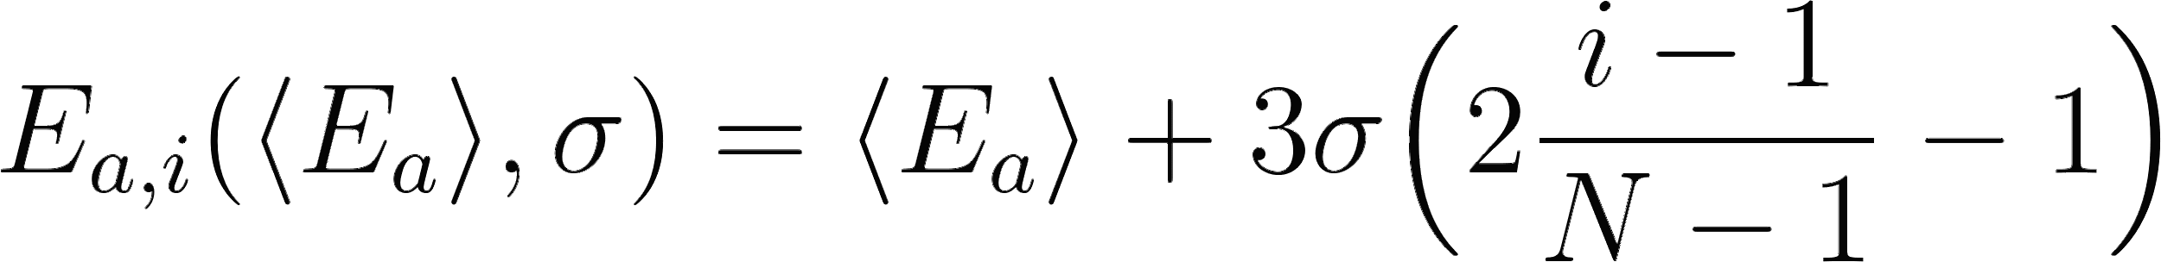 (S1)
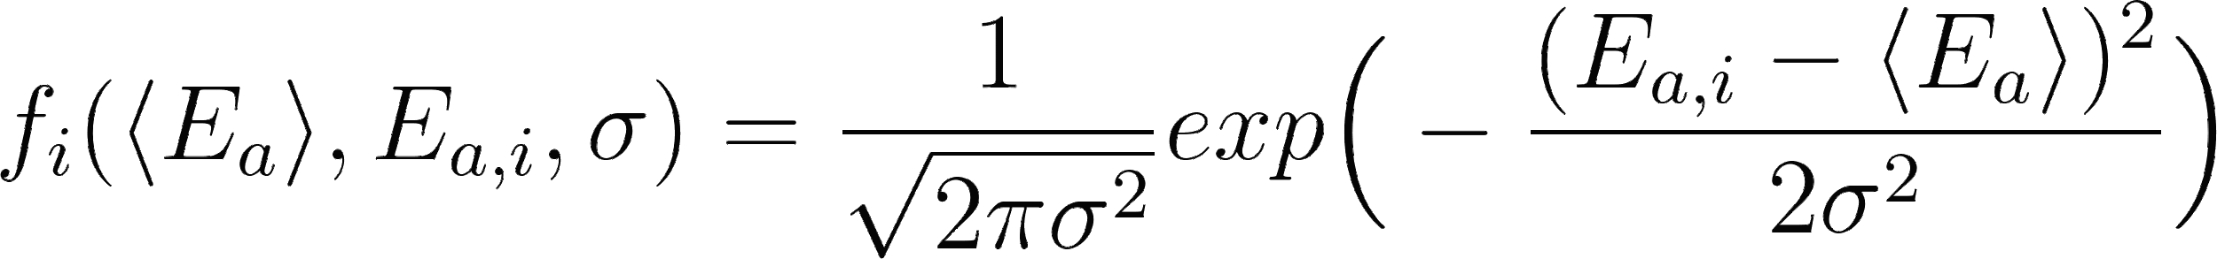 (S2)
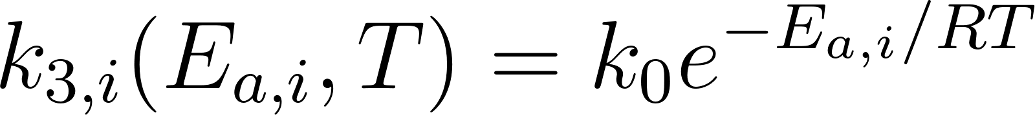 (S3)
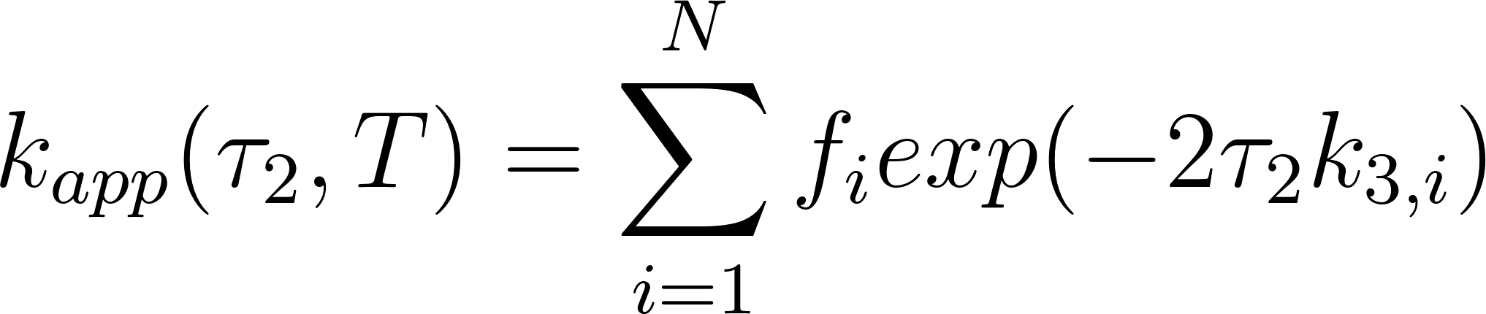 (S4)

Table S1 Isotope labeling schemes and their fitting values for two-Gaussian fit.

ProteinA | MTSL | R (Å) |  | σ (Å)
ProteinA | MTSL | R1 | R2 | σ1 | σ2
Distance and its distribution are restrained

²H | ²H | 31.8±0.1 | 38.2±0.1 | 2.4±0.1 | 2.8±0.1
²H | ¹H | 31.8±0.1 | 38.2±0.1 | 2.4±0.1 | 2.8±0.1
¹H-Leu-CH₃/²H | ²H | 31.9±0.1 | 38.7±0.1 | 2.5±0.1 | 2.7±0.1
¹H-Leu-CH₃/²H | ¹H | 31.8±0.1 | 38.6±0.1 | 2.3±0.1 | 2.9±0.1
Distance, distribution,〈Ea〉and〈Ea〉distribution are restrained

²H | ²H | - | - | - | -
²H | ¹H | 31.9±0.1 | 38.4±0.1 | 2.3±0.1 | 2.8±0.1
¹H-Leu-CH₃/²H | ²H | 32.1±0.1 | 39.1±0.1 | 2.2±0.1 | 2.9±0.1
¹H-Leu-CH₃/²H | ¹H | 31.9±0.1 | 38.4±0.1 | 2.2±0.1 | 2.8±0.1

Table S2 Isotope labeling schemes and their fitting values for two-Gaussian fit.

ProteinA | R1p | R (Å) |  | σ (Å) |  | X²
ProteinA | R1p | R1 | R2 | σ1 | σ2 | X²
²H | ¹H | 31.8±0.1 | 38.3±0.1 | 1.4±0.1 | 2.6±0.1 | 1.1#/1.2*
¹H-Leu-CH₃/²H | ¹H | 32.5±0.1 | 38.5±0.1 | 1.6±0.1 | 2.1±0.1 | 1.0#/1.1*
# Averages for model-free fits to the individual DEER echo curves using DeerLab with validated Tikhonov regularization (n=1000).
* Gaussian global fits based on the program DD/GLADDvu, incorporated into an inhouse Python program to the complete set of Q-band DEER echo curves recorded over a series of temperate and τ₂ values . For the presented two-Gaussian global fit, only the mean distances and corresponding widths are constrained to be invariant.

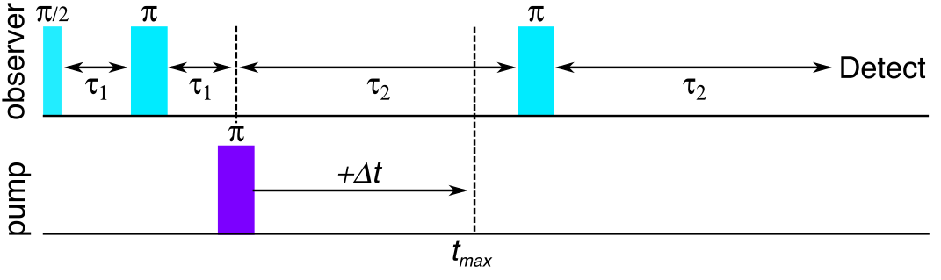

Figure S1. Pulse schemes for four-pulse DEER experiments[3]. In the current work, the duration of the blue π/2 and π pulses are 12 and 24 ns, respectively, and that of the purple π pulse is 10 ns. For all presented experiments the т₂ was kept fixed at 150 ns and the Δt was kept at 8 ns. The values of т₂ alternated between 5, 10, 15 and 20 μsn while the t_{max} remained constant at 4 μs.
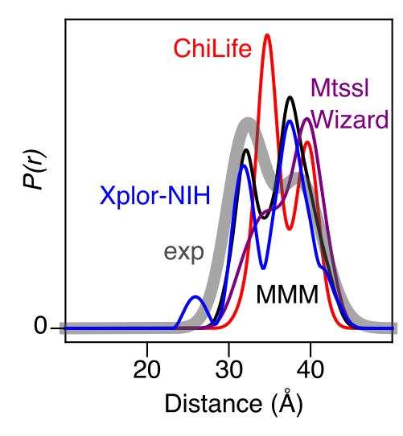

Figure S2. Predicted distance distributions between the nitroxide spin labels at Q39C-R1 and K88C-R1 in AviTag-Protein A confirms a bimodal distribution. The spin label conformer ensembles were calculated from the coordinates of Protein A (PDB code 1BDD) using the rotamer library program MMM (black)[3,6], MtsslWizard (lilac)[7], ChiLife (red)[8] and Xplor-NIH (blue)[9,10] in comparison to the experimental distribution (gray). Q39C-R1 exists in two distinct ensemble populations a and b (see Fig. 1A of main text). The distances are calculated to the carbon atoms of the methyl groups and displayed as the integral of the P(r) distributions.

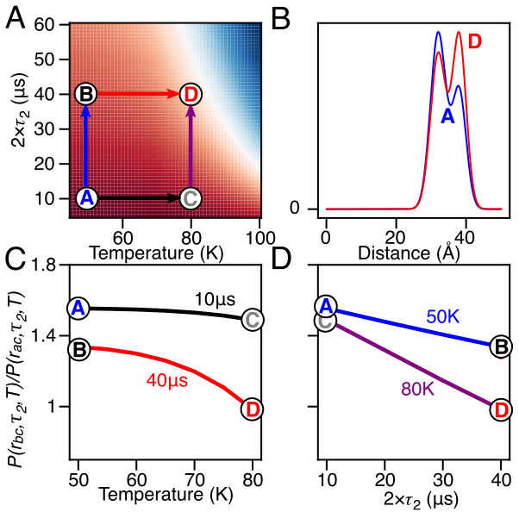

Fig S3. Simulated distance distribution ratio. (A) Heatmap shows the distance population ratio as function of relaxation time (2τ2) and Temperature (T) ranging between 1.6 (red) to 0 (blue). The heatmap was simulated with k₀=7x10¹¹s⁻¹, Eªa=12 kJmol⁻¹, E^{b}a=12.5 kJmol⁻¹, σa=2.5 kJmol⁻¹, σb=2.5 kJmol⁻¹, Tªm=42 μs,T^{b}m=28 μs and P_{bC}/P_{aC}=0.62. Letters designate individual DEER distance distribution for A(10μs,50K,blue), B(40μs,50K,black), C(10μs,80K,lilac) and D(40μs,80K,red). (B) Comparison between DEER distance distribution observed for state A to state D shows population decrease at 32 Å compared to 38 Å. (C) presents population ratio changes as a function of temperature along the transition path of the temperature dimension for states A-to-C (black) and B-to-D (red). (D) Shown are the transition path along the 2τ2 time dimension for states A-to-B (blue) and C-to-D (lilac).

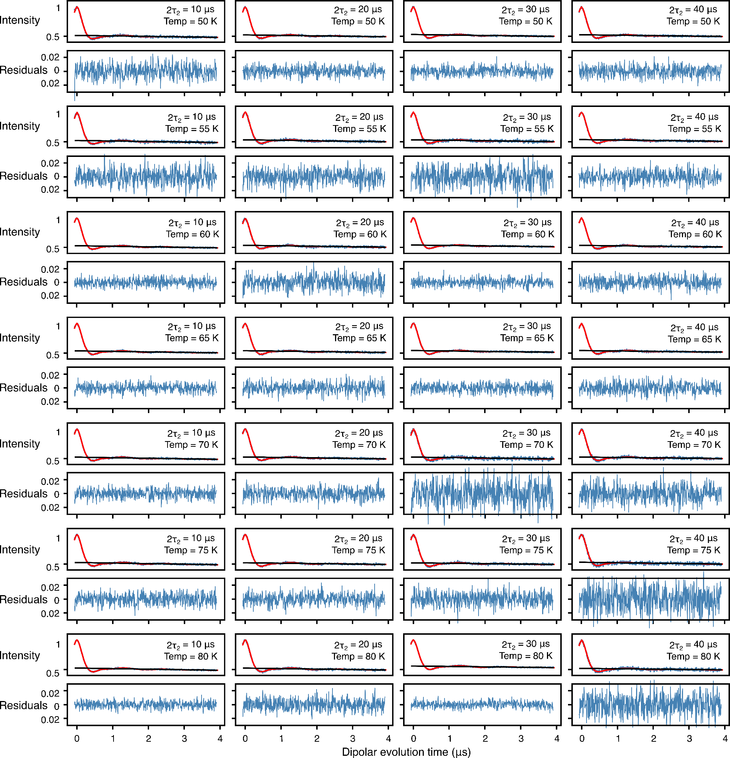
Figure S4. Analysis of Q-band DEER data acquired for spin-labeled proteinA (Q39C-R1/K88C-R1), the protein as well as the MTSL label were fully deuterated (²H-Leu, ²H-R1), by using validated Tikhonov regularization (n=1000). In each panel, the top half displays the experimental (blue) and bestfit (red) DEER echo curves; the bottom half shows the corresponding residuals between experimental and calculated curves. The data at each temperature and 2т₂ combination were fitted individually using validated Tikhonov regulation in the program DeerLab.[11] The mean normalized χ² value of the fits is given in Table 1 of the main text.

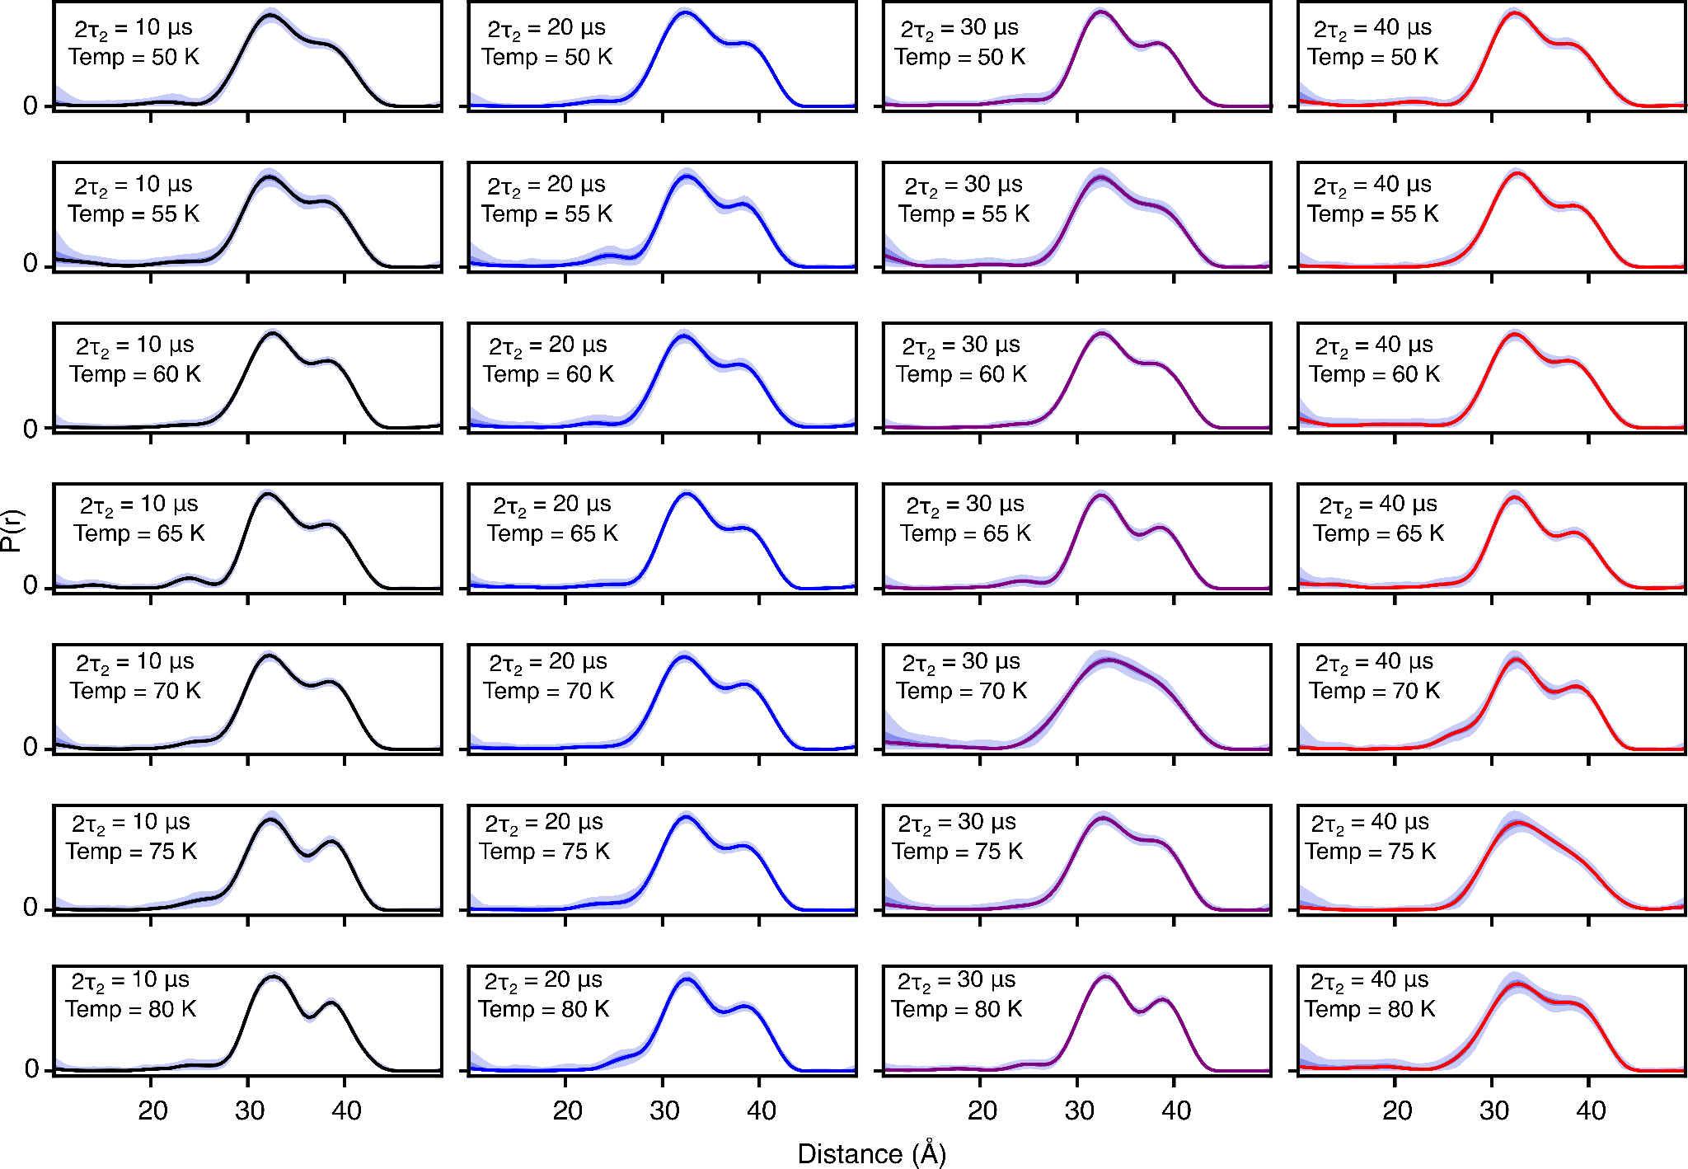
Figure S5. DEER-derived P(r) distributions for for spin-labeled proteinA (Q39C-R1/K88C-R1) by using validated Tikhonov regularization (n=1000)[11], the protein as well as the MTSL label were fully deuterated (²H-Leu, ²H-R1). The fits to the experimental DEER echo curves are shown in Fig. S1. The solid lines present 2т₂ of 10 (black), 20 (blue), 30 (lilac) and 40 μs (red). The shaded region below presents the 95% (light violet) and 50% (dark violet) confidence interval.
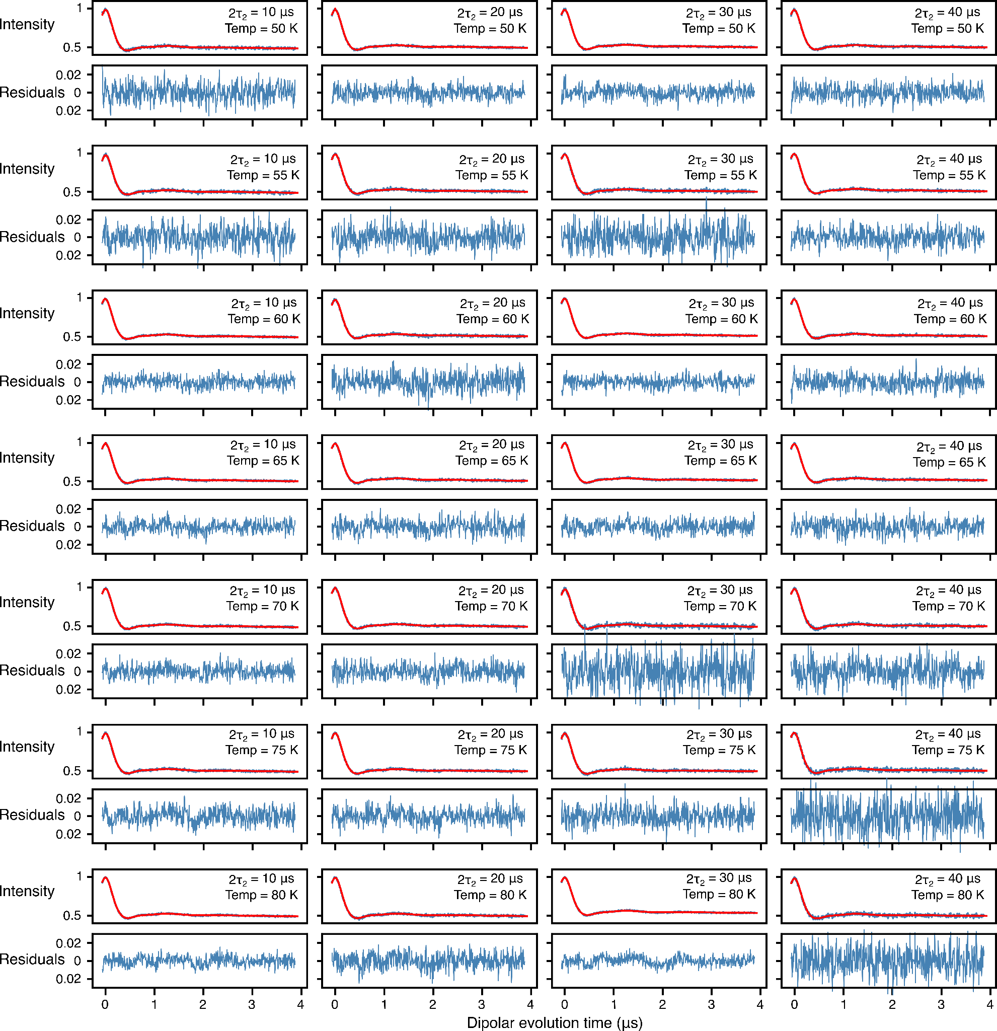
Figure S6. Global analysis of Q-band DEER data acquired for spin-labeled proteinA (Q39C-R1/K88C-R1), the protein as well as the MTSL label were fully deuterated (²H-Leu, ²H-R1), using a 2-Gaussian restrained fit. In each panel, the top half displays the experimental (blue) and bestfit (red) DEER echo curves; the bottom half shows the corresponding residuals between experimental and calculated curves. The data at each temperature and 2т₂ combination were fitted simultaneously with the peak positions and corresponding peak widths in the P(r) distributions treated as global parameters using an in-house Python script [9] based on the program DD/GLADDvu.[12,13] The values of the reduced χ² and optimized global parameters are provided in Table 1 of the main text.

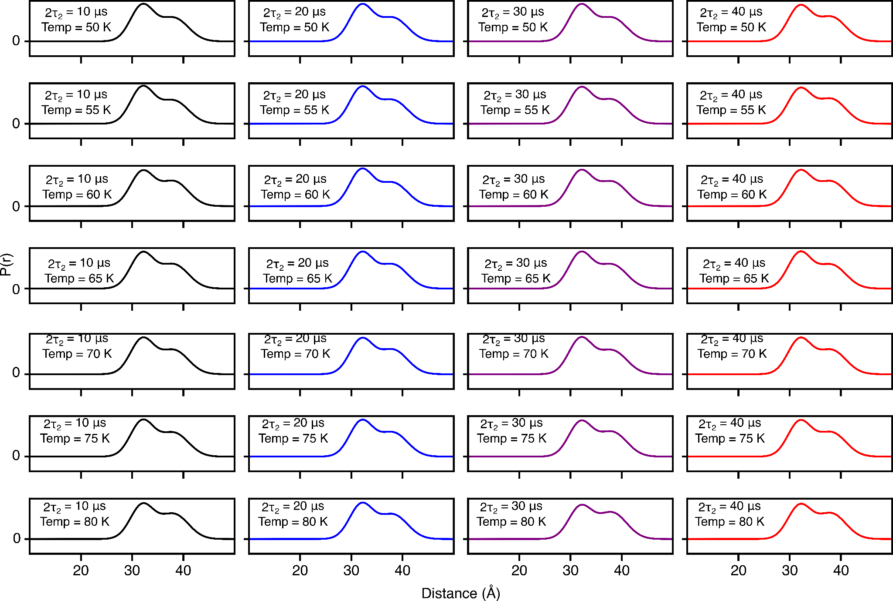

Figure S7. DEER-derived P(r) distributions for for spin-labeled proteinA (Q39C-R1/K88C-R1) by using two-Gaussian global fit in which the peak positions and corresponding widths are treated as global parameters (see main text for details).[10] The protein as well as the MTSL label were fully deuterated (²H-Leu, ²H-R1). The fits to the experimental DEER echo curves are shown in Fig. S5. The solid lines present 2т₂ of 10 (black), 20 (blue), 30 (lilac) and 40 μs (red).

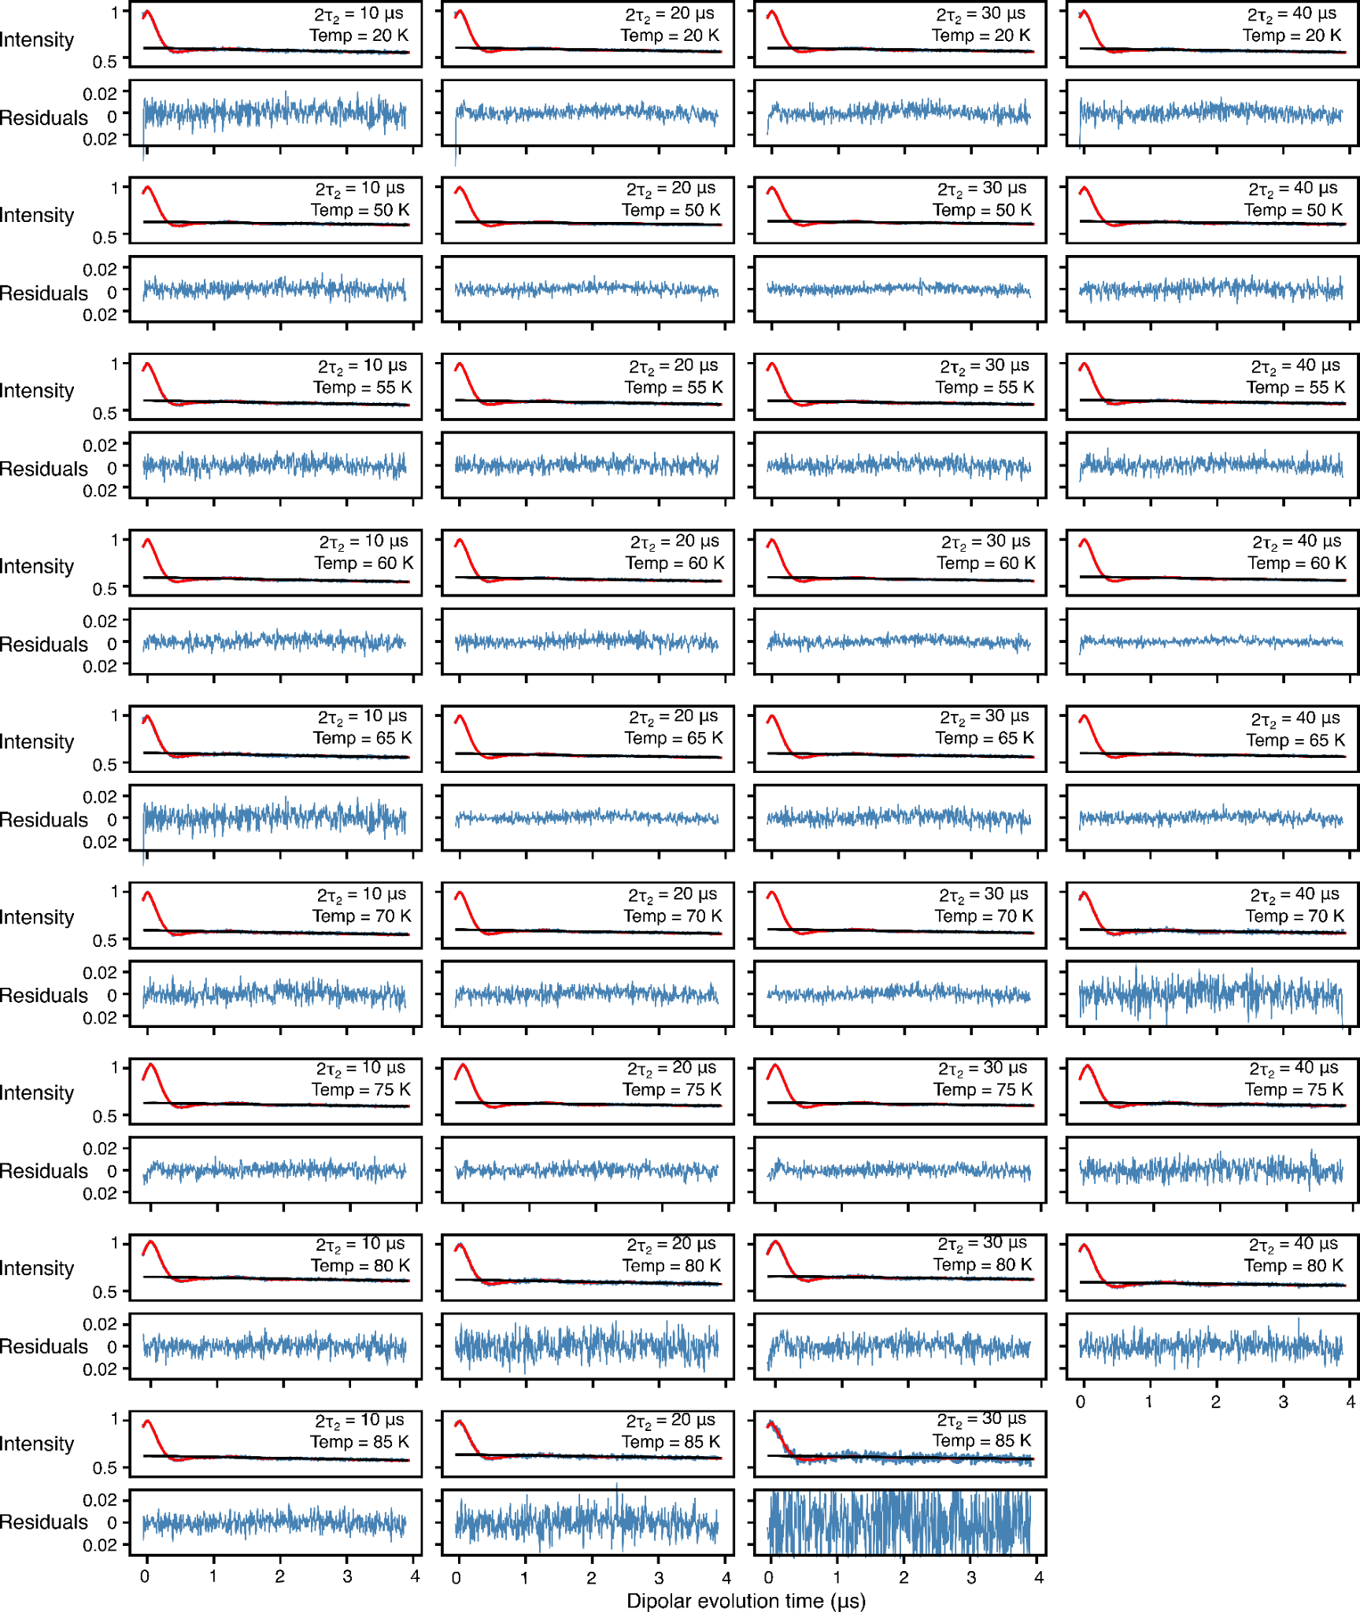
FigureS8. Analysis of Q-band DEER data acquired for spin-labeled proteinA (Q39C-R1/K88C-R1), the protein was fully deuterated while the MTSL label was protonated (²H-Leu, ¹H-R1), by using validated Tikhonov regularization (n=1000). In each panel, the top half displays the experimental (blue) and bestfit (red) DEER echo curves; the bottom half shows the corresponding residuals between experimental and calculated curves. The data at each temperature and 2т₂ combination were fitted individually using validated Tikhonov regulation in the program DeerLab.[11] The mean normalized χ² value of the fits is given in Table 1 of the main text.

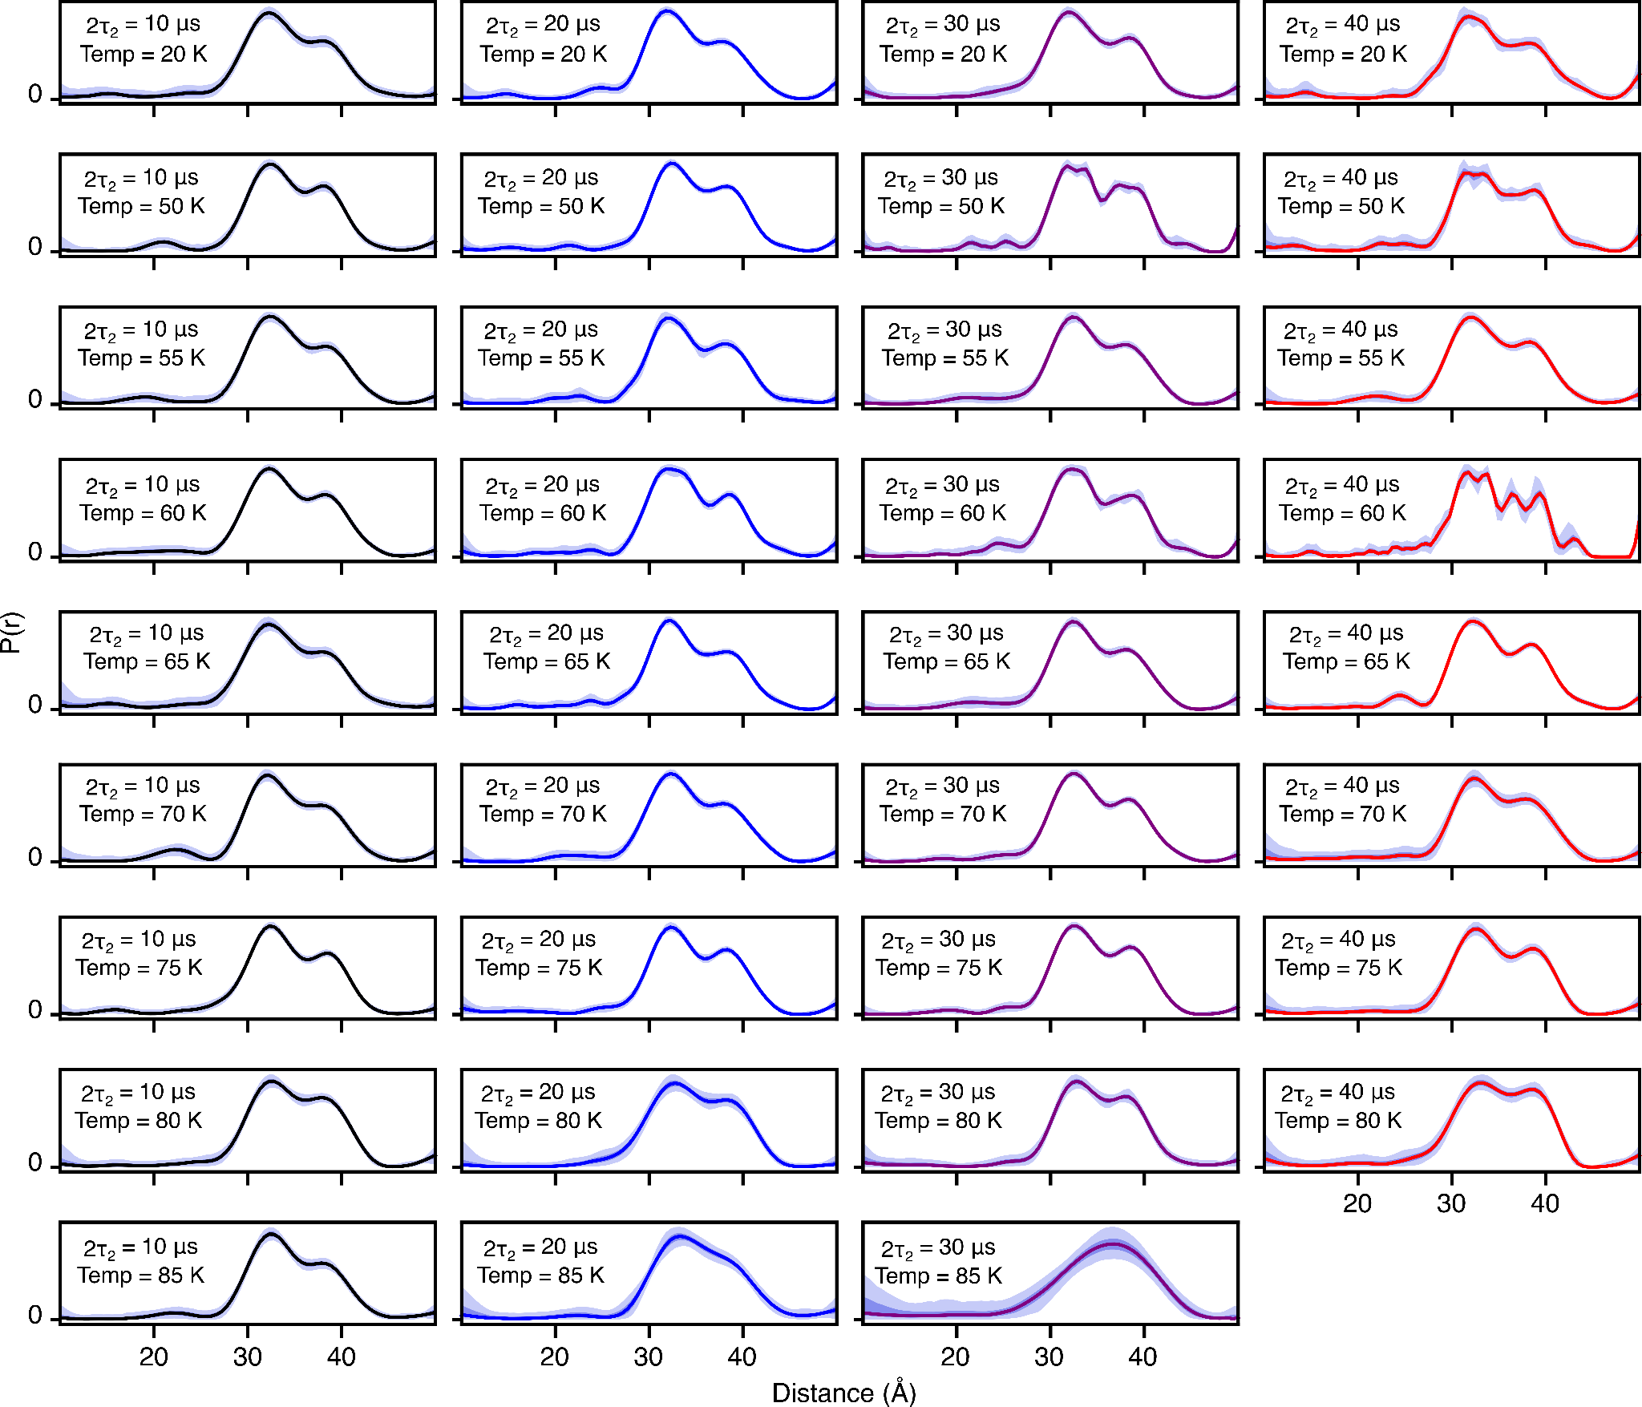

Figure S9. DEER-derived P(r) distributions for for spin-labeled proteinA (Q39C-R1/K88C-R1) by using validated Tikhonov regularization (n=1000), the protein was fully deuterated while the MTSL label was protonated (²H-Leu, ¹H-R1). The fits to the experimental DEER echo curves are shown in Fig. S7. The solid lines present 2т₂ of 10 (black), 20 (blue), 30 (lilac) and 40 μs (red). The shaded region below presents the 95% (light violet) and 50% (dark violet) confidence interval.

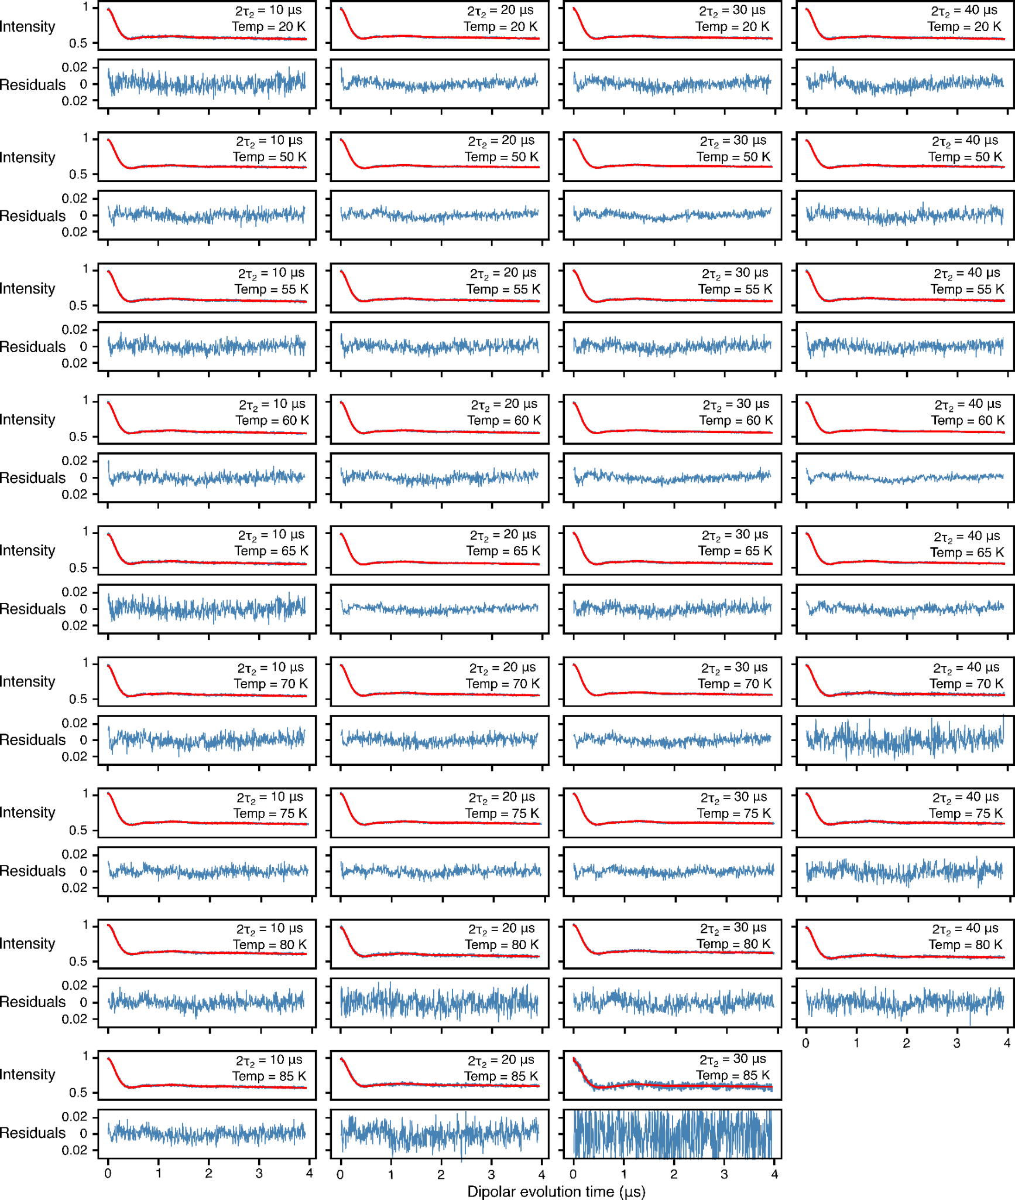
Figure S10. Global analysis of Q-band DEER data acquired for spin-labeled proteinA (Q39C-R1/K88C-R1), the protein was fully deuterated while the MTSL label was protonated (²H-Leu, ¹H-R1), using a 2-Gaussian restrained fit. In each panel, the top half displays the experimental (blue) and bestfit (red) DEER echo curves; the bottom half shows the corresponding residuals between experimental and calculated curves. The data at each temperature and 2т₂ combination were fitted simultaneously with the peak positions and corresponding peak widths in the P(r) distributions treated as global parameters using an in-house Python script[9,10] based on the program DD/GLADDvu.[12,13] The values of the reduced χ² and optimized global parameters are provided in Table 1 of the main text.

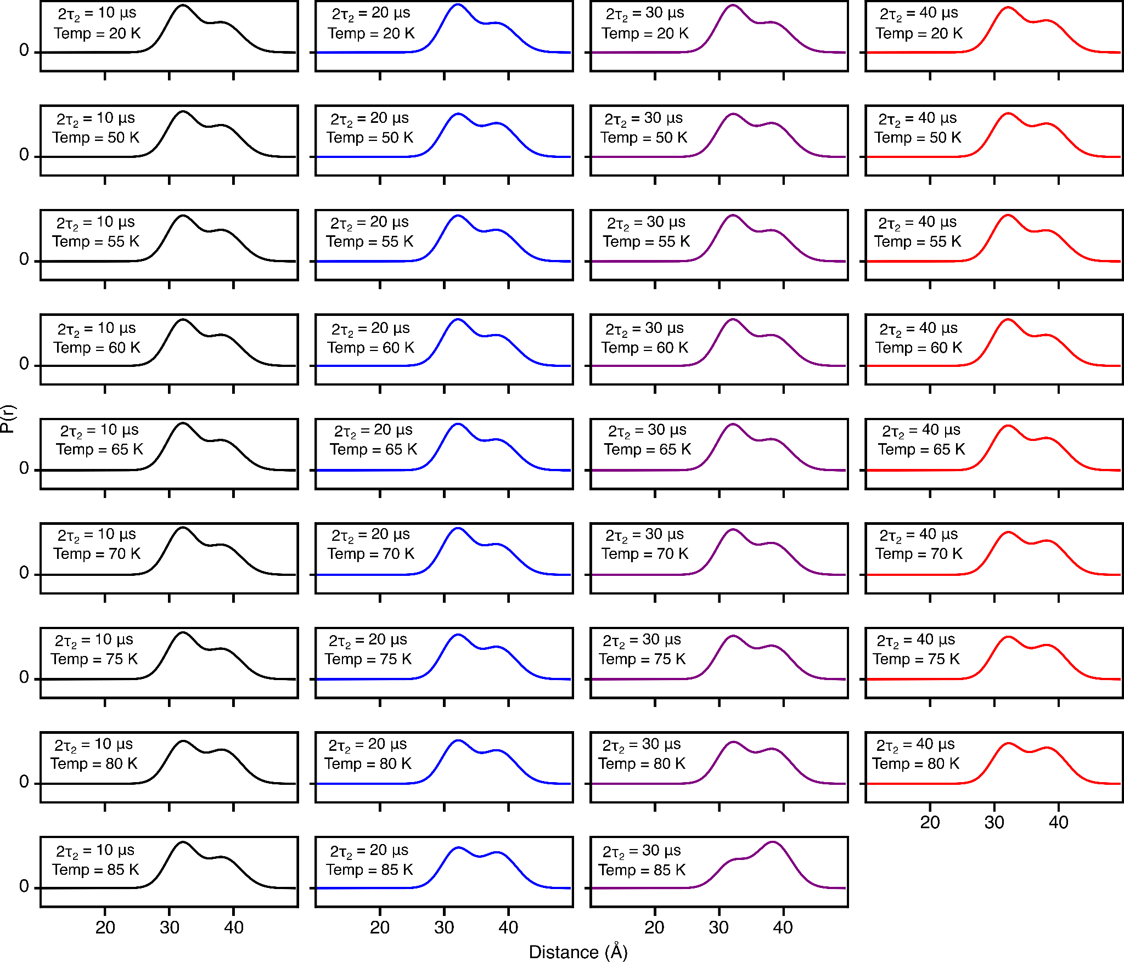

Figure S11. DEER-derived P(r) distributions for for spin-labeled proteinA (Q39C-R1/K88C-R1) by using two-Gaussian global fit in which the peak positions and corresponding widths are treated as global parameters (see main text for details). The protein was fully deuterated while the MTSL label was protonated (²H-Leu, ¹H-R1). The fits to the experimental DEER echo curves are shown in Fig. S9. The solid lines present 2т₂ of 10 (black), 20 (blue), 30 (lilac) and 40 μs (red).
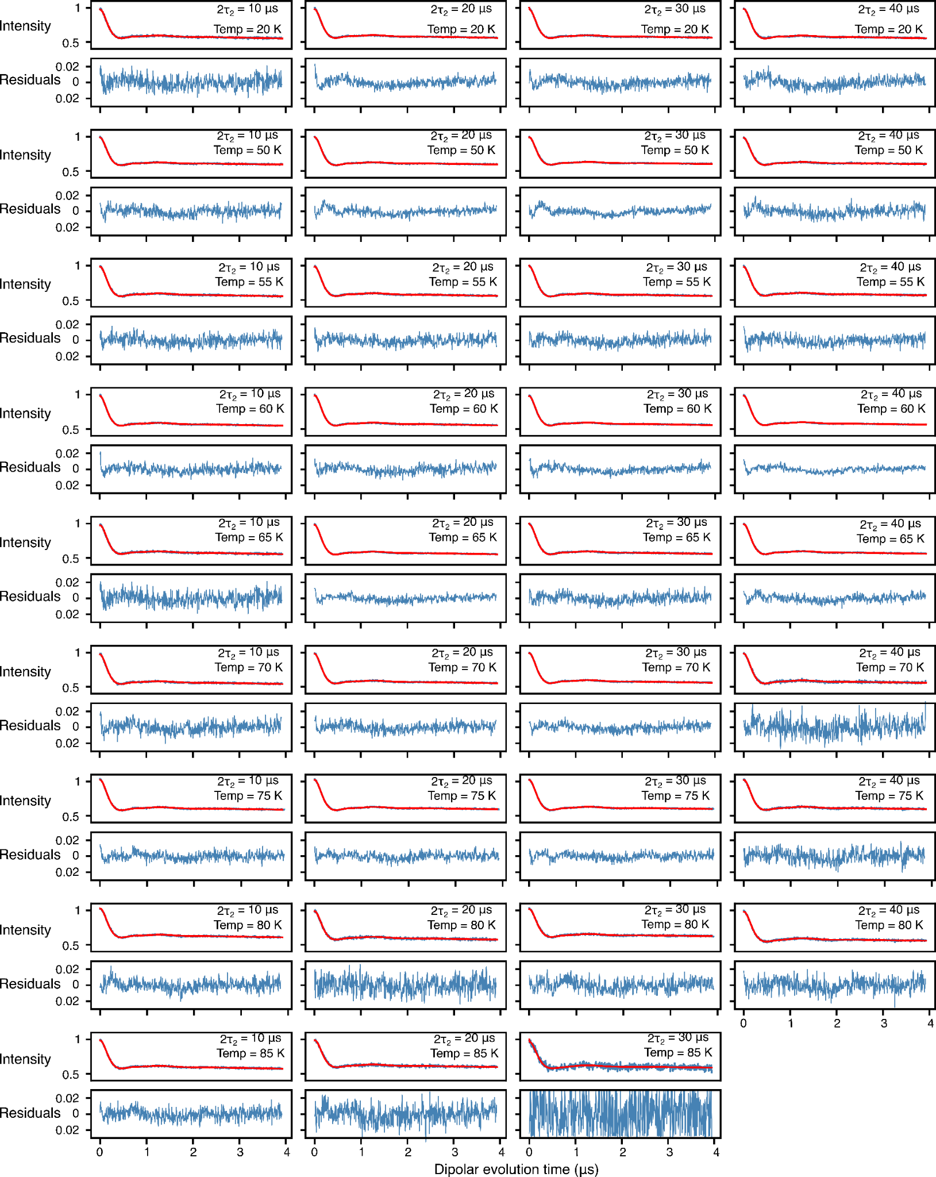
Figure S12. Global analysis of Q-band DEER data acquired for spin-labeled proteinA (Q39C-R1/K88C-R1), the protein was fully deuterated while the MTSL label was protonated (²H-Leu, ¹H-R1), using a 2-Gaussian restrained fit while Gaussian ratios were restrained by the methyl rotation as dictated by eq 5. In each panel, the top half displays the experimental (blue) and bestfit (red) DEER echo curves; the bottom half shows the corresponding residuals between experimental and calculated curves. The data at each temperature and 2т₂ combination were fitted simultaneously, setting activation energy and its width, the peak positions and corresponding peak widths in the P(r) distributions as global parameters using an in-house Python script[9] based on the program DD/GLADDvu.[12,13] The values of the reduced χ² and optimized global parameters are provided in Table 1 of the main text.

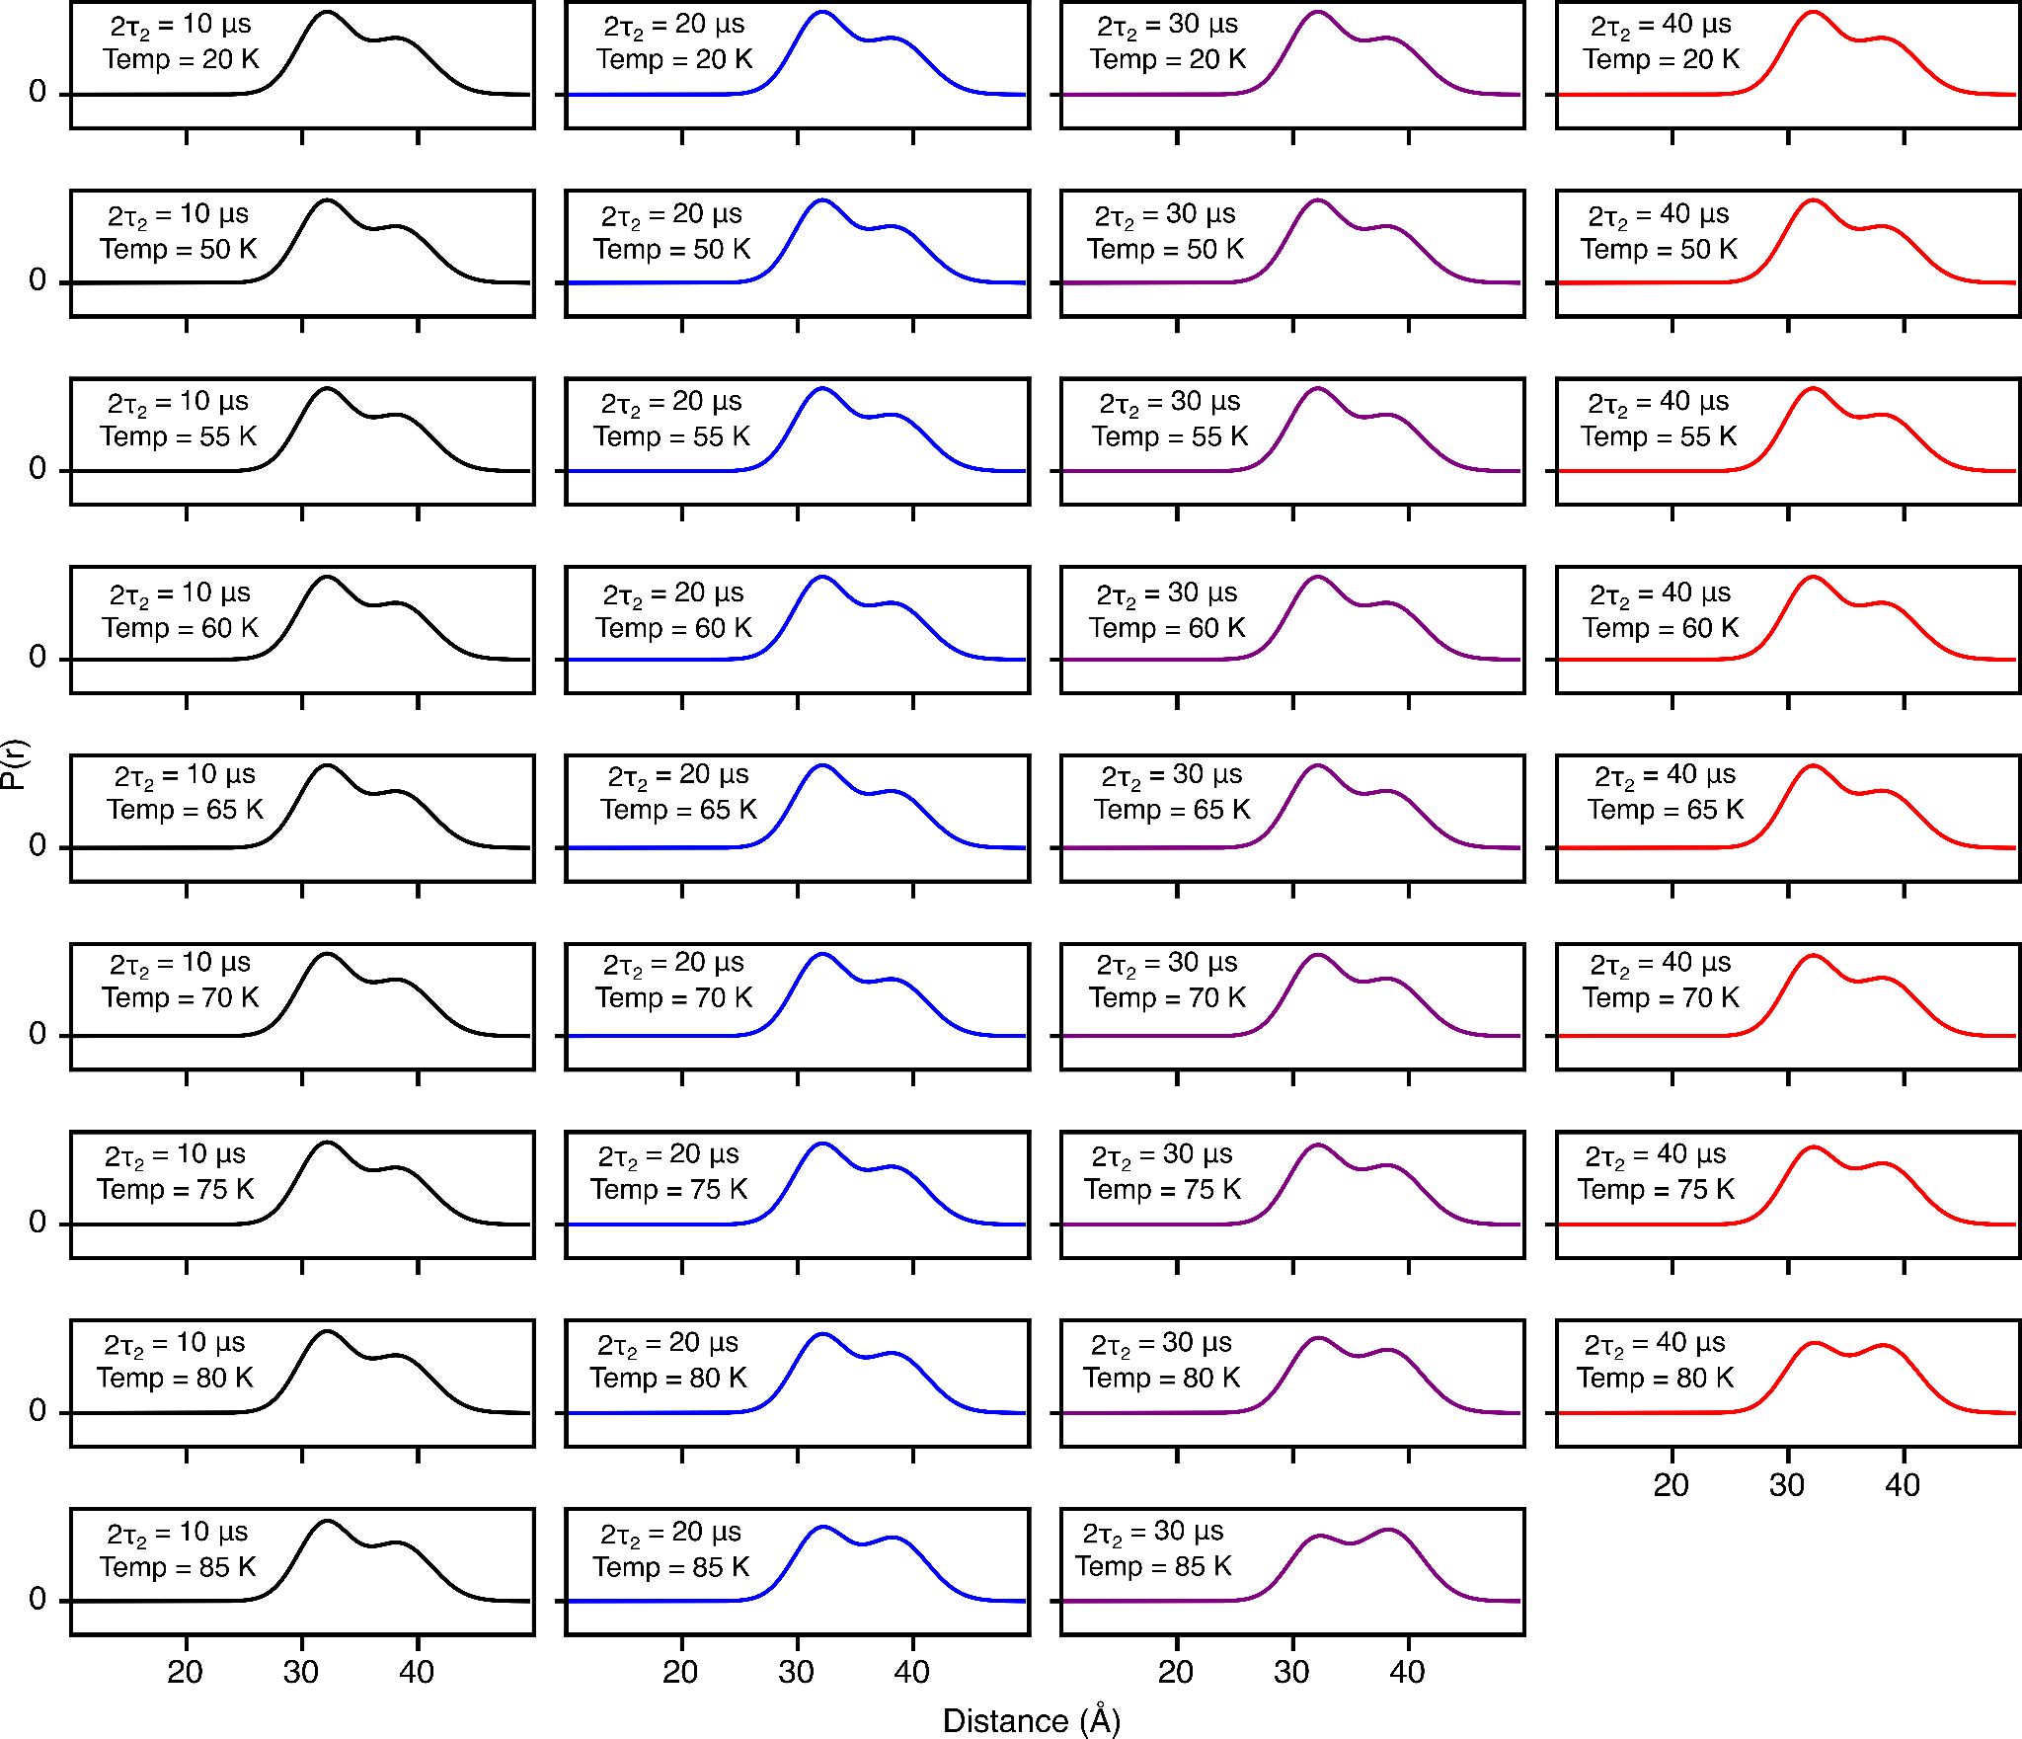

Figure S13. DEER-derived P(r) distributions for spin-labeled proteinA (Q39C-R1/K88C-R1) by using two-Gaussian global fit in which the peak positions and corresponding widths are treated as global parameters. Further, the Gaussian ratios are dictated by the methyl rotation, therefore the activation energy and its width were treated as global parameters (see main text for details). The protein was fully deuterated while the MTSL label was protonated (²H-Leu, ¹H-R1). The fits to the experimental DEER echo curves are shown in Fig. S11. The solid lines present 2т₂ of 10 (black), 20 (blue), 30 (lilac) and 40 μs (red). The shaded region below presents the 95% (light violet) and 50% (dark violet) confidence interval.

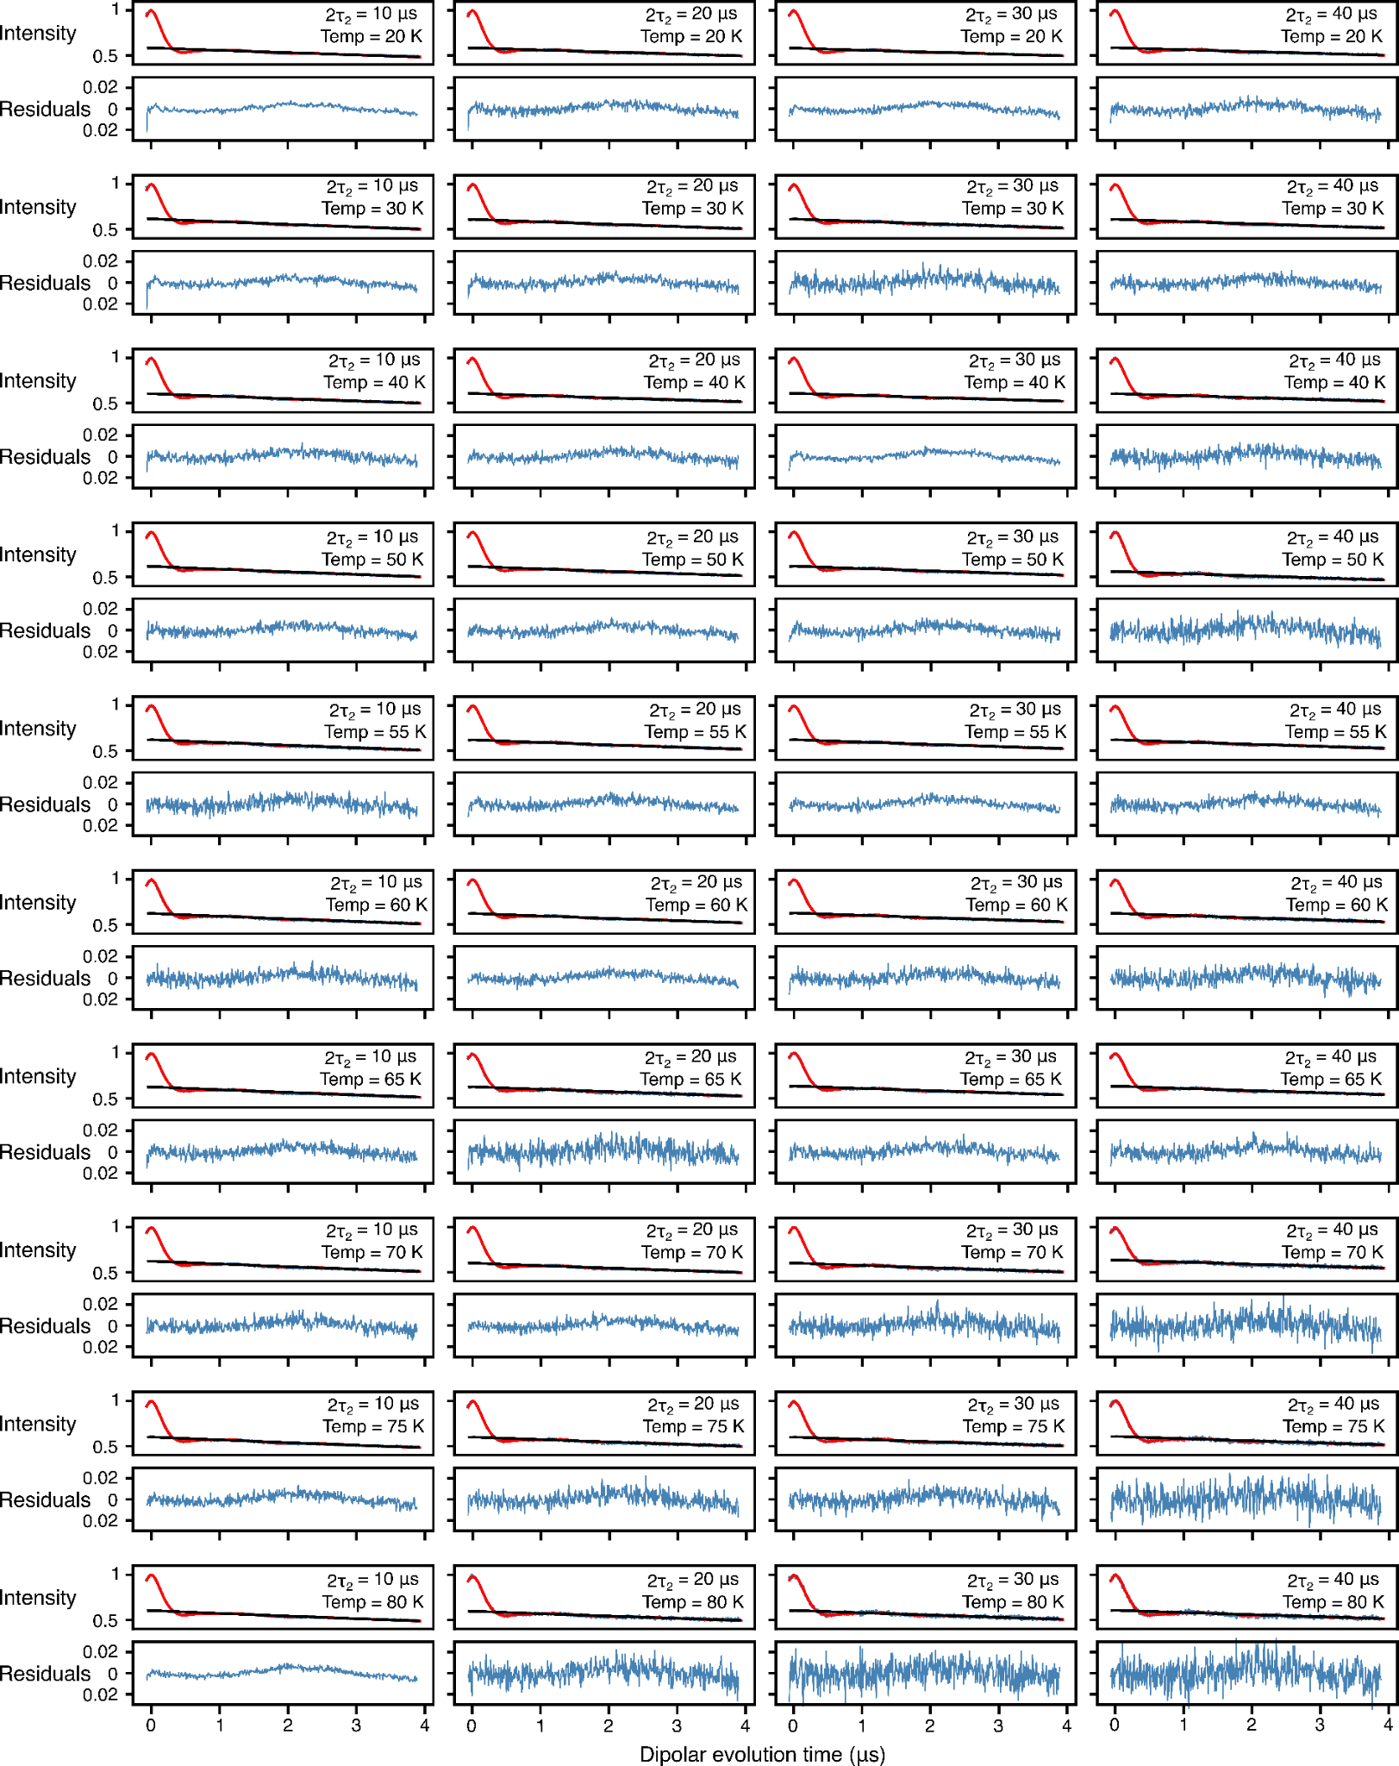
FigureS14. Analysis of Q-band DEER data acquired for spin-labeled proteinA (Q39C-R1/K88C-R1), the protein was fully deuterated with side specific leucine protonation while the MTSL label was deuterated (¹H-Leu, ²H-R1), by using validated Tikhonov regularization (n=1000). In each panel, the top half displays the experimental (blue) and bestfit (red) DEER echo curves; the bottom half shows the corresponding residuals between experimental and calculated curves. The data at each temperature and 2т₂ combination were fitted individually using validated Tikhonov regulation in the program DeerLab.[11] The mean normalized χ² value of the fits is given in Table 1 of the main text.

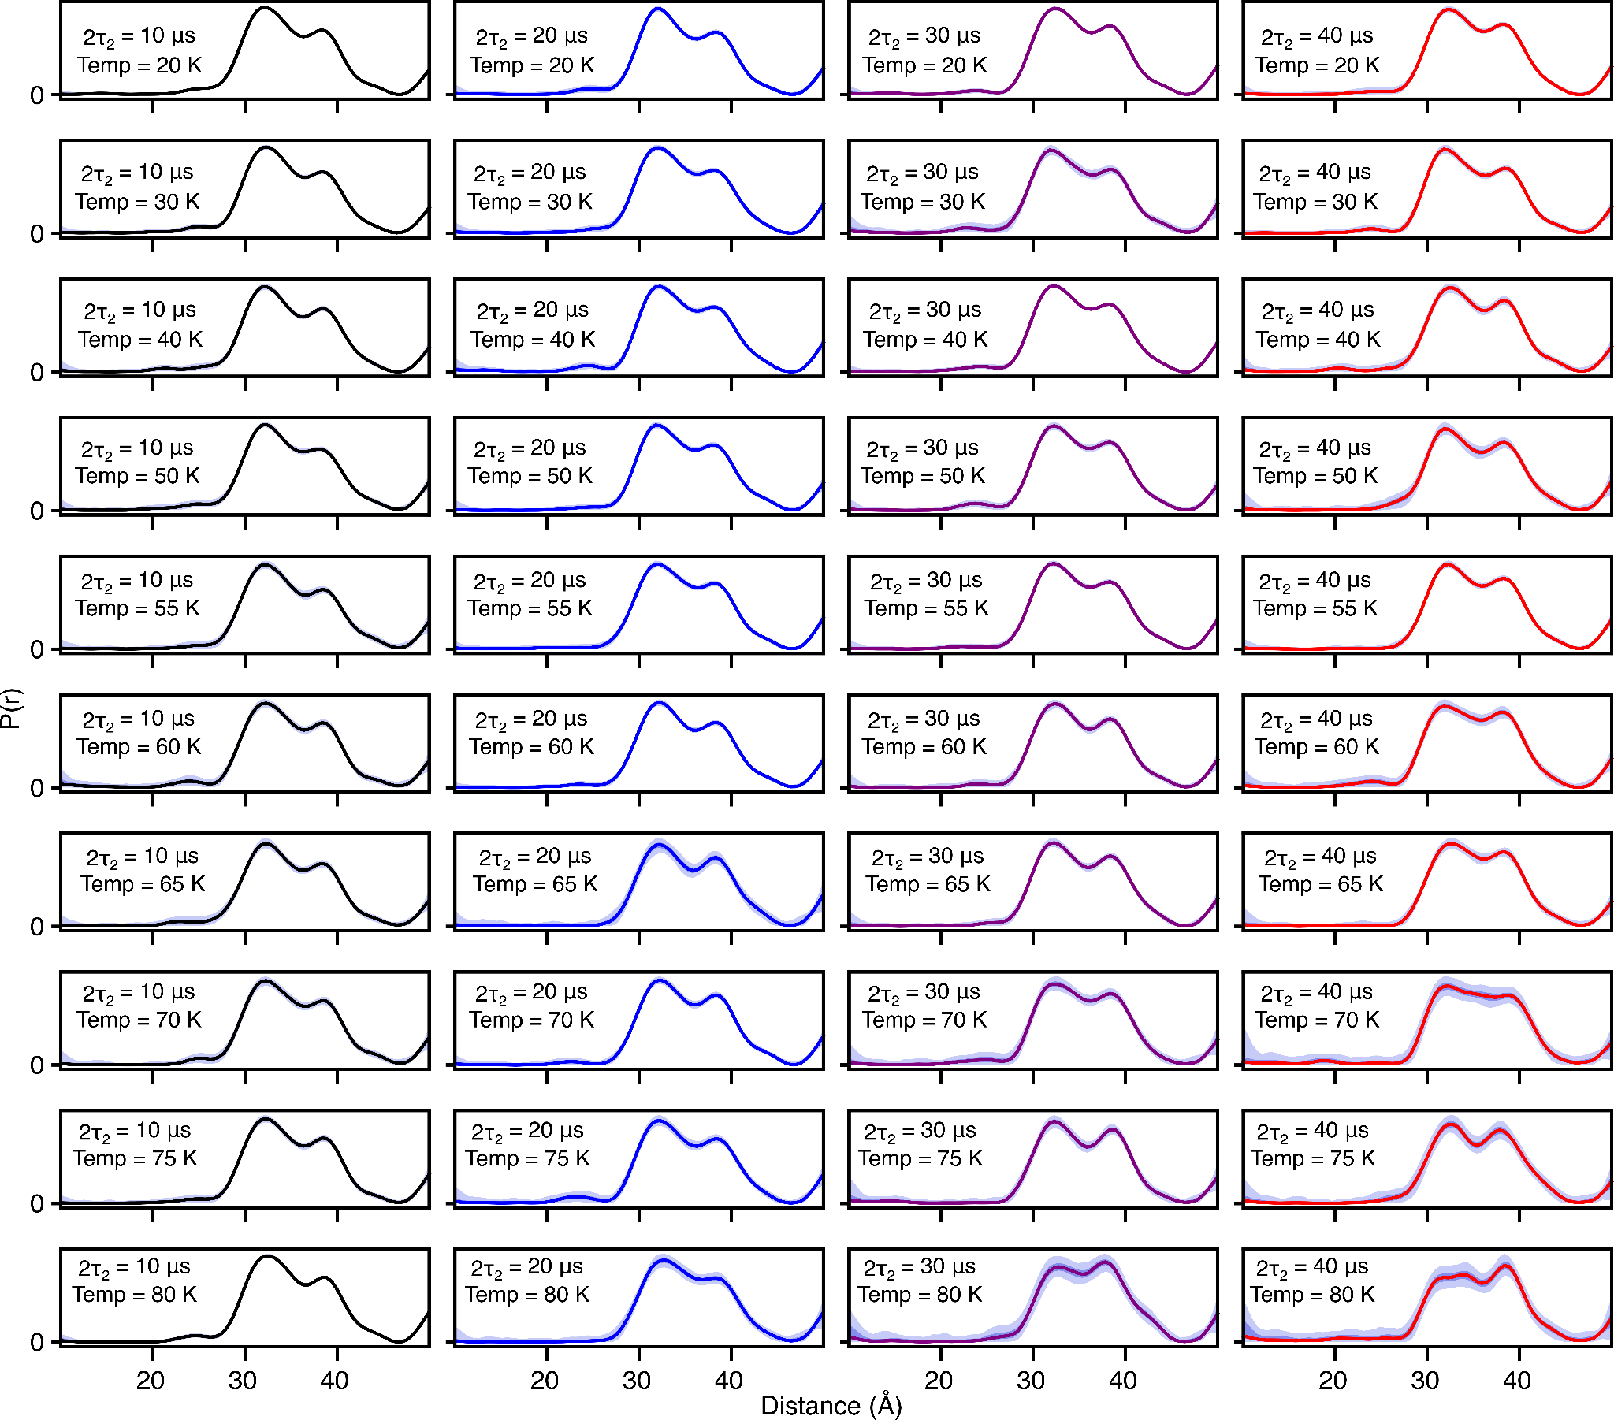

Figure S15. DEER-derived P(r) distributions for for spin-labeled proteinA (Q39C-R1/K88C-R1) by using validated Tikhonov regularization (n=1000), the protein was fully deuterated while the leucine sidechains were protonated (¹H-Leu, ²H-R1). The fits to the experimental DEER echo curves are shown in Fig. S13. The solid lines present 2т₂ of 10 (black), 20 (blue), 30 (lilac) and 40 μs (red). The shaded region below presents the 95% (light violet) and 50% (dark violet) confidence interval.
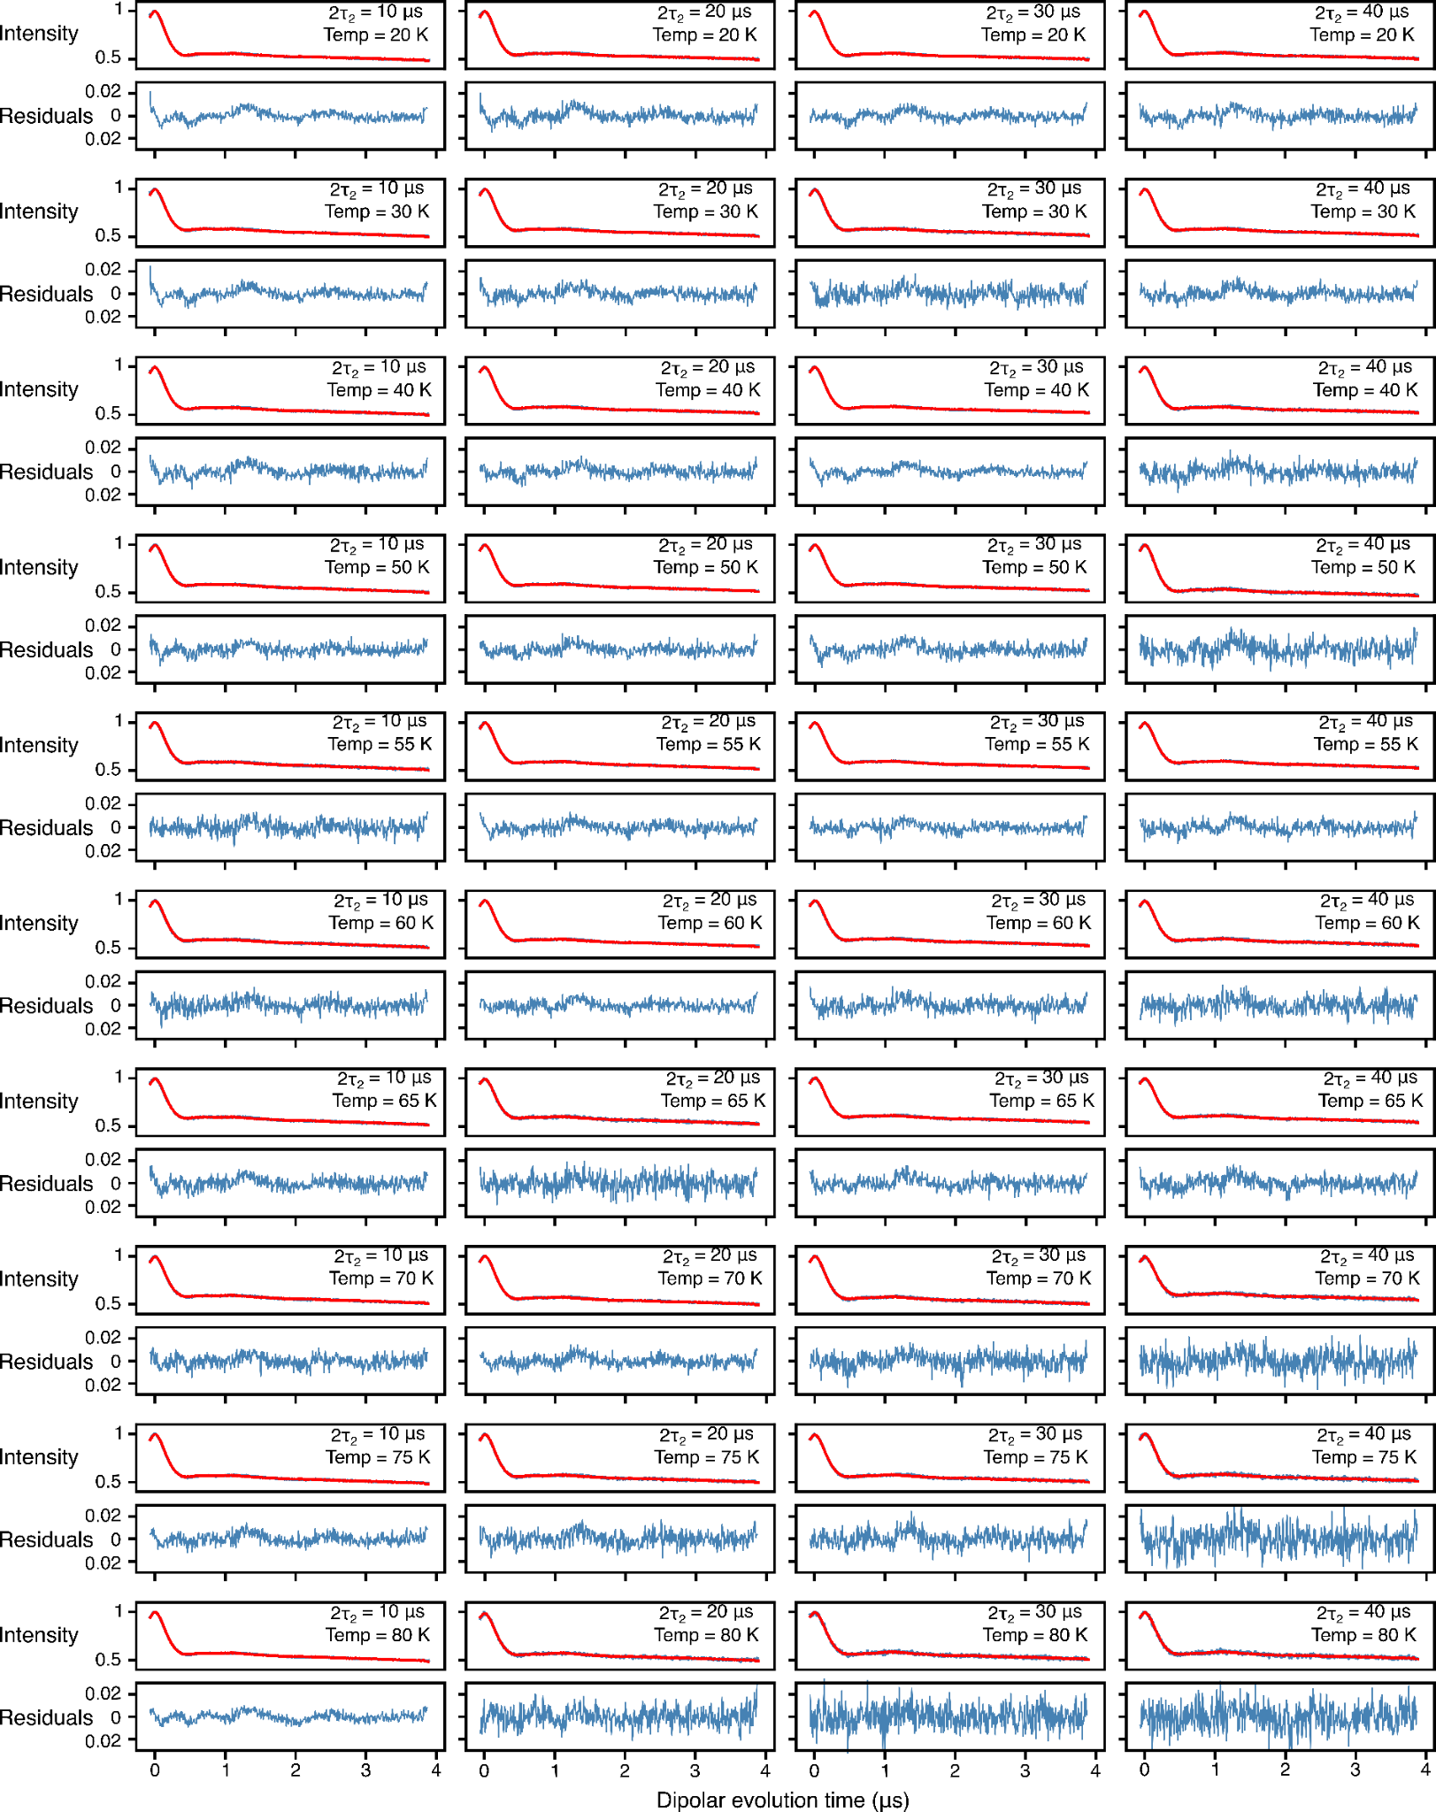
Figure S16. Global analysis of Q-band DEER data acquired for spin-labeled proteinA (Q39C-R1/K88C-R1), the protein was fully deuterated with side specific leucine protonation while the MTSL label was deuterated (¹H-Leu, ²H-R1), using a 2-Gaussian restrained fit. In each panel, the top half displays the experimental (blue) and bestfit (red) DEER echo curves; the bottom half shows the corresponding residuals between experimental and calculated curves. The data at each temperature and 2т₂ combination were fitted simultaneously with the peak positions and corresponding peak widths in the P(r) distributions treated as global parameters using an in-house Python script[9,10] based on the program DD/GLADDvu.[12,13] The values of the reduced χ² and optimized global parameters are provided in Table 1 of the main text.

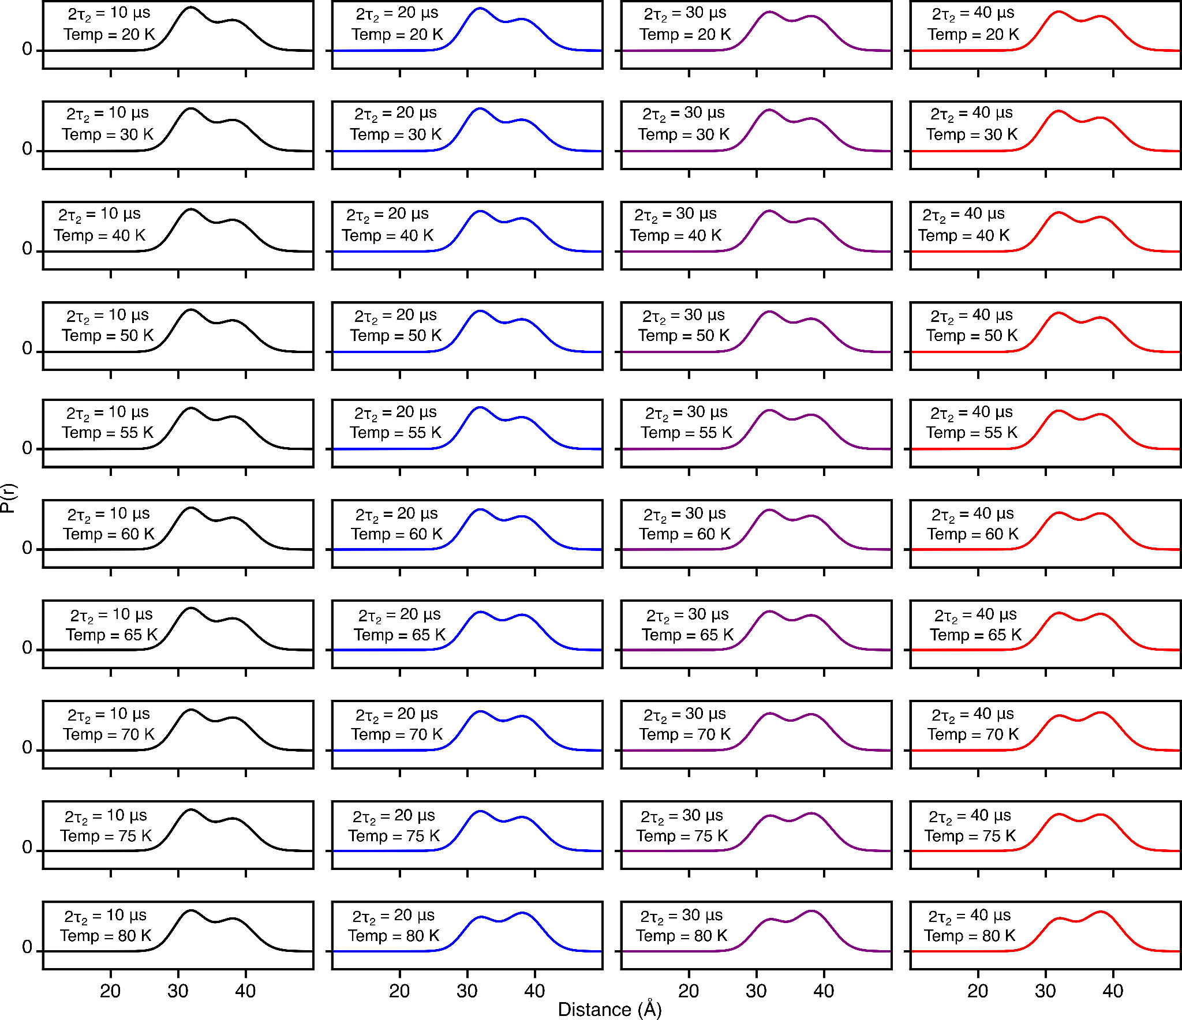
Figure S17. DEER-derived P(r) distributions for for spin-labeled proteinA (Q39C-R1/K88C-R1) by using two-Gaussian global fit in which the peak positions and corresponding widths are treated as global parameters (see main text for details). The protein was fully deuterated while the leucine side chains were protonated (¹H-Leu, ²H-R1). The fits to the experimental DEER echo curves are shown in Fig. S15. The solid lines present 2т₂ of 10 (black), 20 (blue), 30 (lilac) and 40 μs (red).
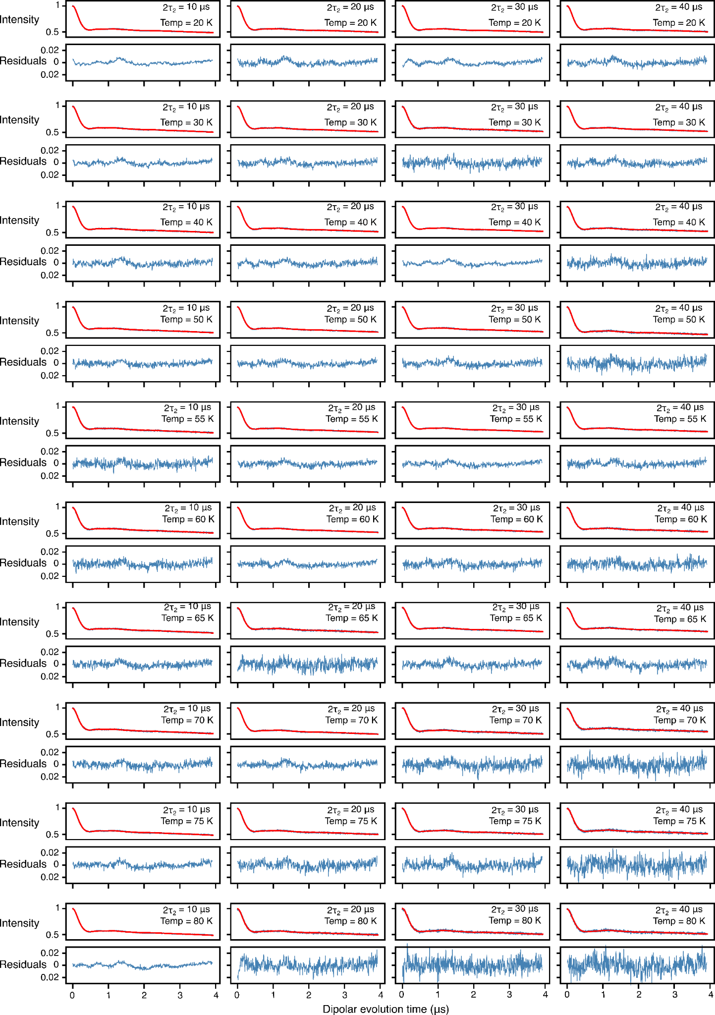
Figure S18. Global analysis of Q-band DEER data acquired for spin-labeled proteinA (Q39C-R1/K88C-R1), the protein was fully deuterated with side specific leucine protonation while the MTSL label was deuterated (¹H-Leu, ²H-R1), using a 2-Gaussian restrained fit while Gaussian ratios were restrained by the methyl rotation as dictated by eq 5. In each panel, the top half displays the experimental (blue) and bestfit (red) DEER echo curves; the bottom half shows the corresponding residuals between experimental and calculated curves. The data at each temperature and 2т₂ combination were fitted simultaneously, setting activation energy and its width, the peak positions and corresponding peak widths in the P(r) distributions as global parameters using an in-house Python script[9] based on the program DD/GLADDvu.[12,13] The values of the reduced χ² and optimized global parameters are provided in Table 1 of the main text.

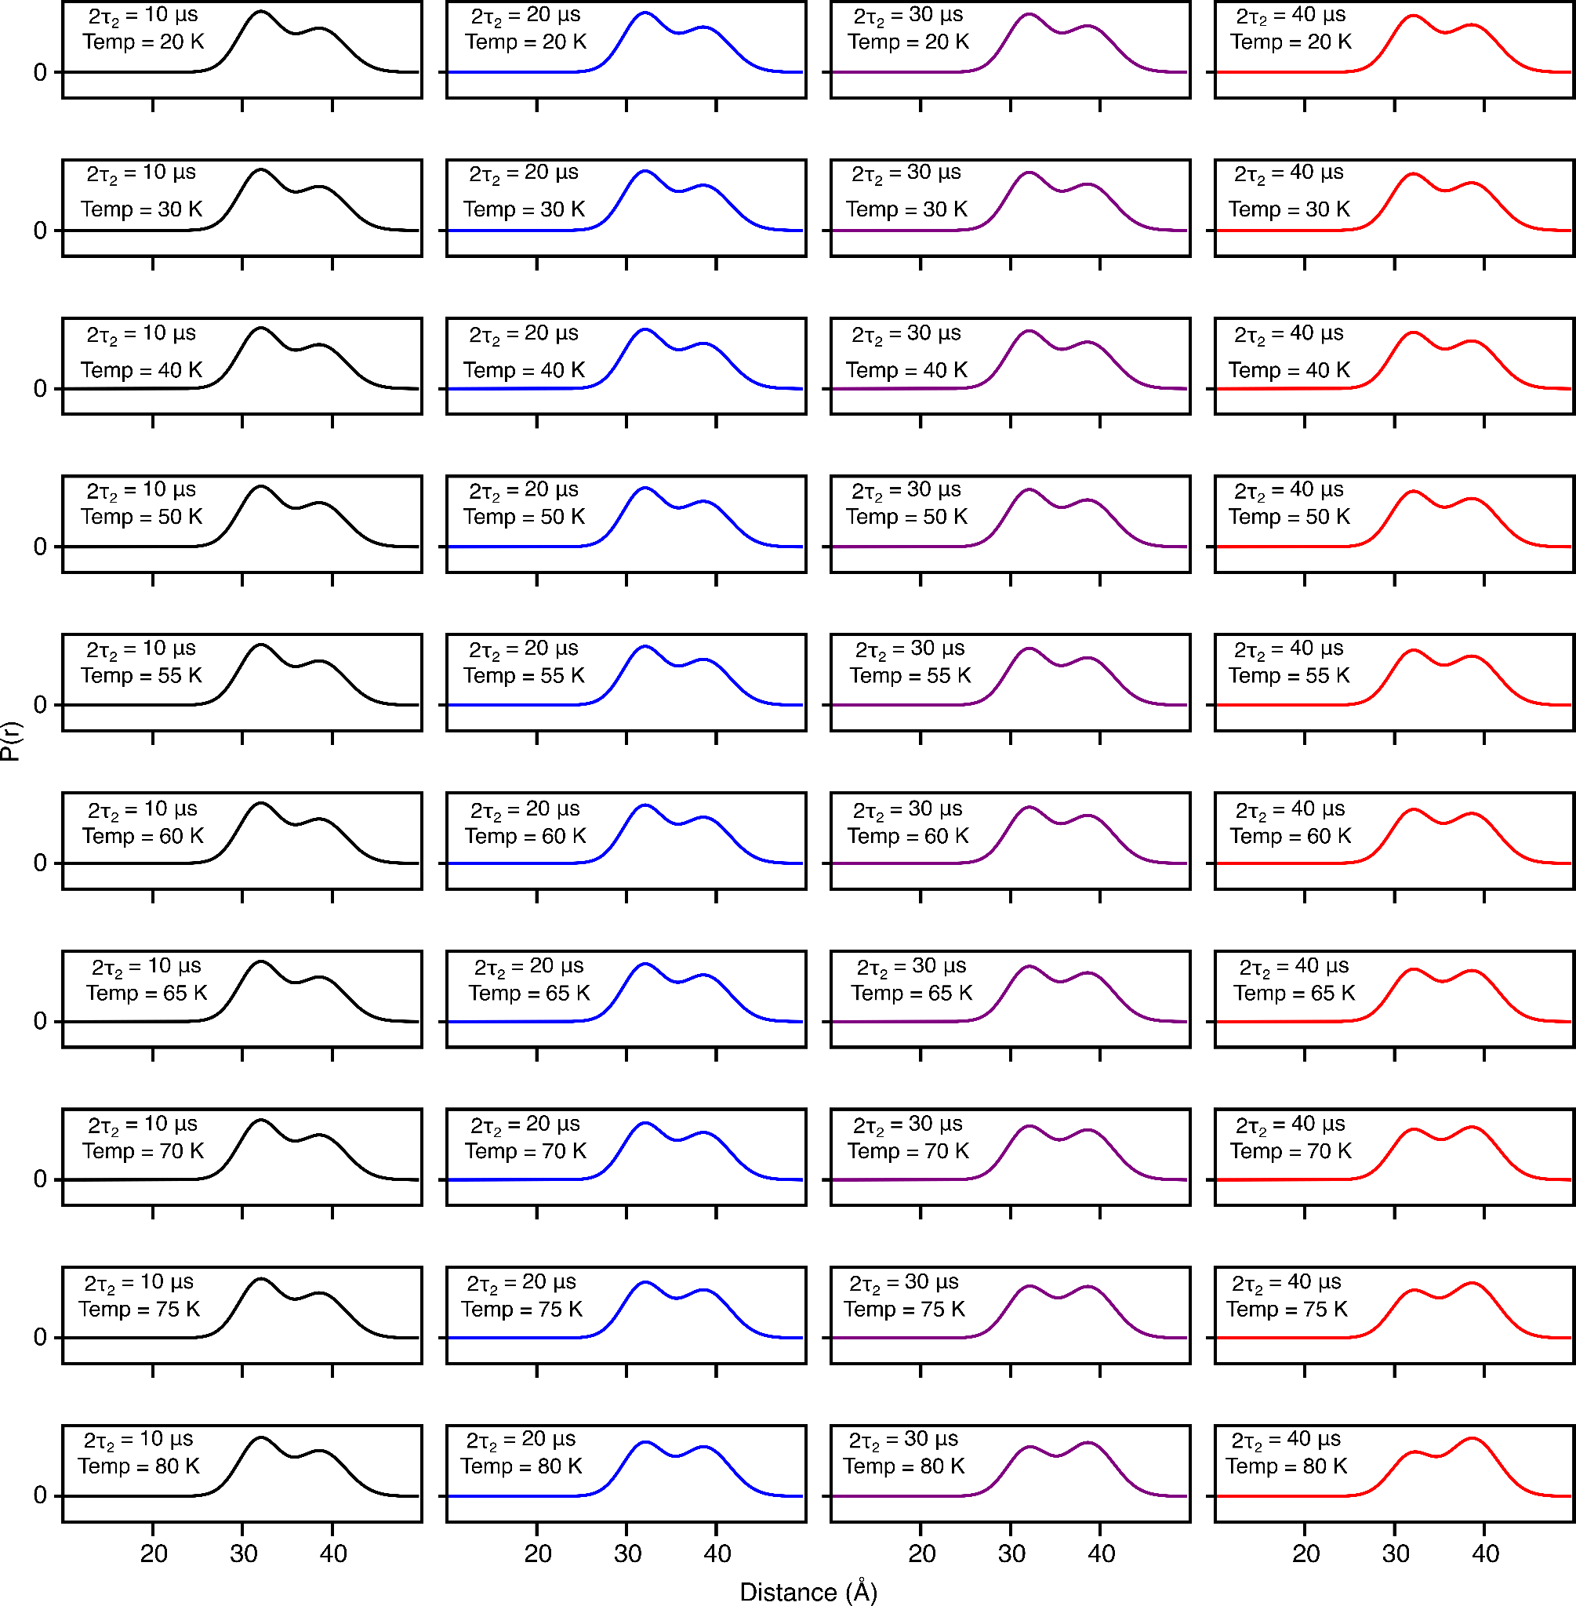
Figure S19. DEER-derived P(r) distributions for spin-labeled proteinA (Q39C-R1/K88C-R1) by using two-Gaussian global fit in which the peak positions and corresponding widths are treated as global parameters. Further, the Gaussian ratios are dictated by the methyl rotation, therefore the activation energy and its width were treated as global parameters (see main text for details). The protein was fully deuterated while the leucine side chain was protonated (¹H-Leu, ²H-R1). The fits to the experimental DEER echo curves are shown in Fig. S17. The solid lines present 2т₂ of 10 (black), 20 (blue), 30 (lilac) and 40 μs (red). The shaded region below presents the 95% (light violet) and 50% (dark violet) confidence interval.

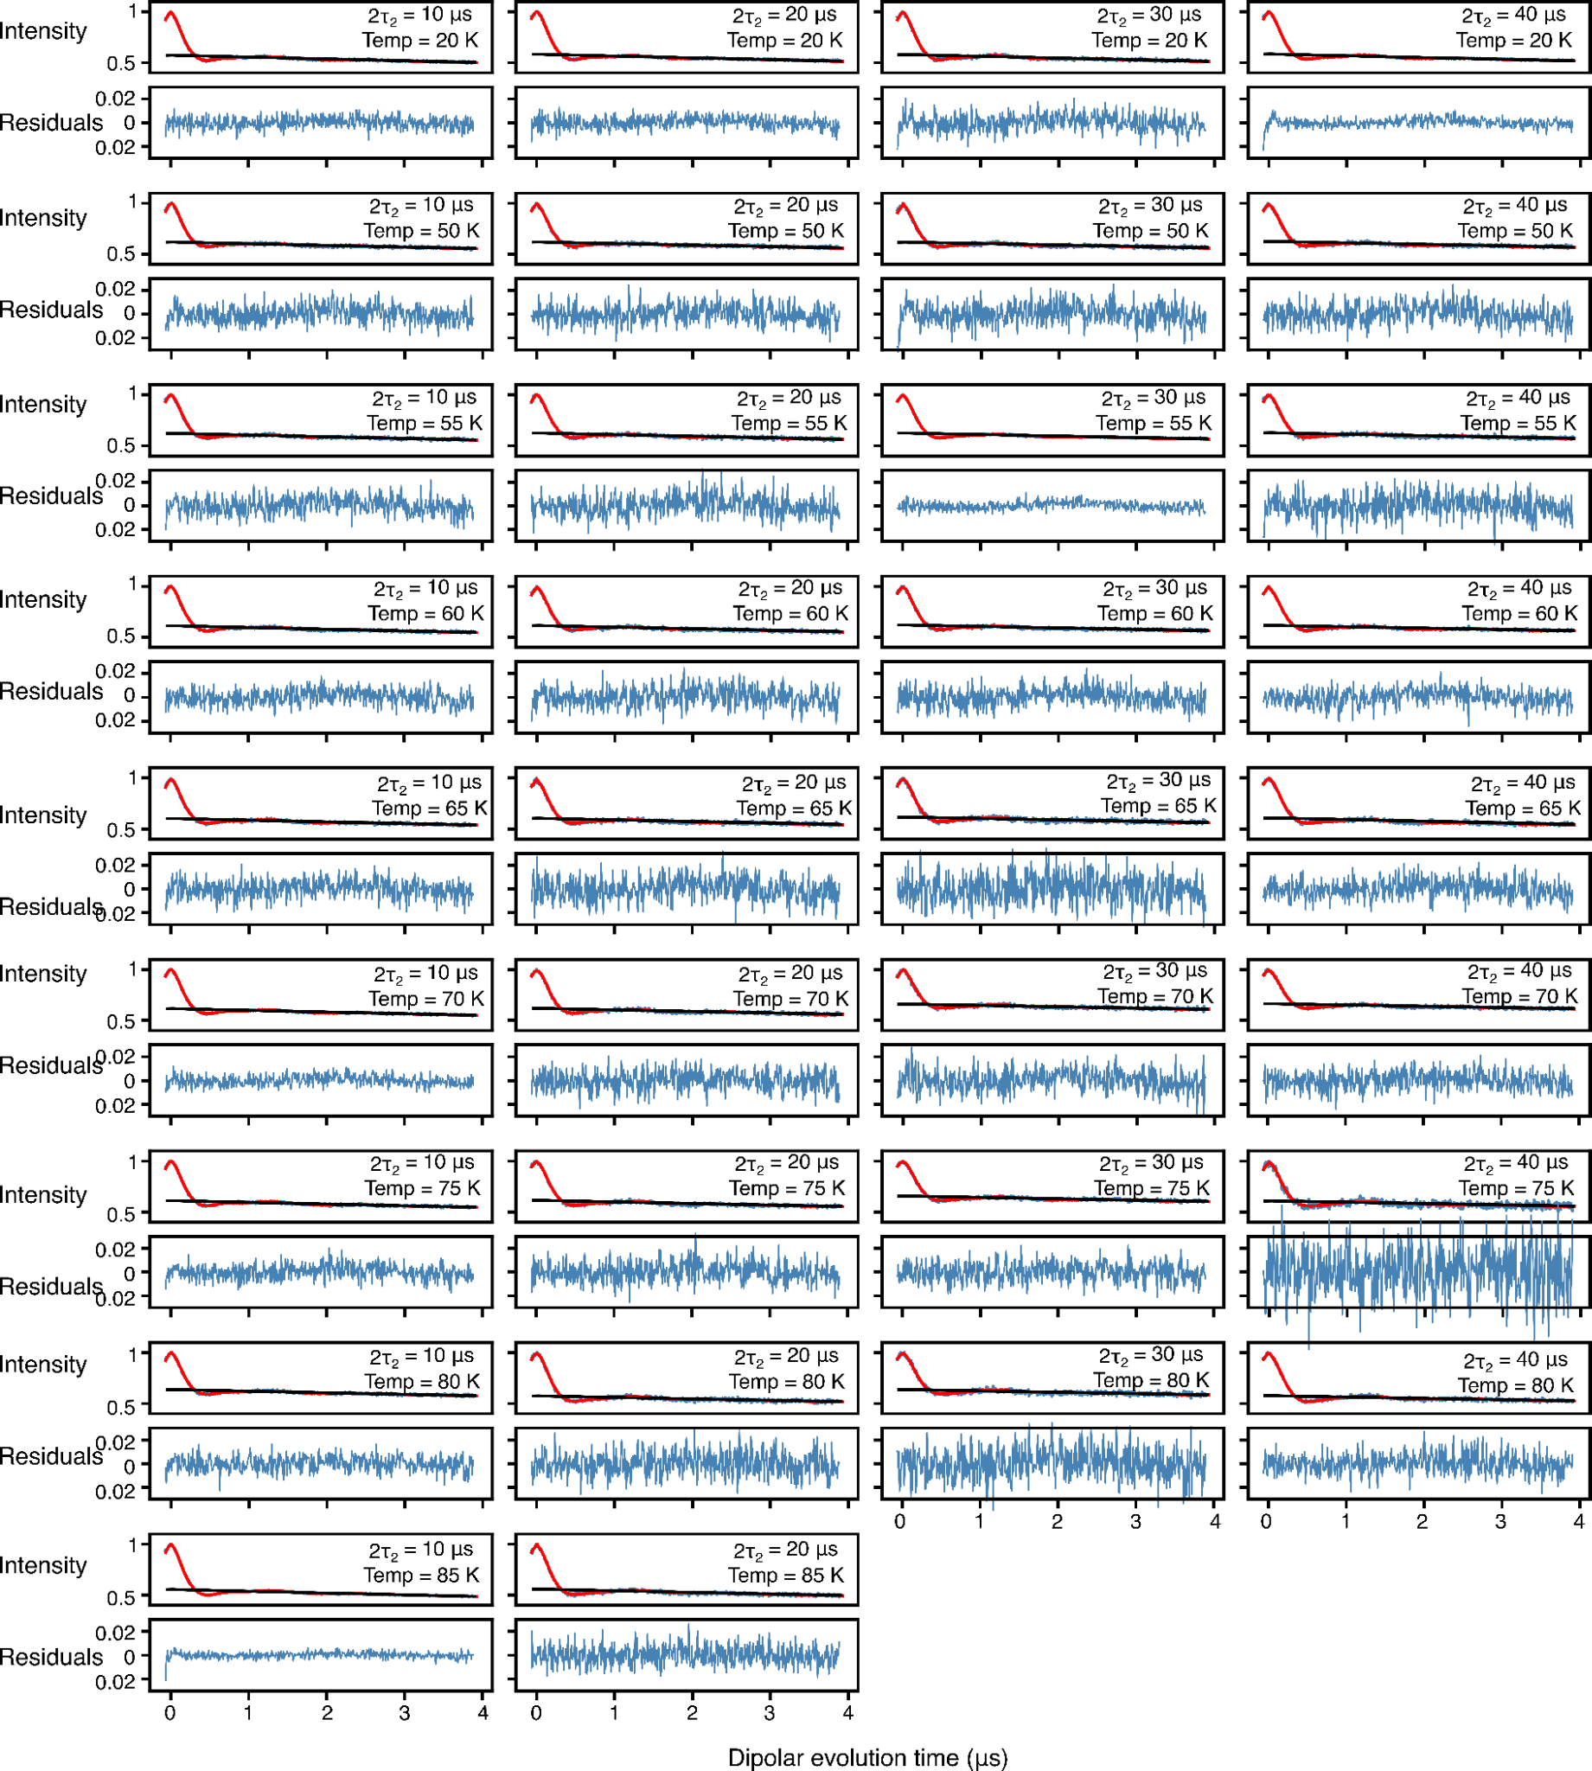
FigureS20. Analysis of Q-band DEER data acquired for spin-labeled proteinA (Q39C-R1/K88C-R1), the protein was fully deuterated with side specific leucine protonation while the MTSL label was protonated (¹H-Leu, ¹H-R1), by using validated Tikhonov regularization (n=1000). In each panel, the top half displays the experimental (blue) and bestfit (red) DEER echo curves; the bottom half shows the corresponding residuals between experimental and calculated curves. The data at each temperature and 2т₂ combination were fitted individually using validated Tikhonov regulation in the program DeerLab.[11] The mean normalized χ² value of the fits is given in Table 1 of the main text.
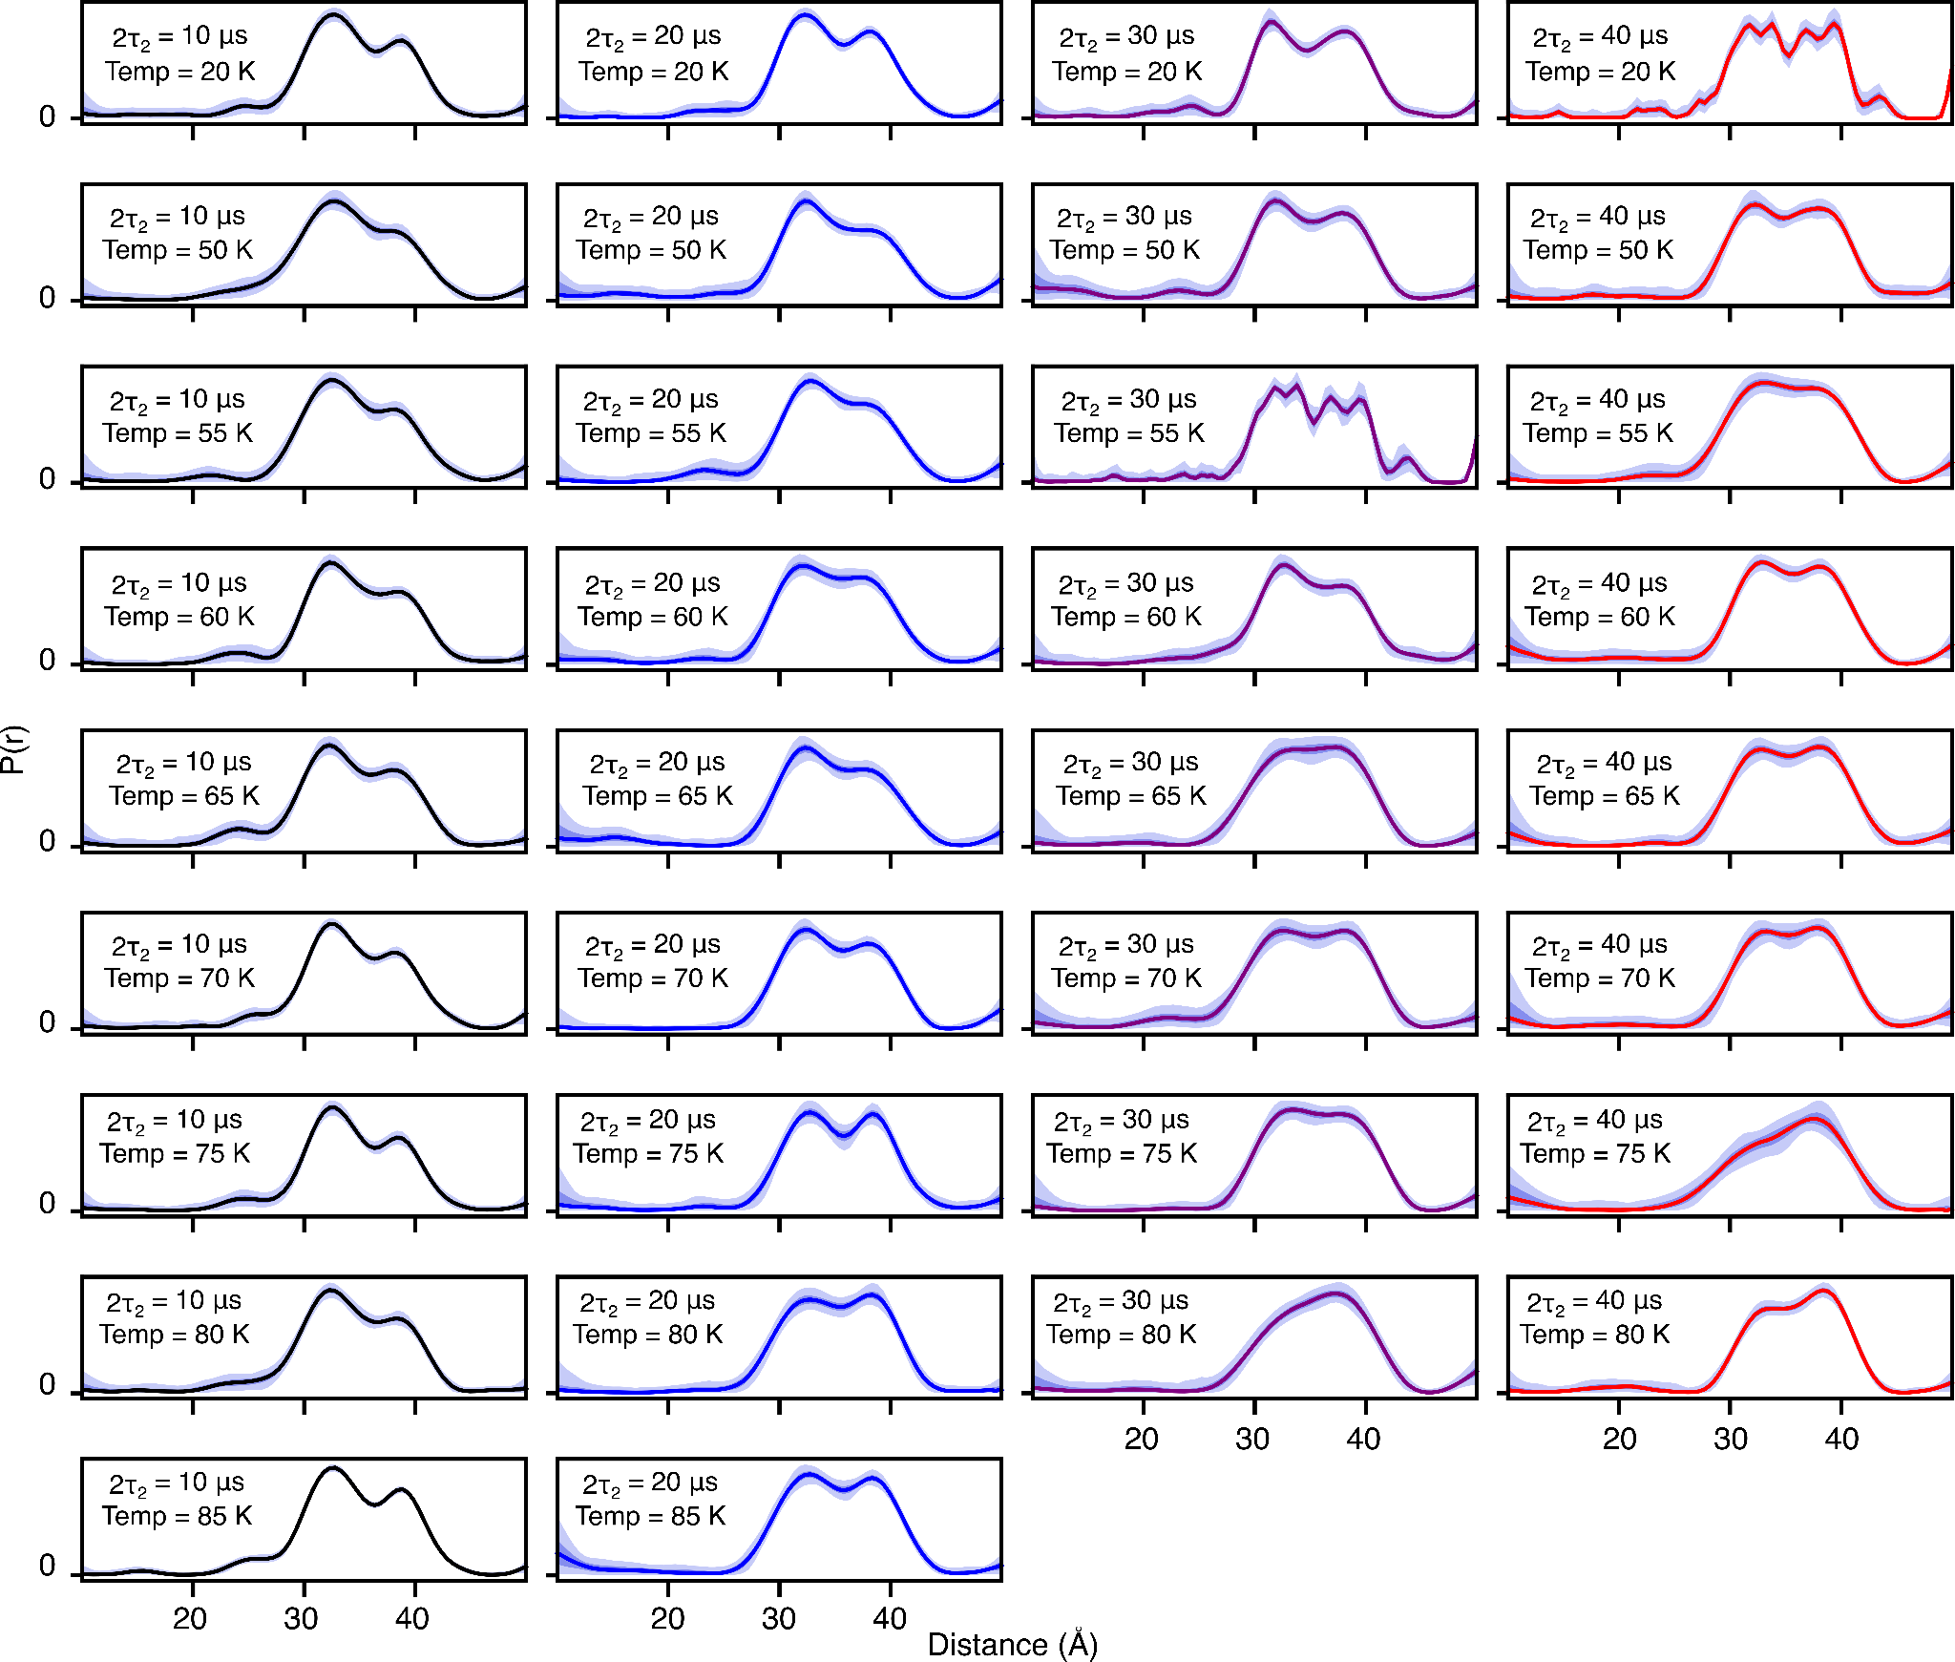
Figure S21. DEER-derived P(r) distributions for for spin-labeled proteinA (Q39C-R1/K88C-R1) by using validated Tikhonov regularization (n=1000), the protein was fully deuterated while the MTSL label and the leucine sidechains were protonated (¹H-Leu, ¹H-R1). The fits to the experimental DEER echo curves are shown in Fig. S19. The solid lines present 2т₂ of 10 (black), 20 (blue), 30 (lilac) and 40 μs (red). The shaded region below presents the 95% (light violet) and 50% (dark violet) confidence interval.
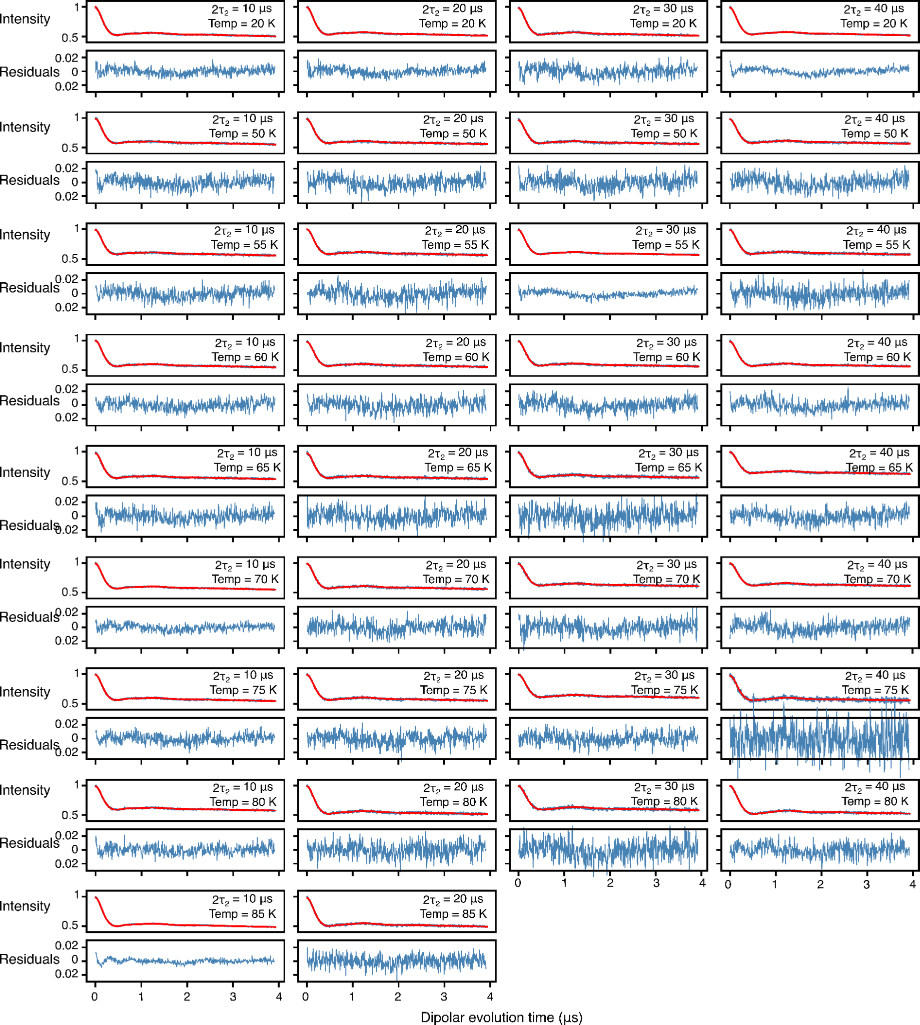
Figure S22. Global analysis of Q-band DEER data acquired for spin-labeled proteinA (Q39C-R1/K88C-R1) using a 2-Gaussian restrained fit,the protein was fully deuterated with protonation of leucine sidechains and MTSL label (¹H-Leu, ¹H-R1), . In each panel, the top half displays the experimental (blue) and bestfit (red) DEER echo curves; the bottom half shows the corresponding residuals between experimental and calculated curves. The data at each temperature and 2т₂ combination were fitted simultaneously with the peak positions and corresponding peak widths in the P(r) distributions treated as global parameters using an in-house Python script[9,10] based on the program DD/GLADDvu.[11–13] The values of the reduced χ² and optimized global parameters are provided in Table 1 of the main text.

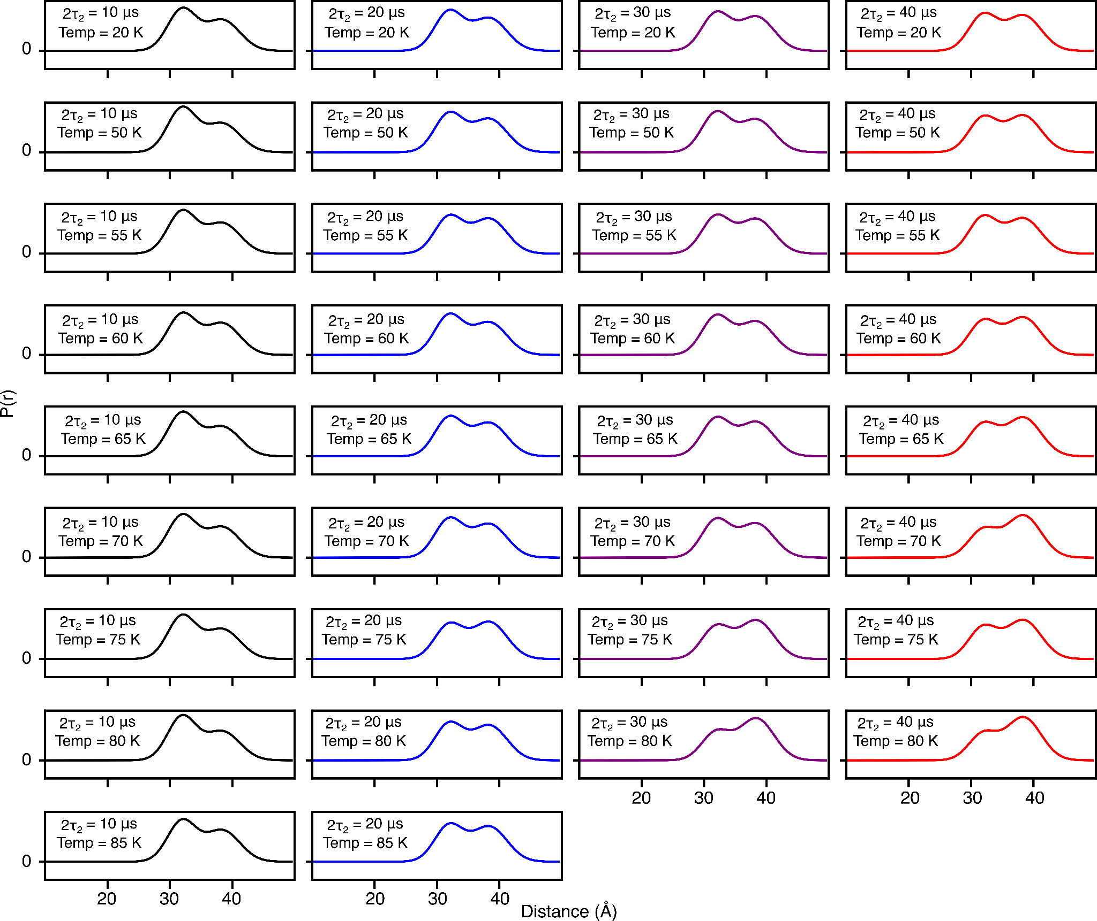
Figure S23. DEER-derived P(r) distributions for for spin-labeled proteinA (Q39C-R1/K88C-R1) by using two-Gaussian global fit in which the peak positions and corresponding widths are treated as global parameters (see main text for details). The protein was fully deuterated while the leucine side chains and MTSL label were protonated (¹H-Leu, ¹H-R1). The fits to the experimental DEER echo curves are shown in Fig. S21. The solid lines present 2т₂ of 10 (black), 20 (blue), 30 (lilac) and 40 μs (red).

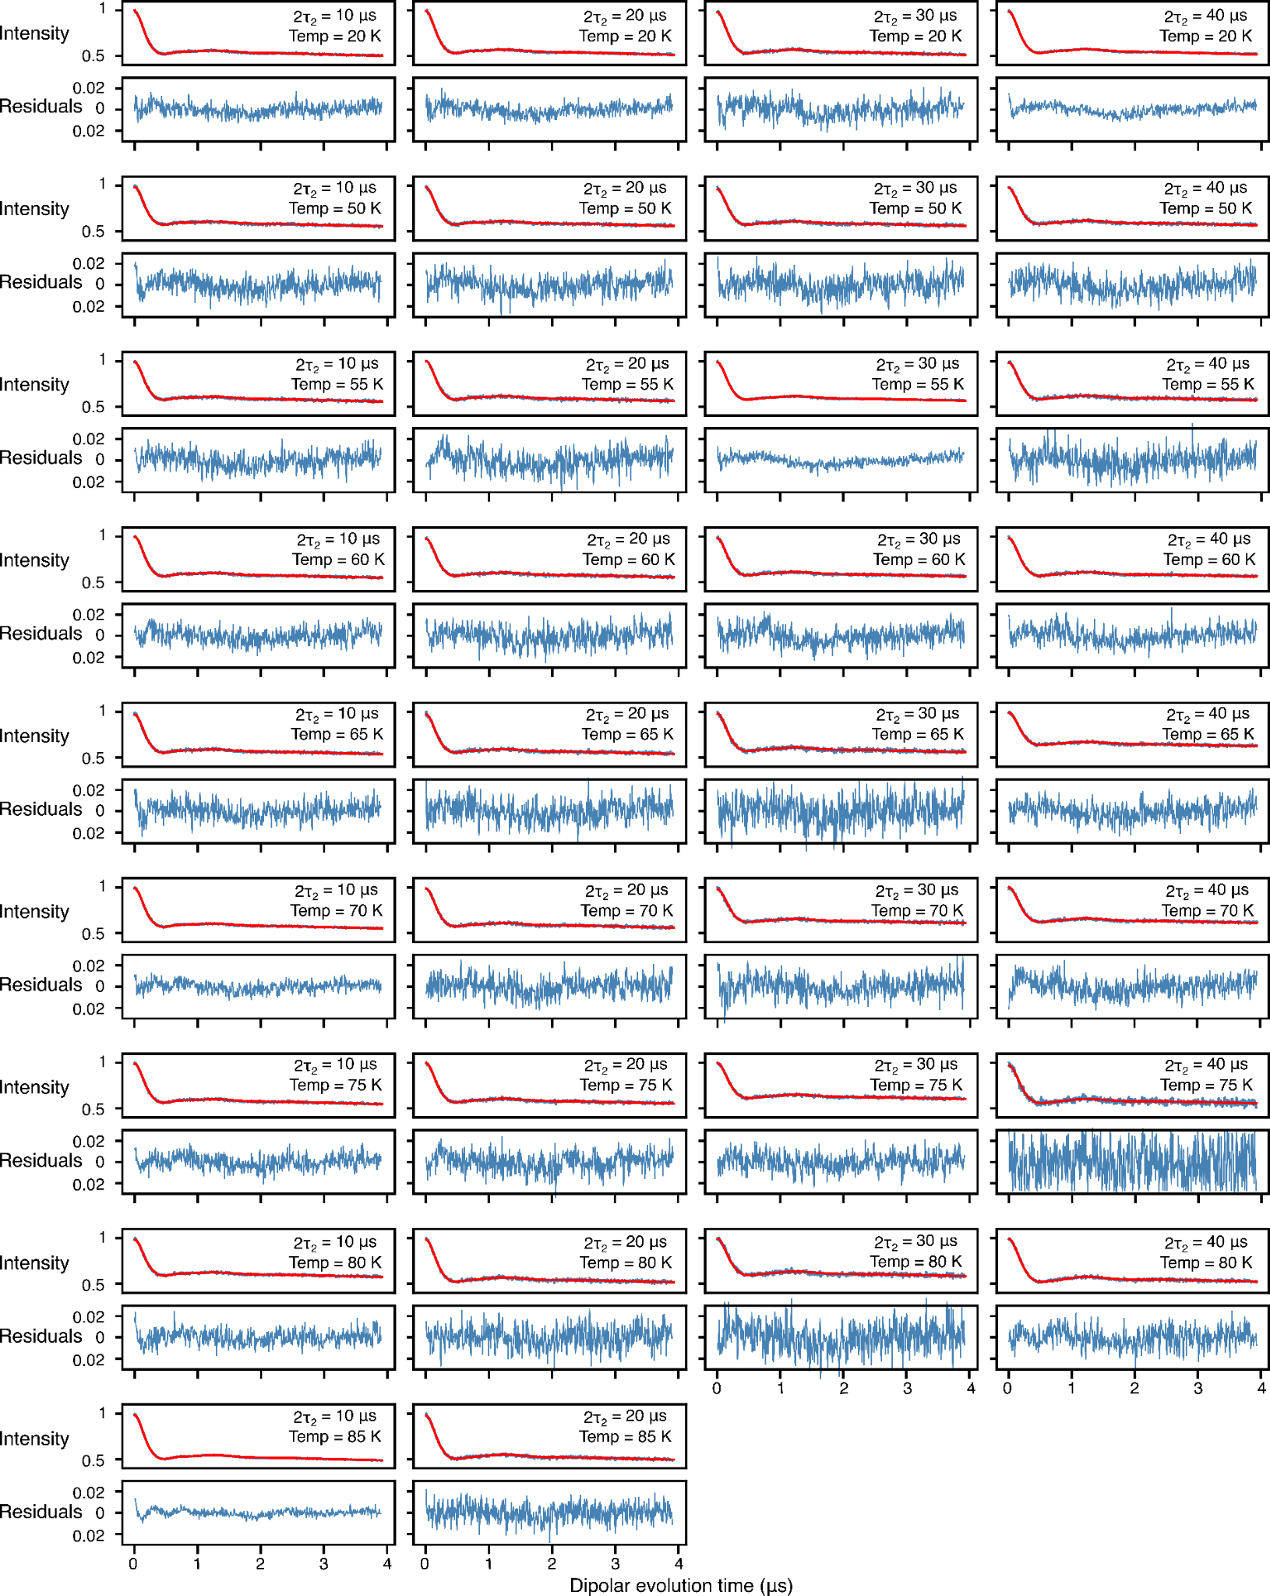
Figure S24. Global analysis of Q-band DEER data acquired for spin-labeled proteinA (Q39C-R1/K88C-R1), the protein was fully deuterated with side specific leucine protonation and the MTSL label was protonated (¹H-Leu, ¹H-R1), using a 2-Gaussian restrained fit while Gaussian ratios were restrained by the methyl rotation as dictated by eq 5. In each panel, the top half displays the experimental (blue) and bestfit (red) DEER echo curves; the bottom half shows the corresponding residuals between experimental and calculated curves. The data at each temperature and 2т₂ combination were fitted simultaneously, setting activation energy and its width, the peak positions and corresponding peak widths in the P(r) distributions as global parameters using an in-house Python script[9] based on the program DD/GLADDvu.[12,13] The values of the reduced χ² and optimized global parameters are provided in Table 1 of the main text.

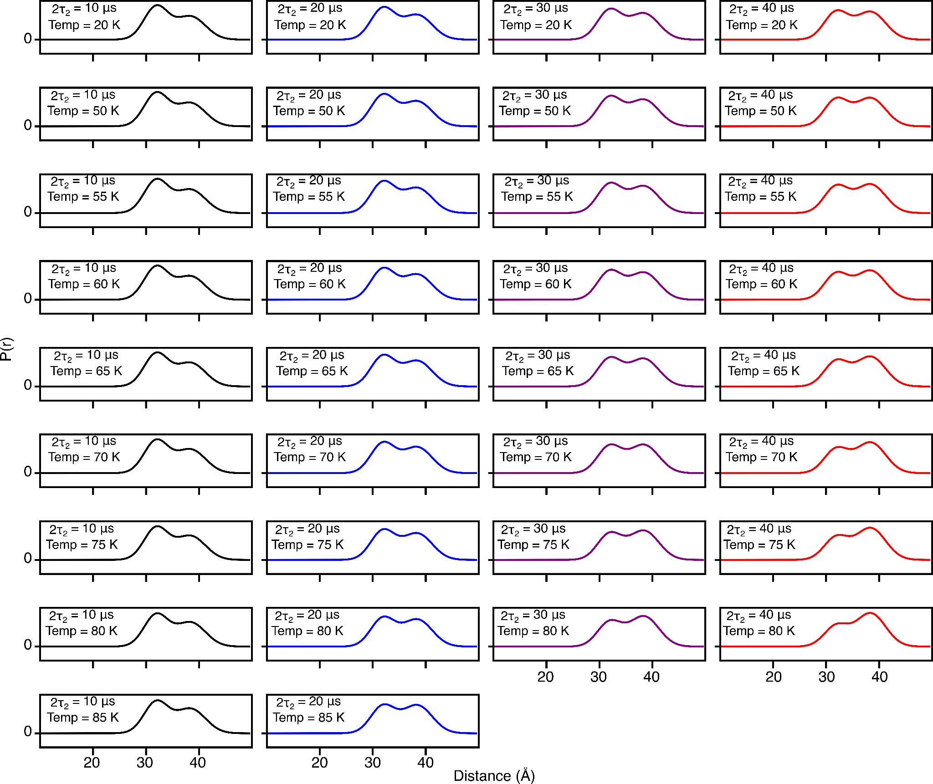
Figure S25. DEER-derived P(r) distributions for spin-labeled proteinA (Q39C-R1/K88C-R1) by using two-Gaussian global fit in which the peak positions and corresponding widths are treated as global parameters. Further, the Gaussian ratios are dictated by the methyl rotation, therefore the activation energy and its width were treated as global parameters (see main text for details). The protein was fully deuterated while the leucine side chain and MTSL label were protonated (¹H-Leu, ¹H-R1). The fits to the experimental DEER echo curves are shown in Fig. S23. The solid lines present 2т₂ of 10 (black), 20 (blue), 30 (lilac) and 40 μs (red). The shaded region below presents the 95% (light violet) and 50% (dark violet) confidence interval.

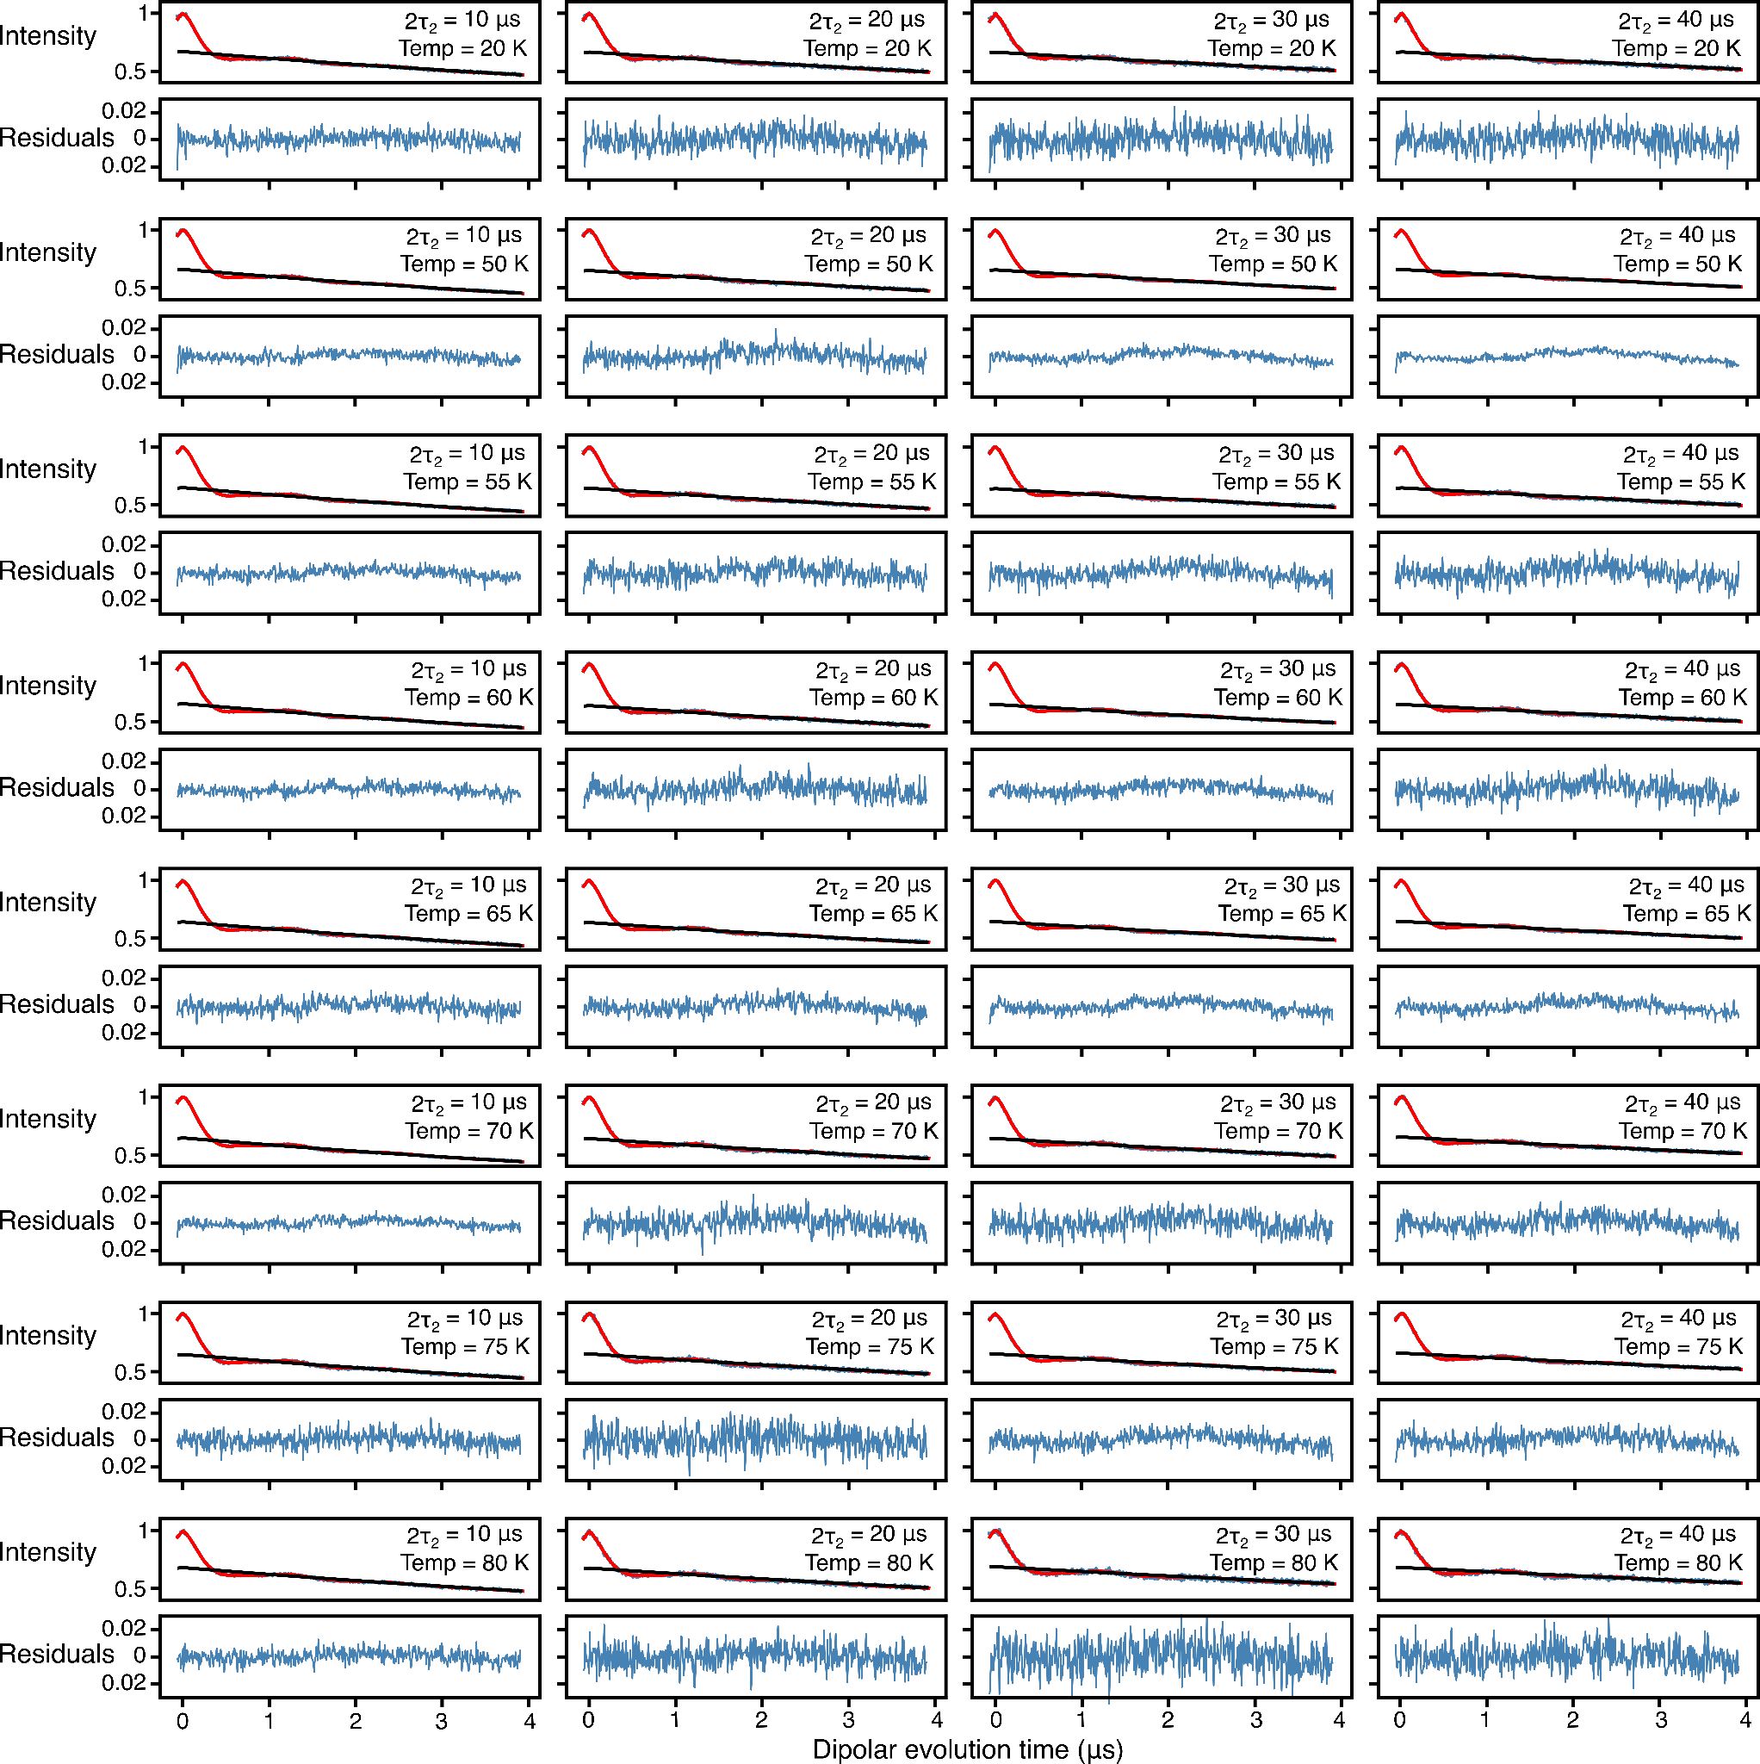
FigureS26. Analysis of Q-band DEER data acquired for spin-labeled proteinA (Q39C-R1p/K88C-R1p) by using validated Tikhonov regularization (n=1000), the protein was fully deuterated while the R1p label was protonated (²H-Leu, ¹H-R1p). In each panel, the top half displays the experimental (blue) and bestfit (red) DEER echo curves; the bottom half shows the corresponding residuals between experimental and calculated curves. The data at each temperature and 2т₂ combination were fitted individually using validated Tikhonov regulation in the program DeerLab.[11] The mean normalized χ² value of the fits is given in Table 1 of the main text.
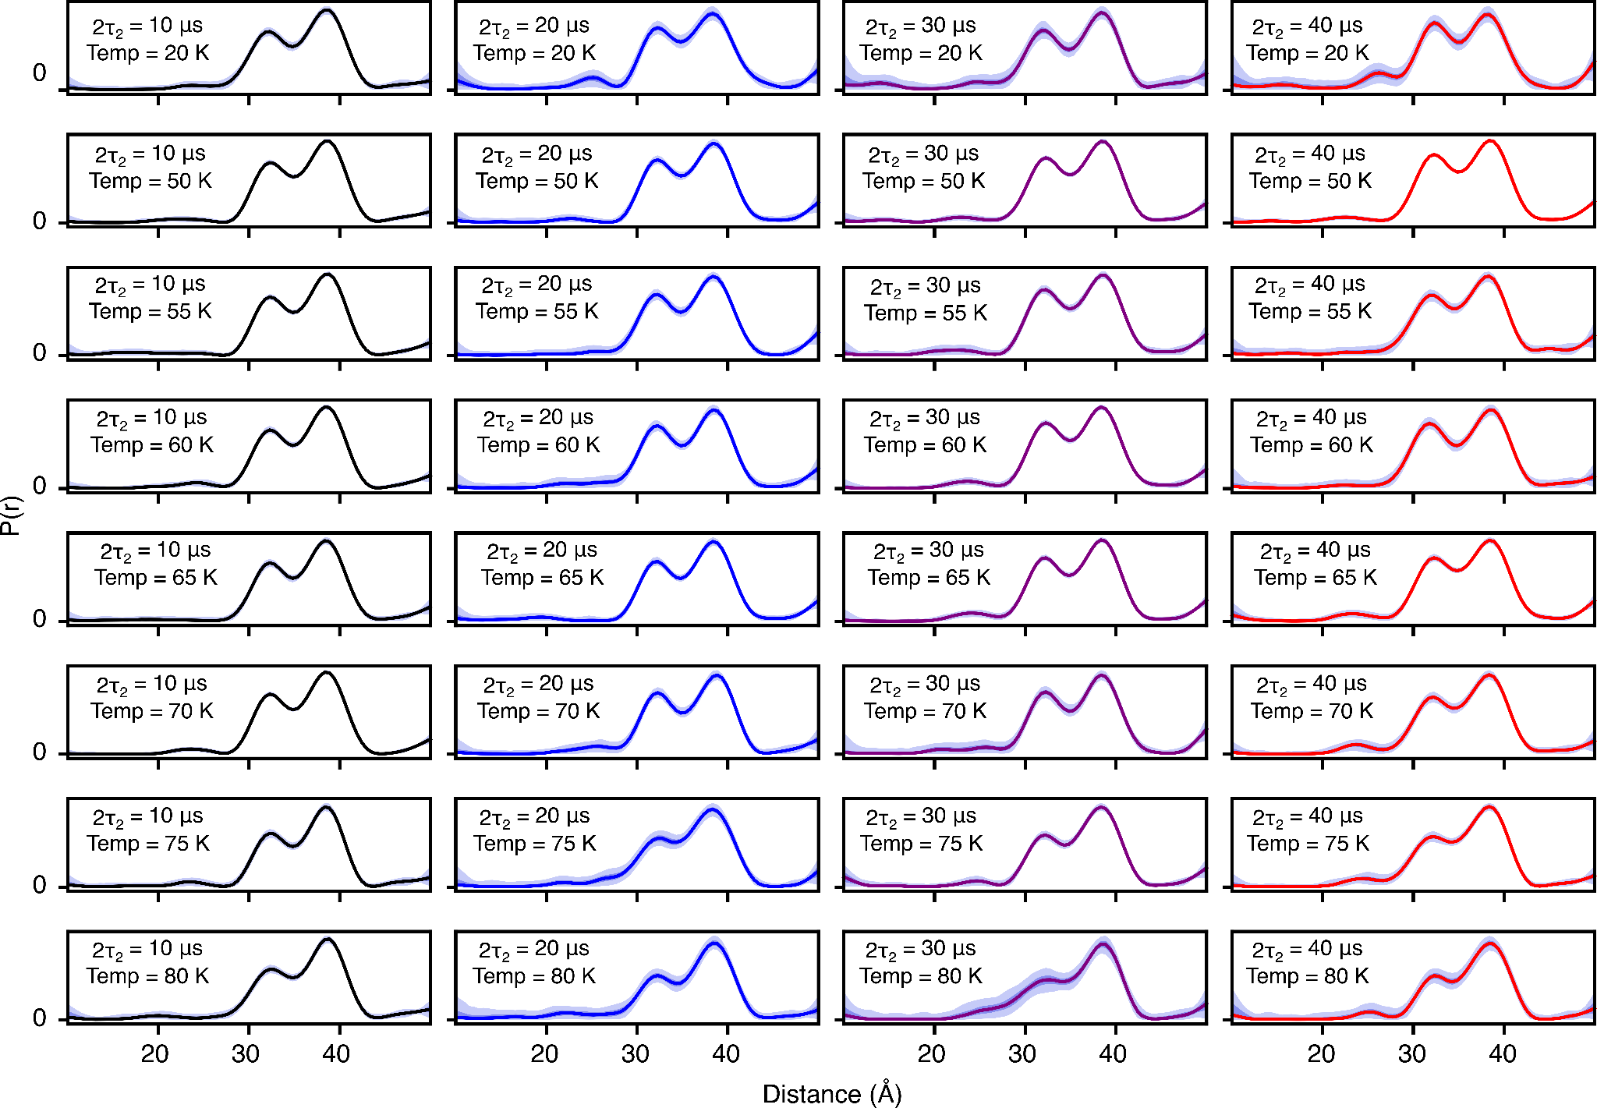
Figure S27. DEER-derived P(r) distributions for for spin-labeled proteinA (Q39C-R1p/K88C-R1p) by using validated Tikhonov regularization (n=1000), the protein was fully deuterated while the R1p label and the leucine sidechains were protonated (¹H-Leu, ¹H-R1). The fits to the experimental DEER echo curves are shown in Fig. S25. The solid lines present 2т₂ of 10 (black), 20 (blue), 30 (lilac) and 40 μs (red). The shaded region below presents the 95% (light violet) and 50% (dark violet) confidence interval.
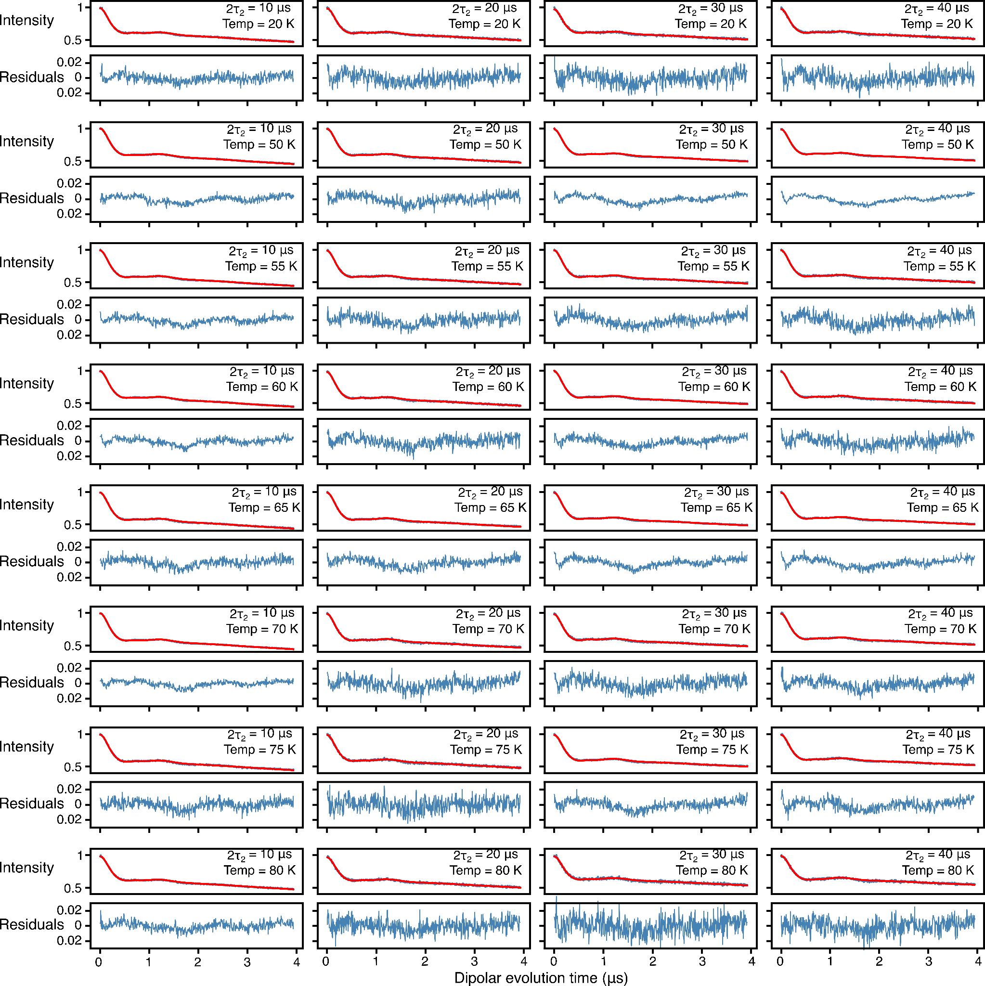

Figure S28. Global analysis of Q-band DEER data acquired for spin-labeled proteinA (Q39C-R1p/K88C-R1p), the protein was fully deuterated while the R1p label was protonated (²H-Leu, ¹H-R1p), using a 2-Gaussian restrained fit. In each panel, the top half displays the experimental (blue) and bestfit (red) DEER echo curves; the bottom half shows the corresponding residuals between experimental and calculated curves. The data at each temperature and 2т₂ combination were fitted simultaneously with the peak positions and corresponding peak widths in the P(r) distributions treated as global parameters using an in-house Python script [9,10] based on the program DD/GLADDvu.[12,13] The values of the reduced χ² and optimized global parameters are provided in Table 1 of the main text.

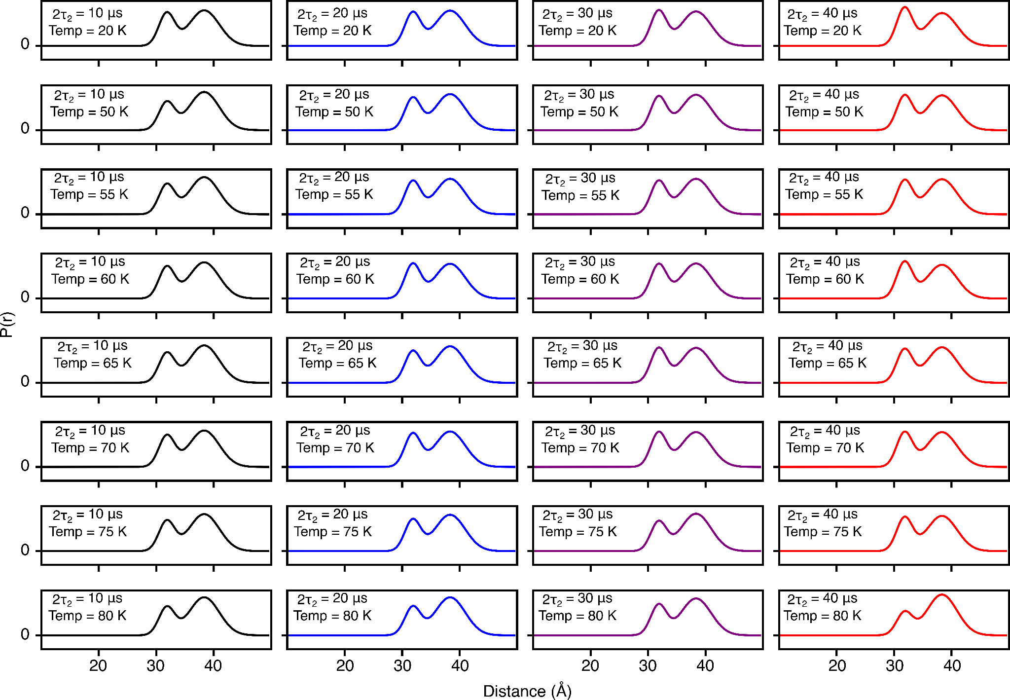
Figure S29. DEER-derived P(r) distributions for for spin-labeled proteinA (Q39C-R1p/K88C-R1p) by using two-Gaussian global fit in which the peak positions and corresponding widths are treated as global parameters (see main text for details). The protein was fully deuterated while the R1p label was protonated (²H-Leu, ¹H-R1p). The fits to the experimental DEER echo curves are shown in Fig. S27. The solid lines present 2т₂ of 10 (black), 20 (blue), 30 (lilac) and 40 μs (red).

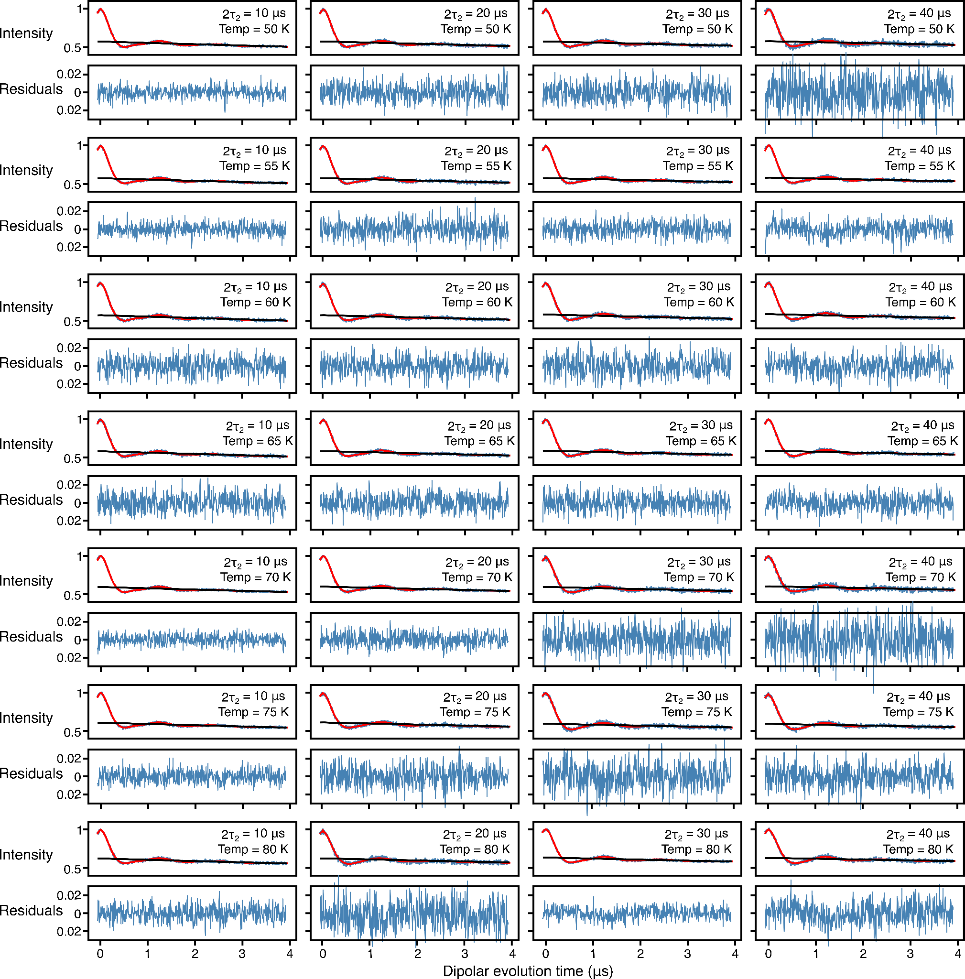
FigureS30. Analysis of Q-band DEER data acquired for spin-labeled proteinA (Q39C-R1p/K88C-R1p), the protein was fully deuterated with side specific leucine protonation while the R1p label was also protonated (¹H-Leu, ¹H-R1p), by using validated Tikhonov regularization (n=1000). In each panel, the top half displays the experimental (blue) and bestfit (red) DEER echo curves; the bottom half shows the corresponding residuals between experimental and calculated curves. The data at each temperature and 2т₂ combination were fitted individually using validated Tikhonov regulation in the program DeerLab.[11] The mean normalized χ² value of the fits is given in Table 1 of the main text.
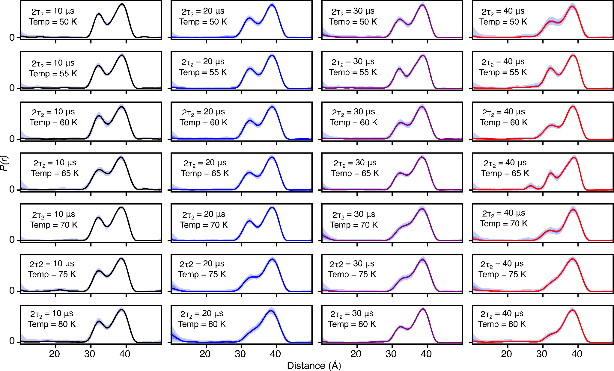
FigureS31. Analysis of Q-band DEER data acquired for spin-labeled proteinA (Q39C-R1p/K88C-R1p) by using validated Tikhonov regularization (n=1000), the protein was fully deuterated while the Leucine side chains and the R1p label were protonated (¹H-Leu, ¹H-R1p). In each panel, the top half displays the experimental (blue) and bestfit (red) DEER echo curves; the bottom half shows the corresponding residuals between experimental and calculated curves. The data at each temperature and 2т₂ combination were fitted individually using validated Tikhonov regulation in the program DeerLab. The mean normalized χ² value of the fits is given in Table 1 of the main text.

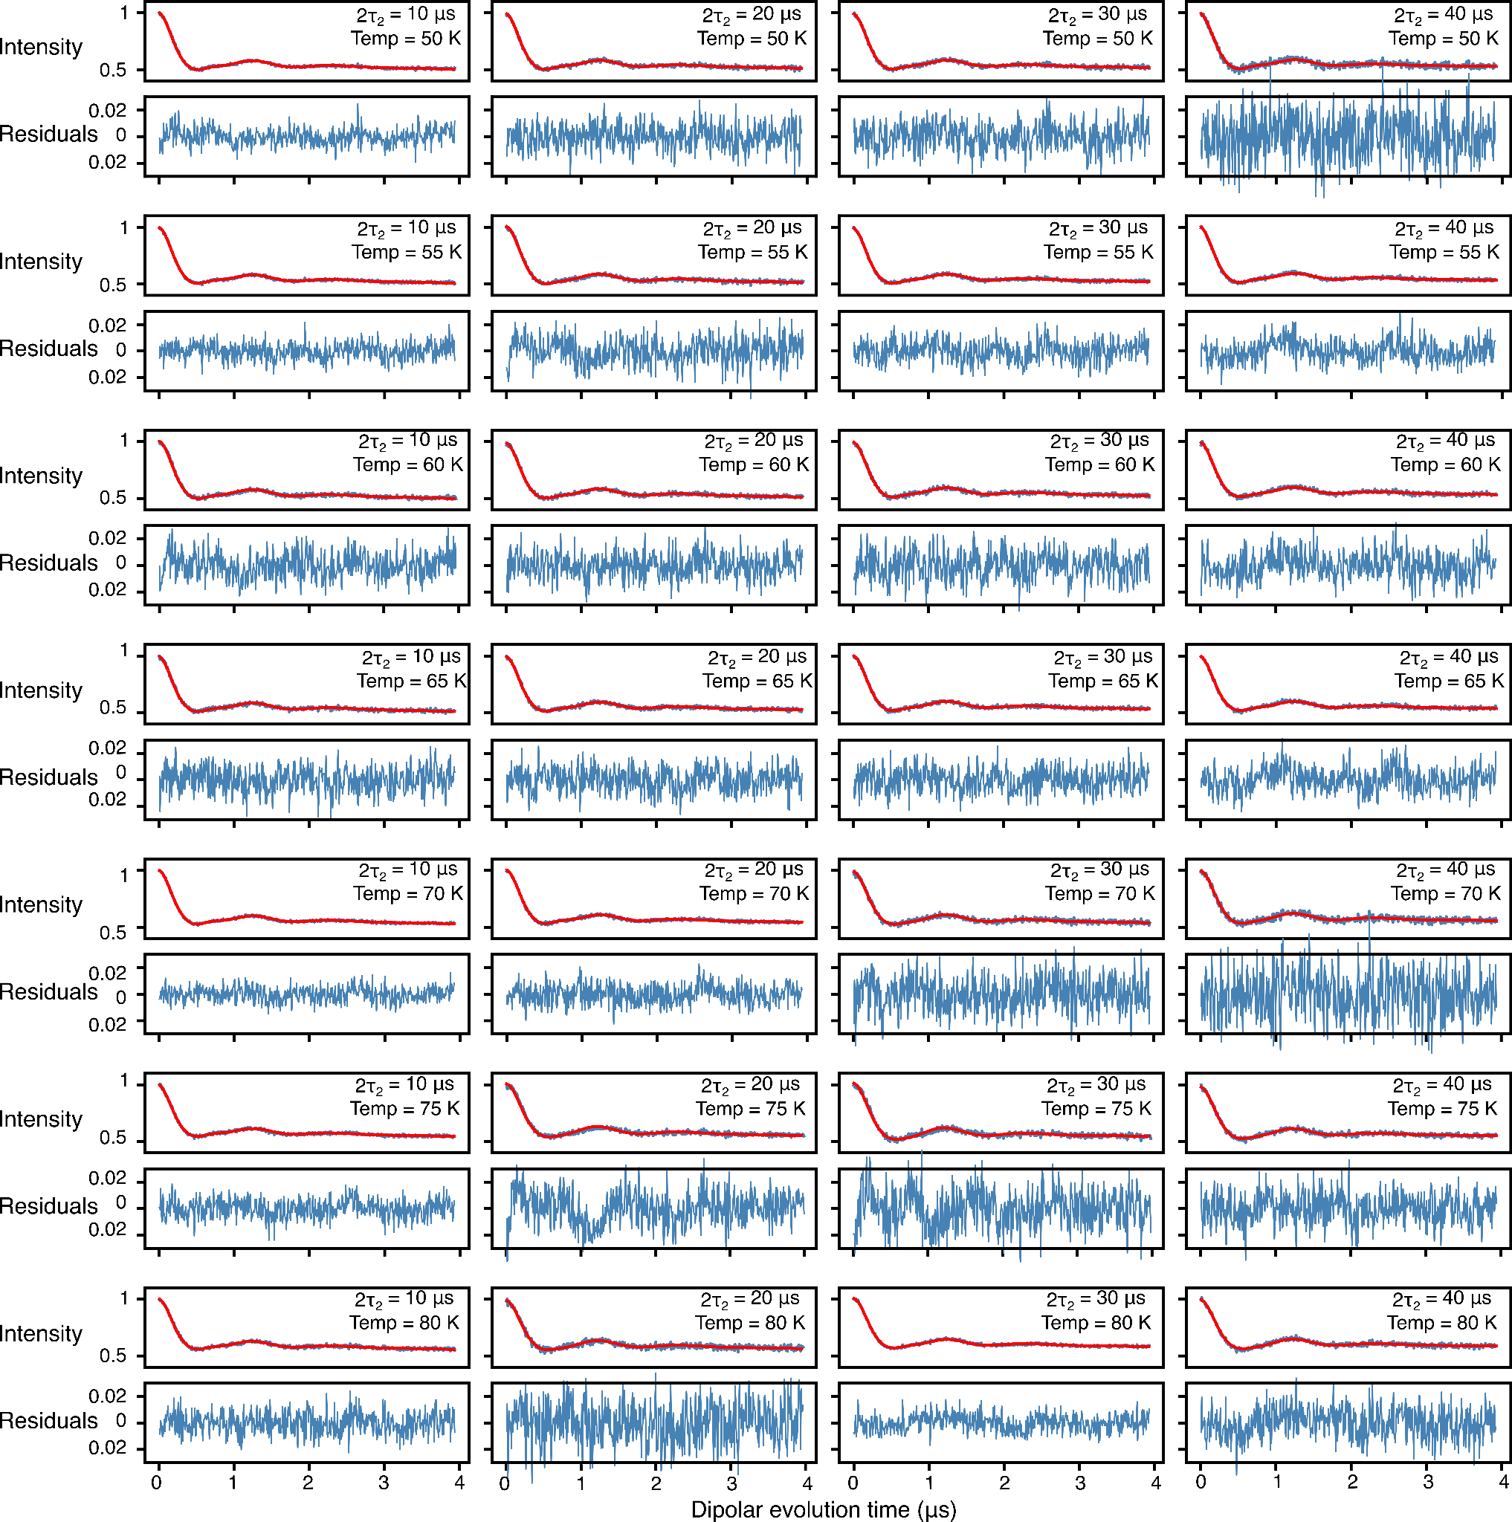

Figure S32. Global analysis of Q-band DEER data acquired for spin-labeled proteinA (Q39C-R1p/K88C-R1p), the protein was fully deuterated with side specific leucine protonation while the R1p label was also protonated (¹H-Leu, ¹H-R1p), using a 2-Gaussian restrained fit. In each panel, the top half displays the experimental (blue) and bestfit (red) DEER echo curves; the bottom half shows the corresponding residuals between experimental and calculated curves. The data at each temperature and 2т₂ combination were fitted simultaneously with the peak positions and corresponding peak widths in the P(r) distributions treated as global parameters using an in-house Python script [9,10] based on the program DD/GLADDvu.[12,13] The values of the reduced χ² and optimized global parameters are provided in Table 1 of the main text.

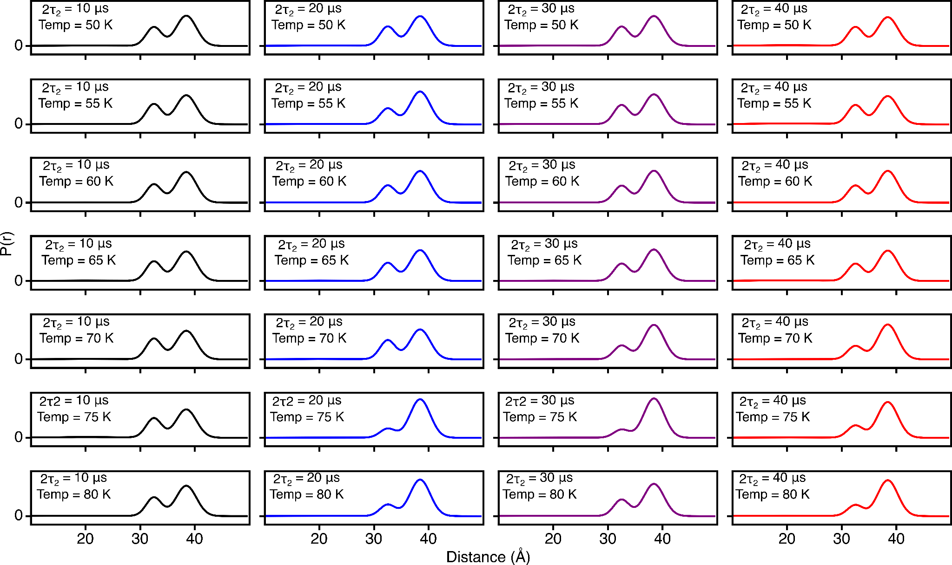

Figure S33. DEER-derived P(r) distributions for for spin-labeled proteinA (Q39C-R1p/K88C-R1p) by using two-Gaussian global fit in which the peak positions and corresponding widths are treated as global parameters (see main text for details). The protein was fully deuterated while the leucine side chains and R1p label were protonated (¹H-Leu, ¹H-R1p). The fits to the experimental DEER echo curves are shown in Fig. S31. The solid lines present 2т₂ of 10 (black), 20 (blue), 30 (lilac) and 40 μs (red).

Supplementary References

1. T. Schmidt and G. Marius Clore, Chemical Communications 56, 10890 (2020).
2. V. Tugarinov, V. Kanelis, and L. E. Kay, Nat. Protoc. 1, 749 (2006).
3. M. Pannier, S. Veit, A. Godt, G. Jeschke, and H. W. Spiess, J. Magn. Reson. 142, 331 (2000).
4. L. K. Nicholson, L. E. Kay, D. M. Baldisseri, J. Arango, P. E. Young, A. Bax, and D. A. Torchia, Biochemistry 31, 5253 (1992).
5. L. S. Batchelder, C. H. Niu, and D. A. Torchia, Journal of the American Chemical Society 105, 2228 (1983).
6. G. Jeschke, Protein Sci. 30, 125 (2021).
7. G. Hagelueken, R. Ward, J. H. Naismith, and O. Schiemann, Appl. Magn. Reson. 42, 377 (2012).
8. M. H. Tessmer and S. Stoll, PLoS Comput. Biol. 19, e1010834 (2023).
9. T. Schmidt, J. Jeon, W.-M. Yau, C. D. Schwieters, R. Tycko, and G. M. Clore, Proc. Natl. Acad. Sci. U. S. A. 119, (2022).
10. T. Schmidt, D. Wang, J. Jeon, C. D. Schwieters, and G. M. Clore, J. Am. Chem. Soc. 144, 12043 (2022).
11. L. Fábregas Ibáñez, G. Jeschke, and S. Stoll, Magn. Reson. 1, 209 (2020).
12. S. Brandon, A. H. Beth, and E. J. Hustedt, J. Magn. Reson. 218, 93 (2012).
13. E. J. Hustedt, R. A. Stein, and H. S. Mchaourab, J. Gen. Physiol. 153, (2021).

