Supplementary Information

A tied Fermi liquid to Luttinger liquid model for the explanation of nonlinear transport in conducting polymers
Jiawei Wang¹, Jiebin Niu¹, Bin Shao^{3,4}, Guanhua Yang¹, Congyan Lu¹, Mengmeng Li¹, Zheng Zhou¹, Xichen Chuai¹, Nianduan Lu¹, Bing Huang⁴, Yeliang Wang^{2*}, Ling Li^{1*}, and Ming Liu^{1*}

¹Key Laboratory of Microelectronic Devices & Integrated Technology, Institute of Microelectronics, Chinese Academy of Sciences, Beijing 100029, China.
²School of Information and Electronics, MIIT Key Laboratory for Low-Dimensional Quantum Structure and Devices, Beijing Institute of Technology, Beijing 100081, China.
³Shenzhen JL Computational Science and Applied Research Institute, Shenzhen 518110, China
⁴Beijing Computational Science Research Center, Beijing 100193, China
*E-mails: yeliang.wang@bit.edu.cn; lingli@ime.ac.cn; liuming@ime.ac.cn

Content
S1. GIWAXS data of F₄TCNQ doped PBTTT film
S2. Device configuration and the basic electrical properties
S3. UV-Visible absorption spectrums for PBTTT films
S4. Comparison between different models in depictions of the nonlinear transport in PBTTT:F₄TCNQ
S5. HALL and Magnetoresistance of doped PBTTT films of different crystalline degree.
S6. Theoretic evaluation of the power law nature in the 1D polymer chain by First principle calculations with 1D Bosonization approach
S7. Schematic diagram of the equivalent circuit of the Fermi liquid - Luttinger liquid resistive network
S8. TEM morphology of HC PBTTT film
S9. Submicrometer channel device for nonlinear transport investigations
S10. Power-law nonlinear transport behavior in P₃HT films

Part.1
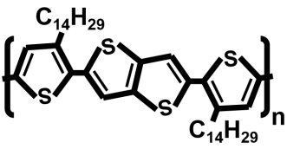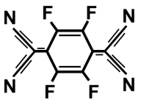
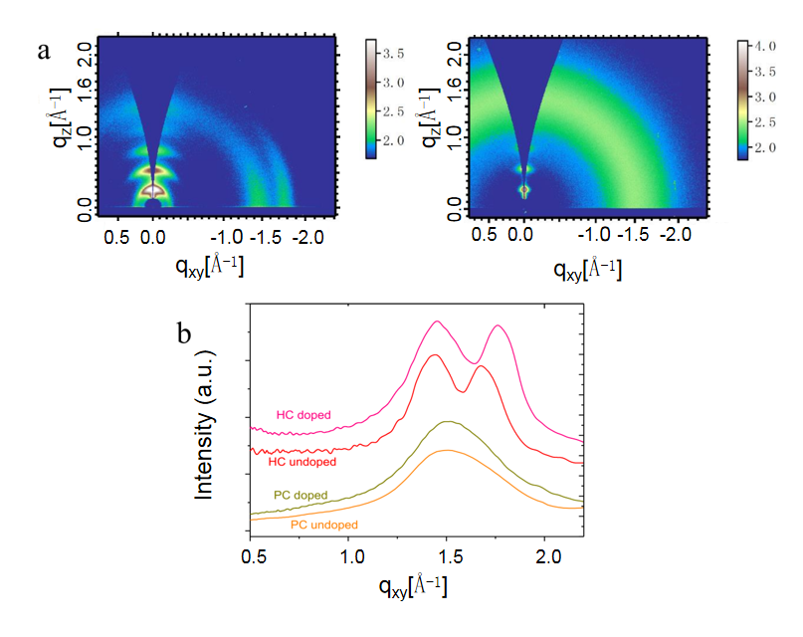
Supplementary Figure.1 The molecular structures of PBTTT-C14 and the doping molecule F₄TCNQ are shown at the top. (a) GIWAXS of doped HC (left) and PC samples (right). (b) Comparison between doped and pristine samples.
For highly crystalline (HC) samples, the doping process could enhance the pi-pi coupling along the [010] direction by suppressing the lattice constant (with the shift of the peak), however, for the poorly crystalline (PC) samples, no enhancement of the crystalline degree of the [010] pi-pi stacking could be identified.
Part. 2
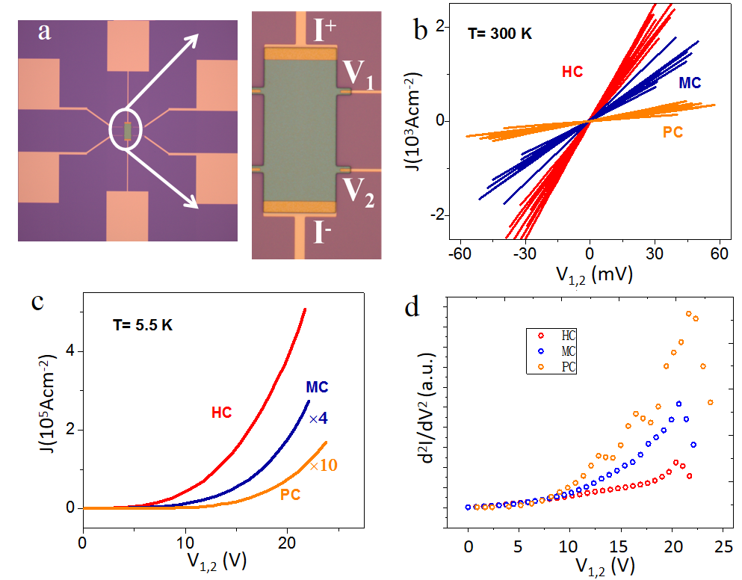
Supplementary Figure.2 Device configuration and the basic electrical properties. a. Optic images of four terminal (4T) devices for the electrical characterizations of doped PBTTT films. Device patterning was realized by UV lithography and Oxygen plasma etching, with a perylene layer protecting the doped polymer. b. Linear I-V curves extracted from tens devices of HC (red), MC (blue), and PC (orange) samples at T = 300 K. c. Nonlinear I-V curves for devices of HC (red), MC (blue), and PC (orange) samples at T = 5.5 K. d. Nonlinearity of I-V curves for HC (red circle), MC (blue circle), and PC (orange circle) samples at T = 5.5 K.
Part. 3
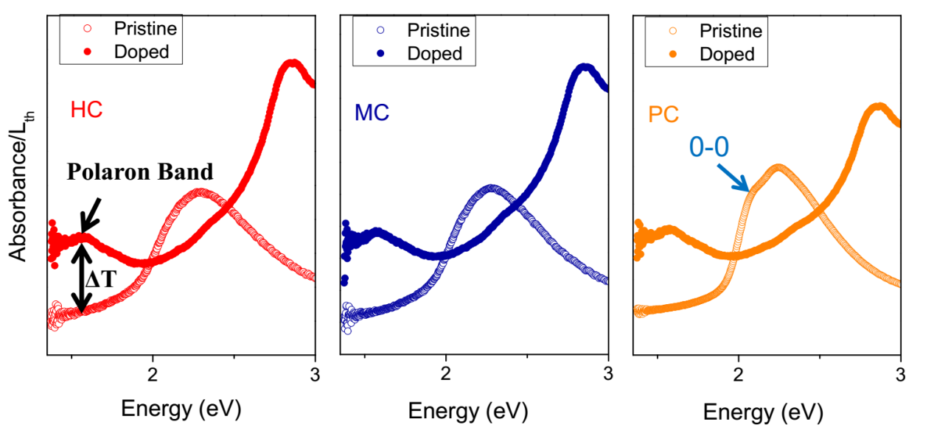
Supplementary Figure.3 UV-Visible absorption spectrums for PBTTT films of HC (red), MC (blue), and PC (orange) samples. The absorptions of pristine and doped films are displayed by circles and dots, respectively. To compare the carrier concentrations or the doping levels, the equation $\frac{ΔT}{T}\sim L_{\text{th}}⋅n$ is employed, whereΔT is the light transmission difference at the polaron band absorption, which is could be extracted with the experiment data, L_{th} is the film thickness. The doping degrees for three types of samples are in similar level from the values of ΔT/L_{th}.
Part. 4
a.
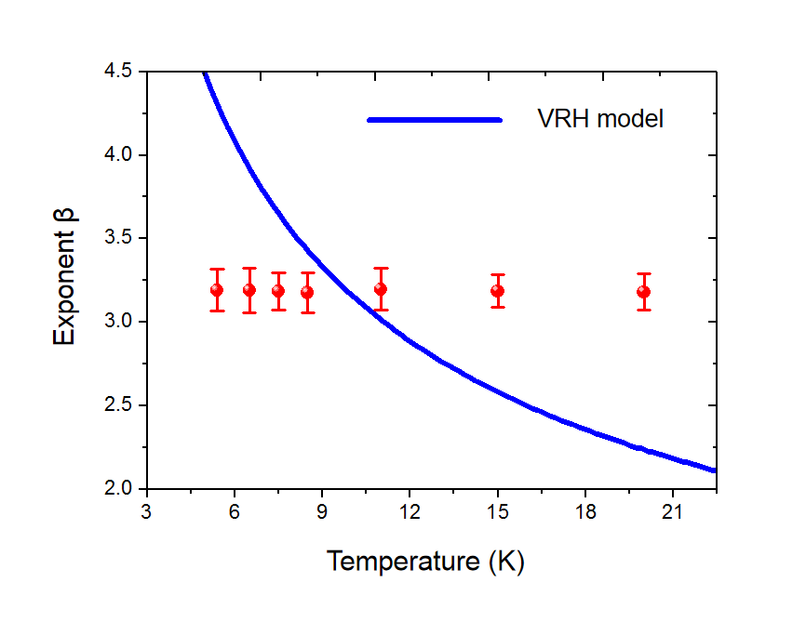
Supplementary Figure.4a Relationship between power-law exponent β and temperature T. It’s clear that the values of β (red circles) extracted in HC samples are almost constant at T ranging from 5.5 K to 20 K, deviating from the functions $β\sim T^{-0.5}$ (blue curve) from 1D VRH theory [1].

b.
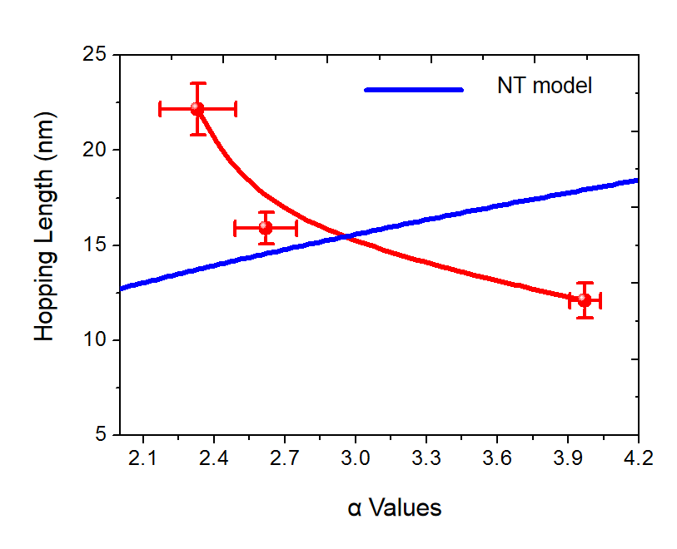
Supplementary Figure.4b Relationship between hopping length L_{ij} and α. Developed from the double well dissipation tunneling system. Nuclear tunneling (NT) theory predicts a α-L relation$α=ηL^{2}/2πℏ$, as depicted with the blue curve. This illustrated well the α-L_{ij} relations from our experimental data (red symbols) [2,3].

c.
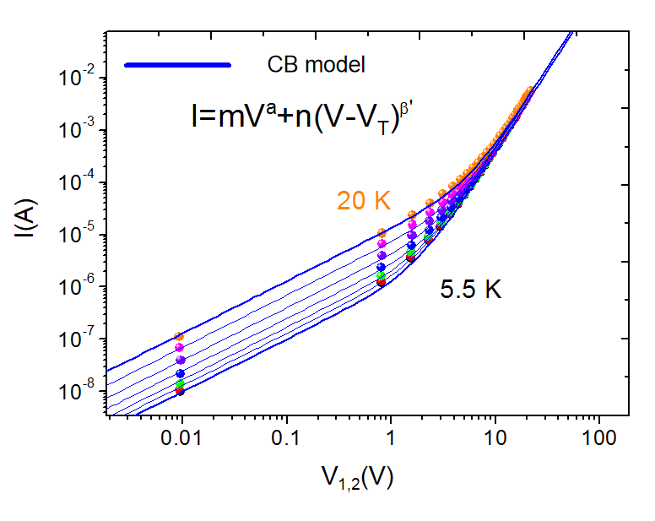
Supplementary Figure.4c Fitting the low-T data with Coulomb blockade (CB) model. The fitting is conducted via the formula $I=mV^{a}+n(V-V_{T})^{β'}$, in which, β’ is independent of temperature; m and n are a constant especially at temperatures below T*, a has a value of 1 above T*. T* is the effective temperature below which the CB effect takes place [4]. The fitting parameters are:
0.000013*x + 0.00000035*(x)^3.1
0.000007*x + 0.00000034*(x)^3.1
0.000004*x + 0.00000034*(x)^3.1
0.0000025*x + 0.00000033*(x)^3.1
0.0000017*x + 0.00000032*(x)^3.1
0.0000013*x + 0.00000031*(x)^3.1
0.000001*x + 0.0000003*(x)^3.1,

The values of V_{T} at all temperature are 0 V, and the values of a are constant as 1, m and n are variables, indicating the temperature is above T*. No macroscopic CB effect could be observed.

d.
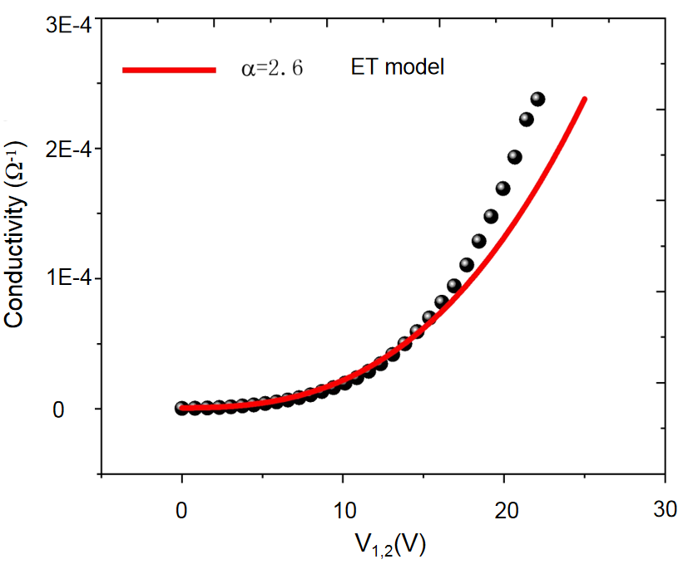
Supplementary Figure.4d Fitting the MC samples data with effective temperature model (ET). The ET model predicts a strict power-law relationship between I and V at high bias limit as $σ\sim (\sqrt{（T_{lattice}）^{2}+(\frac{2}{3}\frac{eV}{k_{B}N}})^{2}）^{α}$. The MC sample exhibited a super-power-law nonlinearity, which deviate what the ET model’s prediction. Thus, the ET model could also be excluded [5].

e.
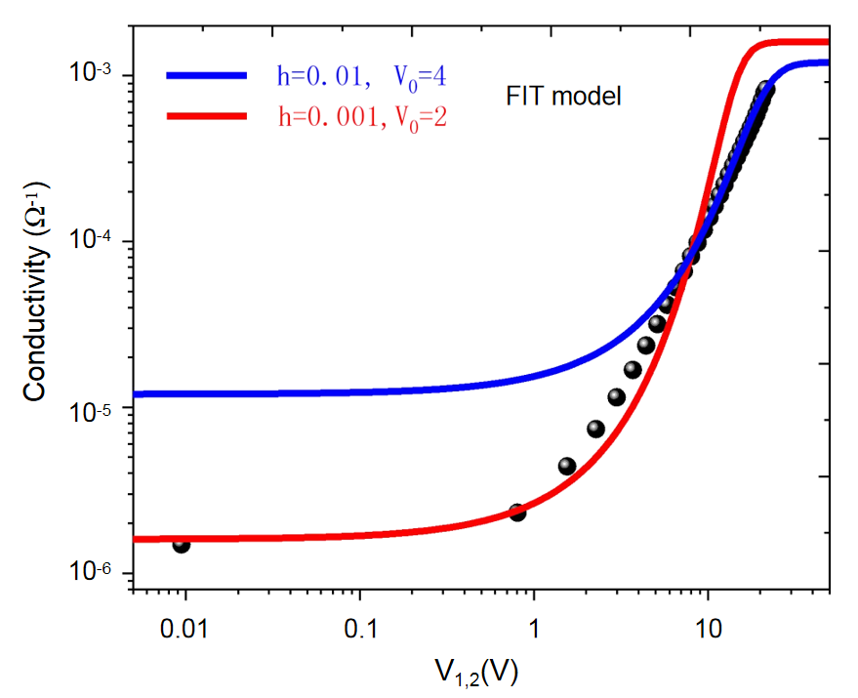
Supplementary Figure.4e Fitting the HC sample data with fluctuation induced tunneling model (FIT). The FIT model predicts a relationship between conductivity σ and V, $σ=σ_{0}\frac{\exp{(}V/V_{0})}{1+h(\exp{(}V/V_{0})-1)}$, which could not well fit the σ-V curve [6]. Physically, FIT relates to the charge hopping among segments, in each of which, carriers could be treated as delocalization to some degree, as the situations in para-crystalline materials with large domains.
Part. 5
a.
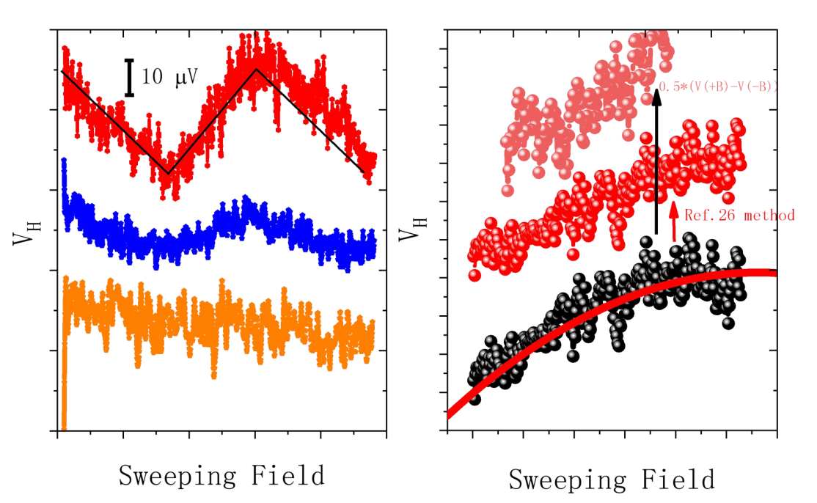

Supplementary Figure.5a Hall effect measurements for devices of HC, MC and PC samples (left), and to subtract the voltage contributed by other factors like offset voltage and magnetoresistance voltage (right).
HC samples exhibit Hall voltage of tens nanovolts, corresponding with carrier concentration n_{hc} = 3~7*10²⁰ cm⁻³, a reasonable value compared to previous study. Carrier concentrations were calculated via$n=\frac{IB}{eV_{H}d}$ , in which I is the current, B is the magnetic field, V_{H} is Hall voltage, d is the film thickness.
As the film crystalline degree decrease, V_{H} decrease with anomalous carrier concentration n_{mc} = 2*10²¹ cm⁻³ for MC sample and V_{H} almost quench in the PC samples, which could be attributed to the suppression of the carrier’s 2D transport with the weakening of the intermolecular couplings, the carrier localized within in the one-dimensional polymer chain could hardly realize normal Lorentz deflection under magnetic field.
Utilizing the differences in the dependence on the sign of the magnet field, we extract Hall voltage by V_{HALL}~0.5*(V(+B)-V(-B)).

b.
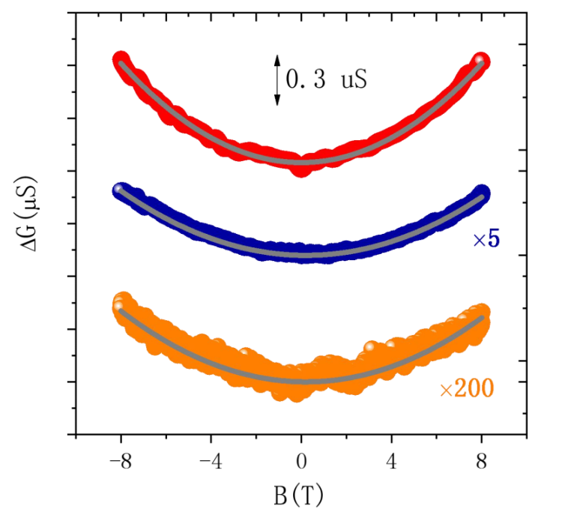
Supplementary Figure.5b Magnetic field B dependence of magneto conductance (ΔG(B) = G(B) − G(0)) for three kinds of samples. The fitting curves are based on the 2D Hikami-Larkin-Nagaoka model $ΔG(B)=\frac{1}{24}\frac{e^{2}}{2π^{2}ℏ}\frac{B^{2}}{B_{φ}^{2}}$, where $B_{φ}=\frac{ℏc}{4eDτ}$ the fitting suggests the weak localization effect contributed by the 2D coherent carriers. The inelastic scattering length is extracted with$λ=\sqrt{Dτ}$, values of λ reach 5.6 nm and 2.9 nm for HC and MC samples, while for the PC samples, the values are around 1 nm, comparable to the intermolecular lattice constant, which could be attributed to the lack of 2D carriers.

Part. 6

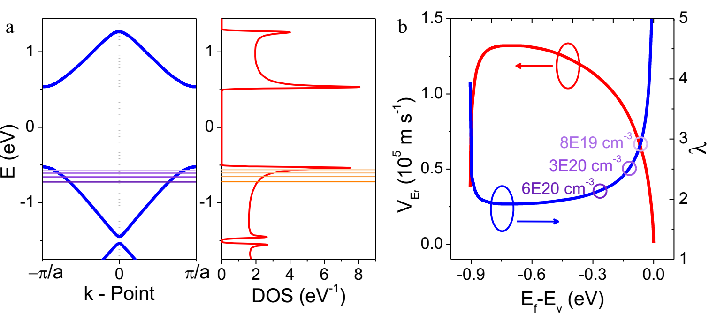
Supplementary Figure.6 Theoretic evaluation of the power-law nature in the 1D polymer chain by first-principle calculations with 1D Bosonization approach. a. Band dispersion and density of states (DOS) of PBTTT 1D polymer chain, the position of Fermi level was determined with various holes’ density on one repeat unit, ranging from 0.1 to 0.7. b. The energy-dependent Fermi velocity (red line), and the relevant power-law exponent (blue line) derived with the Bosonization model, different concentrations of carriers are marked on the curves by circles.
Specially, to gain a further insight into the polymer chains’ 1D electronic liquid characters, we investigated the molecule’s electronic structure and the relevant power-law characters by first-principle calculations, and significantly together with the developed Bosonization method for quasi-1D Fermions systems [7,8]. The calculated band dispersion and density of states (DOS) for the polymer 1D chain are displayed in Supplementary Fig.6a, the Fermi level could be determined with certain hole density per unit in the polymer chain. The Fermi velocity V_{Ef} is obtained at the knowledge of the E-K relation and Fermi level. We obtain the carrier density dependent power-law exponent λ,With Eq (S1) from the Bosonization approach [9].
$λ=\frac{1}{2}\left[\frac{1}{2\sqrt{\frac{4πg}{v_{E_{f}}}+1}}+\frac{1}{2}\sqrt{\frac{4πg}{v_{E_{f}}}+1}\right]-\frac{1}{2}$ , (S1)
in which, $g=\frac{\tilde{V}(0)}{2π^{2}}$ is the electrons’ correlation strength, $\tilde{V}(0)=2(e^{2}/ε)Ln(L/R)$ is the scattering element, the parameter ε, L, and R stand for the dielectric constant, 1D chain’s length, and the 1D electrons average radius, respectively [7, 9]. For L/R have the similar values for PBTTT and the single wall nanotube (SWNT) [10], and values of ε do not vary much for carbon materials, we take the scattering element value of SWNT reported for universal reference, where $\tilde{V}(0)=\text{7.47}πv_{SWNT}$, $v_{SWNT}=\text{8.0}×\text{1}{\text{0}}^{5}$ m/s is the Fermi velocity of SWNT. As shown in Supplementary Fig.6b, the power-law exponent’ values almost keep unchanged aroundα= 2 at large carrier density, while increase dramatically as carrier density decreases. Theα-E curve is expressly marked at carrier concentrations n = 8×10¹⁹, 3×10²⁰, and 6×10²⁰ cm⁻³, with the power-law exponent valuesα= 2.95, 2.5, and 2.1, respectively.

Part. 7
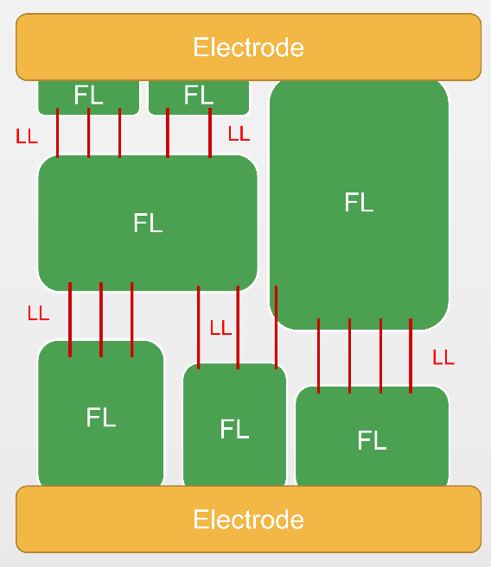
Supplementary Figure.7 Schematic diagram of the equivalent circuit of the Fermi liquid - Luttinger liquid resistive network.
We assume that the resistance of FL-LL tunneling is far larger than that of charge transport in FL regions (R_{FL-LL}>>R_{FL}, R_{FL}=0). When the FL-LL tunneling junction features by the LL transport behaviors, $I\sim V^{β}$，$G\sim T^{α}$, the whole film could also obey the relationship. There are in total m parallel paths in the charge transport channel, and n tunneling junctions in one path, thus we have
$$I_{m}=a_{n,m}{V_{n,m}}^{β}$$$$V_{n,m}={\left(\frac{1}{a_{n,m}}\right)}^{1/β}{I_{m}}^{1/β}$$$$U=\sum_{n}{V_{n,m}=}\sum_{n}{{\left(\frac{1}{a_{n,m}}\right)}^{1/β}}{I_{m}}^{1/β}$$$$I_{m}={\left(1/\sum_{n}{{\left(\frac{1}{a_{n,m}}\right)}^{1/β}}\right)}^{β}U^{β}$$$$I=\sum_{m}{I_{m}}=\sum_{m}{{\left(1/\sum_{n}{{\left(\frac{1}{a_{n,m}}\right)}^{1/β}}\right)}^{β}U^{β}}→→I\sim U^{β}.$$
We have $I\sim U^{β}.$Similarly, we have $G\sim T^{α}$.

Part. 8
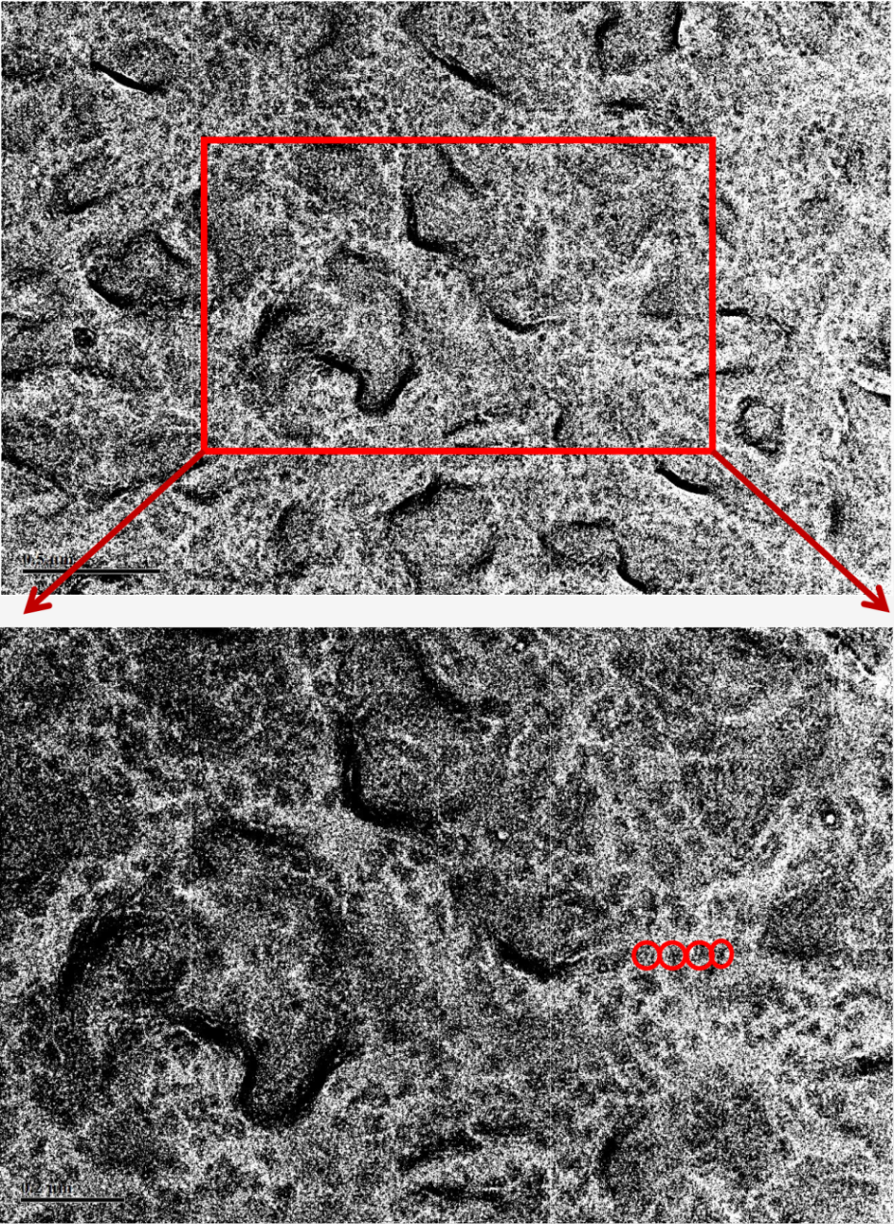
Supplementary Figure.8 TEM image of surface morphology of HC PBTTT film. The PBTTT thin films for TEM characterization were prepared via transfer method. The bared copper grids without any polymer supporting layer were used. The difference of electron beam transmission intensity in crystalline and amorphous regions could reveal the distribution of crystalline grains, as shown by the dark sites. The scale bar is 0.5 um, 0.2um at the upper panel and the low panel, respectively.

Part. 9
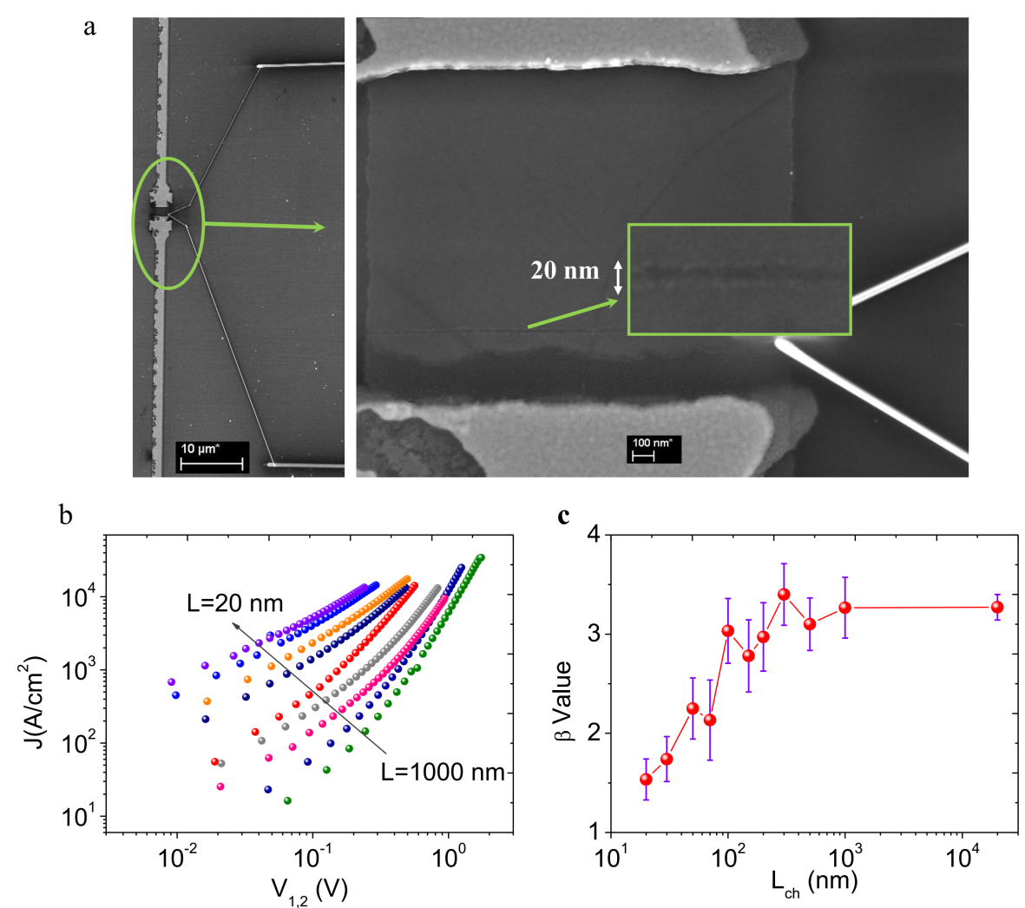
Supplementary Figure.9 Submicrometer channel device for nonlinear transport investigations. a. SEM images of the device with short channel length L_{ch} =20 nm, the scale bars are 10 um(left) and 100 nm (right), respectively. b. I-V curves of the devices with various channel lengths ranging from 1000 nm down to 20 nm, displayed in log-log coordinates. c. The β values extracted from the devices of various channel lengths.
Based on our mesoscopic model, the resistance in the large crystalline grains, which are treated as Fermi liquids, should be Ohmic. Consequently, if we narrow the channel length to around or even smaller than the grains’ character size, there is in large probability that one transport path is occupied by a single FL, thus the I-V curves should behave likes Ohmic contact. And this assumption was certified with electrical characterization on HC samples with various channel lengths from 300 to 20 nm. Supplementary Figure 9a shows the SEM images of the device’s short channel of length L_{ch} = 20 nm at different zoom scales. As shown in Supplementary Fig.9b, the nonlinearity of I-V curves are evidently suppressed with the channel shortening to below 100 nm, the extracted values of power-law exponent β shown in Supplementary Fig.9c decreased from more than 3 to around 1.5 indicates the crossover to Ohmic transport, the obvious phenomenon are consistent well with our mesoscopic model of FLs and LLs.

Part. 10
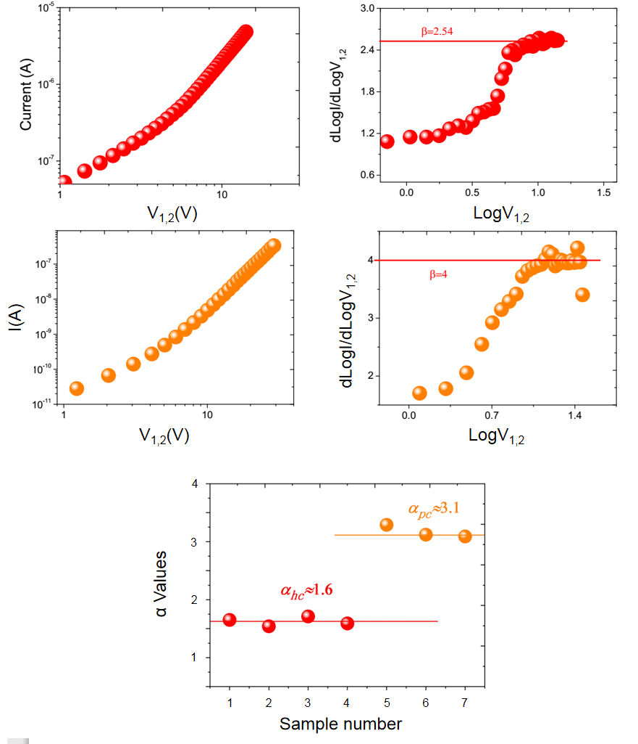
Supplementary Figure.10 Power-law behavior in conducting P₃HT films doped by F₄TCNQ. The values of power-law exponent β in HC samples distributes around 2.5~2.7, and the ones in PC samples are around 4; The distribution of values of α for HC and PC samples indicates the relationship between FL-LL tunneling and LL-LL tunneling,
$β_{LL-LL}-1=α_{LL-LL}=2α_{FL-LL}=2(β_{FL-LL}-1)$.
Details for sample preparations: HC samples based on P₃HT, spin coating of P₃HT’s CB solution (3mg/mL) onto OTS treated SiO₂ substrate, with 140 °C annealing post-coating treatment.
PC samples based on P₃HT, spin coating of P₃HT’s chloroform solution (12mg/mL) onto non-modified SiO₂ substrate etched by HF gas, with surface roughness as high as 6~10 nm.
F₄TCNQ molecules were vacuum-evaporated onto the PBTTT film in AUTO 306 physical vacuum deposition system, with a nominal thickness of 50 nm.
References:
[1] Rodin, AS. et al., Apparent Power-Law Behavior of Conductance in Disordered Quasi-One-Dimensional Systems. Phys. Rev. Lett., 105, 106801 (2010)
[2] Grabert, H. et al., Quantum tunnelling rates for asymmetric double-well systems with Ohmic dissioation. Phys. Rev. Lett. 54, 1605–1608 (1985)
[3] Fisher, M. et al., Dissipative quantum tunnelling in a biased double-well system at finite temperatures. Phys. Rev. Lett. 54, 1609–1612 (1985)
[4] Akai-Kasaya, M, et al., Coulomb Blockade in a Two-Dimensional Conductive Polymer Monolayer. Phys. Rev. Lett., 115, 196801 (2015)
[5] Abdalla, H. et al., Effective Temperature and Universal Conductivity Scaling in Organic Semiconductors. Sci. Rep., 5, 16870 (2015)
[6] Kaiser, AB. et al., Electronic transport properties of conducting polymers and carbon nanotubes. REP PROG PHYS, 64, 1-49 (2001)
[7]Yoshioka, H. et al., Tomonaga-Luttinger liquid theory for metallic fullurene polymers. Phys. Rev. B, 93, 165431 (2016)
[8]Yoshioka, H. et al., Density of states anomalies in multichannel quantum wires. Phys. Rev. B, 84, 075443 (2011)
[9]Egger, R., Luttinger Liquid Behavior in Multiwall Carbon Nanotubes. Phys. Rev. Lett., 83, 5547 (1999)
[10] Ishii, H., Direct observation of Tomonaga–Luttinger-liquid state in carbon nanotubes at low temperatures. Nature, 426, 540 (2003)

