Extended Data for
Daytime-restricted feeding reshapes the gut microbiota to achieve intestinal radioprotection through creatine-mediated ferroptosis inhibition
Yingjuan He^{a#}, Gaomei Zhao^{a#}, Xue Ouyang^{a#}, Shaobo Wang^{b}, Yin Chenª, Chenwenya Liª, Yiyi Jiangª, Tainong Xiongª, Yongwu Heª, Jining Gaoª, Songling Hanª, Jinghong Zhao^{b},
Junping Wang^{a,*}, Cheng Wang^{a,*}
ª State Key Laboratory of Trauma and Chemical Poisoning, Institute of Combined Injury of PLA, College of Preventive Medicine, Army Medical University, Chongqing, China.
^{b} Department of Nephrology, Xinqiao Hospital, Third Military Medical University (Army Medical University), Chongqing, China.
# Y.H., G.Z., and X.O. contribute equally to this study.
*Corresponding Authors
Prof. Cheng Wang
E-mail: wangcheng@tmmu.edu.cn; ORCID: 0000-0002-6690-6433
Prof. Junping Wang
E-mail: wangjunping@tmmu.edu.cn; ORCID: 0000-0001-5905-0940
Number of pages: 12
Number of tables: 3
Number of figures: 7

Contents of extended data:
Table 1. Relative abundance of top 10 bacterial species at the phylum level
Table 2. Significantly changed bacteria in mice subjected to DTRF compared with that in mice subjected to ALF
Table 3. Top 8 pathways enriched by KEGG based on the metabolomics results obtained in the positive ion mode
Fig. 1. Body weight of mice subjected to ALF, DTRF, or NTRF for two weeks
Fig. 2. DTRF improves microbial diversity in irradiated mice
Fig. 3. Faecal Arg contents in mice subjected to ALF given B. pseudolongum
Fig. 4. Bacterial counts in mice peripheral blood
Fig. 5. Relative intensity of oxidized C11-BODIPY in IEC-6 cells
Fig. 6. FerrOrange intensity in IEC-6 cells
Fig. 7. RGX-202 impairs the ability of DTRF to maintain the intestinal length after TAI

Table 1. Relative abundance of top 10 bacterial species at the phylum level
Taxonomy | ALF (%) | DTRF (%)
Bacteroidota | 37.8656 | 55.3714
Firmicutes | 47.0958 | 29.5171
Verrucomicrobiota | 10.5226 | 9.0811
Campilobacterota | 2.2673 | 2.3092
Patescibacteria | 1.0977 | 0.3757
Actinobacteriota | 0.4441 | 1.6738
Proteobacteria | 0.197 | 0.8815
Desulfobacterota | 0.1757 | 0.6424
Deferribacterota | 0.0298 | 0.1017
Spirochaetota | 0.2237 | 0.0389
Cyanobacteria | 0.0421 | 0.0049
Others | 0.0387 | 0.0024

Table 2. Significantly changed bacteria in mice subjected to DTRF compared with that in mice subjected to ALF
Species | P value* | Change
Erysipelotrichaceae_bacterium | 0.003947752 | Up
Kazachstania_unispora | 0.003947752 | Down
Clostridium_sp_CAG_632 | 0.003947752 | Down
Bifidobacterium_pseudolongum | 0.003947752 | Up
Prevotella_sp_PCHR | 0.003947752 | Down
Duncaniella_dubosii | 0.003947752 | Up
Bacteroides_sp_CAG_927 | 0.003947752 | Up
Muribaculaceae_bacterium | 0.006485308 | Up
Allobaculum_stercoricanis | 0.01040562 | Up
Allobaculum_fili | 0.01040562 | Up
Faecalibaculum_rodentium | 0.01040562 | Up
Bifidobacterium_animalis | 0.01040562 | Up
Allobaculum_mucilyticum | 0.01040562 | Up
Caudoviricetes_sp | 0.016309172 | Down
bacterium_01xD8_71 | 0.024974679 | Down
Lactobacillus_taiwanensis | 0.024974679 | Up
Muribaculum_intestinale | 0.024974679 | Up
Alistipes_muris | 0.037372988 | Up
* P values were determined using the Kruskal-Wallis rank test.

Table 3. Top 8 pathways enriched by KEGG based on the metabolomics results obtained in the positive ion mode
Map ID | Map Title | P value
map00830 | Retinol metabolism | 0.107769424
map00590 | Arachidonic acid metabolism | 0.21886283
map05215 | Prostate cancer | 0.21886283
map00780 | Biotin metabolism | 0.254204213
map04960 | Aldosterone-regulated sodium reabsorption | 0.254204213
map00500 | Starch and sucrose metabolism | 0.330827068
map00564 | Glycerophospholipid metabolism | 0.330827068
map00600 | Sphingolipid metabolism | 0.330827068
map00830 | Retinol metabolism | 0.107769424
map00590 | Arachidonic acid metabolism | 0.21886283

Fig.1. Body weight of mice subjected to ALF, DTRF, or NTRF for two weeks. A total of 20 mice were measured. **, P < 0.01; ***, P < 0.001.

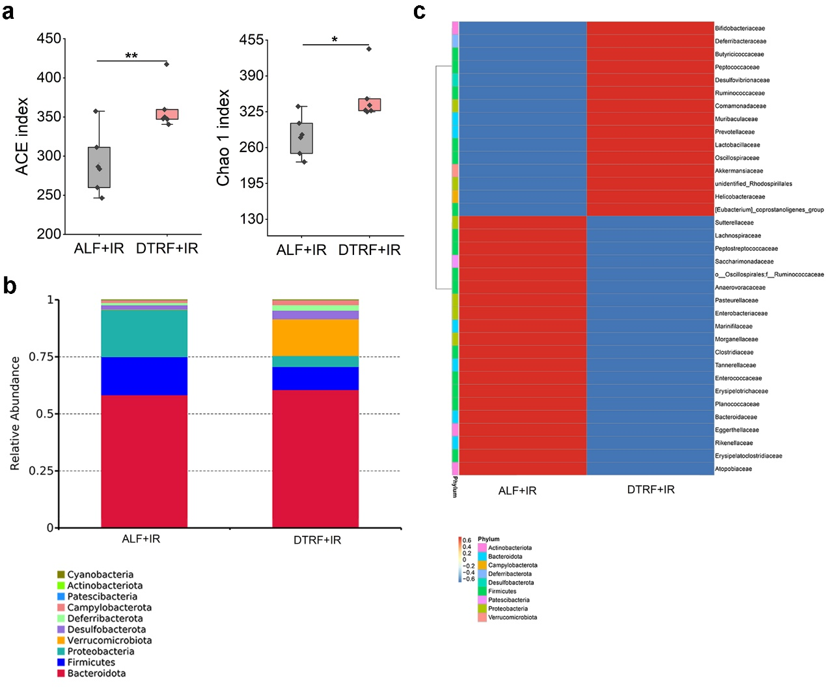
Fig.2. DTRF improves microbial diversity in irradiated mice. a, ACE and Chao 1 indices indicating the α diversity of mouse microbiota. *, P < 0.05; **, P < 0.01. b, Species abundance histogram showing the top 10 bacterial species at the phylum level. c, Clustering heat map showing the alteration of species after TAI and DTRF treatments.

Fig.3. Faecal Arg contents in mice subjected to ALF given B. pseudolongum. Probiotics supplementation (2×10⁸ CFU) was performed for 7 consecutive days before TAI, followed by the addition of B. pseudolongum for another 3 days. *, P < 0.05.

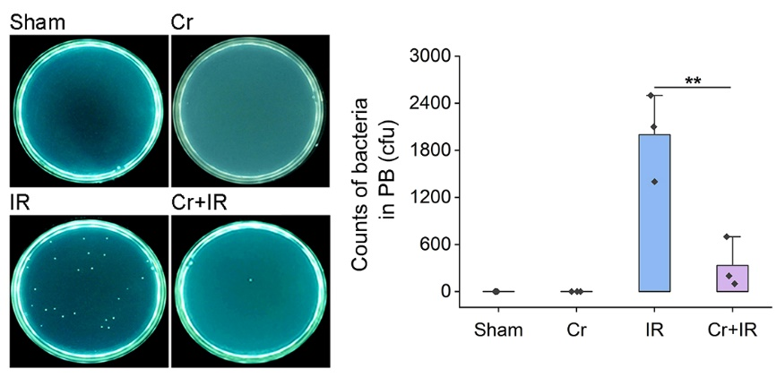
Fig.4. Bacterial counts in mice peripheral blood. Images are representative pictures showing the bacterial growth on culture plates. Statistical results are displayed in the histogram. **, P < 0.01.

Fig.5. Relative intensity of oxidized C11-BODIPY in IEC-6 cells. The ratio of the mean fluorescence intensity of oxidized probes to non-oxidized probes is calculated and shown in the boxplot. ***, P < 0.001.

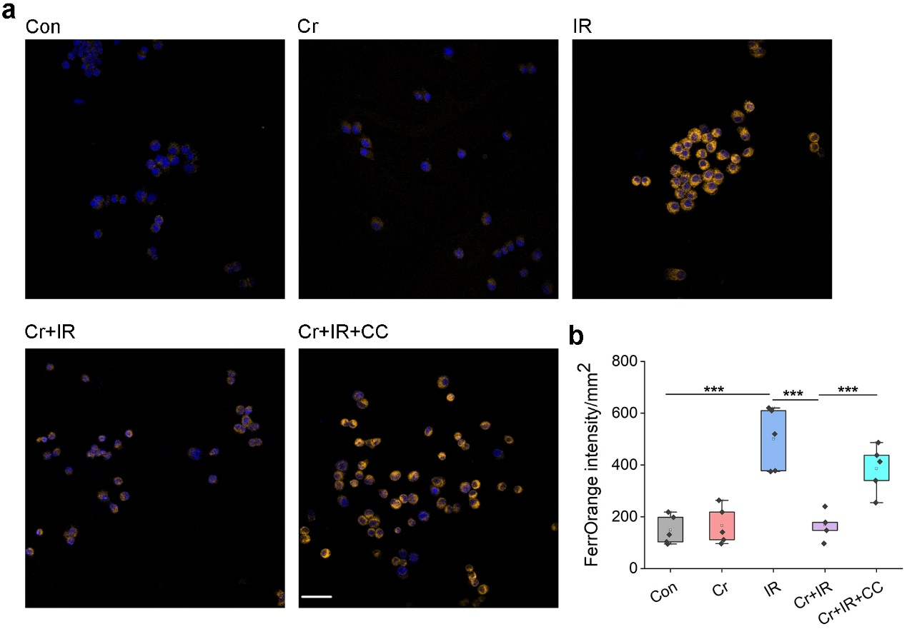
Fig.6. FerrOrange intensity in IEC-6 cells. a, Immunofluorescence microscopy reveals the Fe²⁺ accumulation (orange) in the cells. Nuclei are stained by DAPI (blue). Scale bar indicates 50 μm. b, FerrOrange intensity per square milimeter. Results are shown in the boxplot. ***, P < 0.001.

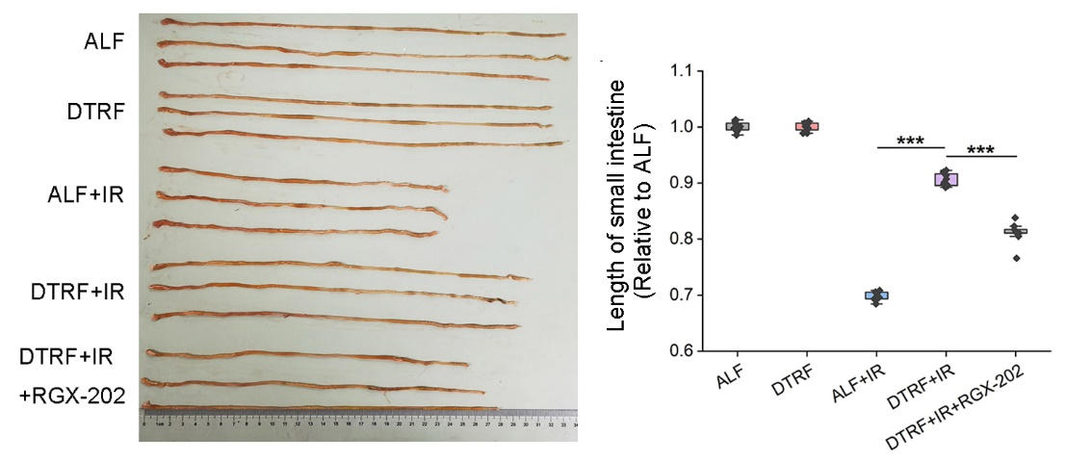
Fig.7. RGX-202 impairs the ability of DTRF to maintain the intestinal length after TAI. Representative photograph showing the small intestine shrinkage in mice after TAI. The measured length of the small intestine relative to ALF is shown in the boxplot. ***, P < 0.001. b, HE staining analysis on the ileal tissue of mice subjected to ALF. Scale indicates 100 μm. Number of crypts per millimeter in mice ileum is shown in the boxplot. ***, P < 0.001.

