Supporting Information
- Synthesis of C₁₄MC-MA-MCA terpolymers
1.1 Synthesis of tetradecyl methacrylate (C₁₄MC)
The C₁₄MC was synthesized by the reaction of methacrylic acid and 1-tetradecanol (a molar ratio 1.2:1), using toluene as solvent, hydroquinone as inhibitor, PTSA as catalyst, water was separated azeotropically using Dean-Stark apparatus. The synthesis routine was showed in Figure S1. After reacting at 130 ℃ for 5 hours, add 1mol/L NaOH, then wash with water in a separating funnel until neutral, and finally vacuum dry for 8 hours to obtain C₁₄MC.
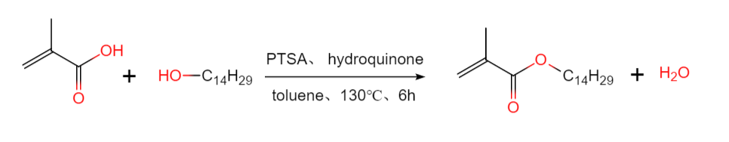
Figure S1. The synthesis routine of tetradecyl methacrylate
1.2. Synthesis of terpolymers
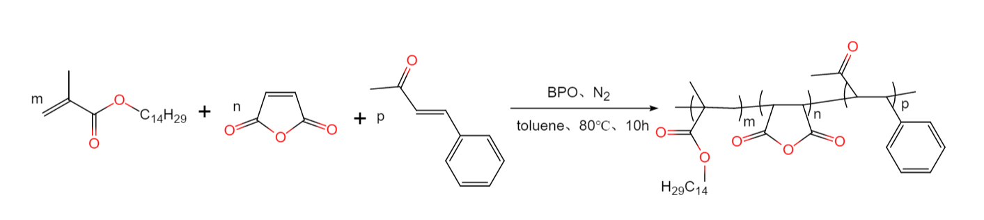
Figure S2. The synthesis routine of C₁₄MC-MA-MCA terpolymers
Terpolymers were synthesized by radical polymerization, the synthesis routine was showed in Figure S2. First, dissolve C14MC, MA, and MCA in toluene at a certain molar ratio, transfer the mixture to a two-neck bottle equipped with a condenser, and purge with nitrogen for 20 minutes before heating. When the temperature reaches 80°C, add BPO (BPO dissolved in toluene, 1wt% of the total mass of monomers) dropwise into the reaction mixture, and reflux for 10 h. Finally, when the reaction system is cooled to room temperature, it is washed with methanol several times until the solution is colorless, filtered to obtain a yellow or light yellow solid, and then vacuum dried for 10h. The resulting polymer is called C₁₄MC-MA-MCA(1:1:1)、C₁₄MC-MA-MCA(2:1:1)、C₁₄MC-MA-MCA(3:1:1)、C₁₄MC-MA-MCA(4:1:1)、C₁₄MC-MA-MCA(5:1:1)、C₁₄MC-MA-MCA(6:1:1).
2. Characterization of the chemical structures of the PPDs
2.1. Fourier Transform Infrared (FT-IR) Spectroscopy
The FT-IR spectra of the prepared monomer and terpolymers are shown in Figure S3. For C₁₄MC, the absorption peak at 1629 cm⁻¹ belongs to the characteristic absorption peak of C＝C, the expansion vibration of C＝O appears at 1722 cm⁻¹, the peak at 1380 and 1167 cm⁻¹ belongs to the －C－O－C－ in the ester, the absorption peak of the long chain alkyl (－[CH₂]_{n}－) appears at 715 cm⁻¹, and the absorption peak is not observed around 3400 cm⁻¹, indicating no impurities (－OH and －COOH) in C₁₄MC. For C₁₄MC-MA-MCA, copolymers show a single substitution peak of benzene in MCA at 744 cm⁻¹, C＝O absorption peak at 1722 cm⁻¹; C＝O and C－O characteristic absorption peak at 1787cm⁻¹ and 1250 cm⁻¹ in MA, 2858 and 2924 cm⁻¹ are characteristic absorption peaks of CH₃- and -CH₂-. There is no C=C stretching peak near 1629 cm⁻¹ in the spectrum of the C₁₄MC-MA-MCA sample, so the C₁₄MC-MA-MCA were successfully synthesized.
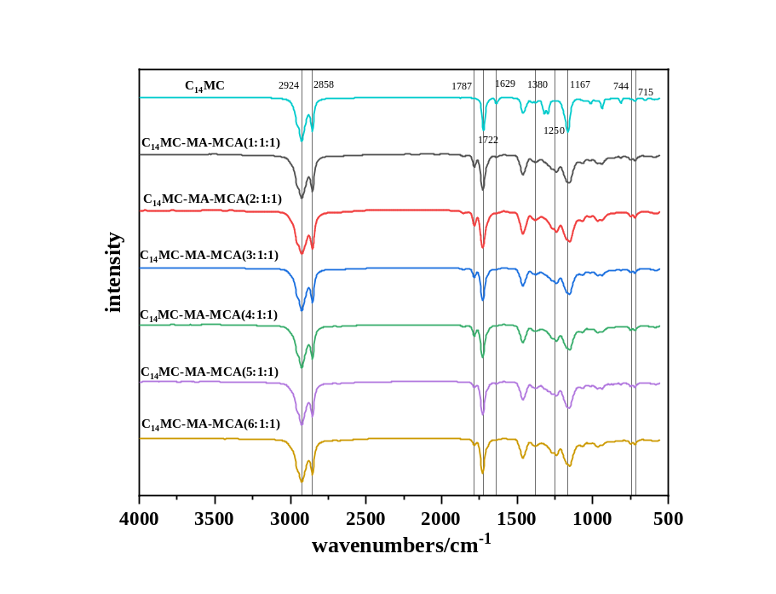
Figure S3. The FT-IR spectra of C₁₄MC and C₁₄MC-MA-MCA
2.2. Proton nuclear magnetic resonance (¹H NMR)
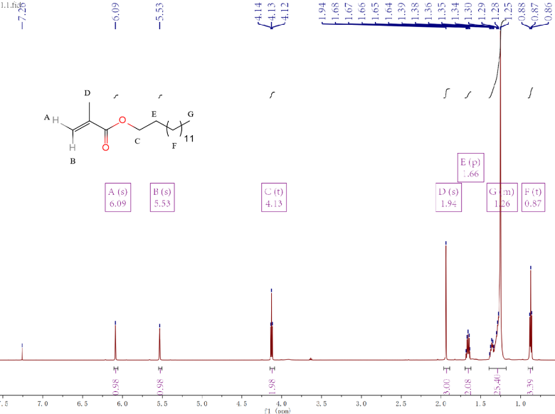
Figure S4. ¹H NMR spectra of C₁₄MC
The chemical structures of the prepared C₁₄MC were characterized by ¹H NMR analysis. The typical ¹H NMR spectra of the prepared monomer and terpolymers are presented in Figure S4. The peak at 7.2 ppm belongs to the solvent (CDCl₃), the peak at 5.53 and 6.09 ppm belongs to C=CH₂, the H of the methylene group adjacent to the oxygen atom shows a chemical shift of 4.13 ppm, the peak of -CH₃ on C=C shows a chemical shift of 1.94 ppm, and the H of the methylene adjacent to the methylene, which is adjacent to the oxygen atom of tetradecyl, is observed at a chemical shift of 1.66 ppm. Moreover, the H in the long-chain methylene bands exhibits a chemical shift of 1.25 ppm, and the chemical shifts for the methyl groups are ranged within 0.87 ppm. The proportion of these hydrogen is approximately consistent with the proportion of various types of hydrogen in C₁₄MC. These results indicate that C₁₄MC was synthesized successfully.
2.3. Gel permeation chromatography (GPC)
The molecular weight and polydispersity of C₁₄MC-MA-MCA were determined by Agilent PL-GPC50 gel permeation chromatography. The internal standard was styrene, the mobile phase was DCM, and the flow rate was 1 ml/min.
3. Measurements of compositions of diesel fuel
The composition of coal-based diesel was analyzed by Pegasus4D®/ 7890B full two-dimensional gas chromatography time-of-flight mass spectrometer (USA). The column was tro (50m×0.2mm×0.5μm) with initial column temperature of 60℃, heated for 1 min to 310 ℃ at 2 ℃/ min for 5 min. and carrier gas is helium gas with a flow rate of 1.0 ml/min.

