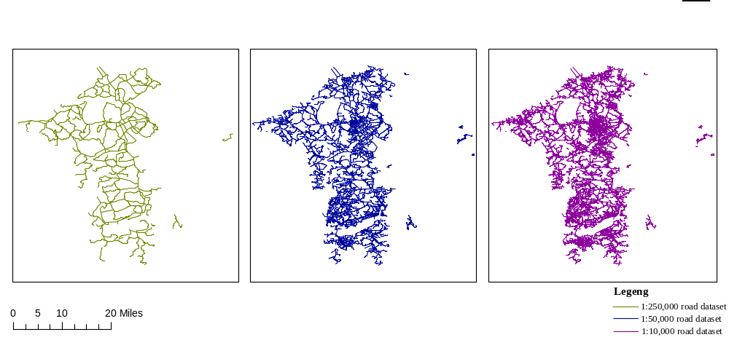
Fig. 1 Experimental data
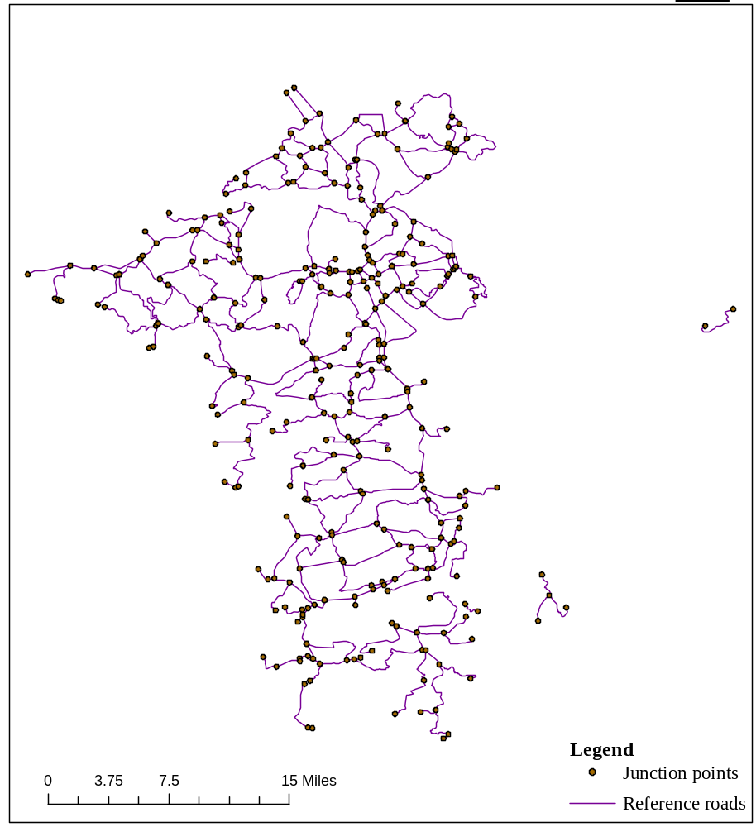
(a)Before extracting landmarks
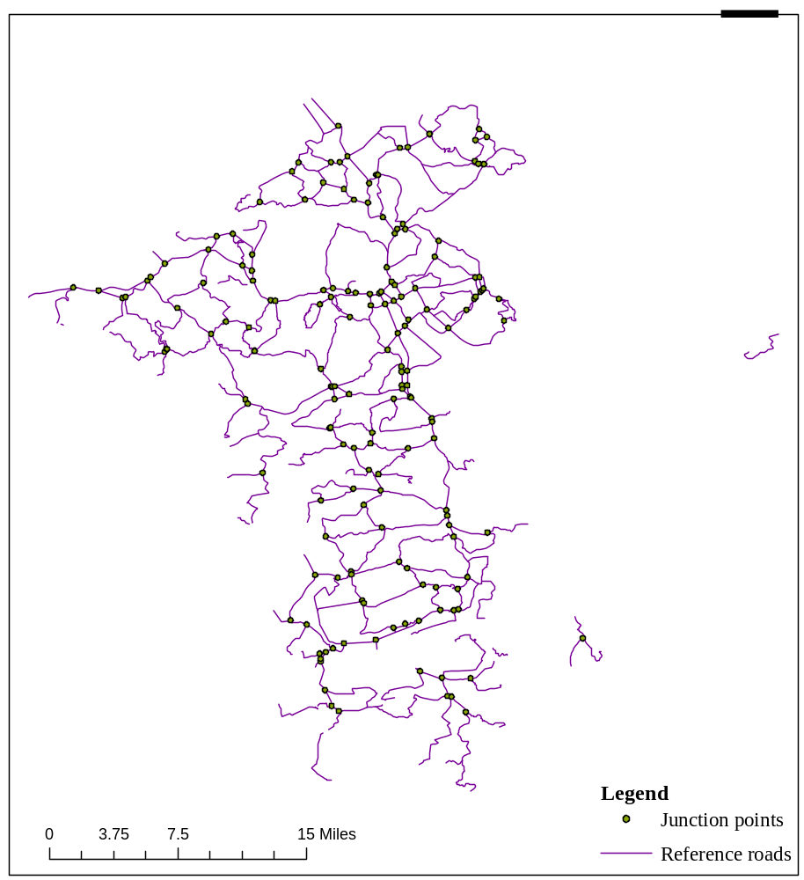
(b)After extracting the landmarks
Fig. 2 Changes in the number of intersections before and after extracting landmarks from a 1:250000 road dataset

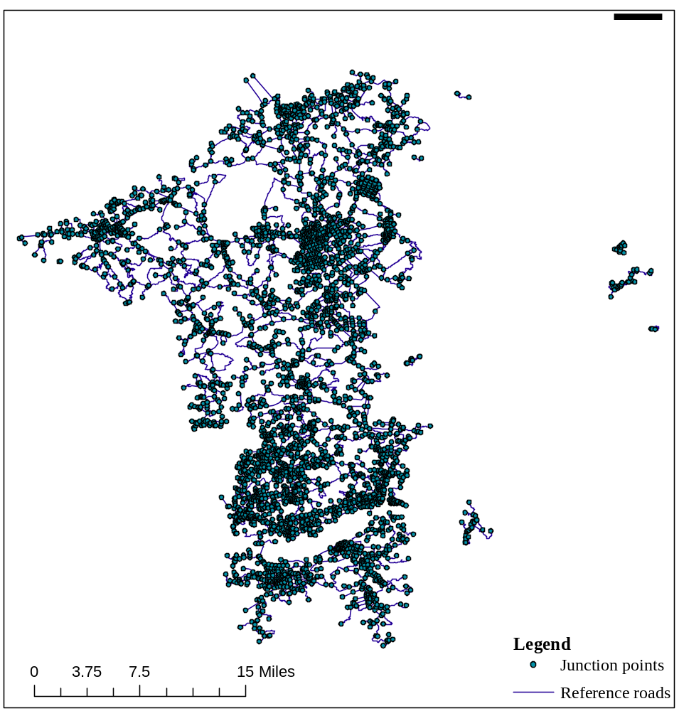
(a)Before extracting landmarks
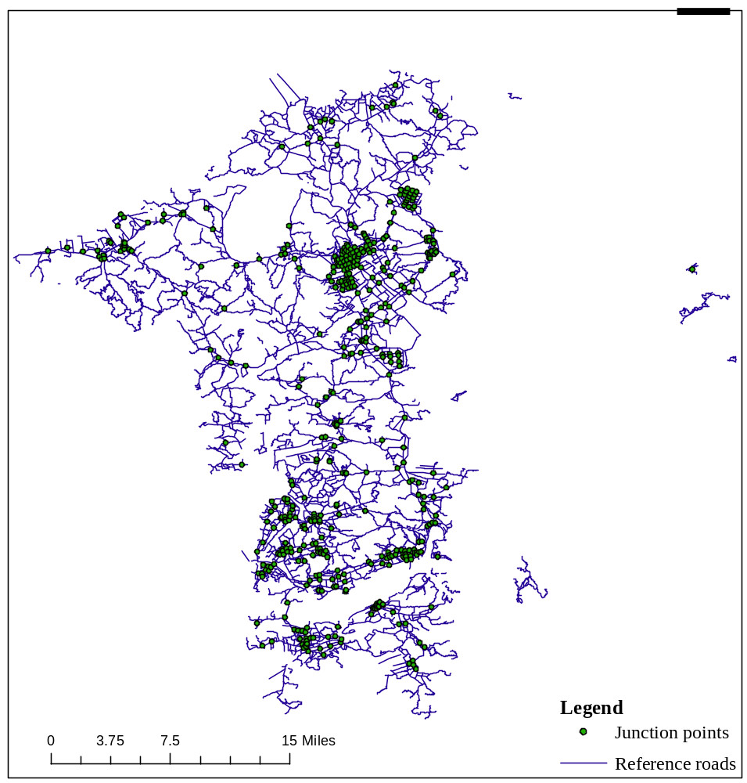
(b)After extracting the landmarks
Fig. 3 Changes in the number of intersections before and after extracting landmarks from a 1:50000 scale road dataset

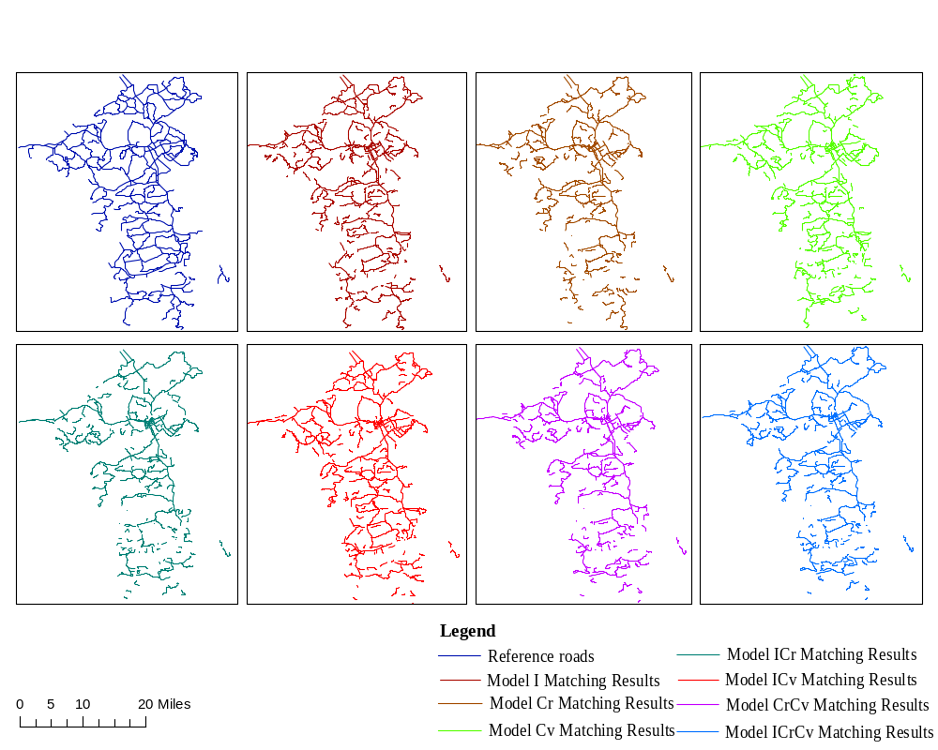
Fig. 4 Reference roads and experimental results of 7 models in Group A

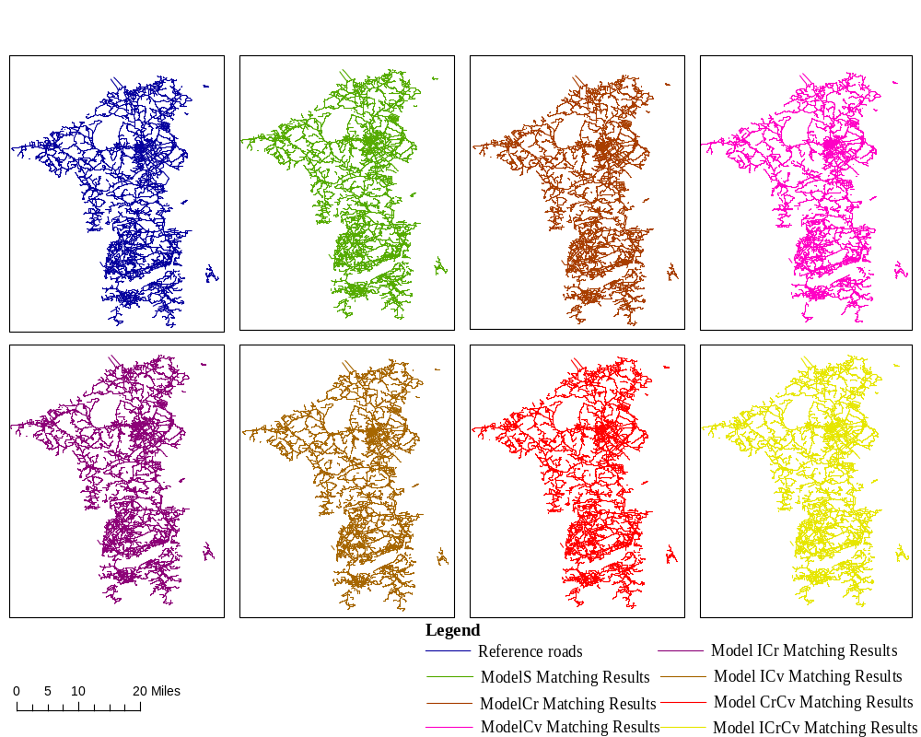
Fig. 5 Reference roads and experimental results of 7 models in Group B
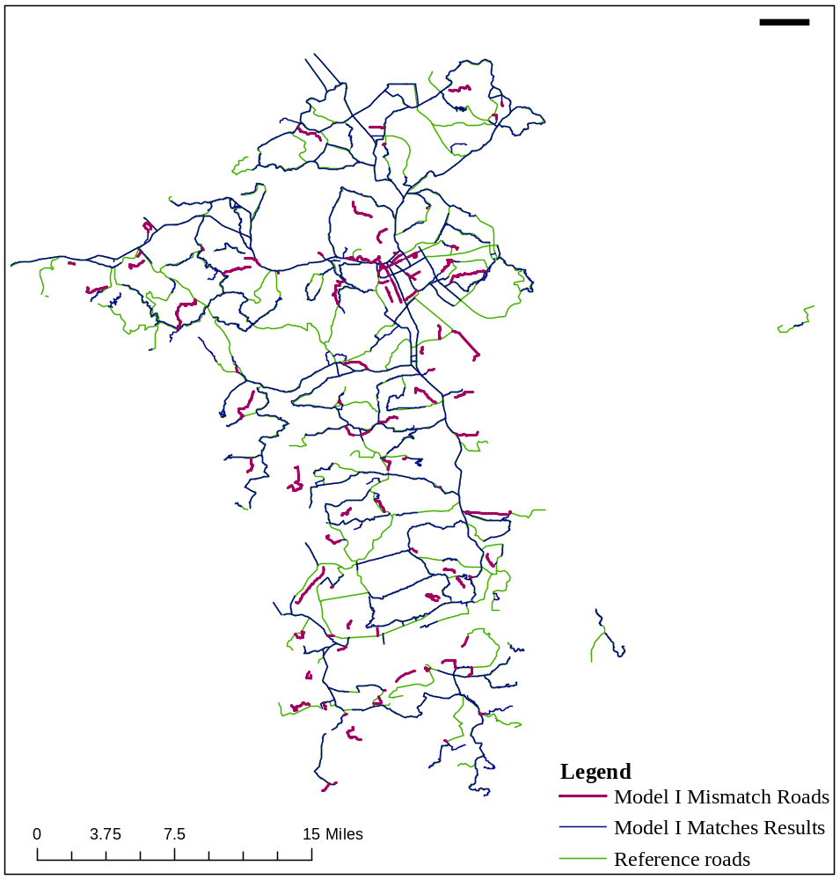
(a)Overlay of Model I matching results with 1:250,000 reference roads
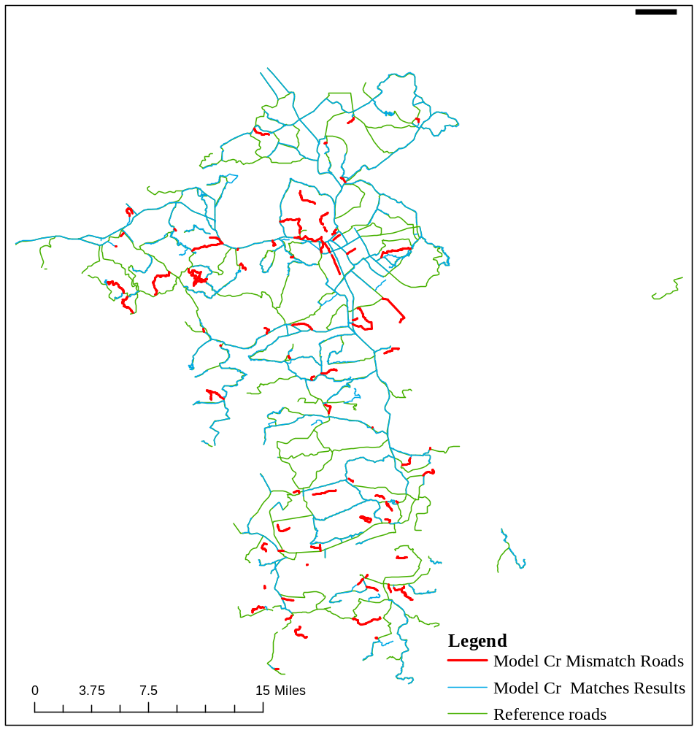
(b)Overlay of model Cr matching results with 1:250,000 reference roads
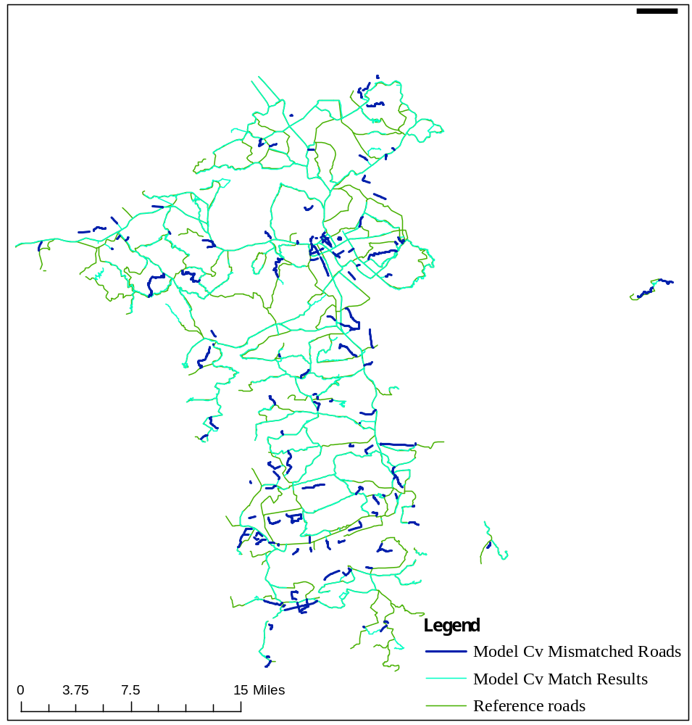
(c)Overlay of model Cv matching results with 1:250,000 reference roads
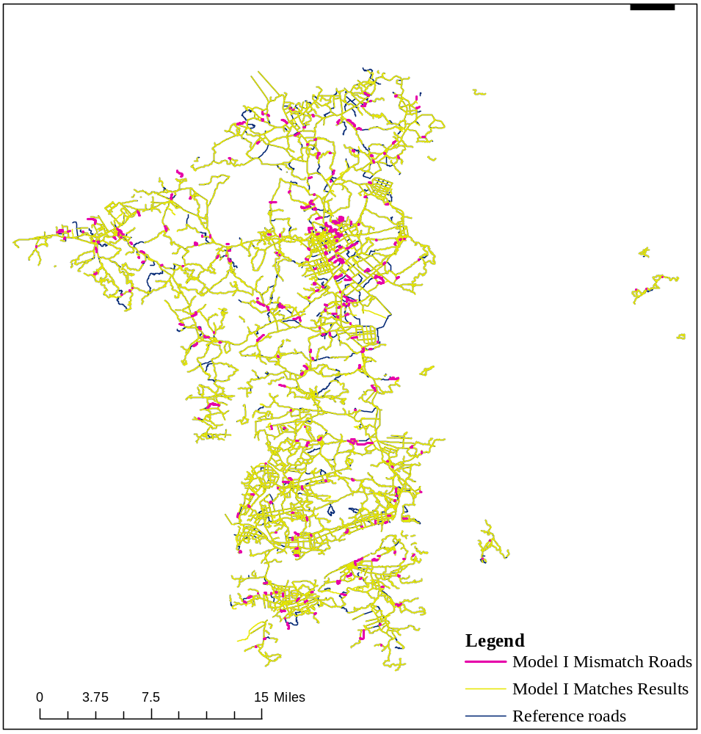
(d)Overlay of Model I matching results with 1:50,000 reference roads

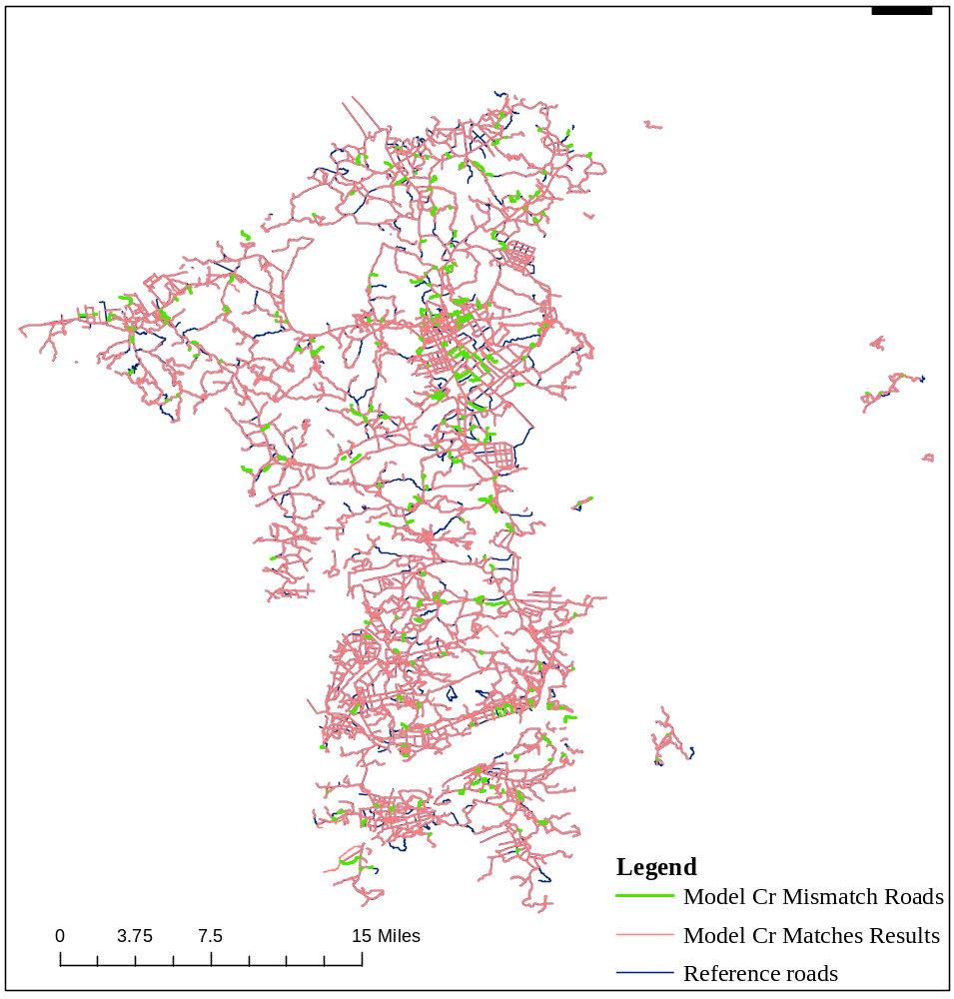
(e)Overlay of model Cr matching results with 1:50,000 reference roads
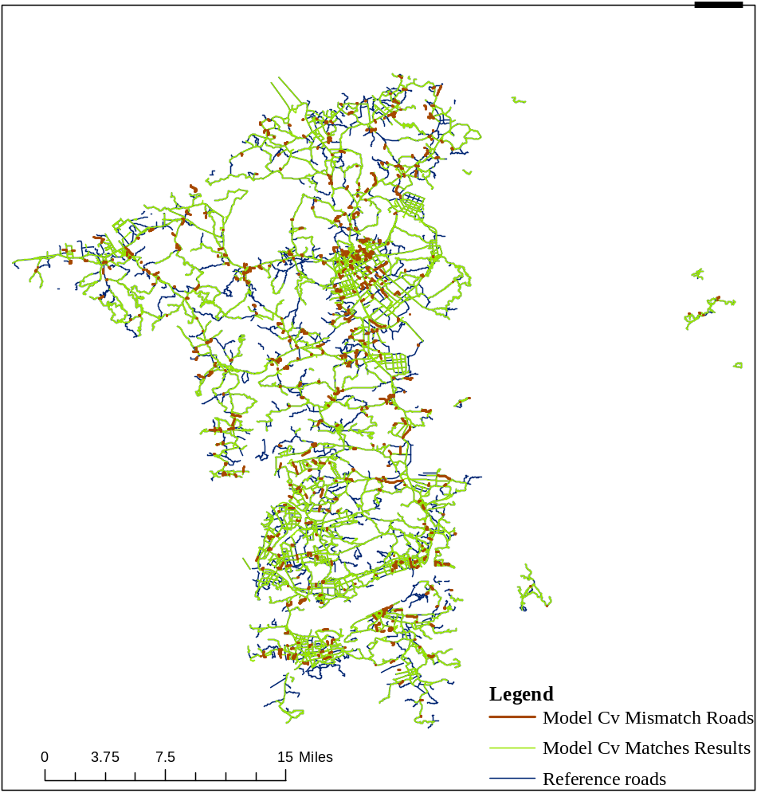
(f)Overlay of model Cv matching results with 1:50,000 reference roads
Fig. 6 Distribution of Matching Results of Models I, Cr, and Cv in Groups A and B

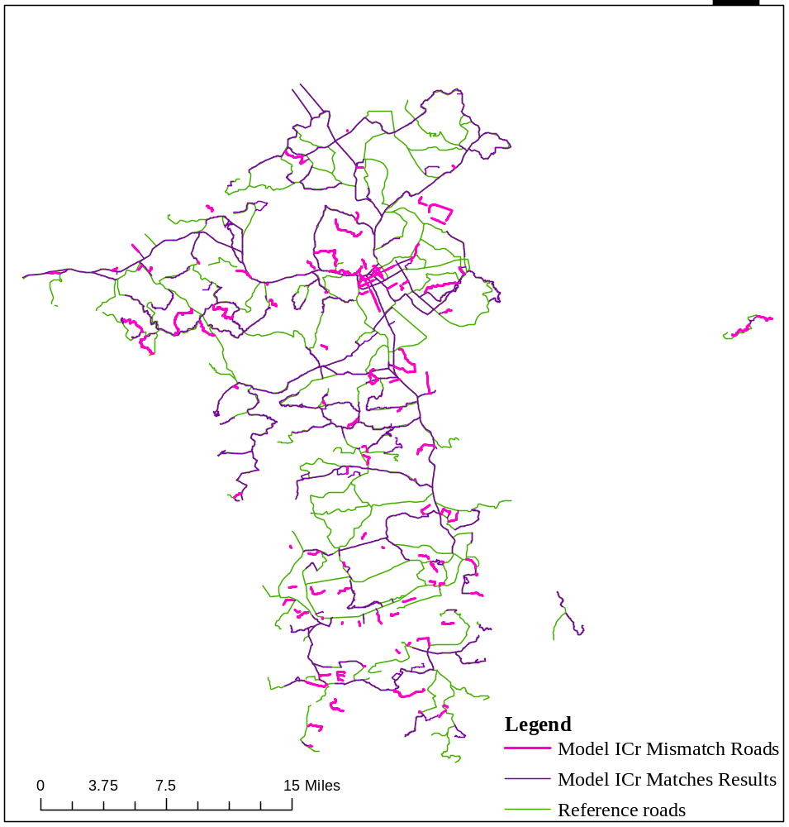
(a)Overlay of model ICr matching results with 1:250,000 reference roads
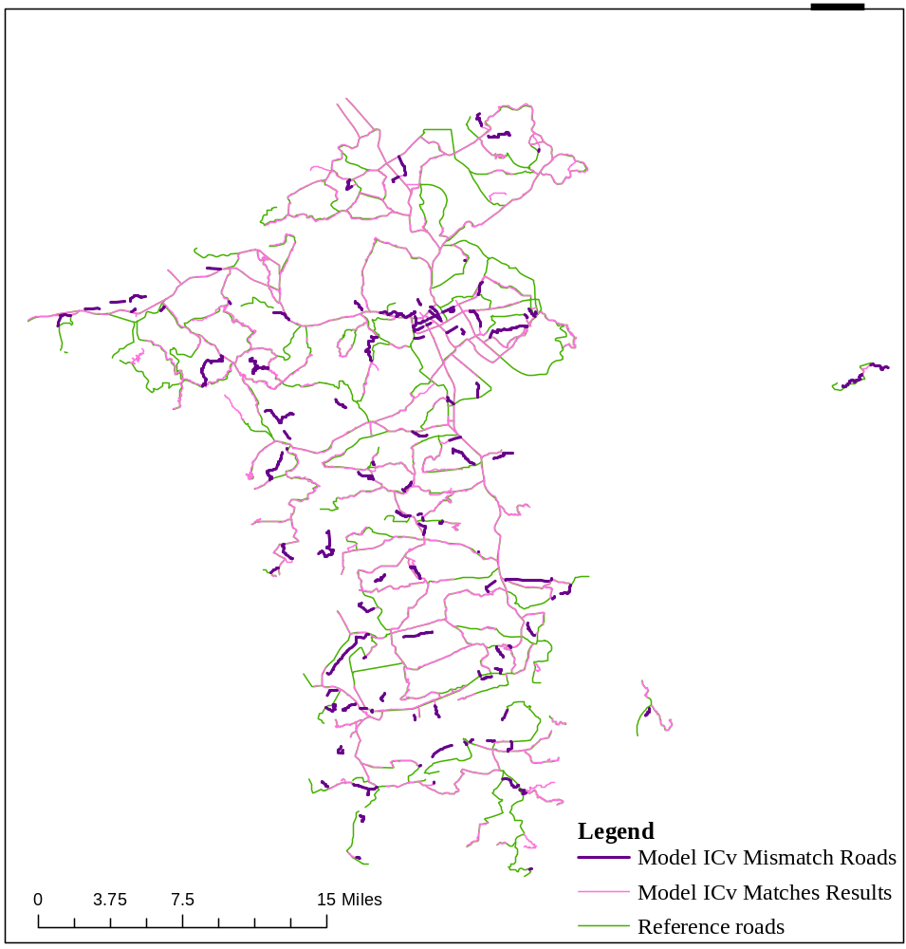
(b)Overlay of model ICv matching results with 1:250,000 reference roads
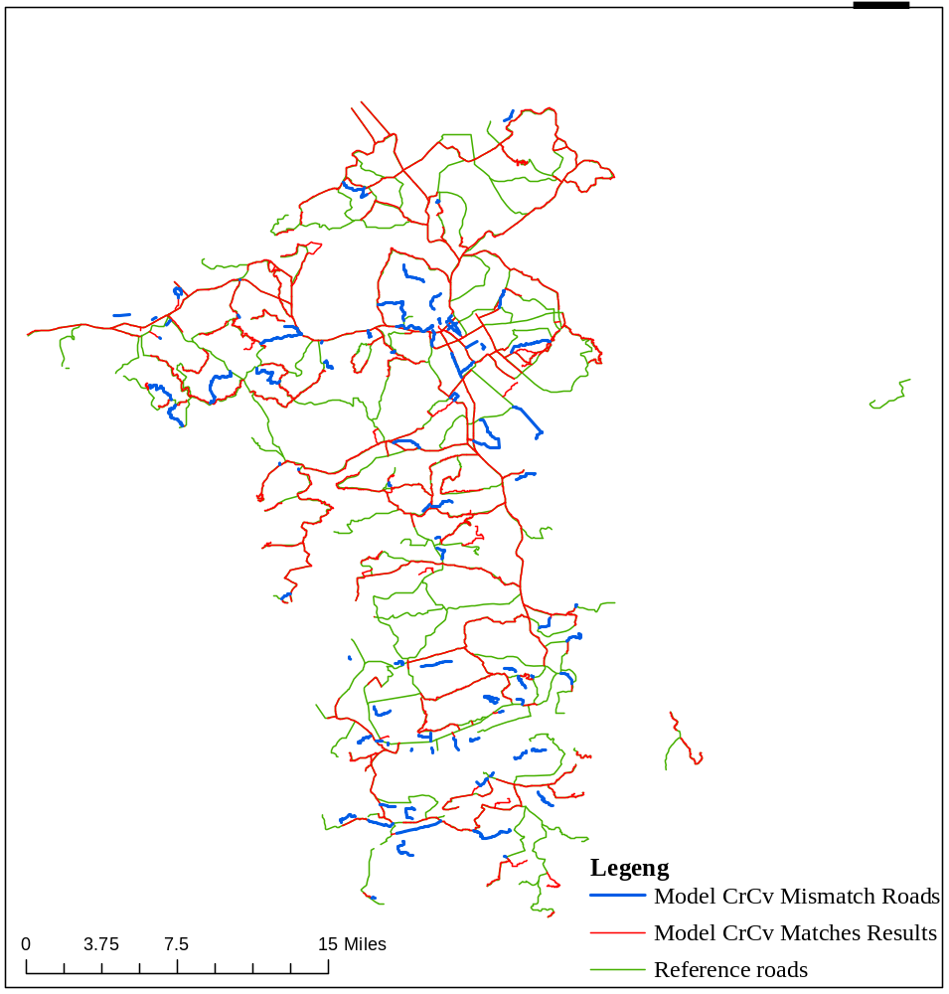
(c)Overlay of model CrCv matching results with 1:250,000 reference roads
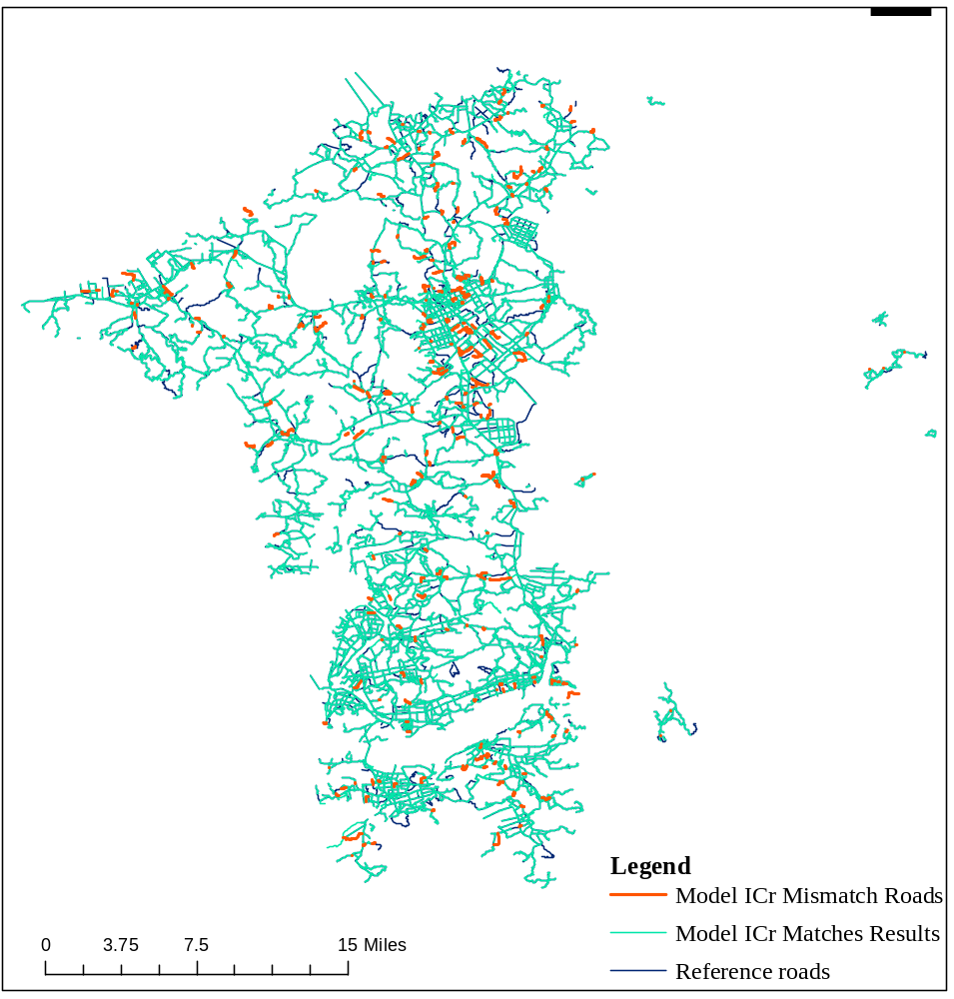
(d)Overlay of model ICr matching results with 1:50,000 reference roads
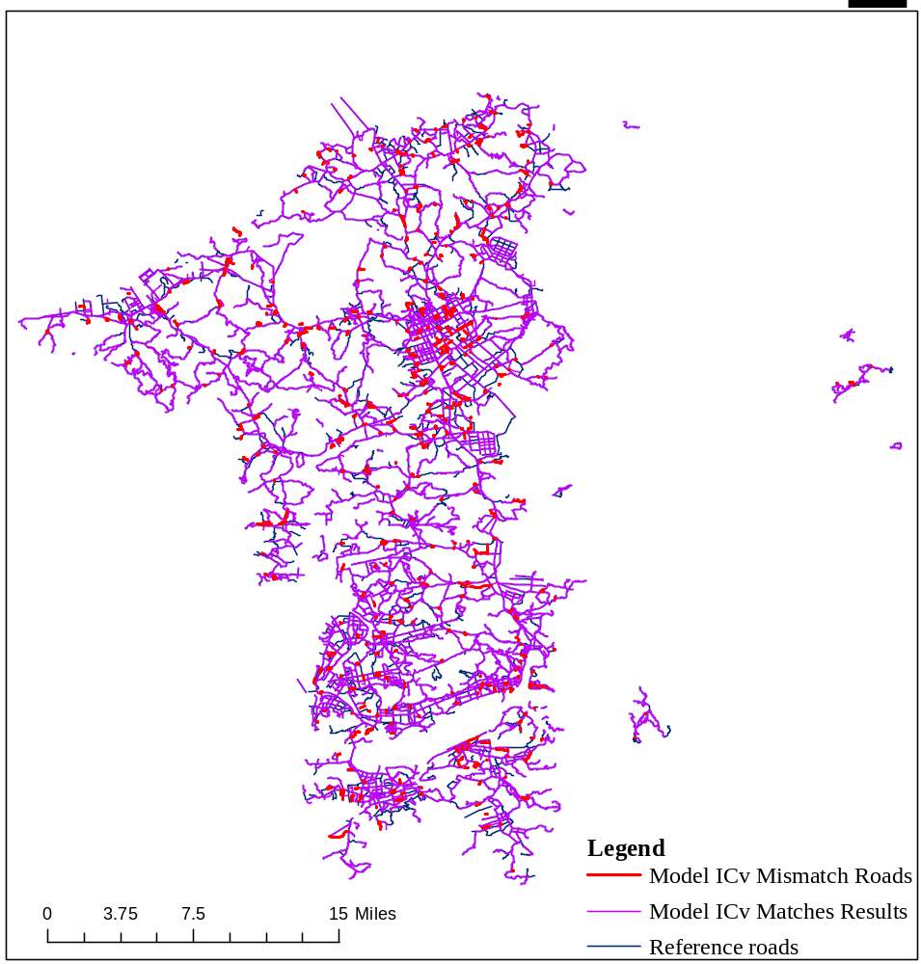
(e)Overlay of model ICv matching results with 1:50,000 reference roads
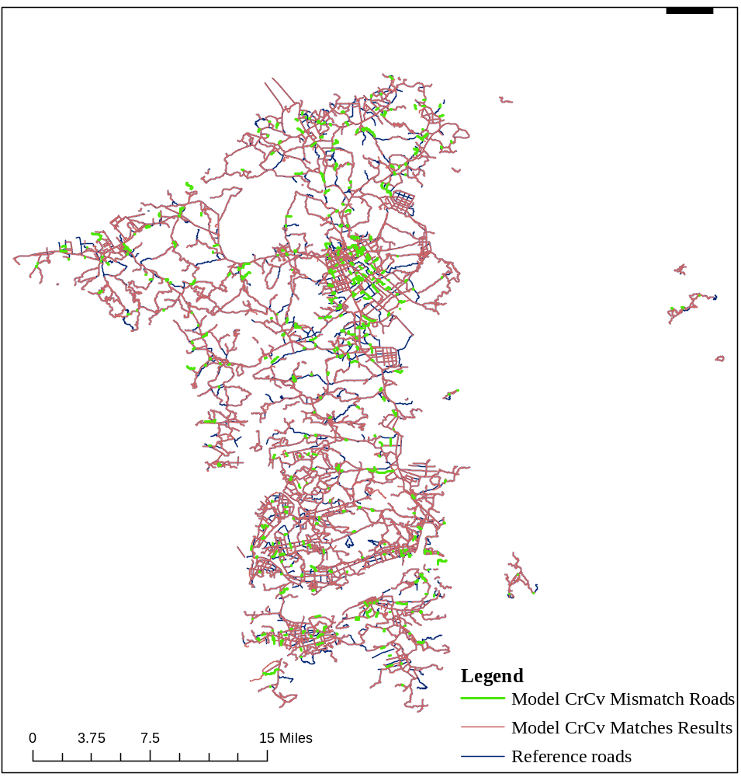
(f)Overlay of model CrCv matching results with 1:50,000 reference roads
Fig. 7 The distribution of matching results of models ICr, ICv, and CrCv in groups A and B

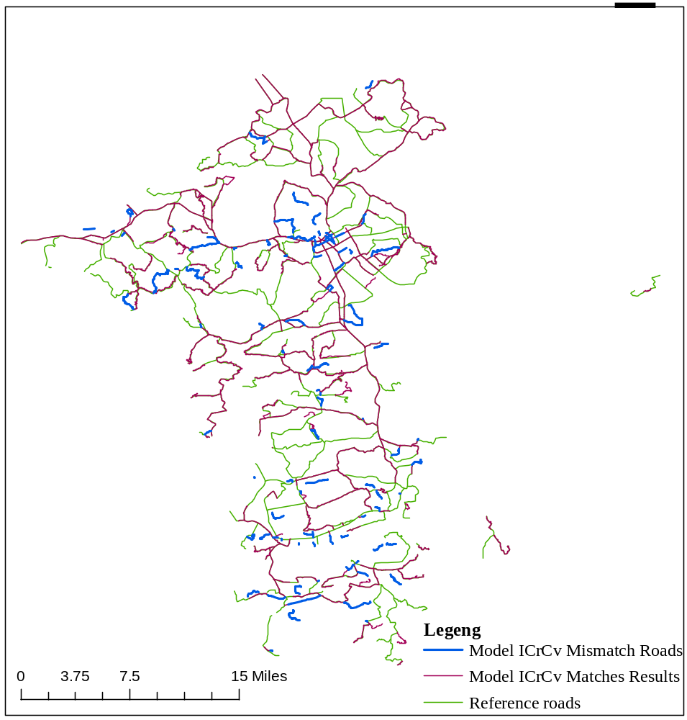
(a)Overlay of model ICrCv matching results with 1:250,000 reference roads

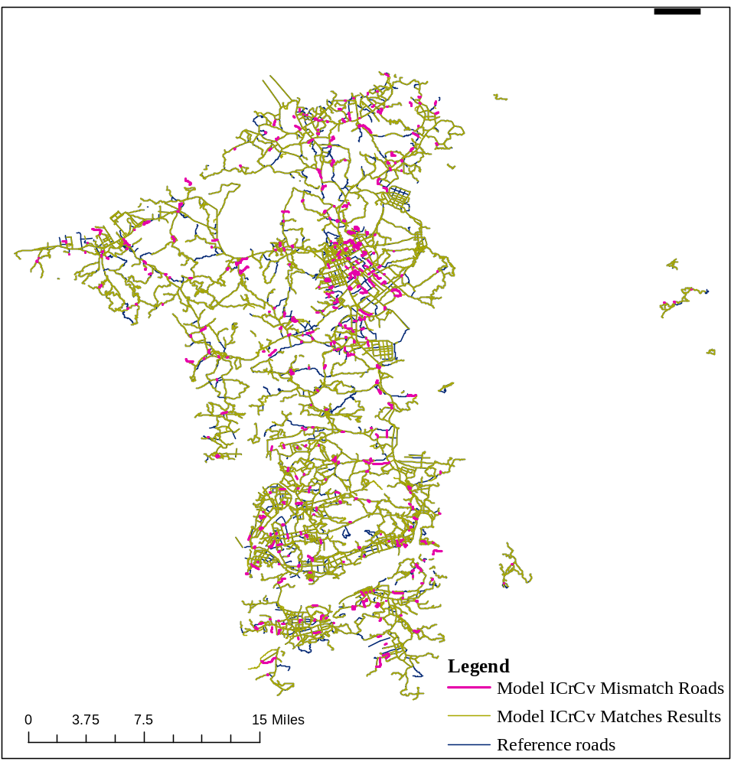
(b)Overlay of model ICrCv matching results with 1:50,000 reference roads
Fig. 8 Mismatched road distribution of model ICrCv on target datasets of 1:50000 and 1:10000

