Supplementary Information
Observation of exciton-vibron coupling in cold dense nitrogen
Binbin Wu, Li Lei*, Jingyi Liu, Yu Tao
Institute of Atomic and Molecular Physics, Sichuan University, Chengdu 610065, People’s Republic of China
*Electronic mail: lei@scu.edu.cn (L. Lei)

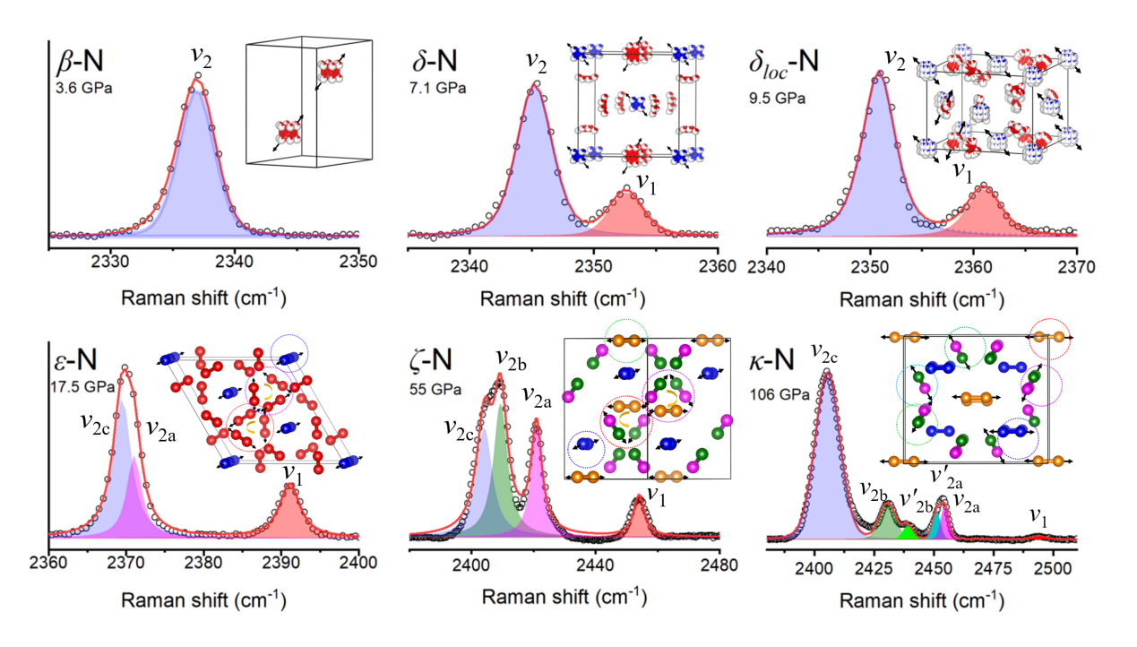
Figure S1. The typical Raman spectra and corresponding vibron modes for solid nitrogen phases.

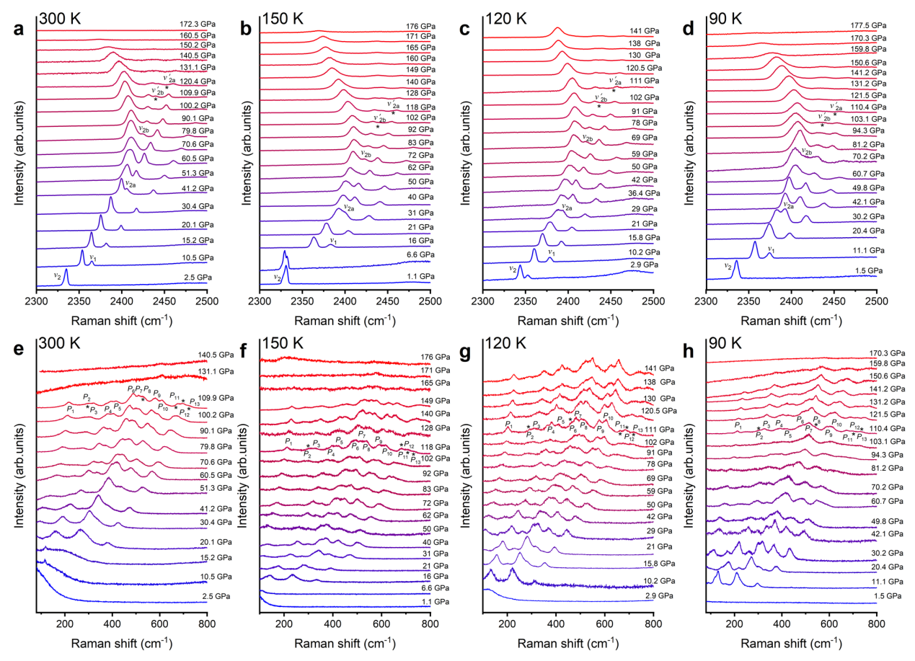
Figure S2 a~d. Gradual evolution of the high-frequency vibron modes ν₁, ν_{2a,} ν′_{2a,} ν_{2b}, ν′_{2b} and ν_{2c} at varying isothermal-compression paths at 300, 150, 120 and 90 K. As the pressure increases, new phonon modes gradually appear, existing modes shift, and splitting of modes may occur due to structural changes during phase transitions. e~h. Gradual evolution of the low-frequency phonon modes (P₁~P₁₃) under different pressures at 300, 150, 120 and 90 K. With pressure, it shifts to higher wavenumbers.

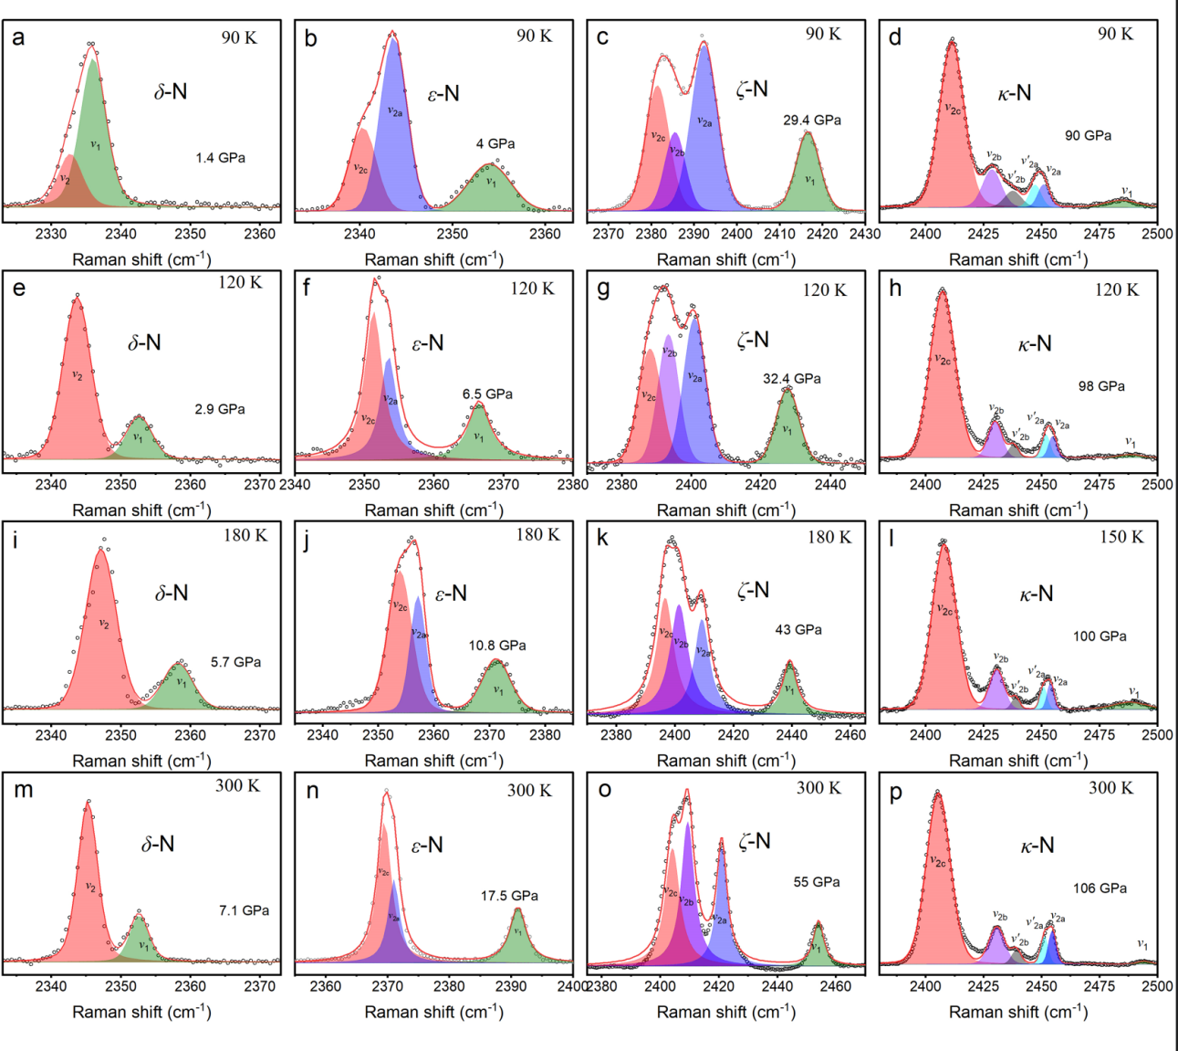
Figure S3. Lorentzian fits for the ν₁, ν_{2a,} ν′_{2a,} ν_{2b}, ν′_{2b} and ν_{2c} modes at different pressures in isothermal-compression pathways. (a, e, i, m), (b, f, j, n), (c, g, k, o) and (d, h, l, p) Lorentzian fits for the ν₁, ν_{2a,} ν_{2b} and ν_{2c} modes at different pressures at 90 K,120 K, 180 K/150 K and 300 K, respectively.

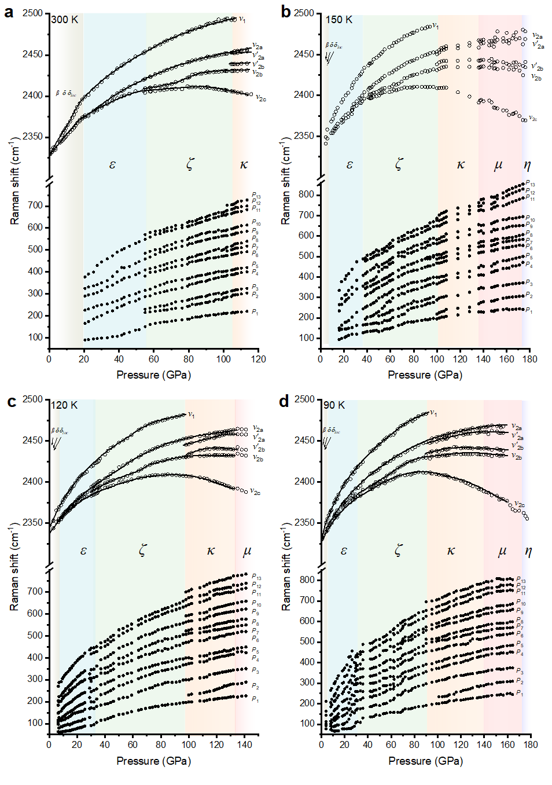
Figure S4. Evolution of vibrational and lattice modes of solid molecular nitrogen at different temperatures as pressure increases. The βδδ_{loc} transition lines is omitted due to the small transition pressure range.
Table S1. Phase transition pressure of nitrogen under different isothermal compression pathways.
Phase  transition | Path I  (300 K) | Path II  (180 K) | Path III  (150 K) | Path IV  (120 K) | Path V  (90 K) | Path VI  (87 K)
β→ δ | 3.5 | - | - | - | - | -
δ→ δ_{loc} | 10.5 | - | - | - | - | -
δ_{loc} → ε | 17.5 | 10.8 | - | 6.5 | 4.0 | -
ε→ ζ | 55.0 | 43.0 | 38.5 | 32.4 | 29.4 | -
ζ→ κ | 106.3 | - | 100.0 | 98.0 | 90.0 | -
κ→ μ | - | - | 130.0 | 135.0 | 150.0 | 153.0
κ→ η | 160.0 | - | 174.0 | - | 177.0 | 176.0

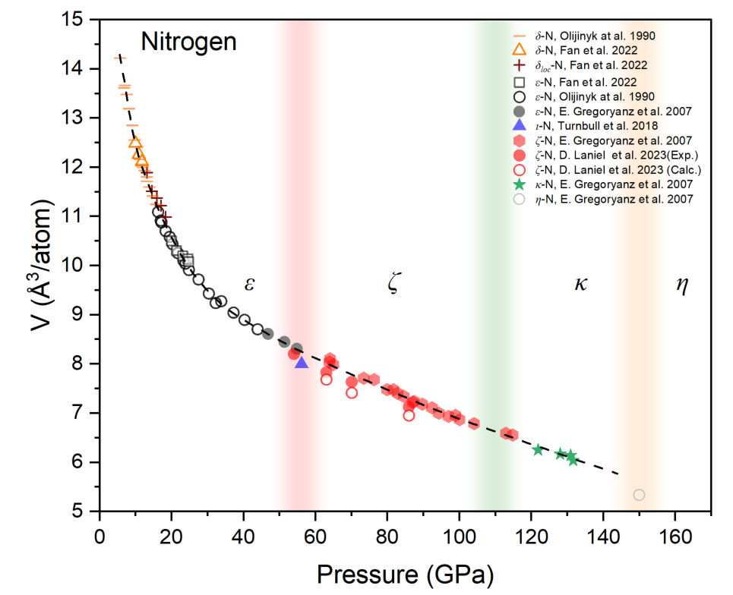
Figure S5. The pressure dependence of the volume of nitrogen.

