Supplemental Tables

Tag ID | Mean Daily Distance Traveled (m/day) | Home Range (m) | First Day Tracked | Last Day Tracked | Days Tracked
14 | NA | NA | 2022-05-31 | 2022-05-31 | 0
16 | NA | NA | 2021-06-24 | 2021-06-24 | 0
41 | 0 | 0 | 2022-08-03 | 2022-11-15 | 104
56 | NA | NA | 2022-08-03 | 2022-08-03 | 0
58 | NA | NA | 2022-08-03 | 2022-08-03 | 0
70 | 0 | 0 | 2022-08-10 | 2022-10-04 | 55
37 | 0 | 0.2 | 2021-06-23 | 2021-07-06 | 13
50 | 0.1 | 0.4 | 2022-08-03 | 2022-08-10 | 7
48 | 0 | 0.7 | 2022-08-02 | 2022-11-01 | 91
26 | 0.3 | 1.1 | 2021-06-25 | 2021-06-29 | 4
49 | 0.2 | 1.4 | 2022-08-03 | 2022-08-17 | 14
35 | 0.2 | 2.2 | 2021-06-24 | 2021-07-07 | 13
19 | 0.5 | 2.3 | 2021-06-24 | 2021-06-29 | 5
17 | 0.1 | 3.4 | 2021-06-24 | 2021-09-18 | 86
39 | 0.2 | 3.5 | 2021-06-22 | 2021-07-28 | 36
46 | 0.1 | 3.6 | 2022-08-02 | 2022-11-01 | 91
31 | 0.6 | 4 | 2021-06-22 | 2021-06-29 | 7
21 | 0.1 | 5.7 | 2021-06-23 | 2021-09-18 | 87
30 | 0.5 | 6.2 | 2021-06-23 | 2021-07-06 | 13
44 | 0.2 | 6.4 | 2022-08-02 | 2022-11-01 | 91
69 | 0.2 | 7.5 | 2022-08-04 | 2022-11-16 | 104
22 | 0.4 | 7.6 | 2021-06-22 | 2021-07-18 | 26
52 | 0 | 7.8 | 2022-08-03 | 2022-11-15 | 104
23 | 0.6 | 8.7 | 2021-06-22 | 2021-07-28 | 36
18 | 0.4 | 9.7 | 2021-06-23 | 2021-09-04 | 73
36 | 0.3 | 11.8 | 2021-06-23 | 2021-09-18 | 87
47 | 0.6 | 12.9 | 2022-08-04 | 2022-11-16 | 104
12 | 1 | 17.1 | 2021-06-22 | 2021-07-19 | 27
55 | 1.2 | 18.4 | 2022-08-01 | 2022-08-16 | 15
51 | 0.8 | 20.5 | 2022-08-03 | 2022-11-15 | 104
20 | 1.7 | 22.5 | 2021-06-23 | 2021-07-27 | 34
40 | 2.2 | 22.5 | 2021-06-23 | 2021-08-12 | 50
15 | 0.9 | 24.3 | 2021-06-23 | 2021-09-04 | 73
53 | 1.2 | 25.4 | 2022-08-03 | 2022-10-03 | 61
68 | 0.2 | 25.6 | 2022-08-10 | 2022-11-01 | 83
62 | 1 | 30.6 | 2022-08-04 | 2022-11-15 | 103
11 | 2.3 | 31 | 2021-06-22 | 2021-07-06 | 14
64 | 0.3 | 53.2 | 2022-08-04 | 2022-11-16 | 104
57 | 1.8 | 60.6 | 2022-06-01 | 2022-07-05 | 34
29 | 13.5 | 67.7 | 2021-06-24 | 2021-06-29 | 5
54 | 2.1 | 73.7 | 2022-08-03 | 2022-11-15 | 104
66 | 5.8 | 74.4 | 2022-08-04 | 2022-08-17 | 13
25 | 2.3 | 75.4 | 2021-06-23 | 2021-09-18 | 87
45 | 1 | 85.6 | 2022-08-02 | 2022-11-02 | 92
42 | 2.6 | 92.7 | 2022-08-02 | 2022-11-01 | 91
65 | 0.5 | 100.5 | 2022-08-10 | 2022-11-16 | 98
24 | 7.7 | 202.3 | 2021-06-23 | 2021-07-28 | 35
27 | 22.6 | 227 | 2021-06-24 | 2021-07-06 | 12
38 | 19.8 | 227.8 | 2021-06-22 | 2021-07-06 | 14
60 | 7 | 236.8 | 2022-06-01 | 2022-07-05 | 34
61 | 21.5 | 300.3 | 2022-08-04 | 2022-08-17 | 13
33 | 12 | 305.5 | 2021-06-23 | 2021-09-18 | 87
32 | 90.5 | 452.6 | 2021-06-24 | 2021-06-29 | 5
34 | 15.3 | 638.9 | 2021-06-25 | 2021-09-18 | 85
28 | 25.3 | 721.4 | 2021-06-24 | 2021-07-27 | 33
13 | 16.3 | 938.3 | 2021-06-23 | 2021-09-18 | 87

Supplemental Table 1. Summary of the tracking period and movements of each tracked individual across both sampling years

Date | Year | Site | Sample Type | Drift weight concentration (mg/m³)
2021-07-20 | 2021 | 2 | Aquatic | 0.00359
2021-07-20 | 2021 | 2 | Terrestrial | 0.000809
2021-07-19 | 2021 | 3 | Aquatic | 0.00373
2021-07-19 | 2021 | 3 | Terrestrial | 0.00469
2021-07-19 | 2021 | 4 | Aquatic | 0.00286
2021-07-19 | 2021 | 4 | Terrestrial | 0.00175
2021-07-19 | 2021 | 5 | Aquatic | 0.000271
2021-07-19 | 2021 | 5 | Terrestrial | 0.00107
2021-07-19 | 2021 | 6 | Aquatic | 0.0332
2021-07-19 | 2021 | 6 | Terrestrial | 0.00252
2021-07-20 | 2021 | 7 | Aquatic | 0.0076
2021-07-20 | 2021 | 7 | Terrestrial | 0.000585
2021-08-18 | 2021 | 2 | Aquatic | 0.00367
2021-08-18 | 2021 | 2 | Terrestrial | 0.00329
2021-08-18 | 2021 | 3 | Aquatic | 0.000647
2021-08-18 | 2021 | 3 | Terrestrial | 0.0187
2021-08-19 | 2021 | 5 | Aquatic | 0.00119
2021-08-19 | 2021 | 5 | Terrestrial | 0.00231
2021-08-19 | 2021 | 6 | Aquatic | 0.00199
2021-08-19 | 2021 | 6 | Terrestrial | 0.00147
2021-08-18 | 2021 | 7 | Aquatic | 0.0000779
2021-08-18 | 2021 | 7 | Terrestrial | 0.0104
2021-09-04 | 2021 | 2 | Aquatic | 0.00000418
2021-09-04 | 2021 | 2 | Terrestrial | 0
2021-09-05 | 2021 | 3 | Aquatic | 0.0104
2021-09-05 | 2021 | 3 | Terrestrial | 0.0171
2021-09-05 | 2021 | 5 | Aquatic | 0.00148
2021-09-05 | 2021 | 5 | Terrestrial | 0.00377
2021-09-05 | 2021 | 6 | Aquatic | 0.172
2021-09-05 | 2021 | 6 | Terrestrial | 0
2021-09-04 | 2021 | 7 | Aquatic | 0.000389
2021-09-04 | 2021 | 7 | Terrestrial | 0
2022-08-16 | 2022 | 2 | Aquatic | 0.0194
2022-08-16 | 2022 | 2 | Terrestrial | 0
2022-08-16 | 2022 | 3 | Aquatic | 0.0000138
2022-08-16 | 2022 | 3 | Terrestrial | 0.0163
2022-08-16 | 2022 | 4 | Aquatic | 0.00559
2022-08-16 | 2022 | 4 | Terrestrial | 0.0358
2022-08-17 | 2022 | 5 | Aquatic | 0.0143
2022-08-17 | 2022 | 5 | Terrestrial | 0
2022-08-17 | 2022 | 6 | Aquatic | 0.000726
2022-08-17 | 2022 | 6 | Terrestrial | 0.00809
2022-08-17 | 2022 | 7 | Aquatic | 0.00539
2022-08-17 | 2022 | 7 | Terrestrial | 0.000643
2022-09-07 | 2022 | 2 | Aquatic | 0.0109
2022-09-07 | 2022 | 2 | Terrestrial | 0.013
2022-09-07 | 2022 | 3 | Aquatic | 0.00446
2022-09-07 | 2022 | 3 | Terrestrial | 0.0116
2022-09-07 | 2022 | 6 | Aquatic | 0.000484
2022-09-07 | 2022 | 6 | Terrestrial | 0
2022-09-07 | 2022 | 7 | Aquatic | 0.0136
2022-09-07 | 2022 | 7 | Terrestrial | 0
2022-11-01 | 2022 | 2 | Aquatic | 0.00317
2022-11-01 | 2022 | 2 | Terrestrial | 0.00438
2022-11-01 | 2022 | 3 | Aquatic | 0.000847
2022-11-01 | 2022 | 3 | Terrestrial | 0

Supplemental Table 2. Aquatic and terrestrial invertebrate drift dry weight concentrations (mg/m³) at each site.

Date Tagged | Tag ID | Fork Length (mm) | Weight (g) | Latitude | Longitude | River Meters
2021-06-22 | 11 | 127 | 23 | 41.53177 | -118.99426 | 7855.4
2021-06-22 | 12 | 127 | 22.9 | 41.52709 | -118.98565 | 9040.3
2021-06-23 | 13 | 190 | 58.5 | 41.50296 | -118.97895 | 11982.8
2022-05-31 | 14 | 138 | 33.6 | 41.53986 | -119.00307 | 6440.5
2021-06-23 | 15 | 135 | 29.6 | 41.50293 | -118.97897 | 11985.3
2021-06-24 | 16 | 158 | 46.1 | 41.51601 | -118.95726 | 12433.2
2021-06-24 | 17 | 138 | 30.4 | 41.51586 | -118.95721 | 12454.4
2021-06-23 | 18 | 177 | 57.1 | 41.50279 | -118.97889 | 12002.4
2021-06-24 | 19 | 128 | 23.3 | 41.51348 | -118.95605 | 12735.4
2021-06-23 | 20 | 128 | 24.7 | 41.54155 | -119.00477 | 6239.3
2021-06-23 | 21 | 204 | 90.8 | 41.51203 | -118.98547 | 10808.2
2021-06-22 | 22 | 234 | 140.3 | 41.53192 | -118.99353 | 7943.2
2021-06-22 | 23 | 140 | 30.5 | 41.53289 | -118.99067 | 8225.4
2021-06-23 | 24 | 214 | 115.1 | 41.51197 | -118.9854 | 10817.4
2021-06-23 | 25 | 225 | 118.7 | 41.54155 | -119.00477 | 6239.3
2021-06-25 | 26 | 241 | 153.3 | 41.53737 | -119.00085 | 6843.5
2021-06-24 | 27 | 168 | 53.8 | 41.53241 | -118.98883 | 8403.3
2021-06-24 | 28 | 197 | 80.7 | 41.53256 | -118.98864 | 8423.5
2021-06-24 | 29 | 121 | 17.3 | 41.51708 | -118.95756 | 12310.7
2021-06-23 | 30 | 199 | 87.6 | 41.54308 | -119.00681 | 6010.9
2021-06-22 | 31 | 228 | 129.9 | 41.52522 | -118.98525 | 9249.4
2021-06-24 | 32 | 148 | 36.2 | 41.51342 | -118.95597 | 12744.5
2021-06-23 | 33 | 142 | 32.1 | 41.54324 | -119.00706 | 5984.8
2021-06-25 | 34 | 178 | 60.7 | 41.53731 | -119.00082 | 6837.6
2021-06-24 | 35 | 116 | 16 | 41.51746 | -118.95763 | 12268.5
2021-06-23 | 36 | 216 | 113.5 | 41.54308 | -119.00681 | 6010.9
2021-06-23 | 37 | 122 | 19.9 | 41.54324 | -119.00706 | 5984.8
2021-06-22 | 38 | 152 | 39 | 41.53277 | -118.99035 | 8257.1
2021-06-22 | 39 | 164 | 48.8 | 41.53197 | -118.99322 | 7968.2
2021-06-23 | 40 | 128 | 22.7 | 41.54155 | -119.00477 | 6239.3
2022-08-03 | 41 | 161 | 52 | 41.51381 | -118.95628 | 12694.3
2022-08-02 | 42 | 152 | 37 | 41.53218 | -118.99313 | 7989.1
2022-08-02 | 44 | 134 | 26 | 41.53283 | -118.99219 | 8095.8
2022-08-02 | 45 | 137 | 28.5 | 41.53008 | -118.98788 | 8642.8
2022-08-02 | 46 | 167 | 51 | 41.53287 | -118.9922 | 8095.9
2022-08-04 | 47 | 129 | 22.5 | 41.50418 | -118.97974 | 11834.6
2022-08-02 | 48 | 129 | 23 | 41.53286 | -118.99223 | 8093.2
2022-08-03 | 49 | 187 | 66 | 41.52299 | -118.9852 | 9501
2022-08-03 | 50 | 193 | 84 | 41.52287 | -118.98519 | 9513.6
2022-08-03 | 51 | 130 | 25 | 41.51608 | -118.95731 | 12426.2
2022-08-03 | 52 | 125 | 19 | 41.51715 | -118.9578 | 12302.9
2022-08-03 | 53 | 160 | 46 | 41.52288 | -118.98522 | 9511.5
2022-08-03 | 54 | 133 | 26.5 | 41.5131 | -118.95384 | 12855.6
2022-08-01 | 55 | 130 | 26 | 41.54139 | -119.00491 | 6239.3
2022-08-03 | 56 | 154 | 41.5 | 41.52327 | -118.98535 | 9467
2022-06-01 | 57 | 173 | 59.6 | 41.52526 | -118.98524 | 9245.5
2022-08-03 | 58 | 157 | 41 | 41.52298 | -118.98524 | 9500.6
2022-06-01 | 60 | 127 | 19.8 | 41.51205 | -118.98548 | 10805.9
2022-08-04 | 61 | 187 | 77 | 41.50504 | -118.98016 | 11727.2
2022-08-04 | 62 | 180 | 64 | 41.50285 | -118.97881 | 11998.6
2022-08-04 | 64 | 157 | 42 | 41.50506 | -118.98015 | 11725
2022-08-10 | 65 | 142 | 32 | 41.50869 | -118.98214 | 11288.3
2022-08-04 | 66 | 131 | 29.5 | 41.50385 | -118.97979 | 11861.6
2022-08-10 | 68 | 209 | 94 | 41.5432 | -119.00722 | 5973.4
2022-08-04 | 69 | 157 | 42.5 | 41.50401 | -118.97966 | 11854.2
2022-08-10 | 70 | 142 | 33 | 41.50869 | -118.98214 | 11288.3

Supplemental Table 3. Locations of initial capture, date of capture, tag ID, fork length, and weight of all tagged LCT from this study.

Supplemental Figures

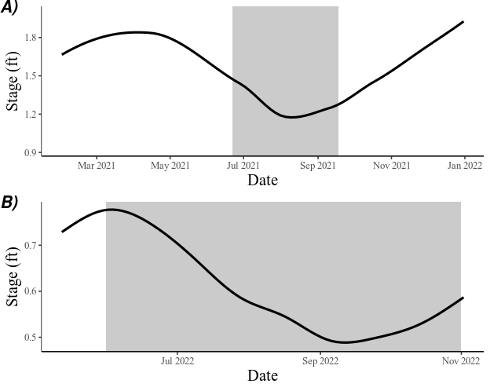
Supplemental Figure 1. Stage measurements for (A) the 2021 sampling period collected from the lower Mahogany Creek and (B) the 2022 sampling period collected from a HOBO Level Logger at Site 7. Absolute baseflow occurred on August 17th and September 9th in (A) 2021 and (B) 2022, respectively. The shaded region represents the LCT tracking period.

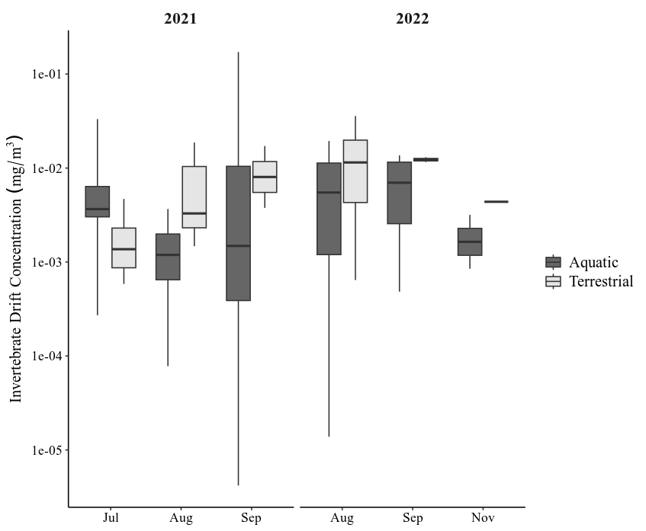
Supplemental Figure 2. Box and whisker plot of terrestrial and aquatic invertebrate drift concentrations (mg/m³) obtained from drift net samples collected at all hydrologic sites in both study years. Boxes display the interquartile range, and whiskers show the 95% range. The Y-axis has been log-transformed. In months with more samples, greater variability in invertebrate drift concentrations was observed for both aquatic and terrestrial invertebrates.
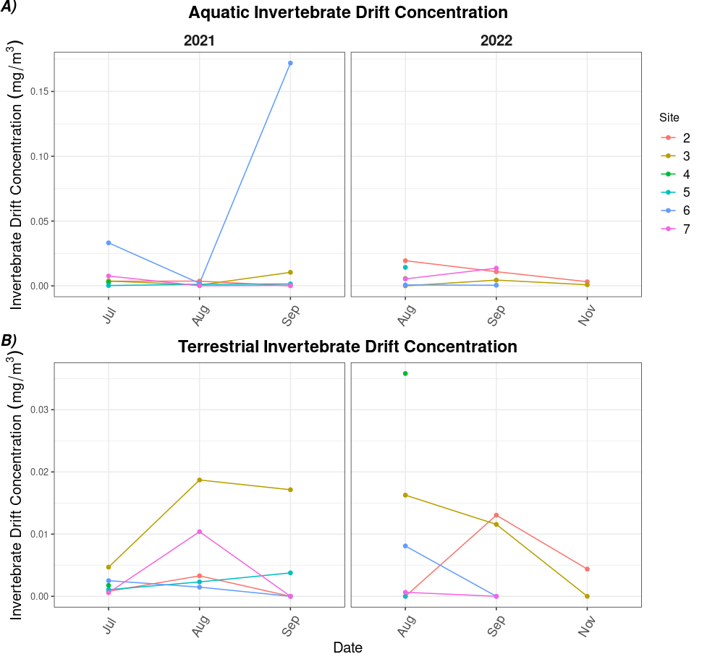
Supplemental Figure 3. (A) Aquatic and (B) terrestrial drifting invertebrate concentrations collected from sites 2 through 7 during the duration of our study. Site 1 was excluded because there were no fish associated with this location throughout the entire study. In 2021, the aquatic invertebrate concentration at Site 6 was much greater than the other values because a single large stonefly drifted into the net. This value was not redacted, as invertebrate drift is highly stochastic by nature, and excluding this value would ignore this principle of “flashy” food subsidies.

