Supplementary
eAppendix 1. The search terms and search strategies
eAppendix 2. Study characteristics of included RCTs
eAppendix 3. Risk of bias of eligible studies
eAppendix 4. Treatment effects in children (aged 6−11 years)
eAppendix 5. Treatment effects in adolescents/adults
eAppendix 6. Formulas for data conversion
eAppendix 7. Grading the evidence of the network meta-analysis using CINeMA

eAppendix 1. The search terms and search strategies
- Medline via PubMed
Domain(s) | Search number | Query
Patients
P1 (Disease) | #1 | "Asthma"[Mesh]
 | #2 | "wheez*"
 | #3 | "bronchial spasm"
 | #4 | "bronchial constriction"
 | #5 | "bronchial hyperreactivity"
 | #6 | "bronchoconstric*"
 | #7 | "respiratory hypersensitivity"
 | #8 | #1 OR #2 OR #3 OR #4OR #5 OR #6 OR #7
P2 (Severity) | #9 | "mild"
 | #10 | "intermittent"
 | #11 | #9 OR #10
P in summary | #12 | #8 AND #11
Interventions & comparators
ICS/LABA | #13 | "Budesonide, Formoterol Fumarate Drug Combination"[Mesh]
 | #14 | "Symbicort"
 | #15 | "Flutiform"
 | #16 | "Foster"
 | #17 | "Zenhale"
 | #18 | "Relvar"
 | #19 | fluticasone furoate-vilanterol trifenatate
 | #20 | "Mometasone Furoate, Formoterol Fumarate Drug Combination"[Mesh]
 | #21 | #13 OR #14 OR #15 OR #16 OR #17 OR#18 OR #19 OR #20
ICS | #22 | "Glucocorticoids"[Mesh]
 | #23 | "budesonide*"
Domain(s) | Search number | Query
 | #24 | "beclometasone*"
 | #25 | "fluticasone*"
 | #26 | "ciclesonide*"
 | #27 | "betamethasone*"
 | #28 | "mometasone*"
 | #29 | #22 OR #23 OR #24 OR #25 OR #26 OR#27 OR #28
 | #30 | "inhal*"
 | #31 | #30 AND #31
SABA or FABA | #32 | "Albuterol"[Mesh]
 | #33 | "bitolterol"
 | #34 | "carbuterol"
 | #35 | "fenoterol"
 | #36 | "isoetharine"
 | #37 | "bronkometer"
 | #38 | "pirbuterol"
 | #39 | "maxair"
 | #40 | "reproterol"
 | #41 | "rimiterol"
 | #42 | "salbutamol"
 | #43 | "Ventolin"
 | #44 | "levosalbutamol"
 | #45 | "terbutaline"
 | #46 | "brethine"
 | #47 | "bricanyl"
 | #48 | "brethaire"
 | #49 | "tulobuterol"
 | #50 | "metaproterenol"
 | #51 | "saba"
 | #52 | "Formoterol Fumarate"[Mesh]
 | #53 | "eformoterol"
 | #54 | "atimos"
 | #55 | "foradil"
 | #56 | "oxis"
 | #57 | #32 OR #33 OR #34 OR #35 OR #36 OR #37 OR #38 OR #39 OR #40 OR #41 OR #42 OR #43 OR #44 OR #45 OR #46 OR #47 OR #48 OR #49 OR #50 OR #51 OR #52 OR #53 OR #54 OR #55 OR #56
LTRA | #58 | "Leukotriene Antagonists"[Mesh]
 | #59 | "montelukast"
 | #60 | "Singulair"
 | #61 | "zafirlukast"
 | #62 | "Accolate"
 | #63 | "pranlukast"
 | #64 | "antileukotriene*"
 | #65 | #58 OR #59 OR #60 OR #61 OR #62 OR #63 OR #64
I and C in summary | #66 | #21 OR #31 OR #57 OR #65
RCTs | #67 | "randomized controlled trial"
 | #68 | "randomized trial"
Domain(s) | Search number | Query
 | #69 | "clinical trial"
 | #70 | "controlled trial"
 | #71 | "randomized clinical study"
 | #72 | "randomised controlled trial"
 | #73 | "randomised trial"
 | #74 | "randomised clinical study"
S in summary | #75 | #67 OR #68 OR #69 OR #70 OR #71 OR #72 OR #73 OR #74
Outcomes | #76 | "exacerbation"
 | #77 | "asthma attack"
 | #78 | "asthmatic attack"
 | #79 | "hospitalization"
 | #80 | "admission"
 | #81 | "emergency visit"
 | #82 | "urgent visit"
 | #83 | "unscheduled visit"
 | #84 | "unplanned visit"
 | #85 | "asthma control"
 | #86 | "asthma symptom"
 | #87 | "quality of life"
 | #88 | "rescue medication"
 | #89 | "rescue inhaler"
 | #90 | "systemic steroid*"
 | #91 | "peak expiratory flow*"
 | #92 | "exhaled nitric oxide"
 | #93 | "eosinophil*"
 | #94 | "adverse events"
 | #95 | "adverse effects"
O in summary | #96 | #76 OR #77 OR #78 OR #79 OR #80 OR #81 OR #82 OR #83 OR #84 OR #85 OR #86 OR #87 OR #88 OR #89 OR #90 OR #91 OR #91 OR #93 OR #94 OR #95
P, I/C, S, and O | #97 | #12 AND #66 AND #75 AND #96

b) Scopus
Domain(s) | Search number | Query
Patients | #1 | TITLE-ABS-KEY (asthma)
P1 Disease | #2 | TITLE-ABS-KEY (wheezing)
 | #3 | TITLE-ABS-KEY (bronchospasm)
 | #4 | TITLE-ABS-KEY (bronchoconstriction)
 | #5 | TITLE-ABS-KEY ("bronchial hyperreactivity")
 | #6 | TITLE-ABS-KEY ("respiratory hypersensitivity")
 | #7 | #1 OR #2 OR #3 OR #4OR #5 OR #6
P2 (Severity) | #8 | TITLE-ABS-KEY (mild)
 | #9 | TITLE-ABS-KEY (intermittent)
 | #10 | #8 OR #9
P in summary | #11 | #7 AND #10
Domain(s) | Search number | Query
Interventions & comparators
ICS/LABA | #10 | TITLE-ABS-KEY (Symbicort)
 | #11 | TITLE-ABS-KEY (flutiform)
 | #12 | TITLE-ABS-KEY (foster)
 | #13 | TITLE-ABS-KEY (zenhale)
 | #14 | TITLE-ABS-KEY ("fluticasone plus vilanterol")
 | #15 | TITLE-ABS-KEY (relvar)
 | #16 | TITLE-ABS-KEY ("budesonide and formoterol")
 | #17 | TITLE-ABS-KEY ("mometasone plus formoterol")
 | #18 | #10 OR #11 OR #12 OR #13 OR #14 OR #15 OR #16 OR #17
ICS | #19 | TITLE-ABS-KEY (glucocorticoids)
 | #20 | TITLE-ABS-KEY (budesonide)
 | #21 | TITLE-ABS-KEY (beclometasone)
 | #22 | TITLE-ABS-KEY (fluticasone)
 | #23 | TITLE-ABS-KEY (ciclesonide)
 | #24 | TITLE-ABS-KEY (betamethasone)
 | #25 | TITLE-ABS-KEY (mometasone)
 | #26 | #19 OR #20 OR #21 OR #22 OR #23 OR #24 OR #25
 | #27 | TITLE-ABS-KEY (inhaled)
 | #28 | #26 AND #27
SABA or FABA | #29 | TITLE-ABS-KEY (albuterol)
 | #30 | TITLE-ABS-KEY (bitolterol)
 | #31 | TITLE-ABS-KEY (carbuterol)
 | #32 | TITLE-ABS-KEY (fenoterol)
 | #33 | TITLE-ABS-KEY (bronkometer)
 | #34 | TITLE-ABS-KEY (pirbuterol)
 | #35 | TITLE-ABS-KEY (maxair)
 | #36 | TITLE-ABS-KEY (reproterol)
 | #37 | TITLE-ABS-KEY (rimiterol)
 | #38 | TITLE-ABS-KEY (salbutamol)
 | #39 | TITLE-ABS-KEY (Ventolin)
 | #40 | TITLE-ABS-KEY (levosalbutamol)
 | #41 | TITLE-ABS-KEY (terbutaline)
 | #42 | TITLE-ABS-KEY (brethine)
 | #43 | TITLE-ABS-KEY (bricanyl)
 | #44 | TITLE-ABS-KEY (brethaire)
 | #45 | TITLE-ABS-KEY (tulobuterol)
 | #46 | TITLE-ABS-KEY (metaproterenol)
 | #47 | TITLE-ABS-KEY (saba)
 | #48 | TITLE-ABS-KEY ("formoterol”)
 | #49 | TITLE-ABS-KEY (eformoterol)
 | #50 | TITLE-ABS-KEY (atimos)
 | #51 | TITLE-ABS-KEY (foradil)
 | #52 | TITLE-ABS-KEY (oxis)
 | #53 | #29 OR #30 OR #31 OR #32 OR #33 OR #34 OR #35 OR #36 OR #37 OR #38 OR #39 OR #40 OR #41 OR #42 OR #43 OR #44 OR #45 OR #46 OR #47 OR #48 OR #49 OR #50 OR #51 OR #52
LTRA | #54 | TITLE-ABS-KEY (“leukotriene antagonists”)
 | #55 | TITLE-ABS-KEY (montelukast)
Domain(s) | Search number | Query
 | #56 | TITLE-ABS-KEY (Singulair)
 | #57 | TITLE-ABS-KEY (zafirlukast)
 | #58 | TITLE-ABS-KEY (Accolate)
 | #59 | TITLE-ABS-KEY (pranlukast)
 | #60 | #54 OR #55 OR #56 OR #57 OR #58 OR #59
I/C in summary | #61 | #18 OR #28 OR #53 OR #60
RCTs | #62 | TITLE-ABS-KEY (“randomized controlled trial”)
 | #63 | TITLE-ABS-KEY (“randomized trial”)
 | #64 | TITLE-ABS-KEY (clinical trial”)
 | #65 | TITLE-ABS-KEY (“controlled trial”)
 | #66 | TITLE-ABS-KEY (“randomized clinical study”)
S in summary | #67 | #62 OR #63 OR #64 OR #65 OR #66
Outcomes | #68 | TITLE-ABS-KEY (exacerbation)
 | #69 | TITLE-ABS-KEY (“asthma attack”)
 | #70 | TITLE-ABS-KEY (“asthmatic attack”)
 | #71 | TITLE-ABS-KEY (“hospitalization”)
 | #72 | TITLE-ABS-KEY (“admission”)
 | #73 | TITLE-ABS-KEY (“emergency visit”)
 | #74 | TITLE-ABS-KEY (“asthma control”)
 | #75 | TITLE-ABS-KEY (“asthma symptom”)
 | #76 | TITLE-ABS-KEY (“quality of life”)
 | #77 | TITLE-ABS-KEY (rescue medication)
 | #78 | TITLE-ABS-KEY (“peak expiratory flow*”)
 | #79 | TITLE-ABS-KEY (“adverse events”)
 | #80 | TITLE-ABS-KEY (“adverse effects”)
O in summary | #81 | #68 OR #69 OR #70 OR #71 OR #72 OR #73 OR #74 OR #75 OR #76 OR #77 OR #78 OR #79 OR #80
P, I/C, S, and O | #82 | #11 AND #61 AND #67 AND #81

eAppendix 2. Study characteristics of included RCTs

First author | Year | Country | n | Interventions | Drug name |  | Dose (mcg/day) |  | Treat weeks |  | Asthma step |  | Prior  ICS | Baseline  % pred FEV₁ |  | Adherence  (%)
Children
Martinez FD | 2011 | USA | 288 | R-ICS, AN-ICS  AN-SABA | BDP |  | 80 |  | 44 |  | 2 |  | yes | 100.8 |  | ND
Garcia ML | 2005 | Spain | 1266 | LTRA  R-ICS | MTK  FP |  | 5*  200 |  | 48 |  | 2 |  | yes | 87.1 |  | ND
Waalkens HJ | 1991 | Nether  lands | 27 | R-ICS/SABA  AN-SABA | BUD/T |  | 400/1000 |  | 8 |  | 1+2 |  | no | 92.8 |  | ND
Zhang Zen Hua | 2020 | China | 120 | R-ICS, AN-ICS | BUD | 200 |  | 52 |  | 2 |  | no |  | 83.5 | ND
Becker A | 2006 | Canada | 587 | LTRA  R-ICS  AN-SABA | MTK  BDP |  | 5*  400 |  | 56 |  | 2 |  | no | 92.0 |  | ND
NCT163293 | 2017 | Canada | 239 | R-ICS  AN-SABA | CIC |  | 200/400 |  | 52 |  | 2 |  | ND | ND |  | ND
Arets HGM | 2002 | Nether  lands | 68 | R-ICS  AN-SABA | FP |  | 250 |  | 12 |  | 1+2 |  | yes | 102.0 |  | ND
NCT4442559 | 2022 | Korea | 53 | LTRA  R-ICS | MTK  No specified |  | 10*  No specified |  | 12 |  | 2 |  | ND | ND |  | ND
Sumino K | 2020 | USA | 206 | R-ICS, AN-ICS | BDP |  | 80 |  | 52 |  | 2 |  | yes | 99.2 |  | 71
Chen YZ | 2006 | China | 1974 | R-ICS  AN-SABA | BUD |  | 200 |  | 156 |  | 2 |  | yes | 85.5 |  | ND
Visitsunthorn N | 2011 | Thailand | 29 | LTRA  AN-SABA | MTK |  | 5* |  | 6 |  | 2 |  | yes | 87.6 ª |  | ND
First author | Year | Country | n | Interventions | Drug name |  | Dose (mcg/day) |  | Treat weeks |  | Asthma step |  | Prior  ICS | Baseline  % pred FEV₁ |  | Adherence  (%)
Camargos P | 2018 | Brazil | 1548 | R-ICS, AN-ICS | BDP |  | 500 |  | 16 |  | 1+2 |  | yes | 89.0 |  | ND
Shah MB | 2014 | India | 60 | LTRA  R-ICS | MTK  BUD |  | 5*  400 |  | 12 |  | 2 |  | no | 68.8ª |  | ND
Adolescents/adults
Pavord ID | 2020 | NZ | 656 | AN-ICS/FABA  R-ICS  AN-SABA | BUD/F  BUD |  | 200/6  400 |  | 52 |  | 2 |  | no | 89.8 |  | ND
Yamauchi K | 2001 | Japan | 30 | LTRA  R-ICS  AN-SABA | PRN  BDP |  | 450*  400 |  | 4 |  | 1+2 |  | no | 95.7 |  | ND
Horiguchi T | 2007 | Japan | 40 | LTRA  R-ICS | PRN  FP |  | 450*  200 |  | 8 |  | 1+2 |  | no | 1.38^{b} |  | 87.4
Haahtela T | 2006 | Finland | 92 | AN-ICS/FABA  AN-SABA | BUD/F |  | 200/6 |  | 24 |  | 1 |  | no | 101.0 |  | ND
Chuchalin A | 2008 | Russia | 175 | R-ICS/LABA  R-ICS  AN-SABA | FP/S  FP |  | 100/50  200 |  | 52 |  | 2 |  | no | 96.6 |  | ND
Zeiger RS | 2005 | USA | 679 | LTRA  R-ICS | MTK  FP |  | 10*  88 |  | 36 |  | 2 |  | no | 94.1 |  | 96.5
Pauwels RA | 2003 | Belgium | 375 | R-ICS  AN-SABA | BUD |  | 400 |  | 156 |  | 2 |  | yes | 86.4 |  | ND
Papi A | 2007 | Italy | 455 | R-ICS/SABA  AN-ICS/SABA  R-ICS  AN-SABA | BDP/A  BDP |  | 500/200  500 |  | 24 |  | 2 |  | yes | 88.6 |  | ND
First author | Year | Country | n | Interventions | Drug name |  | Dose (mcg/day) |  | Treat weeks |  | Asthma step |  | Prior  ICS | Baseline  % pred FEV₁ |  | Adherence  (%)
Renzi PM | 2010 | Canada | 1925 | R-ICS/LABA  R-ICS | FP/S  FP |  | 200/100  200 |  | 24 |  | 1+2 |  | no | 92.7 |  | ND
Bateman ED | 2018 | South Afr | 516 | AN-ICS/FABA  R-ICS | BUD/F  BUD |  | 200/6  400 |  | 52 |  | 2 |  | no | 84.2 |  | 63.6
Per-Olof Ehrs | 2010 | Sweden | 70 | R-ICS  AN-SABA | FP |  | 500 |  | 12 |  | 1 |  | no | 89.9 |  | ND
Osterman K | 1997 | Sweden | 75 | R-ICS  AN-SABA | BUD |  | 400 |  | 52 |  | 1+2 |  | no | 90.9 |  | ND
Bousquet J | 2005 | Europe | 1945 | LTRA  R-ICS | MTK  FP |  | 10*  200 |  | 12 |  | 2 |  | no | 89.4 |  | ND
Boushey HA | 2005 | USA | 225 | LTRA  R-ICS  AN-SABA | ZAF  BUD |  | 40*  400 |  | 52 |  | 2 |  | ND | 88.7 |  | ND
NCT1316380 | 2015 | Argentina | 464 | Tiotropium  AN-SABA | TIO-R |  | 2.5, 5 |  | 12 |  | 2 |  | yes | ND |  | ND
Lazarus SC | 2019 | USA | 221 | Tiotropium  R-ICS | TIO-R  MF |  | 5  440 |  | 12 |  | 2 |  | yes | 92.7 |  | ND
Tamaoki J | 2008 | Japan | 74 | LTRA  R-ICS | PRN  BUD |  | 450  200 |  | 8 |  | 1 |  | no | 84.8 |  | 83.5
Hoshino M | 2009 | Japan | 27 | R-ICS/LABA  R-ICS | FP/S  FP |  | 200/100  200 |  | 8 |  | 2 |  | yes | 87.2 |  | ND
BDP: beclomethasone diproprionate, BDP/A: beclomethasone diproprionate/albuterol, BUD: budesonide, BUD/F: budesonide/formoterol, BUD-T: budesonide/terbutaline, CIC: ciclesonide, FP: fluticasone proprionate, FP/S: fluticasone proprionate/salmeterol, MF: mometasone furoate, MTK: montelukast, PRN: pranlukast, TIO-R: tiotropium Respimat, ZAF: zafirlukast. * dose in mg/day. ND: no data, ªbaseline FEV₁ as FEV₁/FVC ratio, ^{b}baseline FEV₁ in liter.

eAppendix 3. Risk of bias assessment
Table 3.1. Risk of bias of the included studies

First author | Year |  | Randomisation process |  |  | Deviation from intended intervention |  | Missing outcome data |  | Measuremnt of the outcome |  | Selection of the reported results |  | Overall
Sumino K | 2020 |  | + |  |  | + |  | + |  | + |  | + |  | +
Hardy J | 2019 |  | + |  |  | + |  | + |  | + |  | + |  | +
Beasley R | 2019 |  | + |  |  | ! |  | + |  | + |  | + |  | !
Bateman ED | 2018 |  | + |  |  | + |  | + |  | + |  | + |  | +
O'Byrne PM | 2018 |  | + |  |  | + |  | + |  | + |  | + |  | +
Camargos P | 2018 |  | + |  |  | ! |  | + |  | ! |  | ! |  | !
Shah MB | 2014 |  | ! |  |  | ! |  | + |  | + |  | ! |  | !
Visitsunthorn N | 2011 |  | ! |  |  | + |  | + |  | + |  | + |  | !
Postma DS | 2011 |  | + |  |  | + |  | ! |  | + |  | + |  | !
Renzi PM | 2010 |  | ! |  |  | + |  | + |  | + |  | + |  | !
Per-Olof Ehrs | 2010 |  | ! |  |  | ! |  | + |  | + |  | ! |  | !
Hoshino M | 2009 |  | ! |  |  | ! |  | + |  | + |  | ! |  | !
Boulet LP | 2009 |  | + |  |  | ! |  | - |  | + |  | + |  | -
Tamaoki J | 2008 |  | ! |  |  | - |  | - |  | + |  | + |  | -
Reddel H | 2008 |  | + |  |  | + |  | ! |  | + |  | + |  | !
Chuchalin A | 2008 |  | + |  |  | + |  | + |  | + |  | + |  | +
Boonsawat W | 2008 |  | ! |  |  | + |  | + |  | + |  | + |  | !
Stankovic I | 2007 |  | ! |  |  | - |  | - |  | + |  | ! |  | -
Papi A | 2007 |  | + |  |  | + |  | ! |  | + |  | + |  | !
Haahtela T | 2006 |  | + |  |  | ! |  | + |  | + |  | ! |  | !
Zeiger RS | 2005 |  | + |  |  | + |  | + |  | + |  | + |  | +
First author |  | Year |  | Randomisation process | Deviation from intended intervention |  | Missing outcome data |  | Measuremnt of the outcome |  | Selection of the reported results |  | Overall
Garcia ML | 2005 |  | ! |  |  | + |  | + |  | + |  | + |  | !
Boushey HA | 2005 |  | ! |  |  | + |  | ! |  | + |  | + |  | !
Strand AM | 2004 |  | ! |  |  | + |  | - |  | + |  | ! |  | -
Pauwels RA | 2003 |  | + |  |  | + |  | ! |  | + |  | + |  | !
Arets HGM | 2002 |  | - |  |  | - |  | + |  | + |  | ! |  | -
Yamauchi K | 2001 |  | ! |  |  | ! |  | + |  | + |  | ! |  | !
O'Byrne PM | 2001 |  | + |  |  | + |  | - |  | + |  | + |  | -
Osterman K | 1997 |  | + |  |  | + |  | + |  | + |  | + |  | +
Waalkens HJ | 1991 |  | ! |  |  | ! |  | + |  | + |  | ! |  | !
Zhang Zen Hua | 2020 |  | ! |  |  | ! |  | + |  | + |  | ! |  | !
Chen YZ | 2006 |  | + |  |  | + |  | ! |  | + |  | + |  | !
Pavord ID | 2020 |  | + |  |  | + |  | + |  | + |  | ! |  | !
Horiguchi T | 2007 |  | - |  |  | - |  | + |  | + |  | ! |  | -
Becker A | 2006 |  | ! |  |  | + |  | + |  | + |  | ! |  | !
Lazarus SC | 2019 |  | + |  |  | + |  | + |  | + |  | ! |  | !
Martinez FD | 2011 |  | + |  |  | + |  | + |  | + |  | + |  | +
Bousquet J | 2005 |  | + |  |  | + |  | + |  | ! |  | + |  | !
NCT1316380 | 2015 |  | ! |  |  | ! |  | + |  | + |  | ! |  | !
NCT455923 | 2018 |  | ! |  |  | ! |  | + |  | + |  | ! |  | !
NCT4442559 | 2022 |  | ! |  |  | - |  | - |  | - |  | + |  | -
NCT163293 | 2017 |  | ! |  |  | + |  | - |  | + |  | + |  | -

Figure 3.1. Risk of bias assessment according to the Revised Cochrane risk-of-bias tool for randomized trials (RoB 2) algorithm

eAppendix 4. Treatment effects in children
- Non-severe exacerbation
Direct meta-analysis
Figure 4.1. Forest plots of non-severe exacerbation outcome
A) regular ICS vs. AN-ICS, and B) regular ICS vs. LTRA. No pooling for the comparison between regular ICS and AN-SABA (2 RCTs).

Network meta-analysis
Table 4.1. Multiple treatment comparisons on non-severe exacerbation outcome
Reference treatment | Risk ratio (95%CIs)
Reference treatment | AN-SABA | AN-ICS | regICS | LTRA
AN-SABA | 1.9 | 0.74 (0.53,1.02) | 0.61 (0.48,0.78)* | 0.76 (0.58,0.99)*
AN-ICS |  | 54.5 | 0.83 (0.62,1.12) | 1.03 (0.73,1.43)
regICS |  |  | 96.2 | 1.23 (1.04,1.45)
LTRA |  |  |  | 47.3
Relative treatment effects are presented as risk ratios (RR) and 95% CI. The effects of the column interventions were compared to those of the row interventions. * indicates statistical significance. The values in the shaded area are SUCRA (relative to AN-SABA). Abbreviations: AN: as-needed, reg: regular

- % predicted FEV₁
Direct meta-analysis
Figure 4.2. Forest plots of %predicted FEV₁ outcome

A) regular ICS vs. AN-SABA, and B: regular ICS vs. AN-ICS. No pooling for the comparison between LTRA and regular ICS (1 RCT).

A heterogeneity was attributable to the two treatment comparisons: 1) regular ICS vs. AN-SABA, and 2) regular ICS vs. AN-ICS, and sensitivity analyses were performed by excluding one study at a time. First, the study conducted by Chen et al. [42 in main text] for the former comparison, in which participants had mean baseline % predicted FEV₁ <90 was excluded. The result suggested an increment of %predicted FEV₁ from regular ICS was significantly higher than AN-SABA (USMD [95%CI], 6.1% [2.74, 9.40]). Second, the study conducted by Camargos et al. [36 in main text] for the latter comparison, in which asthma step 2 was combined with asthma step 1, and previous ICS was used in more than 90% of the participants was excluded. The result suggested treatment with regular ICS and AN-ICS was similar (USMD [95%CI], 0.5% [-0.1, 1.1]).

Network meta-analysis
Table 4.2. Multiple treatment comparisons of % predicted FEV₁ outcome
Reference Treatment | Mean difference (95%CIs)
Reference Treatment | AN-SABA | AN-ICS | regICS | LTRA | reg ICS/SABA
AN-SABA | 21.7 | 1.91 (-2.23,6.05) | 4.12 (0.74,7.50)* | 0.92 (-5.65,7.49) | 3.10 (-8.32,14.52)
AN-ICS |  | 49.9 | 2.21 (-1.07,5.49) | -0.99 (-7.51,5.53) | 1.19 (-10.96,13.34)
regICS |  |  | 83.5 | -3.20 (-8.83,2.43) | -1.02 (12.93,10.89)
LTRA |  |  |  | 38.2 | 2.18 (-10.99,15.36)
Reg ICS/SABA |  |  |  |  | 56.7
Relative treatment effects are presented as unstandardized mean difference (USMD) and 95% CI. The effects of the column interventions were compared to those of the row interventions. * indicates statistical significance. The values in the shaded area are SUCRA (relative to AN-SABA). Abbreviations: AN: as-needed, reg: regular

Figure 4.3. Publication bias assessments for all relative treatment comparisons on FEV₁ outcome
C
B
A
A) Comparison-adjusted funnel plot, A: AN-SABA, B: AN-ICS, C: regular ICS, D: LTRA, E: regular ICS/terbutaline, B) Contour-enhanced funnel plot of regular ICS vs. AN-SABA, C) Contour-enhanced funnel plot of regular ICS vs. AN-ICS

Table 4.3. Multiple treatment comparisons of non-severe adverse events outcome
Reference treatment | Risk ratio (95%CI)
Reference treatment | AN-SABA | LTRA | regICS | AN-ICS
AN-SABA | 40.9 | 1.08 (0.56,2.08) | 0.88 (0.45,1.72) | 0.59 (0.14,2.57)
LTRA |  | 29.4 | 0.82 (0.39,1.73) | 0.55 (0.12,2.48)
regICS |  |  | 56.3 | 0.67 (0.18,2.48)
AN-ICS |  |  |  | 76.1
Relative treatment effects are presented as risk ratios (RR) and 95% CI. The effects of the column interventions were compared to those of the row interventions. The values in the shaded area are SUCRA (relative to AN-SABA). Abbreviations: AN: as-needed, reg: regular

eAppendix 5. Treatment effects in adolescents/adults
- Non-severe exacerbation
Direct meta-analysis
Figure 5.1 Forest plots of non-severe exacerbation outcome

A) regular ICS vs. AN-SABA, B) regular ICS vs. LTRA, and C) regular ICS/LABA vs. regular ICS. No pooling for the comparison between AN-ICS/FABA and regular ICS (2 RCTs).

Network meta-analysis
Table 5.1. Multiple treatment comparisons on non-severe exacerbation outcome
Reference treatment | Risk ratio (95%CIs)
Reference treatment | AN-SABA | regICS | LTRA | AN-ICS/FABA | reg  ICS/LABA | Tiotropium
AN-SABA | 3.0 | 0.50 (0.33,0.76)* | 0.64 (0.31,1.35) | 0.46 (0.28,0.75)* | 0.41 (0.24,0.71)* | 0.44 (0.21,0.94)*
regICS |  | 54.8 | 1.29 (0.71,2.32) | 0.92 (0.53,1.59) | 0.82 (0.52,1.30) | 0.88 (0.47,1.63)
LTRA |  |  | 32.0 | 0.71 (0.30,1.70) | 0.64 (0.32,1.29) | 0.68 (0.30,1.53)
AN-ICS/FABA |  |  |  | 65.7 | 0.90 (0.45,1.79) | 0.96 (0.40,2.29)
regICS/LABA |  |  |  |  | 77.0 | 1.06 (0.51,2.24)
Tiotropium |  |  |  |  |  | 67.4
Relative treatment effects are presented as risk ratios (RR) and 95% CI. The effects of the column interventions were compared to those of the row interventions. * indicates statistical significance. The values in the shaded area are SUCRA (relative to AN-SABA). Abbreviations: AN: as-needed, reg: regular

- Severe exacerbations
Direct meta-analysis
Figure 5.2 Forest plots of severe exacerbation outcome

A) regular ICS vs. AN-SABA, B) AN-ICS/FABA vs. regular ICS, and C) regular ICS/LABA vs. regular ICS

A heterogeneity for severe exacerbation outcome in the treatment comparisons between regular ICS vs. AN-SABA and regular ICS vs. AN-ICS/FABA was due to the differences in baseline %predicted FEV₁, ACQ-5, and proportion of exacerbation in the past year. The results of subgroup analyses suggested a greater reduction of severe exacerbation risk with regular ICS than AN-SABA in patients with baseline % predicted FEV₁ of <90 (Figure 5.3A), and greater with AN-ICS/FABA compared to regular ICS in patients with baseline % predicted FEV₁ of >88 (Figure 5.3B). In addition, compared with regular ICS, treatment with AN-ICS/FABA significantly reduced severe exacerbation risk in patients with baseline ACQ-5 <1.15 (Figure 5.4 A) and with baseline proportion of exacerbation in the past year <10% (Figure 5.4 B).

Figure 5.3. Subgroup analysis by baseline % predicted FEV₁ on severe exacerbation outcome

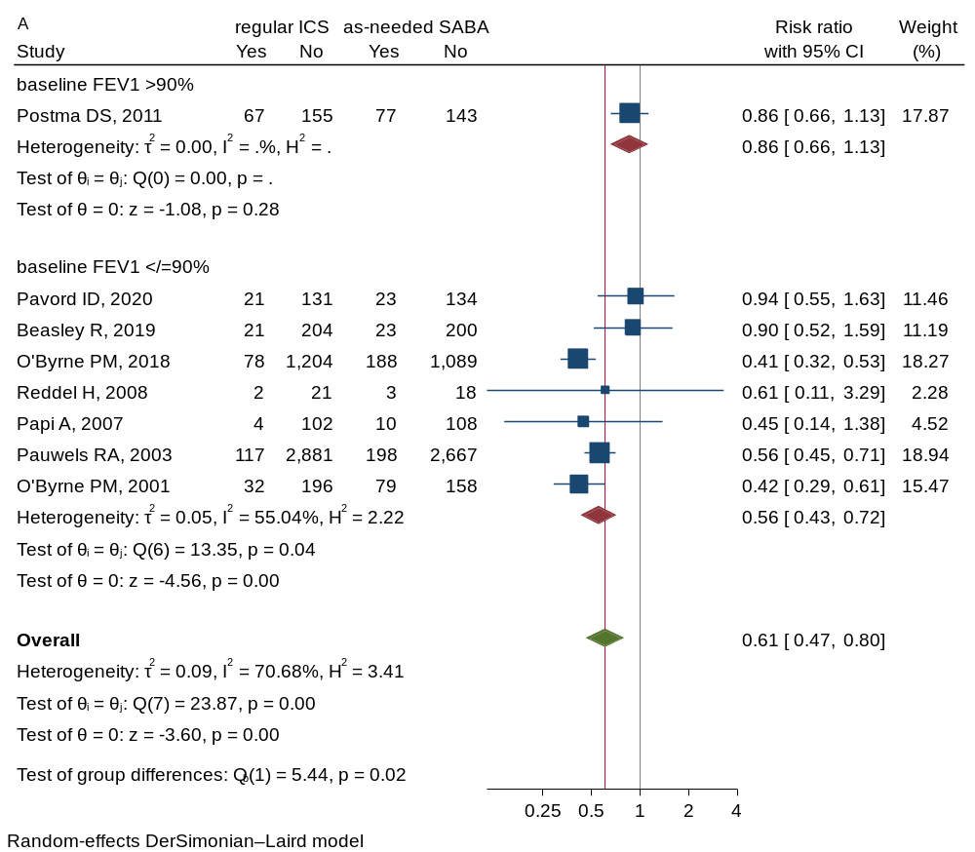

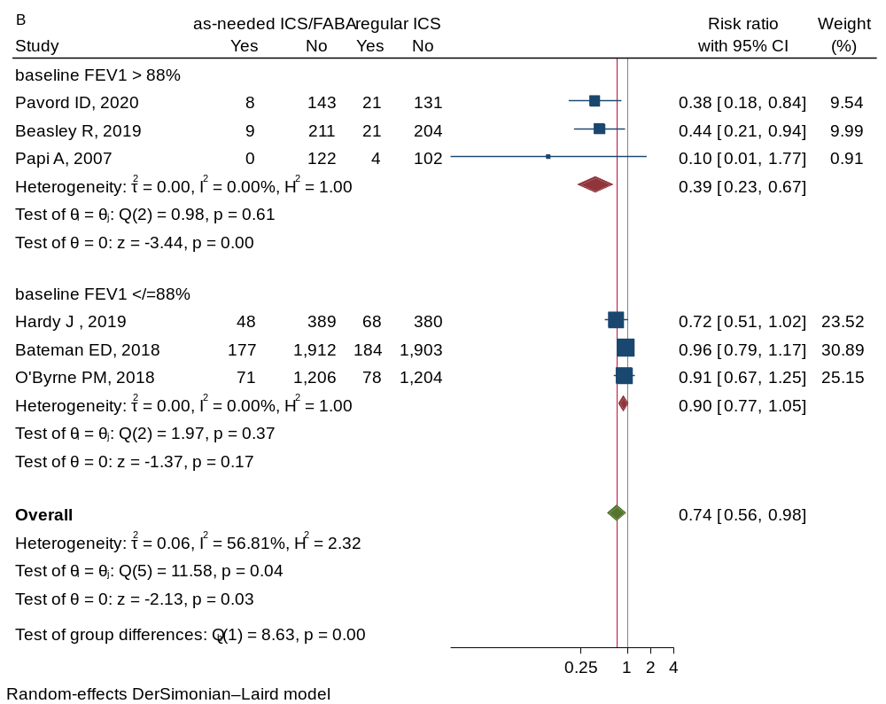

A) regular ICS vs. AN-SABA and B) AN-ICS/FABA vs. regular ICS

Figure 5.4. Subgroup analysis by baseline ACQ-5 and proportion of exacerbation in the past year on severe exacerbation outcome

Network meta-analysis
Table 5.2. Multiple treatment comparisons of severe exacerbation outcome
Reference treatment | Risk ratio (95%CIs)
Reference treatment | AN-SABA | AN-ICS | regICS | LTRA | AN-ICS/FABA | reg  ICS/LABA | Tiotropium
AN-SABA | 4.0 | ND | 0.58 (0.46,0.73)* | ND | 0.42 (0.30,0.58)* | 0.39 (0.27,0.56)* | 0.51 (0.13,1.91)
RegICS |  |  | 36.8 |  | 0.73 (0.54,0.97)* | 0.68 (0.48,0.97)* | 0.88 (0.24,3.24)
AN-ICS/FABA |  |  |  |  | 75.5 | 0.94 (0.61,1.46) | 1.21 (0.32,4.62)
RegICS/LABA |  |  |  |  |  | 81.8 | 1.29 (0.33,4.98)
Tiotropium |  |  |  |  |  |  | 52.0
Relative treatment effects are presented as risk ratios (RR) and 95% CI. The effects of the column interventions were compared to those of the row interventions. * indicates statistical significance. The values in shaded area are SUCRA (relative to AN-SABA). Abbreviations: ND: no data, AN: as-needed, reg: regular

Figure 5.5. Publication bias assessments for all relative treatment comparisons on severe exacerbation outcome
A) Comparison-adjusted funnel plot, A: AN-SABA, B: regular ICS, C: AN-ICS/FABA, D: regular ICS/LABA, E: tiotropium, B) Contour-enhanced funnel plot of AN-ICS/FABA vs. regular ICS, C) Contour-enhanced funnel plot of regular ICS/LABA vs. regular ICS

- Asthma symptoms
Direct meta-analysis
Figure 5.6. Forest plots of asthma symptom outcome (A-C) symptom scale, (D) ACQ-5

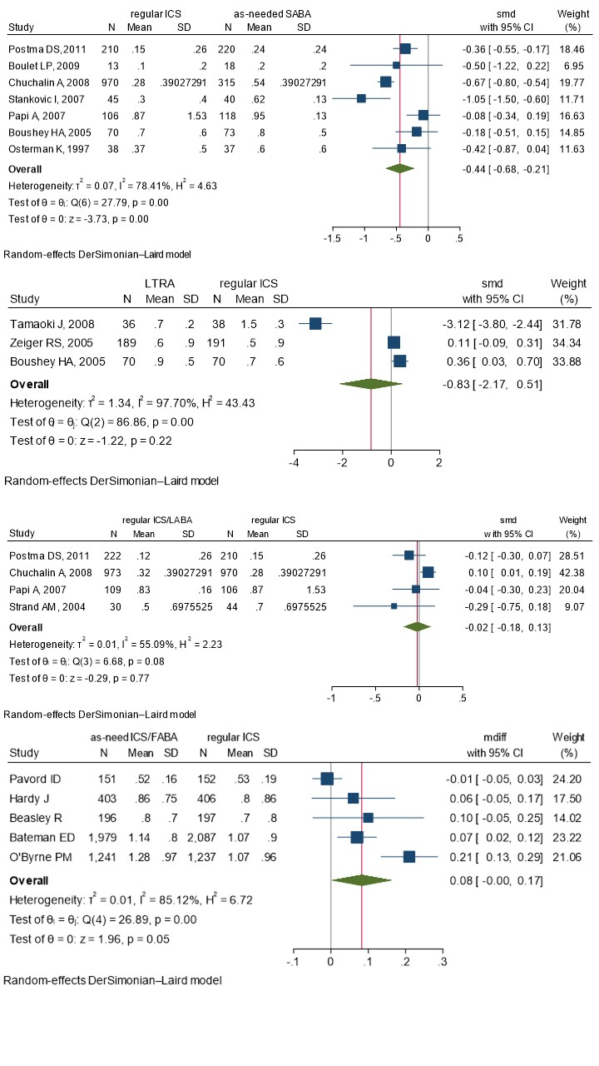
A
B
C
D
A) regular ICS vs. AN-SABA, B) LTRA vs. regular ICS, C) regular ICS/LABA vs. regular ICS, and D) AN-CS/FABA vs. regular ICS

Network meta-analysis
Table 5.3. Multiple treatment comparisons of asthma symptom scale outcome
Reference treatment | SMD (95%CI)
Reference treatment | AN-SABA | regICS | LTRA | AN-ICS/FABA | regICS/LABA
AN-SABA | 12.0 | -0.33 (-0.90,0.24) | -0.94 (-1.93,0.04) | -0.48 (-1.49,0.54) | -0.41 (-1.17,0.35)
regICS |  | 44.5 | -0.61 (-1.49,0.27) | -0.14 (-1.21,0.93) | -0.08 (-0.81,0.65)
LTRA |  |  | 85.1 | 0.47 (-0.88,1.82) | 0.53 (-0.58,1.65)
AN-ICS/FABA |  |  |  | 56.0 | 0.07 (-1.07,1.20)
regICS/LABA |  |  |  |  | 52.5
Relative treatment effects are presented as standardized mean difference (SMD) and 95% CI. The effects of the column interventions were compared to those of the row interventions. The values in the shaded column are SUCRA (relative to AN-SABA). Abbreviations: AN: as-needed, reg: regular

Figure 5.7. Publication bias assessments for all relative treatment comparisons on asthma symptom outcome
A) Comparison-adjusted funnel plot, A: as-need SABA, B: regular ICS, C: LTRA, D: as-needed ICS/FABA, E: regular ICS/LABA, B) Contour-enhanced funnel plot of LTRA vs. regular ICS.

Table 5.4. Multiple treatment comparisons of asthma symptom scale outcome (sensitivity analysis)
Reference treatment | SMD (95%CI)
Reference treatment | AN-SABA | regICS | LTRA | AN-ICS/FABA | regICS/LABA
AN-SABA | 7.0 | -0.40  (-0.59, -0.21)* | -0.10  (-0.45,0.24) | -0.52  (-0.85, -0.19)* | -0.43  (-0.66, -0.20)*
regICS |  | 65.2 | 0.29  (-0.03,0.62) | -0.12  (-0.47,0.23) | -0.04  (-0.26,0.19)
LTRA |  |  | 21.9 | -0.41  (-0.87,0.05) | -0.33  (-0.71,0.05)
AN-ICS/FABA |  |  |  | 83.9 | 0.08  (-0.28,0.45)
regICS/LABA |  |  |  |  | 71.9
Sensitivity analysis excluded the study comparing LTRA vs regular ICS in which higher baseline eosinophil level was a source of heterogeneity. Relative treatment effects are presented as standardized mean difference (SMD) and 95% CI. The effects of the column interventions were compared to those of the row interventions. * indicates statistical significance. The values in the shaded area are SUCRA (relative to AN-SABA). Abbreviations: AN: as-needed, reg: regular

- % predicted FEV₁
Direct meta-analysis
Figure 5.8. Forest plots of %predicted FEV₁ outcome
A
C
B

A) regular ICS vs. AN-SABA, B) LTRA vs. regular ICS, and AN-ICS/FABA vs. AN-SABA

Figure 5.9. Forest plots of FEV₁ (in liter) outcome
A
B

A) AN-ICS/FABA vs. regular ICS, and B) regular ICS/LABA vs. regular ICS

The high degree of heterogeneity for FEV₁ outcome in the treatment comparisons between regular ICS vs. AN-SABA and regular ICS vs. AN-ICS/FABA was due to the differences in baseline asthma step and ICS use at baseline. The results of subgroup analyses suggested treatment with regular ICS resulted in a similar change of %predicted FEV₁ compared to AN-SABA in patients with asthma step 1, but significantly better with regular ICS in patients with asthma step 2 (Figure 5.10). Despite a small magnitude of changes in FEV₁ (in liter), treatment with AN-ICS/FABA was associated with a lesser degree of increasing FEV₁ (in liter), compared to regular ICS in patients who did not use ICS at baseline (Figure 5.11A).

Figure 5.10. Subgroup analysis by asthma step on %predicted FEV₁ outcome

Figure 5.11. Subgroup analysis by baseline ICS use on FEV₁ in liter outcome
A
B

A) AN-ICS/FABA vs. regular ICS, and B) regular ICS/LABA vs. regular ICS

Network meta-analysis
Table 5.5. Multiple treatment comparisons of %predicted FEV₁ outcome
Reference Treatment | USMD (95%CIs)
Reference Treatment | AN-SABA | regICS | LTRA | AN-ICS/FABA | regICS/LABA
AN-SABA | 13.1 | 3.53 (1.68,5.38)* | -0.20 (-3.64,3.25) | 4.45 (1.76,7.15)* | 3.45 (0.40,6.49)*
regICS |  | 69.8 | -3.73 (-6.81,-0.65)* | 0.92 (-1.92,3.76) | -0.08 (-3.06,2.89)
LTRA |  |  | 14.3 | 4.65 (0.54,8.76)* | 3.65 (-0.62,7.91)
AN-ICS/FABA |  |  |  | 86.1 | -1.00 (-4.57,2.56)
regICS/LABA |  |  |  |  | 66.7
Relative treatment effects are presented as unstandardized mean difference (USMD) and 95% CI. The effects of the column interventions were compared to those of the row interventions. * indicates statistical significance. The values in the shaded area are SUCRA (relative to AN-SABA). Abbreviations: AN: as-needed, reg: regular

Figure 5.12. Publication bias assessments for all relative treatment comparisons on %predicted FEV₁ outcome
A
B
C
A) Comparison-adjusted funnel plot, A: AN-SABA, B: regular ICS, C: LTRA, D: AN-ICS/FABA, E: regular ICS/LABA, B) Contour-enhanced funnel plot of regular ICS vs. AN-SABA, C) Contour-enhanced funnel plot of regular ICS/LABA vs. regular ICS

- Asthma-specific quality-of-life
Direct meta-analysis

Figure 5.13. Forest plots of AQLQ outcome

A
B

A) regular ICS vs. as-needed SABA, and B) LTRA vs. regular ICS

Figure 5.14. Subgroup analysis by age group on AQLQ outcome

Figure 5.14. Subgroup analysis by age group on AQLQ outcome

Figure 5.15. Subgroup analysis by baseline %predicted FEV₁ on AQLQ outcome

Network meta-analysis
Table 5.6. Multiple treatment comparisons of AQLQ
Reference treatment | USMD (95%CIs)
Reference treatment | AN-SABA | regICS | LTRA | regICS/LABA
AN-SABA | 23.6 | 0.21 (0.07,0.35)* | -0.03 (-0.19,0.13) | 0.12 (-0.04,0.28)
regICS |  | 95.6 | -0.24 (-0.36,-0.13)* | -0.09 (-0.25,0.07)
LTRA |  |  | 14.1 | 0.15 (-0.04,0.35)
regICS/LABA |  |  |  | 66.7
Relative treatment effects are presented as unstandardized mean difference (USMD) and 95% CI. The effects of the column interventions were compared to those of the row interventions. * indicates statistical significance. The values in the shaded area are SUCRA (relative to AN-SABA). Abbreviations: AN: as-needed, reg: regular

Figure 5.16. Publication bias assessments for all relative treatment comparisons on AQLQ
A
B

A) Comparison-adjusted funnel plot, A: AN-SABA, B: regular ICS, C: LTRA, D: regular ICS/LABA, B) Contour-enhanced funnel plot of regular ICS vs. AN-SABA

- Severe adverse events
Direct meta-analysis
Figure 5.17. Forest plots of severe adverse events outcome
A
B
A) regular ICS vs. AN-SABA, and B) AN-ICS/FABA vs. regular ICS
Network meta-analysis
Table 5.6. Multiple treatment comparisons of severe adverse event outcome
Reference treatment | RR (95%CIs)
Reference treatment | AN-SABA | regICS | AN-ICS/FABA | regICS/LABA
AN-SABA | 6.1 | 0.65 (0.45,0.94)* | 0.79 (0.52,1.21) | 0.57 (0.31,1.02)
regICS |  | 71.6 | 0.83 (0.58,1.18) | 0.87 (0.49,1.54)
AN-ICS/FABA |  |  | 38.7 | 0.71 (0.37,1.39)
regICS/LABA |  |  |  | 83.6
Relative treatment effects are presented as risk ratios (RR) and 95% CI. The effects of the column interventions were compared to those of the row interventions. * indicates statistical significance. The values in the shaded area are SUCRA (relative to AN-SABA). Abbreviations: AN: as-needed, reg: regular

eAppendix 6. Formulas for data conversion
If the original studies reported outcomes as median after treatment or median change from baseline, they were converted to mean or mean change from baseline, respectively. By converting the median into the mean and the first and third quartiles into the SD, we used the following formula:
- mean ~ (Q1 + median + Q3) / 3
- SD ~ (Q3-Q1)/ 2ɸ⁻¹ $(\frac{0.75n-0.125}{n+0.25})$ ~ $\frac{Q3-Q1}{1.35}$
where ɸ = the cumulative distribution function of the standard normal distribution which used the formula in Excel spreadsheet as
SD = (Q3-Q1)/(2*NORM.INV((0.75*n-0.125)/(n+0.25),0,1))
The post-treatment mean was calculated by summing the pre-treatment mean with the mean change given that the original studies provided a pre-treatment mean and a mean change.

eAppendix 7. Grading the evidence of the network meta-analysis using CINeMA
We evaluated the certainty of evidence for all the outcomes by using the Confidence in Network Meta-Analysis Software CINeMA, which covers 6 domains: (1) within-study bias, (2) reporting bias, (3) indirectness, (4) imprecision, (5) heterogeneity, and (6) incoherence and was considered to be a transparent, rigorous, and comprehensive system.
Based on the available evidence, for comparisons of two treatment interventions the clinically meaningful threshold was set at a risk ratio of 0.8 and 1.25 for dichotomous outcomes (i.e., exacerbation, adverse events) and at mean differences of -0.5 and 0.5 for continuous outcome (i.e., symptom score and AQLQ) and mean differences of -10 and 10 for %predicted FEV₁.

7.1. In children
7.1.1. Rating of confidence in NMA on exacerbation
Comparison | N of  studies | Within-study  bias | Reporting  bias | Indirect  ness | Imprecision | Heteroge  neity | Incoherence | Confidence  rating
an-ics:an-saba | 1 | No concerns | Low risk | No concerns | Some concerns | No concerns | No concerns | Moderate
an-ics:r-ics | 3 | No concerns | Low risk | No concerns | Some concerns | Some concerns | No concerns | Low
an-saba:ltra | 1 | Some concerns | Low risk | No concerns | No concerns | Some concerns | No concerns | Low
an-saba:r-ics | 2 | No concerns | Low risk | No concerns | No concerns | No concerns | No concerns | High
ltra:r-ics | 3 | Some concerns | Low risk | No concerns | No concerns | Some concerns | No concerns | Low
an-ics:ltra | 0 | Some concerns | Low risk | No concerns | Major concerns | No concerns | No concerns | Very low

7.1.2. Rating of confidence in NMA on FEV₁
Comparison | N of  studies | Within-study  bias | Reporting  bias | Indirect  ness | Imprecision | Heteroge  neity | Incoherence | Confidence  rating
an-ics:an-saba | 1 | No concerns | Low risk | No concerns | Some concerns | Some concerns | No concerns | Low
an-ics:r-ics | 3 | No concerns | Low risk | No concerns | Some concerns | Some concerns | No concerns | Low
an-saba:r-ics | 3 | Some concerns | Low risk | No concerns | No concerns | Major concerns | No concerns | Very low
ltra:r-ics | 1 | Some concerns | Low risk | No concerns | Some concerns | Some concerns | No concerns | Low
an-ics:ltra | 0 | Some concerns | Low risk | No concerns | Major concerns | No concerns | No concerns | Very low
an-saba:ltra | 0 | Some concerns | Low risk | No concerns | Major concerns | No concerns | No concerns | Very low

7.1.3. Rating of confidence in NMA on adverse events
Comparison | N of  studies | Within-study  bias | Reporting  bias | Indirect  ness | Imprecision | Heterogeneity | Incoherence | Confidence  rating
an-ics:r-ics | 1 | No concerns | Low risk | No concerns | Major concerns | No concerns | No concerns | Low
an-saba:ltra | 2 | Some concerns | Low risk | No concerns | Major concerns | No concerns | No concerns | Very low
an-saba:r-ics | 1 | Some concerns | Low risk | No concerns | Major concerns | No concerns | No concerns | Very low
ltra:r-ics | 3 | Some concerns | Low risk | No concerns | Major concerns | No concerns | No concerns | Very low
an-ics:an-saba | 0 | Some concerns | Low risk | No concerns | Major concerns | No concerns | No concerns | Very low
an-ics:ltra | 0 | Some concerns | Low risk | No concerns | Major concerns | No concerns | No concerns | Very low

7.2. In adolescents/adults
7.2.1. Rating of confidence in NMA on exacerbation
Comparison | N of  studies | Within-study  bias | Reporting  bias | Indirect  ness | Imprecision | Heterogeneity | Incoherence | Confidence  rating
an-ics/faba:  an-saba | 2 | Some concerns | Low risk | No concerns | No concerns | No concerns | No concerns | Moderate
an-ics/faba:r-ics | 2 | Some concerns | Low risk | No concerns | Major concerns | No concerns | Some concerns | Very low
an-ics/faba:  r-ics/laba | 1 | Some concerns | Low risk | No concerns | Major concerns | No concerns | Some concerns | Very low
an-saba:ltra | 1 | Some concerns | Low risk | No concerns | Some concerns | Some concerns | No concerns | Low
an-saba:r-ics | 4 | Some concerns | Low risk | No concerns | No concerns | No concerns | No concerns | Moderate
an-saba:  r-ics/laba | 2 | Some concerns | Low risk | No concerns | No concerns | No concerns | No concerns | Moderate
ltra:r-ics | 3 | Some concerns | Low risk | No concerns | Major concerns | No concerns | No concerns | Very low
r-ics:r-ics/laba | 3 | Some concerns | Low risk | No concerns | Some concerns | Some concerns | No concerns | Low
r-ics:tio | 2 | Some concerns | Low risk | No concerns | Major concerns | No concerns | No concerns | Very low
an-ics/faba:ltra | 0 | Some concerns | Low risk | No concerns | Major concerns | No concerns | No concerns | Very low
an-ics/faba:tio | 0 | Some concerns | Low risk | No concerns | Major concerns | No concerns | No concerns | Very low
an-saba:tio | 0 | Some concerns | Low risk | No concerns | No concerns | Some concerns | No concerns | Low
ltra:r-ics/laba | 0 | Some concerns | Low risk | No concerns | Some concerns | Some concerns | No concerns | Low
ltra:tio | 0 | Some concerns | Low risk | No concerns | Major concerns | No concerns | No concerns | Very low
r-ics/laba:tio | 0 | Some concerns | Low risk | No concerns | Major concerns | No concerns | No concerns | Very low

7.2.2. Rating of confidence in NMA on severe exacerbation
Comparison | N of  studies | Within-study  bias | Reporting  bias | Indirect  ness | Imprecision | Heterogeneity | Incoherence | Confidence  rating
an-ics/faba:  an-saba | 4 | No concerns | Low risk | No concerns | No concerns | No concerns | No concerns | High
an-ics/faba:r-ics | 5 | No concerns | Low risk | No concerns | No concerns | Some concerns | No concerns | Moderate
an-ics/faba:  r-ics/laba | 1 | Some concerns | Low risk | No concerns | Major concerns | No concerns | No concerns | Very low
an-saba:r-ics | 9 | Some concerns | Low risk | No concerns | No concerns | Some concerns | No concerns | Low
an-saba:  r-ics/laba | 4 | Some concerns | Low risk | No concerns | No concerns | No concerns | No concerns | Moderate
ltra:r-ics | 1 | No concerns | Low risk | No concerns | Major concerns | No concerns | No concerns | Low
r-ics:r-ics/laba | 7 | Some concerns | Low risk | No concerns | No concerns | Some concerns | No concerns | Low
r-ics:r-ics/laba | 1 | Some concerns | Low risk | No concerns | Major concerns | No concerns | No concerns | Very low
r-ics:tio | 1 | Some concerns | Low risk | No concerns | Major concerns | No concerns | No concerns | Very low
an-ics/  faba:ltra | 0 | No concerns | Low risk | No concerns | Major concerns | No concerns | No concerns | Low
an-ics/faba:  r-ics/laba | 0 | Some concerns | Low risk | No concerns | Major concerns | No concerns | No concerns | Very low
an-ics/faba:tio | 0 | Some concerns | Low risk | No concerns | Major concerns | No concerns | No concerns | Very low
an-saba:ltra | 0 | No concerns | Low risk | No concerns | Major concerns | No concerns | No concerns | Low
an-saba:  r-ics/laba | 0 | Some concerns | Low risk | No concerns | No concerns | Some concerns | No concerns | Low
an-saba:tio | 0 | Some concerns | Low risk | No concerns | Major concerns | No concerns | No concerns | Very low
ltra:r-ics/laba | 0 | No concerns | Low risk | No concerns | Major concerns | No concerns | No concerns | Low
ltra:tio | 0 | Some concerns | Low risk | No concerns | Major concerns | No concerns | No concerns | Very low
r-ics/laba:tio | 0 | Some concerns | Low risk | No concerns | Major concerns | No concerns | No concerns | Very low

7.2.3. Rating of confidence in NMA on asthma symptom score
Comparison | N of  studies | Within-study  bias | Reporting  bias | Indirect  ness | Imprecision | Heterogeneity | Incoherence | Confidence  rating
an-ics/faba:  an-saba | 2 | Some concerns | Low risk | No concerns | Some concerns | Some concerns | No concerns | Low
an-ics/faba:r-ics | 1 | Some concerns | Low risk | No concerns | Some concerns | Some concerns | No concerns | Low
an-ics/faba:  r-ics/laba | 1 | Some concerns | Low risk | No concerns | Major concerns | No concerns | No concerns | Very low
an-saba:ltra | 1 | Some concerns | Low risk | No concerns | No concerns | Some concerns | Some concerns | Low
an-saba:r-ics | 7 | Some concerns | Low risk | No concerns | No concerns | Major concerns | Some concerns | Very low
an-saba:  r-ics/laba | 3 | Some concerns | Low risk | No concerns | No concerns | Major concerns | No concerns | Very low
ltra:r-ics | 3 | Some concerns | Low risk | No concerns | Some concerns | Some concerns | Some concerns | Low
r-ics:r-ics/laba | 4 | Some concerns | Low risk | No concerns | No concerns | Major concerns | No concerns | Very low
an-ics/faba:ltra | 0 | Some concerns | Low risk | No concerns | Some concerns | Some concerns | No concerns | Low
ltra:r-ics/laba | 0 | Some concerns | Low risk | No concerns | Some concerns | Some concerns | No concerns | Low

7.2.4. Rating of confidence in NMA on FEV₁
Comparison | N of  studies | Within-study  bias | Reporting  bias | Indirect  ness | Imprecision | Heterogeneity | Incoherence | Confidence  rating
an-ics/faba:an-saba | 3 | Some concerns | Low risk | No concerns | No concerns | No concerns | No concerns | Moderate
an-ics/faba:r-ics | 2 | Some concerns | Low risk | No concerns | No concerns | No concerns | No concerns | Moderate
an-ics/faba:r-ics/laba | 1 | Some concerns | Low risk | No concerns | No concerns | No concerns | No concerns | Moderate
an-saba:ltra | 1 | Some concerns | Low risk | No concerns | No concerns | No concerns | No concerns | Moderate
an-saba:r-ics | 9 | Some concerns | Low risk | No concerns | No concerns | No concerns | No concerns | Moderate
an-saba:r-ics/laba | 2 | Some concerns | Low risk | No concerns | No concerns | No concerns | Some concerns | Low
ltra:r-ics | 3 | Some concerns | Low risk | No concerns | No concerns | No concerns | No concerns | Moderate
r-ics:r-ics/laba | 3 | Some concerns | Low risk | No concerns | No concerns | No concerns | Some concerns | Low
an-ics/faba:ltra | 0 | Some concerns | Low risk | No concerns | No concerns | Some concerns | No concerns | Low
ltra:r-ics/laba | 0 | Some concerns | Low risk | No concerns | No concerns | Some concerns | No concerns | Low

7.2.5. Rating of confidence in NMA on asthma-specific quality-of-life
Comparison | N of  studies | Within-study  bias | Reporting  bias | Indirect  ness | Imprecision | Heterogeneity | Incoherence | Confidence  rating
an-ics/faba:  an-saba | 1 | No concerns | Low risk | No concerns | No concerns | No concerns | No concerns | High
an-ics/faba:r-ics | 2 | No concerns | Low risk | No concerns | No concerns | No concerns | No concerns | High
an-saba:ltra | 1 | Some concerns | Low risk | No concerns | No concerns | No concerns | No concerns | Moderate
an-saba:r-ics | 4 | Some concerns | Low risk | No concerns | No concerns | No concerns | No concerns | Moderate
an-saba:  r-ics/laba | 1 | Some concerns | Low risk | No concerns | No concerns | No concerns | No concerns | Moderate
ltra:r-ics | 3 | Some concerns | Low risk | No concerns | No concerns | Some concerns | No concerns | Low
r-ics:r-ics/laba | 1 | Some concerns | Low risk | No concerns | No concerns | No concerns | No concerns | Moderate
an-ics/faba:ltra | 0 | No concerns | Low risk | No concerns | No concerns | Some concerns | Major concerns | Very low
an-ics/faba:  r-ics/laba | 0 | Some concerns | Low risk | No concerns | No concerns | No concerns | Major concerns | Very low
ltra:r-ics/laba | 0 | Some concerns | Low risk | No concerns | No concerns | Some concerns | Major concerns | Very low

7.2.6. Rating of confidence in NMA on severe adverse events
Comparison | N of  studies | Within-study  bias | Reporting  bias | Indirect  ness | Imprecision | Heterogeneity | Incoherence | Confidence  rating
an-ics/faba:  an-saba | 3 | No concerns | Low risk | No concerns | Some concerns | No concerns | No concerns | Moderate
an-ics/faba:r-ics | 5 | No concerns | Low risk | No concerns | Some concerns | No concerns | No concerns | Moderate
an-ics/faba:  r-ics/laba | 1 | Some concerns | Low risk | No concerns | Major concerns | No concerns | No concerns | Very low
an-saba:r-ics | 6 | No concerns | Low risk | No concerns | No concerns | No concerns | No concerns | High
an-saba:  r-ics/laba | 2 | Some concerns | Low risk | No concerns | No concerns | Some concerns | No concerns | Low
r-ics:r-ics/laba | 2 | Some concerns | Low risk | No concerns | Major concerns | No concerns | No concerns | Very low

