Supplementary Material
Table S1- List of plants proteome used for the search of HFM

Chlorophytes |  |  | Chlamydomonas reinhardtii
Chlorophytes |  |  | Coccomyxa subellipsoidea
Chlorophytes |  |  | Dunaliella salina
Chlorophytes |  |  | Micromonas pusilla CCMP
Chlorophytes |  |  | Micromonas sp. RCC299
Chlorophytes |  |  | Ostreococcus lucimarinus
Chlorophytes |  |  | Volvox carteri
Bryophytes |  |  | Marchantia polymorpha
Bryophytes |  |  | Physcomitrella patens
Tracheophyta |  |  | Selaginella moellendorffii
Angiosperm |  | Amborellaceae | Amborella trichopoda
Angiosperm | Monocot | Grass/poaceae | Brachypodium distachyon
Angiosperm | Monocot | Grass/poaceae | Brachypodium stacei
Angiosperm | Monocot | Grass/poaceae | Oropetium thomaeum
Angiosperm | Monocot | Grass/poaceae | Oryza sativa
Angiosperm | Monocot | Grass/poaceae | Panicum hallii
Angiosperm | Monocot | Grass/poaceae | Panicum virgatum
Angiosperm | Monocot | Grass/poaceae | Setaria italica
Angiosperm | Monocot | Grass/poaceae | Setaria viridis
Angiosperm | Monocot | Grass/poaceae | Sorghum bicolor
Angiosperm | Monocot | Grass/poaceae | Triticum aestivum
Angiosperm | Monocot | Grass/poaceae | Zea mays
Angiosperm | Monocot | Musaceae | Musa acuminata
Angiosperm | Monocot | Araceae | Spirodela polyrhiza
Angiosperm | Monocot | Bromeliaceae | Ananas comosus
Angiosperm | Monocot | Zosteraceae | Zostera marina
Angiosperm | Eudicot | Apiacea | Daucus carota
Angiosperm | Eudicot | Brassicaceae | Arabidopsis halleri
Angiosperm | Eudicot | Brassicaceae | Arabidopsis lyrata
Angiosperm | Eudicot | Brassicaceae | Arabidopsis thaliana
Angiosperm | Eudicot | Brassicaceae | Boechera stricta
Angiosperm | Eudicot | Brassicaceae | Brassica rapa
Angiosperm | Eudicot | Brassicaceae | Capsella grandiflora
Angiosperm | Eudicot | Brassicaceae | Capsella rubella
Angiosperm | Eudicot | Brassicaceae | Eutrema salsugineum
Angiosperm | Eudicot | Crassulaceae | Kalanchoe laxiflora( Bryophyllum pinnatum)
Angiosperm | Eudicot | Malvaceae | Gossypium raimondii
Angiosperm | Eudicot | Malvaceae | Theobroma cacao
Angiosperm | Eudicot | Rosaseae | Fragaria vesca
Angiosperm | Eudicot | Rosaseae | Malus domestica
Angiosperm | Eudicot | Rosaseae | Prunus persica
Angiosperm | Eudicot | Rutaceae | Citrus clementina
Angiosperm | Eudicot | Rutaceae | Citrus sinensis
Angiosperm | Eudicot | Solanaceae | Solanum lycopersicum
Angiosperm | Eudicot | Solanaceae | Solanum tuberosum
Angiosperm | Eudicot | Fabaceae | Trifolium pratense
Angiosperm | Eudicot | Fabaceae | Glycine max
Angiosperm | Eudicot | Fabaceae | Phaseolus vulgaris
Angiosperm | Eudicot | Fabaceae | Medicago truncatula
Angiosperm | Eudicot | Salicaceae | Populus trichocarpa
Angiosperm | Eudicot | Salicaceae | Salix purpurea
Angiosperm | Eudicot | Vitaceae | Vitis vinifera
Angiosperm | Eudicot | Euphorbiaceae | Manihot esculenta
Angiosperm | Eudicot | Euphorbiaceae | Ricinus communis
Angiosperm | Eudicot | Cucurbitaceae | Cucumis sativus
Angiosperm | Eudicot | Caricaceae | Carica papaya
Angiosperm | Eudicot | Myrtaceae | Eucalyptus grandis
Angiosperm | Eudicot | Phrymaceae | Mimulus guttatus
Angiosperm | Eudicot | Ranunculaceae | Aquilegia coerulea
Angiosperm | Eudicot | Linaceae | Linum usitatissimum
Angiosperm | Eudicot | Crassulaceae | Kalanchoe marnieriana
Angiosperm | Eudicot | Amaranthaceae | Amaranthus hypochondriacus
Angiosperm | Eudicot | Amaranthaceae | Chenopodium quinoa

Table. S2 showing training sequences for each classes of core histone. Diverse HFM are the sequences obtained from HHblits HMM-HMM search on “nr20-Refseq” database.

Core histone Class | Core histone HFM | Diverse HFM | Total
H2A | 261 | 86 | 347
H2B | 61 | 35 | 96
H3 | 42 | 26 | 68
H4 | 75 | 77 | 152
Total | 439 | 224 | 663

Table. S3 Showing annotation of all NF-YB, NF-YC and resolved annotation of other HFM proteins confused as NF-Ys.
GID | Annotation after this Study | Previous Annotation
AT3G48590 | NF-YC1 | -
AT1G56170 | NF-YC2 | -
AT1G54830 | NF-YC3 | -
AT5G63470 | NF-YC4 | -
AT5G50490 | NF-YC5 | -
AT5G50480 | NF-YC6 | -
AT5G50470 | NF-YC7 | -
AT5G27910 | NF-YC8 | -
AT1G08970 | NF-YC9 | -
AT5G38140 | NF-YC10 | NFYC12
AT1G07980 | DPE-C | NF-YC10
AT5G43250 | DPE-C | NF-YC13
AT5G19490 | DRAP1 | Histone superfamily protein
AT3G12480 | DRAP1 | NF-YC11
AT2G38880 | NF-YB1 | -
AT5G47640 | NF-YB2 | -
AT4G14540 | NF-YB3 | -
AT1G09030 | NF-YB4 | -
AT2G47810 | NF-YB5 | -
AT5G47670 | NF-YB6 | -
AT2G13570 | NF-YB7 | -
AT2G37060 | NF-YB8 | -
AT1G21970 | NF-YB9 | -
AT3G53340 | NF-YB10 | -
AT5G08190 | DR1 | NF-YB12
AT5G23090 | DR1 | NF-YB13
AT2G27470 | DPE-3 | NF-YB11

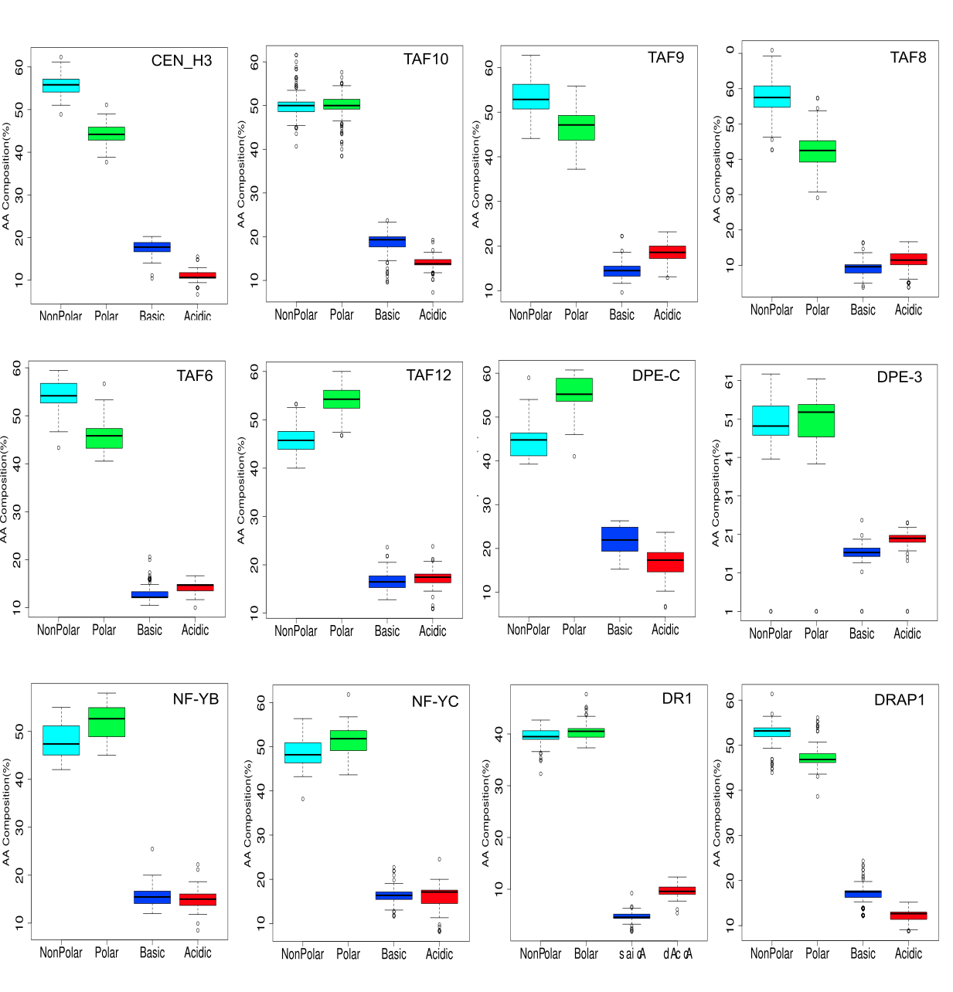
Figure S1. Box plot showing percent composition of Non-Polar, Polar, Basic and Acidic amino acids in cyan, green, blue and red colour respectively on HFM of non-histones proteins

