Supplementary Information

Direct observations of slow photo-induced structural and physical changes

Minaho Nakaie, Kaito Murakami, Yuka Nishiyama, Shuji Shiose, Yuko Miyaji, Yasuo Takeichi, Yasuhiro Niwa & Toshio Naito*

Index

Supplementary Fig. 1 (UV-vis absorption spectra) P. 2
Supplementary Table 1 (Selected Au-C distances) P. 3
Supplementary Fig. 2 (Molecular arrangement) P. 4
Supplementary Fig. 3 (Molecular orbitals) P. 5
Supplementary Fig. 4 (Models in the energy calculation) P. 6
Supplementary Table 2 (CCDC deposit numbers) P. 7
Supplementary Fig. 5 (XPS spectra) P. 8
Notes P. 9

a
b
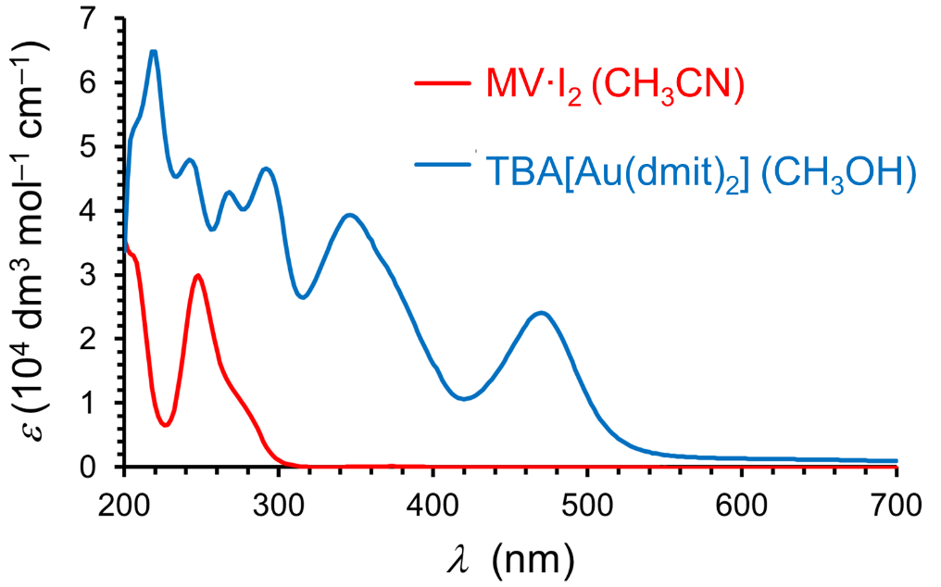
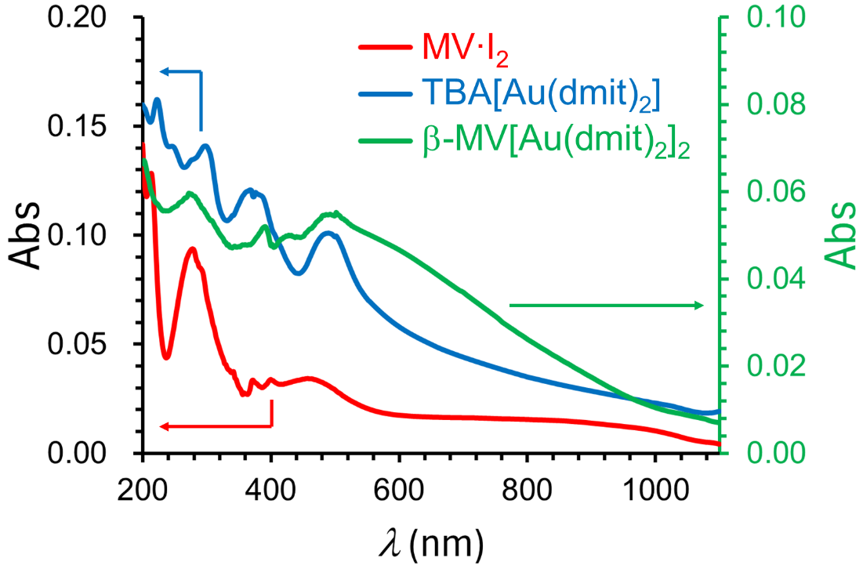

Supplementary Fig. 1⏐Absorption spectra of MV·I₂, TBA[Au(dmit)₂], and β-MV[Au(dmit)₂]₂. a, solution. b, powder states at 295 K. As β-MV[Au(dmit)₂]₂ does not dissolve in solvents, its solution spectrum is not shown. β-MV[Au(dmit)₂]₂ is designated as MV[Au(dmit)₂]₂ in the main text for simplicity.

Supplementary Table 1⏐ Comparison of selected Au-C distances (Å). The Au and C atoms lie in a close distance between interacting MV and Au(dmit)₂ or between interacting pair of Au(dmit)₂. Observed by the single-crystal X-ray structural analyses at 128 K.
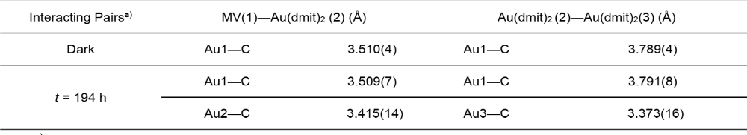^{a)} The numbering scheme of molecules is shown in Supplementary Fig. 2. The Au-C van der Waals distance is 3.36 Å.²⁴

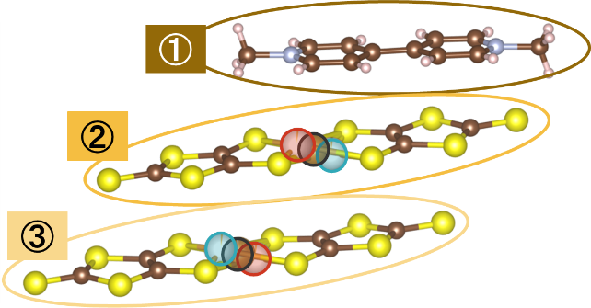

Supplementary Fig. 2⏐ Molecular arrangement in the interacting pairs in Supplementary Table 1. The Au1, Au2, and Au3 atoms are designated by black, red, and blue circles, respectively. Brown, pale blue, pink, yellow spheres designate C, N, H, and S atoms, respectively.

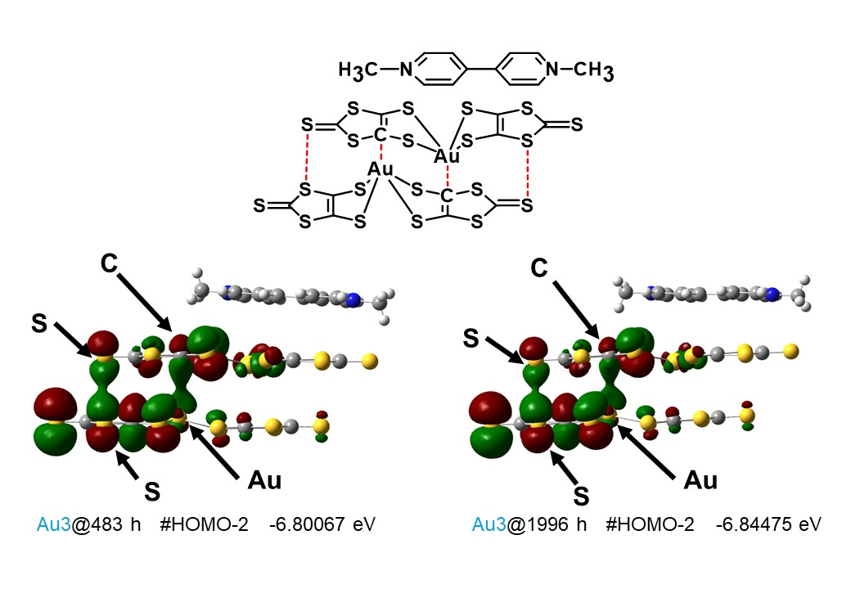
Supplementary Fig. 3⏐ Molecular orbitals (MOs) calculated for the selected three-molecule-system (charge = 0, spin = 0, Supplementary Fig. 4) in MV[Au(dmit)₂]₂ based on the observed structures at t = 483 h and 1996 h. The excitation energy (~300—600 nm) can cause optical transitions of (HOMO-2)—LUMO and HOMO—(LUMO+1), and these orbitals can be partially occupied during photoexcitation and relaxation. Note that covalent bonds form (Au—C and S—S) between the interacting pair of molecules depending on the elapsed time t since the cessation of UV-irradiation.

Supplementary Fig 4⏐ Assumed structures in the energy calculation using density functional theory (DFT). a, Au1 atoms with planar coordination. b, Au2 atoms with non-planar coordination. c, Au3 atoms with non-planar coordination. The difference between Au2 and Au3 lies in the direction of Au atom deviation. Each calculated system consists of three molecules with direct interactions, viz. two Au(dmit)₂ anions and one MV cation, with the two anions having identical molecular structure and related to each other through an inversion centre.

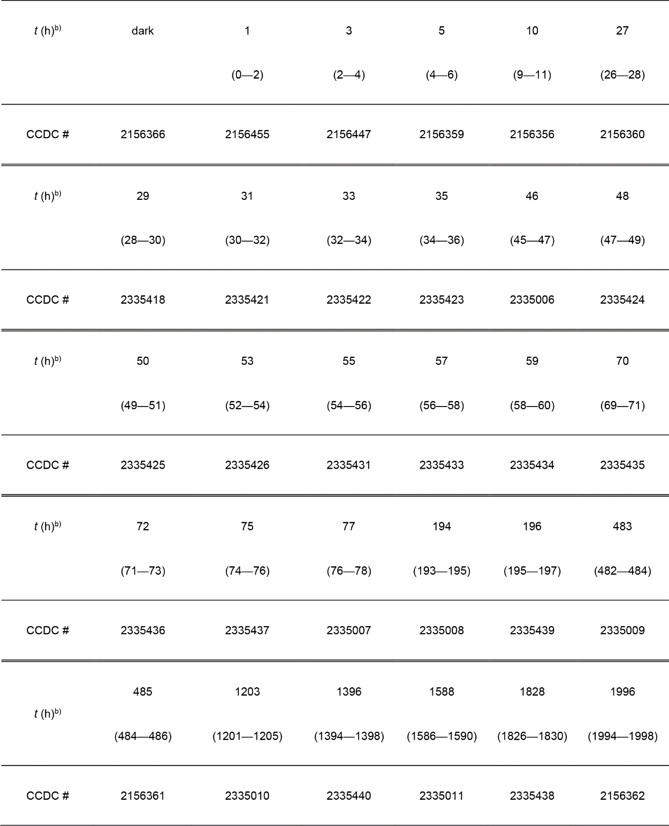
Supplementary Table 2⏐ CCDC deposit numbers of the single-crystal X-ray structural analysis results of MV[Au(dmit)₂]₂ under the dark condition and during relaxation (t > 0 h) after the UV irradiation stopped.^{a)}
^{a)} The temperature during data collection was 128 K for all entries. The same single crystal was used for the data collection for all entries. ^{b)} Because each run of data collection required ~2—4 h, the time t corresponds to the middle point of the data collection. For example, data collected at t = 1–5 h gave the structure at t = 3 h.

Supplementary Fig. 5⏐ Time evolution of XPS spectra. Selected spectra showing the differences between those measured before (dark), during (UV), and after UV irradiation (the elapsed time indicated). a, Au 4f. b, Au 5s. c, S 2s. d, Au 4d. e, S 2p. The colours of the spectra in each panel indicate the elapsed time t as indicated.

Notes
1. When a part of electrons in closed-shell orbitals is excited by UV to occupy molecular orbitals of higher energies, the total orbital angular momenta of the electrons in the original orbitals are no more cancelled. Additionally, the higher-energy orbitals often possess higher orbital angular momenta than the original inner orbitals. Both effects enhance the spin-orbit coupling.

2. The molecular orbitals are generally described by linear combination of atomic orbitals as Eq. 1.
$$ψ=\sum_{i}{{c_{i}ϕ}_{i}} (Eq. 1)$$
where c_{i} and φ_{i} designate coefficients and i-th atomic orbitals, respectively. In the molecular orbital theory, all atomic orbitals φ_{i} are assumed to be unchanged through the chemical reactions as the basis set. All changes in occupancy, energy levels, and molecular orbitals (electron distribution) are attributed to the changes in the coefficients c_{i}. Whether inner-shell electrons are included in the model (Eq. 1), such “rigid atoms” cannot describe the chemical changes in this paper, where substantial changes occur in the atomic orbitals themselves.
When perturbation is large enough like photoexcitation, substantial redistribution of electron densities can occur in materials including chemical reactions. In such cases, the initial basis set is no more complete to describe the transient or final states. Namely, additional atomic orbitals may be required, or different atomic orbitals may be required to describe the original atomic orbitals with spin- or charge-polarized states.

3. In other words, interactions between different orbitals are generally described by linear combination of each orbital as Eq. 1. On the other hand, Eq. 1 also describes the fluctuation between all involved states φ_{i}. Thus, additional interactions may result in a new (meta)stable state necessarily with fluctuation.

