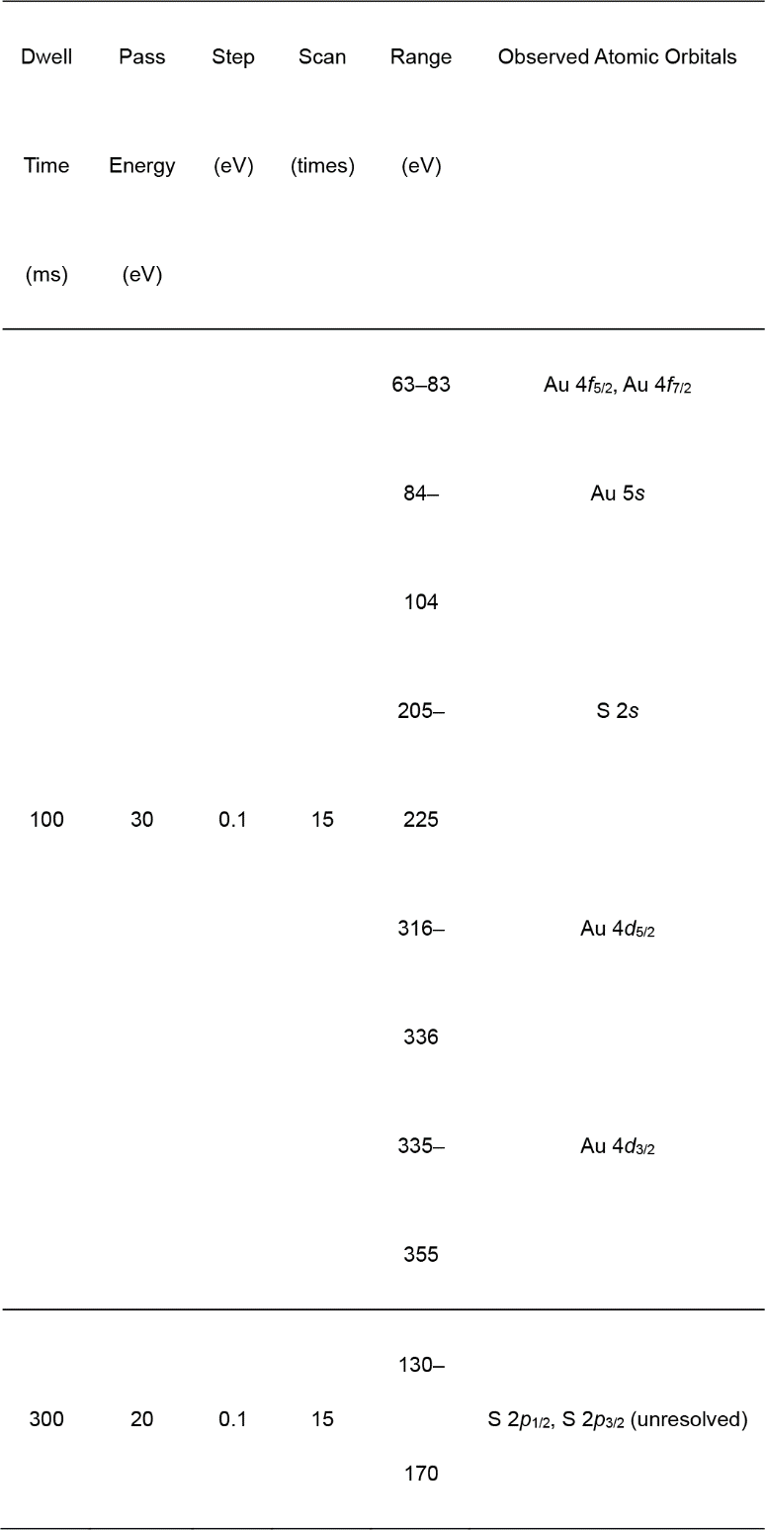
Extended Data Table 1⏐ XPS measurement conditions.

Extended Data Fig. 1⏐ Molecular and crystal structures in MV[Au(dmit)₂]₂. The blue, yellow, brown, orange/white, and pink spheres indicate N, S, C, Au, and H atoms, respectively. a Unit cell of MV[Au(dmit)₂]₂. Disordered (non-planar coordinate) Au atoms are omitted for clarity. b Mixed cation–anion stacking mode. Disordered Au atoms (white spheres) are present only after UV irradiation. The remaining structure was unaffected by UV irradiation.
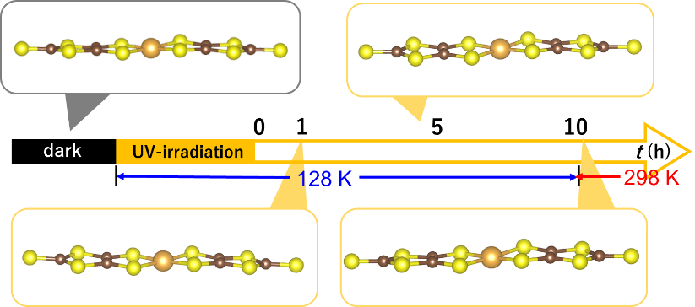
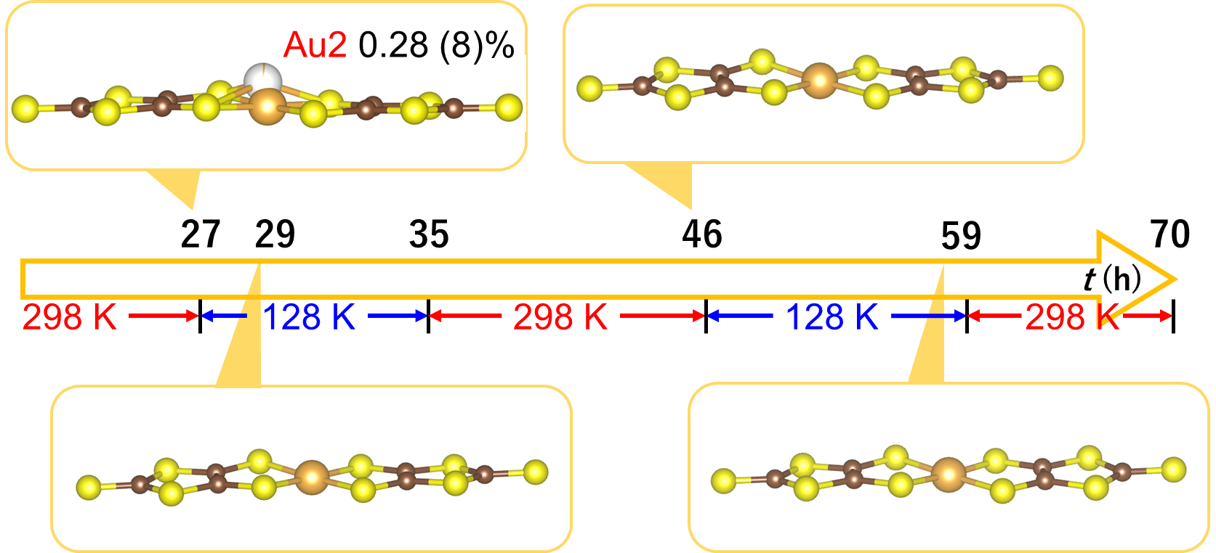
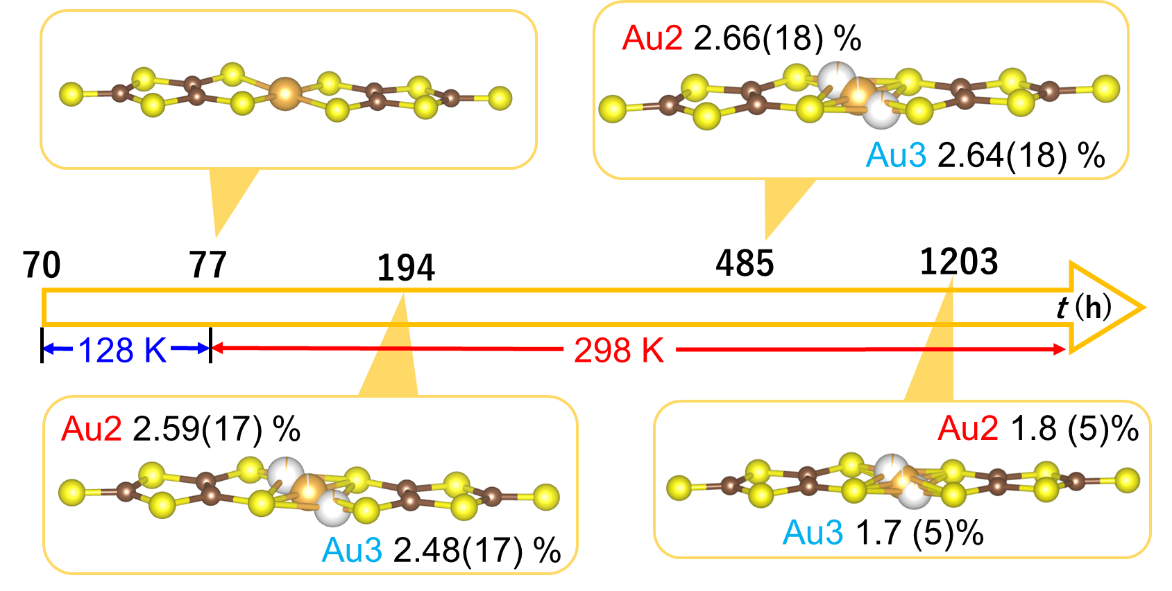
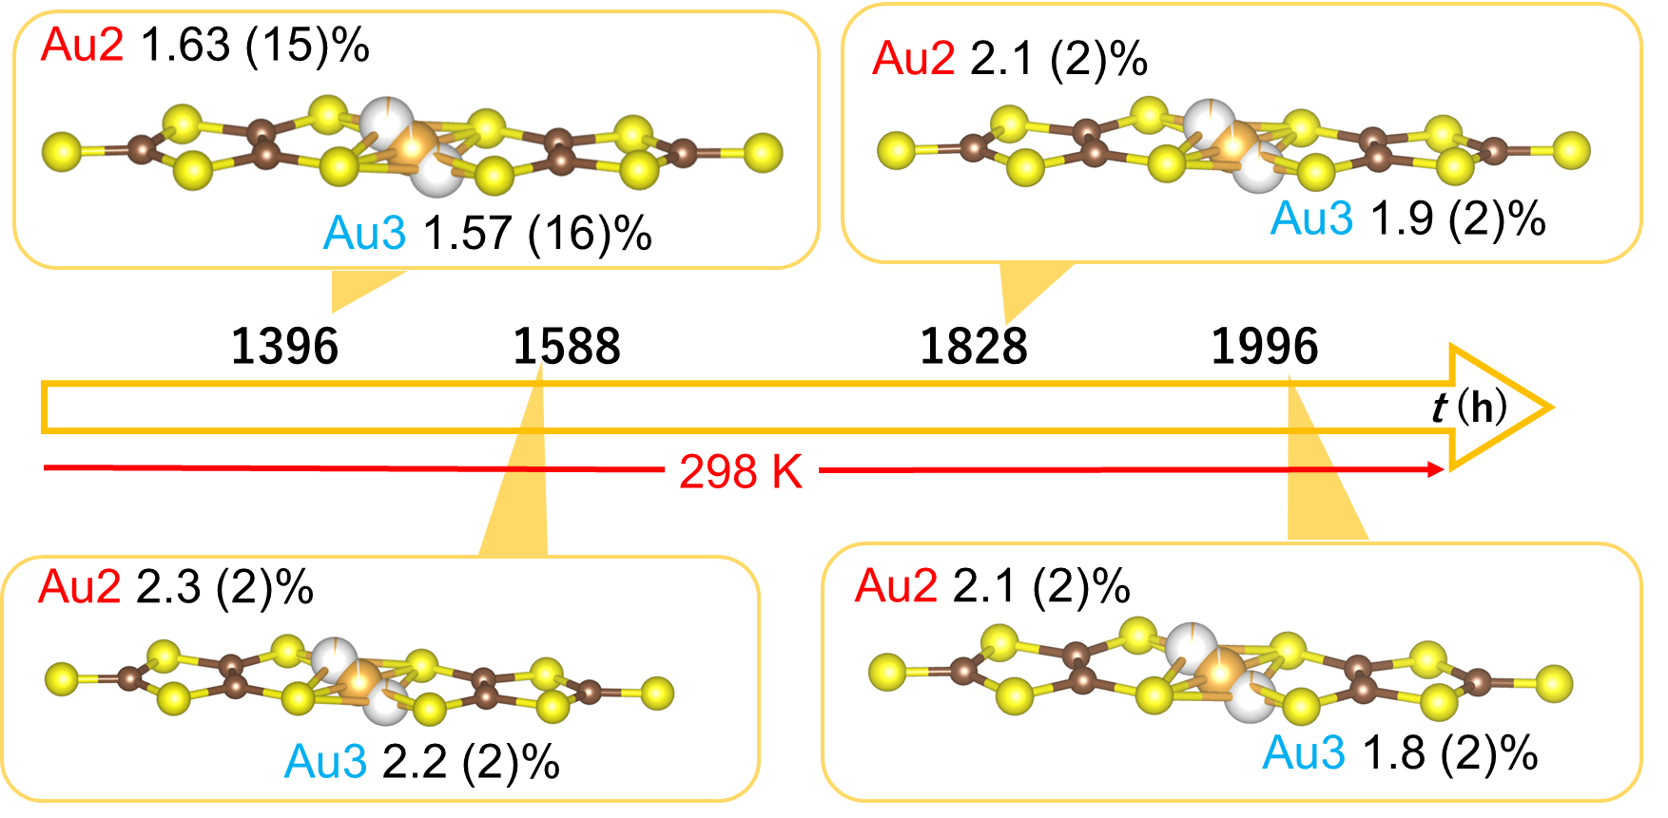
Extended Data Fig. 2⏐ Time evolution of the molecular structures of Au(dmit)₂ radical anions in MV[Au(dmit)₂]₂. The yellow, brown, and orange/white spheres indicate S, C, and Au atoms, respectively. Structural evolution of the elapsed time t since the cessation of UV irradiation upon the single crystal. The ratios (%) beside the Au2 or Au3 labels indicate the occupancies of the Au atoms in structures Au1–Au3. The temperatures under the time axis represent the temperatures of the crystals retained during the indicated periods. Because each run of data collection took 2–4 h, the reported t value corresponds to the midpoint of data collection. For example, the data collected at t = 1–5 h gave the structure at t = 3 h. Thus, each structure should be regarded as the average within a 2–4 h window centred at t.

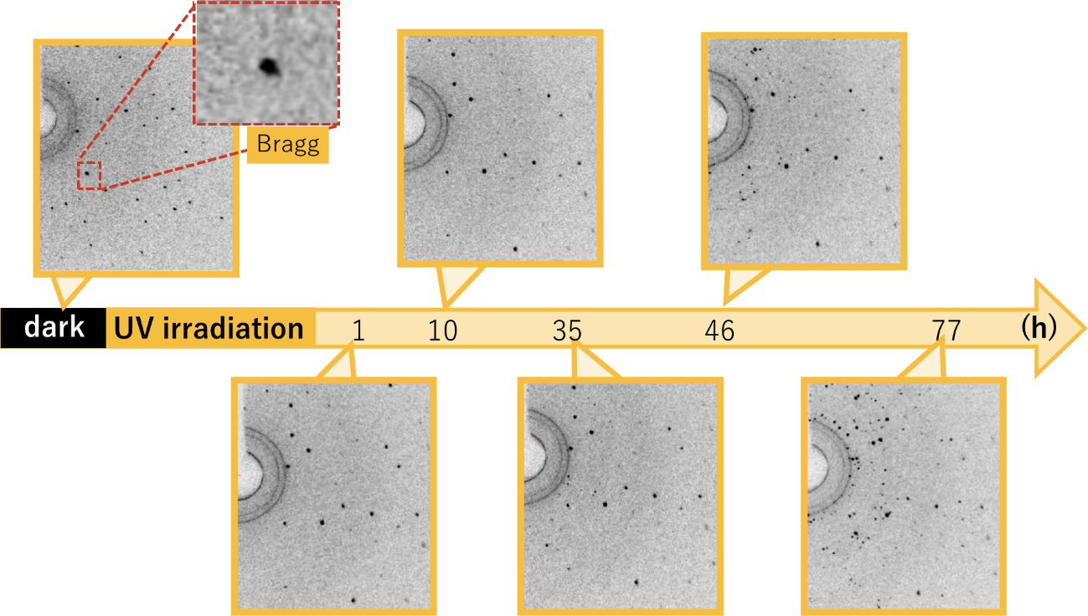
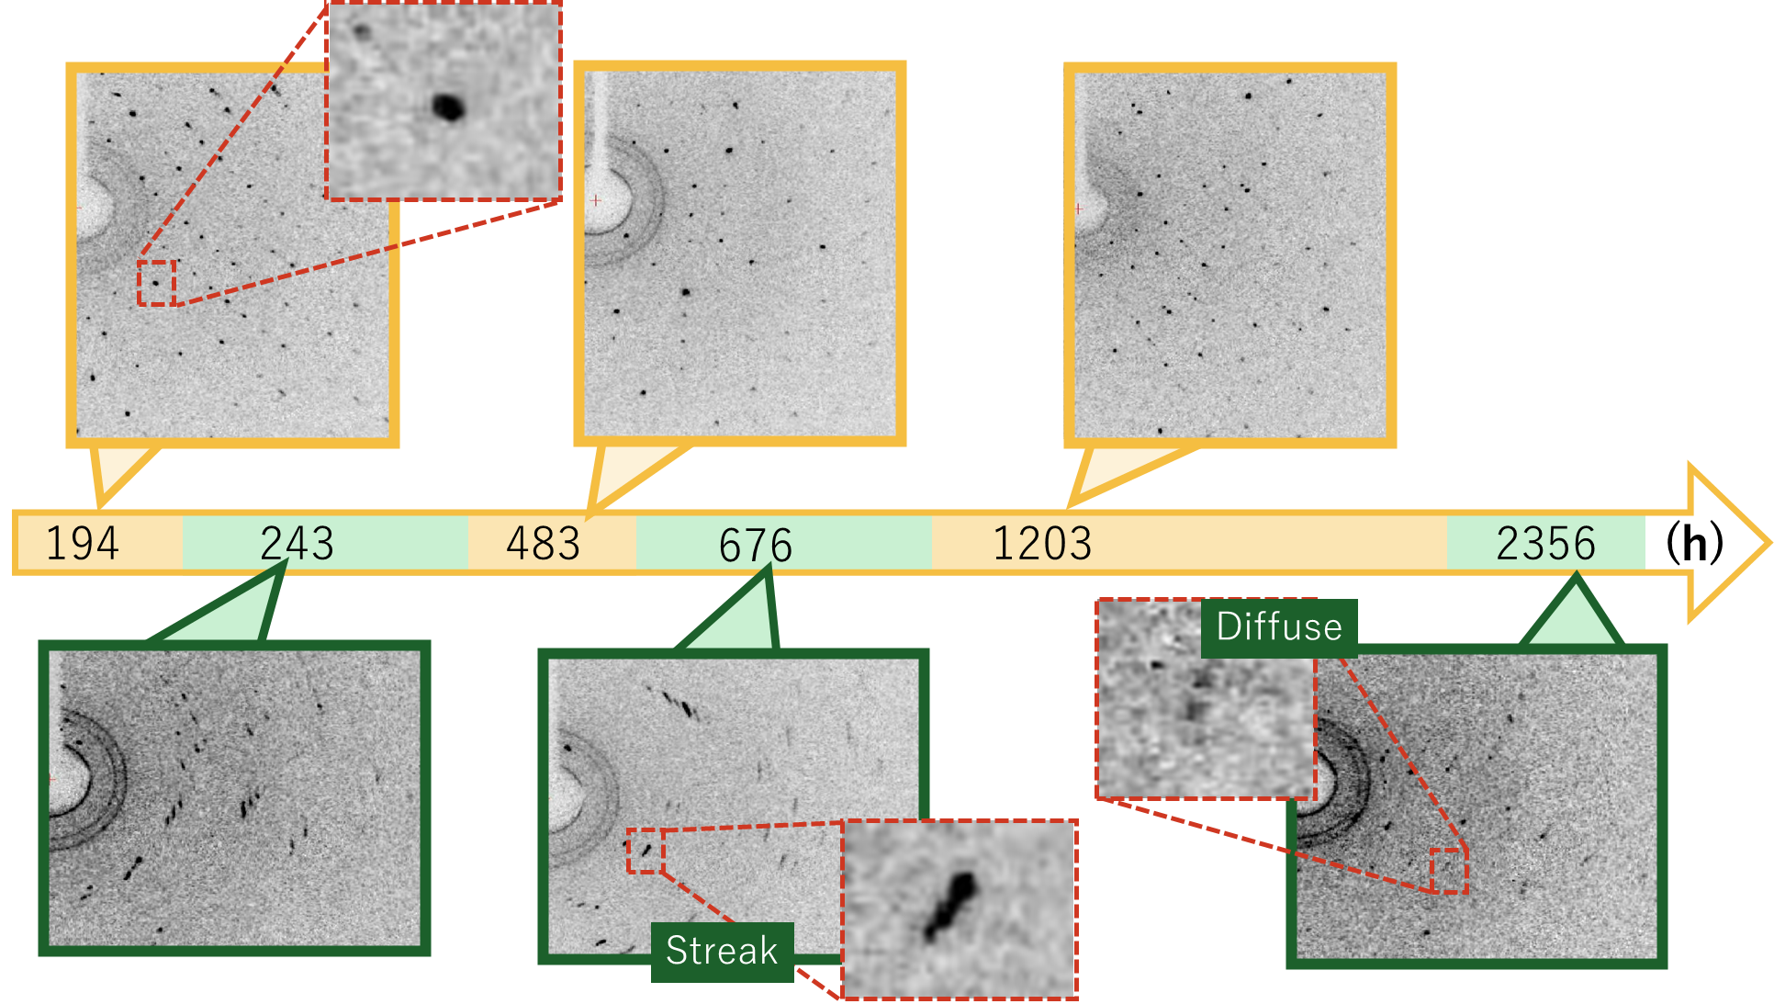
Extended Data Fig. 3⏐ Time evolution of the X-ray oscillation photographs of MV[Au(dmit)₂]₂ (Timeline view). Images were taken at 128 K, based on the same single crystal during relaxation from the UV-excited state. The sample was retained at 128 K until t = 10 h after the cessation of UV irradiation, after which it was retained at 298 K, except during data collection. The UV light source was switched off at t = 0 h. The yellow and green frames indicate photographs of high and low crystallinity, respectively.

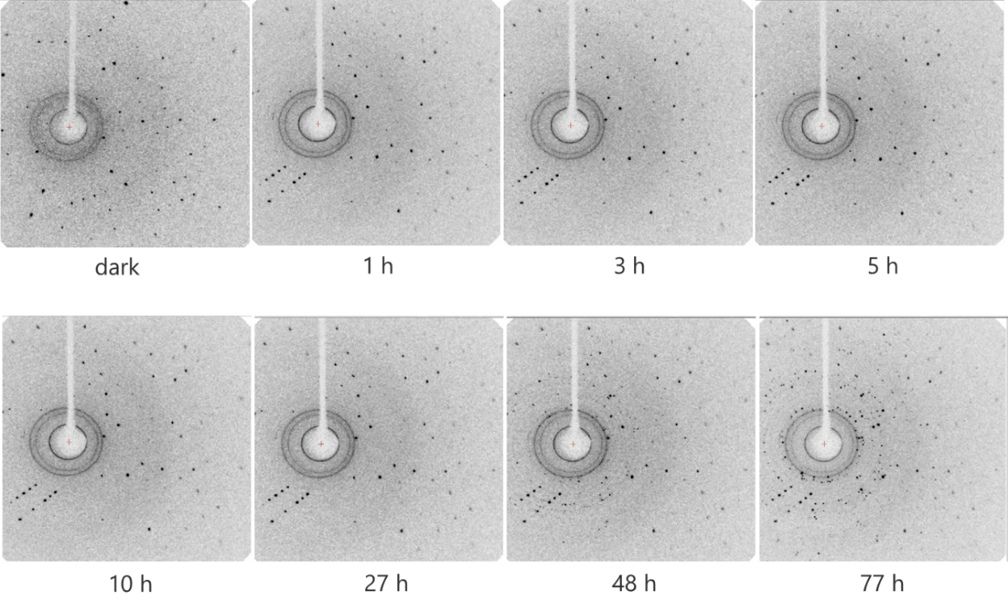
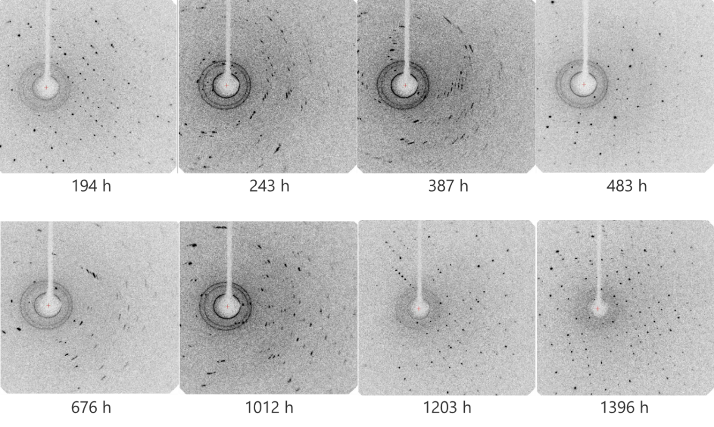
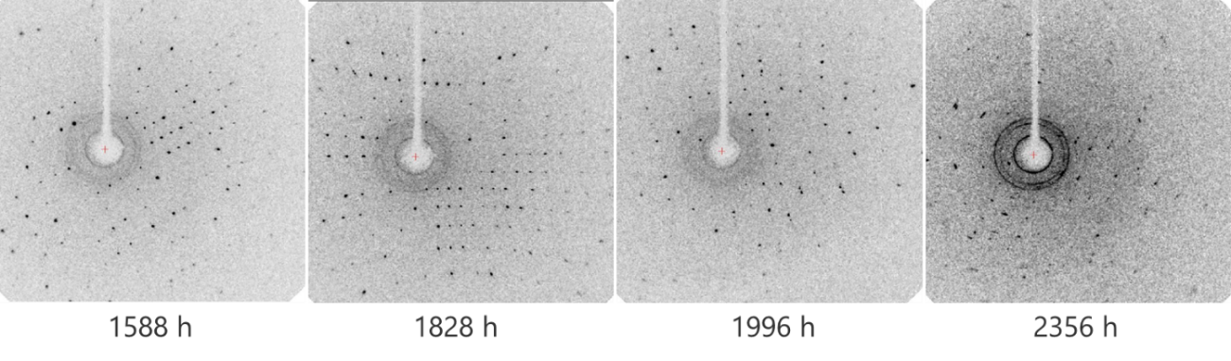
Extended Data Fig. 4⏐ Time evolution of the X-ray oscillation photographs of MV[Au(dmit)₂]₂ (Detailed view). Images were taken at 128 K, based on the same single crystal during relaxation from the UV-excited state. The sample was retained at 128 K until t = 10 h after the cessation of UV irradiation, after which it was retained at 298 K, except during data collection. The UV light source was switched off at t = 0 h.

Extended Data Fig. 5⏐ Time evolution of Au L_{III}-edge XAFS spectra of MV[Au(dmit)₂]₂. (polarization = // b-axis) observed in fluorescence mode. a and b, X-ray absorption near-edge structure (XANES). c and d, Oscillation spectra in reciprocal space. e and f, Amplitudes of the Fourier-transformed extended X-ray absorption fine structure (EXAFS) spectra. Figs. 2b, d, and f show enlarged views of Figs. 2a, c, and e, respectively. Firstly, the dark spectra (Dark1—Dark3) were measured successively three times to confirm the reproducibility. The sample was then exposed to UV light, during which spectrum (4) was recorded. Immediately after the cessation of UV irradiation (t = 0 min), the spectral measurements were repeated during the relaxation process (5–12). Each measurement time was indicated by the beginning and end of the spectral measurement after the cessation of UV irradiation.

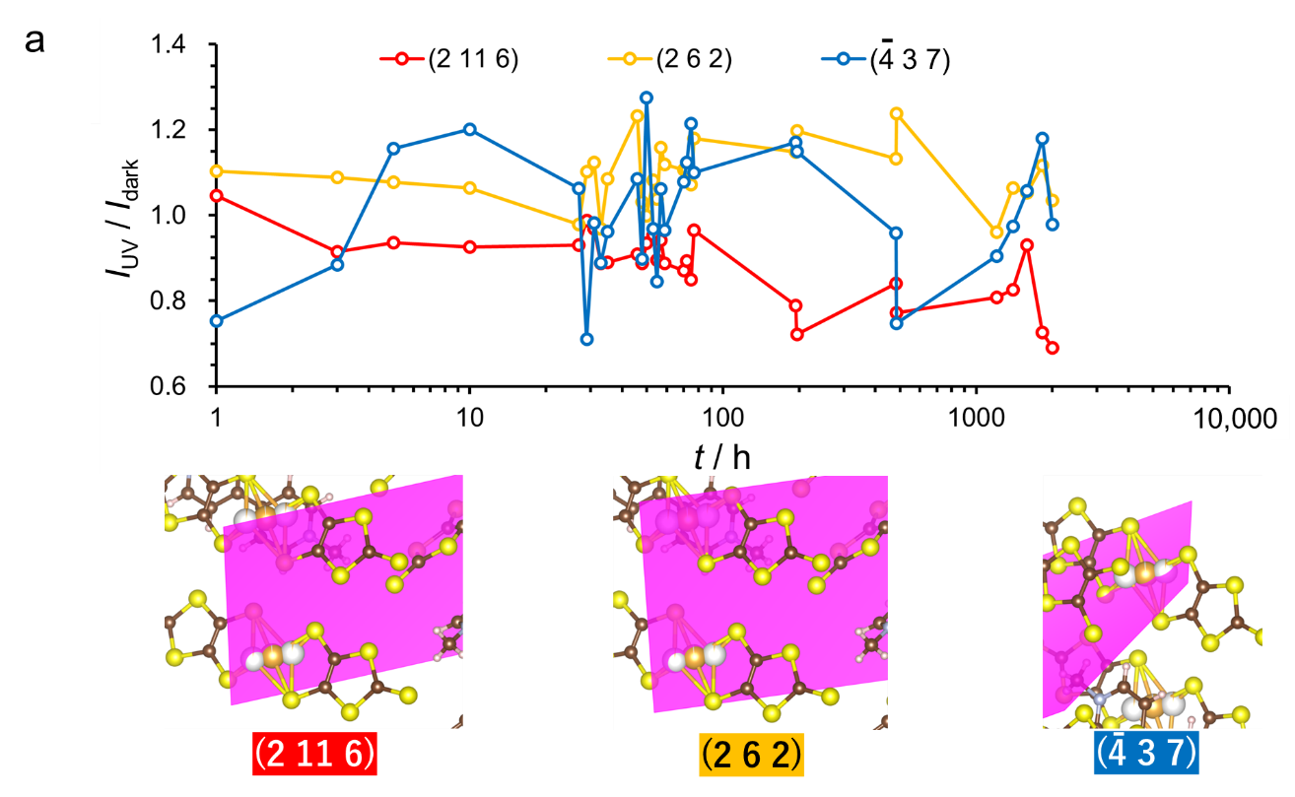
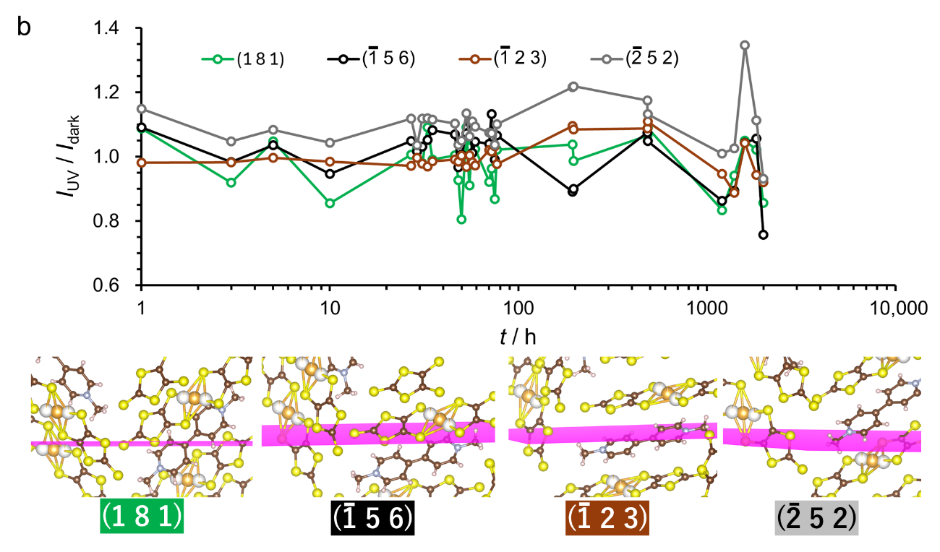Extended Data Fig. 6⏐ Time evolution of selected Bragg reflection intensities I_{rel} after applying UV irradiation for 5 min and then stopping it. Taken from the same data set used for the single-crystal X-ray structural analyses. a, Au planes: Lattice planes intersecting planar- and non-planar coordinate Au atoms. b, Non-Au planes: Lattice planes intersecting neither planar- nor non-planar coordinate Au atoms. The selected planes are shown under the respective images.

Extended Data Fig. 7⏐ Thermodynamic quantities of the MV salt during photoexcitation and succeeding dynamics. The calculated values are based on observed structures using first-principles calculations. a, Electronic energy, E(RωB97XD). b, Molar entropy S (298.15 K, 1 atm). c Molar internal energy U (298.15 K, 1 atm). d Molar heat capacity at constant volume C_{V} (298.15 K, 1 atm). The irradiation was stopped at t = 0 h. The energies under dark conditions at t = 1. Black circles, red squares, and blue triangles indicate the energies of the systems including the planar Au(dmit)₂ (Au1) and two different non-planar Au(dmit)₂ structures (Au2 and Au3). Supplementary Figs. 4a–c show their respective configurations.

Extended Data Fig. 8⏐ Photoexcitation and succeeding dynamics observed by XPS (t = 0–3,000 h). t = 0 indicates XPS data obtained during continuous UV irradiation. The values at t = 0 are indicated by green circles in the main panels. a, BEs of the S 2s spectra normalized to the dark value (215.835 eV). b I of the S 2s spectra normalized by the dark value (445.551). c, BEs of the S 2p spectra normalized to the dark value (151.109 eV). d I of the S 2p spectra normalized to the dark value (432.828). The S 2p spectra contain unresolved 2p_{1/2} and 2p_{3/2} peaks. The insets are based on the same data from the corresponding main panels, with different scales of the horizontal axes to show the earlier

