Table S1. Clinicopathological characteristics of 11 patient samples used for DSP analysis
Patient ID | Menopausal_status | T size (cm) | Grade | Stage | Lymph node status | TILs | Overall Survival events | OS months | Disease Free Survival events | DFS months
Sample 1 | Pre | 2.5 | III | II | Negative | Dense | 0 | 59 | 0 | 59
Sample 2 | Pre | 4 | III | III | Positive | Dense | 0 | 87 | 0 | 87
Sample 3 | Pre | 3 | II | II | Negative | Dense | 0 | 76 | 0 | 76
Sample 4 | Post | 3 | II | II | Negative | Mild | 1 | 11 | 1 | 10
Sample 5 | Post | 3 | II | II | Negative | Mild | 0 | 84 | 0 | 84
Sample 6 | Pre | 5.2 | II | II | Negative | Moderate | 0 | 58 | 1 | 47
Sample 7 | Pre | 3.5 | III | II | Negative | Mild | 0 | 57 | 0 | 57
Sample 8 | Post | 3.5 | III | II | Negative | Dense | 0 | 57 | 0 | 57
Sample 9 | Post | 4 | II | II | Positive | Moderate | 1 | 23 | 1 | 13
Sample 10 | Post | 3 | III | II | Negative | Moderate | 0 | 59 | 0 | 59
Sample 11 | Post | 2.5 | III | II | Negative | Mild | 0 | 59 | 0 | 59
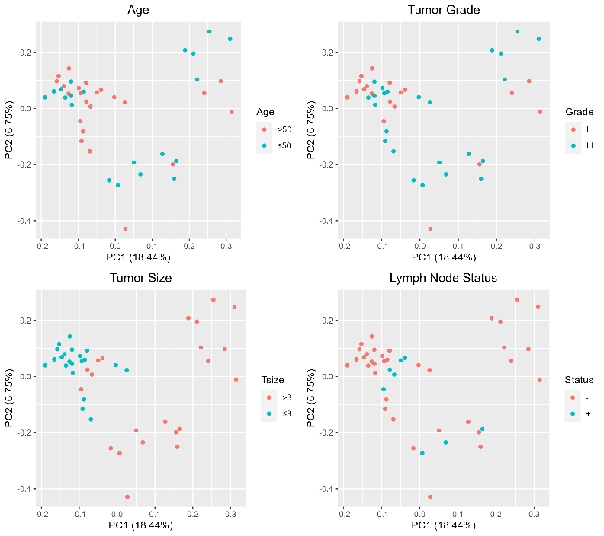Figure S1. Principle component analysis (PCA) plots showing clustering based on age, grade, tumor size and lymph node status

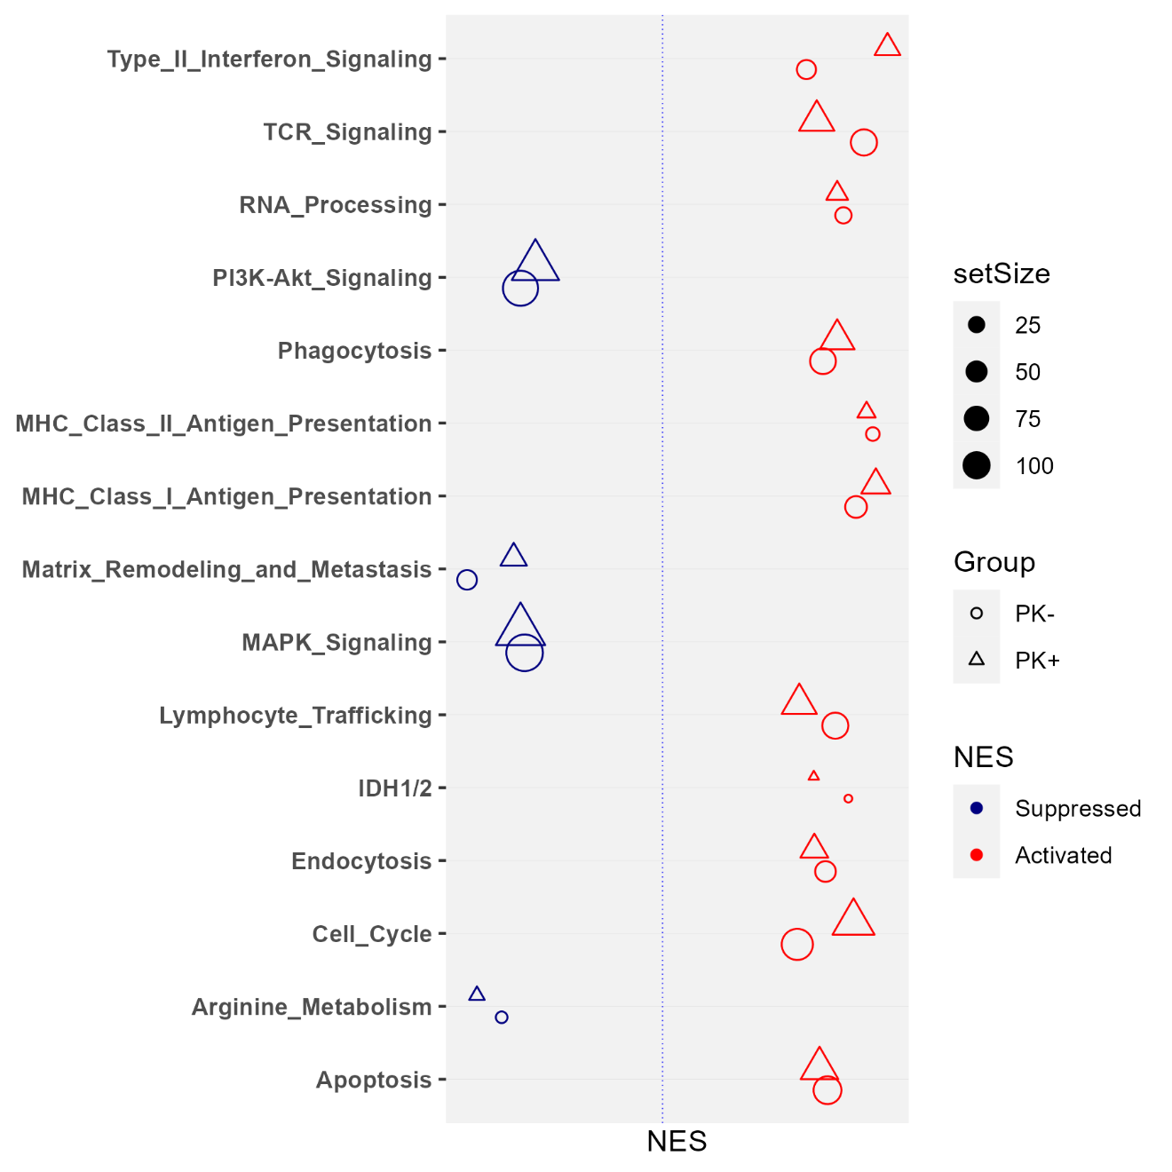

Supplementary figure S2. Commonly regulated pathways between PanCK+ and PanCK- compartment in premenopausal tumors

