Supplement Table 1. Death cases and age-standandised mortality rate of Inflammatory bowel disease Between 1990 and 2021 at the Global and Regional Level
Location | All-age cases (95% UI) |  | Age-standandised mortality rate (95% UI) |  | EAPCs
Location | 1990 | 2021 | 1990 | 2021 | EAPCs
Global | 21418(18423-23613) | 42423(37537-46502) | 0.60(0.52-0.66) | 0.52(0.46-0.58) | -0.31(-0.49--0.13)
Andean Latin America | 60(44-81) | 88(67-112) | 0.22(0.17-0.28) | 0.15(0.11-0.19) | -1.37(-1.62--1.12)
Australasia | 73(67-79) | 449(370-504) | 0.33(0.30-0.36) | 0.73(0.61-0.82) | 3.54(2.58-4.50)
Caribbean | 162(142-184) | 187(151-234) | 0.62(0.55-0.70) | 0.35(0.29-0.44) | -2.08(-2.28--1.88)
Central Asia | 199(182-218) | 259(222-301) | 0.37(0.34-0.39) | 0.30(0.26-0.35) | -1.04(-1.27--0.80)
Central Europe | 593(560-650) | 864(788-948) | 0.43(0.41-0.47) | 0.40(0.36-0.44) | 0.11(-0.17-0.40)
Central Latin America | 312(301-321) | 887(797-976) | 0.36(0.35-0.37) | 0.36(0.32-0.40) | 0.50(0.21-0.79)
Central Sub-Saharan Africa | 88(60-122) | 222(146-321) | 0.40(0.27-0.56) | 0.39(0.26-0.55) | -0.09(-0.15--0.03)
East Asia | 4592(3149-5758) | 5967(4700-7910) | 0.75(0.49-0.94) | 0.33(0.26-0.44) | -3.01(-3.37--2.65)
Eastern Europe | 1797(1655-1976) | 1827(1674-1972) | 0.67(0.62-0.74) | 0.54(0.50-0.59) | -1.43(-2.16--0.68)
Eastern Sub-Saharan Africa | 322(228-416) | 738(487-996) | 0.43(0.29-0.58) | 0.41(0.27-0.57) | -0.16(-0.24--0.08)
High-income Asia Pacific | 593(465-686) | 670(520-893) | 0.34(0.27-0.40) | 0.12(0.10-0.16) | -3.42(-3.78--3.05)
High-income North America | 2416(2175-2541) | 6601(5760-7049) | 0.67(0.61-0.71) | 0.97(0.86-1.03) | 1.49(1.08-1.89)
North Africa and Middle East | 495(378-714) | 1055(857-1389) | 0.30(0.24-0.40) | 0.26(0.21-0.34) | -0.36(-0.48--0.24)
Oceania | 13(7-19) | 21(14-29) | 0.41(0.21-0.61) | 0.25(0.18-0.35) | -1.88(-2.03--1.73)
South Asia | 2745(1905-3528) | 4718(3511-6288) | 0.49(0.33-0.63) | 0.34(0.26-0.45) | -1.21(-1.32--1.10)
Southeast Asia | 770(423-1080) | 1236(888-1470) | 0.33(0.17-0.48) | 0.22(0.16-0.26) | -1.61(-1.75--1.48)
Southern Latin America | 169(158-179) | 194(176-208) | 0.38(0.35-0.40) | 0.22(0.20-0.24) | -1.40(-1.65--1.15)
Southern Sub-Saharan Africa | 109(77-145) | 210(163-254) | 0.38(0.25-0.52) | 0.38(0.30-0.45) | 0.19(-0.22-0.60)
Tropical Latin America | 486(468-507) | 1298(1199-1375) | 0.52(0.49-0.54) | 0.52(0.48-0.55) | 0.11(-0.21-0.44)
Western Europe | 4577(4215-4800) | 12791(10650-13952) | 0.81(0.74-0.85) | 1.11(0.95-1.20) | 1.71(1.30-2.13)
Western Sub-Saharan Africa | 845(582-1121) | 2140(1338-2907) | 0.78(0.54-1.08) | 0.78(0.52-1.02) | 0.03(-0.01-0.06)
World Bank Lower Middle Income | 4797(3473-5817) | 8542(6958-10298) | 0.46(0.32-0.57) | 0.354(0.291-0.426) | -0.94(-1.01--0.86)
World Bank Upper Middle Income | 7462(6047-8545) | 10672(9235-12853) | 0.56(0.44-0.65) | 0.338(0.292-0.409) | -1.98(-2.12--1.83)
World Bank High Income | 8462(7830-8868) | 21580(18333-23241) | 0.68(0.63-0.71) | 0.80(0.69-0.85) | 1.00(0.67-1.34)
World Bank Low Income | 675(498-839) | 1593(1107-2051) | 0.45(0.33-0.56) | 0.43(0.31-0.56) | -0.14(-0.20--0.07)

Supplement Table 2. The number and rate of IBD-associated Disease-adjusted life years (DALYs) Between 1990 and 2021 at the Global and Regional Level
Location | All-age cases (95% UI) |  | Age-standandised DALYs rates (95% UI) |  | EAPCs
Location | 1990 | 2021 | 1990 | 2021 | EAPCs
Global | 948861(808101-1096717) | 1510784(1308508-1750363) | 21.55(18.47-24.82) | 18.07(15.67-20.91) | -0.52(-0.61--0.43)
Andean Latin America | 3710(2621-5137) | 4056(3243-5112) | 10.58(7.99-13.72) | 6.33(5.07-7.98) | -1.73(-2.03--1.43)
Australasia | 7706(5514-10323) | 18181(14279-22717) | 34.48(24.53-46.13) | 41.73(31.88-53.80) | 1.08(0.74-1.43)
Caribbean | 6475(5487-7606) | 7921(6413-9847) | 21.82(18.72-25.30) | 15.47(12.47-19.30) | -1.27(-1.44--1.10)
Central Asia | 13066(10958-15115) | 17039(14249-20607) | 21.36(18.39-24.71) | 17.89(15.04-21.59) | -0.83(-0.98--0.67)
Central Europe | 30676(25949-36467) | 33737(28347-40508) | 22.17(18.76-26.40) | 19.99(16.37-24.17) | -0.08(-0.28-0.12)
Central Latin America | 11772(11222-12377) | 26766(24122-29560) | 10.36(9.96-10.82) | 10.40(9.38-11.48) | 0.49(0.21-0.77)
Central Sub-Saharan Africa | 4269(3000-5694) | 10677(7389-14923) | 13.04(9.33-17.15) | 12.61(8.99-17.32) | -0.08(-0.17-0.01)
East Asia | 167496(120085-212704) | 143569(116156-180091) | 18.35(12.85-22.99) | 7.77(6.32-9.64) | -2.89(-3.18--2.61)
Eastern Europe | 67526(59874-76774) | 60784(54388-68505) | 25.54(22.60-29.01) | 20.10(17.78-22.73) | -1.41(-1.88--0.93)
Eastern Sub-Saharan Africa | 14147(10733-17906) | 33535(23245-43657) | 13.21(9.70-16.60) | 13.12(9.12-17.27) | -0.07(-0.14--0.01)
High-income Asia Pacific | 22939(18874-27271) | 26078(20507-32420) | 12.08(9.99-14.33) | 8.40(6.37-10.68) | -1.00(-1.16--0.84)
High-income North America | 143107(113272-179200) | 266271(220857-319149) | 44.14(34.60-55.45) | 49.59(40.23-60.57) | 0.54(0.33-0.75)
North Africa and Middle East | 29875(22461-40990) | 65235(52158-81440) | 12.48(9.91-16.59) | 11.76(9.47-14.59) | -0.09(-0.14--0.05)
Oceania | 551(302-780) | 884(631-1235) | 13.22(7.20-18.89) | 8.46(6.06-11.62) | -1.75(-1.90--1.59)
South Asia | 146279(114030-186335) | 269363(211770-341921) | 19.47(15.04-24.30) | 16.09(12.71-20.42) | -0.64(-0.71--0.57)
Southeast Asia | 28473(17974-36114) | 40665(30950-47973) | 8.82(5.35-11.79) | 6.14(4.63-7.23) | -1.42(-1.54--1.30)
Southern Latin America | 7986(6780-9515) | 10421(8332-13030) | 16.99(14.42-20.20) | 13.05(10.32-16.43) | -0.69(-0.80--0.57)
Southern Sub-Saharan Africa | 4974(3906-5968) | 8962(7397-10630) | 13.10(9.99-16.57) | 13.13(10.92-15.55) | 0.15(-0.21-0.51)
Tropical Latin America | 19416(18414-20787) | 43913(40418-47689) | 16.75(15.91-17.87) | 17.22(15.86-18.63) | 0.11(-0.14-0.35)
Western Europe | 180624(149913-216859) | 318237(270223-372594) | 37.57(30.67-45.66) | 42.86(34.92-52.30) | 0.66(0.40-0.92)
Western Sub-Saharan Africa | 37796(25897-47096) | 104491(64783-142649) | 28.79(20.02-36.86) | 30.20(19.84-40.71) | 0.18(0.13-0.22)
World Bank Lower Middle Income | 237599(188258-289784) | 441797(361800-528367) | 17.43(13.60-20.76) | 15.02(12.30-17.89) | -0.54(-0.58--0.50)
World Bank Upper Middle Income | 289113(239880-337008) | 319048(277679-366696) | 16.94(13.90-19.37) | 10.04(8.74-11.50) | -1.88(-1.95--1.80)
World Bank High Income | 384805(318155-468362) | 664515(556669-787996) | 32.90(27.00-40.24) | 34.83(28.22-42.69) | 0.39(0.18-0.60)
World Bank Low Income | 30573(23098-39829) | 75809(54297-94511) | 14.66(11.13-17.83) | 15.23(10.98-18.95) | 0.12(0.07-0.17)

Supplement Fig. 1 Temporal trend of global age-standardised incident rate of inflammatory bowel disease in different World Bank income regions from 1990-2021

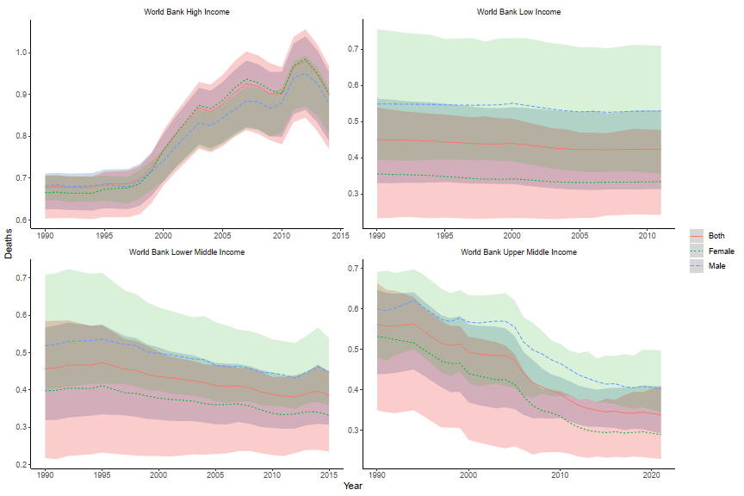Supplement Fig. 2 Temporal trend of global age-standardised mortality rate of inflammatory bowel disease in different World Bank income regions from 1990-2021

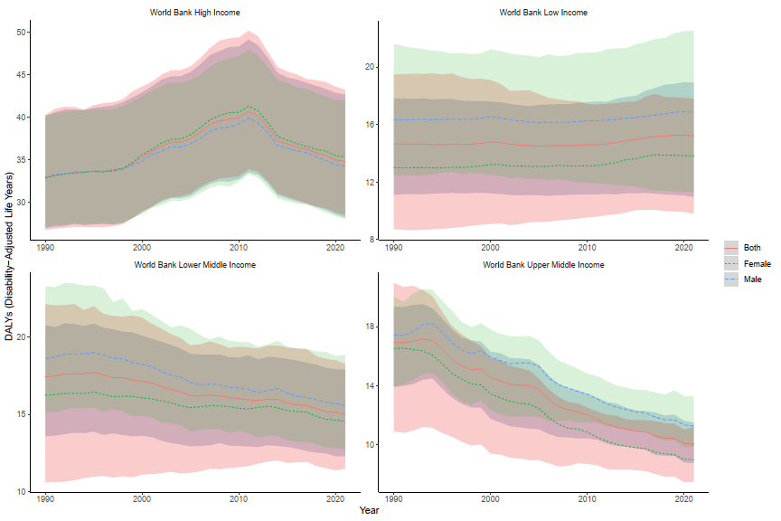Supplement Fig 3 Temporal trend of global age-standardised Disability-Adjusted Life Years (DALYs) of inflammatory bowel disease in different World Bank income regions from 1990-2021

