Supplementary material
Per- and polyfluoroalkyl substances (PFAS) Regulatory Frameworks, Sources, Occurrence, Fate, and Exposure: Trend, Concern, and Research Implication
Md Shahin Alam^{1*}, Gang Chen¹
Corresponding Author Email: ma23ch@fsu.edu
¹Department of Civil and Environmental Engineering, Florida State University, Tallahassee, FL 32310, USA

Bibliometric Analysis
This review article did citation analysis based on publication sources, encompassing 1,459 sources identified through our literature search. To streamline the analysis, a minimum threshold of five publications from a source was set, resulting in 198 articles meeting this criterion. Notably, the journal “Environmental Science & Technology” is the most prolific publisher, with 776 articles and a significant citation count of 58,448. Following closely, “Chemosphere” ranks as the second most prolific publisher, with 656 articles and 24,685 citations. “Science of the Total Environment” secures the third position, contributing 592 articles with a citation count 14,866. Additionally, several journals, including “Environmental International”, “Environmental Pollution”, “Environmental Health Perspectives”, “Journal of Hazardous Materials”, “Environmental Research”, “Water Research”, “Environmental Science and Pollution Research”, “Environmental Toxicology and Chemistry”, “Ecotoxicology and Environmental Safety”, and various chemical engineering journals, have collectively published over 100 research papers related to PFASs. Among these, “Environmental International”, “Environmental Pollution”, “Environmental Health Perspectives”, “Journal of Hazardous Materials”, and “Environmental Research” have emerged as leading journals actively publishing PFAS-related articles, and a frequent inter-citation pattern is observed among these publications (Figure 1-SM).
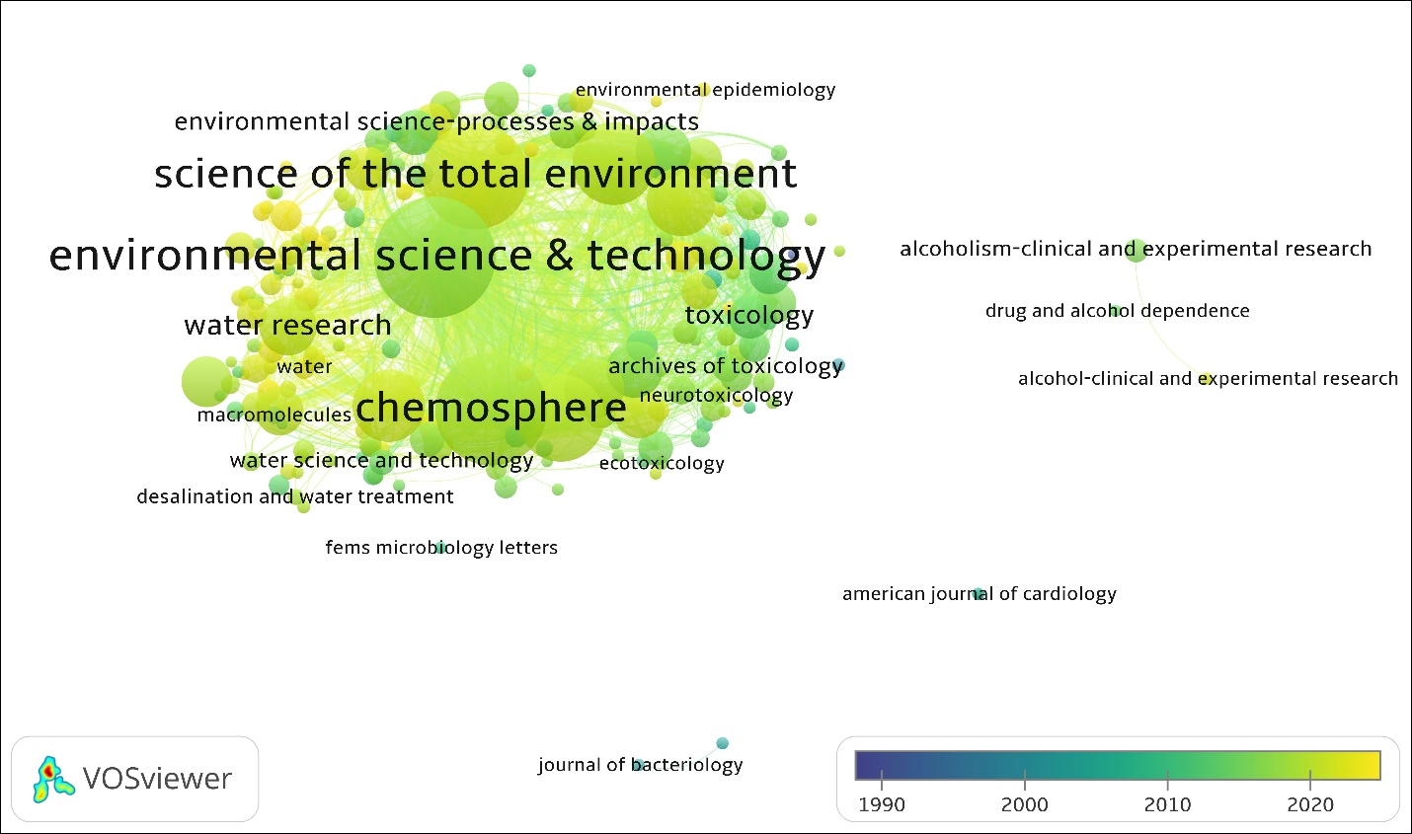
Figure 1-SM: corresponds to an analysis of bibliographic coupling of the most used journals published PFAS articles in the 1990–2023 period with Lin/log modularity.

Fate and Occurrence of PFAS
Table 1-SM displays the average concentrations of six PFAS compounds (PFOA, PFOS, PFNA, PFHxS, PFBS, and HFPO-DA/GenX) in ng/L from various studies aiming to meet USEPA standards for MCL and MCLG in drinking water. The data include surface water, groundwater, and drinking water samples from diverse global locations, such as China, the United States, and Norway. The results show significant variations in PFAS levels across different regions and sample types. For example, PFOA levels in Massachusetts groundwater were notably high at 608.88 ng/L (Barber et al., 2023), while they were much lower in Arizona groundwater at 0.02 ng/L (Canez et al., 2021). PFOS concentrations ranged from 0.14 ng/L in the South China Sea to 1342.33 ng/L in Massachusetts groundwater (Barber et al., 2023; Xiao et al., 2021). Additionally, some PFAS compounds were not detected (ND) in certain samples, highlighting the varying levels of contamination and the global concern over PFAS pollution in water sources. This dataset highlights the critical need for extensive monitoring efforts and regulatory measures to tackle PFAS contamination worldwide.

Table 1-SM: Average distribution of PFOA, PFOS, PFNA, PFHxS, PFBS & HFPO-DA/GenX (ng/L) in the studies reporting PFAS.
Source | Sample Types | Location | PFOA | PFOS | PFNA | PFHxS | PFBS | HFPO-DA/GenX
An et al., 2023 | Surface water | Jiulong River and Xiamen Bay regions, China | 3.9 | 2.52 | ~ | 0.2 | 3.28 | ~
Babayev et al., 2022 | Drinking water | Southeast Alaska, United States | 0.64 | 14.9 | 0.02 | 4.38 | 0.8 | ~
Barber et al., 2023 | Groundwater | Massachusetts, United States | 608.88 | 1342.33 | 18.11 | 751.75 | 32.78 | ~
Björnsdotter et al., 2021 | Surface snow | Svalbard & Jan Mayen, Arctic Norway | ~ | ~ | ~ | ~ | 0.54 | ~
Cáñez et al., 2021 | Groundwater | Arizona, United States | 0.02 | 0.09 | 0.007 | 0.02 | 0.011 | ~
Christie et al., 2023 | Groundwater | Military Bases, United States | 289 | 1925.5 | ND | 140 | ND | ND
da Silva et al., 2022 | Surface water | Florida, United States | 0.24 | 10.4 | 0.37 | 3.04 | 1.15 | ~
Desgens-Martin et al., 2023 | Surface water | California, United States | 104.84 | 20.7 | 9.65 | 23.6 | 73.78 | ND
Feng et al., 2023 | Surface water | Shandong province, Northern China | 313874.97 | 3.4 | 32 | 1.7 | 3.24 | 4466.1
Katz et al., 2022 | Surface water | Rhode Island, United States | 3 | ~ | ~ | 1 | 0.3 | ~
Khan et al., 2022 | Surface water | Central river system, Pakistan | 6.1 | 2.5 | 3.5 | 2.22 | 3.2 | ~
Liu et al., 2023 | Surface drinking water | Shandong Province, Eastern China | 17.55 | 1.5 | 0.65 | 1.3 | 1.77 | ~
Liu et al., 2022 | Groundwater | Central and Eastern Canada | 3500 | 92300 | 500 | 23700 | 3200 | ~
Liu et al., 2021 | Surface water | Yangtze River and Taihu Lake, China | 75.33 | 6.04 | ~ | 6.06 | 6.9 | ~
Ma et al., 2021 | Surface water | Jiangsu and Zhejiang Provinces, China | 8641.15 | 3179.7 | 219.24 | 303.6 | 12.4 | ~
MacInnis et al., 2022 | Surface water | Nunavut, Canada | 1.03 | 3.75 | 1.22 | 2.44 | 0.28 | ~
Martinez et al., 2022 | Surface water | Florida, United States | 0.41 | 0.98 | 0.14 | 0.24 | 0.35 | ~
McMahon et al., 2022 | Groundwater | Eastern United States | 3.6 | 8.9 | 2.71 | 3.36 | 2.47 | ~
Nguyen et al., 2022 | Surface water | Uppsala & Stockholm, Sweden | 14 | 67 | 0.5 | 41 | 5 | ~
Nickerson et al., 2021 | Groundwater | Military installation located, United States | 457772.5 | 568393.7 | 5805 | 168155 | 21723.8 | ~
Pétré et al., 2021 | Surface and Groundwater | North Carolina, United States | 6.1 | 33.7 | 12.3 | 5.3 | 6.5 | 460.7
Reinikainen et al., 2022 | Surface water | Finland | 456.7 | 6651.4 | 188.4 | 2384.04 | 520.4 | ~
Seay et al., 2023 | Potable water | Ohio, United States | 4.51 | 0.996 | 0.348 | 0.569 | 0.751 | 0.0457
Shiu et al., 2023 | Surface water | Taiwan | 0.94 | 1.59 | 0.13 | 0.61 | 0.36 | ~
Tang et al., 2022 | Surface water | Poyang Lake, China | 6.5 | 2.7 | 0.53 | 0.2 | 2.2 | 0.55
Tavasoli et al., 2021 | Surface water | New Hampshire, United States | 2.14 | 3.82 | ND | 1.32 | 1.92 | ~
Vitale et al., 2023 | Surface water | Michigan, United States | 1.03 | 5.58 | ND | 1.6 | 1.35 | ND
Viticoski et al., 2022 | Surface water | Alabama, United States | 6.87 | 8.32 | ~ | ~ | 47 | ~
Xiao et al., 2021 | Surface water | South China Sea | 0.72 | 0.14 | 0.09 | 0.11 | 0.17 | ~
ND= Not Detected

References
Barber, L. B., Pickard, H. M., Alvarez, D. A., Becanova, J., Keefe, S. H., LeBlanc, D. R., Lohmann, R., Steevens, J. A., & Vajda, A. M. (2023). Uptake of Per- and Polyfluoroalkyl Substances by Fish, Mussel, and Passive Samplers in Mobile-Laboratory Exposures Using Groundwater from a Contamination Plume at a Historical Fire Training Area, Cape Cod, Massachusetts. Environmental Science & Technology, 57(7), 5544-5557. https://doi.org/10.1021/acs.est.2c06500
Canez, T. T., Guo, B., McIntosh, J. C., & Brusseau, M. L. (2021). Perfluoroalkyl and polyfluoroalkyl substances (PFAS) in groundwater at a reclaimed water recharge facility. Science of the Total Environment, 791, Article 147906. https://doi.org/10.1016/j.scitotenv.2021.147906
Xiao, S. K., Wu, Q., Pan, C. G., Yin, C., Wang, Y. H., & Yu, K. F. (2021). Distribution, partitioning behavior and potential source of legacy and alternative per- and polyfluoroalkyl substances (PFASs) in water and sediments from a subtropical Gulf, South China Sea. Environmental Research, 201, Article 111485. https://doi.org/10.1016/j.envres.2021.111485

