Supplemental Figures & Tables.
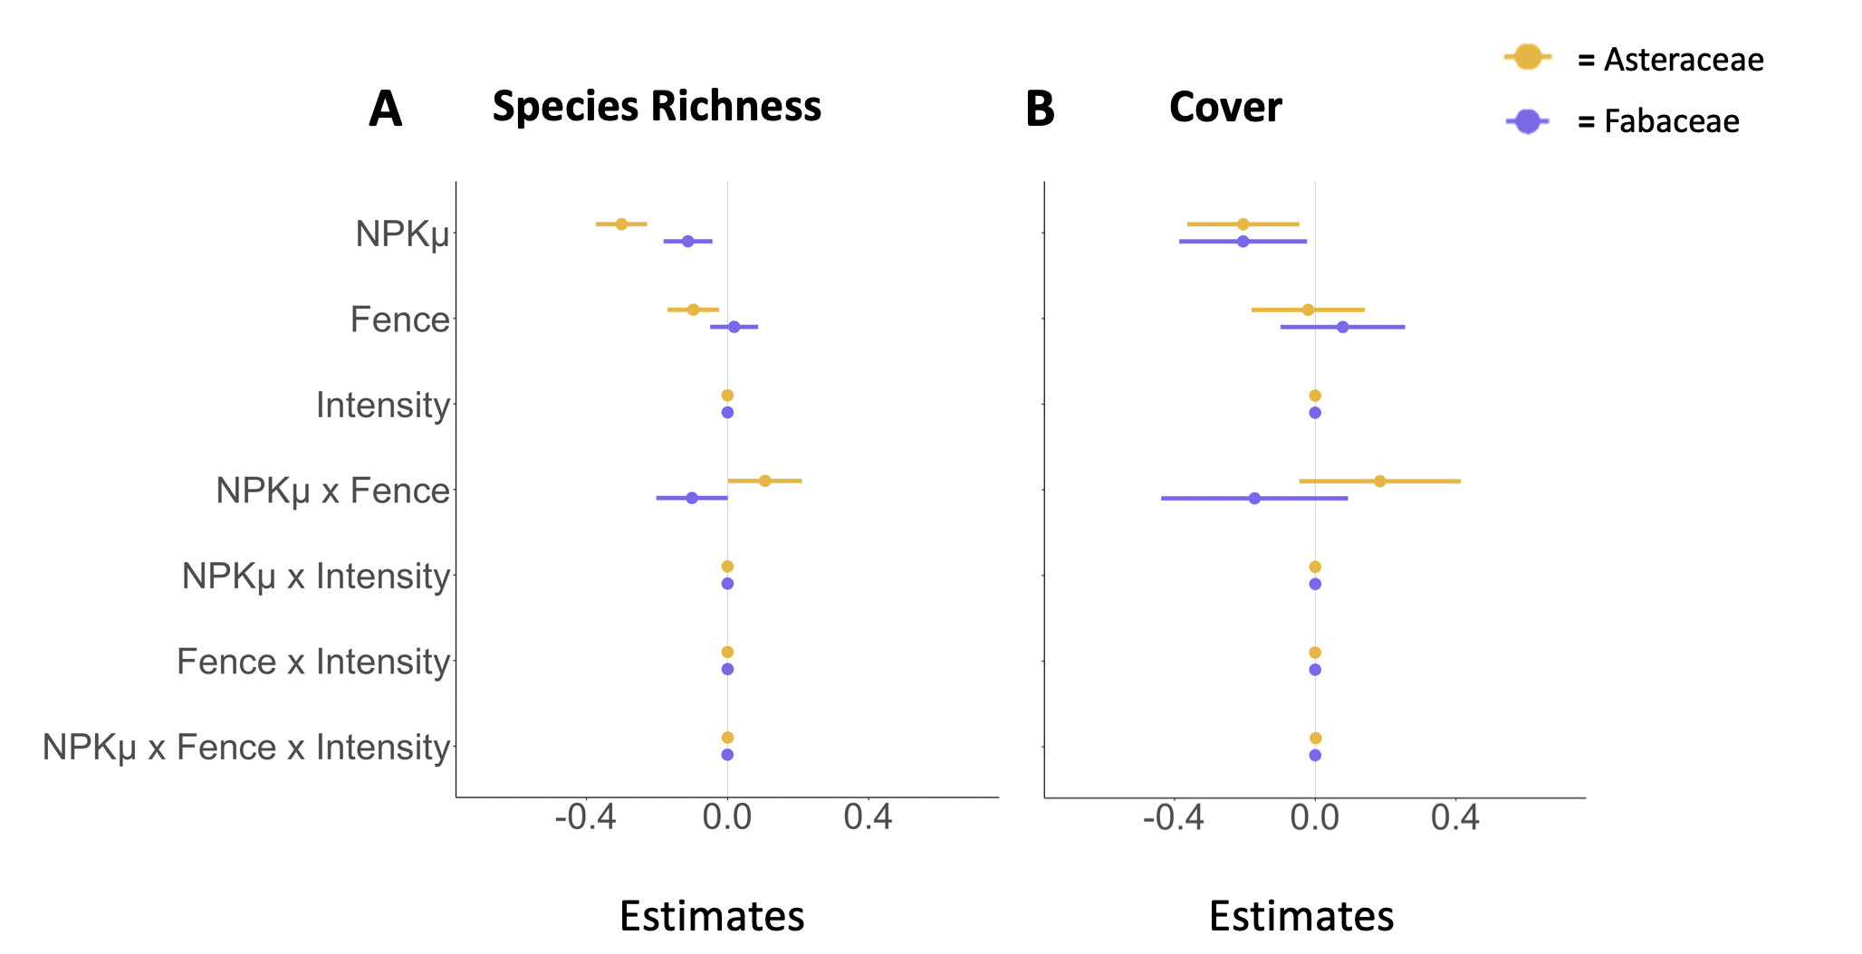

Figure S1. The effect of the fencing x fertilization experiment and herbivore intensity on (A) Species Richness and (B) Cover for Asteraceae (yellow) and Fabaceae (indigo). Model estimates of log response ratios for the effect of different treatments are shown relative to the control treatment (estimate =0). Binary response variables were converted to log response variables to account for the change from pre-treatment to current data and cover data were normalized relative to maximum plot cover. Fence refers to herbivore exclusion fencing. NPK$μ$ refers to the nitrogen, phosphorus and potassium with micronutrients treatment.

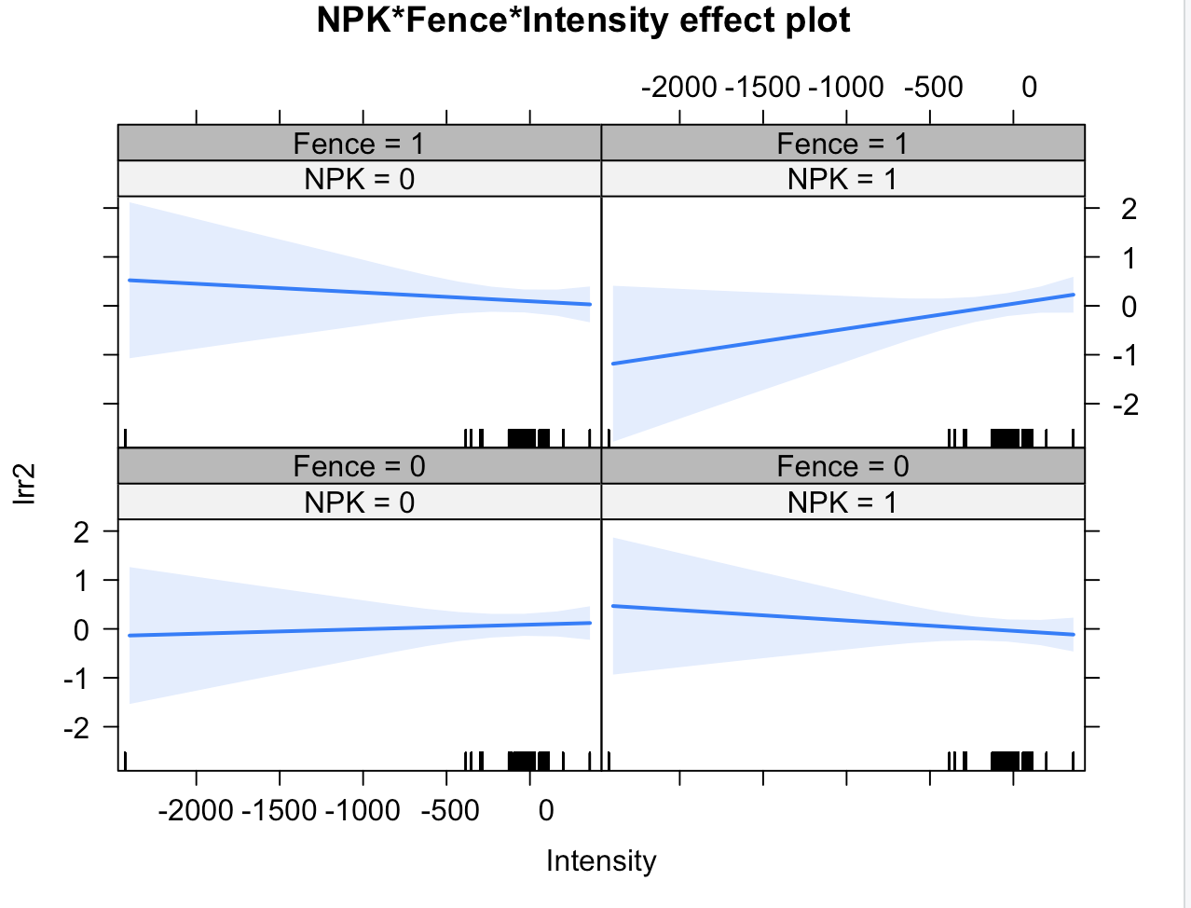^{1,2}
Figure S2. Three-way-interaction plots for the effect of fencing, NPKμ fertilization, and herbivore intensity on forb cover log response ratio. A more negative value for herbivore intensity corresponds to greater herbivore intensity.

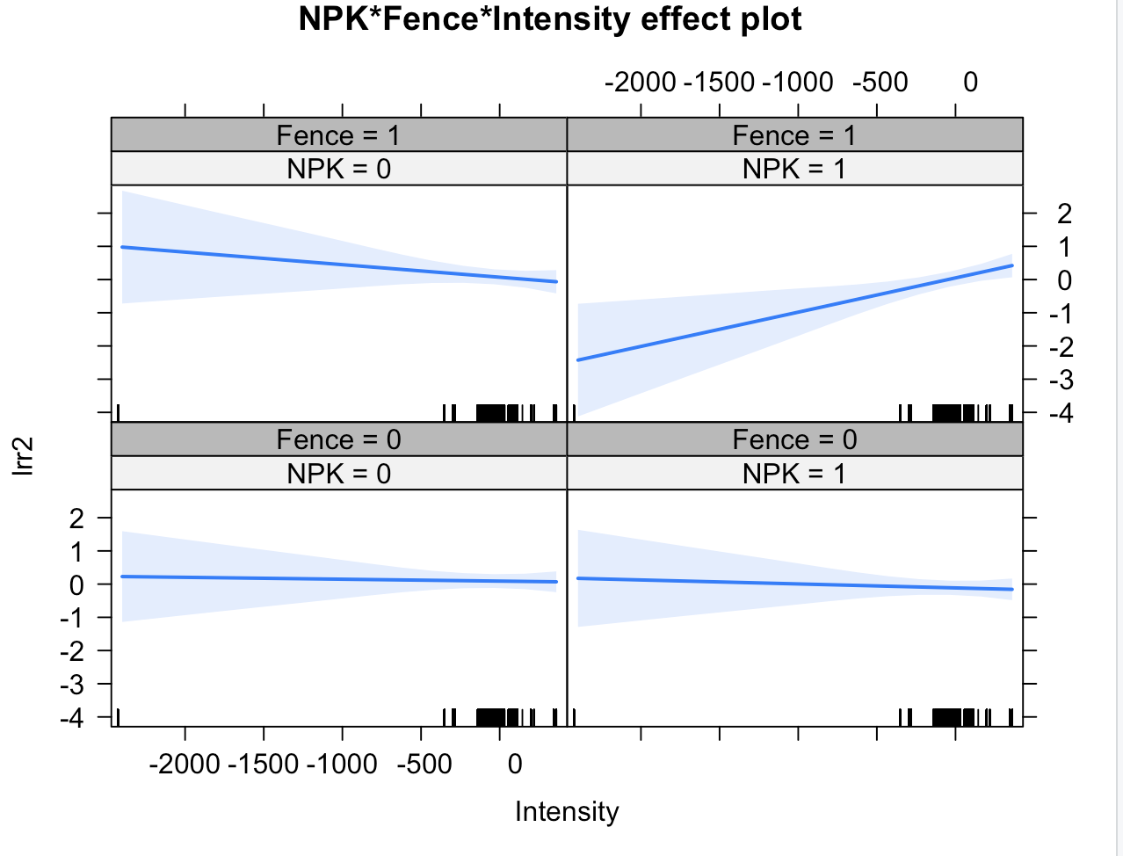
Figure S3. Three-way-interaction plots for the effect of fencing, NPKμ fertilization, and herbivore intensity on Asteraceae cover log response ratio. A more negative value for herbivore intensity corresponds to greater herbivore intensity.

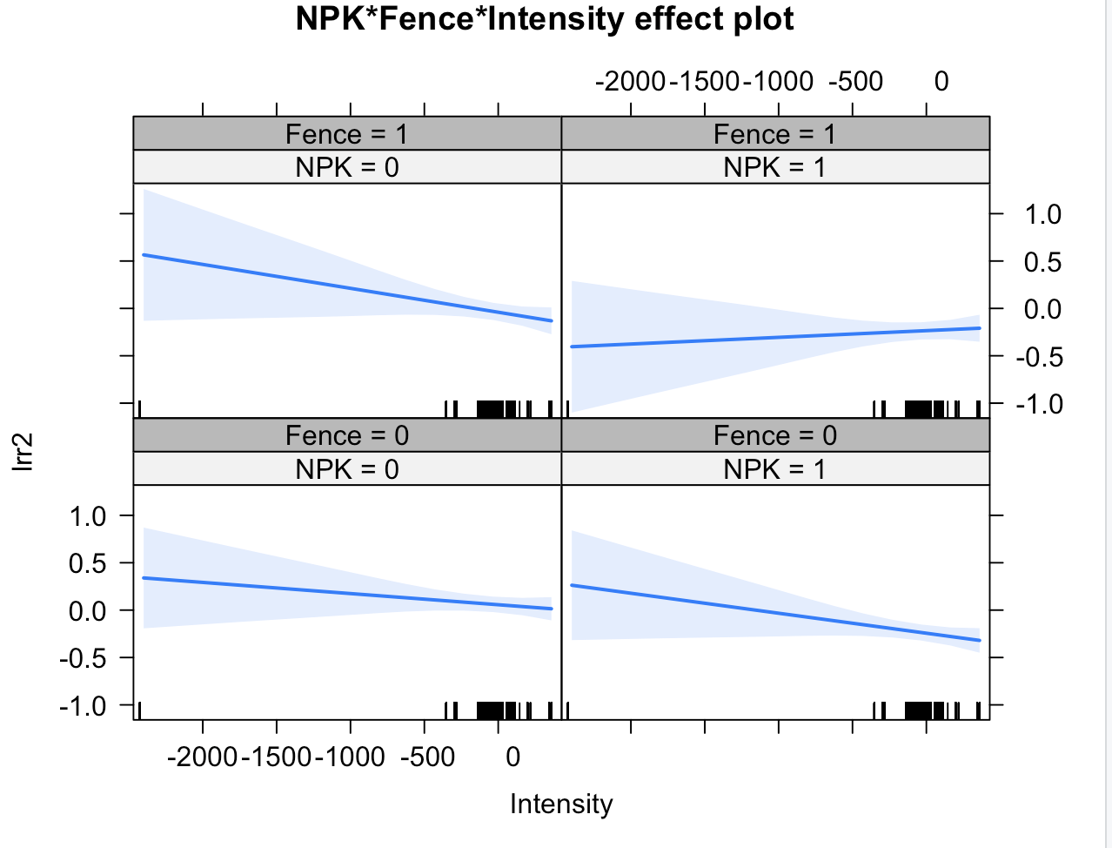

Figure S4. Three-way-interaction plots for the effect of fencing, NPKμ fertilization, and herbivore intensity on Asteraceae richness log response ratio. A more negative value for herbivore intensity corresponds to greater herbivore intensity.

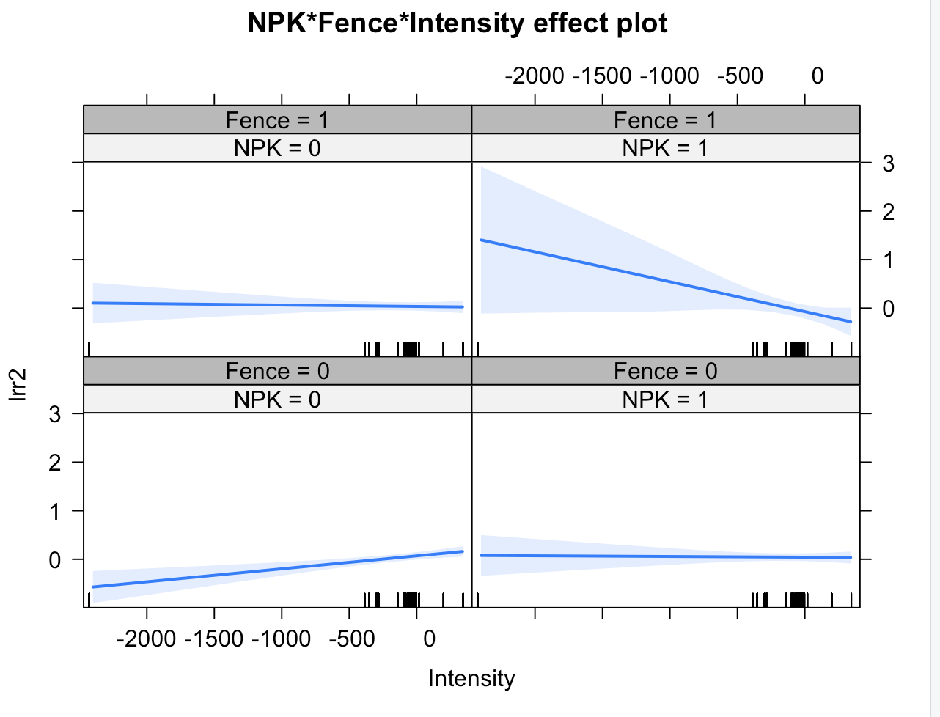
Figure S5. Three-way-interaction plots for the effect of fencing, NPKμ fertilization, and herbivore intensity on Polygonaceae richness log response ratio. A more negative value for herbivore intensity corresponds to greater herbivore intensity.

Table S1. Effects of fertilization on cover and richness of key floral families. Mixed effects model results for the effects of fertilization by nutrient type on Asteraceae Richness, Asteraceae Cover, Fabaceae Richness, Fabaceae Cover, Geraniaceae Richness, Geraniaceae Cover, Apiaceae Richness, Apiaceae Cover, Polygonaceae Richness, Polygonaceae Cover. All response variables were calculated using LRRs. The intercept is the mean value of the unfenced and unfertilized control plots. The parenthetical numbers are the confidence interval. * p<0.05 ** p<0.01 *** p<0.001

 | Asteraceae Richness |  | Asteraceae Cover |  | Fabaceae Richness |  | Fabaceae Cover |  | Geraniaceae Richness |  | Geraniaceae Cover
Predictors | Estimates | t-value;  p-value | Estimates | t-value;  p-value | Estimates | t-value;  p-value | Estimates | t-value;  p-value | Estimates | t-value;  p-value | Estimates | t-value;  p-value
Intercept | 0.05  (-0.02 – 0.11) | 1.36;  0.174 | 0.05  (-0.11 – 0.20) | 0.56;  0.574 | -0.04  (-0.09 – 0.02) | -1.27;  0.204 | 0.20 *  (0.01 – 0.40) | 2.09;  0.037 | 0.07  (-0.01 – 0.15) | 1.64;  0.101 | 0.19  (-0.27 – 0.66) | 0.81;  0.417
N | -0.14 ***  (-0.20 – -0.08) | -4.49;  <0.001 | -0.04  (-0.11 – 0.03) | -1.13;  0.258 | -0.05  (-0.11 – 0.01) | -1.53;  0.127 | -0.56 ***  (-0.65 – -0.47) | -11.90;  <0.001 | 0.03  (-0.04 – 0.09) | 0.84;  0.401 | 0.03  (-0.16 – 0.22) | 0.33;  0.739
P | -0.12 ***  (-0.18 – -0.06) | -3.96;  <0.001 | -0.07 *  (-0.14 – -0.01) | -2.15;  0.032 | 0.08 **  (0.02 – 0.14) | 2.58;  0.010 | 0.17 ***  (0.08 – 0.26) | 3.61;  <0.001 | -0.10 **  (-0.16 – -0.04) | -3.17;  0.002 | 0.12  (-0.07 – 0.32) | 1.28;  0.199
Kμ | -0.06 *  (-0.12 – -0.01) | -2.13;  0.033 | -0.07 *  (-0.14 – -0.00) | -1.99;  0.046 | 0.02  (-0.04 – 0.08) | 0.66;  0.508 | 0.15 **  (0.06 – 0.24) | 3.23;  0.001 | -0.00  (-0.06 – 0.06) | -0.13;  0.900 | -0.32 ***  (-0.52 – -0.13) | -3.32;  0.001
N × P | 0.07  (-0.01 – 0.16) | 1.62;  0.106 |  |  | -0.09 *  (-0.18 – -0.00) | -1.98;  0.047 |  |  | 0.07  (-0.02 – 0.16) | 1.44;  0.149
N × Kμ | 0.00  (-0.08 – 0.09) | 0.04;  0.971 |  |  | -0.07  (-0.16 – 0.02) | -1.57;  0.116 |  |  | -0.04  (-0.13 – 0.05) | -0.85;  0.395
P × Kμ | 0.04  (-0.05 – 0.12) | 0.82;  0.410 |  |  | -0.04  (-0.12 – 0.05) | -0.80;  0.424 |  |  | 0.09  (-0.00 – 0.18) | 1.85;  0.064
N × P × Kμ | -0.02  (-0.14 – 0.10) | -0.35;  0.726 |  |  | 0.06  (-0.07 – 0.19) | 0.93;  0.354 |  |  | -0.06  (-0.20 – 0.07) | -0.97;  0.332

Random Effects
σ² | 0.26 | 1.23 | 0.17 | 1.54 | 0.07 | 2.01
τ₀₀ | 0.22 _{block} | 0.60 _{block} | 0.13 _{block} | 0.66 _{block} | 0.14 _{block} | 0.93 _{block}
 | 0.13 _{site_code} | 0.34 _{site_code} | 0.10 _{site_code} | 0.30 _{site_code} | 0.08 _{site_code} | 0.24 _{site_code}
N | 6 _{block} | 6 _{block} | 6 _{block} | 6 _{block} | 5 _{block} | 5 _{block}
 | 81 _{site_code} | 81 _{site_code} | 70 _{site_code} | 70 _{site_code} | 21 _{site_code} | 21 _{site_code}
Observations | 10951 | 10951 | 5900 | 5900 | 1774 | 1774

 | Apiaceae Richness |  | Apiaceae Cover |  | Polygonaceae Richness |  | Polygonaceae Cover
Predictors | Estimates | t-value;  p-value | Estimates | t-value;  p-value | Estimates | t-value;  p-value | Estimates | t-value;  p-value
Intercept | 0.02  (-0.03 – 0.07) | 0.80;  0.424 | 0.33 *  (0.03 – 0.63) | 2.18;  0.029 | 0.01  (-0.05 – 0.08) | 0.44;  0.663 | 0.13  (-0.12 – 0.37) | 0.99;  0.321
N | -0.04  (-0.10 – 0.02) | -1.20;  0.231 | -0.16  (-0.36 – 0.03) | -1.65;  0.100 | -0.00  (-0.08 – 0.08) | -0.05;  0.963 | 0.34 ***  (0.16 – 0.52) | 3.62;  <0.001
P | -0.00  (-0.06 – 0.06) | -0.05;  0.962 | 0.08  (-0.11 – 0.28) | 0.85;  0.396 | 0.02  (-0.06 – 0.10) | 0.56;  0.576 | 0.05  (-0.13 – 0.24) | 0.58;  0.563
Kμ | 0.04  (-0.02 – 0.10) | 1.36;  0.173 | 0.01  (-0.19 – 0.20) | 0.06;  0.956 | -0.05  (-0.13 – 0.03) | -1.32;  0.189 | -0.19 *  (-0.38 – -0.01) | -2.08;  0.037
N × P | 0.04  (-0.05 – 0.13) | 0.86;  0.390 |  |  | 0.01  (-0.10 – 0.12) | 0.15;  0.884
N × Kμ | 0.01  (-0.08 – 0.11) | 0.32;  0.752 |  |  | 0.04  (-0.07 – 0.15) | 0.73;  0.463
P × Kμ | -0.05  (-0.14 – 0.03) | -1.20;  0.231 |  |  | 0.01  (-0.10 – 0.12) | 0.19;  0.852
N × P × Kμ | 0.02  (-0.10 – 0.15) | 0.36;  0.719 |  |  | -0.02  (-0.18 – 0.14) | -0.21;  0.836

Random Effects
σ² | 0.05 | 1.76 | 0.10 | 2.06
τ₀₀ | 0.07 _{block} | 0.58 _{block} | 0.09 _{block} | 0.40 _{block}
 | 0.08 _{site_code} | 0.34 _{site_code} | 0.06 _{site_code} | 0.36 _{site_code}
N | 5 _{block} | 5 _{block} | 5 _{block} | 5 _{block}
 | 35 _{site_code} | 35 _{site_code} | 33 _{site_code} | 33 _{site_code}
Observations | 1888 | 1888 | 2354 | 2354

Table S2. Effects of fertilization by fencing and herbivore intensity on cover and richness of key floral families. Mixed effects model results for the effects of fertilization by herbivore exclusion via fencing on Asteraceae Richness, Asteraceae Cover, Fabaceae Richness, Fabaceae Cover, Geraniaceae Richness, Geraniaceae Cover, Apiaceae Richness, Apiaceae Cover, Polygonaceae Richness, Polygonaceae Cover. . The intercept is the mean value of the unfenced and unfertilized control plots. All response variables were calculated using LRRs. The parenthetical numbers are the confidence interval. * p<0.05 ** p<0.01 *** p<0.001

 | Asteraceae Richness |  |  | Asteraceae Cover |  | Fabaceae Richness |  | Fabaceae Cover |  | Geraniaceae Richness |  | Geraniaceae Cover
Predictors | Estimates | t-value;  p-value |  | Estimates | t-value;  p-value | Estimates | t-value;  p-value | Estimates | t-value;  p-value | Estimates | t-value;  p-value | Estimates | t-value;  p-value
Intercept | 0.06  (-0.02 – 0.14) | 1.40;  0.161 |  | 0.09  (-0.11 – 0.29) | 0.88;  0.379 | -0.02  (-0.08 – 0.05) | -0.52;  0.604 | 0.03  (-0.25 – 0.31) | 0.22;  0.828 | 0.03  (-0.05 – 0.10) | 0.68;  0.495 | -0.06  (-0.55 – 0.43) | -0.24;  0.809
NPKμ | -0.30 ***  (-0.37 – -0.23) | -8.13;  <0.001 |  | -0.20 *  (-0.36 – -0.05) | -2.52;  0.012 | -0.11 **  (-0.18 – -0.04) | -3.18;  0.002 | -0.21 *  (-0.39 – -0.02) | -2.21;  0.027 | -0.03  (-0.11 – 0.05) | -0.80;  0.424 | -0.22  (-0.63 – 0.19) | -1.06;  0.289
Fence | -0.10 **  (-0.17 – -0.02) | -2.60;  0.009 |  | -0.02  (-0.18 – 0.14) | -0.24;  0.807 | 0.02  (-0.05 – 0.09) | 0.53;  0.593 | 0.08  (-0.10 – 0.26) | 0.87;  0.386 | -0.01  (-0.09 – 0.06) | -0.28;  0.782 | -0.17  (-0.56 – 0.22) | -0.84;  0.403
Intensity | -0.00  (-0.00 – 0.00) | -1.03;  0.308 |  | -0.00  (-0.00 – 0.00) | -0.19;  0.847 | 0.00  (-0.00 – 0.00) | 0.05;  0.962 | -0.00  (-0.00 – 0.00) | -1.03;  0.308 | -0.00  (-0.00 – 0.00) | -0.17;  0.871 | -0.00  (-0.01 – 0.00) | -0.34;  0.740
NPKμ × Fence | 0.11 *  (0.00 – 0.21) | 1.99;  0.046 |  | 0.18  (-0.05 – 0.41) | 1.57;  0.116 | -0.10  (-0.20 – 0.00) | -1.96;  0.051 | -0.17  (-0.44 – 0.09) | -1.27;  0.204 | -0.01  (-0.12 – 0.11) | -0.11;  0.915 | 0.95 **  (0.37 – 1.54) | 3.22;  0.001
NPKμ × Intensity | -0.00  (-0.00 – 0.00) | -0.84;  0.402 |  | -0.00  (-0.00 – 0.00) | -0.26;  0.799 | -0.00  (-0.00 – 0.00) | -0.59;  0.554 | 0.00  (-0.00 – 0.00) | 0.41;  0.680 | -0.00  (-0.00 – 0.00) | -0.75;  0.451 | 0.00  (-0.00 – 0.01) | 1.67;  0.094
Fence × Intensity | -0.00  (-0.00 – 0.00) | -0.97;  0.331 |  | -0.00  (-0.00 – 0.00) | -1.04;  0.296 | 0.00  (-0.00 – 0.00) | 0.64;  0.521 | -0.00  (-0.00 – 0.00) | -0.53;  0.594 | 0.00  (-0.00 – 0.00) | 0.18;  0.861 | 0.00  (-0.00 – 0.01) | 1.41;  0.159
NPKμ × Fence ×  Intensity | 0.00 *  (0.00 – 0.00) | 2.14;  0.033 |  | 0.00 ***  (0.00 – 0.00) | 3.44;  0.001 | -0.00  (-0.00 – 0.00) | -1.35;  0.176 | -0.00  (-0.00 – 0.00) | -0.11;  0.910 | 0.00  (-0.00 – 0.00) | 0.18;  0.857 | -0.01  (-0.01 – 0.00) | -1.62;  0.105
σ² | 0.27 |  | 1.26 |  |  | 0.17 |  | 1.35 |  | 0.07 |  | 1.89
τ₀₀ | 0.22 _{block} |  | 0.60 _{block} |  |  | 0.07 _{block} |  | 0.78 _{block} |  | 0.09 _{block} |  | 0.72 _{block}
 | 0.15 _{site_code} |  | 0.41 _{site_code} |  |  | 0.18 _{site_code} |  | 0.64 _{site_code} |  | 0.07 _{site_code} |  | 0.49 _{site_code}
N | 6 _{block} |  | 6 _{block} |  |  | 6 _{block} |  | 6 _{block} |  | 5 _{block} |  | 5 _{block}
 | 63 _{site_code} |  | 63 _{site_code} |  |  | 55 _{site_code} |  | 55 _{site_code} |  | 18 _{site_code} |  | 18 _{site_code}
Observations | 4223 |  | 4223 |  |  | 2336 |  | 2336 |  | 778 |  | 778

 | Apiaceae Richness |  | Apiaceae Cover |  | Polygonaceae Richness |  | Polygonaceae Cover
Predictors | Estimates | t-value;  p-value | Estimates | t-value;  p-value | Estimates | t-value;  p-value | Estimates | t-value;  p-value
Intercept | 0.01  (-0.06 – 0.09) | 0.40;  0.689 | 0.19  (-0.33 – 0.70) | 0.27;  0.476 | 0.07  (-0.01 – 0.15) | 1.73;  0.084 | -0.03  (-0.46 – 0.39) | -0.16;  0.872
NPKμ | 0.02  (-0.04 – 0.08) | 0.62;  0.533 | 0.23  (-0.25 – 0.70) | 0.93;  0.354 | -0.03  (-0.12 – 0.07) | -0.56;  0.574 | 0.23  (-0.25 – 0.71) | 0.95;  0.344
Fence | 0.00  (-0.06 – 0.06) | 0.05;  0.959 | 0.40  (-0.09 – 0.88) | 1.60;  0.109 | -0.04  (-0.14 – 0.07) | -0.68;  0.495 | -0.30  (-0.80 – 0.20) | -1.18;  0.238
Intensity | -0.00  (-0.00 – 0.00) | -0.20;  0.843 | -0.00  (-0.01 – 0.00) | -0.49;  0.632 | 0.00 **  (0.00 – 0.00) | 3.60;  0.001 | 0.00  (-0.00 – 0.00) | 0.35;  0.729
NPKμ × Fence | -0.00  (-0.10 – 0.09) | -0.07;  0.941 | -0.39  (-1.10 – 0.32) | -1.07;  0.284 | -0.08  (-0.23 – 0.07) | -1.02;  0.309 | 0.98 *  (0.23 – 1.73) | 2.56;  0.011
NPKμ × Intensity | 0.00  (-0.00 – 0.00) | 0.07;  0.945 | -0.00  (-0.01 – 0.00) | -1.28;  0.201 | -0.00 **  (-0.00 – -0.00) | -2.75;  0.006 | -0.00  (-0.00 – 0.00) | -0.17;  0.866
Fence × Intensity | -0.00  (-0.00 – 0.00) | -0.65;  0.513 | -0.00  (-0.01 – 0.00) | -0.50;  0.619 | -0.00 **  (-0.00 – -0.00) | -2.92;  0.004 | -0.00  (-0.00 – 0.00) | -1.12;  0.263
NPKμ × Fence ×  Intensity | 0.00  (-0.00 – 0.00) | 0.29;  0.773 | 0.00  (-0.00 – 0.01) | 0.86;  0.390 | -0.00  (-0.00 – 0.00) | -0.86;  0.390 | 0.00  (-0.00 – 0.01) | 1.74;  0.082
σ² | 0.04 |  | 1.94 |  | 0.10 |  | 2.36
τ₀₀ | 0.12 _{block} |  | 0.81 _{block} |  | 0.09 _{block} |  | 0.55 _{block}
 | 0.04 _{site_code} |  | 0.00 _{site_code} |  | 0.07 _{site_code} |  | 0.53 _{site_code}
N | 5 _{block} |  | 5 _{block} |  | 5 _{block} |  | 5 _{block}
 | 22 _{site_code} |  | 22 _{site_code} |  | 26 _{site_code} |  | 26 _{site_code}
Observations | 788 |  | 788 |  | 954 |  | 954

