Supplementary Figure 1. Quality assessment of included trials.
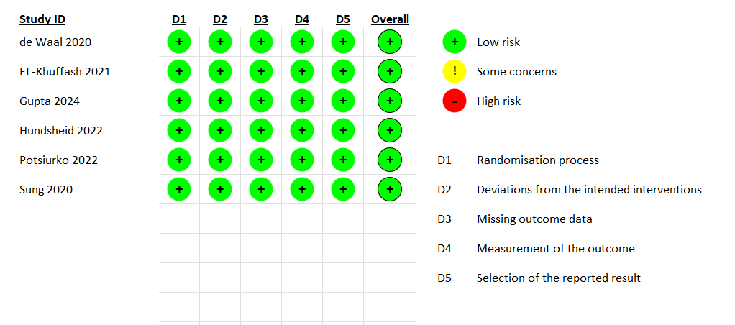

Supplementary Figure 2. Effect of conservative management on the incidence of necrotizing enterocolitis.
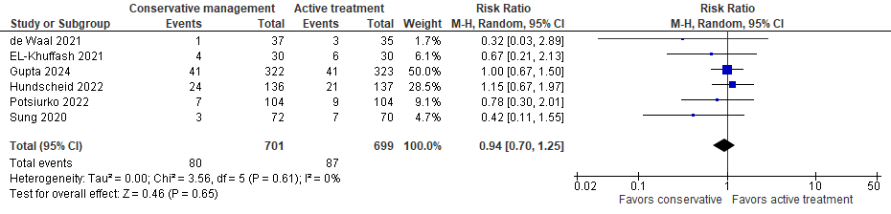

Supplementary Figure 3. Effect of conservative management on the incidence of intraventricular hemorrhage.
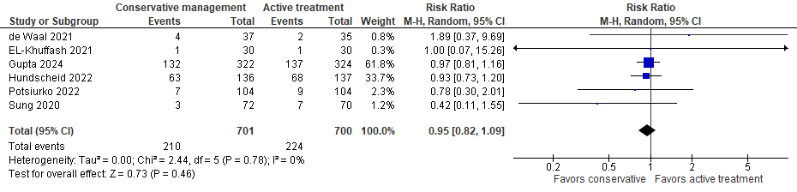
Supplementary Figure 4. Effect of conservative management on the incidence of retinopathy of prematurity.
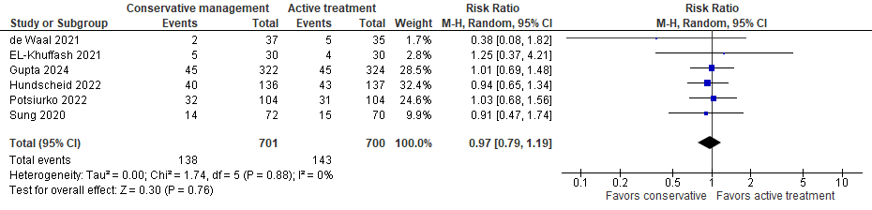
Supplementary Figure 5. Effect of conservative management on the incidence of sepsis.
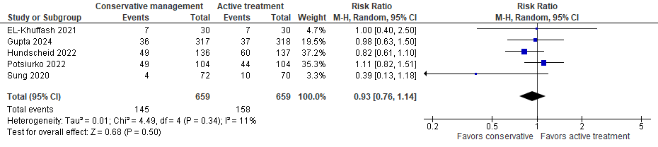
Supplementary Figure 6. Effect of conservative management on the incidence of pulmonary hemorrhage.
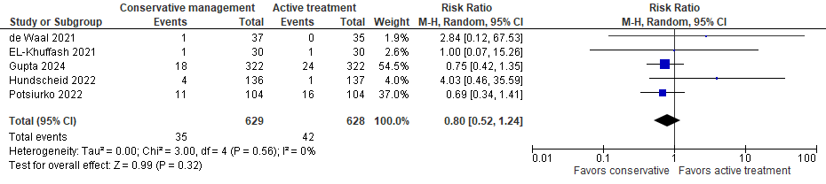
Supplementary Figure 7. Effect of conservative management on the proportion of infants requiring surgical PDA ligation or transcatheter occlusion.
