Appendix
Figure A1. Classification of States and Union Territories in India by level of development
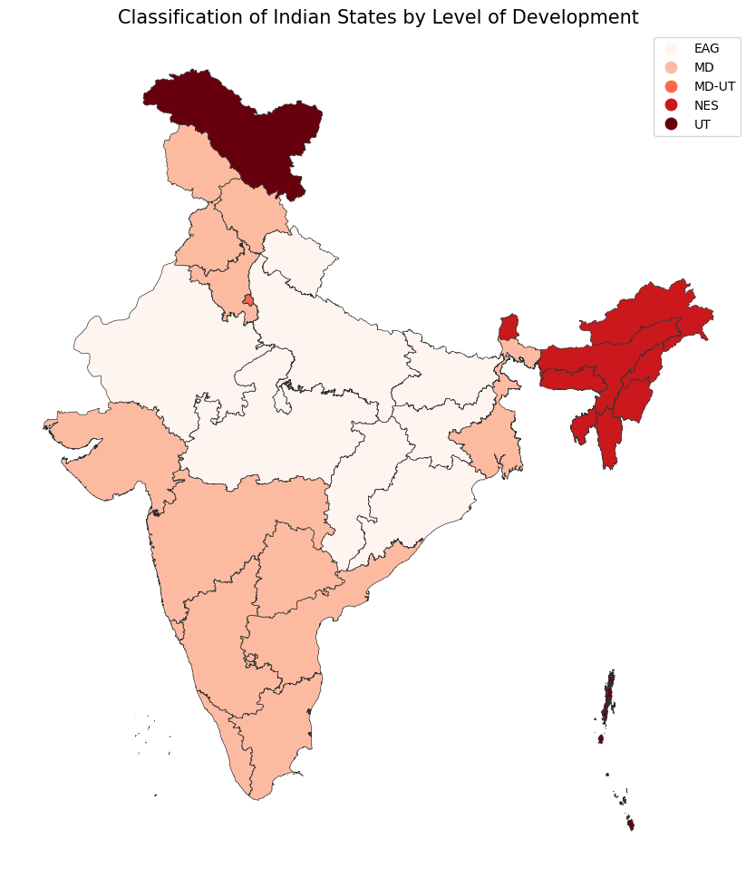
Note: EAG – Empowered Action Group States Group (Bihar, Chhattisgarh, Jharkhand, Madhya Pradesh, Odisha, Rajasthan, Uttar Pradesh and Uttarakhand); NES – Northeast States (Arunachal Pradesh, Assam, Manipur, Meghalaya, Mizoram, Nagaland, Sikkim, and Tripura); MD – More Developed States (Andhra Pradesh, Goa, Gujarat, Haryana, Himachal Pradesh, Karnataka, Kerala, Maharashtra, Punjab, Tamil Nadu, Telangana, West Bengal) ; UT – Union Territories (Dadra and Nagar Haveli and Daman & Diu, Jammu & Kashmir, Ladakh., Chandigarh., Puducherry, Lakshadweep., Andaman and Nicobar Islands); MD-UT – More Developed Union Territory (Delhi).

Table A1. Fixed effects Poisson regression results predicting outlier-adjusted change in suicides (with a population offset) as a function of the decriminalization of suicide in 16 less developed Indian states, 2001-2020.

 | Less developed states
Covariates | IRR (95% CI)
Decriminalization of suicide
Before 2018 | --
2018 and after | 1.856 (1.028 – 3.363)**
Infant mortality (per 1,000 live births) | 1.004 (0.997 – 1.011)
Gross state domestic product per capita (Indian rupees) | 1.000 (0.999 – 1.000)
Literacy rate (%) | 0.978 (0.946 – 1.011)
N (# of states) | 310 (16)
*p<0.1; **p<0.05; ***p<0.001
N represents state-year combinations
State and year indicators included but not shown

Figure A2. Suicides (per 100,000 population) among men and women in all 35 states and Union Territories in India (A) and by level of state development (B) from 2001 – 2020. The vertical line indicates the decriminalization of suicide in 2018.
- All states
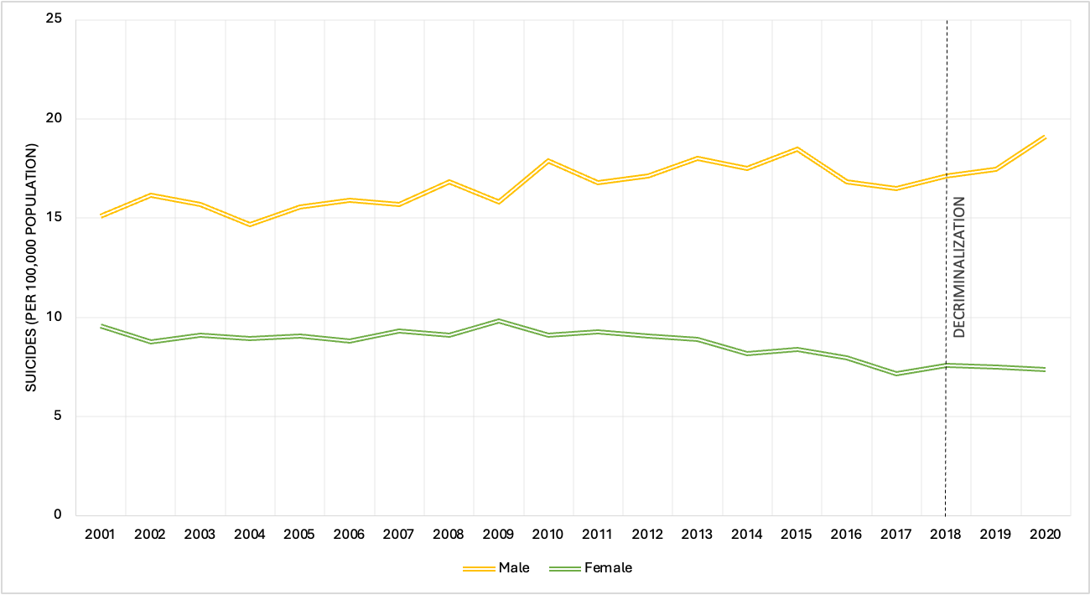
- By level of state development
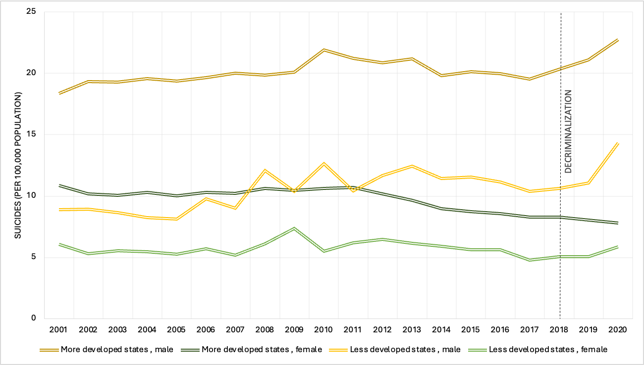

Table A2. Fixed effects Poisson regression results predicting change in suicides among males and females (with a population offset) as a function of the decriminalization of suicide in 35 Indian states, 2001-2020.

 | Male suicides | Female suicides
Covariates | IRR (95% CI) | IRR (95% CI)
Decriminalization of suicide | 1.293 (0.582 - 2.874) | 0.645 (0.346 - 1.202)
Infant mortality (per 1,000 live births) | 0.999 (0.985 - 1.012) | 0.995 (0.985 - 1.004)
Gross state domestic product per capita (Indian rupees) | 1.000 (0.999 - 1.000) | 0.999 (0.999 - 1.000)
Literacy rate (%) | 0.992 (0.948 - 1.039) | 1.001 (0.965 - 1.039)
N (# of states) | 620 (31) | 620 (31)
*p<0.1; **p<0.05; ***p<0.001
N represents state-year combinations
State and year indicators included but not shown

