Supplementary Material:

Figure 3: Kaplan-Meier survival curve, univariate analysis for radiation dosing A) entire cohort, B) age ≤3years, C) STR, and D) WHO grade 3
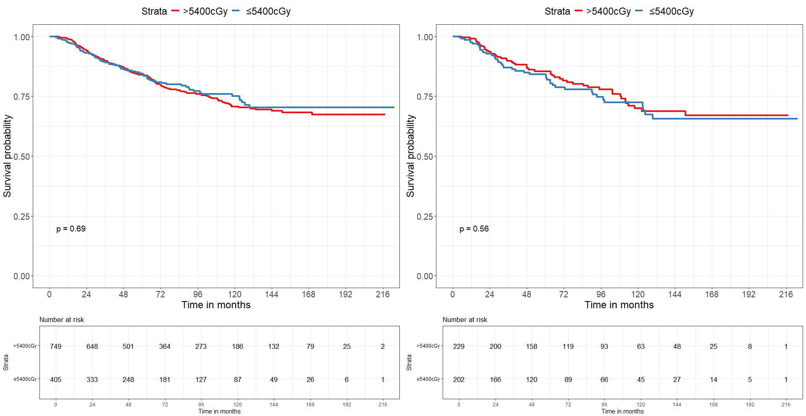

B

A

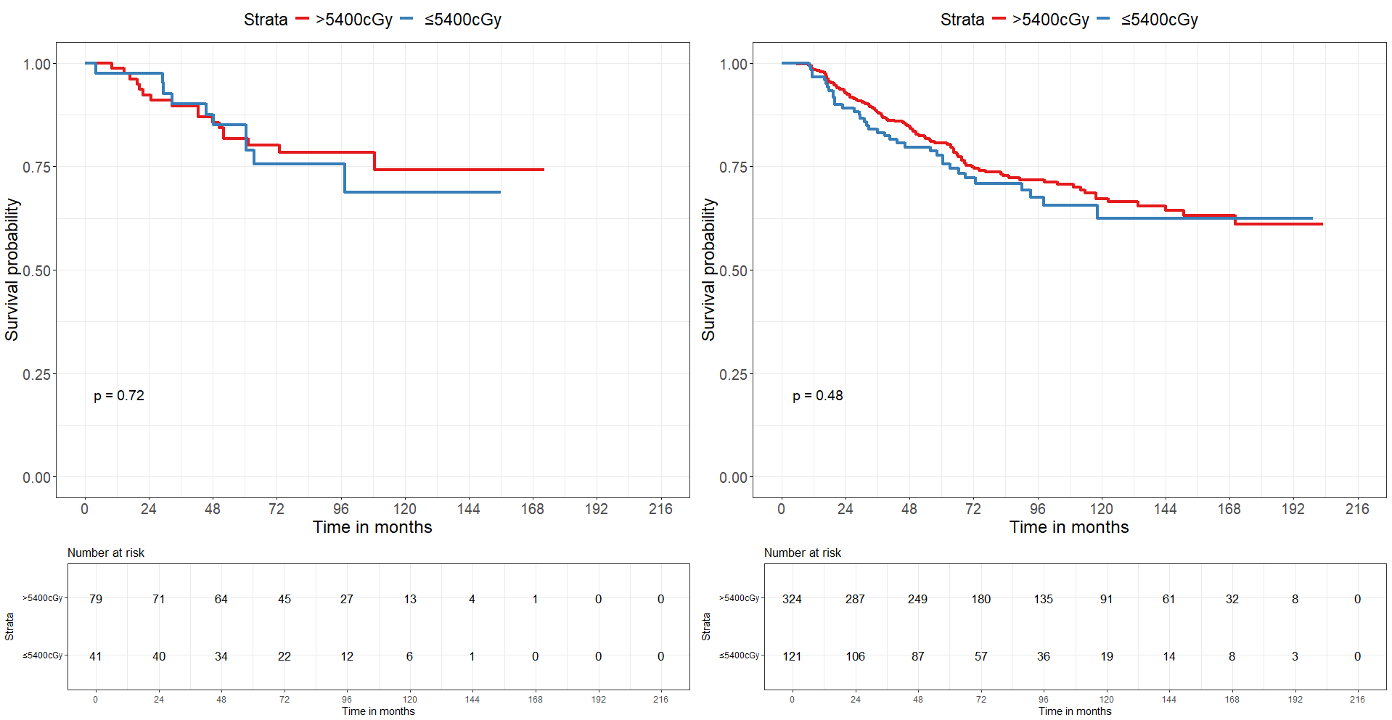

C

D

Abbreviations: World Health Organization (WHO), Subtotal resection (STR), Centigray (cGy)
Figure 4: Adjusted survival curve, multivariate analysis, for A) Radiation dosing B) radiation dosing and age C) radiation dosing and surgical extent, and D) radiation dosing and grade
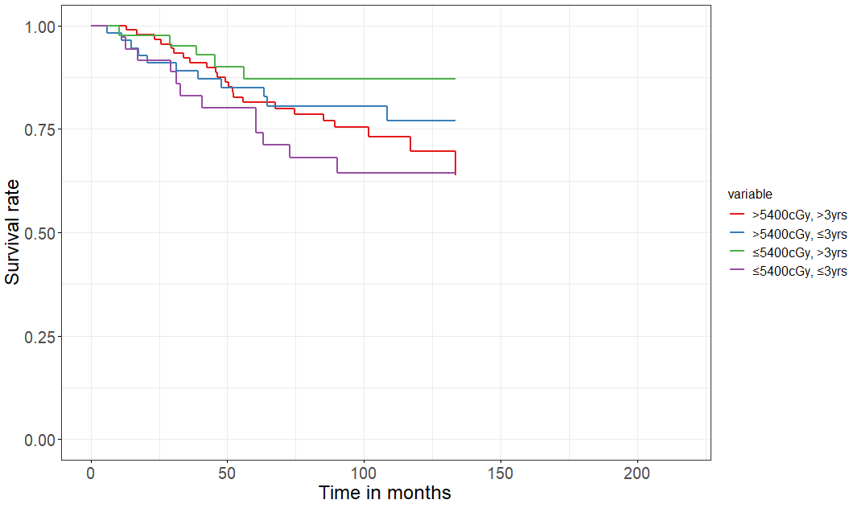
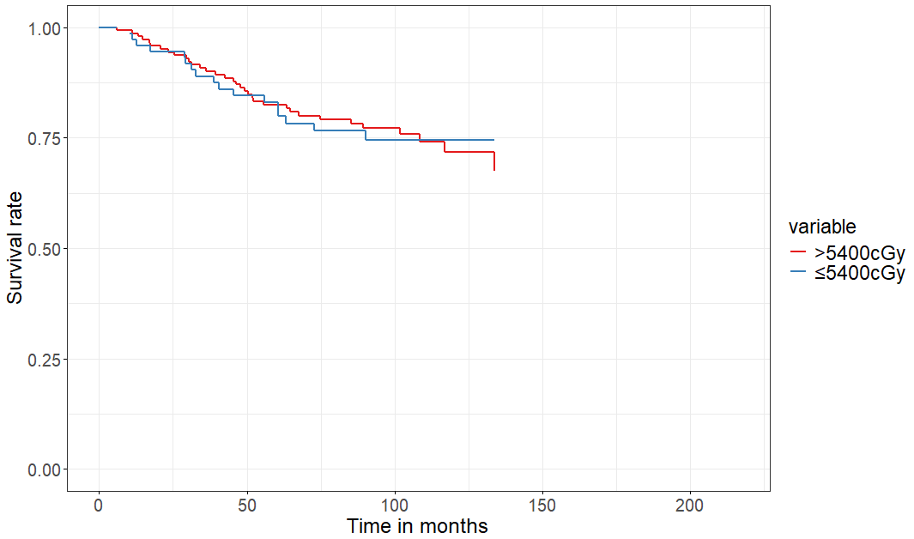
B

A

p=0.15
p=0.80

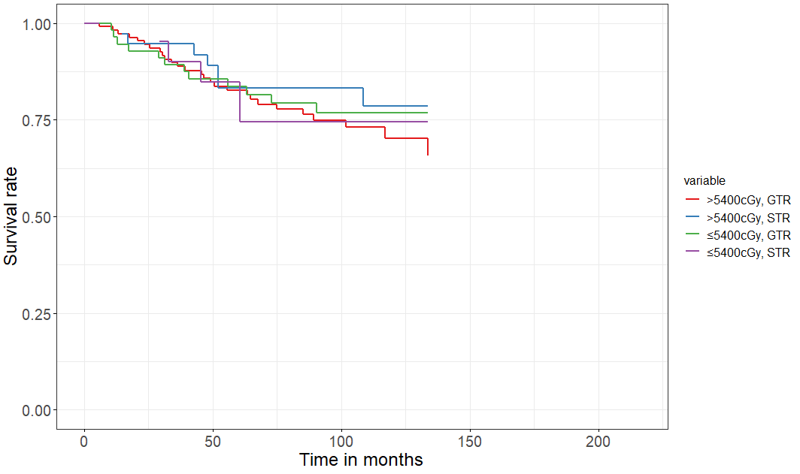
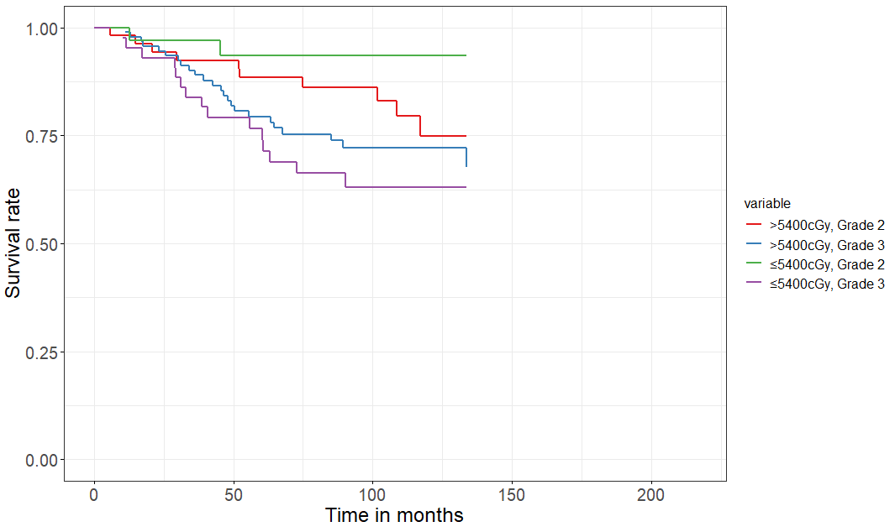
C

D

p=0.85
p=0.02

Abbreviations: Gross total resection (GTR), Subtotal resection (STR), Centigray (cGy)
Adjusted for sex, race, comorbidities, tumor size, tumor location, radiation particle type, and if chemotherapy was received

Figure 5: Adjusted survival curve, multivariate analysis, for A) entire cohort, B) age ≤3years, C) STR, and D) WHO grade 3
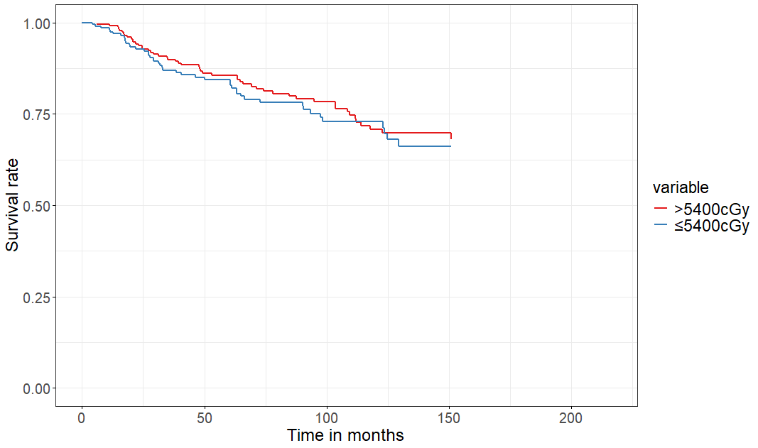
A

B

C

p=0.80
p=0.48

p=0.56

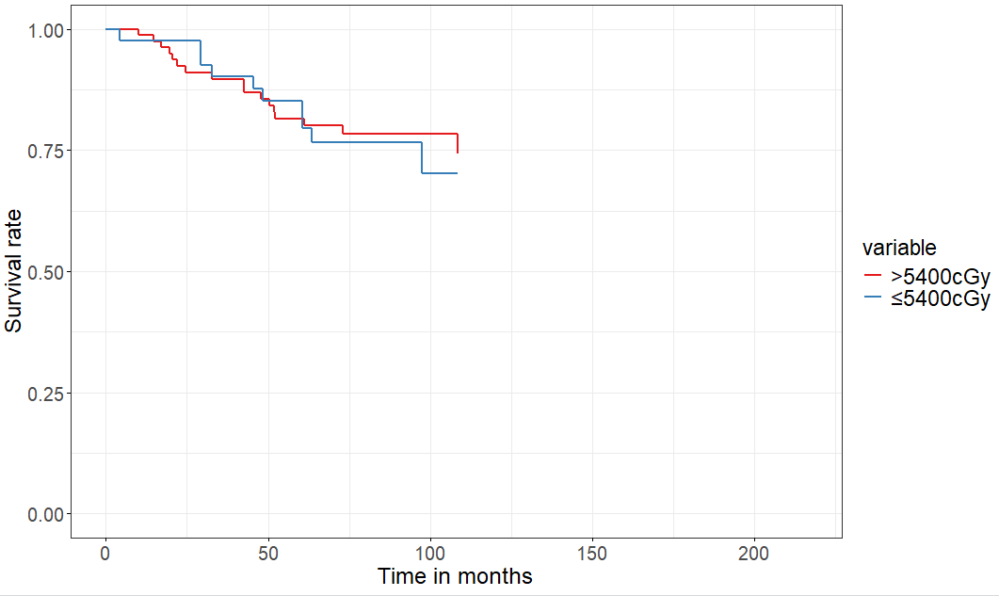
D

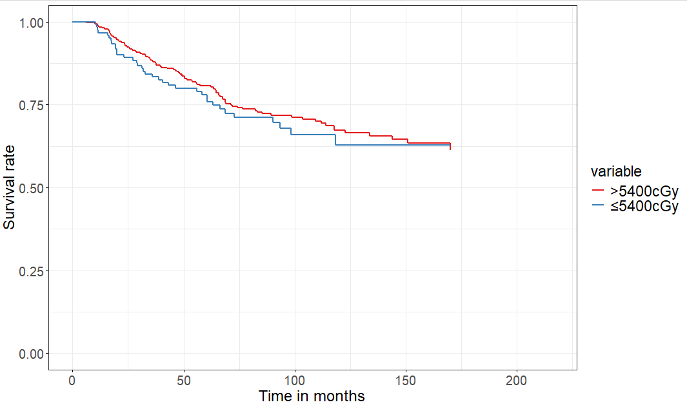

p=0.72

Abbreviations: World Health Organization (WHO), Subtotal resection (STR), Centigray (cGy)
Adjusted for sex, race, comorbidities, tumor size, tumor location, radiation particle type, and if chemotherapy was received

Table 3: Cox proportional hazard ratios for overall survival with intermediate model

 |  |  | Crude |  | Adjusted*
Variable | N, total | N, deaths | HR (95% CI) | p-value | HR (95% CI) | p-value
Radiation dose
>5400 cGy | 749 | 163 | Reference |  | Reference
≤5400 cGy | 405 | 77 | 0.95 (0.72-1.06) | 0.69 | 0.99 (0.62-1.57) | 0.97
Surgical resection
GTR | 90 | 26 | Reference |  | Reference
STR | 264 | 67 | 1.07 (0.68-1.67) | 0.77 | 1.08 (0.66-1.75) | 0.77
Grade
WHO grade 2 | 300 | 59 | Reference |  | Reference
WHO grade 3 | 316 | 129 | 1.95 (1.43-2.65) | <0.001 | 2.02 (1.25-3.25) | 0.004
Abbreviations: Gross total resection (GTR), Subtotal resection (STR), Centigray (cGy), World health organization (WHO)
*Adjusted for all covariates within table

