Appendix
A. Expanding on the analytical model of Jobmann & Schulz 1989 and its methods

The main goal of Jobmann & Schulz 1989 was to determine as accurately as possible the recoverable geothermal energy from the deep groundwater of the Upper Jurassic aquifer in the above mentioned area. To accomplish this, the study area was covered with an array of geothermal doublets (Fig. 6). For the longest possible lifetime of such doublet arrays and in general multi-well systems, the distance between the boreholes should be as large as possible, however keeping the hydraulic connection between injector and producer.
Jobmann & Schulz 1989 indicated that their methods can in principle also be applied to other - not necessarily identical - geological conditions in the world. Therefore, we summarize in this work the main analytical aspects of the methodology developed by Jobmann & Schulz 1989 to assess the recoverable geothermal energy in hot sedimentary aquifers with the help of a principle model that involves the optimal placement of geothermal doublet arrays.
The approach used for a two-dimensional analytical model is based on Gringarten & Sauty 1975, which in turn has been improved by Schulz 1987. Provided there prevail straightforward hydraulic flow conditions, the thermal behavior of a geothermal doublet situated in a confined aquifer can be described fully by an analytical solution. This analytical solution can then be extended to the case of geothermal doublet arrays or multi-well configurations. Jobmann & Schulz 1989 introduced this approach based on a layer cake model, which consider a confined aquifer overlain and underlain by non-permeable aquitards. One of the major advantages of this approach lies in its ability to show without further numerical computations the key controls on the thermal breakthrough and the thermal lifetime of a geothermal doublet and geothermal doublet arrays in general.
In this context, a major focus of investigation was laid on the cooling zone formed around the injection well that expands over time and reaches the production well after a time called the thermal breakthrough (t_{TB}) time. Analytically, the thermal breakthrough occurrence time is defined as $t_{TB}= T_{0}-1°C$, where a temperature deviation $ΔT$of 1 °C from the initial reservoir temperature $T_{0}$ at the production well is registered Jobmann & Schulz 1989. However, as pointed out by Jobmann & Schulz 1989, Willems et al. 2017a and Willems et al. 2017b the temperature drop occurring at the production well takes place in general fairly slowly, so that the actual thermal life time for a doublet is much greater than the thermal breakthrough time. To this end, the thermal lifetime t_{N} of a geothermal doublet was defined as the time at which the aquifer fluid temperature at the production well drops below a certain value, at which the geothermal doublet is no longer economically operational.
Following main assumptions made in this approach, the physical equations governing the fluid and heat transport processes in porous geothermal reservoirs result from the conservation laws of momentum, mass and energy. For momentum conservation, the validity of Darcy law as a simplified form of the Navier-Stokes equation in porous geologic media is assumed. All physical parameters are constant and isotropic, the aquifer itself is infinite. The solution of the heat transport equation in such aquifer affected by an injection and production wells is facilitated by the widely known solution obtained by earlier works (e.g. Dacosta & Bennett 1960; Bear 1972) for the hydraulic part using the velocity potential, the stream function and the velocity equations. One of the main outcomes is the temperature distribution in terms of, among other physical parameters, a multi-parameter time variable and the thermal breakthrough time. For the purpose of this work, we focus on the time at which the thermal breakthrough is established, given by
$t_{TB}=\frac{ρ_{A}c_{A}}{ρ_{F}c_{F}}∙\frac{M}{Q}∙A\left(ϕ_{0}\right)$ , (10)
where $ρ_{A}$, $c_{A}$, $ρ_{F}$, $c_{F}$ are the density and specific thermal capacity under constant pressure for the aquifer and fluid respectively, $M$ denotes the aquifer thickness, $Q$represents the flow rate and $A\left(ϕ_{0}\right)$ is expressed as follows
$A\left(ϕ_{0}\right)=\frac{k_{f}Q}{M}\int_{ϕ_{0}}^{∞}{\frac{1}{v^{2}} dϕ}$ , (11)
where the integration contour is the streamline $ψ_{0}=ψ\left(x_{0},y_{0}\right)$ and $v$ denotes the total velocity defined as the superposition of the natural groundwater flow and the fluid flow imposed by the geothermal doublet (Schulz 1987). Moreover, $k_{f}$ stands for the hydraulic conductivity. In general, this integral has to be solved numerically. However, Schulz 1987 demonstrated that for the case of a relatively negligible natural groundwater flow, this integral can be fully solved analytically. In addition, when considering the straight line connecting the injection and production wells, the thermal breakthrough for the case of negligible groundwater flow velocities can be given fully analytically by the following expression
$t_{TB}=\frac{ρ_{A}c_{A}}{ρ_{F}c_{F}}∙\frac{4π}{3}∙\frac{Ma^{2}}{Q}$ , (12)
where $a$ denotes the half-length between injection and production wells (see Fig. 6). The key controls on the thermal breakthrough are the separation between injection and production wells in the first place due to its quadratic dependency, followed by the thickness of the aquifer and the flow rate.
According to the definition of the thermal lifetime of a geothermal doublet or a doublet array in general, Schulz 1987 and Jobmann & Schulz 1989 also obtained an analytical expression considering the straight line connecting the injection and production well for the thermal lifetime
$t_{N}={\left(\frac{ρ_{S}c_{S}}{ρ_{F}c_{F}}\right)}^{2}∙κ_{S}∙{\left(\frac{4πa^{2}}{3Q}\right)}^{2}∙\frac{1}{{\left({erfc}^{-1}(P)\right)}^{2}}+t_{TB}$ , (13)
where $ρ_{S}$, $c_{S}$ and $κ_{S}$are the density, the specific thermal capacity at constant pressure and the thermal diffusivity of the surrounding rock (overriding and underlying aquitards) respectively, $erfc$ is the complementary error function and $P$ represents the fraction of cooled formation fluid related to the initial temperature. In case it is considered that for 20 % reduction of the initial temperature of the extracted formation fluid the geothermal doublet is no longer economically operational, then $P=0.2$. It is worth mentioning that in these analytical considerations the temperature analyzed immediately before the extraction well lies on the straight line connecting the injection and extraction well. According to Schulz 1987 and Jobmann & Schulz 1989 the actual production temperature is much higher since the production temperature results from the mixing temperature of all streamlines that reach the production well. Hence, using the analytical expression for $t_{TB}$ constitutes an exceedingly conservative way of estimating the thermal lifetime of a geothermal doublet. Nevertheless, the major advantage of the expressions $t_{TB}$ and $t_{N}$ is that they enable a quick overview.
Once analytical expressions for the thermal breakthrough and the thermal lifetime of a geothermal doublet are found, the amount of recoverable energy that can be harnessed by operating a geothermal doublet can be expressed in these two terms. Generally, the energy generated by a geothermal doublet can be expressed as
$E=ρ_{F}∙c_{F}∙Q∙\left(T_{E}-T_{I}\right)∙∆t$ , (14)
where $T_{E}$ and $T_{I}$ represent the extraction and injection temperature, respectively and $∆t$ denotes the considered time of operation for a given geothermal doublet. Since the extraction and injection temperatures keep constant until the thermal breakthrough is established, the produced energy until this time is then given by
$E_{TB}=ρ_{F}∙c_{F}∙Q∙\left(T_{E}-T_{I}\right)∙t_{TB}$ . (15)
Jobmann & Schulz 1989 calculated the additional amount of energy that can be harnessed from the time at which the thermal breakthrough is established until the actual thermal life time with
$E_{N}=ρ_{F}∙c_{F}∙Q∙\int_{T_{TB}}^{T_{N}}{\left(T_{E}\left(t\right)-T_{I}\right)∙dt}$ . (16)
In this case, the extraction temperature is no longer constant since after the thermal breakthrough the temperature at the production well starts to drop. Many authors (e.g. Jobmann & Schulz 1989; Willems et al. 2017a; Willems et al. 2017b) argue that this amount of energy can be significant and depending on the operational flow rates and initial temperature of the aquifer it can reach several orders of magnitude of the energy extracted until the occurrence of the thermal breakthrough.

B. Model setup showing the principal layout of the geothermal doublet array (Fig.B.1)

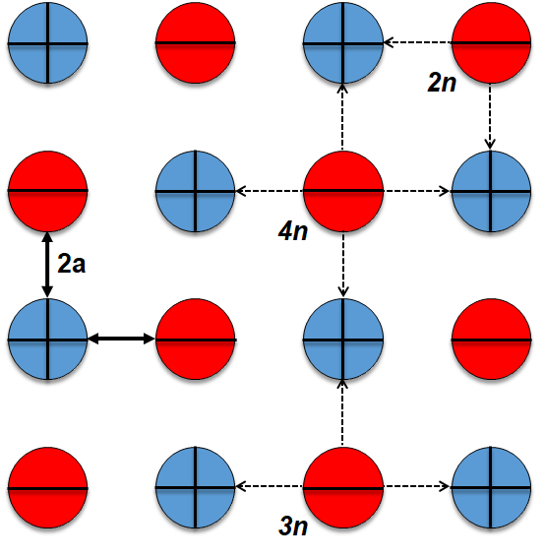
Fig. B.1. Layout of the geothermal doublet array used for the numeric simulations. Production well in red (minus symbol) and injection well in blue (plus symbol). Distance between injection and production well is labeled as 2a. Number of neighboring wells is denoted as n.

C. Different model parameters and their combinations (Tab. C.1-3)
Parameter | Acronym | Value | Unit | Reference
Geothermal gradient | Γ | 0.03 | °C/km | Conservative estimate (based on Wolfgramm et al. 2014)
Hydraulic gradient |  | 1 | mm/m | Conservative estimate (based on natural groundwater flow in relevant porous sedimentary formations of the NGB, e.g. Bauer et al. 2019)
Surface temperature | T_{GST} | 10 | °C | Typical annual mean value (e.g. Wolfgramm et al. 2014, Norden et al. 2020)
Depth | D | 1000 | m | Average estimation of middle-deep geothermal resources hosted in Mesozoic formations of the NGB
Salinity | S | 130 | kg/m³ NaCl | Average estimate (based on Schneider et al. 2014, Wolfgramm et al. 2011b)
Dynamic viscosity | $$μ$$ | 0.0008 | Pa*s | Average value (based on Kuder 2018, Meehan 1980)
Density aquifer | ρ_{af} | 2650 | kg/m³ | Typical mean value (based on Schön 2015)
Density aquitard | ρ_{at} | 2200 | kg/m³ | Typical average (based on Schön 2015)
Density fluid | ρf | 1080 | kg/m³ | Typical average value for brines in the NGB (based on Kuder 2018, Rowe and Chou 1970)
Thermal conductivity aquifer | λ_{af} | 2.5 | W/(m*K) | Typical average (based on Emirov and Ramazanova 2007, Fuchs et al. 2015)
Thermal conductivity aquitard | λ_{at} | 2 | W/(m*K) | Typical average (based on Emirov and Ramazanova 2007, Fuchs et al. 2015)
Thermal conductivity fluid | λ_{f} | 0.615 | W/(m*K) | Average estimation (based on Kuder 2018, Phillips et al. 1981)
Specific heat capacity aquifer | c_{af} | 800 | J/(kg*K) | Average estimation (based on Abdulagaov et al. 2019, Somerton 1992)
Specific heat capacity aquitard | c_{at} | 850 | J/(kg*K) | Average estimation (based on Abdulagaov et al. 2019, Somerton 1992)
Specific heat capacity fluid | c_{f} | 3635 | J/(kg*K) | Average estimation (based on Kuder 2018, Phillips et al. 1981)
Filter line length | ≙ M | ≙ M | m | Full filter line is equivalent to reservoir thickness
Borehole inclination | α | 90 | ° | Vertical borehole
Bore hole radius | r | 0,16 | m | Typical average in engineering
Permeability aquitard | Κ_{at} | 0.1 | mD | Typical average (based on Wolfgramm et al. 2014, Franz et al. 2018)
Porosity aquitard | Φ_{at} | 0.2 | - | Typical average (based on Wolfgramm et al. 2014, Franz et al. 2018)
Tab. C.1. General model parameters.

Scenario | Varying parameters | Constant parameters | Explanation
A_{1, 2, 3, 4} | M, Q, Κ_{af}, Φ_{af} | 2a, T_{Inj} | Doublet array layout. Sub-scenarios according to distance variation (2a)
S_{1, 2, 3, 4} | M, Q, Κ_{af}, Φ_{af} | 2a, T_{Inj} | Single doublet layout. Sub-scenarios according to distance variation (2a)
CA | T_{Inj} | M, Q, Κ_{af}, Φ_{af} | Doublet array layout
CS | T_{Inj} | M, Q, Κ_{af}, Φ_{af} | Single doublet layout
Tab. C.2. Overview of simulation scenarios based on the parameter combination used for the analysis of the impact on the performance parameters. See Tab.2 in the main article for values of specific model parameters.

No. | Poro / Perm [%; mD] | Flow Rate [l/s] | Thick- ness [m] | Inter-well distance [m] | Injection temperature [K] | Array | Single
1 | [15, 20, 25, 30] ; [1, 100, 400, 800] | [30; 40; 50; 60) | [20, 25, 30, 35] | 500 | 293,15 | x
2 | [20] ; [1, 100, 400, 800] | [30; 40; 50; 60) | 25 | 500 | [290,15, 293,15, 296,15, 299,15] | x
3 | [15, 20, 25, 30] ; [1, 100, 400, 800] | 30 | 25 | 500 | 293,15 | x
4 | [20] ; [100] | 30 | 25 | 500 | [290,15, 293,15, 296,15, 299,15] | x
5 | [15, 20, 25, 30] ; [1, 100, 400, 800] | 40 | 25 | 500 | 293,15 | x
6 | [15, 20, 25, 30] ; [1, 100, 400, 800] | 50 | 25 | 500 | 293,15 | x
7 | [20] ; [100] | 40 | 25 | 500 | [290,15, 293,15, 296,15, 299,15] | x
8 | [15, 20, 25, 30] ; [1, 100, 400, 800] | 60 | 25 | 500 | 293,15 | x
9 | [15, 20, 25, 30] ; [1, 100, 400, 800] | 30 | 20 | 500 | 293,15 | x
10 | [15, 20, 25, 30] ; [1, 100, 400, 800] | 30 | 30 | 500 | 293,15 | x
11 | [15, 20, 25, 30] ; [1, 100, 400, 800] | 30 | 35 | 500 | 293,15 | x
12 | [15, 20, 25, 30] ; [1, 100, 400, 800] | 40 | 25 | 500 | 293,15 |  | x
13 | [15, 20, 25, 30] ; [1, 100, 400, 800] | 30 | 25 | 500 | 293,15 |  | x
14 | [15, 20, 25, 30] ; [1, 100, 400, 800] | 40 | 30 | 500 | 293,15 | x
15 | [15, 20, 25, 30] ; [1, 100, 400, 800] | 40 | 25 | 500 | 293,15 |  | x
16 | [15, 20, 25, 30] ; [1, 100, 400, 800] | 40 | 35 | 500 | 293,15 | x
17 | [15, 20, 25, 30] ; [1, 100, 400, 800] | 50 | 25 | 500 | 293,15 |  | x
18 | [15, 20, 25, 30] ; [1, 100, 400, 800] | 60 | 25 | 500 | 293,15 |  | x
19 | [15, 20, 25, 30] ; [1, 100, 400, 800] | 30 | 20 | 500 | 293,15 |  | x
20 | [15, 20, 25, 30] ; [1, 100, 400, 800] | 30 | 30 | 500 | 293,15 |  | x
21 | [15, 20, 25, 30] ; [1, 100, 400, 800] | 40 | 30 | 500 | 293,15 |  | x
22 | [15, 20, 25, 30] ; [1, 100, 400, 800] | 50 | 30 | 500 | 293,15 |  | x
23 | [15, 20, 25, 30] ; [1, 100, 400, 800] | 60 | 30 | 500 | 293,15 |  | x
24 | [15, 20, 25, 30] ; [1, 100, 400, 800] | 40 | 20 | 500 | 293,15 |  | x
25 | [15, 20, 25, 30] ; [1, 100, 400, 800] | 30 | 35 | 500 | 293,15 |  | x
26 | [15, 20, 25, 30] ; [1, 100, 400, 800] | 40 | 20 | 500 | 293,15 | x
27 | [15, 20, 25, 30] ; [1, 100, 400, 800] | 40 | 35 | 500 | 293,15 |  | x
28 | [15, 20, 25, 30] ; [1, 100, 400, 800] | 50 | 20 | 500 | 293,15 |  | x
29 | [15, 20, 25, 30] ; [1, 100, 400, 800] | 60 | 20 | 500 | 293,15 |  | x
30 | [15, 20, 25, 30] ; [1, 100, 400, 800] | 50 | 35 | 500 | 293,15 |  | x
31 | [15, 20, 25, 30] ; [1, 100, 400, 800] | 60 | 35 | 500 | 293,15 |  | x
32 | [15, 20, 25, 30] ; [1, 100, 400, 800] | 60 | 20 | 500 | 293,15 | x
33 | [15, 20, 25, 30] ; [1, 100, 400, 800] | 50 | 30 | 500 | 293,15 | x
34 | [20] ; [100] | 30 | 25 | 500 | [290,15, 293,15, 296,15, 299,15] |  | x
35 | [15, 20, 25, 30] ; [1, 100, 400, 800] | 50 | 35 | 500 | 293,15 | x
36 | [20] ; [100] | 40 | 25 | 500 | [290,15, 293,15, 296,15, 299,15] |  | x
37 | [20] ; [100] | 50 | 25 | 500 | [290,15, 293,15, 296,15, 299,15] |  | x
38 | [15, 20, 25, 30] ; [1, 100, 400, 800] | 30 | 25 | 700 | 293,15 | x
39 | [15, 20, 25, 30] ; [1, 100, 400, 800] | 30 | 25 | 700 | 293,15 |  | x
40 | [15, 20, 25, 30] ; [1, 100, 400, 800] | 30 | 30 | 700 | 293,15 | x
41 | [15, 20, 25, 30] ; [1, 100, 400, 800] | 30 | 30 | 700 | 293,15 |  | x
42 | [15, 20, 25, 30] ; [1, 100, 400, 800] | 30 | 35 | 700 | 293,15 | x
43 | [15, 20, 25, 30] ; [1, 100, 400, 800] | 30 | 35 | 700 | 293,15 |  | x
44 | [15, 20, 25, 30] ; [1, 100, 400, 800] | 30 | 25 | 900 | 293,15 |  | x
45 | [15, 20, 25, 30] ; [1, 100, 400, 800] | 30 | 25 | 900 | 293,15 | x
46 | [15, 20, 25, 30] ; [1, 100, 400, 800] | 30 | 30 | 900 | 293,15 |  | x
47 | [15, 20, 25, 30] ; [1, 100, 400, 800] | 30 | 30 | 900 | 293,15 | x
48 | [15, 20, 25, 30] ; [1, 100, 400, 800] | 30 | 35 | 900 | 293,15 |  | x
49 | [15, 20, 25, 30] ; [1, 100, 400, 800] | 30 | 35 | 900 | 293,15 | x
50 | [15, 20, 25, 30] ; [1, 100, 400, 800] | 30 | 25 | 1200 | 293,15 |  | x
51 | [15, 20, 25, 30] ; [1, 100, 400, 800] | 30 | 25 | 1200 | 293,15 | x
52 | [15, 20, 25, 30] ; [1, 100, 400, 800] | 30 | 30 | 1200 | 293,15 |  | x
53 | [15, 20, 25, 30] ; [1, 100, 400, 800] | 30 | 30 | 1200 | 293,15 | x
54 | [15, 20, 25, 30] ; [1, 100, 400, 800] | 30 | 35 | 1200 | 293,15 |  | x
55 | [15, 20, 25, 30] ; [1, 100, 400, 800] | 30 | 35 | 1200 | 293,15 | x
Tab. C.3. Sweep combinations of specific model parameters used in 55 numerical simulation scenarios.

D. Effect of varying reservoir thickness M on performance parameters (Fig. D.1-3)
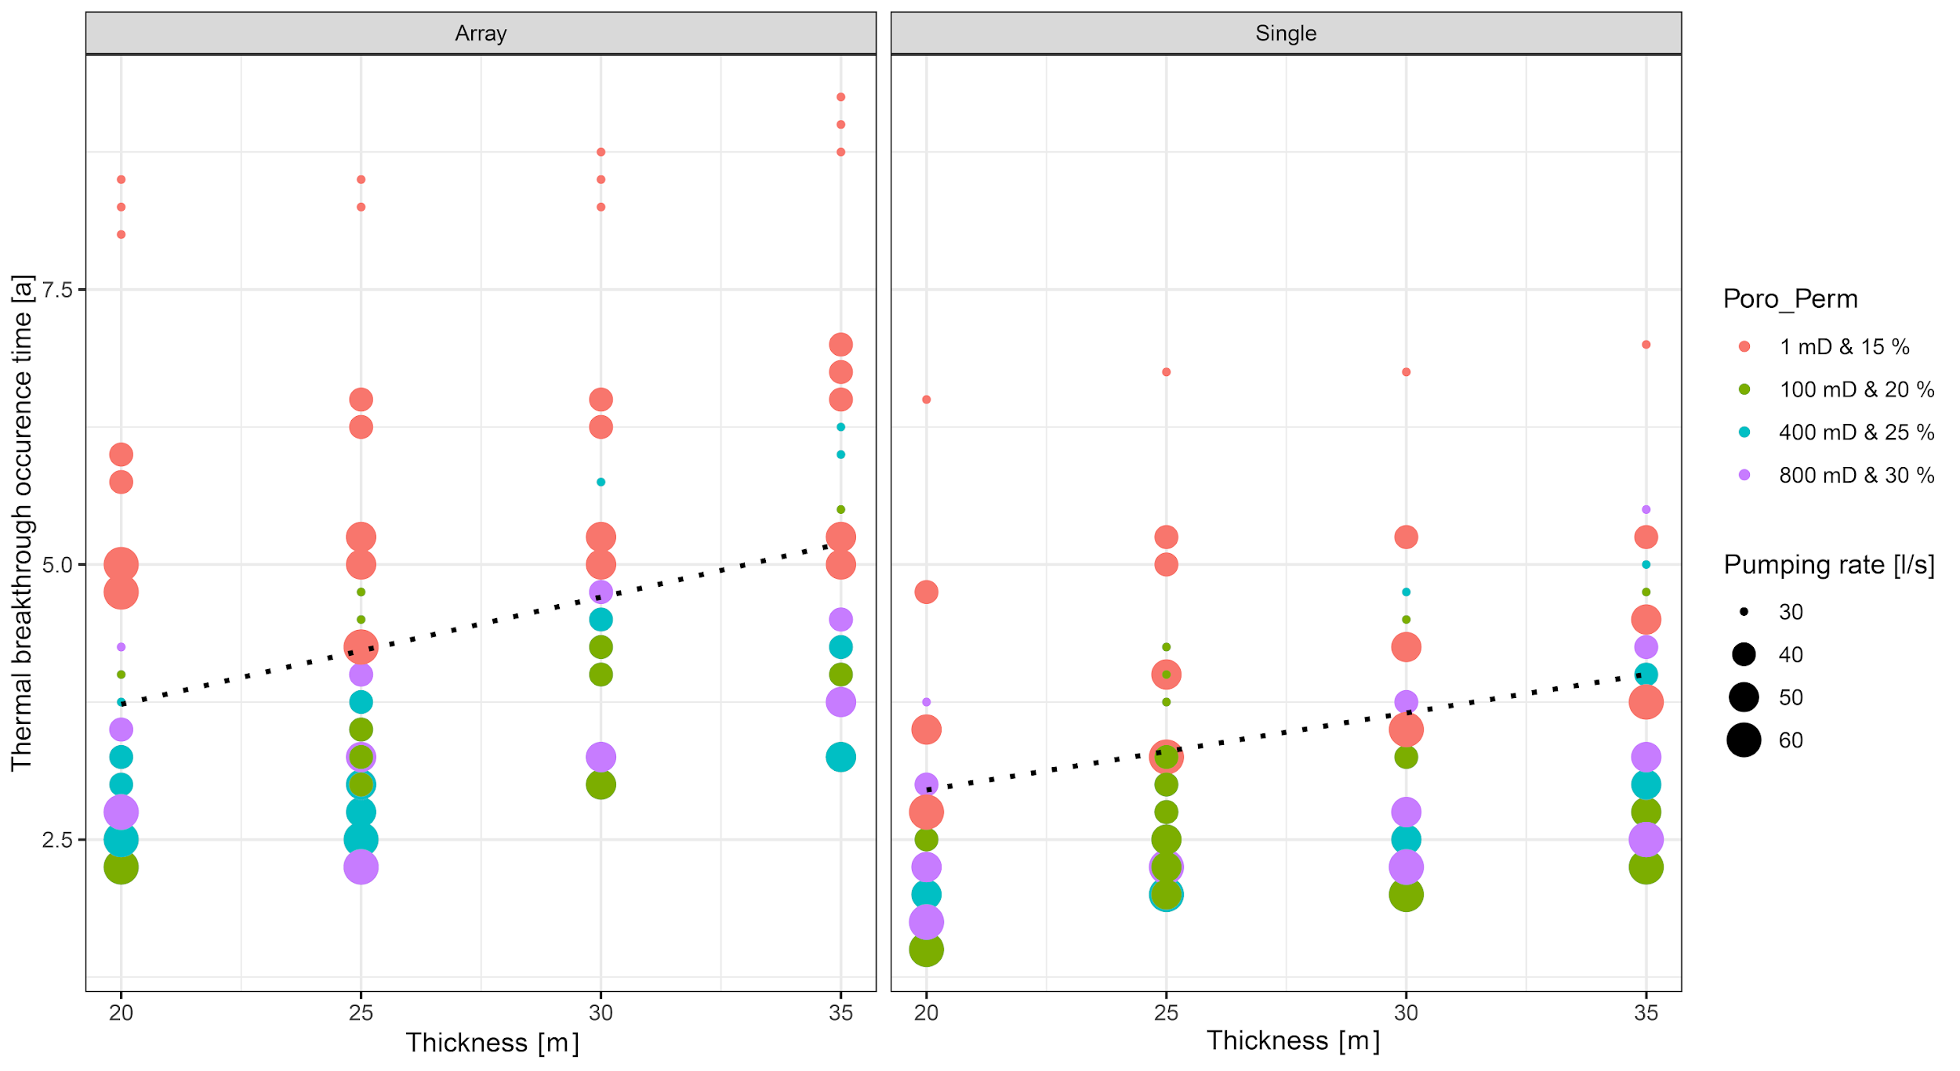
Fig. D.1. Effect of varying reservoir thickness M on thermal breakthrough occurrence time, 2a = 500 m. The porosity and permeability sweep is displayed via different colors and the pumping rate sweep via increasing size of the data points (solid circles). Left plot shows simulation results linked to the model with the geothermal doublet array, right plot exhibits simulation outcomes derived from the geothermal single doublet.

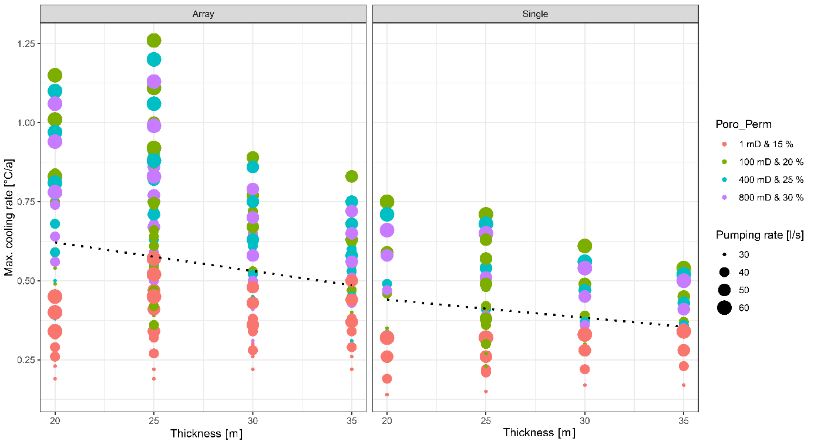
Fig. D.2. Effect of varying aquifer thickness M on maximum cooling rate.

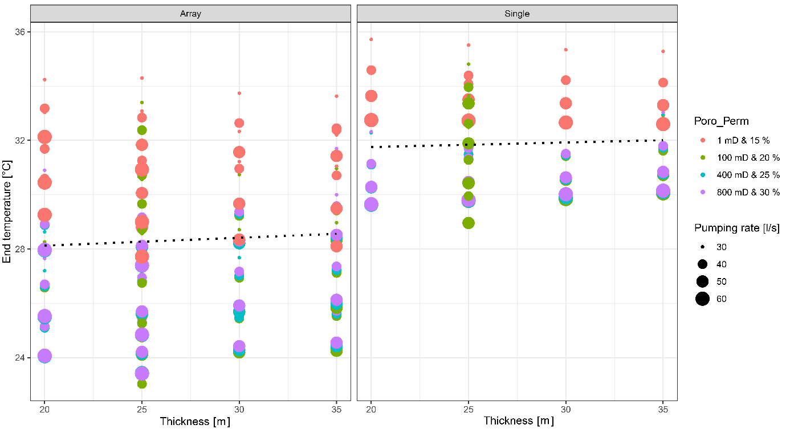
Fig. D.3. Impact of aquifer thickness M on end temperature.

E. Effect of varying injection temperature on thermal breakthrough occurrence time (Fig. E.1)

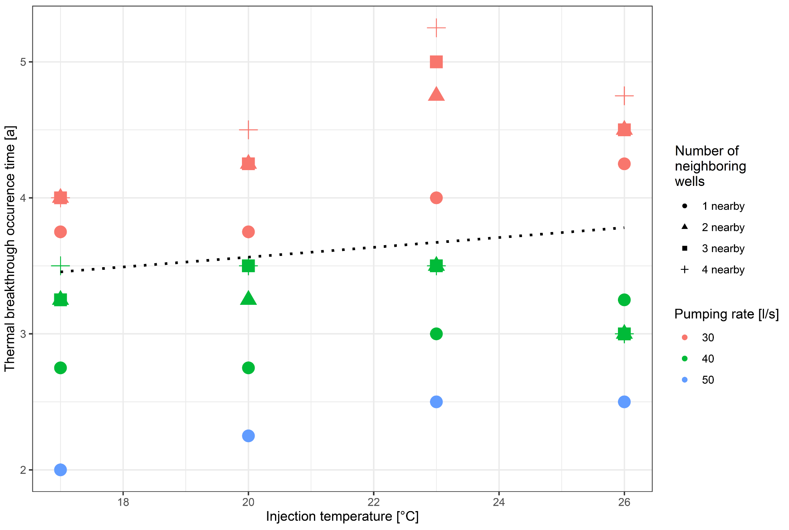
Fig. E.1. Influence of the injection temperature on thermal breakthrough occurrence time, 2a = 500 m. Pumping rate sweep is displayed through different colors and the number of neighboring wells with the aid of different shapes of the data points (symbols).

F. Effect of number of neighboring wells on maximum cooling rate (Fig. F.1)

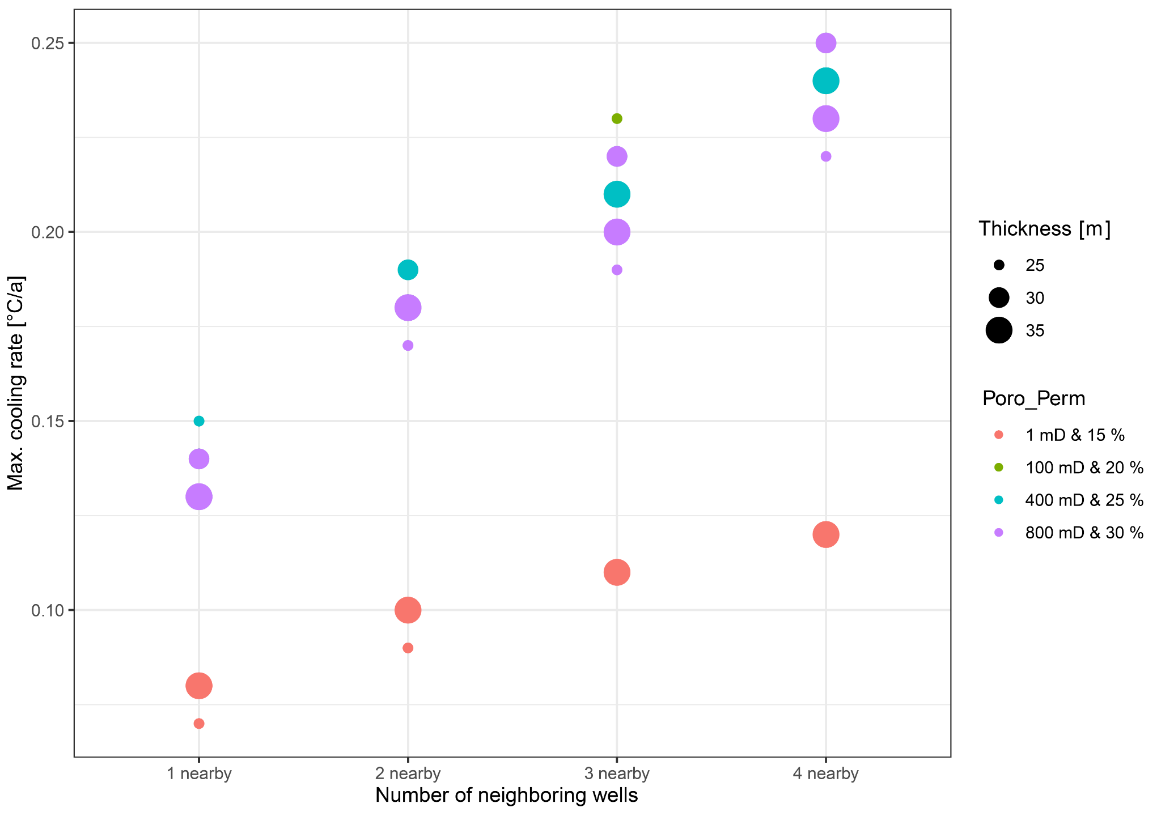
Fig. F.1. Dependency of the maximum cooling rate from the number of neighboring wells n. The porosity and permeability sweep is displayed via different colors and the reservoir thickness sweep by increasing the size of the data points (solid circles). Inter-well distance is 700 m.

