Suppl.Figures
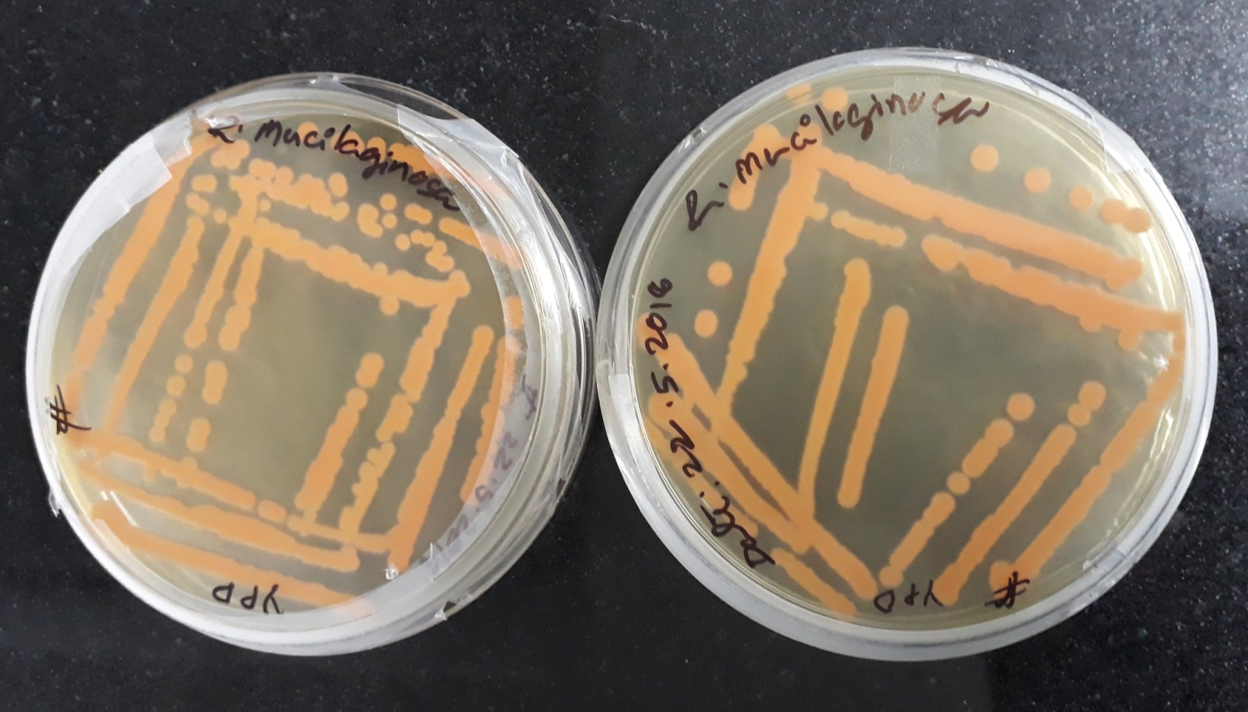

Suppl.Fig. 3.1 Displays R. mucilaginosa cultivation colonies in yeast media

Suppl.Fig.3.6 Standard correlation graph for estimation of β-carotene in R. mucilaginosa

by Spectrophotometric method

