Supplementary information for
The NMDA receptor subunit GluN2D is a target for rapid antidepressant action
Vestring et al.

Includes:
Supplementary Figures 1-7
Supplementary Table 1

Supplementary Figure 1

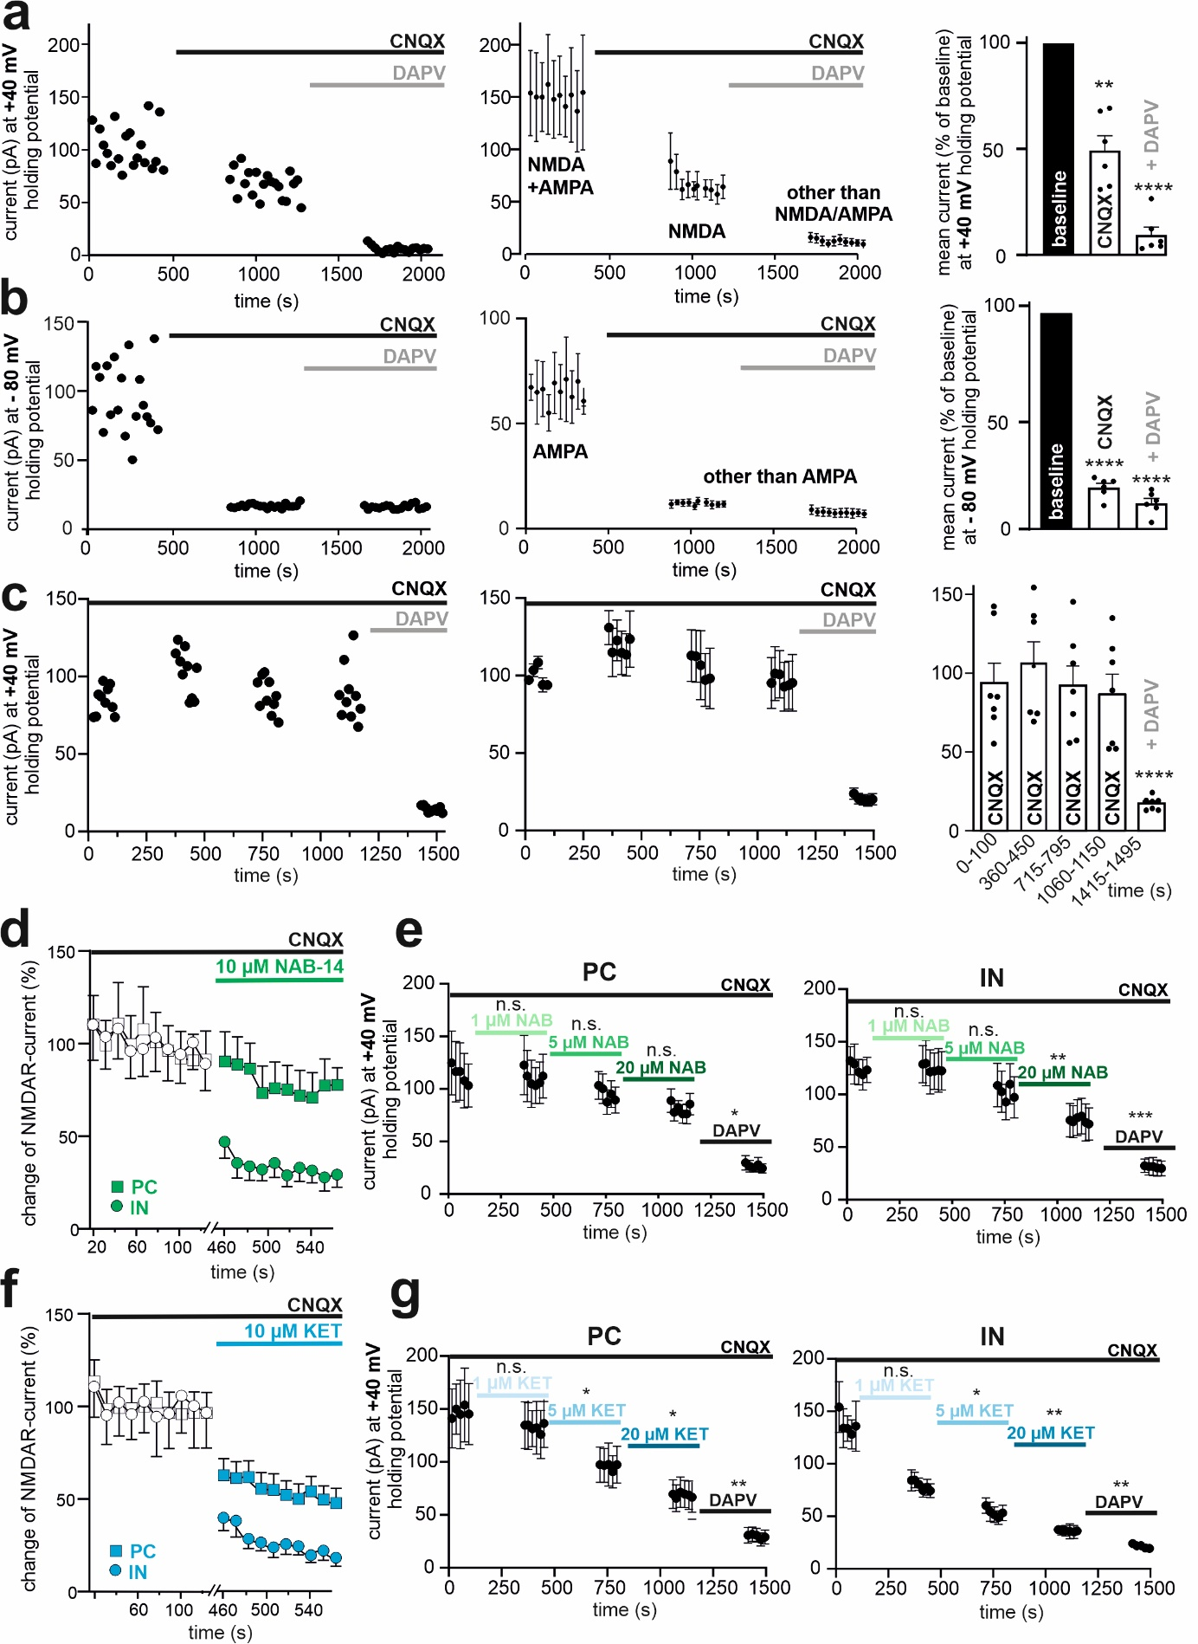
Supplementary Fig. 1: Characterization of NMDA currents, predominant inhibition of NMDA EPSCs by NAB-14 and KET in interneurons.
a, Representative recordings (maximum current amplitudes; left), averaged time courses (middle) and group analyses (right) of NMDAR currents at holding potentials of +40 mV in CA1 PCs before and after the bath application of CNQX (10 µM) to block AMPAR currents and subsequently DAPV (50 µM) to block NMDAR currents. Repeated measures ANOVA, F[141.8], n = 6). The data are presented as the means ± SEMs. **p < 0.01, ****p < 0.0001.
b, Representative single-cell recording (left) averaged time courses (middle) and group analyses (right) of NMDAR currents at holding potentials of -80 mV in CA1 PCs before and after the bath application of CNQX (10 µM) to block AMPAR currents and subsequently DAPV (50 µM) to block NMDAR currents. Repeated measures ANOVA, F[1308], n = 6). The data are presented as the means ± SEMs. ****p < 0.0001.
c, Representative experiment (left), averaged time course (middle) and group analysis (right) of currents in PCs at a holding potential of +40 mV in the continuous presence of CNQX and the addition of DAPV at the end of the experiments. These experiments indicate the stability of NMDAR currents over time and their complete inhibition by DAPV. Repeated measures ANOVA, F[20.06], n = 7). The data are presented as the means ± SEMs. ****p < 0.0001.
d, The maximum amplitude of NMDAR currents was reduced after 10 µM NAB-14 bath application in INs (circles) but not in PCs (squares; normalized to their initial baseline averages) in the presence of CNQX. The data are presented as the means ± SEMs.
e, Mean amplitudes of NMDAR currents measured at a holding potential of +40 mV in the presence of CNQX in PCs (middle) and INs (right) before and after bath application of incremental concentrations (1, 5 and 20 µM) of NAB-14 and DAPV (50 µM) at the end of the experiments. PC: Repeated measures ANOVA, F[6.604], n = 8). *p < 0.05. IN: Repeated measures ANOVA, F[17.99], n = 7). The data are presented as the means ± SEMs. **p < 0.01, *** p < 0.001.
f, The reduction in NMDAR currents induced by 10 µM KET bath application was more pronounced in INs (circles) than in PCs (squares; normalized to their initial baseline averages in the presence of CNQX). The data are presented as the means ± SEMs.
g, Mean amplitudes of NMDAR currents measured at a holding potential of +40 mV in the presence of CNQX in PCs (middle) and INs (right) before and after bath application of incremental concentrations (1, 5 and 20 µM) of KET and DAPV (50 µM) at the end of the experiments. PC: Repeated measures ANOVA, F[21.12], n = 8). *p < 0.05, **p < 0.01. IN: Repeated measures ANOVA, F[23.69], n = 7). The data are presented as the means ± SEMs. *p < 0.05, **p < 0.01.
See Supplementary Table 1 for further information on the statistical analysis.

Supplementary Figure 2

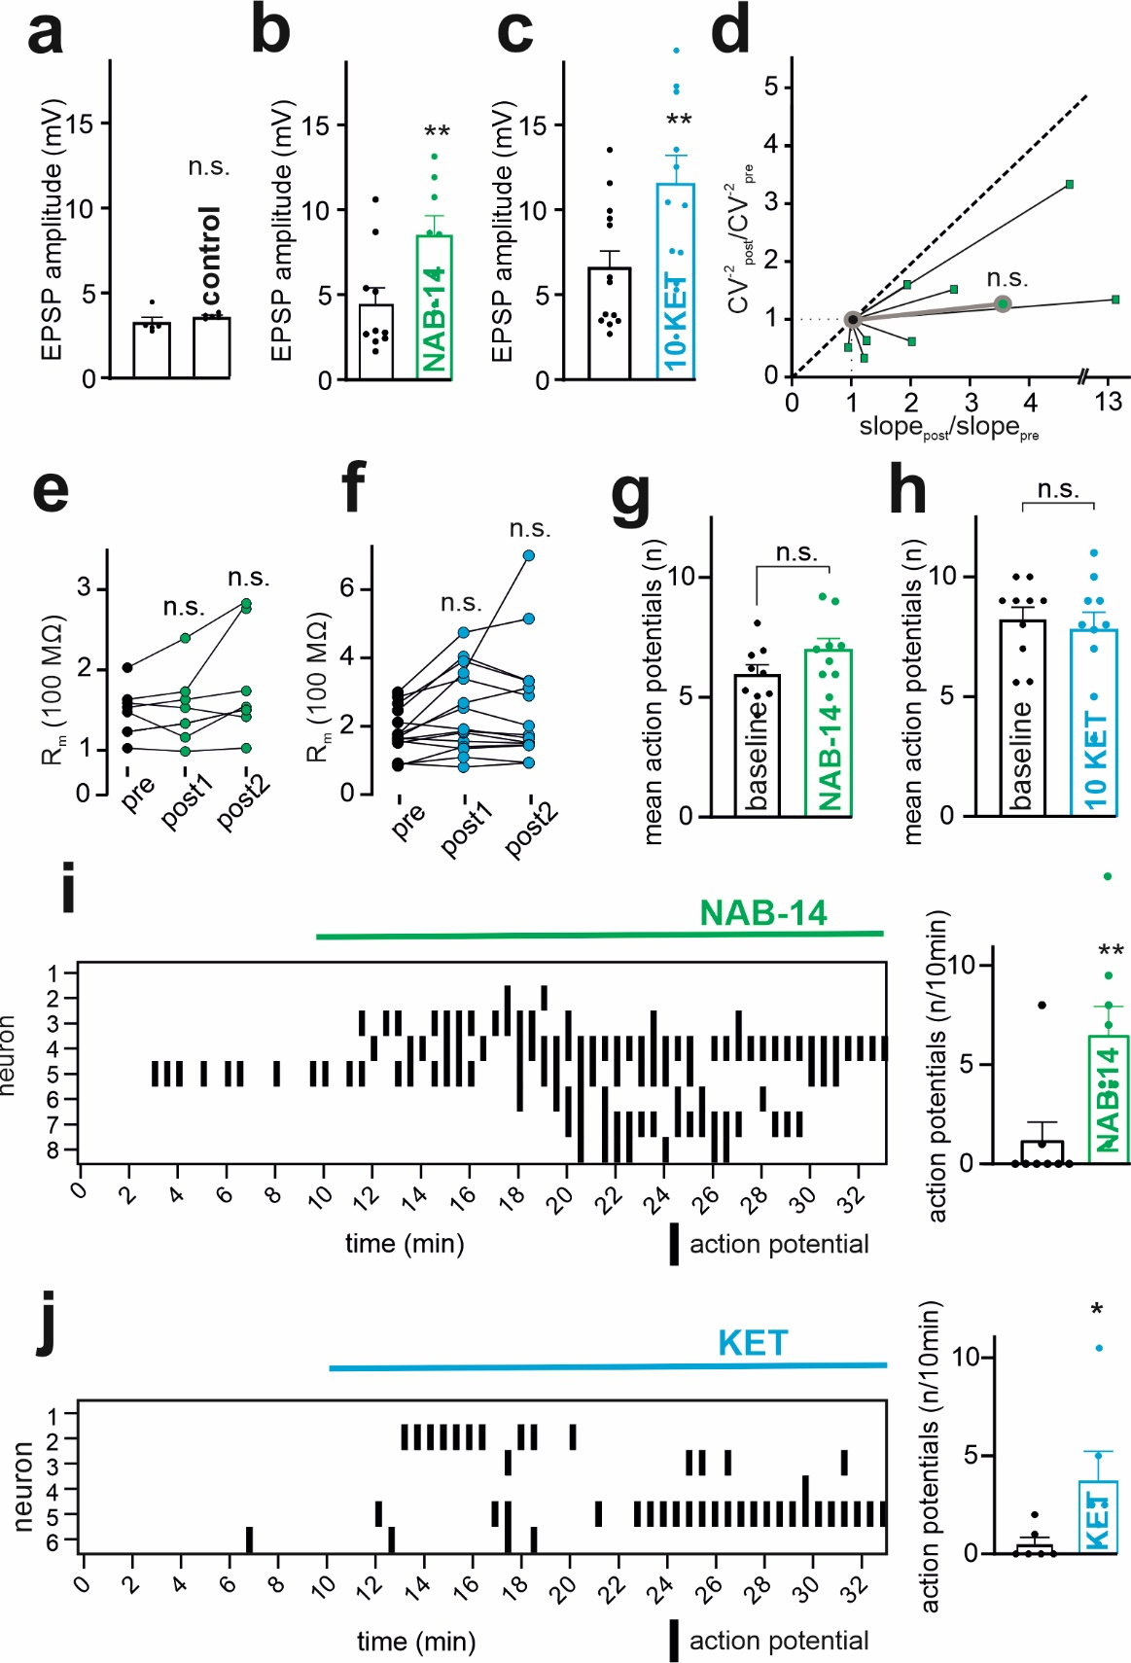
Supplementary Fig. 2: NAB-14 and KET increase EPSPs via postsynaptic inhibition of hippocampal microcircuits.
a, The mean EPSP amplitudes in the MICA remained stable over 30 min in the control condition. Paired t test (p = 0.3773, n = 6). The data are presented as the means ± SEMs.
b, The mean EPSP amplitudes in the MICA increased after the addition of 10 µM NAB-14 to the bathing solution. Paired t test (p = 0.0036, n = 10). The data are presented as the means ± SEMs. **p < 0.01.
c, The mean EPSP amplitudes in the MICA increased after the addition of 10 µM KET to the bathing solution. Paired t test (p = 0.0015, n = 13). The data are presented as the means ± SEMs. **p < 0.01.
d, CV analysis of the effect of NAB-14 wash-in during MICA, consistent with a postsynaptic mechanism. The gray circles represent the averages of all analyzed cells. Paired t test (p = 0.4992, n = 8).
e, The PC input resistance (R_{m}) did not change at 10, 20 and 30 min in the MICA after NAB-14 bath application. Repeated measures ANOVA, F[4.183, n = 8].
f, The PC input resistance (R_{m}) did not change at 10, 20 and 30 min in the MICA after KET bath application. Repeated measures ANOVA, F[1.419, n = 15].
g, No significant changes in the number of APs during the burst of APs in the MICA protocol after bath application of NAB-14. Paired t test (p = 0.1125, n = 12). The data are presented as the means ± SEMs.
h, No significant changes in the number of APs during the burst of APs in the MICA protocol after bath application of KET. Paired t test (p = 0.4633, n = 9). The data are presented as the means ± SEMs.
i, Raster blot (left) and group analysis (right) showing that NAB-14 bath application leads to the conversion of subthreshold EPSPs to APs. Paired t test (p =0.0078, n = 8). The data are presented as the means ± SEMs. **p < 0.01
j, Raster blot (left) and group analysis (right) showing that KET bath application leads to the conversion of subthreshold EPSPs to APs. Paired t test (p =0.0313, n = 6). The data are presented as the means ± SEMs. *p < 0.05
See Supplementary Table 1 for further information on the statistical analysis.

Supplementary Figure 3

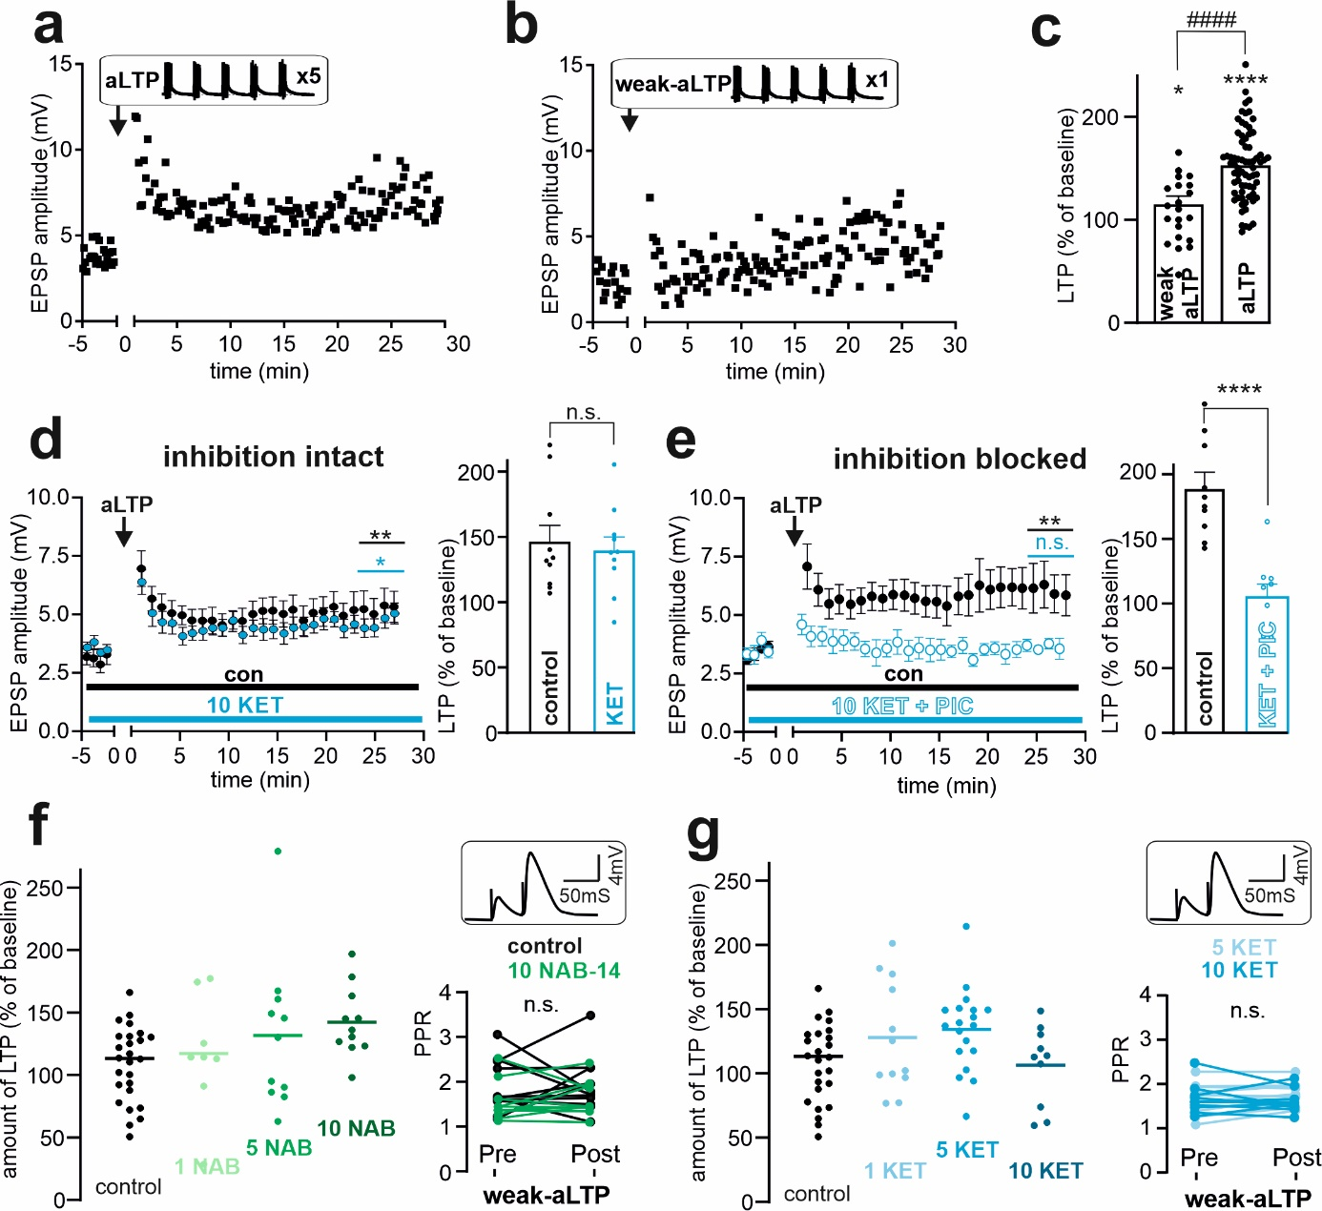
Supplementary Fig. 3: Interneurons shape hippocampal LTP.
a, Representative aLTP experiment. Each square represents the maximum EPSP amplitude before and after 125 EPSP→AP pairings (inset).
b, Representative weak associative LTP (weak-aLTP) recording with 25 EPSP→AP pairings (inset).
c, Significant LTP was induced by both protocols but was significantly greater in the aLTP group than in the weak-aLTP group. Unpaired t test (p <0.0001, n = 25 (weak aLTP), n = 70 (aLTP)). The data are the means ± SEMs. **** p < 0.0001.
d, Time scale of aLTP in control solution (black) or in the presence of 10 µM KET (blue) in the bath solution (left). Group analysis (right) revealed no difference between the conditions. Unpaired t test (p = 0.7119, n = 10 (control), n = 10 (KET)). The data are the means ± SEMs.
e, Experimental setup identical to that in (D) but in the presence of the GABA_{A} antagonist picrotoxin (PIC, 50 µM) both under control conditions (black) and together with KET (blue). Unpaired t test (p < 0.0001, n = 10 (control), n = 8 (KET)). The data are the means ± SEMs. **** p < 0.0001.
f, (Left) Single-experiment overview of weak-aLTP experiments analyzed in Fig. 3A and (right) analysis of PPR pre- vs. postweak-aLTP induction in the presence of 10 µM NAB-14 in the bathing solution (green) and under control conditions (black) (inset: representative paired-pulse EPSP trace). Control: paired t test (p = 0.4911, n = 9); NAB-14: paired t test (p = 0.9095, n = 10).
g, (Left) Single-experiment overview of weak-aLTP experiments analyzed in Fig. 3C and (right) analysis of PPR pre- vs. post weak-aLTP induction in the presence of 5 or 10 µM KET in the bathing solution. 5 KET: paired t test (p = 0.1289, n = 9); 10 KET: paired t test (p = 0.5566, n = 10).
See Supplementary Table 1 for further information on the statistical analysis.

Supplementary Figure 4

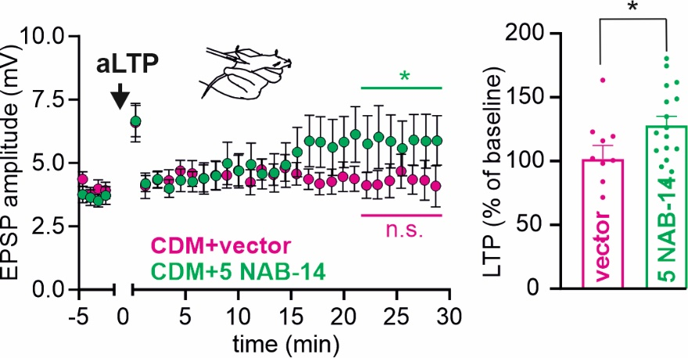
Supplementary Fig. 4: NAB-14 restores LTP after CDM
A single intraperitoneal NAB-14 injection (5 mg/kg, green) resulted in a partial rescue of aLTP in CDM mice compared to that in CDM mice that received an injection of the vector (magenta) used to dissolve NAB-14 (left: time course, right group analysis). Unpaired t test (p = 0.0361, n = 12 (vector), n = 19 (NAB-14)). The data are the means ± SEMs. * p < 0.05.

Supplementary Figure 5

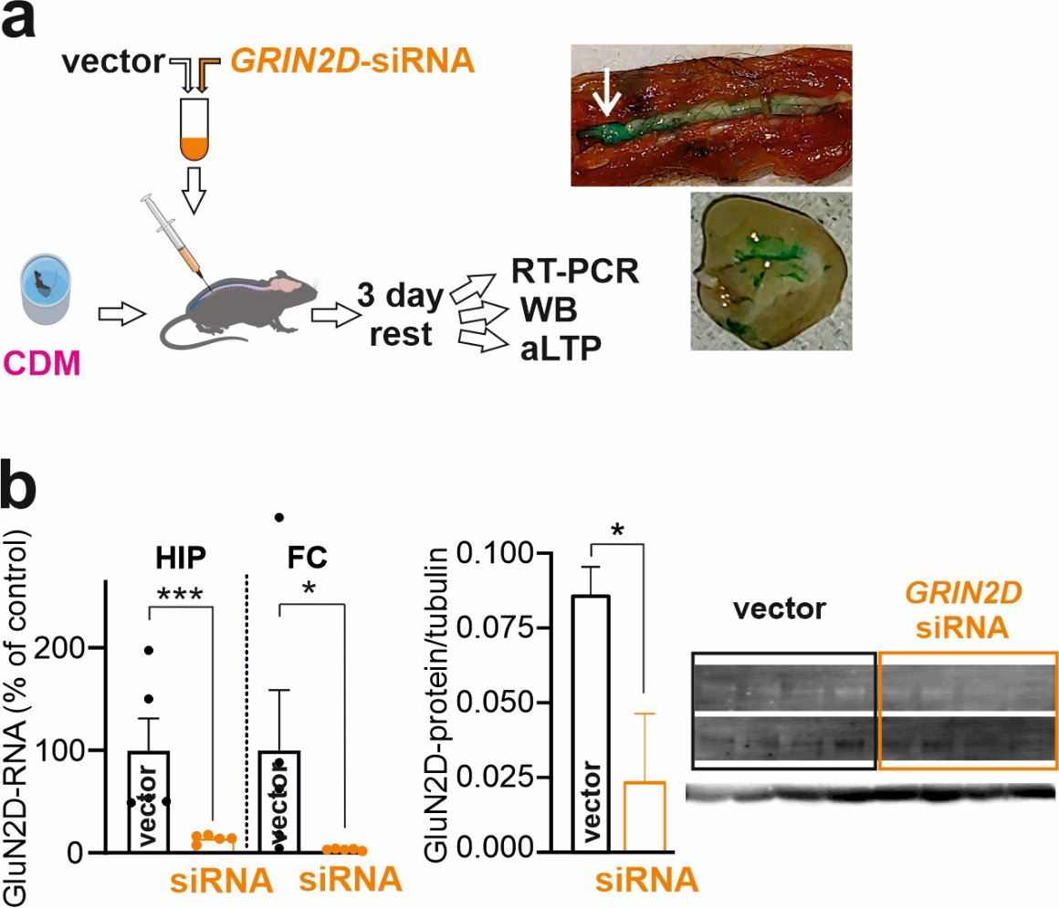
Supplementary Fig. 5: In vivo siRNA application.
a, Schematic overview of the siRNA protocol. GRIN2D siRNA was injected intrathecally after exposure to CDM, followed by three days of rest. Thereafter, readout measurements, real-time PCR, Western blotting and ex vivo aLTP measurements were performed. Green ink was injected into anesthetized mice between the L5 and L6 vertebrae (white arrow) to confirm the accuracy and reliability of the intrathecal injection technique. The ink diffused throughout the vertebral canal (top) and into the brain (bottom, coronal section).
b, RT–PCR showed that GluN2D mRNA expression was significantly lower in the HIP and the frontal cortex (FC) after siRNA treatment than after vector injection (left). Unpaired t test (p = 0.0159, n = 5 (vector), n = 5 (siRNA)). Western blot analysis of protein expression in vector-injected control mice and siRNA-treated animals revealed a significant reduction in GluN2D protein expression (right). Unpaired t test (p = 0.028, n = 4 (vector), n = 4 (siRNA)). The data are the means ± SEMs. *p < 0.05.
See Supplementary Table 1 for further information on the statistical analysis.

Supplementary Figure 6

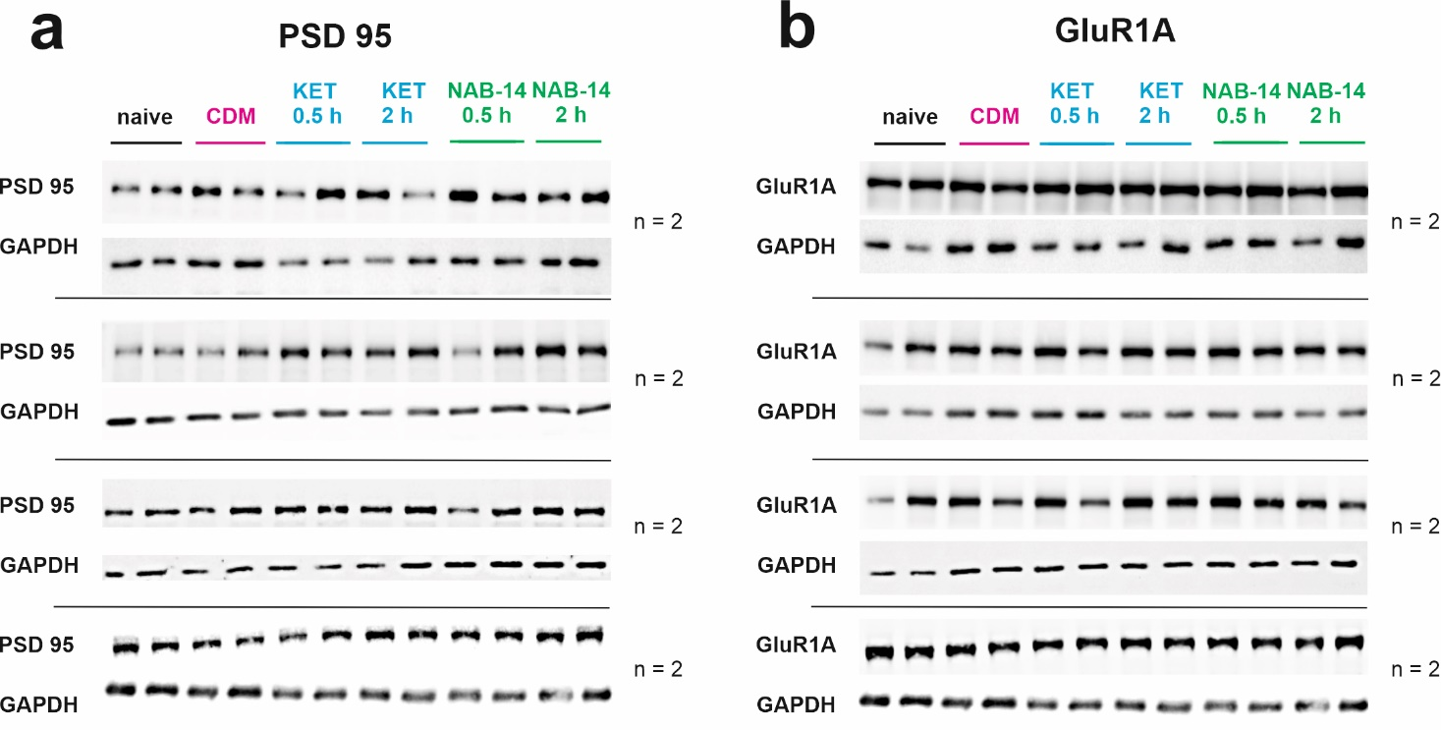
Supplementary Fig. 6: Western blots of PSD 95 and GluR1A.
a, Western blots of PSD95 under different treatment conditions: naïve, CDM, and CDM treated with KET or CDM treated with NAB-14 at the indicated time intervals after injection.
b, Western blots of GluR1A under different treatment conditions: naïve, CDM, and CDM treated with KET or CDM treated with NAB-14 at the indicated time intervals after injection.

Supplementary Figure 7

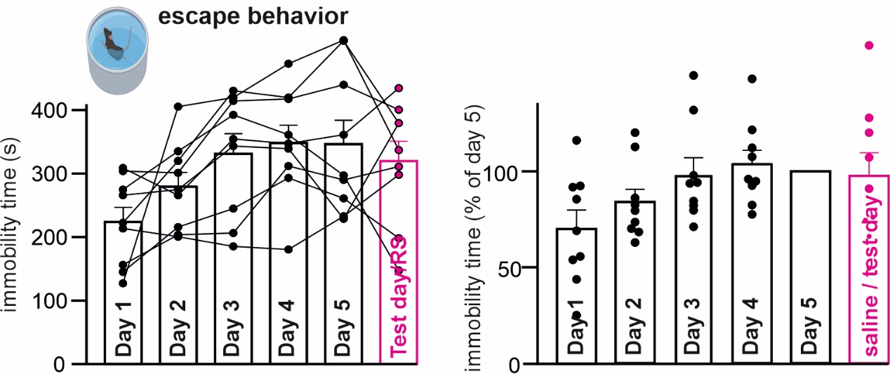
Supplementary Fig. 7: Immobility times in the CDM protocol
Averaged immobility times gradually increased from day 1 to day 5 and remained stable on the test day (left: absolute values, right: values normalized to day 5). The column data are the means ± SEMs.
See Supplementary Table 1 for further information on the statistical analysis.

Supplementary Table 1: Extended statistical analyses
Excel file containing extended statistics

