Supplementary Materials 2: Table 1, Sample Characteristics
Table 1. Sociodemographic Characteristics of Participants (n = 86) at baseline, and n = 33 participants included in the GAM analysis at baseline, and the n = 14 participants who met Kratochwill’s criteria for SCD Multiple-baseline design.
Baseline characteristic | n = 86 |  | n = 33 |  | n = 14
Baseline characteristic | N | % | N | % | N | %
Age | 75.54 (SD = 9.1) |  | 76.21 (SD = 8.37) |  | 78.1 (SD = 9.4)
Gender
Female | 39 | 48.7 | 14 | 43.8 | 5 | 35.7
Male | 41 | 51.3 | 19 | 56.2 | 9 | 64.3
Marital status
Single | 15 | 18.8 | 7 | 19.7 | 4 | 28.6
Married/partnered | 5 | 6.2 | 3 | 9.5 | 0 | 0.0
Divorced | 13 | 16.3 | 5 | 13.3 | 1 | 7.1
Separated | 10 | 12.5 | 4 | 12.4 | 2 | 14.3
Widowed | 37 | 46.2 | 14 | 45.1 | 7 | 50.0
Years in Education | Mean = 12.4; Median = 11.5; Min = 2; Max = 24. |  | Mean =12.1; Median = 11, Min =2, Max = 22 |  | Mean = 11.8; Median = 10.5; Min = 2; Max = 20
Living Arrangement
Living alone | 68 | 85 | 28 | 82.9 | 12 | 85.7
Living with spouse | 4 | 5 | 2 | 6.9
Living with child/grandchild | 8 | 10 | 3 | 10.1 | 2 | 14.3
Mobility
No problems | 24 | 30 | 10 | 30.3 | 5 | 35.7
Slight problems | 21 | 26.3 | 7 | 21.2 | 3 | 21.4
Moderate problems | 19 | 23.2 | 9 | 27.3 | 5 | 35.7
Severe problems | 15 | 18.8 | 7 | 21.2 | 1 | 7.1
Unable to walk | 1 | 1.2 | 0 | 0 | 0 | 0
Self-care
No problems | 49 | 61.3 | 16 | 48.5 | 6 | 42.9
Slight problems | 20 | 25 | 12 | 36.4 | 6 | 42.9
Moderate problems | 6 | 7.5 | 3 | 9.1 | 1 | 7.1
Severe problems | 4 | 5 | 2 | 6.1 | 1 | 7.1
Unable to wash or dress | 1 | 1.2 | 0 | 0 | 0 | 0
Usual activities
No problems | 30 | 37.5 | 16 | 48.5 | 7 | 50.0
Slight problems | 25 | 31.3 | 8 | 24.3 | 3 | 21.4
Moderate problems | 16 | 20 | 6 | 18.2 | 3 | 21.4
Severe problems | 4 | 5 | 1 | 3.0 | 0 | 0
Unable for usual activities | 5 | 6.2 | 2 | 6.1 | 1 | 7.1
Pain
No pain/discomfort | 25 | 31.3 | 8 | 24.3 | 2 | 14.3
Slight pain/discomfort | 21 | 26.3 | 8 | 24.3 | 2 | 14.3
Moderate pain/discomfort | 22 | 27.5 | 11 | 33.3 | 8 | 57.1
Severe pain/discomfort | 9 | 11.2 | 5 | 15.2 | 1 | 7.1
Extreme pain/discomfort | 3 | 3.7 | 1 | 3.0 | 1 | 7.1
Anxiety & Depression
Not anxious or depressed | 25 | 31.2 | 12 | 36.4 | 5 | 35.7
Slightly anxious or depressed | 24 | 30 | 9 | 27.3 | 5 | 35.7
Moderately anxious or depressed | 25 | 31.2 | 10 | 30.3 | 4 | 28.6
Severely anxious or depressed | 6 | 7.5 | 2 | 6.1 | 0 | 0
Extremely anxious or depressed | 0 | 0 | 0 | 0 | 0 | 0

Supplementary Materials: Visual Analysis
Visual Analysis: EQ5D-5L Utility Index Scores

Only participants with three sessions per phase were included in visual SCD analyses. This yielded n = 14 participants with usable data. Per the guidelines, the effect ought to be replicated at least three times to permit conclusion that such effect exists. As can be seen, the level of Utility Index in the baseline phase was highly variable, ranging from .22 to .90. No one had median perfect health (Utility Score of 1) during the baseline phase. As such there was room for improvement for all participants in terms of health. Medians rather than means were inspected because means in SCD research are susceptible to outliers (Ledford, Lane, & Severini, 2018).

Level
The level median utility score at intervention phase was improved for 7/14 participants (50%), relative to baseline. It must be borne in mind that ceiling effects caused by the maximum score of the utility index (1) may impact the trends observed over time for participants. Comparing the change in level among these seven cases to the minimally important difference of .074 (Walters & Brazier, 2005), we could see that all seven participants demonstrated positive changes in level between phases that surpassed this difference (ranging from .079 to .363). Thus, according to guidelines, the study demonstrates a functional relationship between the befriending intervention and improvements in health utility score. For those participants (7/14) whose utility scores declined between phases, five met the criterion for minimally important difference of .074 (ranging from .088 to .203), while two did not (changes of .024 and .065 respectively).

Trends
Trends in the baseline phase (“secular trends”, calculated as unstandardised estimates using ordinary least squares) were positive for 8/14 participants, close to zero for 3/14 participants, and negative for 3/14 participants. Magnitude of all slopes was small (the largest effect was .108). Trends in the intervention phase (“intervention trends”) were positive for 4/14 participants, and negative for 10/14 participants.

During the baseline phase, there were three cases who were close to zero in terms of their trend. 2/3 of these cases shifted to a positive slope (i.e. a therapeutic effect) during the intervention phase, while one stayed close to zero. There were three cases who had a negative slope during the baseline phase (of a small magnitude). For these three cases, two had a larger negative slope (a contra-therapeutic effect) during the intervention phase, and one stayed the same for both phases in terms of slope. The remainder (n = 8) had positive slopes during the baseline phase. Of these, one had a positive slope/therapeutic effect of lower magnitude during the intervention phase, one had a positive slope/therapeutic effect of larger magnitude during the intervention phase, five shifted to a negative slope/contra-therapeutic effect during the intervention phase, and one went from a positive slope to a slope of zero.

Variability
Variability was captured using the median absolute deviation (MAD) per phase. For participants who had high scores on the utility index, MAD was lower, because of the ceiling effect (e.g. see P042). For participants in both phases, MAD did not surpass .26. Interpreting variability from visual analysis was impeded somewhat by the high proportion of missingness across participants.

Table S2. Characteristics of Utility Scores among n = 14 participants with >3 sessions per phase.
Case ID | Sessions in Phase A | Sessions in Phase B | Level (median) Phase A | Level (median) Phase B | MAD Phase A | MAD Phase B | Trend Phase A | Trend Phase B
P008 | 6 | 5 | .766 | .620 | .106 | .246 | -.016 | -.078
P042 | 3 | 7 | .903 | 1.000 | .050 | .000 | .094 | .007
P055 | 3 | 8 | .336 | .699 | .003 | .042 | .001 | .036
P073 | 5 | 6 | .650 | .815 | .068 | .159 | -.034 | -.036
P086 | 5 | 5 | .651 | .448 | .261 | .227 | .092 | -.053
P137 | 4 | 4 | .220 | .116 | .151 | .155 | .048 | -.006
P165 | 7 | 5 | .753 | .855 | .101 | .108 | .003 | .053
P167 | 6 | 3 | .843 | .755 | .019 | .018 | .027 | -.123
P170 | 3 | 9 | .907 | .883 | .000 | .173 | .108 | -.019
P183 | 4 | 7 | .707 | .642 | .021 | .138 | .024 | -.027
P184 | 3 | 4 | .660 | .739 | .073 | .185 | .013 | -.100
P197 | 3 | 10 | .778 | .620 | .093 | .172 | .031 | .028
P222 | 5 | 3 | .456 | .563 | .155 | .027 | -.029 | -.126
P235 | 4 | 6 | .699 | .920 | .100 | .010 | .010 | .000

Figure S1. Single case graphs for Utility Index Scores for n = 14 participants with data meeting standards.

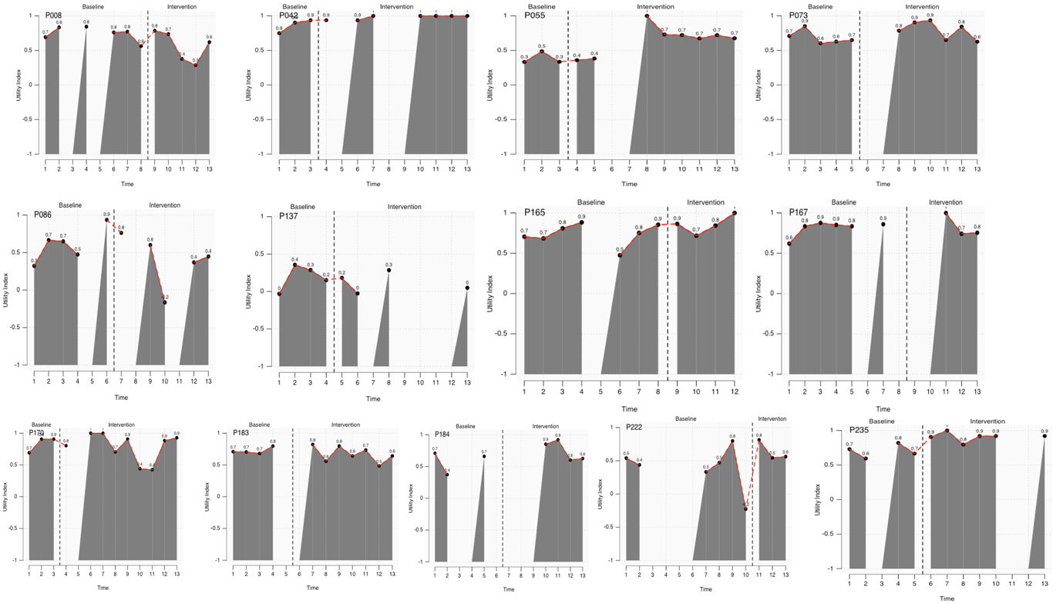

To comment on immediacy, median utility scores for the final three datapoints in the baseline phase were directly compared to the median utility scores for the first three datapoints in the intervention phase, for each participant. Positive effects larger than the minimally important difference of .074 were present in 6/14 cases. Negative effects larger than this difference were present in 2/14 cases. Of the remaining 5 cases, 6 cases had differences that were smaller than .074, either in the positive (1) or negative (3) direction. One case had too much missingness to calculate immediacy of effect.

Table S3. Data to calculate immediacy of effect for disutility scores.

Case | Median of final three datapoints in Phase A | Median of first three datapoints in Phase B | Mean of final three datapoints in Phase A | Mean of first three datapoints in Phase B | Raw mean change
P008 | .772 | .378 | .707 | .468 | -.239
P042 | .903 | .937 | .863 | .937 | .074
P055 | .336 | .359 | .386 | .371 | -.015
P073 | .629 | .786 | .627 | .786 | .159
P086 | .706 | .682 | .706 | .683 | -.023
P137 | .288 | .078 | .266 | .079 | -.187
P165 | .753 | .844 | .694 | .809 | .115
P167 | .86 | 1 | .86 | 1 | .14
P170 | .907 | .901 | .835 | .902 | .067
P183 | .739 | .691 | .739 | .691 | -.048
P184 | .66 | NA, NA, NA | .66 | NA | NA
P197 | .667 | .587 | .78 | .57 | -.21
P222 | .472 | .563 | .348 | .641 | .293
P235 | .744 | .907 | .744 | .901 | .157

