Answer to reviewers
We like to profoundly thank the reviewers for their comments and questions. We revised our manuscript based on the two reviewers' insightful comments. The referees asked questions that significantly strengthened the discussion, and we look forward to hearing whether the referees are satisfied with our modifications.
Very importantly, since we submitted our original manuscript, three remarkable papers have been published in Nature, PNAS and Nature Communications:
[1] P. Z. Sun et al., Unexpected catalytic activity of nanorippled graphene. Proceedings of the National Academy of Sciences 120, e2300481120 (2023).
[2] O. J. Wahab et al., Proton transport through nanoscale corrugations in two-dimensional crystals. Nature 620, 782-786 (2023).
[3] Z. F. Wu et al., Proton and molecular permeation through the basal plane of monolayer graphene oxide. Nature Communications, 14, 7756 (2023)
The research published by Professor Geim, Professor Unwin and Professor Lozada-Hidalgo highlights the importance of nanoscale corrugations, nanoripples and defects in graphene and graphene oxide towards proton transport and proton binding. These articles provide a complementary state-of-the-art to our original references. Therefore, we added the references to the revised manuscript in the introduction:
‘Pristine graphene(1) already fulfills these two criteria, partly as the graphene basal plane is impermeable to water and other molecules(2), and exhibits a certain degree of proton conductivity(3), also influenced by nanoscaled ripples(4) and corrugations (5), particularly in monolayer graphene oxide (6)’
In light of recent breakthroughs in understanding proton transport through graphene, we modified the title to propose a more generic approach that opens a proton path through graphene:
Sulfophenylation of graphene opens a transmembrane proton path.
Considering the discussions over leakage or so-called edge effects, the level of current measured in these studies falls in the range of fA-pA at 100 mV applied bias, which is the range of ionic currents measured for a low abundance of defects in graphene (3 mS·cm⁻² as reported in reference 3). We measure 8 up to 100 mS·cm⁻² for pristine exfoliated graphene at 100 mV bias, an offset which is negligible compared to the conductance increase upon sulfonation (i.e., up to 50 S·cm⁻²) for a 0.78 μm² freestanding membrane on a ~1 μm circular aperture.
Separately – not asked by the reviewers – we have updated our theoretical sections discussing the measured experimental conductances upon sulfophenylation. We calculated the effect of the sulfophenyl group on both one side and two sides of the sp³ defect and derived the proton flux based on how much the three benzene rings get distorted around the sp³ carbon atoms. We, therefore, modified Figure 1 and the related main text, updated the supporting information, and added the following discussion in the main text:
Using circumcoronene models (Fig. 1B), we calculated the extend of lattice expansion upon diazotisation, including hydrogenated and phenylated circumcoronene (Table S1, see Supplementary material 1.1) to explore their impact on proton transmembrane conductance through graphene membranes. Fig. 1B shows that larger functional groups induced greater distortion in the hexagonal ring (up to 6.8% for double sulfophenyl functionalization), resulting in an increase in proton flux. Functionalization, on both sides, with phenyl or sulfophenyl groups increased the proton flux by eight to nine orders of magnitude, while hydrogenation only increased the flux by one order of magnitude. Notably, quantum tunnelling was less prominent with larger ring sizes.

Fig. R1 (Fig. 1) Proton-selective six-membered benzenoid ring expansion in exfoliated single-layer monocrystalline graphene by diazotization with 4-sulfobenzenediazonium tetrafluoroborate (4-SBD). (A) Illustration depicting the functionalization of graphene with 4-SBD. Besides the direct coupling of the sulfophenylated radical to the graphene basal plane, which converts sp² carbon to sp³, 4-SBD could also link to the ortho position of a previously grafted benzene ring via a radical coupling or an azo coupling. (B) Simulations on the relationship of transmembrane transport proton flux with different functional states of monolayer graphene. The flux was simulated using the Wentzel–Kramers–Brillouin (WKB) tunneling approximation based on the density functional theory (DFT) with PBE0 density functional potential energy barriers. The cropped images of the simulation models near functional groups indicate the correspondence between functional states and proton flux. *The protonated -SO₃⁻ groups with identical functions are presented in parallel. (C) Illustration of the ionic current measurements setup. An exfoliated graphene flake is transferred on a Si/SiN chip with a 1 μm in diameter circular aperture in a 30 nm thick SiN free-standing membrane (details on the chip fabrication procedure can be found in the Supplementary material, section 2.2). The as-prepared chip was then mounted in a flow cell containing two reservoirs containing electrolyte solutions (HCl, KCl, CuCl₂, CaCl_{2,} and FeCl₃). The transmembrane ionic current was measured by applying a series of biases (from -100 to 100 mV in 10 mV intervals) between two Ag/AgCl electrodes immersed on both sides of the graphene layer. From current-voltage curves (I-V, Fig. S18-S21) the areal conductance was determined. (D) Areal conductance (at 100 mV) was measured in 0.1 M HCl and 0.1M KCl as a function of 4-SBD reaction times ranging from 0 to 96 h. Inset: Normalized areal conductance measured in 0.1 M electrolytes for HCl, KCl, CuCl₂, CaCl_{2,} and FeCl₃. For the discussion of selectivity, the conductance of specific chloride salt was normalized to HCl by dividing the measured conductivity by bulk conductivities for each salt (details in the Supplementary material section 2.2). The error bar represents the standard deviation between devices 1 and 2. Notably, device 3 exhibited a proton conductance of 22.3 S·cm⁻² after a 93 h 4-SBD treatment. However, it is essential to highlight that device 3 was crafted during the preliminary study using a distinct chip fabrication procedure. Consequently, we refrain from including it in the comparison with devices 1 and 2 to maintain consistency in the analysis.
We also added to the supplementary materials the methods we used in these simulations:
  - Tunneling calculations.
We modeled graphene using circumcoronene, which was subsequently functionalized with various groups (H, phenyl, protonated and deprotonated sulfophenyl). Always, two neighboring carbon atoms were functionalized to prevent radical formation, with the groups positioned on opposite sides of the circumcoronene ring. Systems were fully optimized using the PBE0 hybrid density functional, TZP basis set, many-body dispersion (MBD) correction, and good numerical quality settings, as implemented in the AMS suite(1, 2). Once optimized, we substituted functional groups with H atoms (Fig. S1) and investigated hexagonal ring distortion's impact on proton tunneling through the rings. The potential energy barriers were determined through DFT calculations using the Born-Oppenheimer approximation (as described above), while corresponding particle fluxes through the membrane were calculated using the Wentzel–Kramers–Brillouin (WKB) approximation, as described in our previous work(3).
Table S1 Flux of proton calculated at 300 K using WKB approximation.
System | Ring area (Å²) | Classical flux | Quantum flux | Total flux
graphene | 5.158 | 1.738 × 10⁻²⁹ | 5.994 × 10⁻²⁷ | 6.011 × 10⁻²⁷
2H graphene | 5.446 | 4.405 × 10⁻²⁷ | 2.165 × 10⁻²⁶ | 2.606 × 10⁻²⁶
SBD-graphene | 5.464 | 9.073 × 10⁻²³ | 3.978 × 10⁻²² | 4.886 × 10⁻²²
protonated SBD-graphene | 5.467 | 5.358 × 10⁻²⁴ | 3.595 × 10⁻²³ | 4.131 × 10⁻²³
2-side SBD-graphene | 5.497 | 2.832 × 10⁻¹⁹ | 9.996 × 10⁻¹⁹ | 1.283 × 10⁻¹⁸
protonated 2-side SBD-graphene | 5.509 | 1.304 × 10⁻¹⁹ | 4.712 × 10⁻¹⁹ | 6.016 × 10⁻¹⁹
2-side phenyl-graphene | 5.499 | 2.227 × 10⁻¹⁹ | 7.802 × 10⁻¹⁹ | 1.003 × 10⁻¹⁸
The particle flows (flux) are given in hartree atomic units of length/time.

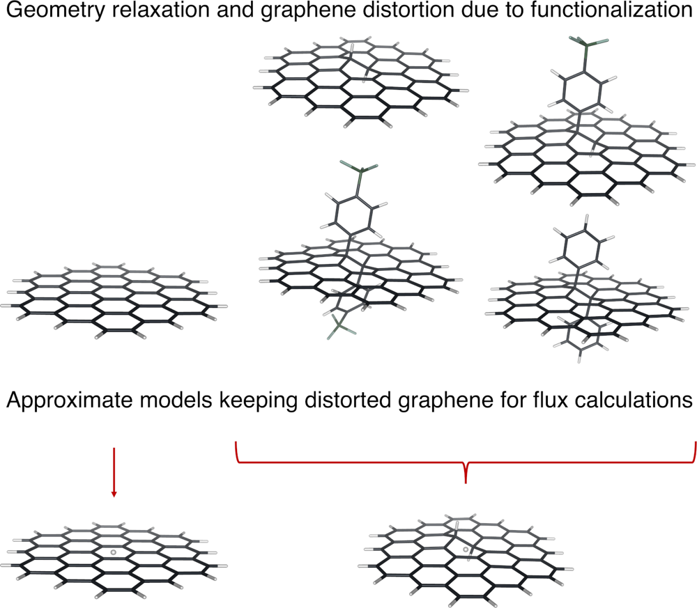
Fig. R2 (Fig. S1) Simulations models: Step 1, all models were relaxed as explained in the Methods section; Step 2, all the functional groups were substituted by H atom at their relaxed geometries; Step 3, new models were used to obtain DFT potential energy barrier, to be used in Step 4, to calculate the proton flux employing WKB approximation.

Point-to-point answers
Answer to Reviewer 1
- I miss an isotope experiment. It would have great to see D+ come through the membrane.
Indeed. This experiment was carried out employing CVD graphene and an adhesion layer -- a covalently functionalized hydrophobic layer -- to maximize success rates. We observed no significant difference in conductance for H⁺ vs D⁺ for the SBD-treated CVD graphene (Fig. R1B). Given that CVD graphene has grain boundaries and additional defects compared to exfoliated graphene, we believe that the study of H⁺ vs D⁺ transport with CVD graphene should be a new manuscript with additional control measurements that fall out of the scope of this original paper. We will also prepare graphene samples under different growth conditions to separately pinpoint the exact role of grain boundaries vs. sulfophenylation. We are therefore reluctant to discuss absolute changes in areal conductances for proton and deuterium at this stage. However, our conclusions still hold. Upon sulfophenylation, proton and deuterium transport through the functional graphene more efficiently compared to pristine CVD graphene.
.
Fig. R3 Ionic conductance of sulfophenlylated CVD graphene on a chip coated with an adhesion layer in HCl, DCl, KCl and LiCl. (A). Ionic measurements were performed using a flow cell setup with two chambers filled with 0.1 M solutions, while the graphene-coated SiN chip device was positioned in the middle. The CVD graphene was transferred onto a Si/SiN chip featuring a circular aperture with a diameter of 1 μm. Prior to the measurements, the graphene underwent specific treatment with the SBD solution (1 mg·ml⁻¹ in 0.1 M HCl). (B) To facilitate a comparison of ion transport, the ionic conductances were normalized to HCl based on the bulk solution conductivity. (0.1 M HCl: 3.7 S m⁻¹; 0.1 M KCl: 1.28 S m⁻¹; 0.1 M LiCl: 0.81 S m⁻¹; 0.1 M DCl: 2.72 S m⁻¹).
- The discussion of the activation energy suggests an Arrhenius analysis (and temperature dependence) so I was glad to see the DMFC experiments as a function of temperature. Clearly the power density does not exhibit Arrhenius behavior, but perhaps the short circuit density density does?
Absolutely, thank you for pin-pointing this aspect of the data. We investigated further the Arrhenius analysis as suggested by the referee.
In Fig. R4-6, the membrane conductance shows a favorable Arrhenius-type relationship between the membrane conductance and temperature, but not for pristine graphene, nor for SBD treatments longer than 4 days. We analyzed the data by conducting linear fitting using the Einstein-Nernst equation(1) and the σT-equation(2).
Remarkably, the Arrhenius plots revealed that the 4-day SO₃⁻-CVD graphene membrane exhibits an activation energy of approximately 6.9 kJ mol⁻¹ (0.072 eV), signifying its high proton conductivity. Moreover, the proton transport through the SO₃⁻-graphene membrane suggests a Grotthus mechanism (≤0.4 eV) where protons hop at a faster rate than the dissociation mechanism from its hydrations(3). In tandem with the analysis of the conductance, the short-circuit current also follows an Arrhenius behavior. Remarkably, SBD-treated samples showed a linear relationship of ln (σT) vs. T⁻¹ up to 4-day of treatment (revised Fig. 4D).
We updated the manuscript with the following discussion:
By analyzing the measured conductance and temperature-dependence, the proton conductances of SO₃⁻-graphene membranes exhibit an Arrhenius behavior as described by equation (1):
ln(σ𝑇) = ln(σ₀) − ln(𝑒)𝐸_{𝑎}/𝑘_{𝐵}×𝑇⁻¹ (1)
where σ is the measured conductance, T is the temperature, E_{a} is the activation energy and k_{B} is the Boltzmann’s constant. Samples after 1, 2, 3 and 4 days of SBD treatment show a linear relationship of ln (σT) vs. T⁻¹, with a fitted E_{a} of 6.9 kJ mol⁻¹ (0.072 eV) after 4 days of SBD treatment (Fig. 4D). Pristine graphene does not show an Arrhenius behavior. The relatively low E_{a} after 4 days of SBD treatment suggests that protons cross the membrane via a Grotthus mechanism (≤0.4 eV) where the proton hops through the membrane at a faster rate than dissociating from the hydronium ion (50). After 5-day and 6-day, ln(σT) vs. T⁻¹ present a less linear relationship compared to 4-day of treatment (Fig. S45), which could be caused by the polymerization of SBD, therefore hindering proton transport, leaving larger defects/cracks with a lower proton selectivity compared to methanol crossover.

Fig. R4 (Fig. 4). DMFC performance with CVD graphene and SO₃⁻-graphene membranes. (A) Power-current density (P-I) and voltage-current density (V-I) curves for Nafion 117, pristine graphene, 4-day, and 6-day 4-SBD treated SO₃⁻-graphene. The cell voltage (V) and the power density (P) as a function of current density (I) were measured in a 1 M methanol/water solution at 60 °C. (B) Maximum power density as a function of temperature. (C) Equivalent circuit and Nyquist plots of electrochemical impedance spectroscopy (EIS) measured at the open circuit voltage for pristine graphene and SO₃⁻-graphene in a DMFC. A Nafion layer was spin coated on graphene and SO₃⁻-graphene, and the stack was transferred on a polycarbonate porous support (~16% of PC with ca. 3μm diameter holes) filled with Nafion. (D) ln(σ𝑇) as a function of T⁻¹ for pristine and SBD-treated graphene. The energy barriers were calculated based on eq. (1) following an Arrhenius analysis. (E) P-I curves of the DMFC fuel cell operating at 60 °C with aqueous solutions of methanol (respectively 1 and 5 M) for a ~183 μm thick Nafion 117 layer and 4-day SO₃⁻-graphene. (F) Decreases of maximum power density upon operating the DMFC in 5 M methanol compared to 1 M methanol. The blue dashed line corresponds to the decrease of the power density of a DMFC with only Nafion 117 when switching from 1 M methanol to 5 M methanol.
We added the following contents in the supplementary information:
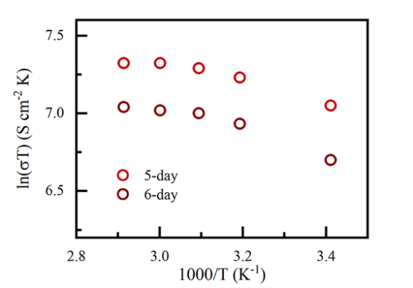
Fig. R5 (Fig. S45) ln(σ𝑇) as a function of the inverse of temperature for SO₃⁻-graphene membranes after 5 days and 6 days of 4-SBD treatment.
Next, as suggested by the referee, we analyzed short circuit currents as a function of temperature. We plotted ln(I×T) vs. T⁻¹ for pristine graphene and after 1, 2, 3 and 4 days (Fig. S46A) and 5, 6 days (Fig. S46B) of SBD treatment. For all samples, ln(I×T) follows a linear (and similar) trend with T⁻¹. In the case of DMFCs, the behavior of the short-circuit current (respectively the current density) can be influenced by multiple factors other than temperature, including methanol concentration, catalyst activity and membrane properties. We believe that analysing ln(σ𝑇) as a function of T⁻¹ is therefore more representative of the membrane properties compared to ln(I×T) vs. T⁻¹ (Fig. R6).
Fig. R6 (Fig. S46) ln(I×T) as a function of the inverse of temperature for graphene membranes with 4-SBD treatments from 0 to 6 days.
- I appreciate that the authors have used various indirect methods to try to quantify how much 4-SBD grafts onto the sample as function of time. It would have been great with direct observation using STM for example.
STM characterization necessitates stringent surface flatness and cleanness, and is carried in ultra-high vacuum conditions. In our study, the treatment was conducted in an aqueous solution, which prevents in situ STM characterization. Instead, we performed high-resolution transmission electron microscopy (HRTEM) characterization. No pinhole-like defects were found in any of the sample batches, indicating the absence of large pore openings introduced during the SBD treatment. The evidence from XPS and Raman spectroscopy, along with the observed changes in proton conductance, supports the conclusion that the increase in proton conductance vs. SBD treatment time is not related to larger pores, defects or cracks.
In situ and operando investigations to elucidate the reaction mechanisms between diazonium and free-standing graphene in water are challenging and will require the development of new analytical platforms. We believe HRTEM remains the best method to visualize our samples with atomic resolution.
- Since the authors have used microfabricated membranes with well-defined aperture sizes I would really, really like if the authors could confirm that the total conductance indeed scales with the area of the aperture in the expected (trivial) way? This would be a very elegant argument to ensure that edge effects are not important (which I expect to be true, but I'm not entirely sure).
We agree and initially also aimed at measuring whether the conductance scales with the membrane area. Unfortunately, for a similar aperture diameter, using exfoliated graphene, proton conductances range between 21.8 and 50.0 S·cm⁻². A value significantly larger than pristine graphene, however still within a scaling factor of 2 for a given difference in the thickness of supporting membrane (60 nm vs. 30 nm) after 4 days of SBD treatment. Albeit, we fabricated 16 devices on apertures larger than 1μm² (with CVD graphene). All showed leakage even before treating graphene with SBD. As mentioned in the main text, edge effects – presumably ion leakage between the pristine graphene and the chips contribute to 0.008 to 0.1 S·cm⁻² of areal conductance (for respectively a maximum conductance in 0.1 M HCl of 20-50 S·cm⁻² after 4 days of SBD treatment). We added to the main manuscript a discussion of edge effects:
Presumably ion leakage between the pristine graphene and the chips contributes to 0.008 to 0.1 S·cm⁻² of areal conductance (for respectively a maximum conductance in 0.1M HCl of 20-50 S·cm⁻² after 4 days of SBD treatment). Therefore, edge effects would only contribute to 0.2-1% of the total conductance measured.
- Did the authors perform a reference experiment with soaking in "inert" water solution (as opposed to their 4-SBD solution under otherwise similar conditions?
Our analysis revealed no obvious variations in proton conductance in the presence of water or in the presence of a diluted HCl solution.
The following discussion was added to the Supplementary material:
The graphene membrane samples underwent a thorough rinsing process in ultrapure water (Fig. S42) and 0.1 M HCl (Fig. S43). For that, graphene samples were floated on ultrapure water and 0.1 M HCl for 2 to 12 days and tested in a DMFC at 60 °C. We did not measure a significant change in power output at a temperature of 60 °C. This observation suggests that water and 0.1 M HCl only (i.e., without SBD), result in no significant influence on the performance of pristine graphene membranes in terms of their maximum power output within DMFCs, suggesting the effect to be attributed to the functionalization of graphene with SBD.
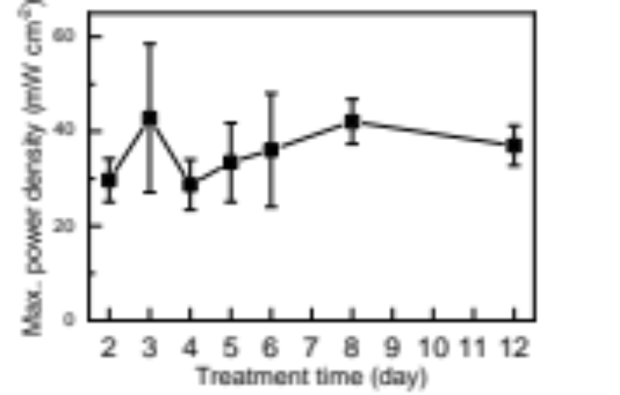
Fig. R7 (Fig. S42) Maximum power output of Direct Methanol Fuel Cells (DMFCs) with graphene membranes floated on pure water. Graphene membranes were floated on ultrapure water using the same conditions applied for the SBD treatment. The fuel cell tests were operated at 60 °C, with same flow rate of 1 M methanol solution and oxygen as tests conducted with SO₃⁻-graphene membranes.
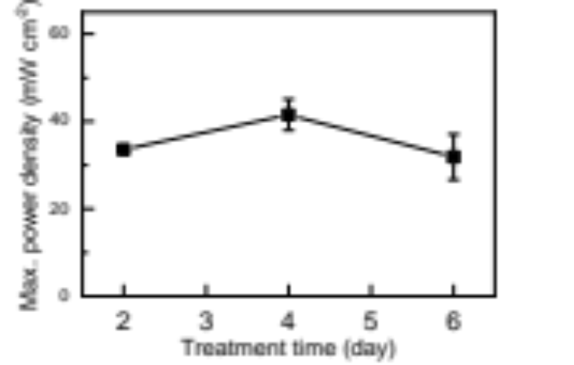
Fig. R8 (Fig. S43) Maximum power output of Direct Methanol Fuel Cells (DMFCs) with graphene membranes floated on 0.1 M HCl solution. Graphene membranes were floated on 0.1 M HCl using the same conditions applied for the SBD treatment. The fuel cell experiments were performed at 60 °C, with the same flow rate of the 1 M methanol solution and oxygen as experiments conducted with SO₃⁻-graphene membranes.
- Considering the benzene ring payload with its sp2 carbon - how is it possible to ever reach sp3/sp2 of 1:1 even at 100% coverage of the graphene?
We agree with the referee. For single-crystalline graphene, sp³ species should be minimal; those originate from sample manipulation, transfer, or CVD growth. Despite careful PMMA removal and rinsing, residual contamination influences the C1s spectrum. Though absolute values may be related to impurities, relative ratios still allow the characterization of SBD grafting, particularly thanks to the sulfur band.
We added the following discussion in the main text to clarify this point:
Moreover, semi-quantitative analyses were also conducted to determine the chemical composition of the grafted sites (Table S2). The sp³C/sp²C ratio, initially at 0.2 for pristine graphene, indicates impurities from transfer and manipulation as pristine graphene should be free of sp³ hybridization. Therefore, the absolute value of the sp³C/sp²C ratio could not reveal the number of sp³ sites introduced by the SBD treatment. However, discussing the sp³C/sp²C ratio evolution reveals the state of sp³/sp² conversion of graphene upon 4-SBD treatment. Relative ratios of -SO₃⁻ and -N=N with respect to the total chemical species from XPS, particularly the S2p, C1s and N1s spectrum, indicate the relative increase of sulfophenyl groups grafted on the graphene surface vs reaction time. For ease of comparison, we plotted sp²C/sp³C and -SO₃⁻, -N=N- in Fig. 3C. Incubating graphene with diluted SBD (0.1 mg·ml⁻¹ instead of 1 mg·ml⁻¹), resulted in no more changes in the relative sp³C/sp²C (0.86) and S2p content (1.7) after 2-day of SBD treatment (Table S2), validating that the changes in relative component ratios were increased upon SBD functionalization. On the contrary, the sp³C/sp²C ratio, for the treatment with 1 mg·ml⁻¹ SBD, first increased to 1.0 after 2-day treatment and then dropped to 0.3 after 6-day treatment. Indeed, the oligomerization procedure only introduces more sp²C in benzene rings instead of more sp³ sites on graphene.

Table S2:
Duration of treatment | 4-SBD concentration (mg·ml⁻¹) | Peaks relative concentration (%) |  |  |  |  |  |  |  | sp³C/sp²C ratio
 |  | S2p | C1s |  |  |  | N1s
 |  | SO₃⁻ | sp² | sp³ | C-N | O-C-O | N=N | NH₂ | NO_{x}
pristine |  | 0 | 69.9 | 13.0 | 9.2 | 3.3 | 3.9ª | 0.7ª | 0 | 0.19
2 days | 1 | 2.6 | 36.7 | 36.3 | 13.1 | 9.2 | 1.2 | 0.6 | 0.4 | 1.00
4 days | 1 | 5.2 | 55.8 | 19.7 | 10.6 | 3.2 | 3.1 | 0.6 | 1.9 | 0.35
6 days | 1 | 6.3 | 58.9 | 17.7 | 7.6 | 2.9 | 3.3 | 2.0 | 1.5 | 0.30
2 days | 0.1 | 1.7 | 39.4 | 34.0 | 13.9 | 7.5 | 2.4 | 0.7 | 0.5 | 0.86
6 days | 0.1 | 1.7 | 39.5 | 33.3 | 13.8 | 10.2 | 0.9 | 0.4 | 0.3 | 0.84
ª Nitrogen content in the pristine sample is assigned to adsorbed N₂.
- Why does CVD graphene require more time for grafting the SBD than exfoliated graphene?
There is an offset of 12 hours to reach maximum reactivity (i.e., 84 hours for exfoliated graphene in free-standing configuration where both sides of graphene are reacting with SBD vs. 96 hours for CVD graphene where only one side of graphene could react with SBD due to the DMFC device setup).
In fact, compared to exfoliated graphene where SBD reacts on both sides of the free-standing graphene, CVD graphene must be protected using a Nafion top layer in the DMFC to prevent the membrane from cracking during the MEA and SBD treatment, slowing down the reaction kinetics (noted by a 12 h time delay). There are also differences between the starting raw materials, i.e., CVD vs. exfoliated graphene (content of amorphous carbon for example) that could affect this offset in reaction times.
We added in the main text (in red, after the original paragraph):
The higher resistance after 6 days of reaction with 4-SBD also suggests a hindrance of the proton transport pathway due to oligomerization. In ionic measurements (Fig. 1), however, the maximum areal conductance was reached earlier in time (i.e., 84 h, 3.5-day). This bias in the time to reach a maximum conductance (respectively, 84h for exfoliated graphene, and 4 days, i.e. ~96h for CVD graphene) is likely due to the need for a Nafion support coating on the upper part of the CVD graphene in the DMFC setup.
- There is some confusion of definitions to clear up. For example: Quote "Accordingly, the relative ratio of -SO 3- increases from 0 for pristine graphene to 5.2 after 4 days of treatment and further increases to 6.4 after 6-day of treatment. "
The ratio of -SO3- to what?
Same question for "ratio of -N=N-" in the following sentence. Fig 3C: What does "constitution relative ratio" mean?
In the quoted statement, the ratio of "-SO₃-" refers to the relative area of sulfonate (-SO₃-) groups to the total spectrum area from XPS. It indicates the proportion of -SO₃- groups in relation to other functional groups on the graphene surface.
Similarly, the "ratio of -N=N-" corresponds to the relative abundance of -N=N- groups on the graphene surface to the total spectrum area from XPS. It represents the proportion of -N=N- groups in relation to other functional groups on the graphene surface.
Regarding Fig. 3C, the term "constitution relative ratio" refers to the relative ratio or abundance of specific constituents or components within the sample being analyzed. In the context of the figure, it represents the relative proportion of different constituents present in the graphene membrane.
We revised the manuscript accordingly:
Relative ratios of -SO₃⁻ and -N=N- with respect to the total chemical species from XPS, particularly S2p, C1s and N1s spectrum, indicate the relative increase of sulfophenyl groups grafted on the graphene surface vs reaction time.
"power-current (P-V)" should perhaps be "power-current (P-I)"
Thank you. We have revised this in the manuscript.
Fig. 4A shows the power-current (P-V P-I) and voltage-current (V-I) plots for pristine CVD graphene, Nafion, and SO₃⁻-graphene at 60 °C.
- If only one side of the graphene is functionalized with SBD in the DMFC setup, what happens if the electrodes are inverted such that the proton flow through the membrane goes in the opposite direction?
Indeed, the DMFCs presented in the manuscript were always operated with Nafion coated graphene facing the anode and the sulfophenylated side facing the cathode (Fig. R9A, left). Nafion was used as a graphene transfer layer, as a support during the functionalization with 4-SBD (in the floating configuration, see Fig 2A) and to minimize the formation of cracks and therefore solvent/ion leakage during the DMFC operation. In such a reverse assembly (Fig. R9A, right), the 4-SBD treated side was facing the anode, via the channels of the porous polycarbonate track-etched support and Nafion. For the device with the membrane in the reverse assembly, the protons now cross the membrane from the sulfophenylated side to the untreated side, allowing us to probe potential mechanistic differences of proton transport compared to the forward membrane assembly (including differences in the interaction between the membrane and solutions-gas).
We added to the Supplementary material:
To explore potential differences in DMFC performances between the standard (i.e., forward) membrane assembly, we tested devices with the sulfophenylated membrane side facing the anode at 60 °C (Fig. S47). Such device showed a slight difference in conductance, compared to the forward membrane assembly (i.e., 5.4 S·cm⁻² vs. 5.6 S·cm⁻², normalized to the electrode area). However, we observed a small decrease in the open circuit voltage (580 mV vs. 630 mV) and the maximum power output (70 mW·cm⁻² vs. 109 mW·cm⁻²), compared to the forward membrane assembly. Since the conductance values are similar in both assemblies, we speculated the differences to be caused by the hydrostatic pressure induced delamination and methanol leakage.
Fig. R9 (Fig. S47) Comparison of DMFC performances for SO₃⁻-graphene facing the anode (reverse assembly) vs. SO₃⁻-graphene facing the cathode (forward assembly). (A) For the forward assembly (left), which has been applied in DMFC measurements in the main text, the 4-SBD treated side of graphene was facing the cathode via the channels of the porous PC support. In this comparison, (the reverse assembly, right), the 4-SBD treated side of graphene was facing the anode via the channels of porous PC support. Power-current density (P-I) and voltage-current density (V-I) curves (B) and the Nyquist plot of EIS measured at 200 mV (C) of the DMFC with the reverse membrane assembly. In this measurement, the proton was transported from the sulfophenylated side to the untreated side. The DMFC was operated with 1 M methanol under 60 °C.

- The wording on the effect of going from 1 M MeOH to 5 M is misleading. Where the text says that power density drops to 10% it should say by 10% (if I understand fig 4f correctly).
That is correct indeed. We changed the wording in the revised manuscript.
After a switch from 1 M to 5 M methanol, the maximum power density with Nafion 117 dropped by ~53%. The drop in maximum power density, switching methanol from 1 M to 5 M, was reduced to by ~10% after 4 days of reaction time with 4-SBD (Fig. 4F).
- In the supplementary information, we learn that out of a total of 55 samples, quote "28 did not show any ion pathway upon 4-SBD treatment presumably due to a poor wetting of the SiN aperture".
I.e. 50% of the samples showed no ionic conductance at all?
How can that be? Why would that depend on poor wetting of the aperture? If anything, poor wetting should allow ions to bypass the graphene (ionic shunting)?
This question seems pretty important.
28 devices did not show ionic currents, indeed. High failure rates are one of the intrinsic drawbacks of solid-state nanopore techniques (4). Several factors contribute to failure rates, including the transfer procedures of microflakes, device wetting (air bubbles present in the SiN aperture or incomplete SiN etching during microfabrication), and the adhesion between the microflake and the substrate.
Determining the exact cause of these failures is a challenging task, as the devices are fully sealed during testing, and we lack an in-situ approach to precisely detect the specific reasons behind them. Devices failed due to large leakage currents, evidenced by a sudden increase in the ionic current (e.g., from 200 pA to >10 nA) after changing solutions (Fig. R11). In contrast, successful devices consistently exhibited a gradual increase in ionic current in HCl and a relatively small increase with KCl (<2 nA). For devices attributed to poor wetting or the presence of polymer residues, their ionic current remained relatively low (< 300 pA) throughout the treatment, accompanied by asymmetric I-V curves (Fig. R12). These low ionic signals are indicative of poor solution-solid interactions (5), such as the presence of trapped gas bubbles because of poor wetting. We were unable to confirm whether it was because of the presence of (thick) residues from the polymer-assisted transfer step or poor wetting as the definitive cause of such low currents. We added now I-V curves of the devices in Appendix R1).
We revised the supplementary material:
We prepared 55 devices made of exfoliated graphene, including 3 working devices, 10 leaking devices, 14 delaminated devices during operation and 28 devices that did not show any ion pathway before and after SBD treatment. Some of the chips did not reach a full micropore opening during the microfabrication procedure (Fig. S26), which did not allow us to accurately analyze the success rate regarding the graphene transfer and ionic current measurements.
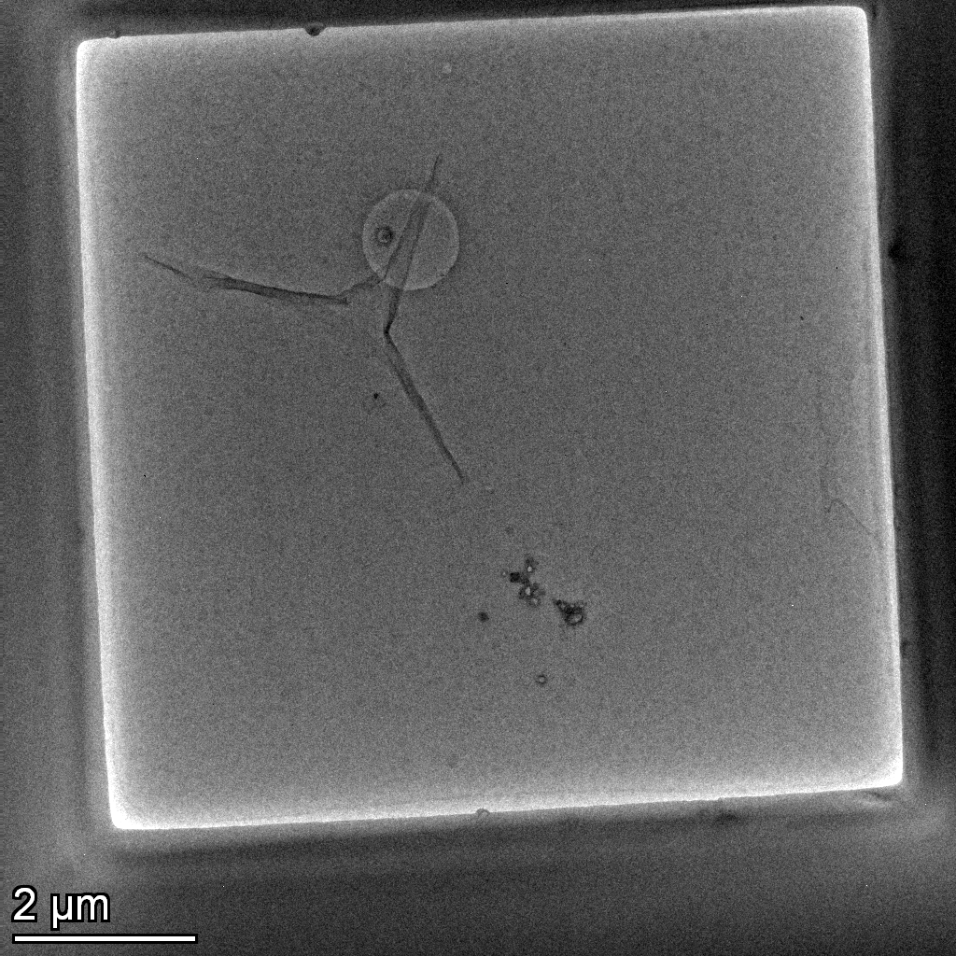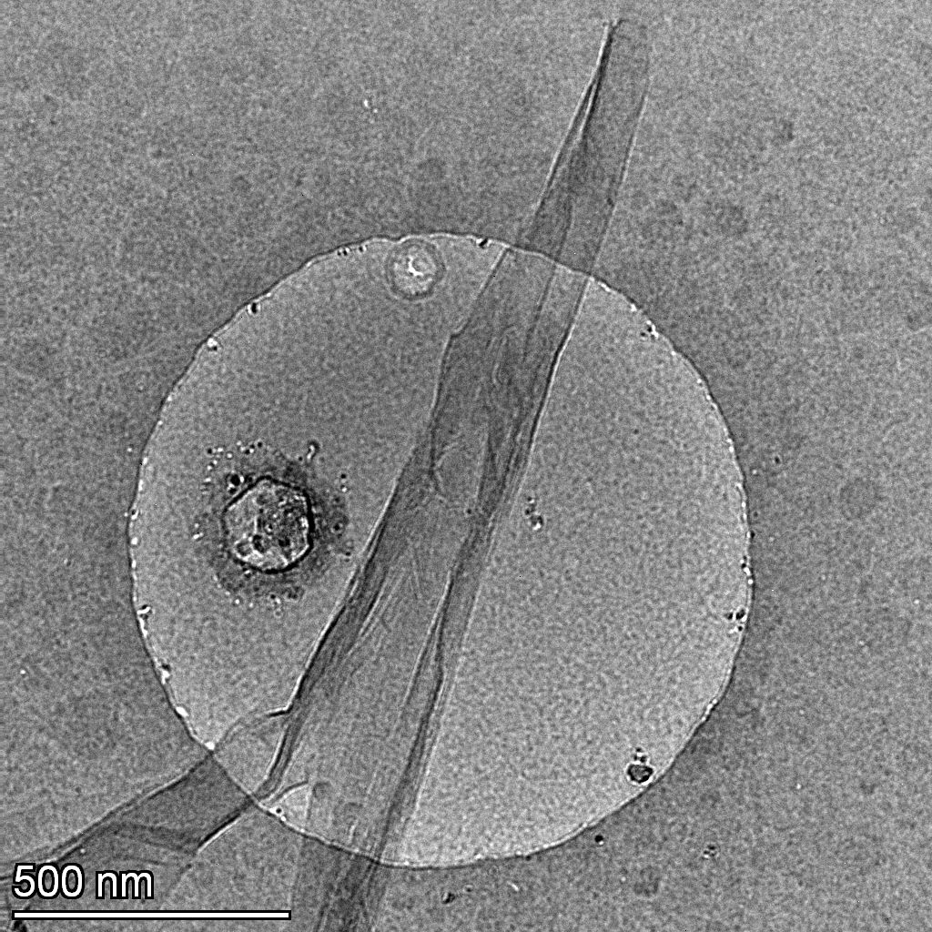
Fig. R10 (Fig. S26) TEM images of a SiN chip with a pore not fully opened-etched.
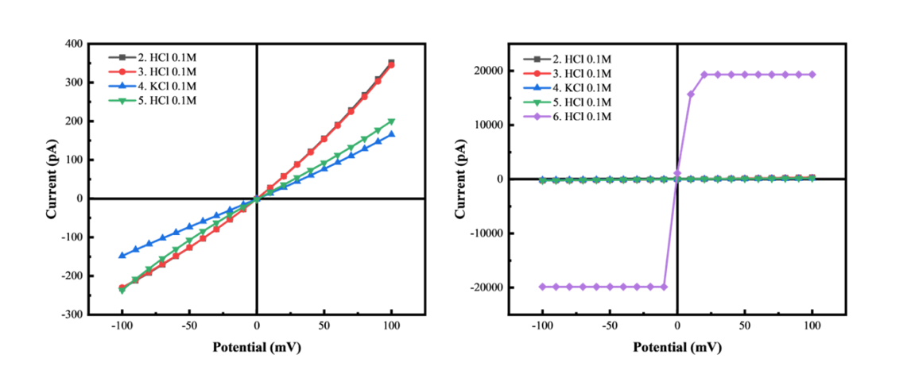
Fig. R11 (Fig. S27) I-V curves of a failed device assigned to delamination of exfoliated graphene. The measurements were conducted with 0.1 M HCl and 0.1 M KCl solutions under ambient conditions.

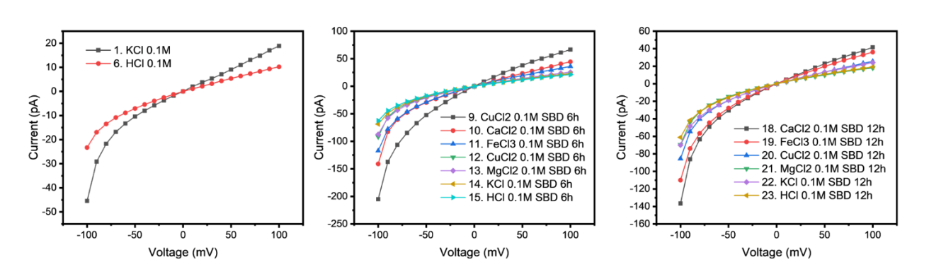
Fig. R12 (Fig. S28) I-V curves of failed devices assigned to clogging due to poor wetting or polymer residue on exfoliated graphene. The measurements were conducted with 0.1 M HCl and 0.1 M KCl solutions under ambient conditions.

Appendix. R1 I-V curves of devices fabricated with exfoliated graphene.

Sample 1_2022-July-05 S1 Clogged device
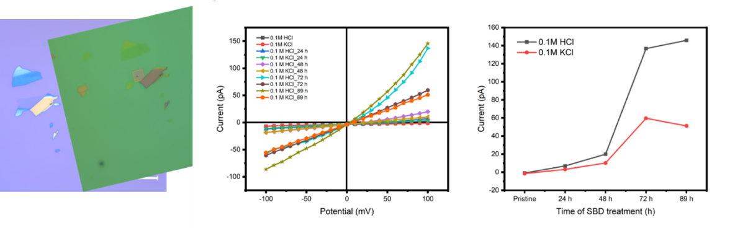

Sample 2_2022-July-05 S2 Clogged device
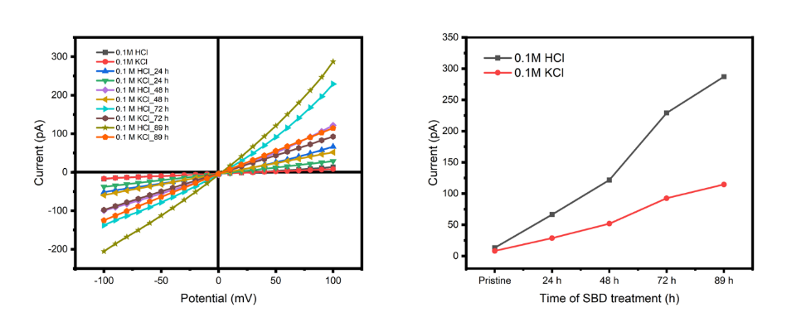
Sample 3_2022-July-05 S3 Clogged device
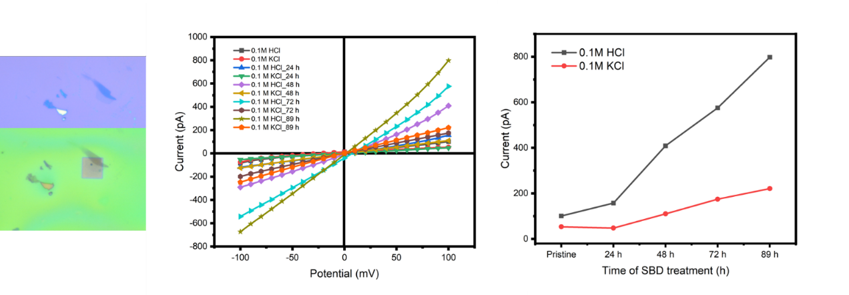

Sample 4_2022-July 05-S4 Clogged device
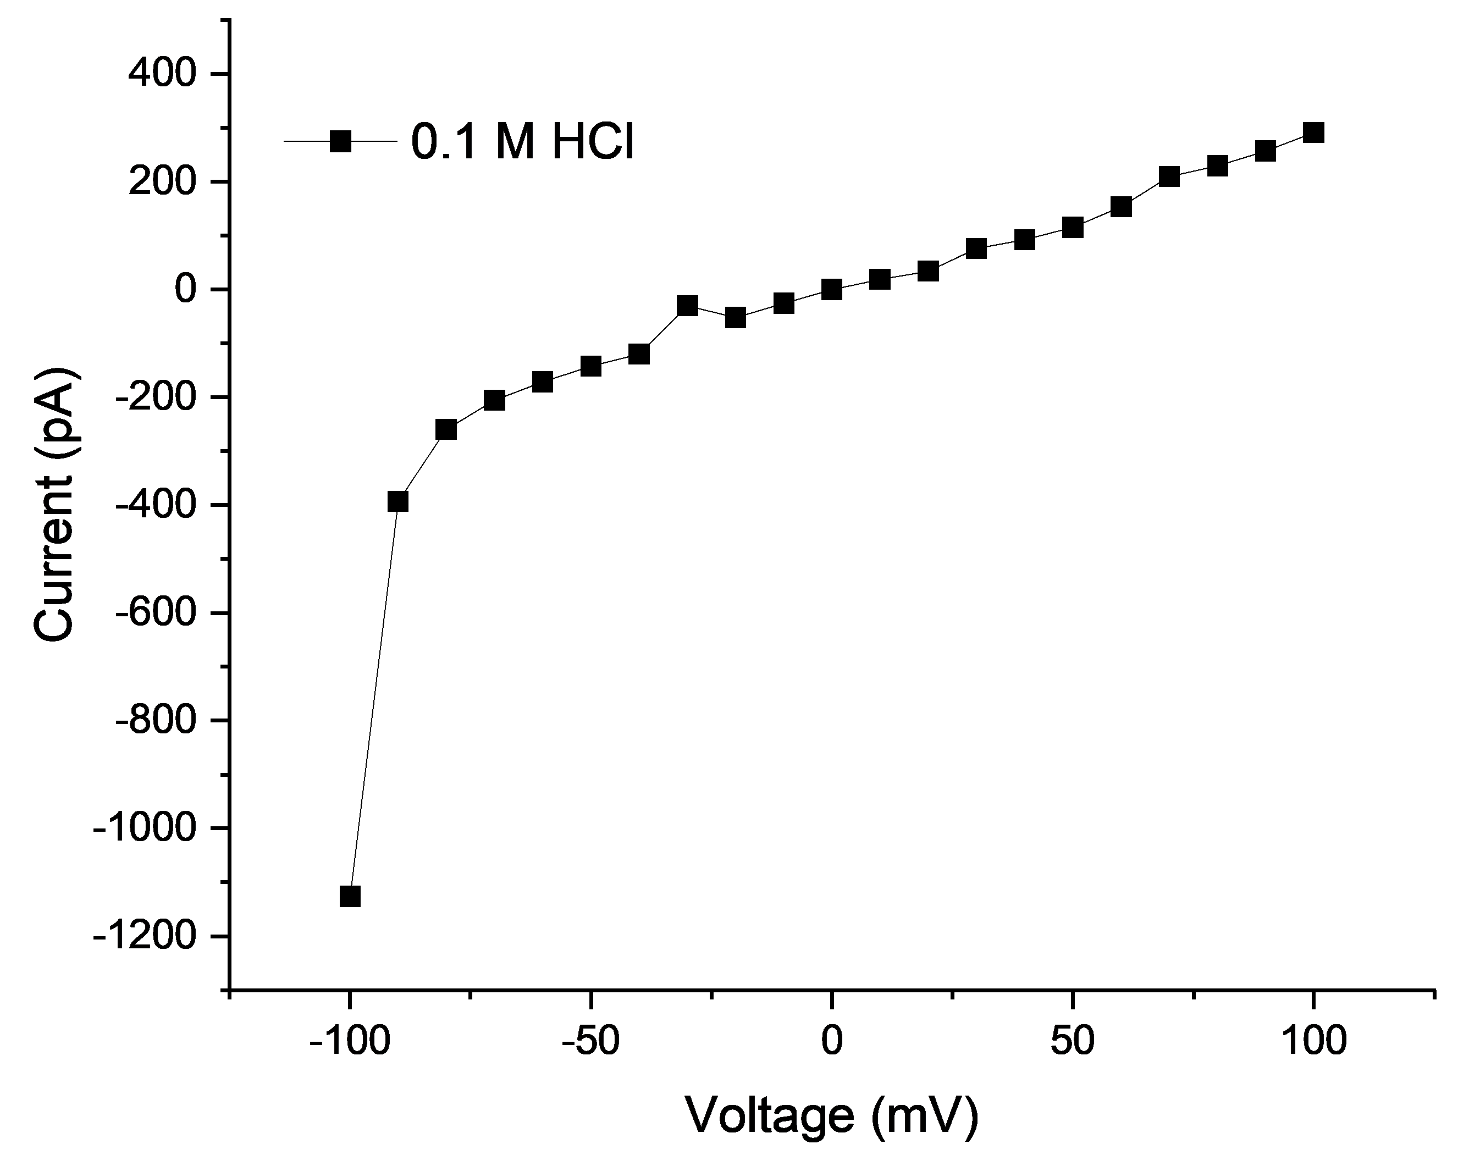

Sample 4_2022-July 05-S5 Clogged device
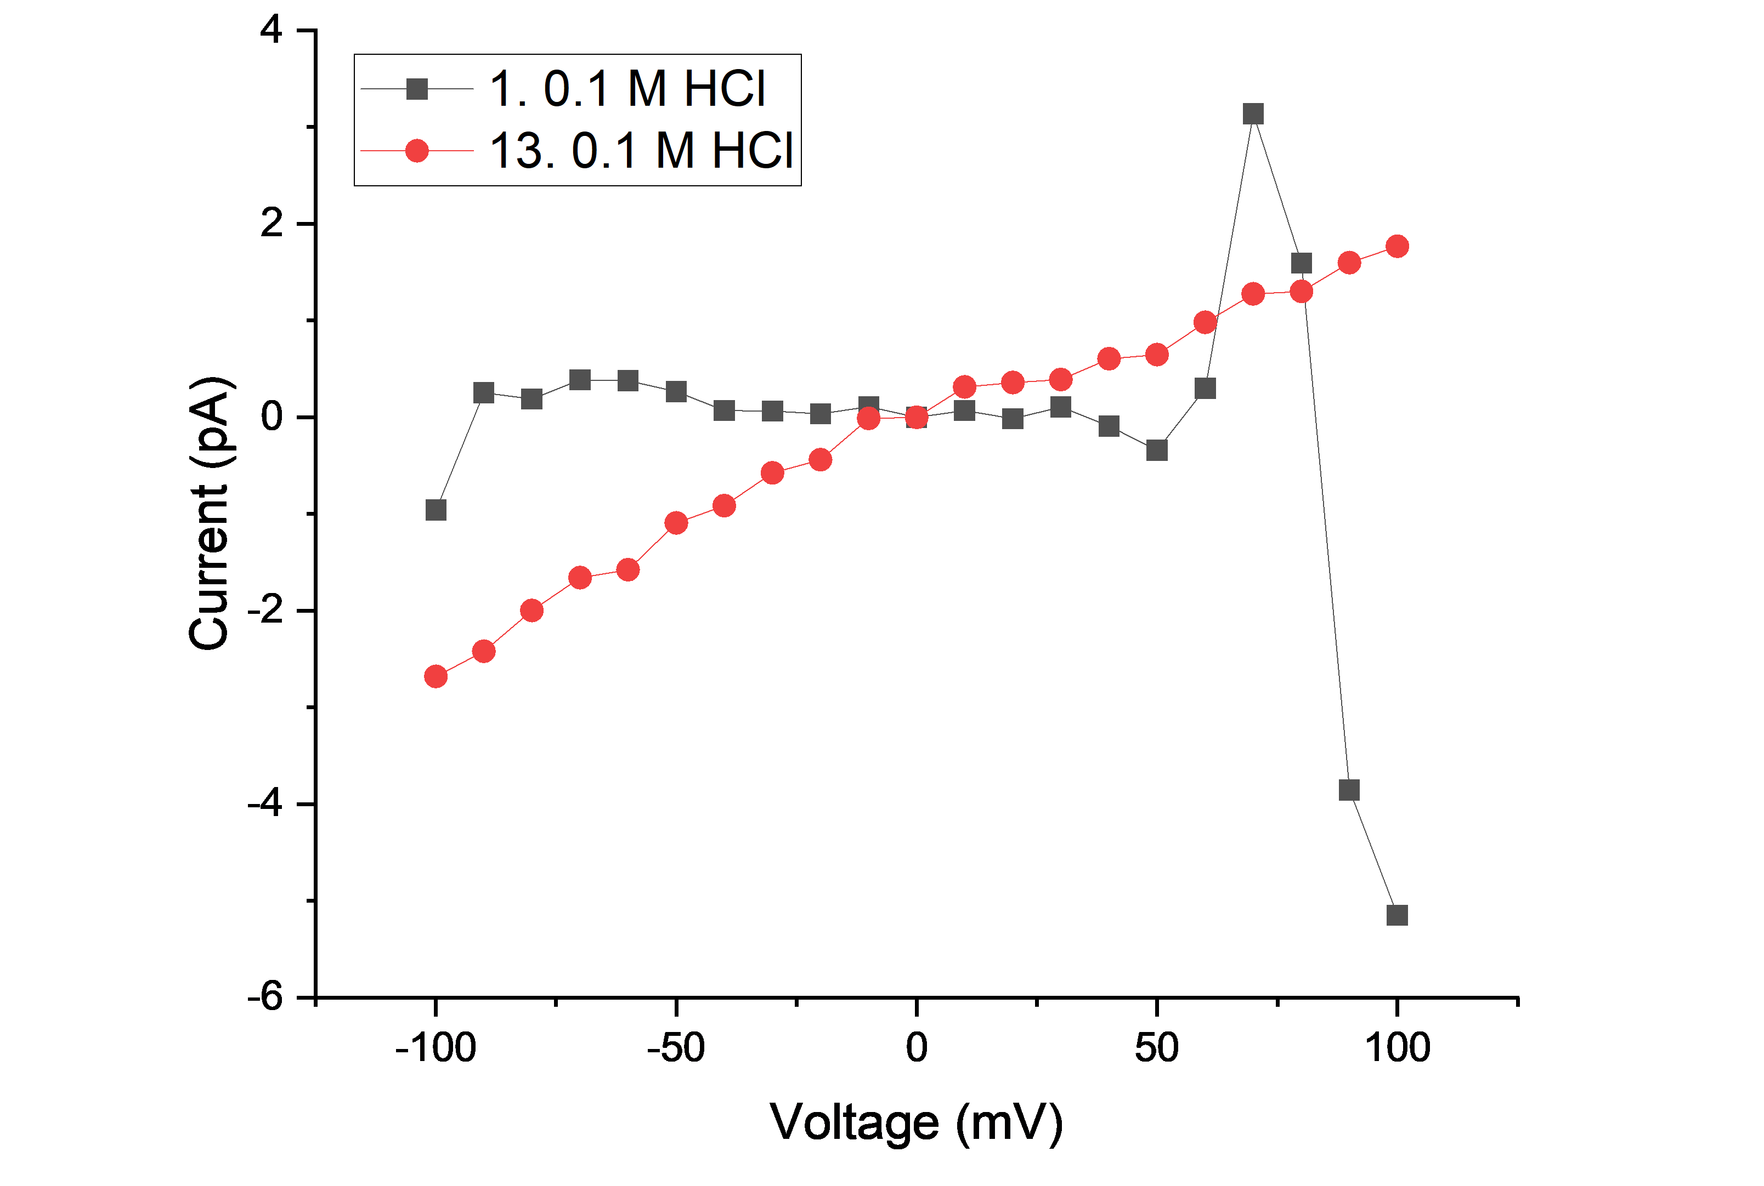

Sample 5_2022-July 05-S6 Clogged device
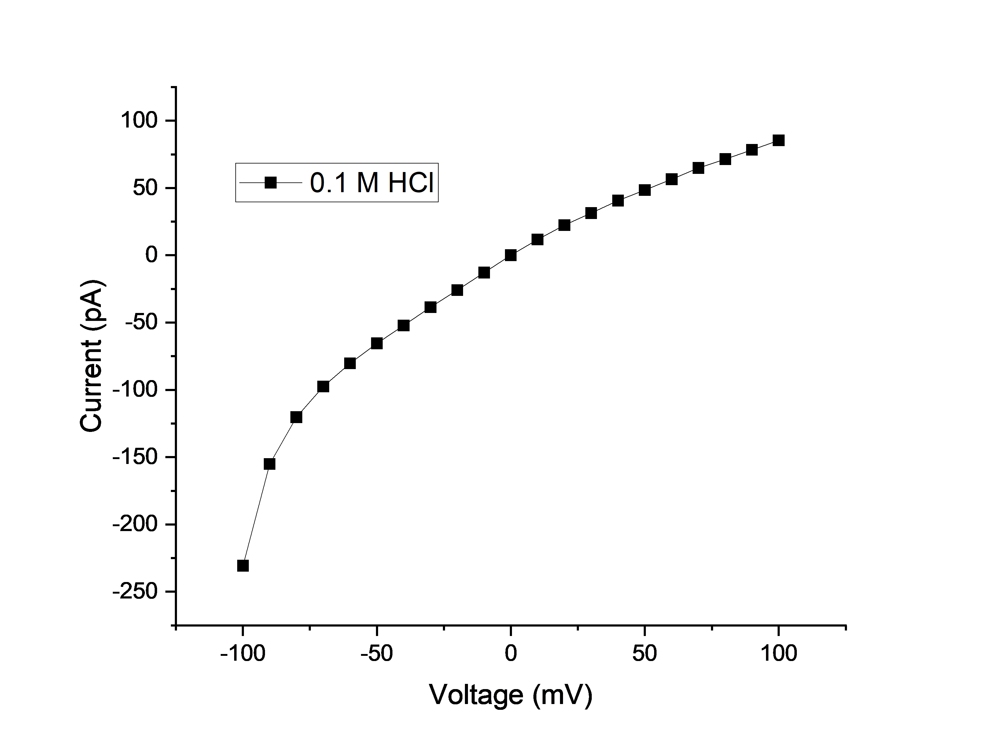

Sample 6_2022-July 05-S7 Leaking device
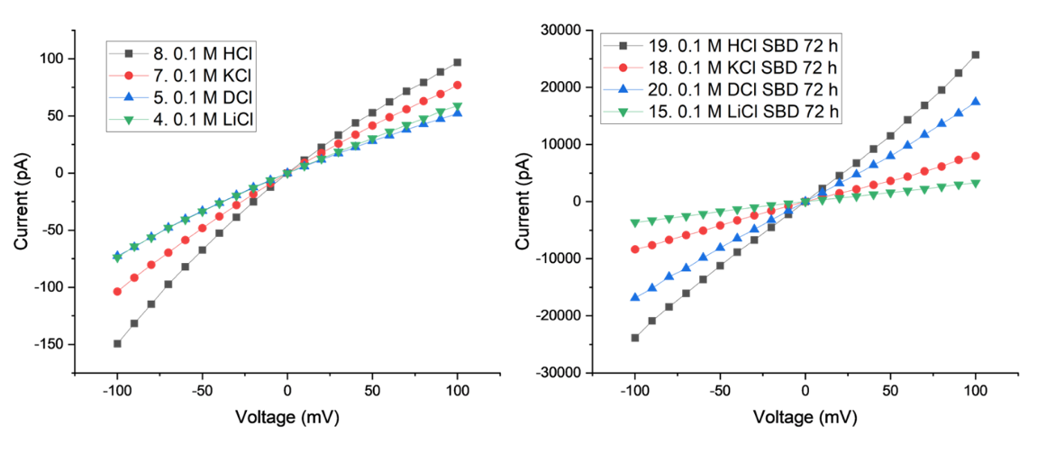

Sample 7_2022-July 05-S8 Clogged device
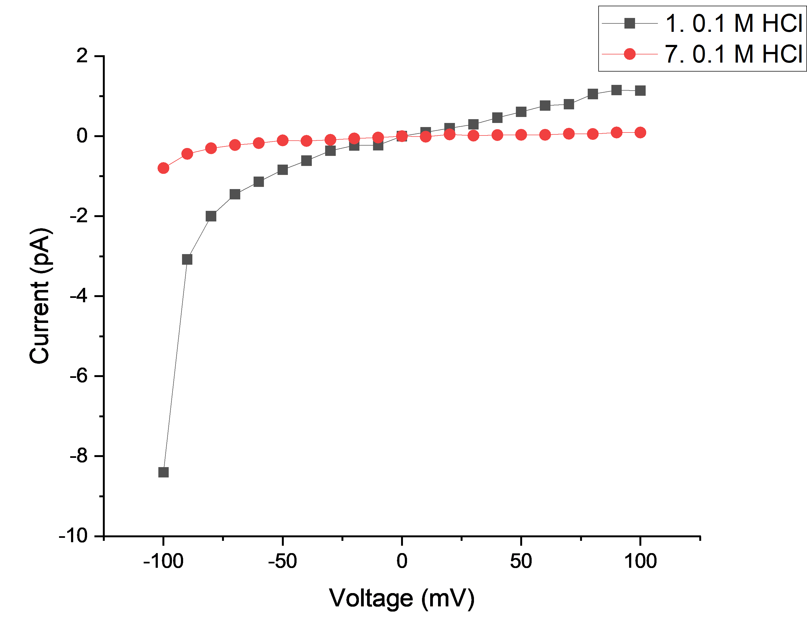

Sample 8_XK029 A_S1-2 Clogged device
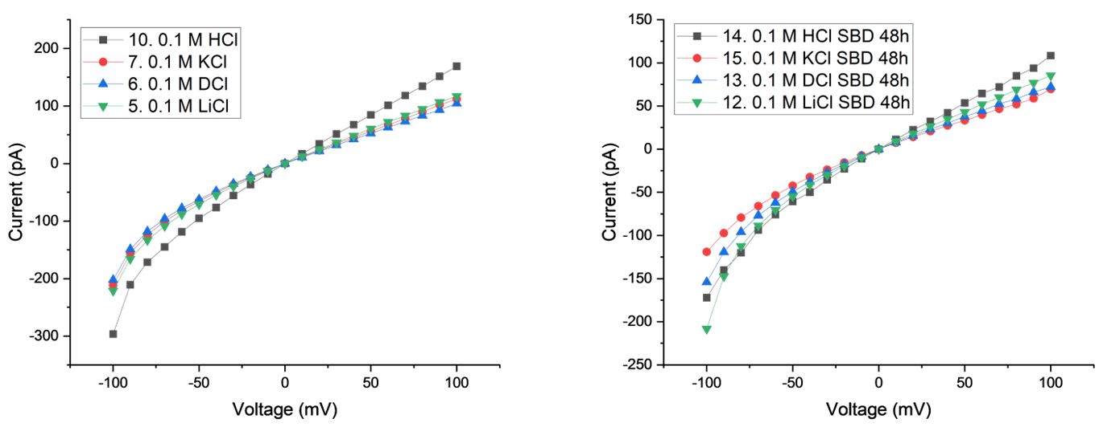

Sample 9_XK029 A_S2 Clogged device
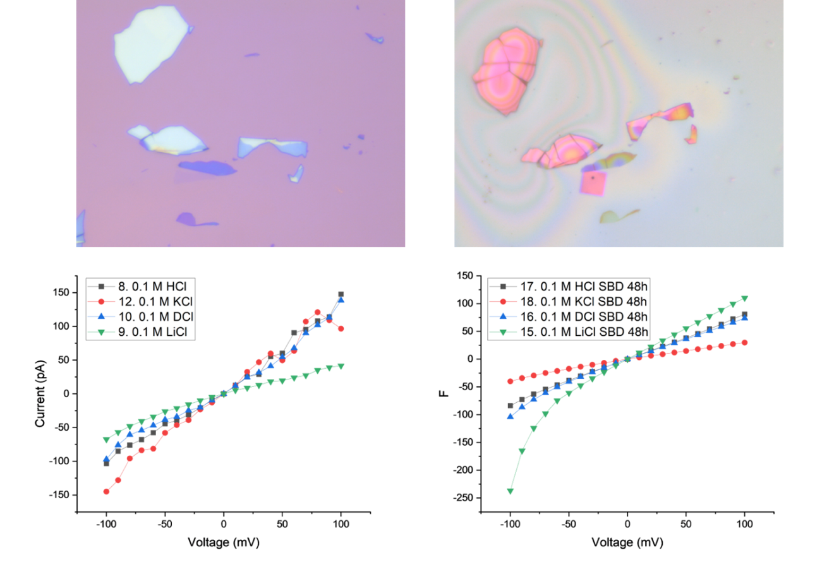

Sample 10_XK029 A_S4 Leaking device
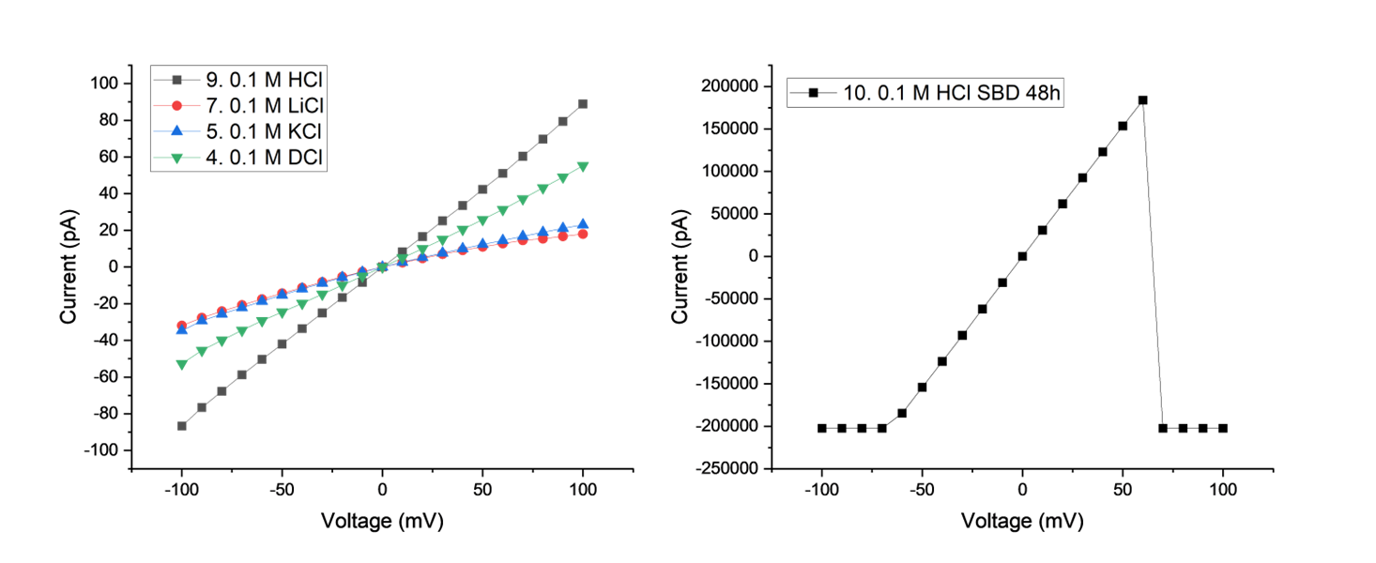

Sample 11_XK029_S5 Clogged device
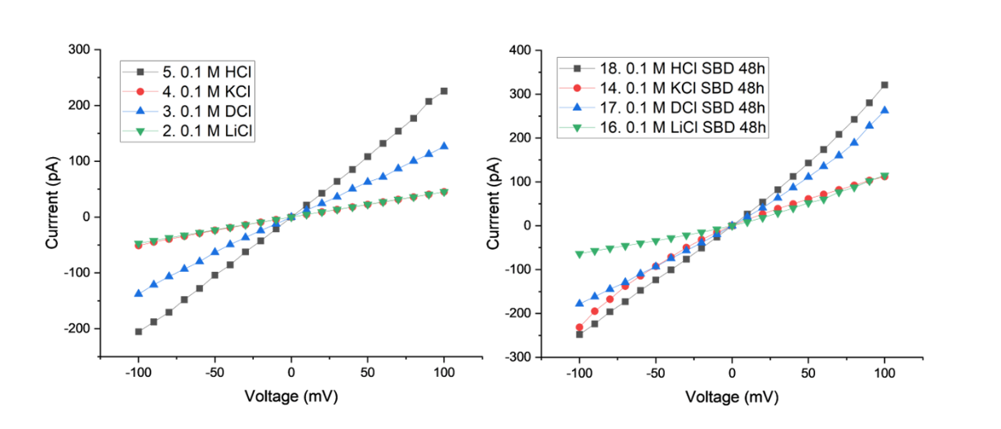

Sample 12_2023- Jan -24 S1 Leaking device
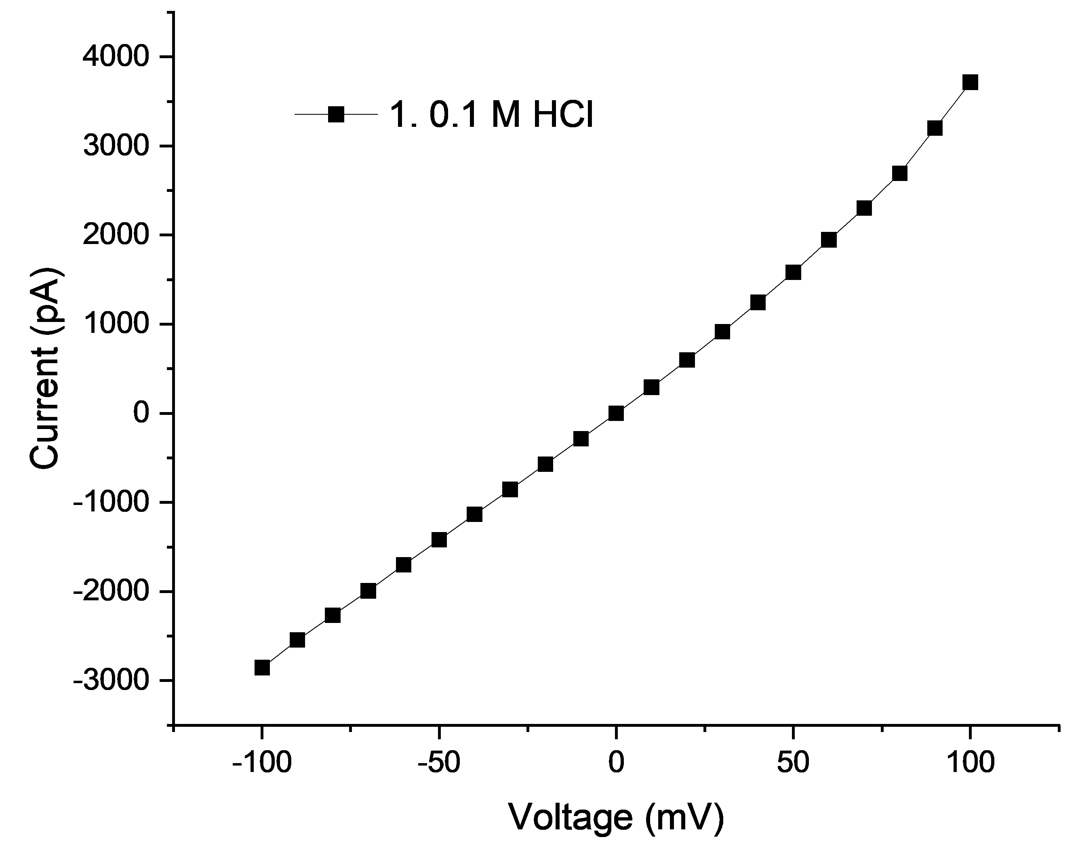

Sample 13_2023- Jan- 24 S2 Clogged device
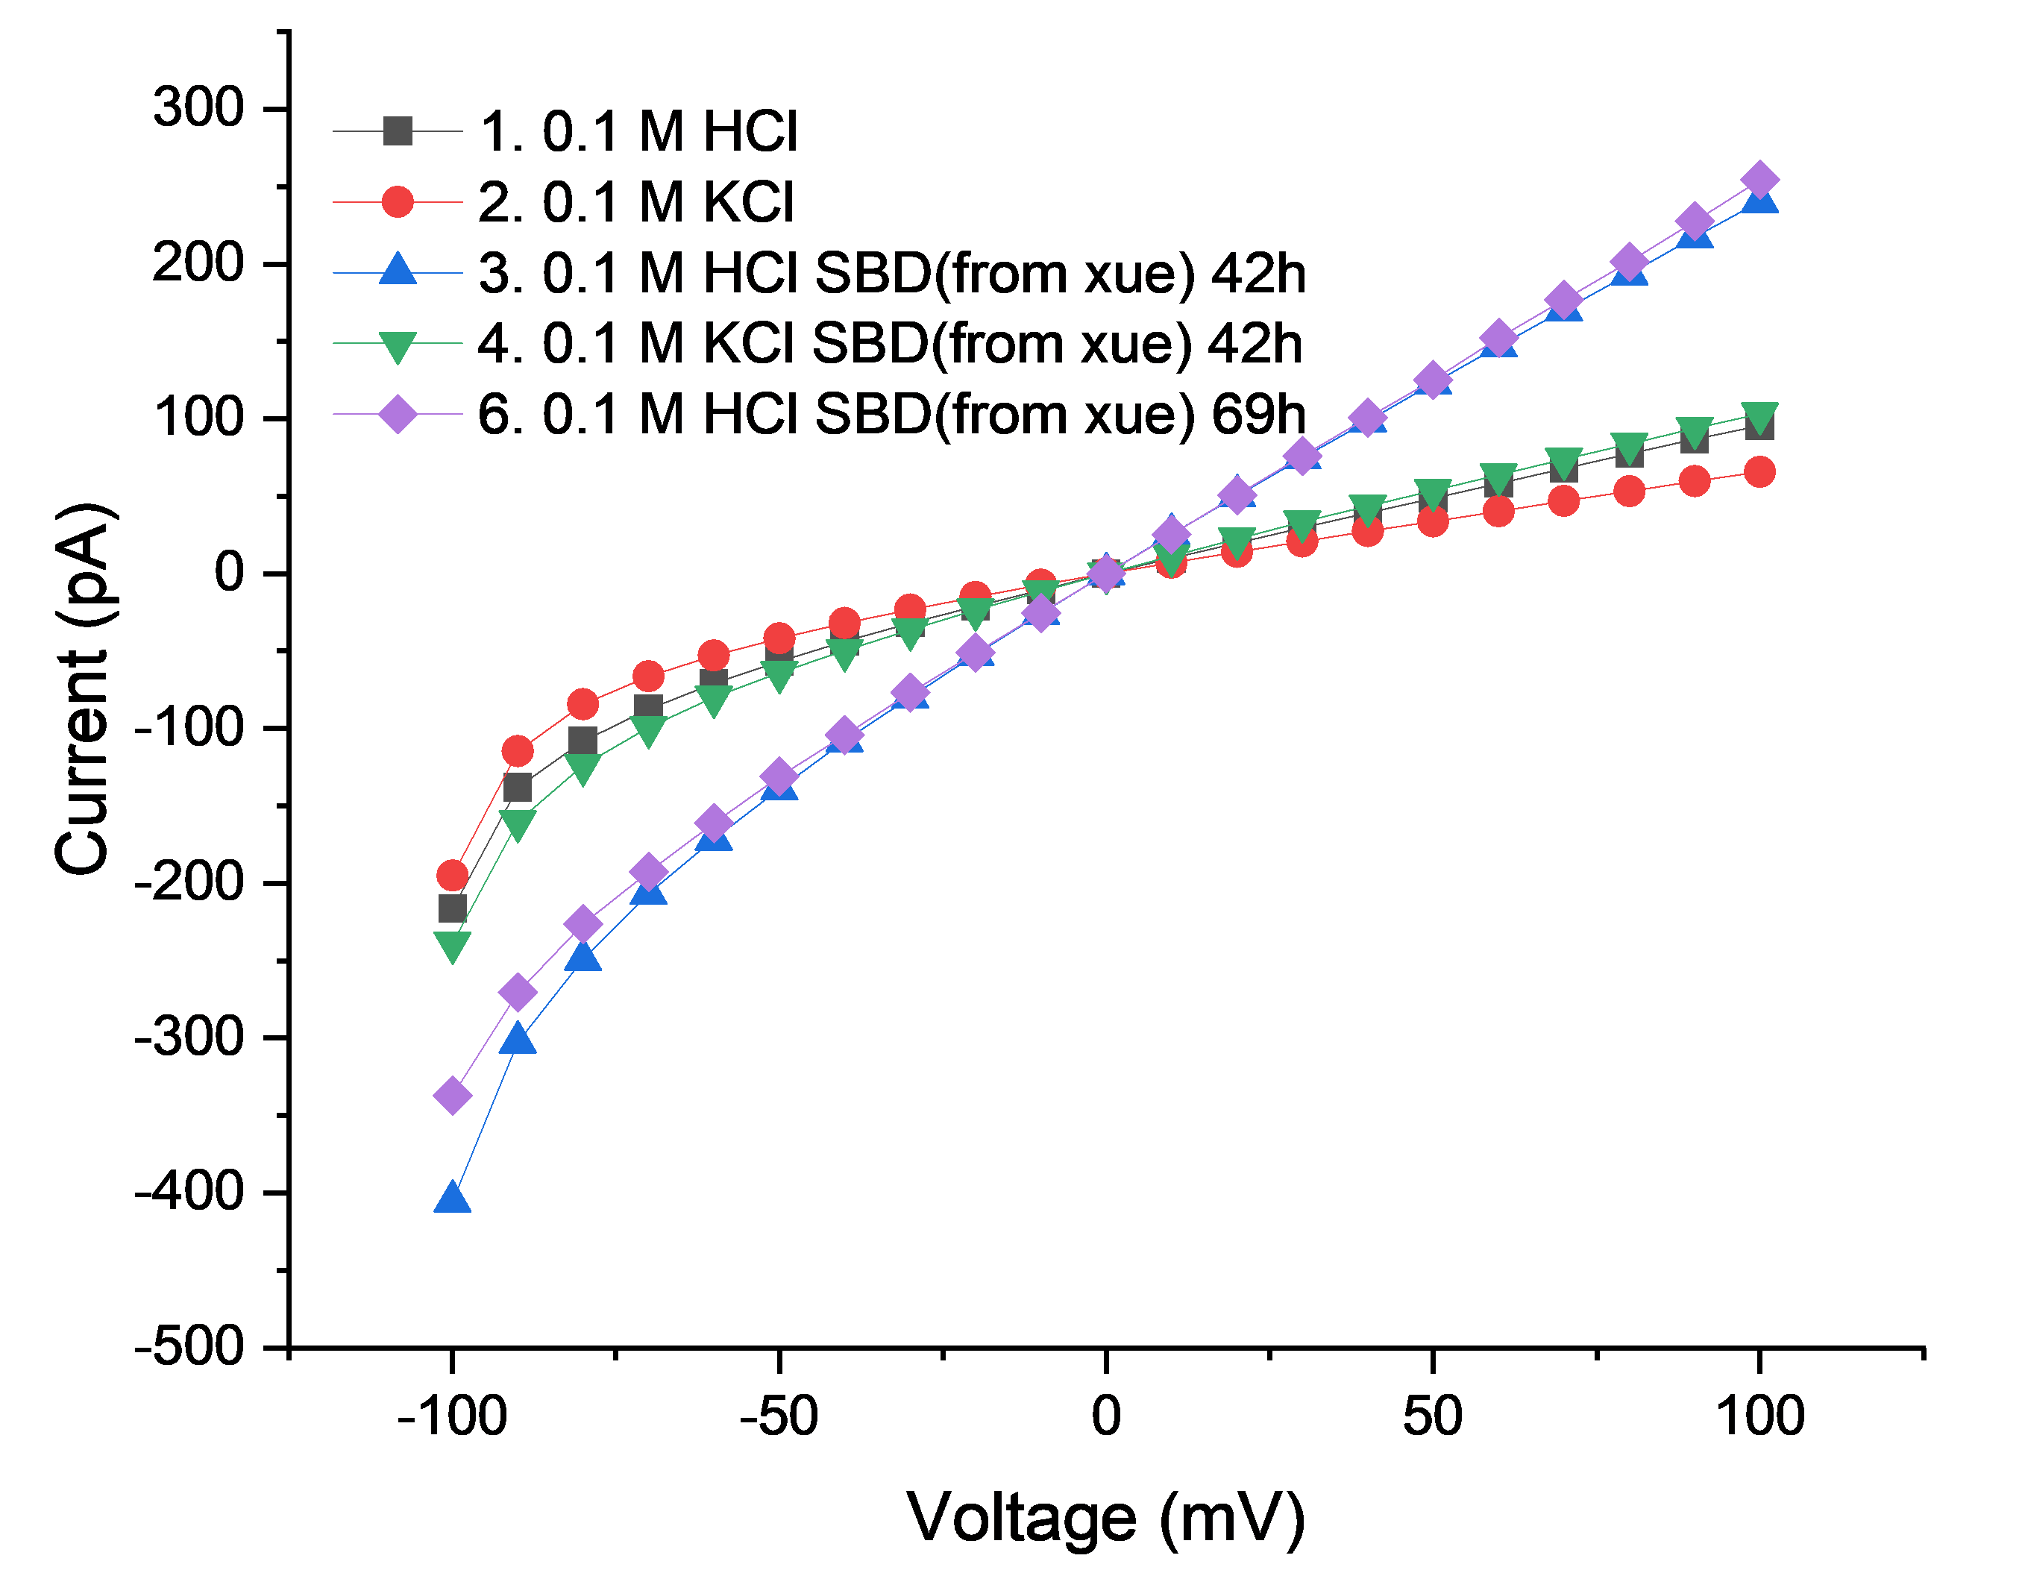

Sample 14_2023- Jan- 24 S3 Leaking device
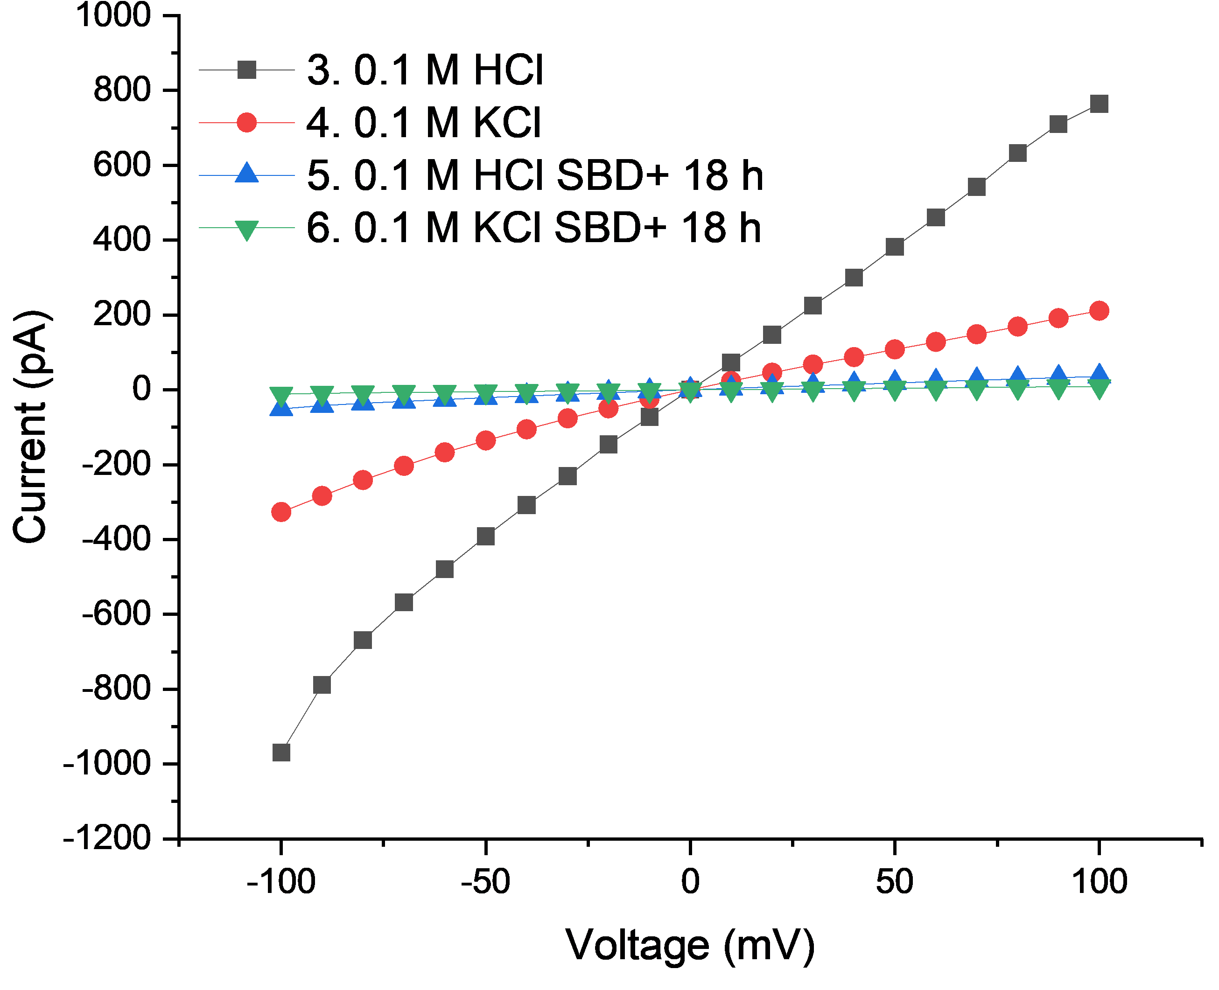

Sample 15_SBD+_XK029 Leaking device

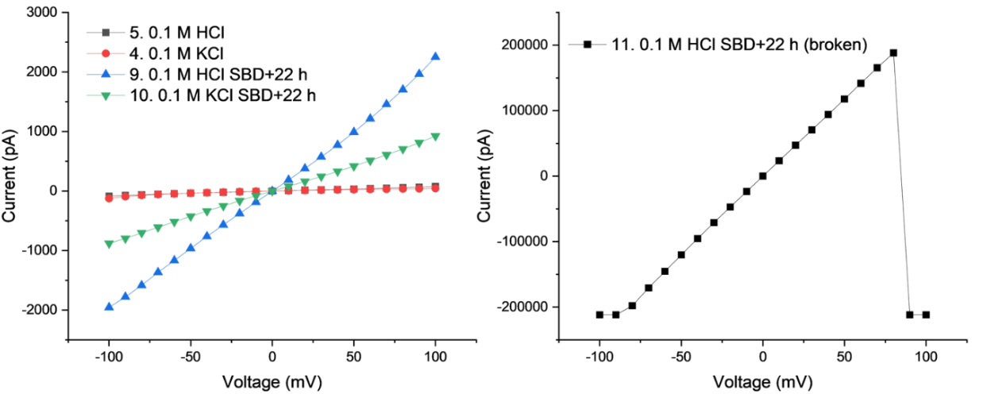

Sample 16_Clogged device

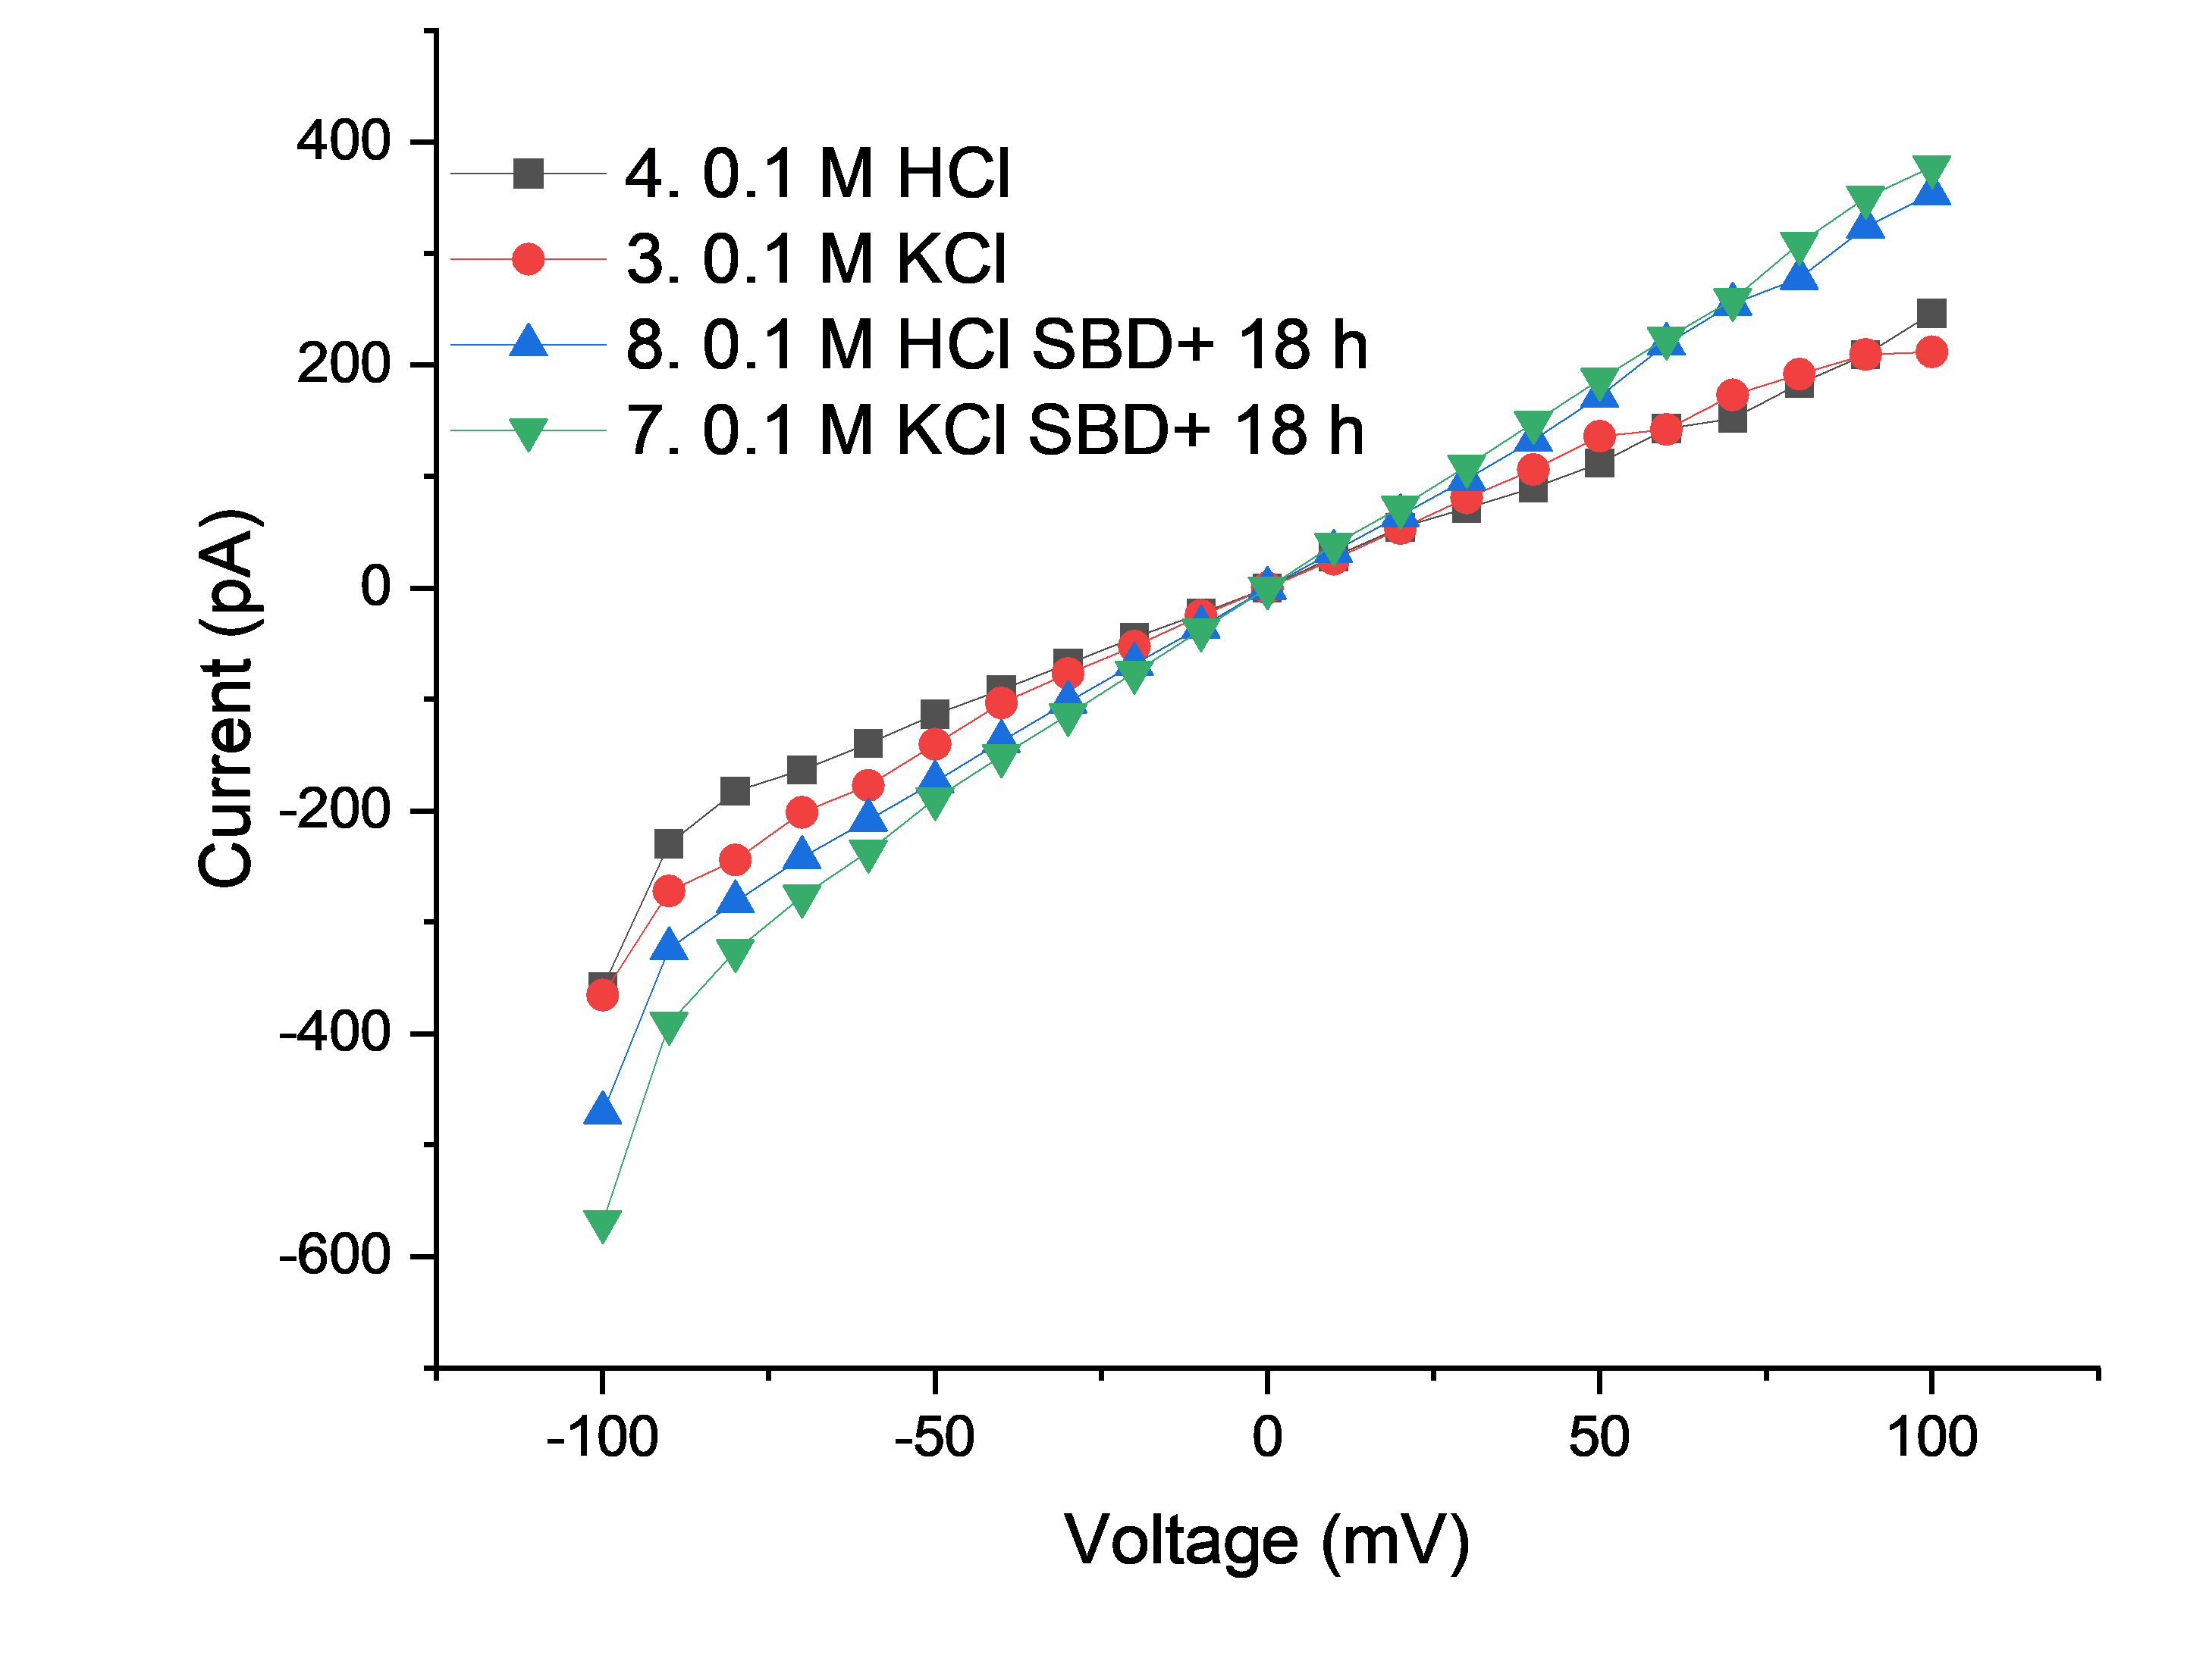
In addition to ionic current measurements, in DMFCs, six devices showed output powers at least three times lower than those reported in Fig.4. Despite utilizing freshly synthesized 4-SBD and applying identical treatment conditions, the SBD treatment of these samples did not yield any significant improvement compared to untreated graphene membranes. These failed devices exhibited maximum power outputs of 33.46, 31.49, 30.84, and 54.73 mW·cm⁻² with functionalized side facing the anode and the two other devices with maximum power outputs of 46.70 and 43.42 mW·cm⁻² with the functionalized side facing the cathode. This shows the necessity to improve the fabrication procedure to improve the reaction between graphene and SBD, as we observed in experiments with exfoliated graphene.

Answer to Reviewer 2
- They found that the conductivity of the non-treated CVD sample was 6.9 S cm-2 and that the functionalisation increases the conductivity to 30.9 S cm-2. This is an enhancement by factor of ~5, which is interesting, but not giant.
We thank the referee for his/her comment. Another reader may have been confused as well, indeed. The enhancement is by a factor ~5000 for 4-SBD treated exfoliated graphene (i.e., up to 50 S·cm⁻² vs. 0.008-0.1 S·cm⁻²) and ~5 (i.e., 30.9 S·cm⁻² vs. 6.9 S·cm⁻²) for CVD graphene. We understand the confusion and believe that the revised manuscript now addresses the differences between the experiments carried out with exfoliated graphene (first part) and the DMFC application (second part). We removed ‘giant’ from the text.

We added to the main text:
‘The proton conductance we measured is based on the comparative study of proton transport through exfoliated graphene before and after SBD functionalization and not through cracks, defects, or grain boundaries in CVD graphene. Hence, the factor of ~5 measured with CVD graphene should not be used in any comparison with exfoliated graphene samples (Fig.1). After 4 days of SBD treatment, exfoliated graphene presents an up to 5000 times higher (50 S·cm⁻² vs. 0.01 S·cm⁻², Fig. 1) proton conductance while keeping also a high selectivity to other cations (e.g., H⁺ conductance is 2 times higher than K⁺) after a 4-day SBD treatment.’
We revised the title of our manuscript to avoid the confusion that our study claims a giantly performing fuel cell device which was not aimed in any case. The new title is now:
‘Sulfophenylation of graphene opens a transmembrane proton path.’ The fuel cell was only used here as a characterization technique for methanol crossover vs proton permeance.
- Comparison with the literature shows that power densities of ~50 mW cm-2 are not rare (e.g. A. Paneri, et al. Journal of Membrane Science, 467, 217-255, 2017), which then gives an improvement of about ~2 with respect to the state of the art. The performance is in any case good and the result is interesting.
Power densities of 50 mW·cm⁻² are typically observed for DMFCs, indeed. We used DMFCs to further characterize proton transport, yet not on exfoliated flakes. Our results are perfectly in agreement with previous works on the topic of CVD graphene in DMFCs, and CVD graphene is known to underperform in DMFCs regarding the poor proton-selective conductance, derived majorly from the defects/pinholes/grain boundary/oxidized sites. Our DMFC measurements were conducted with partially free-standing CVD graphene (16% area) with the rest area being considered leak-tight. The limitation on the power output of DMFCs, regarding the observed giant proton conductance through SO₃⁻-graphene lattice, is the free-standing area. Therefore, the power outputs through SO₃⁻-graphene lattice compared to CVD graphene should be estimated as > 600 mW·cm⁻², normalized to the free-standing graphene area.
- They explain that pristine CVD graphene is a poorly selective proton conductor, with multiple defects which leak methanol. Hence, their treatment presumably seals these nanoscale, methanol permeable defects, increasing the membrane’s performance. This would be consistent with their TEM images.
Indeed, the pristine CVD graphene is poorly selective towards proton transport, presumably because of larger defects in the lattice, grain boundaries, possibly cracks to name a few. SBD polymerization would seal these defects and indeed improve the selectivity towards protons, together with a single crystalline area being functionalized with SBD similarly to exfoliated graphene. We added the following paragraph:
Concerning the higher conductances for pristine CVD graphene compared to pristine exfoliated graphene (6.9 ±1.1 S·cm⁻² vs. 0.008-0.1 S·cm⁻² respectively), we hypothesize that pristine CVD graphene is less selective towards proton transport compared to exfoliated graphene, presumably because of larger defects in the lattice, grain boundaries, and possibly cracks. SBD polymerization would seal these defects and the functionalization of single crystalline area would improve the selectivity towards protons, still to a lower extend compared to exfoliated graphene (only a factor ~5).

- The edges of the crystal were not clamped in any way. For this experiment, the characterisation of the samples is much less robust.
In fuel cells we used Nafion as a stabilizing and transfer polymer. Clamping the graphene with washers requires more fabrication steps. More contaminations would also be introduced from the additional processing steps, especially polymeric materials. With our (bare chip) approach, the graphene is only exposed once to a transfer polymer and is kept clean by extensive rinsing procedures before functionalization experiments. We also considered ion conductive polymers, e.g., Nafion for ion transport measurements. However, the charged ion conductive layer would influence our study on the proton selectivity over charged species, K⁺, and Cl⁻ to name a few.
For CVD graphene experiments, Nafion can be considered as a clamp or washer as it conforms the graphene from the top, since the discussion is about the proton selectivity over methanol. Also, Nafion allows the functionalization of graphene without any additional process contaminants or fabrication steps. Additionally, considering the discussions over leakage or edge effects with SU-8 washers/clamps, the level of current measured in these studies falls in the range of fA-pA at 100 mV bias, which is the range of ionic currents measured for a low abundance of defects in graphene (3 mS·cm⁻² as reported in reference 3). We measured 0.008 up to 0.1 S·cm⁻² for pristine exfoliated graphene at 100 mV bias (i.e. down to three times as much), an offset possibly attributed to leakage between graphene and the carrier chip, but still negligible compared to the conductance increase upon sulfonation (i.e., up to 50 S·cm⁻² which is up to ~ 5000 higher) for a 0.78 µm² freestanding membrane on a ~1 µm circular aperture. And if the graphene membrane is gone by delamination after the sulfophenylation, areal conductances in HCl and KCl (and other ions) would be at least as high as bare chip. This is not what we observed.

- Only pristine, untreated graphene flakes were characterised (optically and with Raman). The authors then measured the ionic conductivity of their samples using various electrolytes.
Raman characterization of graphene was performed on a SiO₂ substrate and floating on Nafion as a function of SBD reaction time (Fig. 3 and S31-33). The assessment of disorder information in the graphene lattice upon SBD treatment was also assessed using other techniques, namely XPS, AFM and HRTEM (Supporting materials, section 3.2).
- They found that for longer treatment times (few days), the conductivity of the samples increased by about 5000 times and reached about 50 S cm-2 with 0.1 M HCl. This value is only a factor of ~5 smaller than the conductivity of the 1 um hole in the substrate measured with 0.1 M HCl solution. If the authors had not put any membrane over the hole, the conductivity would be only slightly larger.
The statement of the referee does not take into consideration that sulfophenylated graphene is proton selective.
The conductance of a bare pore is 270 S·cm⁻² in 0.1 M HCl, which is ~5 times larger than SO₃⁻-graphene. The proton conductance through the bare chip is not proton-selective. To further confirm that the proton selectivity over K⁺ could not be achieved by the functionalization on the chip, we tested the supporting chips after SBD treatment to test the potential influence of the pore in the chip after SBD treatment and observed no influence from SBD treatment on ion transport. Specifically, we conducted measurements on bare chips with aperture sizes of 1 μm (Fig. R14A). Free translocation of ions through the aperture were observed, and there was no selectivity between HCl and KCl, as seen in the normalized conductance (Fig. R14B). As the measurements were conducted through chips, and therefore the ionic current with 0.1 M electrolytes exceeded the detection limit of our instrument (200 nA), the measurements were conducted with 0.01 M HCl and KCl instead.
We added the following results in the supplementary information:
For the bare chip featuring a through aperture, the conductance with 0.1 M HCl is approximately 270 S·cm⁻² (Fig. S17). Subsequently, the conductances are adjusted downwards with electrolyte dilution to 0.01 M. Interestingly, after an 84 h incubation period with 4-SBD, there is no discernible difference in normalized conductances between KCl and HCl (Fig. S18).
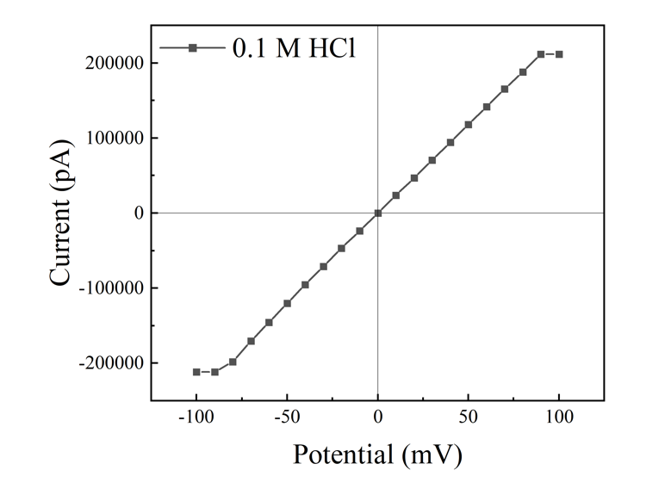
Fig. R13 (Fig. S17) I-V curve of bare chip with 0.1 M HCl.
Fig. R14 (Fig. S18) Ionic conductances of bare chips after SBD treatment. (A) To address the detection limit issue (<200 nA), we employed diluted HCl and KCl (0.01 M) to characterize the ionic conductances through bare chips with an aperture size of 1 µm. (B) To facilitate a comparison of ion transport, the ionic conductance was normalized based on the bulk solution conductivity. (0.1 M HCl: 3.7 S·m⁻¹; 0.1 M KCl: 1.28 S·m⁻¹)

- There is a serious concern that the authors are measuring leakage in between the flake and the substrate, which may be filled with the SBD molecules that provide some ionic selectivity, but otherwise let unimpeded flow of protons. As it stands, there is no compelling evidence that sp3 dislocations lead to a giant enhancement of the proton conductivity of graphene. In summary, the authors present interesting results on the use of organic molecules to improve the properties of CVD graphene proton conductive membranes in fuel cell applications. These experiments are well conducted and will be of interest to the community. However, there is no evidence for a giant enhancement in the proton conductivity of graphene arising from sp3 dislocations in the lattice. On this basis, I am unable to recommend the manuscript for publication.
We thank the referee’s critical insights on the proton transport pathway, edge leakage vs. transmembrane transport through functionalized graphene lattice. In response to these considerations, we have revisited and refined our results, drawing inspiration from studies on proton transport through nanoscale corrugations, nanoripples, and defects. These concerns about the leakage justify why we carried experiments on the proton selectivity over other cations with exfoliated graphene (inset Fig. 1D) and the proton selectivity over methanol with CVD graphene in a DMFC (Fig. 4). Notably, prior research has indicated the conductivity of K⁺ through a 2D slit, where the size closely resembled that of a single water layer (6). This finding implies that achieving proton selectivity over K⁺ requires a pathway smaller than that of a single water atom. Moreover, the size of the 4-SBD molecule in our study is considerably larger than K⁺. Considering the leakage conductance through the interlayer of graphene and the substrate (<0.1 S·cm⁻²), we regarded that the ion transport through leakage is negligible compared to SO₃⁻-graphene (up to 50 S·cm⁻²). The transport of K⁺ through the functionalized lattice seems implausible, and more likely to occur through the large defects in the lattice. So that the conductance contribution from the non-functionalized site, e.g., vacancy defects, pinholes or even leakage, would be around 40% compared to the total conductance (20 S·cm⁻² vs. 50 S·cm⁻², illustrated in the inset of Fig 1D comparing normalized conductances in HCl and KCl after 84h of SBD treatment).
For a better estimation of the fraction of ionic current contributed by leakage, we updated the Supplementary material with the following discussion:
Concerning the presence of an observed leakage current (possibly unavoidable in our experiments), we determined its contribution through a comprehensive analysis. Our estimation is based on understanding if there is a correlation between KCl conductance and interlayer height. In Fig. S29A, we compare the conductances of HCl and KCl across our nanopore devices, ranging from a bare open chip to a chip covered with SO₃⁻-graphene.
Upon the introduction of exfoliated graphene onto the aperture, the normalized conductance for both HCl and KCl drops from ~270 S·cm⁻² to below 0.1 S·cm⁻² compared to the open aperture, indicating a leak-tight device with minimal current leakage through the graphene-chip interlayer. Post the 4-SBD treatment, the HCl conductance increases up to 50 S·cm⁻², while the normalized KCl conductance reaches ~20 S·cm⁻². These results provide insights into estimating the size of the leakage pathway. The conductivity of KCl through a slit-like pathway with a thickness of 6.6-6.7 Å (2L graphene) is approximated to be only about 20% lower than the bulk conductivity of KCl (24) (Fig S29B). In contrary, the KCl conductance of our graphene-covered devices is more than 100 times lower than that of our open-pore devices, suggesting that the graphene-chip interlayer is considerably smaller than 2 layers of carbon atoms. Given this limited leakage size, it is reasonable to conclude that 4-SBD would not penetrate this interlayer.
Considering the substantial difference between leaking current and transmembrane ionic current, coupled with the subnanometer scale of the leakage space, it is justified to assert that the influence of leakage is contributing to 0.008-0.1 S·cm⁻² of conductance in our discussion concerning proton-selective transport through SO₃⁻-graphene with exfoliated graphene.
Fig. R15 (Fig. S29) Estimation of leakage current vs. transmembrane ionic current. (A) The ion transport normalized conductance through the open aperture of the chip is ~270 S·cm⁻² for both HCl and KCl. Upon the transfer of exfoliated graphene onto the aperture, the conductance for both HCl and KCl drops below 0.1 S·cm⁻², signifying a leak-tight device with minimal current leakage through the graphene-chip interlayer. Following the 4-SBD treatment, the HCl conductance increases to 50 S·cm⁻², while the KCl conductance reaches 20 S·cm⁻². (B) Considering the study on potassium conductance through a slit-like pathway with a space height of 2-layer graphene, the KCl conductance is estimated to be approximately 20% lower than in water bulk(24). Thus, the leakage space in our study is estimated to be smaller than two layers of carbon atoms, indicating the improbable contribution of such an effect to either the high proton conductance, allowing entry of SBD molecules into the interlayer, or to proton selectivity. For ease of ion transport comparison, the ionic conductance was normalized based on the bulk solution conductivity (0.1 M HCl: 3.7 S·m⁻¹; 0.1 M KCl: 1.28 S·m⁻¹).
- However, there is no evidence for a giant enhancement in the proton conductivity of graphene arising from sp3 dislocations in the lattice.
For exfoliated graphene, sulfophenylation increases the conductance of the membrane from 0.008-0.1 S·m⁻² (i.e., pristine graphene) up to 50 S·m⁻² after SBD treatment in HCl (that is up to a 5000-time increase compared to pristine graphene). The proton selectivity observed over K⁺ and methanol suggests that transport predominantly occurs within a confined space, narrower than one-atom thickness, rather than through leakage. We acknowledge that directly observing proton transport through the lattice would provide additional robust evidence for the proposed proton transport pathway. In our study, the grafting of sulfophenyl groups via sp³ dislocation was evidenced through characterizations (Raman and XPS). We conducted an additional theoretical study about the effect of sp³ dislocation and the proton flux alongside the proton shuttling from the water bulk to the graphene basal with the assistance of the SO₃⁻ group. Recently, the proton transport through graphene corrugations and nanoripples, detected by electrochemical probes, aligns well with our findings that the distortion of graphene lattice lifts the transmembrane proton transport.
Additionally, incubating graphene only with ultrapure water or 0.1M HCl for days did not yield an increase of power of the DMFC as it is measured after the functionalization with SBD.
Fig. R7 (Fig. S42) Maximum power output of Direct Methanol Fuel Cells (DMFCs) with graphene membranes floated on pure water. Graphene membranes were floated on ultrapure water using the same conditions applied for the SBD treatment. The fuel cell tests were operated at 60 °C, with same flow rate of 1 M methanol solution and oxygen as tests conducted with SO₃⁻-graphene membranes.
Fig. R8 (Fig. S43) Maximum power output of Direct Methanol Fuel Cells (DMFCs) with graphene membranes floated on 0.1 M HCl solution. Graphene membranes were floated on 0.1 M HCl using the same conditions applied for the SBD treatment. The fuel cell experiments were performed at 60 °C, with same flow rate of the 1 M methanol solution and oxygen as experiments conducted with SO₃⁻-graphene membranes.
References.
1. R. G. Linford, S. Hackwood, Physical techniques for the study of solid electrolytes. Chemical Reviews 81, 327-364 (1981).
2. R. B. Nuernberg, Numerical comparison of usual Arrhenius-type equations for modeling ionic transport in solids. Ionics 26, 2405-2412 (2020).
3. N. Agmon, The Grotthuss mechanism. Chemical Physics Letters 244, 456-462 (1995).
4. M. Thakur et al., High durability and stability of 2D nanofluidic devices for long-term single-molecule sensing. npj 2D Materials and Applications 7, 11 (2023).
5. Y. He, M. Tsutsui, Y. Zhou, X.-S. Miao, Solid-state nanopore systems: from materials to applications. NPG Asia Materials 13, 48 (2021).
6. A. Esfandiar et al., Size effect In Ion transport through angstrom-scale silts. Science 358, 511-513 (2017).

