Supplementary Figure S1. (A) Predictive ability of the model indicating positive or negative Q2, respectively, for the comparison between CTR and LCRS (up) and CTR and LCMR (down). (B) Metabolites with VIP > 1.0 corresponding to component 1 for the PLS-DA in the comparison between CTR and LCRS (up) and CTR and LCMR (down). The colored boxes on the right indicate the relative concentrations of the corresponding metabolite in each group under study.
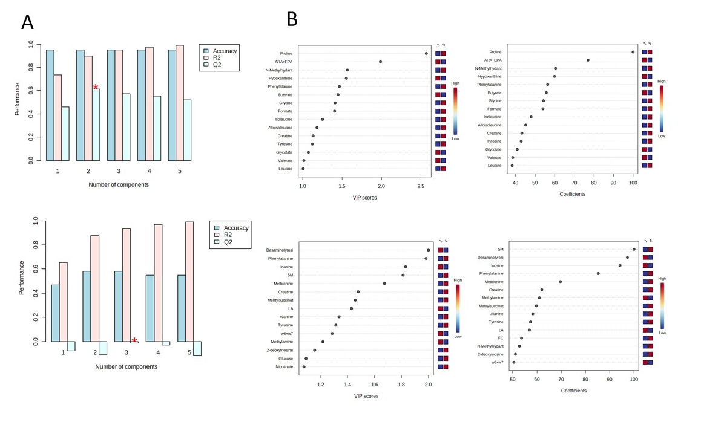

Supplementary Figure S2. (A) Pathway enrichment analysis of polar metabolites identified in calf fecal samples. Bar chart based on KEGG pathways.

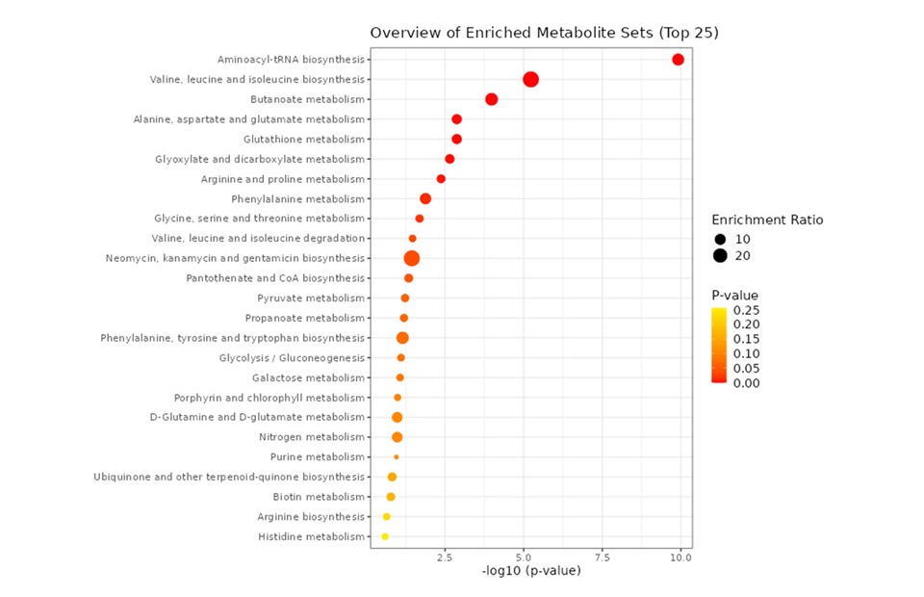

Supplementary Figure S3. Enrichment analysis: Disease signature of metabolites identified in calf fecal samples.
