Supplementary materials
- Isolated compounds from ethanol extracts of the roots of Rumex abyssinicus
Table 1: Comparison of the observed 13CNMR spectroscopic data of Compound-1 with literature
Position | Observed data of Compound-1 |  | Reported data of Chrysophanol
Position | δ1H | δ13C | δ1H | δ13C
1 | 11.95 s | 161.8 | 12.06 s | 162.45
2 | 7.24 s | 124.6 | 7.13 s | 124.57
3 |  | 149.6 |  | 149.35
4 | 7.65 s | 120.0 | 7.68 s | 121.37
5 | 7.72 (d J=6,) | 119.8 | 7.85 dd (J=1.2,8Hz) | 119.94
6 | 7.82 t (J=6 Hz) | 137.8 | 7.72 t(J=6,1OHz) | 136.96
7 | 7.39 d (J=6Hz) | 124.9 | 7.31 dd (J=1.2,8Hz) | 124.577 C
8 |  | 162.0 |  | 162..58
9 |  | 192.0 |  | 192.58
10 |  | 181.0 |  | 182.02
11 |  | 133.8 |  | 133.68
12 |  | 116.3 |  | 113.77
13 |  | 114.2 |  | 115.90
14 |  | 133.5 |  | 133.32
C-me | 2.44 s | 22.1 | 2.5 s | 22.26
Table 2: Comparison of the observed 13CNMR spectroscopic data of Compound-2 with literature
Position | Observed data of Compound-2 |  | Reported data of Emodin
Position | ẟ H | ẟ C | ẟH | ẟC
1 | 11.96 s | 161.9 | 121 | 161.88
2 | 7.11b s | 124.5 | 7.18 b s | 124.63
3 | - | 149.7 | - | 148.77
4 | 7.42 s | 121.0 | 7.50 b s | 121.0
5 | 7.06 d J=1.2 | 109.2 | 7.20 d J=1.6 | 109.5
6 | - | 164.9 | - | 164.9
7 | 6.55 d J=1.2 | 108.3 | 6.49d.J=1.6 | 108.4
8 | 12.04 s | 166.03 | 12.15 s | 166.2
9 | - | 181.7 | - | 182.2
10 | - | 190.1 | - | 190.7
11 |  | 135.5 |  | 135.6
12 |  | 109.3 |  | 109.4
13 |  | 113.7 |  | 113.9
14 |  | 133.2 |  | 133.3
me | H-Me δ 2.50 s | C-Me δ 21.97 | H-Me 2.40 s | C-Me δ 21.98
Table 3: Comparison of the observed H-NMR spectroscopic data of Compound-3 with literature
H | Observed data H-NMR data of RA-3(δ,ppm) | Reported data on Physicon
OH-1 | 11.87 s | 12.01 s
H-2 | 7.01 br.s | 7.18br.s
CH3- | 2.33 s | 2.40 s
H-4 | 7.31 br.s | 7.50 br.s
H-5 | 6.98 d J=2.4 Hz | 7.20 d,J=1.6Hz
H-6 | - | -
H-7 | 6.49 d J=2.4 Hz | 6.60 d,J=1.6Hz
OH-8 | 11.95 s | 12.15 s
Table 4: Comparison of the observed H-NMR spectroscopic data of Compound-4 with literature
H | Observed data (δ in ppm) | Reported data on Helminthosporin (δ in ppm)
1-OH | 12.06 s | 12.00 s
2-H | 7.13 br s | 7.09 br s
3a-Me | 2.5 s | 2.48 s
4-H | 7.67 br s | 7.64 br s
5-H | 7.85 dd, J=1.2, 8Hz | 7.81 dd, J=1.1, 7.5 Hz
6-H | 7.70 t, J=6,1OHz | 7.67 t, J=8.3, 7.9 Hz
7-H | 7.29 dd, J=1.2, 8Hz | 7.29dd,J=1.2, 8.3Hz
8-OH | 12.15 s | 12.03 s
Table 5: Comparison of the observed H-NMR spectroscopic data of Compound-5 with literature
H | Observed data (δ in ppm) | Reported data of Chrysophanol bi-anthrone (δ in ppm)
1-OH | 12.01 s | 12.09 s
2-H | 7.18 br s | 7.16 br s
3a-CH3 | 2.40 s | 2.48 s
4-H | 7.50 br s | 7.59 br s
5-H | 7.20 d, J=1.6 Hz | 7.27 d, J=2.4 Hz
6-H | - | -
7-H | 6.60 d, J= 1.6 HZ | 6.68 , J=2.4 Hz
8-OH | 12.15 s

- Isolated compounds from ethanol extracts of the leaves of Verbascum sinaiticum
Table 1: CNMR of isolated Compound 1(Luteolin) and Compound 2 (Chrysoeriol-7-O-glucoside)
Carbon number | Compound 1 | Compound 2
2 | 164.3 | 164.2
3 | 103.3 | 103.4
4 | 182.1 | 182.0
5 | 161.9 | 161.1
6 | 99.2 | 99.5
7 | 164.5 | 163.0
8 | 94.2 | 95.1
9 | 157.7 | 156.9
10 | 104.1 | 105.4
1 | 121.9 | 121.3
2 | 113.7 | 110.4
3 | 146.1 | 56.2
4 | 150.1 | 148.1
5 | 116.4 | 115.8
6 | 119.4 | 120.5
1 |  | 100.1
2 |  | 69.6
3 |  | 73.2
4 |  | 65.7
5 |  | 76.4
6 |  | 60.7
Table 2: CNMR of isolated Compound 3 (Ajugol) and Compound 4 (Aucubin)
Carbon number | Compound 3 | Compound 4
1 | 5.8 | 5.28(98.8)
3 | 6.48 | 6.32( 140.0)
4 | 5.25 | 5.14(105.7 )
5 | 3.0 | 2.8(42.7 )
6 | 4.32 | 4.58( 81.0)
7 | 2.4 | 5.88( 129.0)
8 | 2.09 | (147.2 )
9 | 2.86 | 3.16( 46.8 )
10 | 1.52 | 4.3(59.9 )
1 | 5.08 | 4.8(95.8 )
2 |  | ( 73.2 )
3 |  | (76.6 )
4 |  | ( 70.0 )
5 |  | (76.1)
6 | 4.18,4.0 | 4.8,3.9(61.1)
- Different spectroscopic data result of HPLC (retention time)

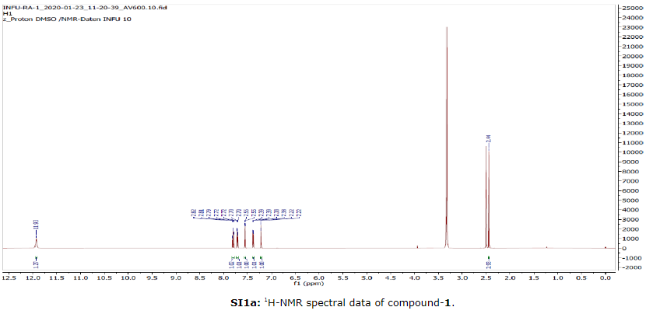
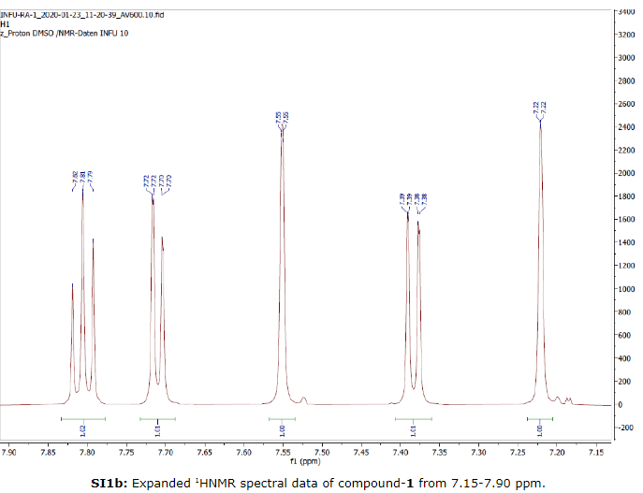
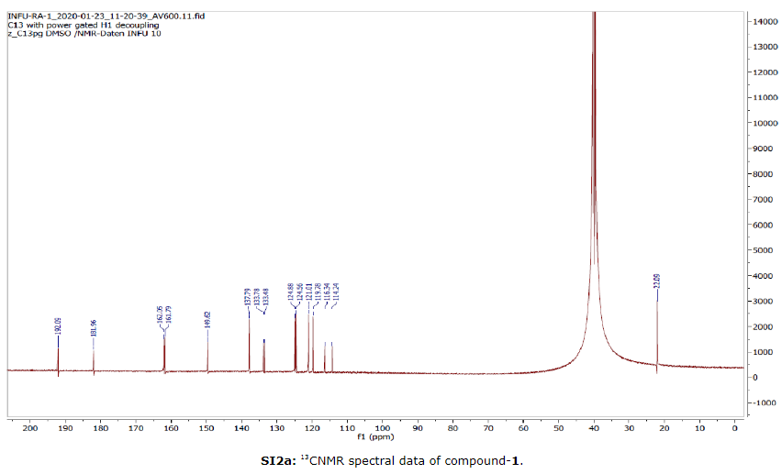
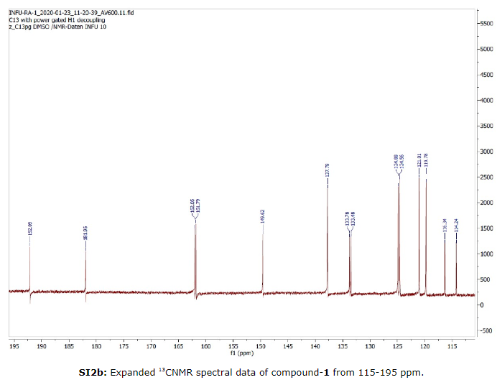
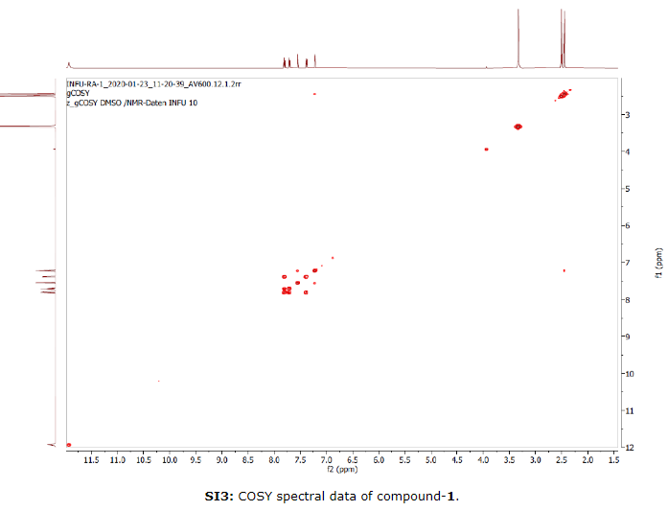
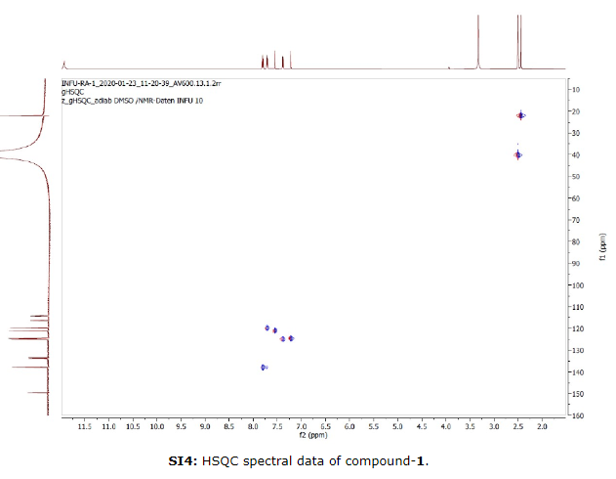
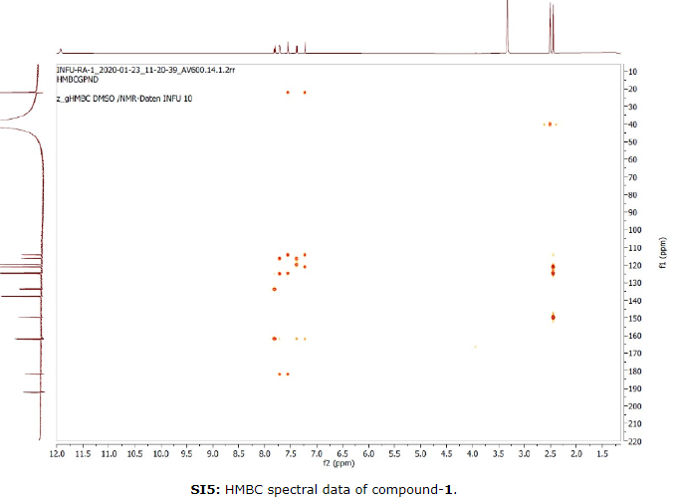
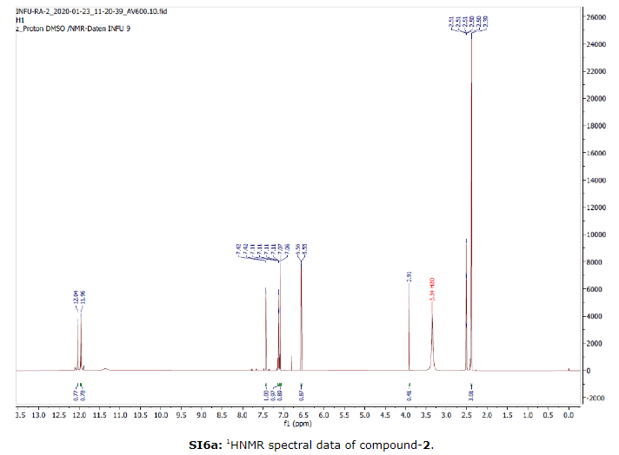
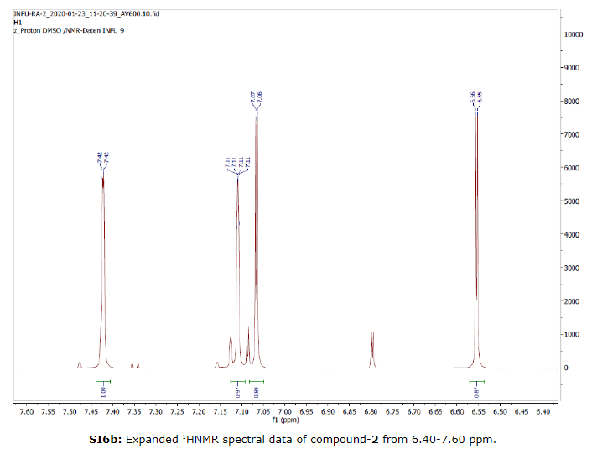
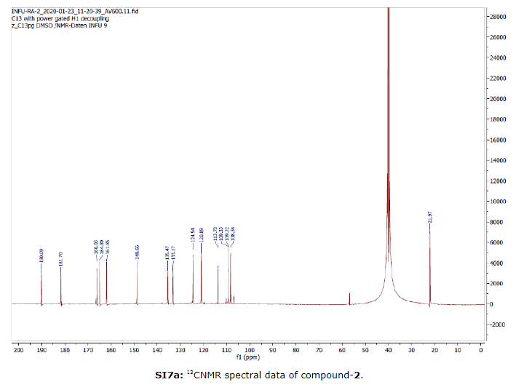
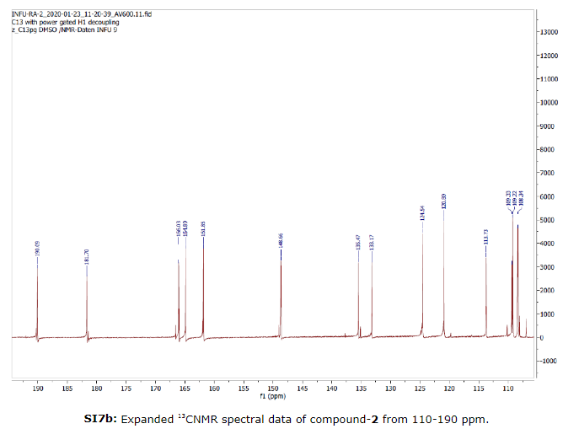
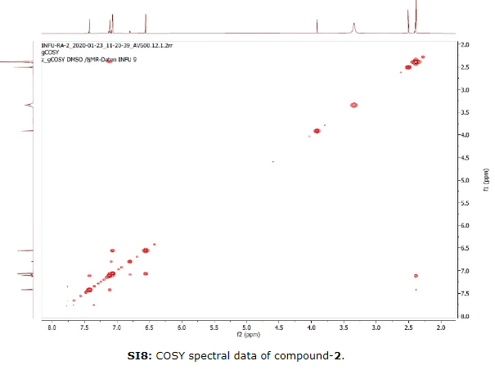
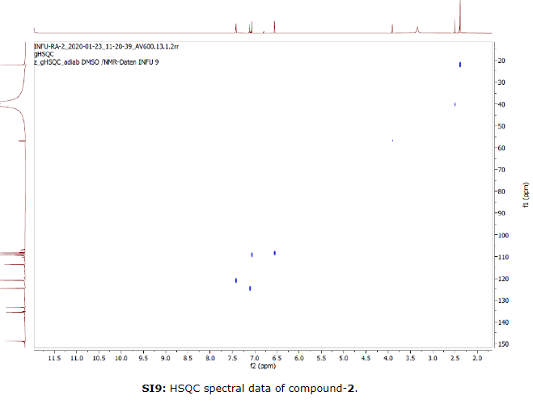
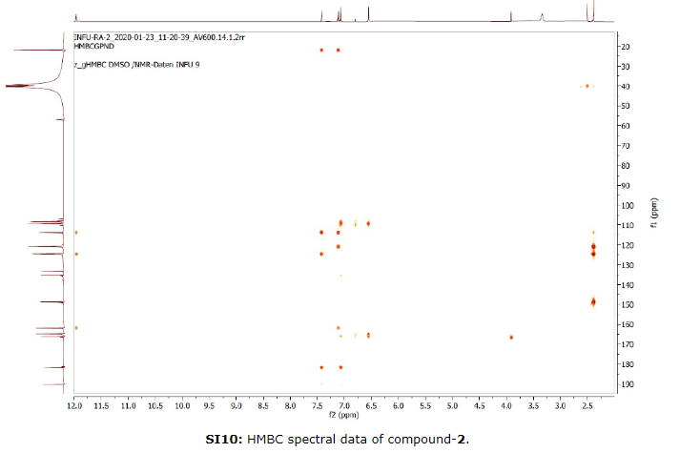

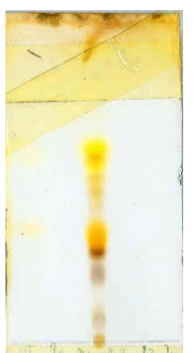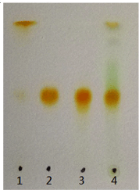
Plate 1: TLC for ethanol extract of R. abyssinicus and V. sinaiticum respectively

