Supplemental Material
1. Coupled mode theory for a resonant system
In general, the resonant system with $2×n$ resonators is governed by the following coupled mode equations
$$\begin{aligned}\frac{d}{dt}a=\left(iΩ-Γ_{e}-H_{int}\right)a_{t}+{K^{T}∙S}_{t}^{in},\#\left( AUTONUM \backslash * Arabic \right)\end{aligned}$$
where $a={\left(a_{1},a_{2},. .., a_{2n}\right)}^{T}$ describes the resonance amplitudes of the resonant modes. The diagonal matrices $Ω$ and $Γ_{e}$ describe the resonant frequencies and total decay rates of $2×n$ resonators, respectively. The hollow matrix $H_{int}=\frac{K^{+}K}{2}-Γ_{e}$ describes the couplings between the resonators through the waveguides. For vowel classification task, the coupling coefficient with 3 channels and $2×n$ resonators is given by the matrix
$$\begin{aligned}K=\left(\begin{matrix}\begin{matrix}κ_{1}\exp\left(+iβ_{1}l_{1}\right) & ⋯\end{matrix} & \begin{matrix}κ_{n}\exp\left(+iβ_{n}l_{n}\right) & 0 \end{matrix} & \begin{matrix}⋯ & 0\end{matrix} \\ \begin{matrix}κ_{1}\exp\left(-iβ_{1}l_{1}\right) & ⋯\end{matrix} & \begin{matrix}κ_{n}\exp\left(-iβ_{n}l_{n}\right) & κ_{n+1}\exp\left(-iβ_{n+1}l_{n+1}\right)\end{matrix} & \begin{matrix}⋯ & κ_{2n}\exp\left(-iβ_{2n}l_{2n}\right)\end{matrix} \\ \begin{matrix} 0 & ⋯\end{matrix} & \begin{matrix} 0 & κ_{n+1}\exp\left(+iβ_{n+1}l_{n+1}\right)\end{matrix} & \begin{matrix}⋯ & κ_{2n}\exp\left(+iβ_{2n}l_{2n}\right)\end{matrix}\end{matrix}\right)\#\left( AUTONUM \backslash * Arabic \right)\end{aligned}$$
where$κ$, $β$ and $l$ represent coupling coefficient, wavevector and the position of resonator. $β_{i}$ and $κ_{i}$ follow the relations $β_{i}=\frac{ω_{i}}{c}$ and $κ_{i}=$ $\sqrt{\frac{{2ω}_{i}}{Q_{i}^{w}}}$, where $ω_{i}$ and $Q_{i}^{w}$ represent resonant frequency and quality factor of the i^{th} resonator, respectively. ${ϕ_{i}=β}_{i}l_{i}$, where $ϕ_{i}$ stands for the phase delay at the position of each resonator compared with the reference plane [Fig. S1]. The resonant frequency $ω_{i}$ can be used to calculate wave vector $β_{i}$ when quality factor of the resonator is high (typically >30).
Outgoing wave amplitude and output power can be derived from power conservation
$$\begin{aligned}S_{t}^{out}=e^{-jβL}\left(S_{t}^{in}-K^{*}∙a_{t}\right)\#\left( AUTONUM \backslash * Arabic \right)\end{aligned}$$
$$\begin{aligned}P_{t}^{out}={\left|S_{t}^{in}-K^{*}∙a_{t}\right|}^{2}\#\left( AUTONUM \backslash * Arabic \right)\end{aligned}$$
where $β$ and $L$ are wave vector and the length of the waveguide, respectively.
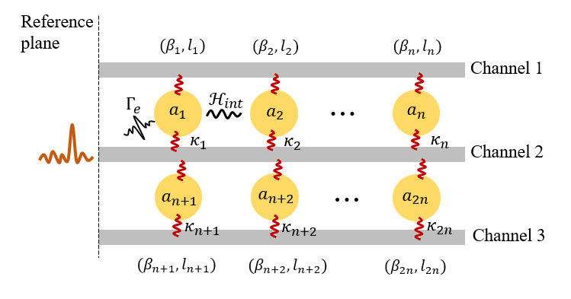
Fig. S1. The vowel recognition system consists of three channels and two rows of resonators.
2. A trainable bias term in resonant neural network
In neural network, the bias term b_y is trainable. A conventional RNN with biases is described as
$$h_{t}=W^{h}∙h_{t-1}+W^{x}∙x_{t}+b_{h},$$
where $h_{t}$ and $b_{h}$ are hidden states and the corresponding biases, respectively. In conventional RNN, a bias allows one to shift the hidden neuron value. A bias term can be implemented in the optical neural network as well. H. Zhang et al. proposed a method to add the bias term to MZI-based neural network through an additional constant input weighted by a complex-valued weight (Nat. Commun. 12, 1, 1-11, 2021). Similarly, we could also add trainable bias to resonance-based RNN. The resonance-based RNN can be described using the backward Euler method as
$$a_{t} =M^{a}{∙a}_{t-1}+M^{in}∙S_{t}+b_{i},$$
where $a_{t}$ are hidden states (i.e., electric field amplitudes). The bias is implemented by a constant input in one waveguide, and an additional complex-valued variable $b_{i}$ is allocated in the weight vector to make the bias trainable (Fig. S2). The variable $b_{i}$ can be decomposed to the resonant frequency and the decay rate values ($ω_{i}$ and $τ_{i}$) in the resonance system.
We present the training results of resonance-based RNN with and without bias term in the Fig. S3. The resonance-based RNN with and without bias term achieve classification accuracies of 83.7% and 81.9%, respectively. In this simple example, an additional bias term could improve the accuracy by approximately 2%.

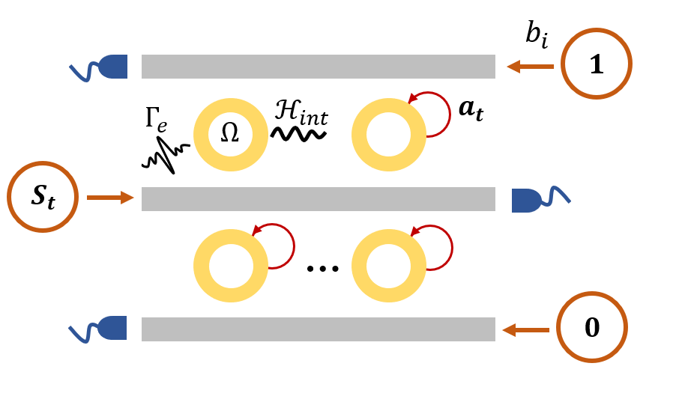
Figure S2 Schematic of the resonant recurrent network and the implementation of bias.
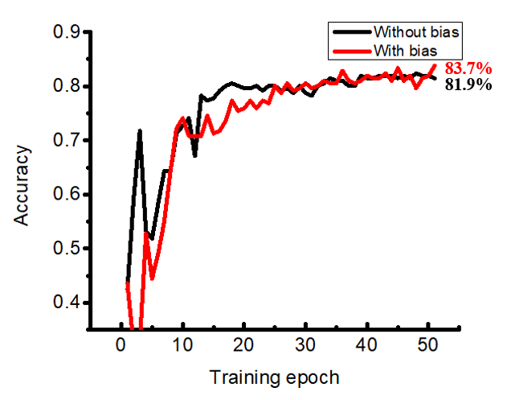
Figure S3 Comparison of training results for resonance-based RNN without and with a bias term.
3. Relation between actual geometric parameters and CMT parameters
When training the resonance-based RNN, we optimize CMT parameters including resonant frequency, coupling coefficient and the position of each resonator. For actual geometric properties, however, we need to consider practical situation and limitation. For example, the position of each resonators needs to satisfy $l_{m}-l_{m-1}>r_{m}+r_{m-1}$, where $l_{m}$ and $r_{m}$ represents the position and the radius of the $m^{th}$ resonator, respectively. The resonant frequencies of the resonance-based RNN are optimized during the training process. The size of each resonator can be directly obtained from the resonant frequencies using the formula of whispering gallery mode $L=m∙λ$, where $L$ is the circumference of the resonator and $λ$ is resonant wavelength. The distance $d$ between each resonator and waveguide can be obtained from simulation. Besides acoustic methods, optical implementation has some advantages in terms of fast modulation speed and compact footprint. Here, we performed the simulation in optical domain to calculate the relation between the quality factor of the resonator and distance $d$ using finite-element method (FEM) [Fig. S4 (b)]. Such relationship can be used to calculate the exact distance $d$ using the optimized quality factors. Considering each resonator can couple to two waveguides on both sides, here we assume that the coupling coefficients (the distances d) on both sides are the same. After optimization, the distance d between each resonator and waveguide is different in each location. Therefore, the actual waveguide geometry has to be curved to satisfy the optimized distance d in each location. A part of optimized CMT parameters is selected and then the corresponding actual geometric parameters are calculated [Fig. S4 (c)], where$λ_{0}$ = 1.55 μm. A part of trained resonant system is plotted according to the actual positions and sizes of resonators, as shown in Fig. S4 (a).
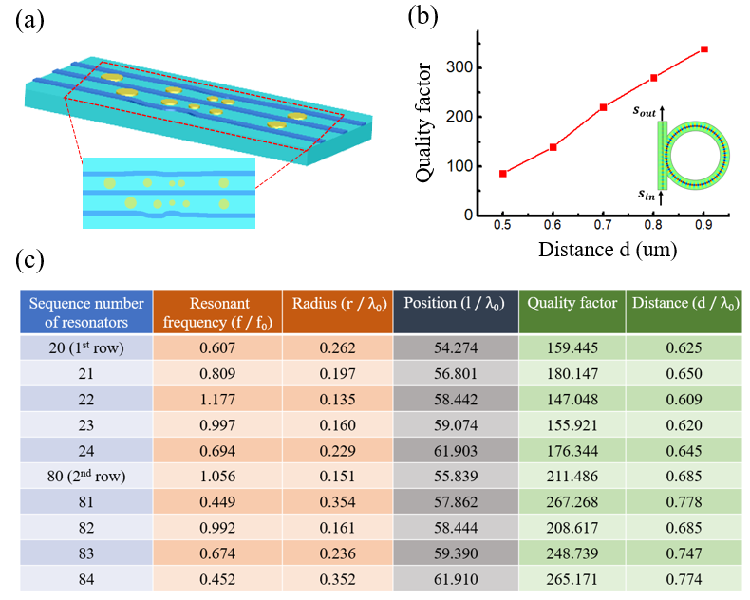
Fig. S4. The actual geometric parameters and CMT parameters of a resonant system after optimization. (a) Diagram of a part of resonance-based RNN architecture based on actual geometric parameters. (b) The relation between the quality factor each resonator and the distance $d$ calculated by FEM simulation. (c) A part of actual geometric parameters and the corresponding CMT parameters.
4. The resonant recurrent network with nonlinearities
In the acoustic domain, nonlinear could be also introduced (T. Rossing, Springer Handbook of Acoustics, Springer Science & Business Media, 2007). Here we further clarified how to implement nonlinearity in the optical domain.
A straightforward realization of the nonlinear activation function in the optical domain is using saturable absorption (SA). The realization of this effect involves the patterning of graphene or other absorptive 2D materials on top of the linear optical circuit etched into a dielectric such as silicon. An advantage of saturable absorption is that the nonlinear response can be observed at input powers on the mW scale (Optical Materials Express, 8, 10, 3055-3071, 2018), making saturable absorption a promising candidate for resonance-based RNN platform.
This nonlinear response is easily achieved using the proposed CMT-based framework through the incorporation of an additional term as
$$\frac{da}{dt}=\left(iω_{0}-\frac{1}{τ_{e}}-\frac{1}{τ_{SA}}\right)a+κ∙S^{in},$$
where nonlinear term $τ_{SA}$ are the resonator lifetimes corresponding to the saturable absorption losses, respectively. The term $τ_{SA}$ consists of an intensity-dependent absorption/damping, which is mathematically defined as
$$\frac{1}{τ_{SA}}=\frac{\frac{1}{τ_{SA,0}}}{1+\frac{{\left|a\right|}^{2}}{{\left|a_{th}\right|}^{2}}},$$
where $τ_{SA,0}$ denotes the resonator lifetime in the limit $a=0$ (where $a$ is the electric field in the resonator).$\frac{1}{τ_{SA,0}}$and $a_{th}$ can be regarded as saturable absorption strength and threshold, respectively. An example of the saturable absorption response is plotted in Fig. S5. The result shows that the damping $\frac{1}{τ_{SA}}$ has a nonlinear dependence on the resonance amplitude $a$.

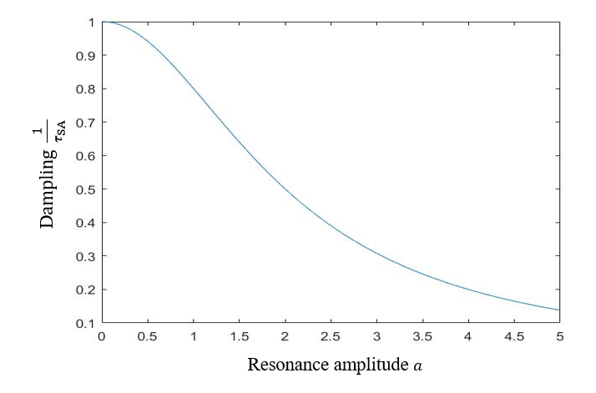
Figure S5 Saturable absorption response with the parameters $τ_{SA,0}$=1.0 and $a_{th}$=2.0.
As an example, we present a version of the resonance-based RNN with saturable absorption and the corresponding performances. The training results show that the resonant system with this form of nonlinearity can also perform well on the vowel classification task from the main text, achieving classification accuracies of 82.1% (Fig. S6). The linear system achieves training classification accuracies of 81.7% (Fig. 3). For this relatively simple problem, the resonant system with a nonlinear term does not show much improvements compared to the linear system. Further optimization can be used to improve the effectiveness of nonlinearity.
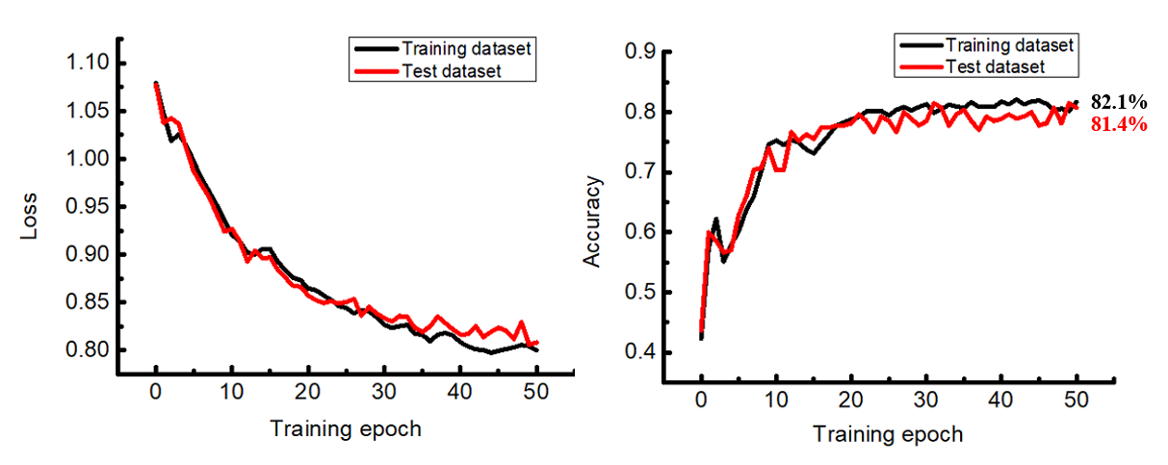
Figure S6 Training results for resonance-based RNN with a saturable absorption nonlinearity. The parameter $τ_{SA,0}$ is trainable and $a_{th}$ = 1 × 10⁻⁸ is used in the saturable absorption example.
5. Details about vowel signal preprocessing, loss function and neural network training
The sampling rate of the audio recording is 16 kHz. Every audio vowel sequence from the training set was windowed to a length of 200. Real-valued audio signal is first converted to complex signal with only positive frequencies because the CMT equation is applied to the positive frequency components of the field amplitudes. We take the Fourier transform of the audio signal to remove its negative frequency and then take the inverse Fourier transform of the signal back to the time domain.
The loss function is defined as the categorical cross-entropy between the probability distributions of the output and label. The output of the system is determined by the time-integrated power at each output channel. There are 3 output channels in our model, and therefore the time-integrated power gives a non-negative vector of length 3. Such vector is then normalized by its sum and interpreted as the system’s output probability distribution. The label probability distribution is the correct one-hot vector of length 3 which represents the energy distribution for each vowel.
The model is constructed using the open-source machine learning framework TensorFlow. The training process was performed for 50 epochs using the Adam optimization algorithm with a mini-batch size of 9 and a learning rate of 0.002.
6. Details about LSTM task
The LSTM task is to observe and then classify vowel sequences. LSTM training dataset contains three vowel classes: ae(t), iy(t) and ei(t). The sampling rate of the audio recording is 16 kHz. Each input vowel sequence was windowed to 100 time steps. The time duration of 100 time steps is 100/16000 = 6.25 ms. The system output is computed at the end of input sequence by integrating the power over 20 time steps at the output waveguide channel. The loss function is the same as the definition in the last section. The physical configuration contains three parallel waveguides and two rows of resonators, each row consisting of 20 resonators.
7. The resonant frequency of resonators and the mean energy spectrum of three vowel classes
Each audio waveform was sampled from its original recording with a 16-kHz sampling rate. The majority of the mean energy for all vowel classes is below 5 kHz. There is a strong overlap between three vowel classes and therefore the vowel classification task learned by the resonant system is nontrivial. During training process, the resonant frequency is constrained between 100 Hz to 5000 Hz.
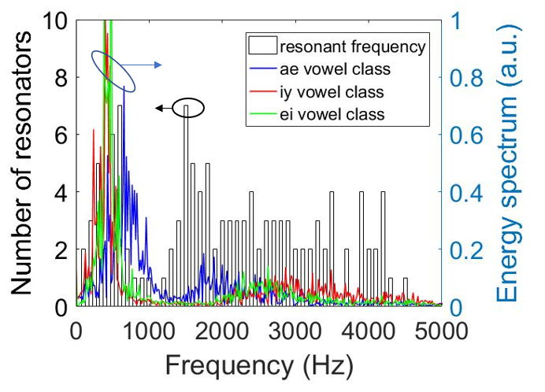
Fig. S7. The resonant frequency of resonators and the mean energy spectrum for the ae, ei, and iy vowel classes.
8. Computing time (inference and training) and footprint analysis of the resonant system
(1) Computing time
For inference, the computing time scale as $O$ ($N/m$), where N is the total number of resonators and m is the number of channels. There is $N/m$ resonators along one dimension. The computing time of inference is determined by the wave propagation time through the system. Since light travels extremely fast, in practice a more dominant time would be the readout time when optical signal is read out by photodetectors, which is on the order of picoseconds.
For training, it is performed in digital computer. The proposed resonant system is described by the temporal coupled mode equation $\frac{da}{dt}=\left(iΩ-Γ_{e}-H_{int}\right)a+K^{T}∙S_{t}$, where the matrices $Ω$, $Γ_{e}$, and $H_{int}$ represent the resonance frequency, the decay rate into channels, and the coupling between resonators, respectively. This equation can be implemented using Tensorflow in a digital computer through discretization:
$$a_{t} =M^{a}{∙a}_{t-1}+M^{in}∙S_{t}.$$
Here, the differential equation is discretized using the backward Euler method. $M^{a}$ describes the connection between the present states and the previous states where $M^{a}={(I-i∆t∙Ω+∆t∙Γ_{e}+∆t{∙H}_{int})}^{-1}$, and $M^{in}$ describes the input coupling given by $M^{in}=∆t{∙K∙M}^{a}$. We assume that the resonant system has $N$ resonators, and therefore the neural network has $N$ hidden neurons $a=(a_{1},a_{2}⋯a_{N})$. The matrix $M^{a}$ has $N×N$ entries and $M^{in}$ has $N×3$ entries (3 channels) in the vowel classification case.
In above equation, $a_{t}$ is the hidden state at the time step $t$, for $0≤t≤m∆t$. For simplicity, we will assume that $a_{t}$ is the output and the loss function is the mean squared error $MSE=\frac{1}{2}{(a_{t}-y)}^{2}$. In training process, the derivative of $MSE$ with respect to each parameter is calculated using backpropagation algorithm. This derivative can be computed iteratively from the top down using the following facts: $\frac{∂MSE}{∂a_{t}}=a_{t}-y,$ and $\frac{∂a_{t}}{∂w_{ij}}=a_{t-1}.$ The derivative of $MSE$ with respect to each parameter $w_{ij}$ is
$$\frac{∂MSE}{∂w_{ij}}=\frac{∂MSE}{∂a_{t}}∙\frac{∂a_{t}}{∂w_{ij}}={(a_{t}-y)}^{T}a_{t-1}$$
The training time complexity can be assessed by the calculation of derivatives $\frac{∂MSE}{∂w_{ij}}$, which scales as $O(N^{2})$.
(2) Footprint. The size of the device scales as the number resonators used. Each resonator would take 10 micrometers size.
Comparing to detection and electronic feedback:
- The inference time is much faster. The electronic feedback system will be limited by the electro-optical (EO) conversion, which is not fast. Here the proposed resonance system uses optical feedback. As such, it bypasses the EO conversion.
- The training time would be similar as both systems are trained by digital computers.
- The energy is more efficient for the resonance-based system, again due to bypassing the EO conversion.

