Supplementary Materials for
(This file contains supplementary figures 1–7)

Emetine dihydrochloride inhibits invasiveness and motility of hepatocellular carcinoma cells by blocking the MAPK pathway and inducing destabilization of Twist1
Haelim Yoon and Sayeon Cho*

Laboratory of Molecular and Pharmacological Cell Biology, College of Pharmacy, Chung-Ang University, Seoul 06974, Republic of Korea.

Haelim Yoon: limtiny@naver.com, Sayeon Cho: sycho@cau.ac.kr

* Correspondence to: Sayeon Cho, Ph.D., College of Pharmacy, Chung-Ang University, Seoul 06974, Republic of Korea. Email: sycho@cau.ac.kr

RT-PCR
Gene | Primer sequence
GAPDH | sense, 5’-gtcttcaccaccatggagaagg-3’  antisense, 5’-cctgcttcaccaccttcttgat-3’
TWIST1 | sense, 5’-acgtgtccagctcgccagtc-3’  antisense, 5’-tggagtccagctcgtcgctc-3’.
qRT-PCR
Gene | Primer sequence
GAPDH | sense, 5ʹ-ggtgtgaaccatgagaagtatga-3’  antisense, 5ʹ-gagtccttccacgataccaaag-3ʹ;
MMP2 | sense, 5' - agcgagtggatgccgccttta-3'  antisense, 5' -cattccaggcatctgcgatgag-3'
MMP9 | sense, 5' - gccactactgtgcctttgagtc-3'  antisense, 5' -ccctcagagaatcgccagtagt-3'
CDH1 | sense, 5ʹ-tacactgcccaggagccaga-3ʹ  antisense, 5ʹ-tggcaccagtgtccggatta-3ʹ;
CDH2 | sense, 5ʹ-cctccagagtttactgccatgac-3ʹ  antisense, 5ʹ-gtaggatctccgccactgattc-3ʹ;
VIM | sense, 5ʹ-aggcaaagcaggagtccactga-3ʹ  antisense, 5ʹ-atctggcgttccagggactcat-3ʹ.
Supplement Table 1. List of Primers

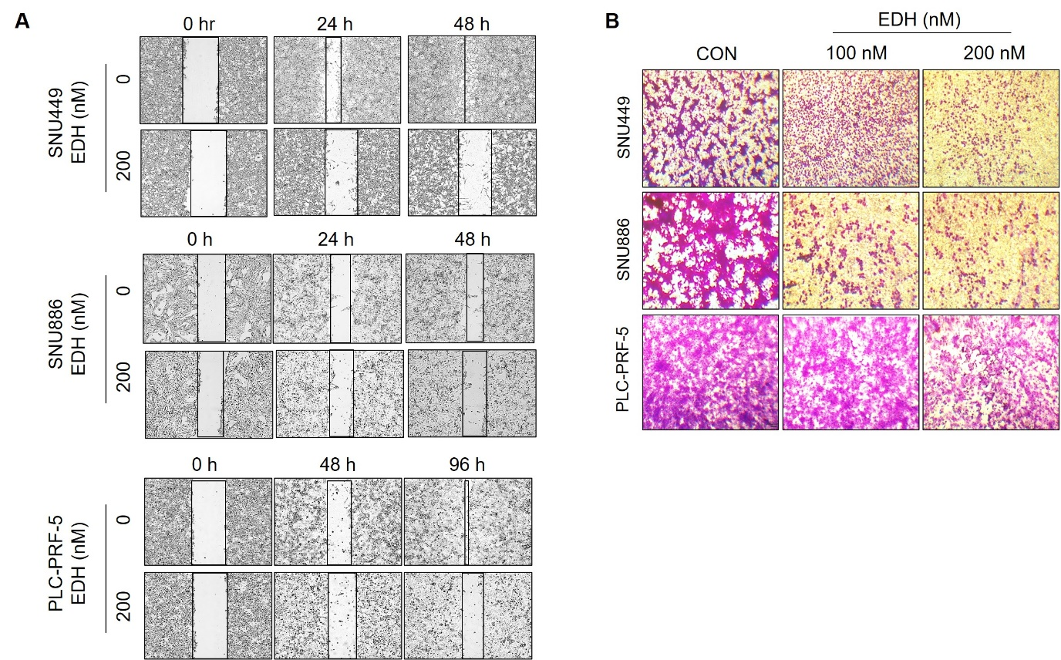
Supplement Fig. 1 EDH inhibits cell motility via regulation of migration and invasion in various HCC cell line. (A) Various HCC cell lines were treated with EDH, and then captured wound closure values at each time point. The wound area was observed by a JuLI stage real-time imaging system (B) Migration assay was performed using transwell plate. EDH was treated in upper chamber, contained in 1% FBS medium and incubation for 24 hours. All data are representative of three experiments.

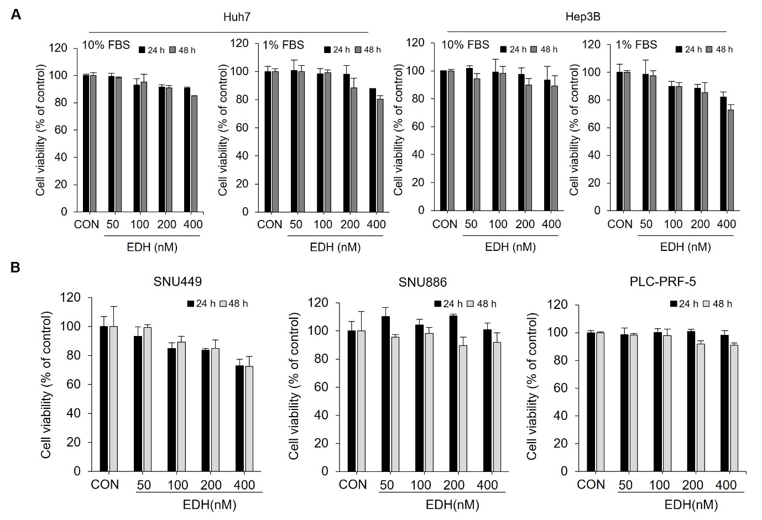
Supplement Fig. 2 Cytotoxicity of EDH in various HCC cell line. (A) Huh7 and Hep3B cells were treated for 24 and 48 hours after adding cell culture medium containing 1% or 10% FBS with or without EDH (50, 100, 200, and 400 nM). Cell viability was measured using EZ-Cytox. (B)Various HCC cell lines (SNU449, SNU886, and PLC-PRF-5) cells were treated with EDH at the indicated concentrations. EDH contained in 10% FBS medium was treated with each cell line for 24 and 48 hours, and cell viability was measured using EZ-Cytox solution. Data are representative of three experiments, *p < 0.05, **p < 0.01, and ***p < 0.001 compared to EDH untreated control.

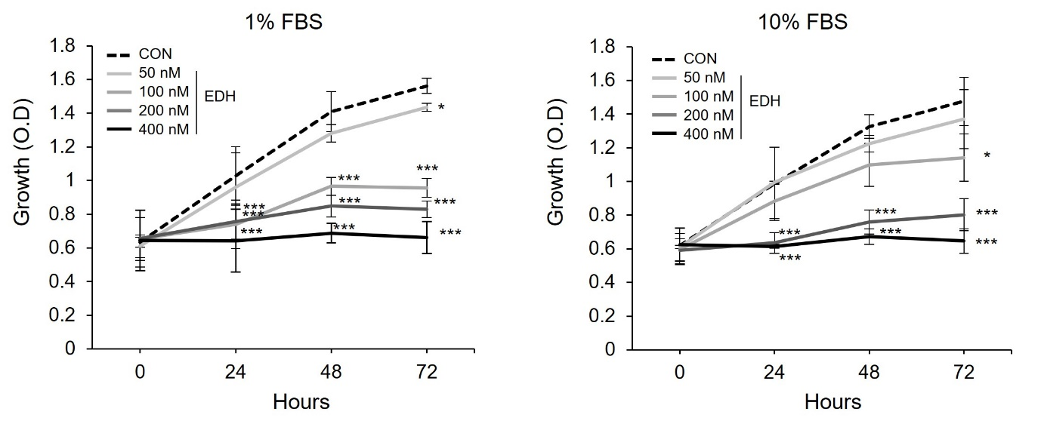
Supplement Fig. 3 EDH inhibits cell growth. Huh7 cells (1.5 × 10³ cells/well) were seeded in 96-well plates. Cells were treated with EDH (50, 100, 200, and 400 nM) in media containing 10% FBS. Cellular growth was measured at each time point using the EZ-Cytox solution. Data are representative of three experiments, *p < 0.05, and ***p < 0.001 compared to EDH untreated control.

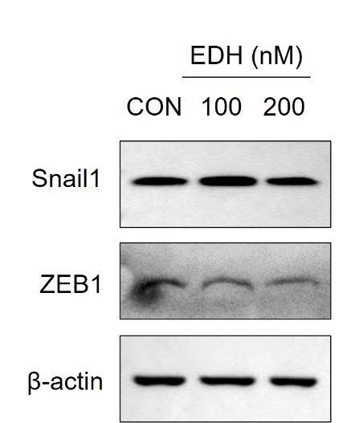
Supplement Fig. 4 EDH is not involved in the regulation of Snail1 and ZEB1 proteins. Huh7 cells were treated with EDH (100, and 200 nM), and the protein levels of Snail1 and ZEB1 were analyzed by immunoblotting.

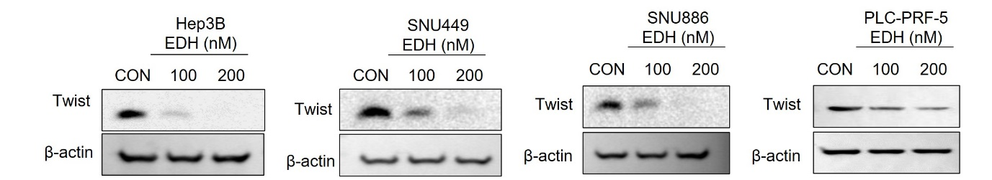
Supplement Fig. 5 EDH reduces the protein stability of Twist1. Various HCC cell lines (hep3B, SNU449, SNU886, and PLC-PRF-5) were treated with EDH (50, 100, and 200 nM) for 24 hours and then immunoblotting was performed using total cell lysates to determine protein levels of Twist1.

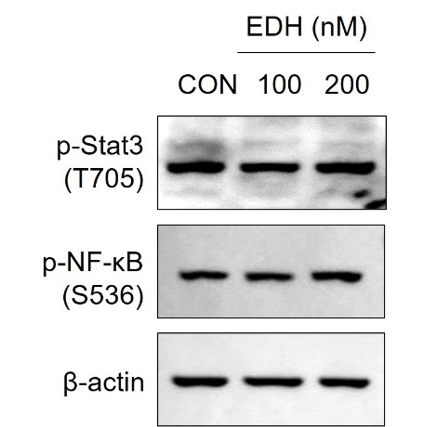
Supplement Fig. 6 Verification of various signaling pathways involved in Twist1 regulation by EDH treatment. After treating Huh7 cells with EDH (100 and 200 nM) for 24 hours, cell lysates were obtained and protein levels were evaluated by immunoblotting.

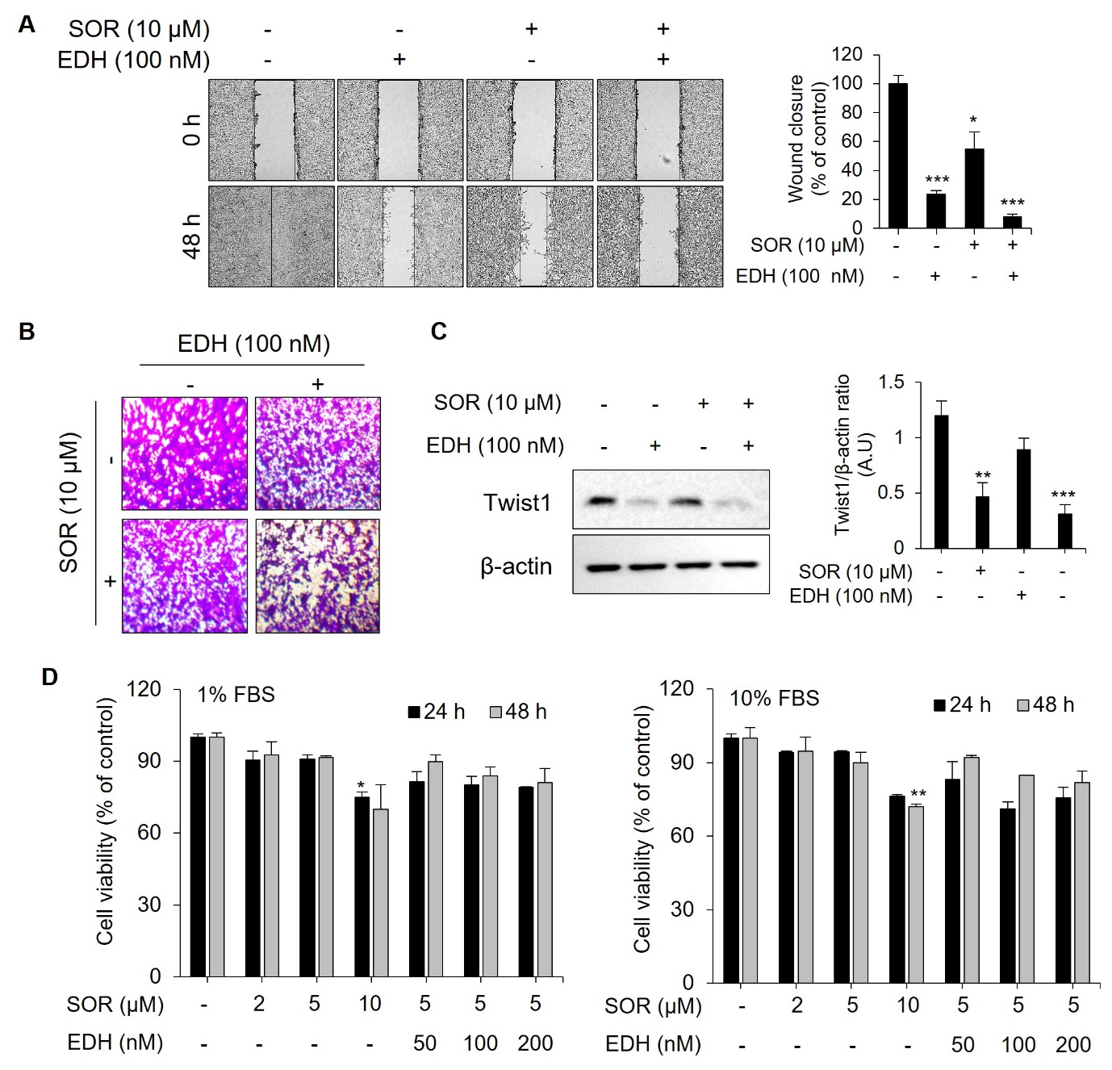
Supplement Fig. 7 Twist1 reduction effect due to combined treatment of EDH and sorafenib. (A) Huh7 cells were treated with EDH (100 nM) and sorafenib (10 μM) for 48 hours. Wound closure values were quantified by measuring the percentage of wound closure compared to the time point 0 hours for each sample using three independent experiments and displayed as bar graphs. (B) Huh7 cells were co-treated with the EDH (100 nM) and sorafenib (10 μM) in the upper chambers coated with Matrigel. After incubation for 21 hours, images of the invaded cells were taken. Data are representative of three experiments. (C) Huh7 cells were treated with EDH (100 nM) or sorafenib (10 μM) alone or together for 24 hours, and then immunoblotting was performed using whole cell lysates to determine protein levels of Twist1. (D) Huh7 cells were treated with sorafenib (2, 5, and 10 μM) or co-treated with sorafenib and EDH. The cell viability was measured using the EZ-Cytox solution. Quantified data were expressed as the means ± SD and analyzed by one-way ANOVA post hoc test. *p < 0.05, **p < 0.01, and ***p < 0.001, when compared to the EDH-untreated group.

