Supporting Information (SI)

Affinity of Drug Candidates Binding to SARS CoV-2 PLpro Assessed by a Generalized-ensemble Method

Masashi Muramoto,¹ Simon Hikiri,² Suzuka Saito¹, Xie Qilin,¹ Kota Kasahara,^{2,3} Junichi Higo^{4,5}, Takuya Takahashi^{*2}

¹ Graduate School of Life Sciences, Ritsumeikan University, 1-1-1 Noji-higashi, Kusatsu, Shiga 525-8577, Japan

² College of Life Sciences, Ritsumeikan University, 1-1-1 Noji-higashi, Kusatsu, Shiga 525-8577, Japan

³ Central Pharmaceutical Research Institute, Japan Tobacco Inc.

⁴ Graduate School of Information Science, University of Hyogo, 7-1-28 Minatojima Minamimachi, Chuo-ku, Kobe, Hyogo 650-0047, Japan

⁵ Research Organization of Science and Technology, Ritsumeikan University, 1-1-1 Noji-higashi, Kusatsu, Shiga 525-8577, Japan

Correspondence and requests for materials should be addressed to T.T. (e-mail: tkhs@sk.ritsumei.ac.jp)

Table S1. Constitution of computed systems

-----------------------------------------------------------------------------------------------------------

System $N_{tot}$ ^{a)} $N_{wat}$^{b)} $N_{cmp}$^{c)} $N_{Na}$^{d)} $N_{Cl}$^{e)} $L_{box}$^{f)}

-----------------------------------------------------------------------------------------------------------

PLpro–GRL0617 98,245 31,016 43 90 92 99.52 Å

PLpro–XR8-24 98,260 31,014 64 90 92 99.54 Å

PLpro–XR8-23 98,259 31,012 69 90 92 99.51 Å

PLpro–ZN-3-56 98,245 31,014 49 90 92 99.53 Å

-----------------------------------------------------------------------------------------------------------
^{a)} $N_{tot}$ is the number of all atoms in each system. Number of atoms in PLpro is 4,972.
^{b)} $N_{wat}$ is the number of water molecules.

^{c)} $N_{cmp}$ is the number of atoms in compound.

^{d)} $N_{Na}$ is the number of $Na^{+}$ ions.

^{e)} $N_{Cl}$ is the number of $Cl^{-}$ Cl ions.

^{f)} $L_{box}$ is the side length of the periodic boundary box (cubic) after NPT simulation. The box volume is given by $L_{box}×L_{box}×L_{box}$.

Figure S1.
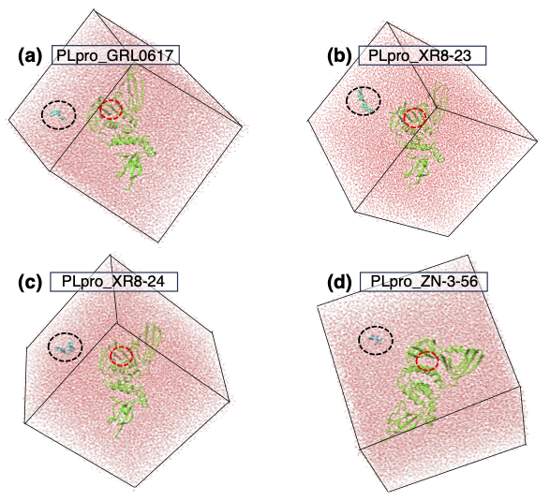

Figure S1: The initial conformations of mD-VcMD simulations of four systems. The system name is indicated near the panel name (a)–(d). Black broken-line circles indicate the positions of compounds. Red broken-line circles are ligand-binding site of PLpro.

Figure S2.

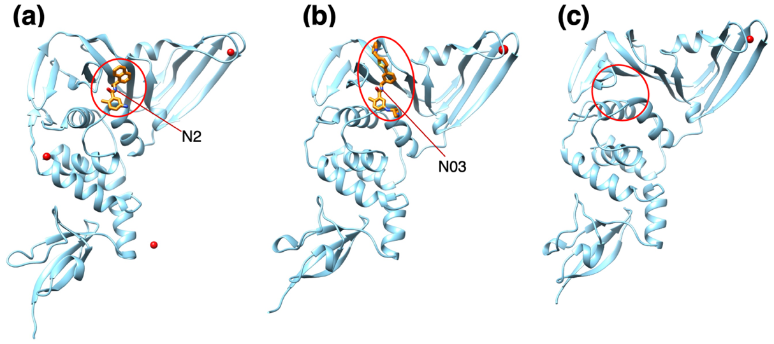
Figure S2: Crystallographic structures for (a) PLpro–GRL0617 complex (PDB ID: 7CJM), (b) PLpro–XR8-24 complex (PDB ID: 7LBS), and (c) apo-form (PDB ID: 6XG3). Red circles indicate ligand-binding sites. Orange-models are GRL0617 for panel (a) and XR8-24 for (b). Nitrogen atoms labeled “N2” and “N03” are mentioned in main text. Zn ions are indicated by small red spheres.

Supplementary Section 1: Zn ion or divalent metal ions in crystallographic structures

As mentioned in the MATERIALS AND METHODS section of the main text, the positions of zinc (Zn) ions in the three crystallographic complex structures (PDB IDs: 7CJM, 7LBS, and 6XG3) are distant from the ligand-binding site of PLpro (Figure S2). The two crystallographic complex structures (7CJM and 7LBS) are involved in the four systems of the current study, and 6XG3 is the apo-form of PLpro, which corresponds to unbound conformations emerging in the simulation. Note that the initial conformations of simulation (Figure S1) are also unbound conformations. Therefore, we presume that the Zn ion does not affect largely the compound-binding for the PLpro–GRL0617 and PLpro–XR8-24 systems.

On the other hand, crystallographic complex structures for PLpro–XR8-23 and PLpro–ZN-3-56 are not reported so far. To assess a possibility that a Zn ion exists in or near the ligand-binding sites of PLpro for these two systems, we checked the Zn positions in various crystallographic structures that contain PLpro. From PDB search, we obtained 42 PDB entries (Nov. 29, 2023): 7UV5, 7RBS, 7LOS, 7LLZ, 7LLF, 7LBR, 7CJD, 6XG3, 7D47, 7QCG, 7QCK, 7QCI, 7QCJ, 8FWN, 7JRN, 7D6H, 7NFV, 7OFU, 7QCM, 7QCH, 7NT4, 8EUA, 7OFT, 7OFS, 6WUU, 6WX4, 6WZU, 6XA9, 6XAA, 7JIR, 7JIT, 7LFV, 7LFU, 7LKE, 7CMD, 7D7K, 7D7l, 7JIV, 7JIW, 7LBS, 7RBR, and 8CX9. From visual investigation, 39 PDB structures showed no Zn or divalent metal ions in or near the ligand-binding site. On the other hand, a divalent metal ion exists near the ligand-binding sites in three PDB entries: 7D47, 7CMD, and 8EUA. The structure of 7D47 contains two PLpro molecules (dimer) and a calcium (Ca) ion (not zinc ion) exists in the ligand-binding sites of Chain B, whereas no divalent metal ion exists near the binding site of Chain A. The structure 7CMD contains four PLpro molecules (tetramer) and a Zn ion exists near the binding site of Chain D, although no Zn ion exists near the binding site for the other three chains. The structure 8EUA, which consists of a single PLpro molecule (monomer), contains one Zn ion near the binding sites.

The above observation does not prove that a Zn ion or other divalent metal ion does not exist near or in the binding site for the PLpro–XR8-23 and PLpro–ZN-3-56 systems. However, we note that the ligand-binding site of 92.9% ($=39/42$) of the crystallographic structures was distant from Zn or other divalent ions. We further note that the interaction between the divalent metal ion and the ligand-binding site is not seen in all multimers even in the two PDB entries of 7D47 and 7CMD, as explained above. Therefore, it is likely that a divalent metal ion less influences the compound-binding for the PLpro–XR8-23 and PLpro–ZN-3-56 systems.

Supplementary Section 2: Definition of reaction coordinates
The $i$-th reaction coordinate, denoted as $RCi$ here, is defined as follows. First, we set two atom groups $G_{A}^{(RCi)}$ and $G_{B}^{(RCi)}$ (Figure S3) and calculate the centroids ($×$ marks in the figure) of the two atom groups. Then, $RCi$ is the distance between the centroids. When two RCs ($RC1$ and $RC2$) are introduced, two sets of atom groups should be set in the molecular system: One set is denoted as $G_{A}^{(RC1)}$ and $G_{B}^{(RC1)}$, and the other as $G_{A}^{(RC2)}$ and $G_{B}^{(RC2)}$. The inter-centroid distance between $G_{A}^{(RC1)}$ and $G_{B}^{(RC1)}$ is $RC1$, and that between $G_{A}^{(RC2)}$ and $G_{B}^{(RC2)}$ is $RC2$. The actual set of $G_{A}^{(RCi)}$ and $G_{B}^{(RCi)}$ for the present study is shown in Figure 1 of the main text.
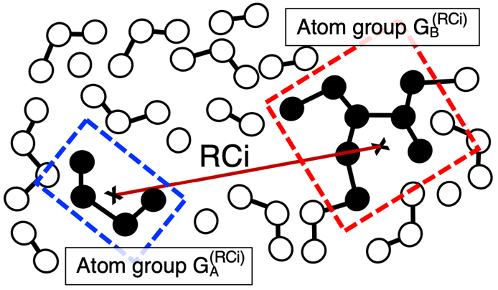
Figure S3: An RC, denoted as $RCi$, is schematically shown. Two atom groups $G_{A}^{(RCi)}$ and $G_{B}^{(RCi)}$ are shown by black filled circles in blue and red broken-line rectangles, respectively. Centroid of each group is presented by $×$ mark. $RCi$ is the distance (brown line) between the two centroids.

Table S2. Atom groups to define $RC1$ and $RC2$
-----------------------------------------------------------------------------------------------------------------
RC atom group ^{a)} contents
-----------------------------------------------------------------------------------------------------------------
$RC1$ $G_{A}^{(RC1)}$ Residues G266-N267-Y268 -Q269-C270-G271 (see Figure 1b)
$G_{B}^{(RC1)}$ V165-R166-E167-T168 (see Figure 1b)

$RC2$ $G_{A}^{(RC2)}$ $G_{A}^{(RC1)}+G_{B}^{(RC1)}$
$G_{B}^{(RC2)}$ Common region among the four compounds (see Figure 1a).
-----------------------------------------------------------------------------------------------------------------
Atom groups set to PLpro (i.e., $G_{A}^{(RC1)}$, $G_{B}^{(RC1)}$, and $G_{A}^{(RC2)}$) involve only main-chain atoms. Figure 1b of main text visualizes the atom groups and two RCs.

Table S3. Parameters for RC space constructed by RC1 and RC2.
-----------------------------------------------------------------------------
$i$ ^{a)} $RCi_{min}$ ^{b)} $RCi_{max}$ ^{c)} $n_{vs}^{(RCi)}$ ^{d)}
-----------------------------------------------------------------------------
$1$ $0.0 Å$ $25.4890 Å$ 34
$2$ $0.0 Å$ $49.2801 Å$ 48
-----------------------------------------------------------------------------
^{a)} Identifier of RC. An RC is denoted as $RCi$ ($i=1$ or 2).
^{b)} Minimum value for $RCi$.
^{c)} Maximum value of $RCi$.

^{d)} Number of zones set along each RC axis. Position of each zone along $RCi$ is given in Table S4 of SI.

Table S4. Zones along each RC
--------------------------------------------------------------------------------------
$k$ ^{a)} Lower and upper boundaries for the $k$-th zone along $RCi$ ^{b)}
--------------------------------------------------------------------------
$RC1_{low}(k)$ $RC1_{up}(k)$ $RC2_{low}(k)$ $RC2_{up}(k)$
--------------------------------------------------------------------------------------
1 0.0000 1.0000 0.0000 1.0000
2 0.5000 1.5000 0.5000 1.5000
3 1.0000 2.0000 1.0000 2.0000
4 1.5000 2.5000 1.5000 2.5000
5 2.0000 3.0000 2.0000 3.0000
6 2.5000 3.5000 2.5000 3.5000
7 3.0000 4.0000 3.0000 4.0000
8 3.5000 4.5000 3.5000 4.5000
9 4.0000 5.0000 4.0000 5.0000
10 4.5000 5.5250 4.5000 5.5000
11 5.0000 6.0500 5.0000 6.0000
12 5.5250 6.6012 5.5000 6.5000
13 6.0500 7.1525 6.0000 7.0000
14 6.6012 7.7313 6.5000 7.5000
15 7.1525 8.3101 7.0000 8.0000
16 7.7313 8.9179 7.5000 8.5000
17 8.3101 9.5256 8.0000 9.0000
18 8.9179 10.1638 8.5000 9.5000
19 9.5256 10.8019 9.0000 10.0000
20 10.1638 11.5039 9.5000 10.5000
21 10.8019 12.2058 10.0000 11.0000
22 11.5039 12.9780 10.5000 11.5500
23 12.2058 13.7501 11.0000 12.1000
24 12.9780 14.5995 11.5500 12.7050
25 13.7501 15.4489 12.1000 13.3100
26 14.5995 16.3832 12.7050 13.9755
27 15.4489 17.3175 13.3100 14.6410
28 16.3832 18.3452 13.9755 15.3730
29 17.3175 19.3729 14.6410 16.1051
30 18.3452 20.5034 15.3730 16.9104
31 19.3729 21.6339 16.1051 17.7156
32 20.5034 22.8775 16.9104 18.6014
33 21.6339 24.1210 17.7156 19.4872
34 22.8775 25.4890 18.6014 20.4615
35 19.4872 21.4359
36 20.4615 22.5077
37 21.4359 23.5795
38 22.5077 24.7585
39 23.5795 25.9374
40 24.7585 27.4701
41 25.9374 29.0028
42 27.4701 30.9952
43 29.0028 32.9877
44 30.9952 35.5779
45 32.9877 38.1681
46 35.5779 41.5354
47 38.1681 44.9026
48 41.5354 49.2801
--------------------------------------------------------------------------------------
^{a)} $k$ is index assigned to a zone (the $k$-th zone) along the $RCi$-axis. Numbers of zones set for the axes are: $n_{vs}^{(RC1)}=34$ for $RC1$ and $n_{vs}^{(RC2)}=48$ for $RC2$ (see Table S3).
^{b)} The lower and upper boundaries of the $k$-th zone along the axis $RCi$ ($i=1 or 2$) are denoted as $RCi_{low}(k)$ and $RCi_{up}(k)$, respectively. Unit of zones is $Å$. Entire sampling range $[RCi_{min},RCi_{max}]$ (see Table S3) for axis $RCi$ satisfies the following equation: $\left[RCi_{min},RCi_{max}\right]=[RCi_{low}\left(1\right),RCi_{up}\left(n_{vs}^{(RCi)}\right)]$.

Supplementary Section 3: Inter-zone transition and its probability
In the main text, we explained that the 2D-RC space is divided into many small zones and that the conformation transitions among the neighboring zones using an inter-zone transition probability. In this section of SI, we provide more detailed explanation for the inter-zone transition. Full details of the protocols are given in Ref. [1].
Zones set along each of $RC1$ and $RC2$ axes are given in Table S4. For convenience, a 2D zone, which was denoted by its zone indices as $(l,m)$ in the main text, is re-expressed by a vector $L$. One may consider the vector as $L=(l,m)$ for instance, where $l$ and $m$ are the zone indices along the $RC1$ and $RC2$ axes, respectively. Note that neighboring zones overlap mutually in each of the $RC1$ and $RC2$ axes (Table S3). Figure S4a of SI illustrates schematically a part of the 2D space where four neighboring zones, named $L_{1}, L_{2}, L_{3}$, and $L_{4}$ (numbering of index $i$ for $L_{i}$ is arbitrary), overlap in an intersection (shaded region). The four zones are framed with different colors. Assume that the conformation is located at the black filled circle at time $t$ in Figure S4a and that the current zone is $L_{1}$ (the red-framed zone). Thus, the conformation is confined in the red-framed zone in the time interval of $[t; t+∆τ_{trns}]$ as explained in the main text. If the conformation has moved along the broken line in Figure S4a during the time interval, then the conformation is at the position of the magenta filled circle at time $t+∆τ_{trns}$. Note that this conformation is in the intersection in that the four 2D zones overlap.
At time $t+∆τ_{trns}$, an inter-zone transition is applied to the conformation from $L_{1}$ (the current zone) to one of the four zones ($L_{1},⋯,L_{4}$). If $L_{1}$ transitions to $L_{1}$, it is a self-transition. When applying the inter-zone transition, the atomic coordinates of the system are fixed at the position of the magenta filled circle of Figure S4a. In the main text, we explained that the mD-VcMD simulation is done iteratively and that the system’s probability assigned to the 2D RC zone $(l,m)$ computed from the $J$-th iteration is expressed as $Q_{cano}^{[J]}(l,m)$. In this SI section, we re-express it as $Q_{cano}^{[J]}(L)$. In our previous studies,^{[1][2]} the inter-zone transition probability from any of the four zones to $L_{i}$ is set as:

$B_{L_{i}}^{[J]}={\left[Q_{cano}^{[J]}\left(L_{i}\right)\sum_{k=1}^{n_{link}}{\frac{1}{Q_{cano}^{[J]}\left(L_{k}\right)}} \right]}^{-1}$, (S1)

where $n_{link}$ is the number of the zones involving the intersection (the shaded region of Figure S4a). The “$B_{L_{i}}^{[J]}$” in the above equation is denoted as “$J_{L_{i}}$” in Refs. [1] and [2]. In Figure S4a, $n_{link}=4$ because four zones overlap in the intersection at time = $t+∆τ_{trns}$. The value of $n_{link}$ depends on the dimensionality of the RC space (i.e., the number of RCs introduced) and on the position of the intersection in the RC space.^{[1]} In general, the inter-zone transition is applied at time = $t+ n×∆τ_{trns}$ ($n$ is an integer). Then, the current zone is updated immediately after the inter-zone transition. For instance, if $L_{3}$ is selected for the current zone at time $t+∆τ_{trns}$, the conformation is confined in $L_{3}$ (the green frame) for the next time interval $[t+∆τ_{trns}; t+2∆τ_{trns}]$.
Sampling with Equation S1 for the inter-zone transition probability produces an even distribution in theory:^{[1],[2]}

$Q_{entire}^{[J]}\left(L_{i}\right)≈constant (∀i)$, (S2)

where $Q_{entire}^{[J]}\left(L\right)$ is the number of snapshots detected in zone $L_{i}$ during the $J$-th iteration. The canonical distribution $Q_{cano}^{[J]}\left(L_{i}\right)$ is computed according to the method introduced in Refs. [1] and [2].
We note that Equation S2 is satisfied for all zones in the 2D-RC space (not only the four zones in Figure S5a). Thus, Equation S1 has an advantage to obtain a free-energy landscape extensively by $PMF^{[J]}\left(L_{i}\right)=-RTln[Q_{cano}^{[J]}\left(L_{i}\right)]$. However, Equation S2 involves a practical problem as follows. Suppose two zones $L_{a}$ and $L_{b}$ satisfy an inequality of $Q_{cano}^{[J]}\left(L_{a}\right)≫Q_{cano}^{[J]}\left(L_{b}\right)$: The enthalpy assigned to $L_{a}$ considerably lower than that to $L_{b}$ or the entropy assigned to $L_{a}$ is considerably larger than that to $L_{b}$ at the simulation temperature (usually a room temperature). Then, once the conformation has visited $L_{b}$ in the simulation, the conformation stays in $L_{b}$ for considerably long to satisfy $Q_{entire}^{[J]}\left(L_{a}\right)≈Q_{entire}^{[J]}\left(L_{b}\right)$ (Equation S2), which means that a conformation trapping occurs in zone $L_{b}$. Because the conformational space of a biological system is very complicated in general, many traps may exist in the space. Besides, very unstable conformations may be less informative biophysically than stable conformations.
To escape this difficulty, in this study, we modulated $Q_{W}^{[J]}\left(L_{i}\right)$ as

$Q_{W}^{[J]}\left(L_{i}\right)= {\left[Q_{cano}^{[J]}\left(L_{i}\right)\right]}^{f}$, (S3)

where $f$ ($0≤f≤1$) is a modulator, and $B_{L_{i}}^{[J]}$ is reset:

$B_{L_{i}}^{[J]}={\left[Q_{W}^{[J]}\left(L_{i}\right)\sum_{j=1}^{n_{link}}{\frac{1}{Q_{W}^{[J]}\left(L_{j}\right)}} \right]}^{-1}$. (S4)

When $f=1$, Equation S4 is equivalent to Equation S1 and when $f=0$, $Q_{W}^{[J]}\left(L_{i}\right)=1$. In the present study we set $f=0.3$, by which the spatial undulations of $Q_{cano}^{[J]}\left(L_{i}\right)$ is relaxed as: $Q_{cano}^{[J]}\left(L_{A}\right)≫Q_{cano}^{[J]}\left(L_{B}\right)→Q_{W}^{[J]}\left(L_{A}\right)>Q_{W}^{[J]}\left(L_{B}\right)$. Figure S4b shows schematically the spatial undulations of $Q_{cano}^{[J]}\left(L_{i}\right)$ and $Q_{W}^{[J]}\left(L_{i}\right)$. The optimal $f$ presumably depends on the system’s complexity. For the present study, some values of $f$ were tested, and the number of zones visited during the simulation was the largest when setting $f=0.3$. Although Equation S2 is not satisfied when $f≠1$, the canonical distribution $Q_{cano}^{[J]}\left(L_{i}\right)$ is computable using $Q_{entire}^{[J]}\left(L_{i}\right)$ for all the three mD-VcMD variants (the original, the subzone-based, and the GA-guided mD-VcMD).^{[1]} When the iteration $J$ has finished, $B_{L_{i}}^{[J]}$ is calculated using Equation S4, and the $(J+1)$-th iteration starts with using $B_{L_{i}}^{[J]}$ if the convergence is not obtained (the convergence is explained in the next section of SI). For the first iteration, we set simply as: $Q_{cano}^{[0]}\left(L\right)=const (∀L)$.
Remember that the current simulation starts from a single conformation (Figure S1). Thus, there are zones (empty zones) that have not been sampled in the first to $J$-th iterations, whereas the number of empty zones decreases with proceeding iteration No. We note that the value of $Q_{cano}^{(J)}$ is unknown for the empty zones. Then, if we wet as $Q_{cano}^{(J)}\left(L'\right)=0.0$ (i.e., $Q_{W}^{(J)}\left(L'\right)=0.0$), where $L^{'}$ is the position of an empty zone, then, the transition probability $B_{L^{'}}^{[J]}$ for the empty zone becomes infinity: $B_{L^{'}}^{[J]}→∞$. This means that the empty zone becomes a strong attractor in the $(J+1)$-th iteration: Once the conformation falls in the empty zone, the conformation cannot escape from the zone. In this study, we set as $Q_{cano}^{(J)}\left(L'\right)=Q_{cano}^{(min)}$ temporarily. Then the empty zone may be sampled in the $(J+1)$-th iteration, and $Q_{entire}^{(J+1)}\left(L'\right)$ is set by the number of conformations detected in the zone.
We note that the function form of Equations S1 and S4 are the same. Thus, the computer program (GROMACS^{[5]} with the PLUMED plug-in^{[6]} or omegagene/myPresto^{[7]}) can be corded to input either $Q_{cano}^{[J]}\left(L\right)$ or $Q_{W}^{[J]}\left(L\right)$.
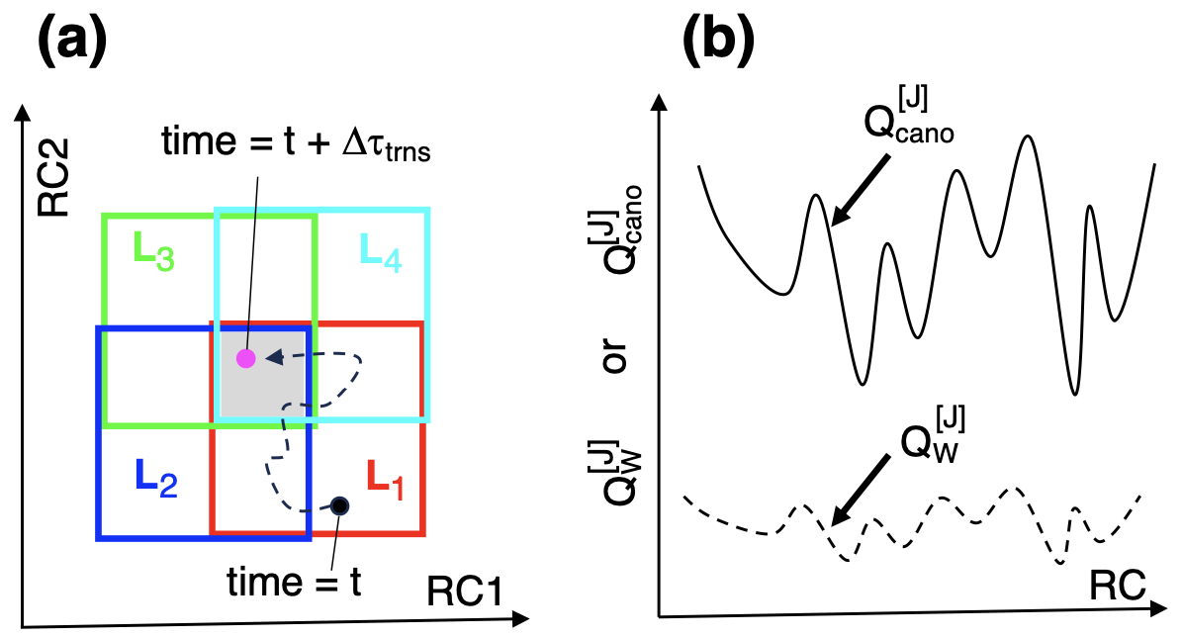
Figure S4 (a) Part of 2D-RC space constructed by $RC1$ and $RC1$. Terms used in this panel are explained in text. (b) Difference of $Q_{cano}^{[J]}$ and $Q_{W}^{[J]}$. The x-axis “$RC$” is either $RC1$ or $RC2$. The y-axis is $Q_{cano}^{[J]}$ or $Q_{W}^{[J]}$. Solid line corresponds to $Q_{cano}^{[J]}$ and broken line to $Q_{W}^{[J]}$.

Supplementary Section 4. Convergence check of $Q_{cano}$
To assess the convergence of the probability distribution obtained from the $J$-th iteration, we used a potential of mean force $F_{J}\left(l,m\right)$ at the simulation temperature (300 K). The potential of mean force is defined using $Q_{cano}^{\left[J\right]}(l,m)$ as follows:

$F_{J}\left(l,m\right)=-RTln\left[Q_{cano}^{\left[J\right]}\left(l,m\right)\right]$. (S5)

Remember that $l$ and $m$ are the 2D indices to specify a position of a 2D zone in the 2D-RC space and that the spatial pattern of $F_{J}(l,m)$ is a free-energy landscape in the 2D-RC space.
A correlation coefficient $C_{cor}^{[J,K]}$ quantifies the similarity of 2D-RC spatial patterns of the potential of mean force between the $J$-th and $K$-th iterations:

$C_{cor}^{[J,K]}=\frac{S_{JK}}{S_{J}S_{K}}$ , (S6.1)

where

$S_{J,K}={\left[<F_{J}F_{K}>-<F_{J}><F_{K}>\right]}^{1/2}$, (S6.2)

$<F_{J}F_{K}>=\frac{\sum_{l,m}{F_{J}\left(l,m\right)F_{K}\left(l,m\right)×δ_{l,m}^{[J;K]}}}{n_{pick}^{\left[J;K\right]}}$ , (S6.3)

$<F_{α}>=\frac{\sum_{l,m}{F_{α}\left(l,m\right)×δ_{l,m}^{[J;K]}}}{n_{pick}^{\left[J;K\right]}}$ ($α=J$ or $K$), (S6.4)

$S_{α}={\left[<{F_{α}}^{2}>-<F_{α}>^{2}\right]}^{1/2}$, (S6.5)

$<{F_{α}}^{2}>=\frac{\sum_{l,m}{F_{α}{\left(l,m\right)}^{2}×δ_{l,m}^{[J;K]}}}{n_{pick}^{\left[J;K\right]}}$ , (S6.6)

$n_{pick}^{\left[J;K\right]}=\sum_{l,m}{δ_{l,m}^{[J;K]}}$, (S6.7)
and

$δ_{l,m}^{[J;K]}=\left\{\begin{matrix}1 (if zone \left(l,m\right) is sampled in both iterations J and K) \\ 0 (else)\end{matrix}\right.$. (S6.8)

The closer the $C_{cor}^{[J,K]}$ to unity, the similar the $F_{J}$ and $F_{K}$ to each other.
As mentioned in the main text, $Q_{cano}^{\left[J\right]}\left(l,m\right)$ is computed from the fourth to $J$-th iterations with discarding the data from the first to third iteration, and the snapshots from the first to third iteration are used for analyses. To assess the convergence from the first iteration, on the other hand, $Q_{cano}^{\left[J\right]}\left(l,m\right)$ for $J=1, 2$ and 3 should be calculated. Then, $Q_{cano}^{\left[J\right]}\left(l,m\right)$ for $J≤3$ is calculated using the data from the first to $J$-th iterations.

Supplementary Section 5. Principal Component Analysis (PCA)
Because the conformation of a snapshot is represented by many atoms, the snapshot is represented as a point in a high-dimensional space. An ensemble of $N_{all}$ snapshots is expressed by a distribution of $N_{all}$ points in the high-dimensional space. Now, we express the position of the $k$-th snapshot in the high-dimensional space as: $d^{(k)}=(d_{1}^{(k)},d_{2}^{(k)},⋯, d_{N_{d}}^{(k)})$, where $d_{j}^{(k)}$ is the $j$-th component of the $k$-th snapshot, $k=1,2,⋯,N_{all}$, and $N_{d}$ is the dimensionally of the space.
In PCA,^{[3],[4]} a variance-covariance matrix $A$ is calculated, whose $(i,j)$-th element is defined as:

$A_{ij}=<d_{i} d_{j}>-<d_{i}><d_{j}>$ , (S7)

where

$<d_{i} d_{j}>=\frac{\sum_{k=1}^{N_{all}}{w_{k} d_{i}^{(k)} d_{j}^{(k)}}}{\sum_{k=1}^{N_{all}}{w_{k}}}$ , (S8)

and

$<d_{i}>=\frac{\sum_{k=1}^{N_{all}}{w_{k} d_{i}^{(k)}}}{\sum_{k=1}^{N_{all}}{w_{k}}}$ . (S9)

The $w_{k}$ is the statistical weight assigned to snapshot $k$ computed by a protocol.^{[1]} If all the points have an equal statistical weight ($w_{k}=const$; $∀k$), $w_{k}$ can be omitted in Equations S8–10. Diagonalization of $A$ provides a set of eigenvectors $\{u_{1},⋯,u_{N_{d}}\}$ and a set of eigenvalues $\{λ_{1},⋯,λ_{N_{d}}\}$, which satisfy the following equations: $Au_{i}=λ_{i}u_{i}$ and $u_{i}∙u_{j}=0$ (for $i≠j$). By normalizing the eigenvectors as $\left|u_{i}\right|=1$ ($∀i$), we reset the norms of the eigenvectors so that the following equation is satisfied: $u_{i}∙u_{j}=δ_{ij}$. This means that the set of the eigenvectors can be used as an orthogonalized and normalized basis set to describe the distribution of the $N_{all}$ points in the $N_{d}$-dimensional space, and we call the space generated by the eigenvectors as “PC space”. The $u_{i}$ is referred to as the $i$-th principal component (PC) axis, and $u_{i}$ is designated as “$PCi$”: $u_{i}→PCi$.
The averaging operation in Equations S8 and S9 is taken over $N_{all}$ snapshots that are the integration of the four systems: $N_{all}=4×N_{snp}=13.6 ×10^{5}$. Remember that $N_{sngl}(=3.4×10^{5}$) is the number of snapshots from a single system as mentioned in the main text. The reason why the integrated snapshots were used to calculate the PC axes is because we aim to view the distribution of each system in a unified coordinate system: $PCi$ is the same for all systems. We also note that the statistical weight is normalize for each system as $\sum_{k=1}^{N_{snp}}{w_{k}(α)}=1.0$, where $α$ specifies the system to be analyzed ($α=$ PLpro–GRL0617, PLpro–XR8-24, PLpro–XR8-23, or PLpro–ZN-3-56). The individual normalization is to treat each system with the same weight. Note that the statistical weight is usually denoted simply as “$w_{k}$” without “$α$” in this paper.
The $k$-th point $d^{k}$ (snapshot $k$) in the original space is converted to a position $r^{k}$ in the PC space. The $m$-th coordinate of $r^{k}$ is expressed in the PC space as:

$r_{m}^{(k)}=u_{m}∙(d^{(k)} - <d>)$ , (S10)

where $<d>$ is the averaged position (Equation S9): $<d>=(<d_{1}>,<d_{2}>,⋯,<d_{N_{d}}>)$. Note that Equation S10 has a form of scalar product, which means that the $m$-th element $r_{m}^{(k)}$ is the projection of $d^{k}$ on the eigenvector $u_{m}$ (or $PCm$). By Equation S10, $d^{(k)}$ defined in the original space is converted to $r^{(k)}=(r_{1}^{(k)}, r_{2}^{(k)},⋯,r_{N_{d}}^{(k)})$ in the PC space.
Here, the eigenvectors are arranged so that their eigenvalues are aligned in a descending order of their magnitude: $λ_{1}≥λ_{2}≥⋯≥λ_{N_{d}}$. In PCA, the entire standard deviation, $SD_{entire}$, of the distribution of the $N_{all}$ points in the $N_{d}$-dimensional space is calculated as: $SD_{entire}=[\sum_{i=1}^{N_{d}}{\{<{d_{i}}^{2} >-<d_{i}>^{2}\}}]^{\frac{1}{2}}=\sum_{i=m}^{N_{d}}{λ_{m}}$, where the eigenvalue $λ_{m}$ is the elementary standard deviation along the $PCm$ axis. Therefore, the larger the eigenvalue of an eigenvector, the larger the contribution of the eigenvector to $SD_{entire}$. The contribution ratio by $PCm$ to $SD_{entire}$ is quantified by:

${CR}_{i}=\frac{λ_{i}}{\sum_{j=1}^{N_{d}}{λ_{j}}}$ . (S11)

$CR_{i}$ decreases with increasing $i$ by the arrangement of the eigenvectors mentioned above. The contribution from ${CR}_{1}$ to $CR_{N_{pick}}$ to $SD_{entire}$ is given as:

$CR\left(1;N_{pick}\right)=\sum_{j=1}^{N_{pick}}{CR_{j}}$ . (S12)

If a small number of PCs contribute largely to the entire distribution, the small number of PCs can capture the overall futures of the $N_{d}$-dimensional distribution.
In this study, we analyze the structural distribution in a 2D PC space constructed by PC1 and PC2. Each system provides an ensemble of $N_{sngl}$ points whose coordinates in the 2D PC space are presented as $(r_{1}^{(1)}, r_{2}^{(1)})$, $\left(r_{1}^{(2)}, r_{2}^{(2)}\right), …, (r_{1}^{(N_{sngl})}, r_{2}^{{(N}_{sngl})})$: The $k$-th point is at $\left(r_{1}^{(k)}, r_{2}^{(k)}\right)$ in the 2D PC space, and the first and second elements are projection of $d^{k}$ on $PC1$ and $PC2$, respectively.
In the present study, the vector $d^{(k)}=(d_{1}^{(k)},d_{2}^{(k)},⋯, d_{N_{d}}^{(k)})$ is defined by distances between atoms in the system as done in our previous study.^{[4]} It is important to select the same atoms from the four systems to compare the conformational distribution among the systems. Thus, we selected the following atoms for the present stydy: 316 $Cα$ atoms from PLpro (number of residues of PLpro is 316) and 8 heavy atoms from a core region (Figure S5) for each compound. The number of atoms is 324 in total, and then the number of atom pairs is $324×\left(324+1\right)=52,650$. The distance for each atom pair for snapshot $k$ is an element of the vector $d^{(k)}$. Ordering of the 324 atoms is arbitrary.
The core region is common for all four compounds (Figure S5). As explained above, selection of the core region is important to compare the PCA results among the four systems. Furthermore, it is likely that the core region plays an important role for the compound–receptor binding. As shown in the crystallographic structures for the PLpro–GRL0617 complex (PDB ID: 7CJM) and PLpro–XR8-24 complex (PDB ID: 7LBS), the core region of the compounds is located in the binding-site of PLpro with the same orientation.

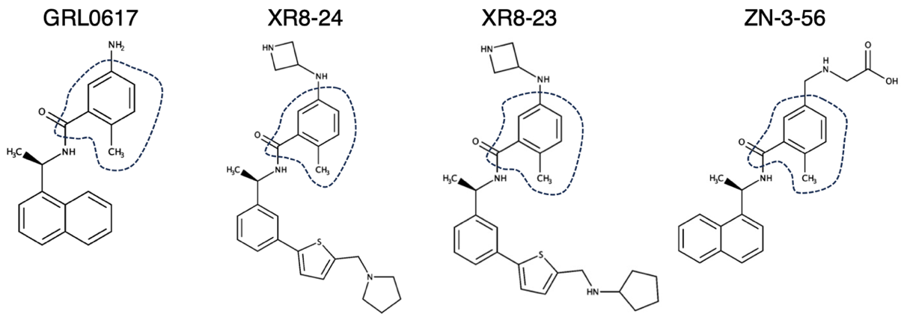
Figure S5.

Figure S5: Core regions (surrounded by broken lines) used for PCA and t-SNE methods for four compounds: (a) GRL0617, (b) XR8-24, (c) XR8-23, and (d) ZN-3-56. The core region consists of eight heavy atoms. Outside of the core region is called “a non-core region”. Hydrogen atoms are excluded from either the core and non-core regions.

Figure S6.
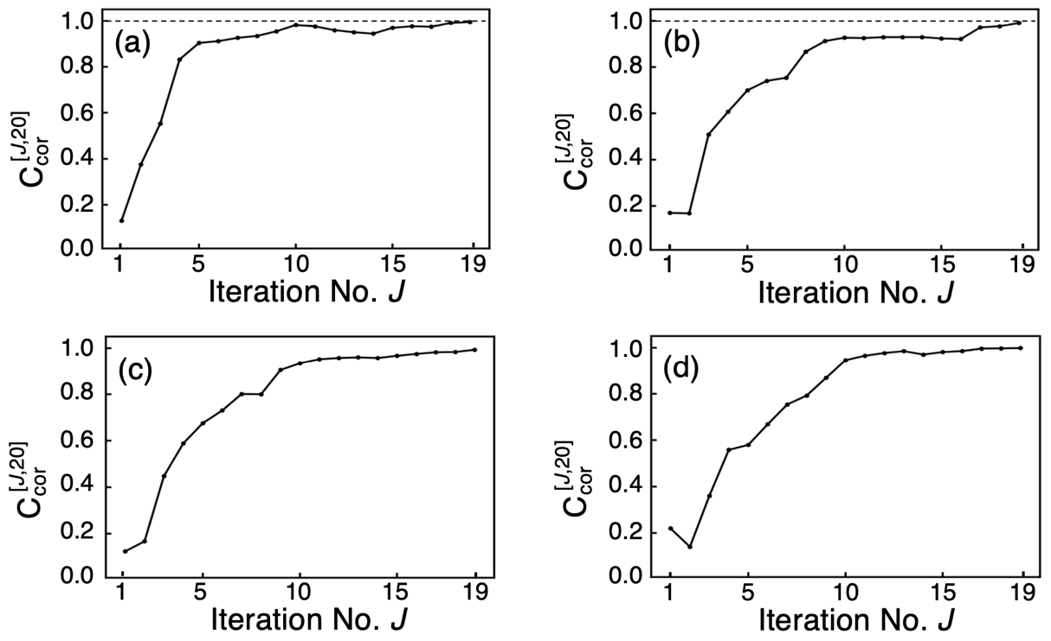
Figure S6: Correlation coefficient, $C_{cor}^{[J,20]}$ (Equation S6.1), as a function of the iteration No. $J$ ($J=1,…,19$). The coefficient quantifies a similarity of spatial pattern between free-energy landscapes $F_{J}$ and $F_{20}$ (Equation S5). (a) PLpro–GRL0617, (b) PLpro–XR8-24, (c) PLpro–XR8-23 and (d) PLpro–ZN-3-56. Broken lines show level of $C_{cor}^{[20,20]}=1$.

Supplementary Section 6. Fluctuations of cleft–width of binding site
The standard deviation of $RC1$ corresponds to the amount of the cleft–width fluctuations of the ligand–binding site of PLpro (Figure 1b of the main text). Here we present a method to calculate the quantity at a given $RC2$ value ($RC2_{x}$) with replacing $Ω_{i}$ by ${RC1}_{i}$ ($RC1$ of the $i$-th snapshot) in Equation 4 of the main text:

$SD_{RC1}(RC2_{x})={\left[\frac{\sum_{i=1}^{N_{snp}}{w_{i}×{{RC1}_{i}}^{2}×D_{i}(RC2_{x})}}{\sum_{i=1}^{N_{snp}}{w_{i}}×D_{i}(RC2_{x})}-<RC1>^{2}\right]}^{1/2}$, (S13)

where $D_{i}(RC2_{x})$ is a specific case of $D_{i}$ of Equation 3 of the main text defined as:

$D_{i}\left(RC2_{x}\right)=\left\{\begin{matrix}1 (for RC2_{x}-δ≤RC2<RC2_{x}+δ ) \\ 0 \left(otherwise\right)\end{matrix}\right.$ . (S14)

$<RC1>$ is defined in Equation 2 of the main text. Mathematically, $δ$ should be very small ($δ→0$) to calculate $SD_{RC1}$ at $RC2= RC2_{x}$. Practically, however, we set $δ=2 Å$ to calculate $SD_{RC1}$ from the finite number ($N_{snp}$) of snapshots.
To analyze $SD_{RC1}$ at various RC2 extensively, we moved $RC2_{x}$ as follows. First, we set the range to $RC2_{min}≤RC2<RC2_{min}+2δ$, where $RC2_{min}$is the smallest $RC2$ in the snapshot’s ensemble for each system. After calculating $SD_{RC1}$ in this range, we shift the range to $RC2_{min}+2δ≤RC2<RC2_{min}+4δ )$ and compute $SD_{RC1}(RC2_{x})$ for this range, and so on. This procedure is repeated till the largest $RC2$ appears in a range. Figure S7 plots $SD_{RC1}$ along the RC2 axis.

Figure S7.
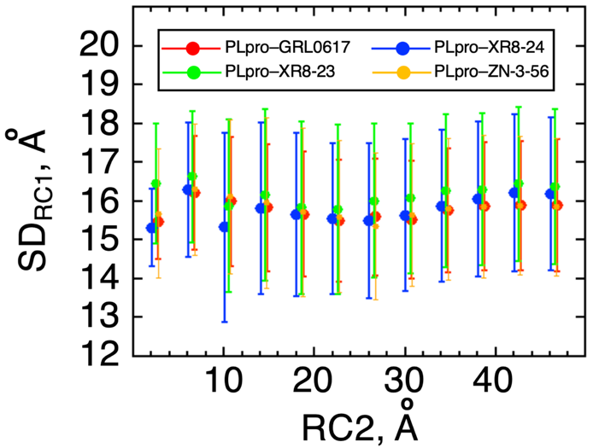
Figure S7: Standard deviation $SD_{RC1}$ of $RC1$ (i.e., fluctuation width of $RC1$) at various values of $RC2$ (x-axis) for four systems (see inset). Filled circles are average $<RC1>$. Method to calculate $SD_{RC1}$ is explained in Supplementary Section 6.

Figure S8.
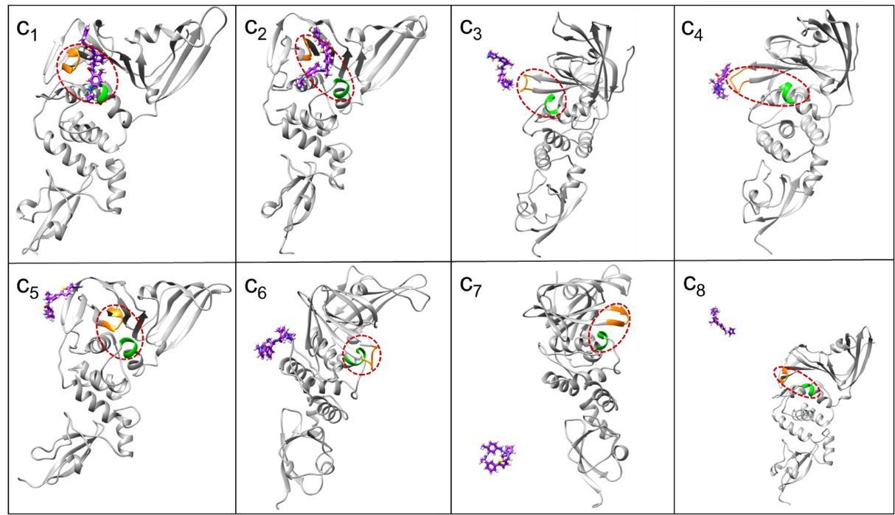
Figure S8: Conformations of the PLpro–XR8-24 system picked from sites $c_{1},…,c_{8}$ defined in Figure 2b of main text. Panel names of this figure correspond to site names $c_{1},…,c_{8}$ in Figure 2b. Purple molecule is XR8-24. Orange and green segments are atom groups used to set rection coordinate $RC1$ (Figure 1b): Residues 266–271 and 165–168, respectively. Brown-colored broken line indicates the position of the ligand-binding site of PLpro. Molecules in panels are drawn from different directions to show clearly the positions of the ligand-binding site and compound.

Figure S9.
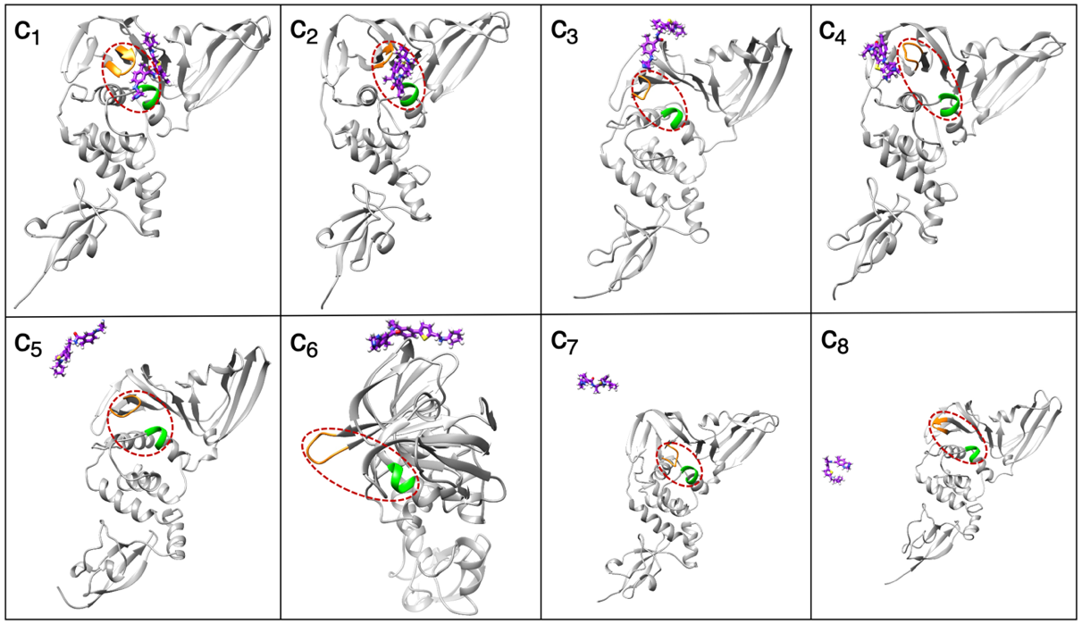
Figure S9: Conformations of the PLpro–XR8-23 system picked from sites $c_{1},…,c_{8}$ defined in Figure 2c of main text. Panel names of this figure correspond to site names $c_{1},…,c_{8}$ of Figure 2c. See legends of Figure S8 for more details of this figure.

Figure S10.
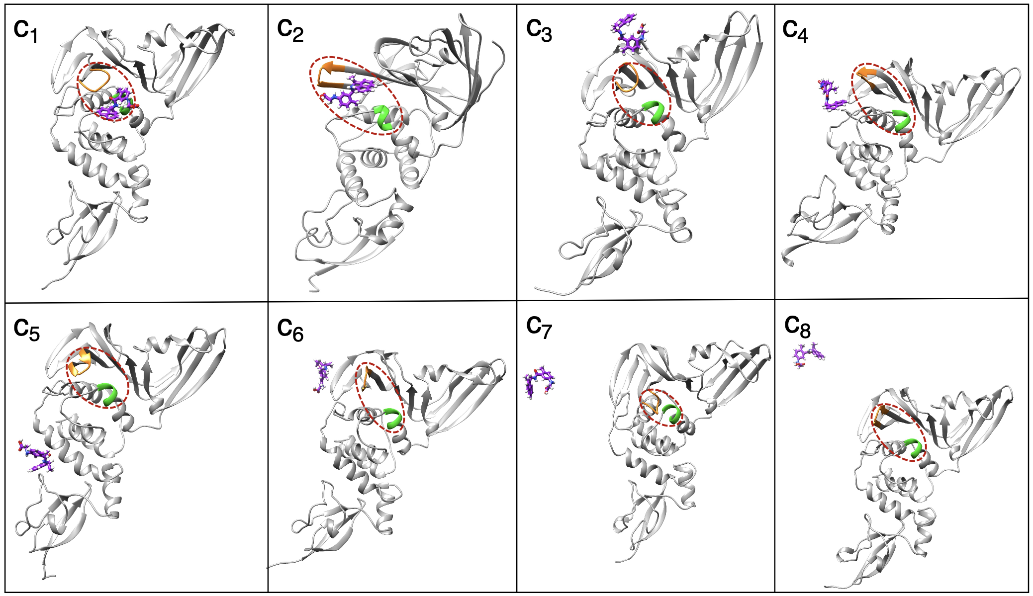
Figure S10: Conformations of the PLpro–ZN-3-56 system picked from sites $c_{1},…,c_{8}$ defined in Figure 2d of main text. Panel names of this figure correspond to site names $c_{1},…,c_{8}$ of Figure 2d. See legends of Figure S8 for more details of this figure.

Figure S11.
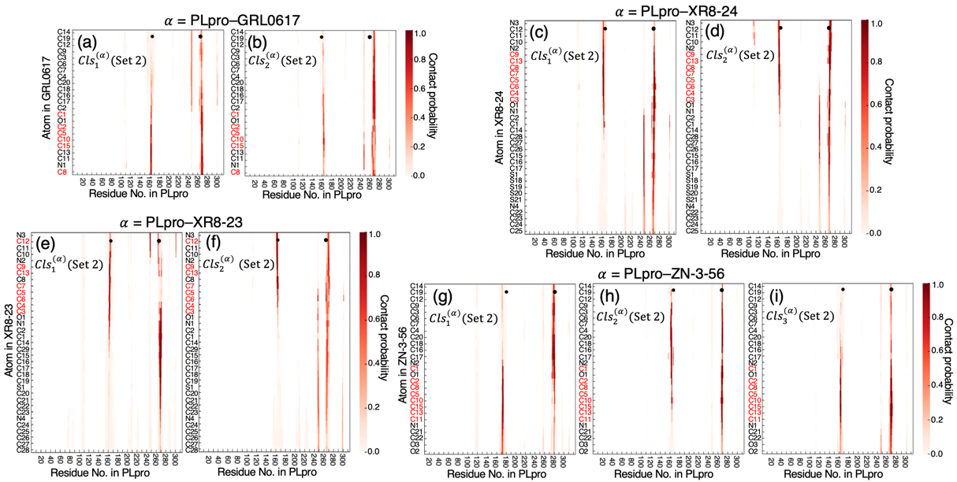
Figure S11: Contact map between PLpro (X-axis) and compounds (Y axis) for each cluster with clustering parameter Set 2 (Table 3). Contact probability, which is normalized in each cluster, is presented by color scale. Panels (a) and (b) are for clusters ${Cls}_{1}^{(α)}(Set 2)$ and ${Cls}_{2}^{(α)}(Set 2)$ of $α=$ PLpro–GRL0617 system, (c) and (d) are for clusters ${Cls}_{1}^{(α)}(Set 2)$ and ${Cls}_{2}^{(α)}(Set 2)$ of $α=$ PLpro–XR8-24 system, (e) and (f) are for clusters ${Cls}_{1}^{(α)}(Set 2)$ and ${Cls}_{2}^{(α)}(Set 2)$ of $α=$ PLpro–XR8-23 system, and (g), (h) and (i) are for clusters ${Cls}_{1}^{(α)}(Set 2)$, ${Cls}_{2}^{(α)}(Set 2)$ and ${Cls}_{3}^{(α)}(Set 2)$ of $α=$ PLpro–ZN-3-56 system. Red colored atom names in Y axis are those of core region (Figure S5 of SI). Small black spheres indicate position of atom group $G_{A}^{(RC1)}$ (residues 266–271) and $G_{B}^{(RC1)}$ (residues 165–168) (see Figure 1b of main text). Space between $G_{A}^{(RC1)}$ and $G_{B}^{(RC1)}$ corresponds to the ligand–binding site.
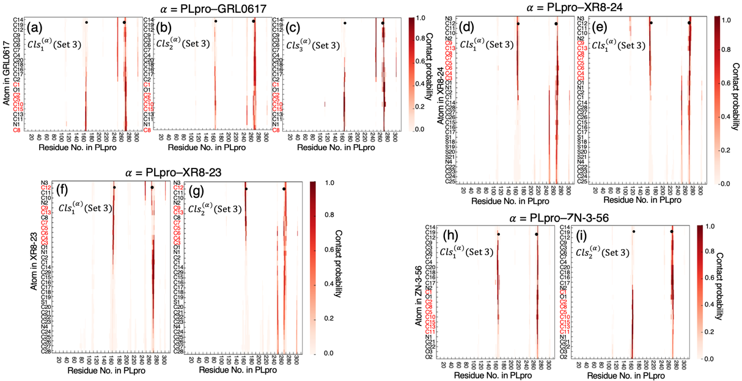
Figure S12.
Figure S12: Contact map between PLpro (X-axis) and compounds (Y axis) for each cluster with clustering parameter Set 3 (Table 3). Contact probability, which is normalized in each cluster, is presented by color scale. Panels (a), (b) and (c) are for clusters ${Cls}_{1}^{(α)}(Set 3)$, ${Cls}_{2}^{(α)}(Set 3)$ and ${Cls}_{3}^{(α)}(Set 3)$ of $α=$ PLpro–GRL0617 system, (d) and (e) are for clusters ${Cls}_{1}^{(α)}(Set 3)$ and ${Cls}_{2}^{(α)}(Set 3)$ of $α=$ PLpro–XR8-24 system, (f) and (g) are for clusters ${Cls}_{1}^{(α)}(Set 3)$ and ${Cls}_{2}^{(α)}(Set 3)$ of $α=$ PLpro–XR8-23 system, and (h) and (i) are for clusters ${Cls}_{1}^{(α)}(Set 3)$ and ${Cls}_{2}^{(α)}(Set 3)$ of $α=$ PLpro–ZN-3-56 system. Red colored atom names in Y axis are those of core region (Figure S5 of SI). Small black spheres indicate position of atom group $G_{A}^{(RC1)}$ (residues 266–271) and $G_{B}^{(RC1)}$ (residues 165–168) (see Figure 1b of main text). Space between $G_{A}^{(RC1)}$ and $G_{B}^{(RC1)}$ corresponds to the ligand-binding site.

Figure S13.
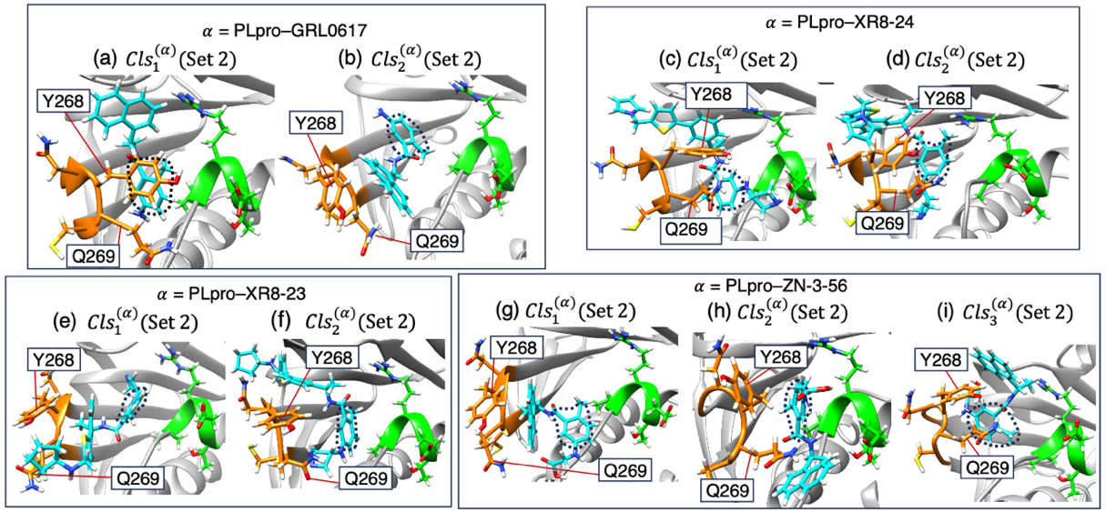
Figure S13: Complex structure picked from each cluster obtained from clustering parameter Set 2 (Table 3). Panels (a) and (b) are from clusters ${Cls}_{1}^{\left(α\right)}(Set 2)$ and ${Cls}_{2}^{(α)}(Set 2)$ of $α=$ PLpro–GRL0617 system, (c) and (d) are for clusters ${Cls}_{1}^{(α)}(Set 2)$ and ${Cls}_{2}^{(α)}(Set 2)$ of $α=$ PLpro–XR8-24 system, (e) and (f) are for clusters ${Cls}_{1}^{(α)}(Set 2)$ and ${Cls}_{2}^{(α)}(Set 2)$ of $α=$ PLpro–XR8-23 system, and (g), (h) and (i) are for clusters ${Cls}_{1}^{(α)}(Set 2)$, ${Cls}_{2}^{(α)}(Set 2)$ and ${Cls}_{3}^{(α)}(Set 2)$ of $α=$ PLpro–ZN-3-56 system. Orange-colored segment is the loop region (residues 266–271) and green colored one is a part of helix (165–168): See Figure 1b of main text for these segments. Side-chains of two amino-acid residues Y268 and Q269 are labeled. Cyan-colored molecules are compounds and broken-line circles are the core region (Figure S5 of SI).

Figure S14.
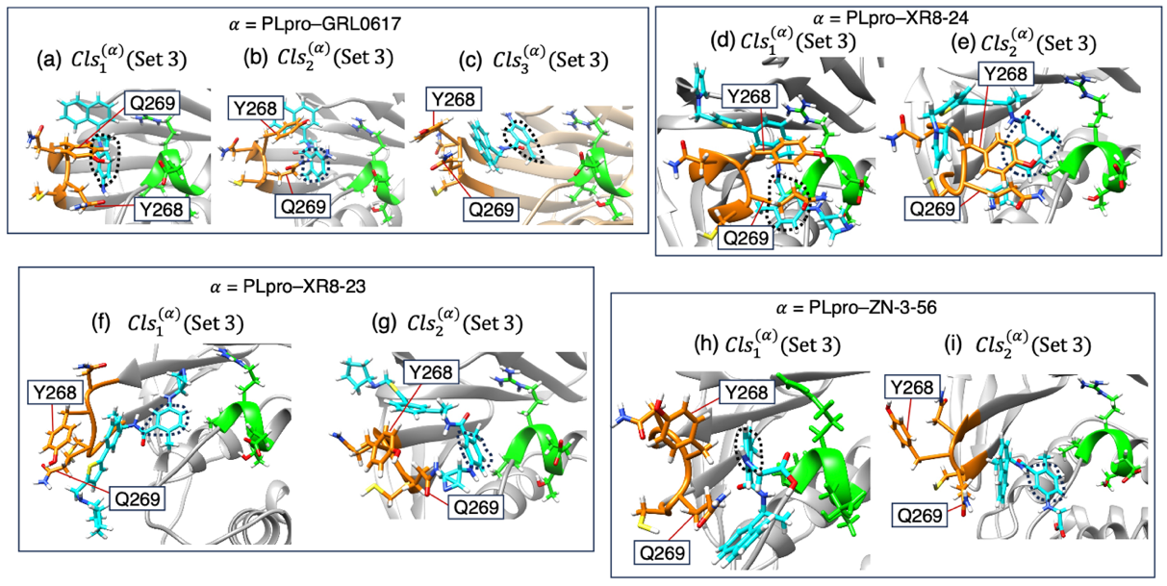
Figure S14: Complex structure picked from each cluster obtained from clustering parameter Set 3 (Table 3). Panels (a), (b) and (c) are from clusters ${Cls}_{1}^{(α)}(Set 3)$, ${Cls}_{2}^{(α)}(Set 3)$ and ${Cls}_{3}^{(α)}(Set 3)$ of $α=$ PLpro–GRL0617 system, (d) and (e) are for clusters ${Cls}_{1}^{(α)}(Set 3)$ and ${Cls}_{2}^{(α)}(Set 3)$ of $α=$ PLpro–XR8-24 system, (f) and (g) are for clusters ${Cls}_{1}^{(α)}(Set 3)$ and ${Cls}_{2}^{(α)}(Set 3)$ of $α=$ PLpro–XR8-23 system, and (h) and (i) are for clusters ${Cls}_{1}^{(α)}(Set 3)$ and ${Cls}_{2}^{(α)}(Set 3)$ of $α=$ PLpro–ZN-3-56 system. Orange-colored segment is the loop region (residues 266–271) and green colored one is a part of helix (residues 165–168): See Figure 1b of main text for these segments. Side-chains of two amino-acid residues Y268 and Q269 are labeled. Cyan-colored molecules are compounds and broken-line circles are the core region (Figure S5 of SI).

References

[1] Higo, J.; Kusaka, A.; Kasahara, K.; Kamiya, N.; Hayato, H.; Xie, Q.; Takahashi, T.; Fukuda, I.; Mori, K.; Hata, Y.; and Fukunishi. Y. GA-guided mD-VcMD: A genetic-algorithm-guided method for multi-dimensional virtual-system coupled molecular dynamics. Biophysics and Physicobiology, 17, 161–176 (2020). DOI: 10.2142/biophysico.BSJ-2020008

[2] Higo, J.; Kasahara, K.; Wada, M.; Dasgupta, B.; Kamiya, N.; Hayami, T.; Fukuda, I.; Fukunishi, Y.; Nakamura, H. Free-energy landscape of molecular interactions between endothelin 1 and human endothelin type B receptor: Fly-casting mechanism. Protein Eng. Des. Sel. 32, 297–308 (2019). DOI: 10.1093/protein/gzz029

[3] Jolliffe, I.T. Principal Component Analysis (2nd ed.). Springer, (2002). ISBN 978-0-387-95442-4
[4] Xie, Q., Kasahara, K., Higo, J., Takahashi, T. Molecular mechanisms of functional modulation of transcriptional coactivator PC4 via phosphorylation on its intrinsically disordered region. ACS Omega, 8, 14572−14582 (2023). http://doi.org/10.1021/acsomega.3c00364

[5] Kutzner, C.; Páll, S.; Fechner, M.; Esztermann, A.; de Groot B. L.; Grubmüller, H. More bang for your buck: Improved use of GPU nodes for GROMACS 2018. Journal of Computational Chemistry 40, 2418–2431 (2019). DOI:10.1002/jcc.26011

[6] Bonomi, M.; Branduardi, D.; Bussi, G.; Camilloni, C.; Provasi, D.; Raiteri, P.; Donadio, D.; Marinelli, F.; Pietrucci, F.; Broglia, R.; Parrinello. M. PLUMED: A portable plugin for free-energy calculations with molecular dynamics. Comp. Phys. Commun. 180, 1961–1972 (2009). DOI: 10.1016/j.cpc.2009.05.011

[7] Kasahara, K.; Ma, B.; Goto, K.; Dasgupta, B.; Higo, J.; Fukuda, I.; Mashimo, T.; Akiyama, Y.; Nakamura, H. myPresto/omegagene: a GPU-accelerated molecular dynamics simulator tailored for enhanced conformational sampling methods with a non-Ewald electrostatic scheme. Biophysics and Physicobiology. 13, 209–216 (2016). DOI: 10.2142/biophysico.13.0_209

