Appendix A
The minimum video length needed to obtain an accurate estimate of tentacle insertion rate (TIR) was determined experimentally. This was done by calculating TIR from the same video (n = 4 different videos) using video sections of varying lengths and then selecting the minimum video length after which variability in TIR was minimized (Figure A1A). Once 4 minutes was selected as the threshold, the spread in TIR obtained from several different 4-minute-long sections of the same video (n = 4 videos) was quantified and determined to be negligible (Figure A1B).
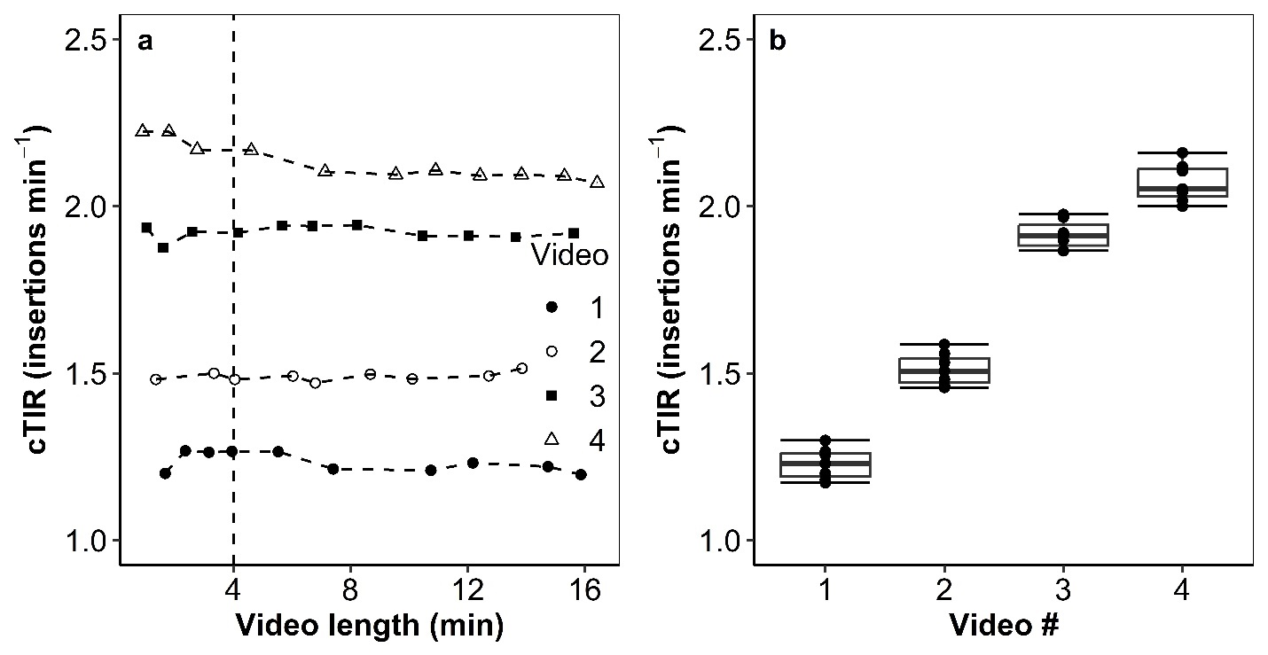
Figure 8. Variability in complete tentacle insertion rates (cTIR) calculated using video sections of different lengths (A) and variability in cTIR calculated using different four-minute sections of each video (B). In A, the dashed line corresponds to 4 minutes, the minimum video length threshold used for calculating TIR in this manuscript.

Appendix B
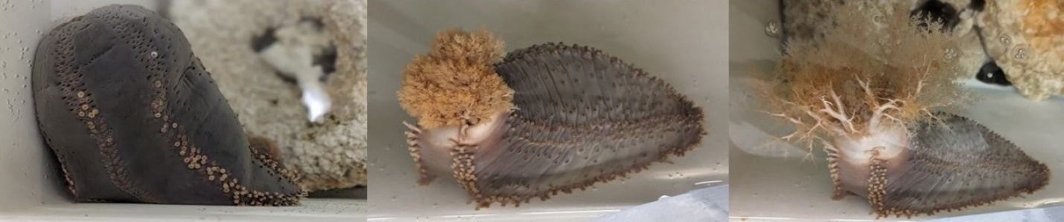
Figure 9. Sea cucumbers exhibiting closed (left), partially open (middle) and fully open (right) crown morphologies.

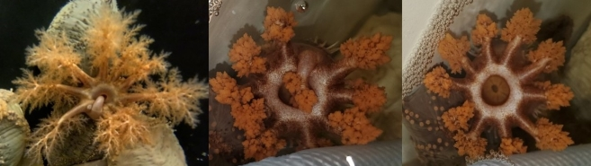
Figure 10. Complete tentacle insertion (cTIR; left), incomplete tentacle “insertion” (iTIR; middle) and oral pumping (OP; right).

