Supplementary Figures

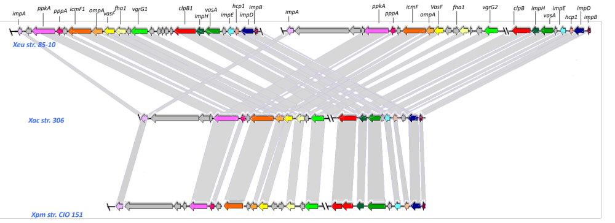
Figure S1. Genomic organization of the characterized T6SS cluster. Alignment orthologous sequences and the hits of T6SS genes are represented as colored arrows. The colors follow the same guidelines as in Fig. 1. A unique color was assigned to highly conserved orthologs of Xanthomonas euvesicatoria str. 85-10, Xanthomonas citri subsp. citri str. 306 and Xanthomonas phaseoli pv. manihotis str. CIO 151. The lines represent the orthologous genes found with ORTHOMCL.

