Supplementary Material

Pathway | Symbol | alias | Gene Name | Features | Expression regulated by (IPA#) | activity regulated by
All | HSPA5 | BIP/ GRP78 | heat shock protein family A (Hsp70) member 5 | unfolded protein sensor | ATF4, ABP1, and ATF6
PERK | EIF2AK3 | PERK | eukaryotic translation initiation factor 2 alpha kinase 3 | inhibited by BIP | XBP1s
PERK | DNAJC3 | P58IPK | DnaJ heat shock protein family (Hsp40) member C3 | inhibitor of PERK | XBP1s
PERK | NFE2L2 | NRF2 | nuclear factor, erythroid 2 like 2
PERK | EIF2A |  | eukaryotic translation initiation factor 2A | regulator of translation, activated by phos by PERK, inhibited by dephos by PPP1R15A
PERK | ATF4 |  | activating transcription factor 4 | downstream of EIF2a
PERK | BCL2 |  | BCL2 apoptosis regulator | target of CHOP | ATF4
PERK | CALR |  | calreticulin | downstream of ATF4 | ATF4
PERK | CANX |  | calnexin | downstream of ATF4 | ATF4
PERK | DDIT3 | CHOP | DNA damage inducible transcript 3 | downstream of ATF4  mediator of apoptotic response1 | ATF4
PERK | HSP90B1 | GRP94 | heat shock protein 90 beta family member 1 | downstream of ATF4- ERAD component | ATF4
PERK | PPP1R15A | GADD34 | protein phosphatase 1 regulatory subunit 15A | inhibits EIF2a | ATF4, DDIT3
PERK | PPARG | PPARγ | peroxisome proliferator activated receptor gamma | downstream EIF2a
ATF6 | ATF6 |  | activating transcription factor 6 | in ER, transcription factor
ATF6 | MBTPS1 |  | membrane bound transcription factor peptidase, site 1 | golgi TM protein cleaves ATF6 to nuclear form
ATF6 | MBTPS2 |  | membrane bound transcription factor peptidase, site 2 | golgi TM protein cleaves ATF6 to nuclear form
IRE1 | ERN1 | IRE1 | endoplasmic reticulum to nucleus signaling 1 | ER TM kinase and splicing factor, activates XBP1
IRE1 | XBP1 |  | X-box binding protein 1 | TF downstream of IRE1, interacts w CEBPs |  | ERN1/IRE1
IRE1 | EDEM1 |  | ER degradation enhancing alpha-mannosidase like protein 1 | downstream of XBP1 | XBP1s | XBP1
ERAD | DNAJB9 |  | DnaJ heat shock protein family (Hsp40) member B9 | HSP40 member- (co-chaperone for Hsp70 protein HSPA5/BiP that acts as a key repressor of the ERN1/IRE1-mediated unfolded protein response) | XBP1
ERAD | HSPA1A |  | heat shock protein family A (Hsp70) member 1A | HSP70 member co-chaperone of BIP downstream of XBP1(ATF6)-ERAD
ERAD | HSPA1B |  | heat shock protein family A (Hsp70) member 1B | HSP70 member co-chaperone of BIP downstream of XBP1(ATF6)-ERAD
ERAD | HSPA4 | HSP70 | heat shock protein family A (Hsp70) member 4 | HSP70 member co-chaperone of BIP downstream of XBP1(ATF6)-ERAD | ATF4
ERAD | HSPH1 |  | heat shock protein family H (Hsp110) member 1 | part of degredation downstream of XBP1(ATF6)
ERAD | OS9 |  | OS9 endoplasmic reticulum lectin | ERAD component
ERAD | SEL1L |  | SEL1L adaptor subunit of ERAD E3 ubiquitin ligase | ERAD component | ATF4
ERAD | SYVN1 |  | synoviolin 1 | ERAD component | XBP1
ERAD | UBXN4 | Erasin | UBX domain protein 4 | involved in protein degredation
ERAD | VCP |  | valosin containing protein | involved in protein degredation, binds UBXN4
ER protein folding | ERO1B |  | endoplasmic reticulum oxidoreductase 1 beta | activated by PDI- protein folding/unfolding
ER protein folding | P4HB | PDI | prolyl 4-hydroxylase subunit beta | PDI component | XBP1s

Table S1. Components of the unfolded protein response pathways. The genes of the various key components of the 3 main UPR pathways are listed along with their common aliases, and to which branch of the pathway they belong. Key features as well as what other pathway member regulates them (either transcriptionally or other means) are also listed. # Ingenuity Pathway Analysis (IPA; Qiagen)

Supplemental Figures and Figure Legends
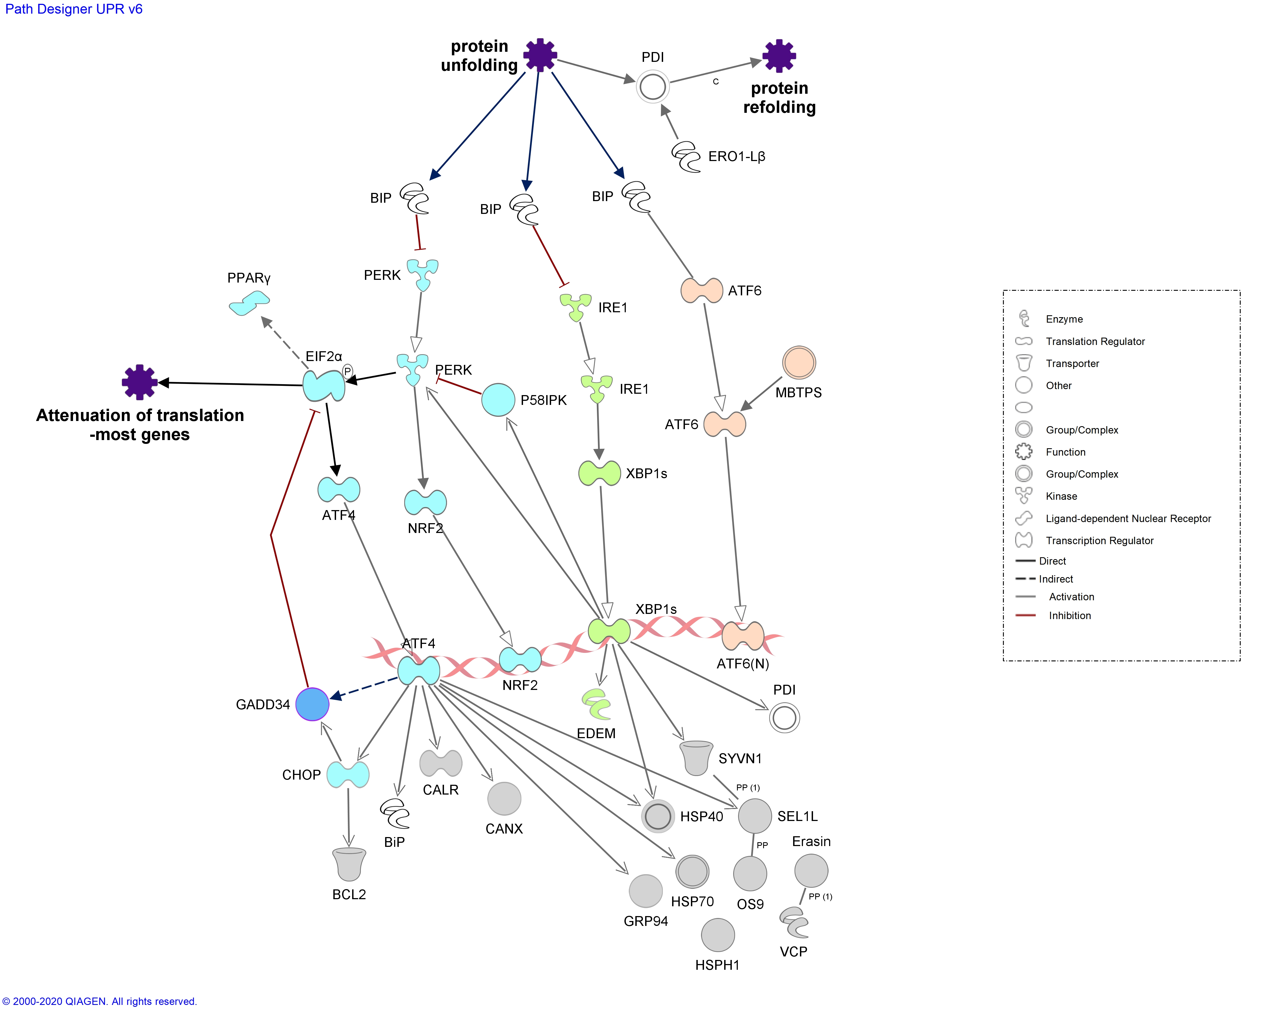
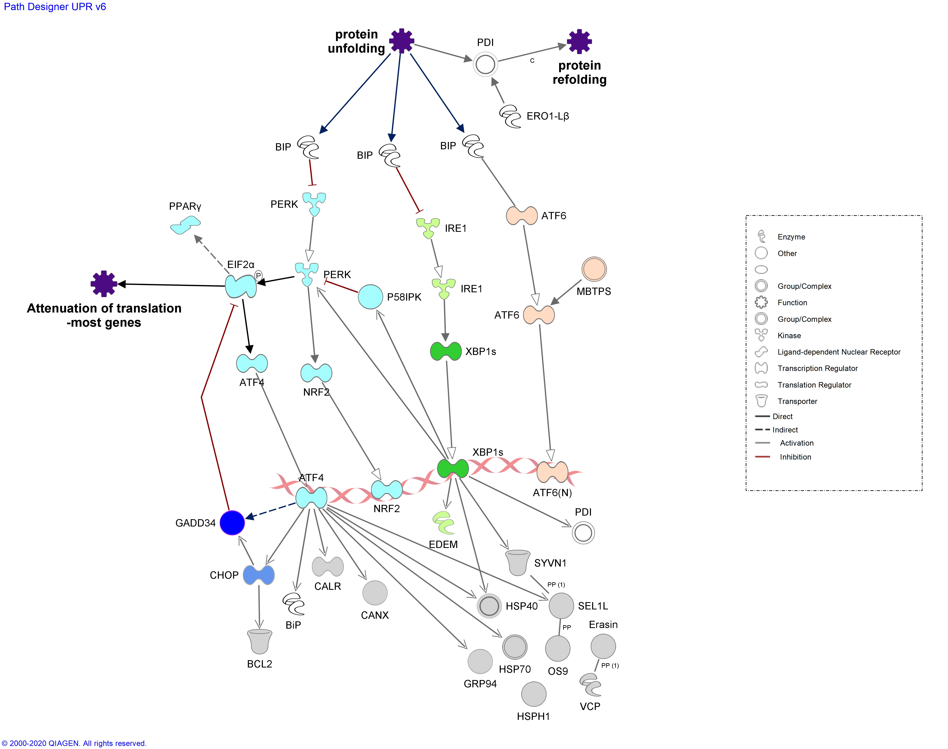
ERAD
ER
Nucleus
ER Stress
Golgi

Figure S1. Unfolded Protein Response Pathway. A schematic illustrating the 3 UPR pathways; PERK (Blue), IRE1(Green) and ATF6 (Orange) and the genes associated or regulated by them based on Ingenuity Pathway Analysis (IPA) interactions. Relationship indicated with open arrow are translocation of molecule or it’s function; relationships indicated by filled arrowhead are functional interactions and gene expression regulation is illustrated with line arrows. Molecule shapes and line colour legends are in the Box in the figure.

Figure S1. Unfolded Protein Response Pathway. A schematic illustrating the 3 UPR pathways; PERK (Blue), IRE1(Green) and ATF6 (Orange) and the genes associated or regulated by them based on Ingenuity Pathway Analysis (IPA) interactions. Relationship indicated with open arrow are translocation of molecule or it’s function; relationships indicated by filled arrowhead are functional interactions and gene expression regulation is illustrated with line arrows. Molecule shapes and line colour legends are in the Box in the figure.

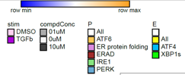
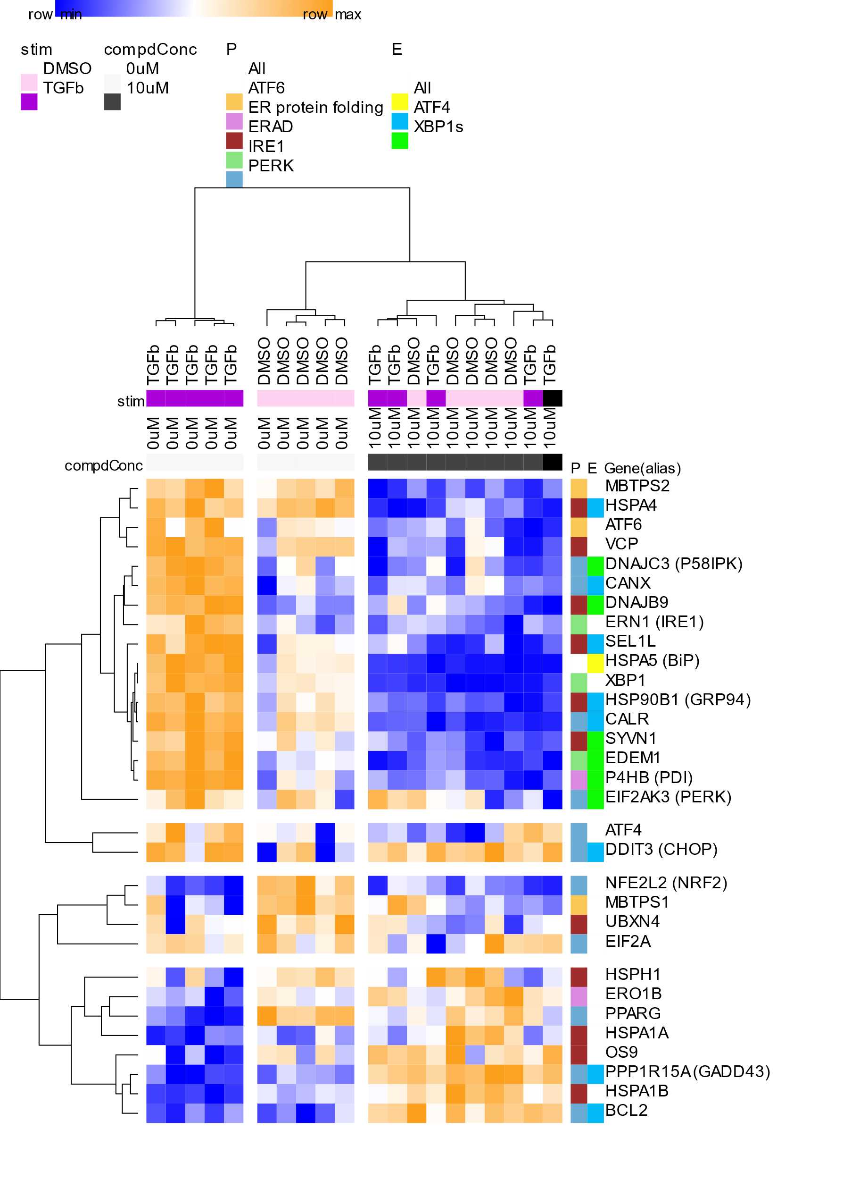
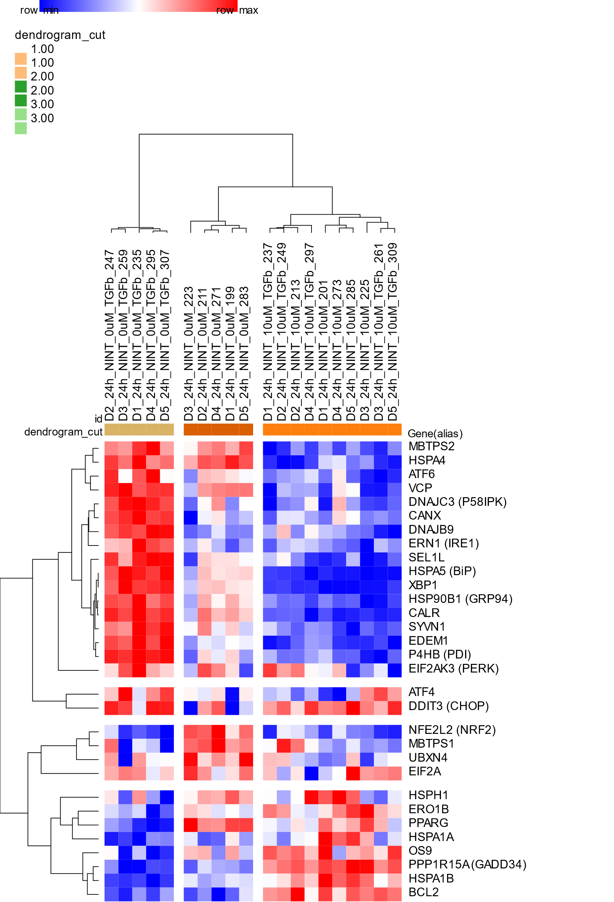
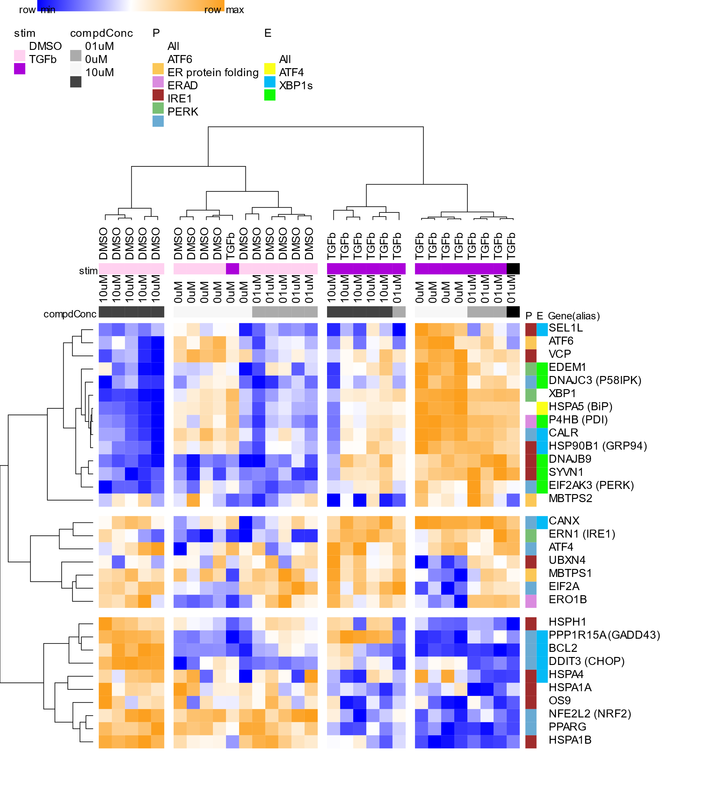
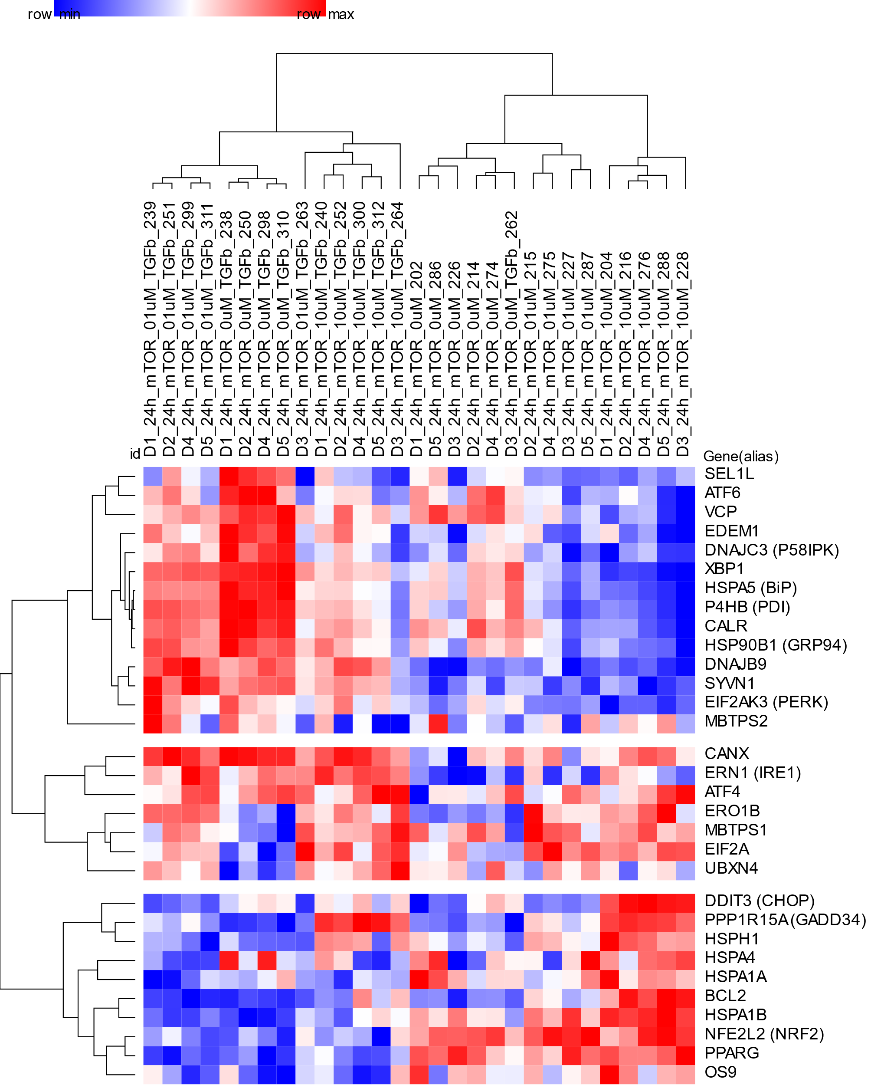
a
b

Figure S2. Modulation of TGFβ1 altered UPR pathway genes by compounds. Heatmap of gene expression (log2(TPM)) of the UPR genes from Table S1 for IPF fibroblasts (5 donors, 3-5 replicates) treated with TGFβ1 (0.123ng/ml) for 24h and additionally with nintedanib (a) or AZD8055 (b) at concentrations shown. The genes are further colour coded into pathway (P) and expression regulators (E) according to Table S1. (a) 10 μM nintedanib reverses the induction of expression caused by TGFβ1 for a large set of the UPR genes (top panel) including the majority of genes downstream of ATF4 and all the gens downstream of XBP1s. For another set of genes, including PPP1R15A, 10 μM nintedanib reversed the repression of TGFβ1 (bottom panel). (b) The mTOR inhibitor AZD8055 is also able to reverses the induction of expression caused by TGFβ1 for a similar set of UPR genes to nintedanib (top panel). Similarly AZD8055 reversed the repression of TGFβ1 (bottom panel) for another set of genes including PPP1R15A.

CRISPR TGFb assay negative controls
a
b

Figure S3. No effect of CRISPR controls on TGFβ-induced fibroblast activation. TGFβ-induced myofibroblast activation was quantified in normal human primary fibroblasts electroporated with Tracr and Cas9 protein only controls. Cells in starvation conditions were incubated with positive control compounds (mTOR inhibitor and ALK5 inhibitor) (3 µM) for 1 hr before treatment with TGFβ (0.125 ng/ml) for 24 h. Unstimulated cells were treated with 0.1% (v/v) DMSO for normalisation. Myofibroblast activation was measured by immunofluorescence of αSMA and represented as percent cell activation, based on Columbus linear classifier algorithms using intensity, texture and morphology features.

Day 21 lung MSD TNFa
a
b

Figure S4. Loss of PPP1R15A has no impact on bleomycin-induced MMP12 but does impact bleomycin-induced TNFα protein levels (a) Whole lung gene expression of Mmp12 at Day 5 and Day 21 after intratracheal bleomycin or saline control in wildtype (WT) and Ppp1r15a-/- (KO) mice. Bars represent mean ± s.e.m. of n= 4-7 mice per group. Gene expression quantified using RT-PCR. (b) Whole lung TNFα protein levels were measured using MSD technology in lung homogenates, at Day 21 post-bleomycin or saline challenge in wildtype or Ppp1r15a-/- mice. Dots represent individual animals, bars represent mean ± s.e.m. *P<0.05

a
b

Figure S5. PPP1R15A gene deficient animals had reduced bleomycin-induced lung inflammation at Day 5. Whole lung TNFα (a) and IL1β (b) protein levels were measured using MSD technology in lung homogenates, at Day 5 post-bleomycin or saline challenge in wildtype or Ppp1r15a-/- mice. Dots represent individual animals, bars represent mean ± s.e.m. *P<0.05

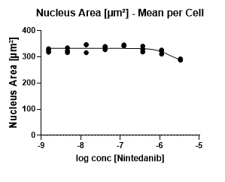
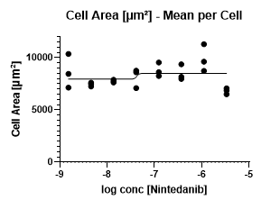
b
a
c

Figure S6. Nintedanib has no effect on etoposide-induced fibroblast senescence. IPF fibroblasts were cultured in the presence of etoposide (3 µM) and with the indicated nintedanib concentrations for 72hrs, after which the cells were stained with an anti-p21 antibody as well as the cell and nucleus stains CellMask and Hoechst. The cells were imaged and the p21 inhibition percentage (a), nucleus area (b) and cell area (c) with nintedanib was determined using image analysis. Representative data for n=1 IPF donor cell lines with each dot representing technical replicates.
a
b

Figure S7. Etoposide-induced senescence in IPF lung fibroblasts is inhibited by the mTOR inhibitor AZD8055. IPF fibroblasts were cultured in the presence of etoposide (3 µM) and with the indicated compound concentrations for 72hrs, after which the cell and nucleus areas quantified using CellMask and Hoechst staining and size quantified using image analysis. n=5 IPF donor cell lines.

