Figure S1: miRNA abundance by isoform

Abundance of individual miRNAs detected across small RNA libraries (RPTM). Only includes miRNAs with over 100 total RPTM across all libraries. Reads for miR3634-3p made up most mapped reads. Reads mapping to miR159, miR162, miR166, miR395, miR3623 families were also highly abundant relative to other families.

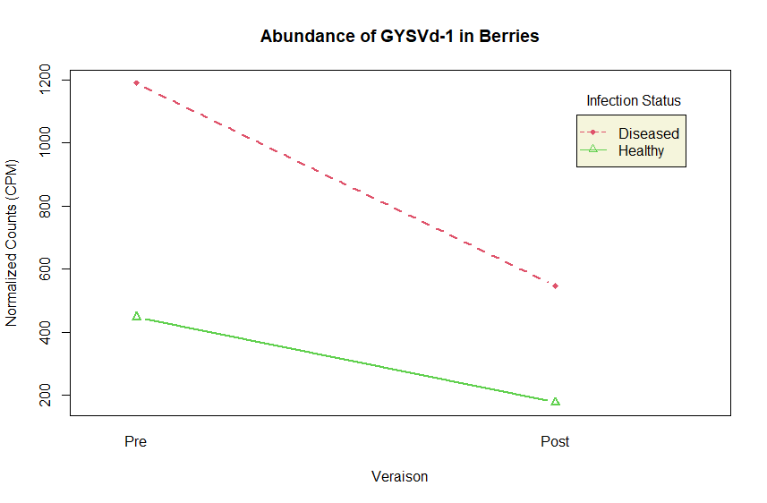
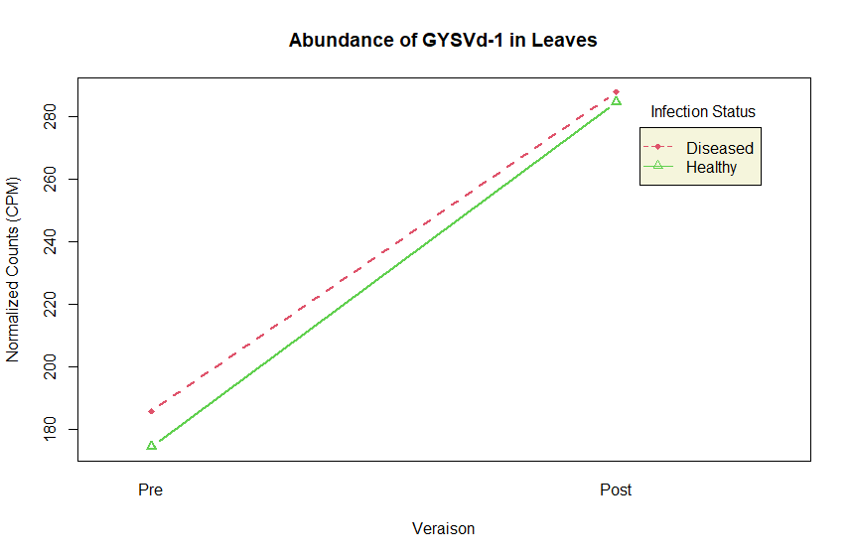
Figure S2: Relative abundances of viroidal RNAs between phenological stages

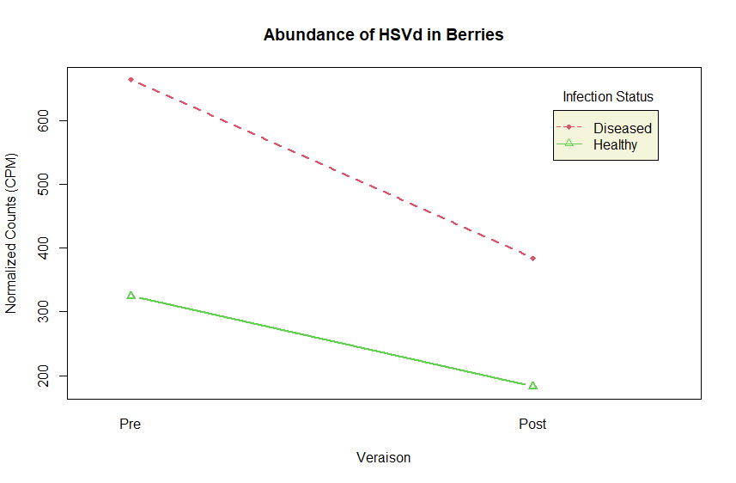
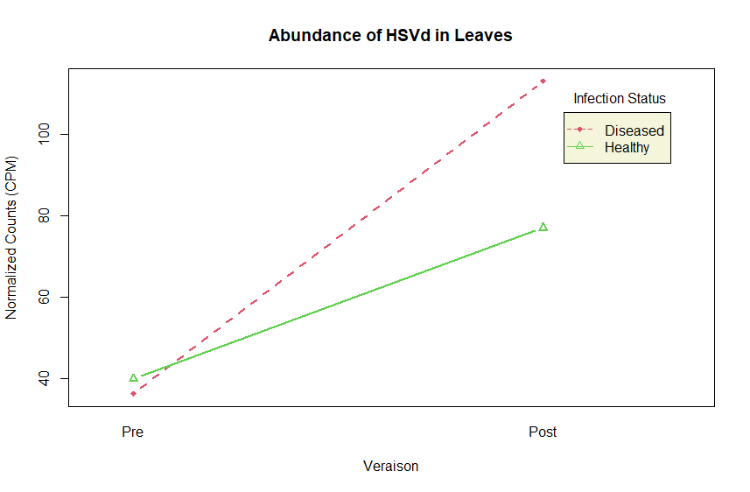

Interaction plots showing the direction of the change in viroidal RNA read abundance (CPM) from pre- to post-veraison in both GRBV-negative (green) and GRBV-positive (red) vines. Made in R.

Figure S3: miRNA target prediction T-plots
A
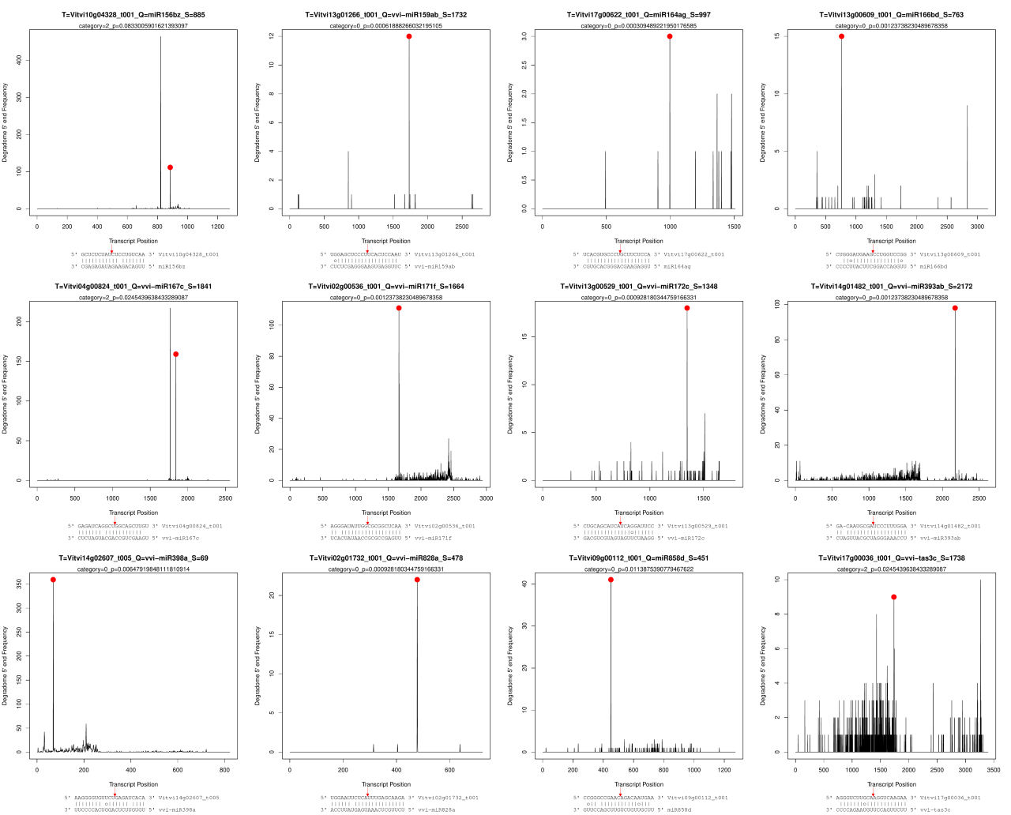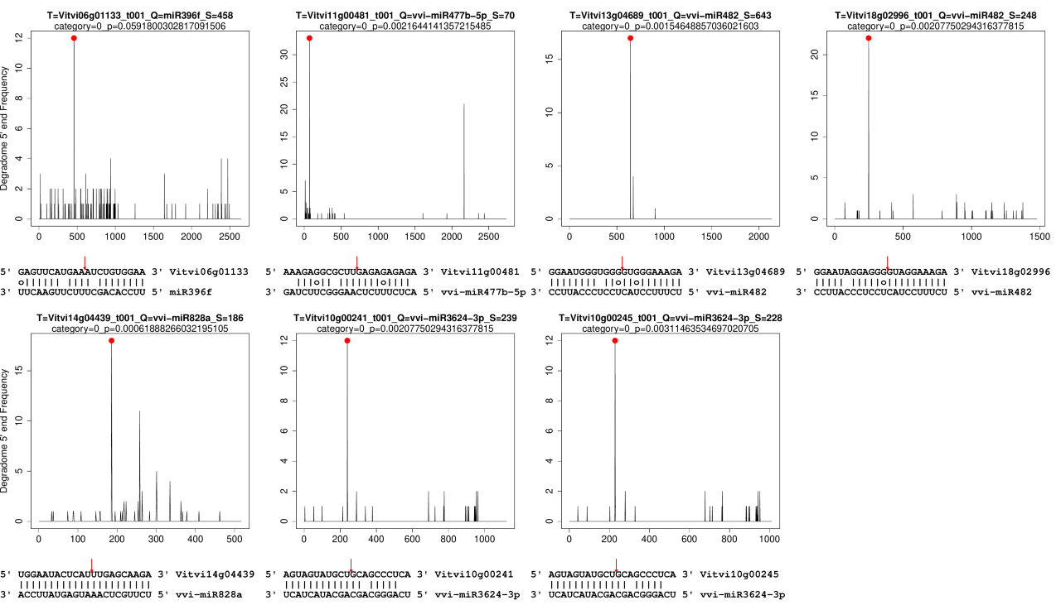
B
T-plots, transcript alignments, and cleavage site locations for select, conserved (A) and novel (B) sRNA targets in the grapevine transcriptome. The red dots indicate the abundance of 5’ends lining up in the correct location within the predicted transcript. Other peaks indicate other locations 5’-ends from the degradome data mapped to in the transcript. The red arrows indicate the predicted cleavage location in the alignment of the transcript and the miRNA.
Figure S4: GRBV-derived sRNA target prediction T-plots
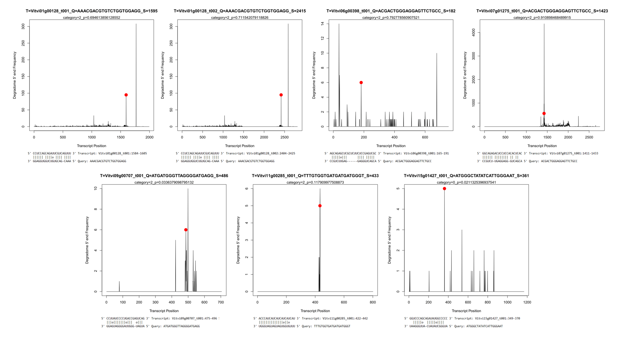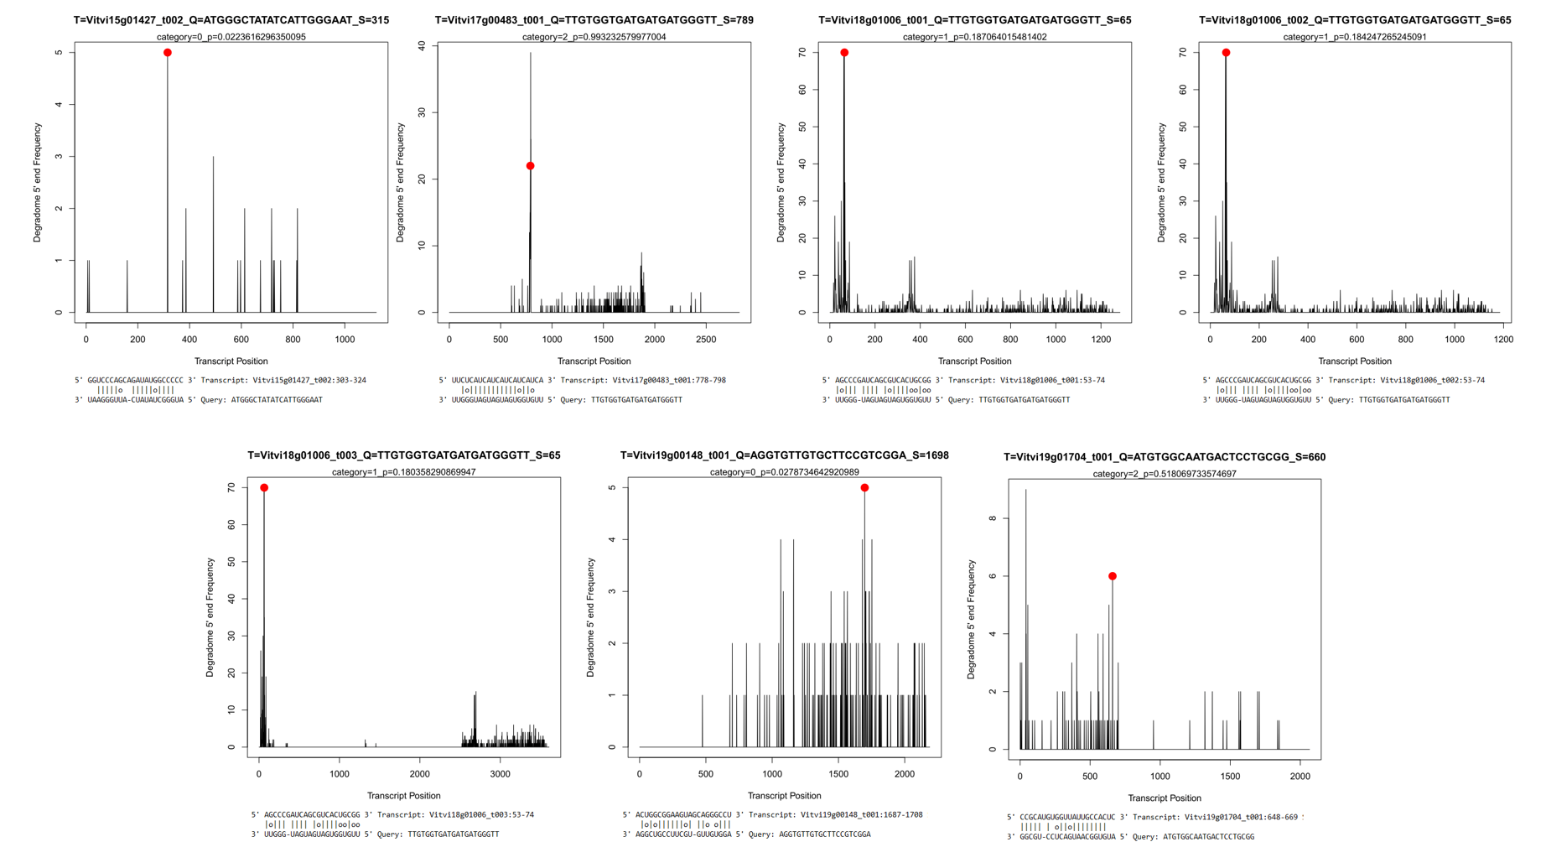
T-plots and transcript alignments for grbvasRNA targets in the grapevine transcriptome. Individual peaks represent the occurrence of degradome reads with 5’ ends aligning to a specific location within the grapevine transcript. Red dots are placed at the tip of the peak located at the predicted 10nt slice site.

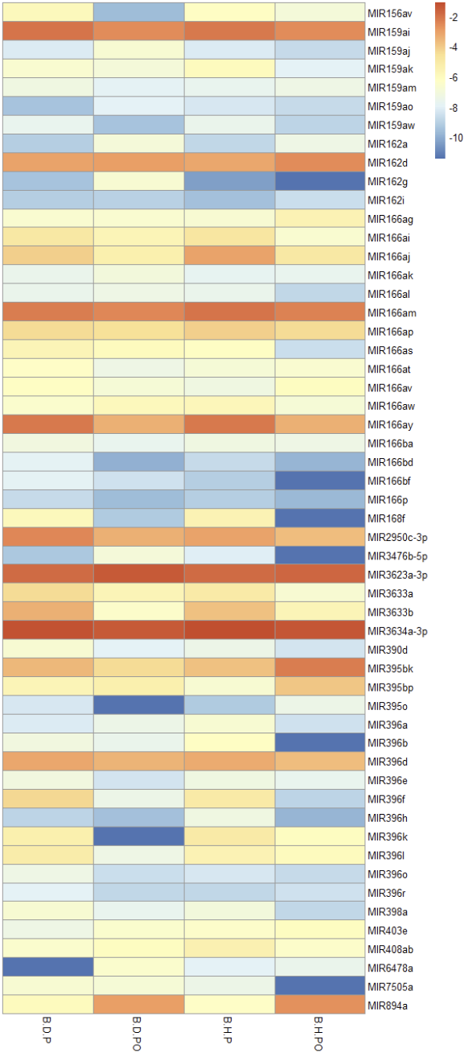
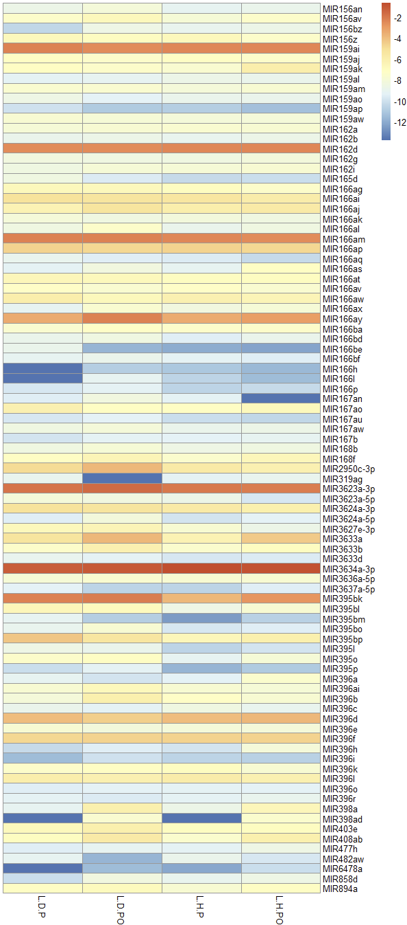
Figure S5: miRNA abundance heatmaps

Heatmaps showing normalized abundances of miRNAs which passed initial cutoffs (at least one count in a minimum of six different samples) in leaves (left) and berries (right). The numeric scale is derived from the normalization coefficients generated in ‘edgeR,’ such that the further a number is from zero, the lower the relative expression.

