HDL from 36h Fasted Participants Potently Promote Efflux of Cholesteryl Ester from Activated Microglia
Joanne K. Agus ¹ and Oscar M. Muñoz Herrera ^{1,2}, Christopher Rhodes ¹, Jack Jingyuan Zheng ¹, Chenghao Zhu ¹, Maurice Wong ⁴, Xinyu Tang ¹, Izumi Maezawa ³, Lee-Way Jin ³, Carlito B. Lebrilla ⁴, Danielle J. Harvey ⁵, Angela M. Zivkovic ¹
Supplemental materials
Supplementary Figure 1. The mean diameter of fasted HDL is larger than the mean diameter of postprandial HDL.

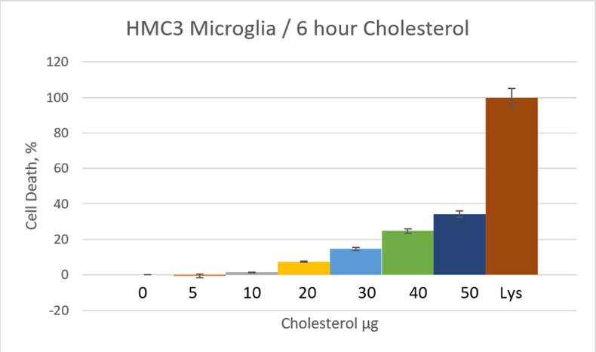
a
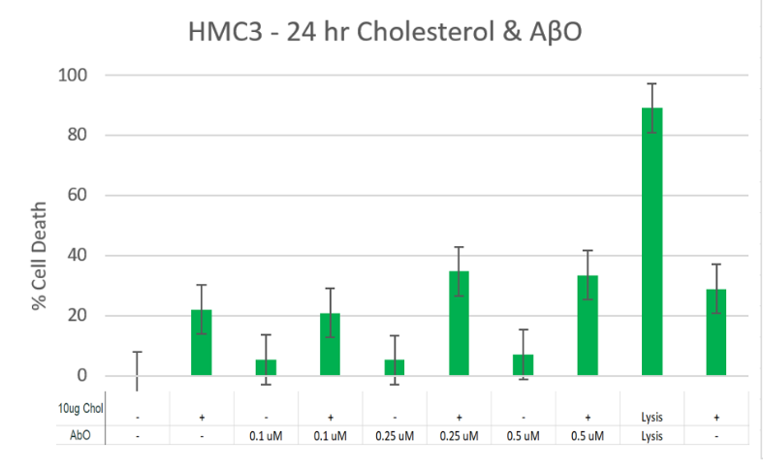
c
b
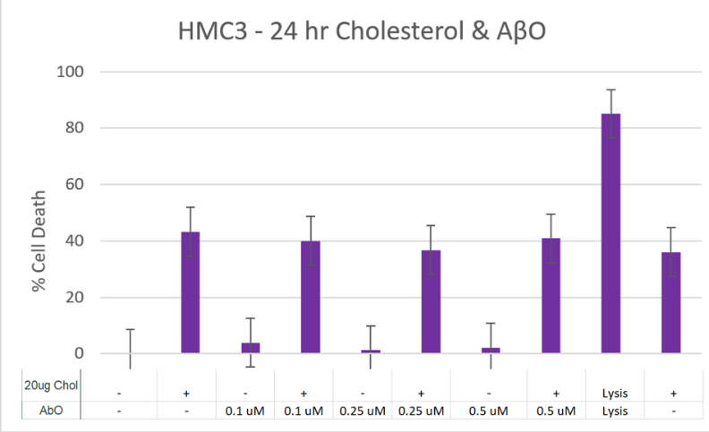

Supplementary Figure 2. HMC3 Cytotoxicity Assay. A) Cholesterol loaded HMC3 microglia (varying doses), for 6 hours. B) Cholesterol (10µg/mL) loaded and AβO treated HMC3 microglia, for 24 hours. C) Cholesterol (20µg/mL) loaded and AβO treated HMC3 microglia, for 24 hours.

