Supplementary Figures

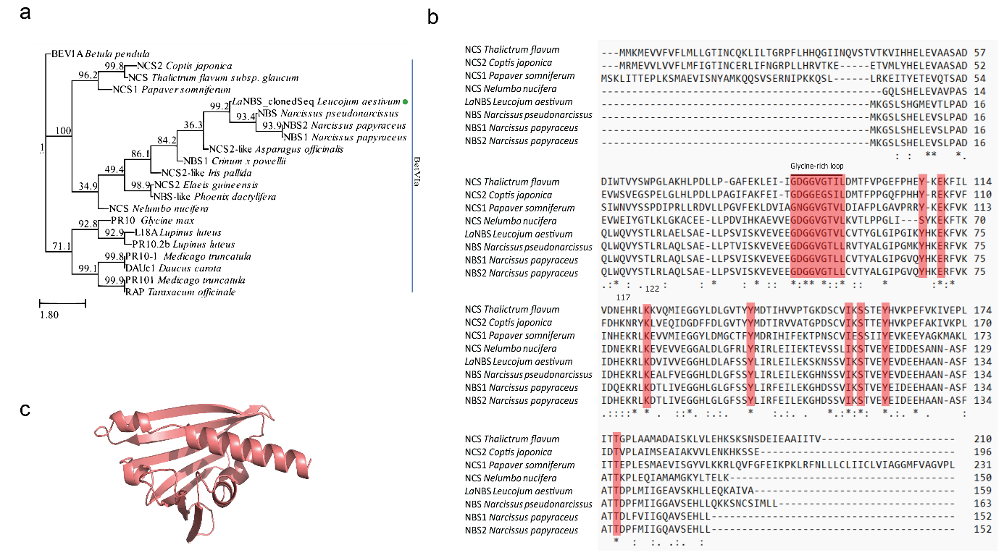

Supplementary Fig. 1: Phylogenetic analysis, multiple sequence alignment and folding of LaNBS
a Clustal omega tool was used to align amino acid sequences. Numbers above the branch are ultrafast bootstrap support (%) and green dot is the protein sequence used in the experiment. b Multiple sequence alignment was performed with 8 sequences. Highlighted are the conserved along with major residues of the catalytic site from different species. Identical amino acids marked with an asterisk (*), amino acids with high similarity marked with colon (:) and less similar with period (.). c LaNBS candidate folding was predicted with Collabfold2 and is shown as cartoon.

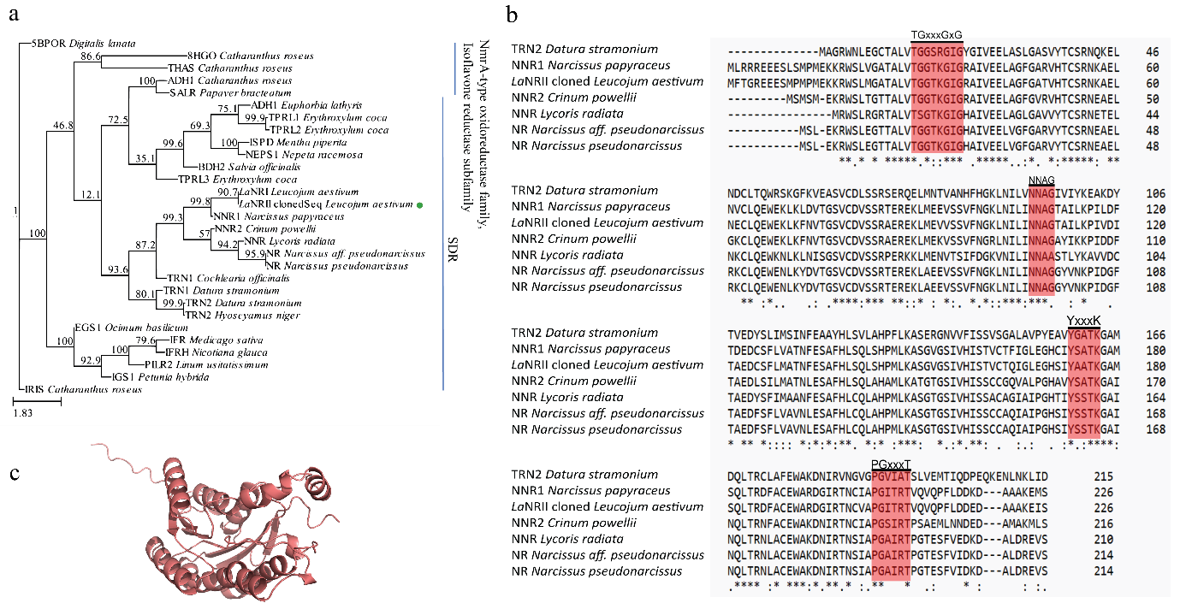
Supplementary Fig. 2: Phylogenetic analysis, multiple sequence alignment and folding of LaNRII
a Clustal omega tool was used to align amino acid sequences. Numbers above the branch are ultrafast bootstrap support (%) and green dot is the protein sequence used in the experiment. b Multiple sequence alignment was performed with 7 sequences. Highlighted are the conserved along with major residues of the catalytic site from different species. Identical amino acids marked with an asterisk (*), amino acids with high similarity marked with colon (:) and less similar with period (.). c LaNRII candidate folding was predicted with Collabfold2 and is shown as cartoon.

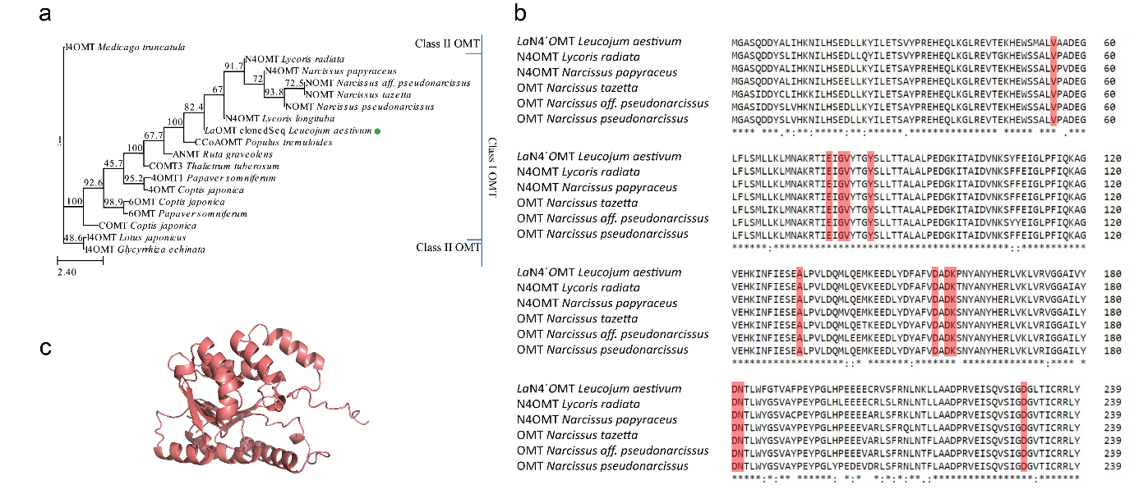

Supplementary Fig. 3: Phylogenetic analysis, multiple sequence alignment and folding of LaN4´OMT
a Clustal omega tool was used to align amino acid sequences. Numbers above the branch are ultrafast bootstrap support (%) and green dot is the protein sequence used in the experiment. b Multiple sequence alignment was performed with 7 sequences. Highlighted are the conserved along with major residues of the catalytic site from different species. Identical amino acids marked with an asterisk (*), amino acids with high similarity marked with colon (:) and less similar with period (.). c LaN4´OMT candidate folding was predicted with Collabfold2 and is shown as cartoon.

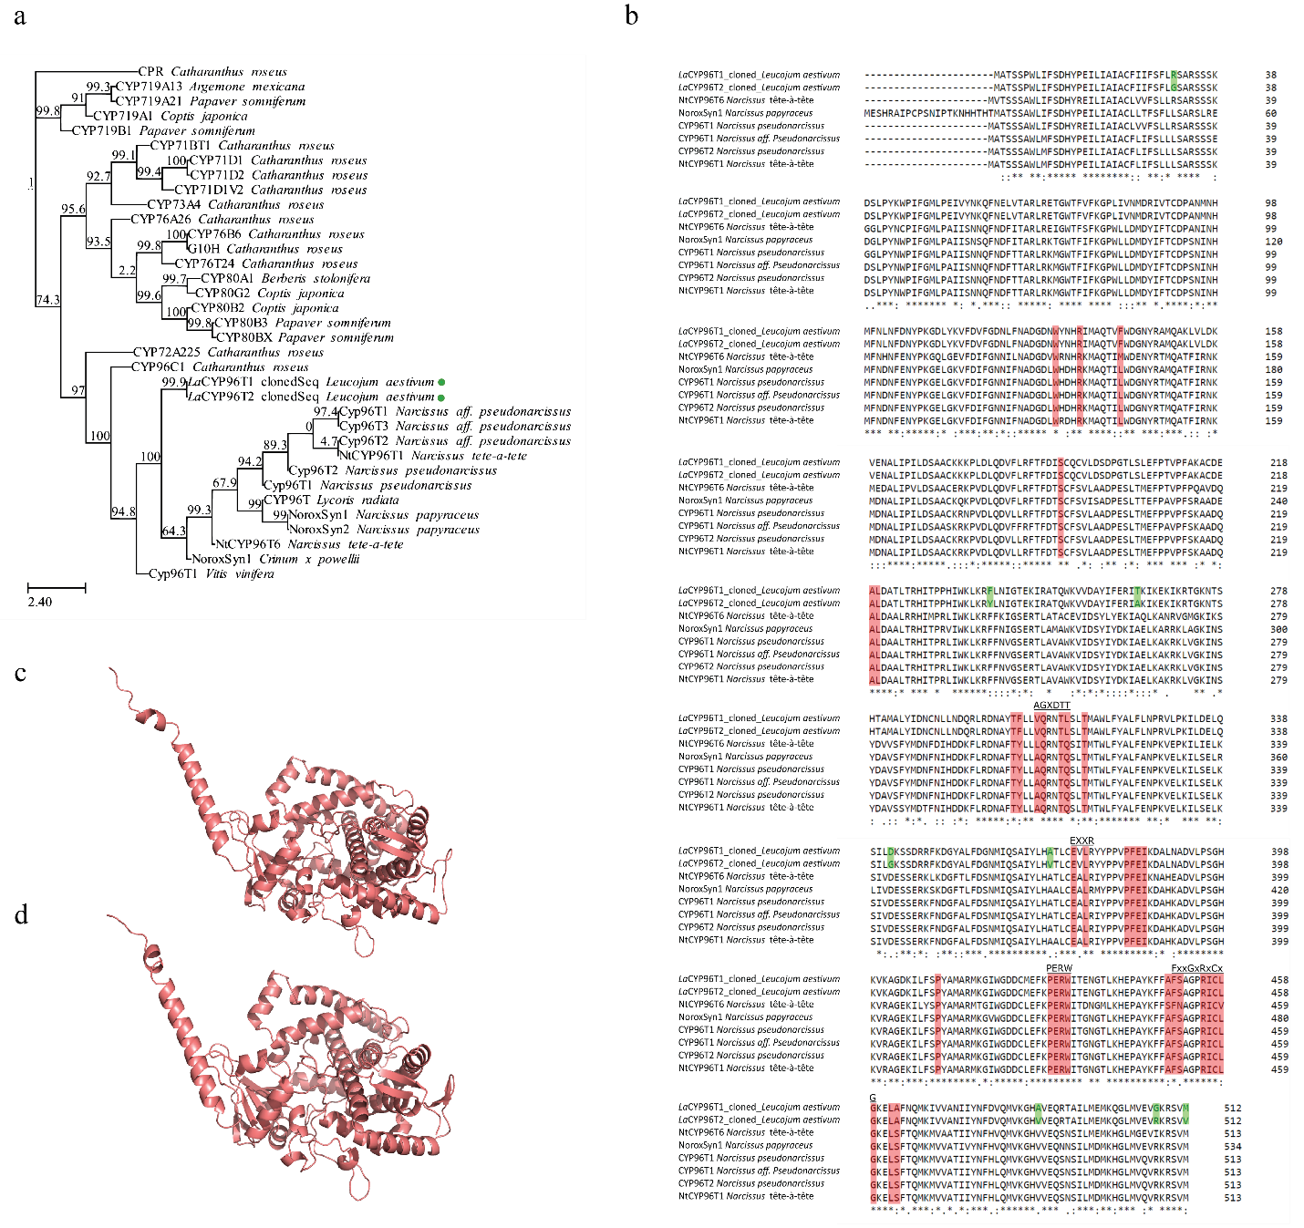

Supplementary Fig. 4: Phylogenetic analysis, multiple sequence alignment and folding of LaCYP96T1 and LaCYP96T2.
a Clustal omega tool was used to align amino acid sequences. Numbers above the branch are ultrafast bootstrap support (%) and green dots are the protein sequence used in the experiment. b Multiple sequence alignment was performed with 8 sequences. Highlighted are the conserved along with major residues of the catalytic site from different species. Identical amino acids marked with an asterisk (*), amino acids with high similarity marked with colon (:) and less similar with period (.). c LaCYP96T1 candidate folding was predicted with Collabfold2 and is shown as cartoon. d LaCYP96T2 candidate folding was predicted with Collabfold2 and is shown as cartoon.
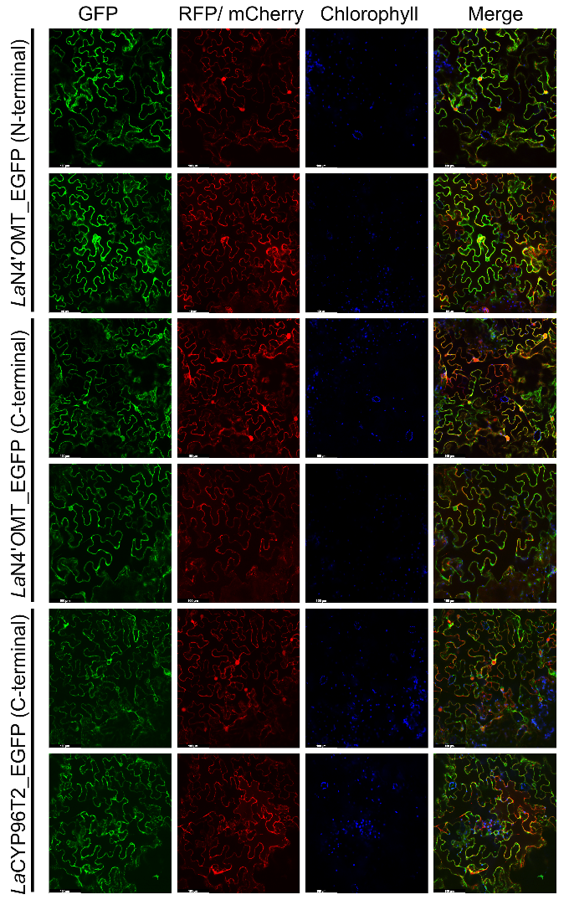

Supplementary Fig. 5: Localization study of LaN4’OMT and LaCYP96T2.
The indicated fusion proteins were co-expressed with the red fluorescent protein (RFP) or ER-mCherry in N. benthamiana leaves via Agrobacterium tumefaciens. Green fluorescent protein (fusion protein), Red florescence protein (RFP) or cherry red florescence protein (ER-mcherry), chlorophyll (blue), merged fluorescence images (Merge). Scale bar in the image is 100µM.

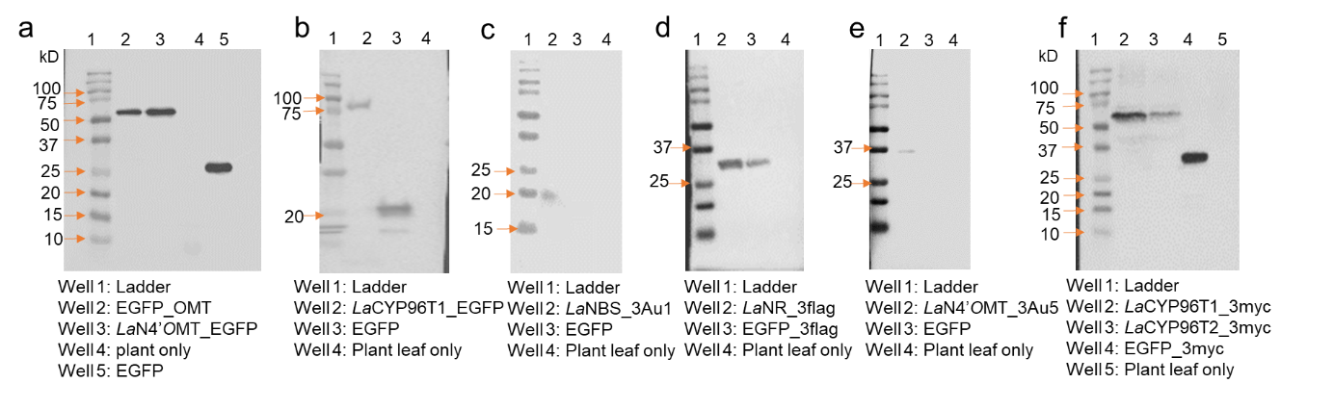

Supplementary Fig. 6: Western blot analysis illustrating the expression of fusion proteins of LaCYP96T1 and LaN4´OMT with EGFP along with LaNBS, LaNRII, LaN4´OMT, LaCYP96T1, LaCYP96T2 in N. benthamiana leaf lysate.
a N-terminal EGFP_LaN4´OMT, C-terminal EGFP_LaN4´OMT. b C-terminal EGFP_LaCYP96T1. c LaNBS. d LaNRII. e LaN4´OMT. f LaCYP96T1 and LaCYP96T2.

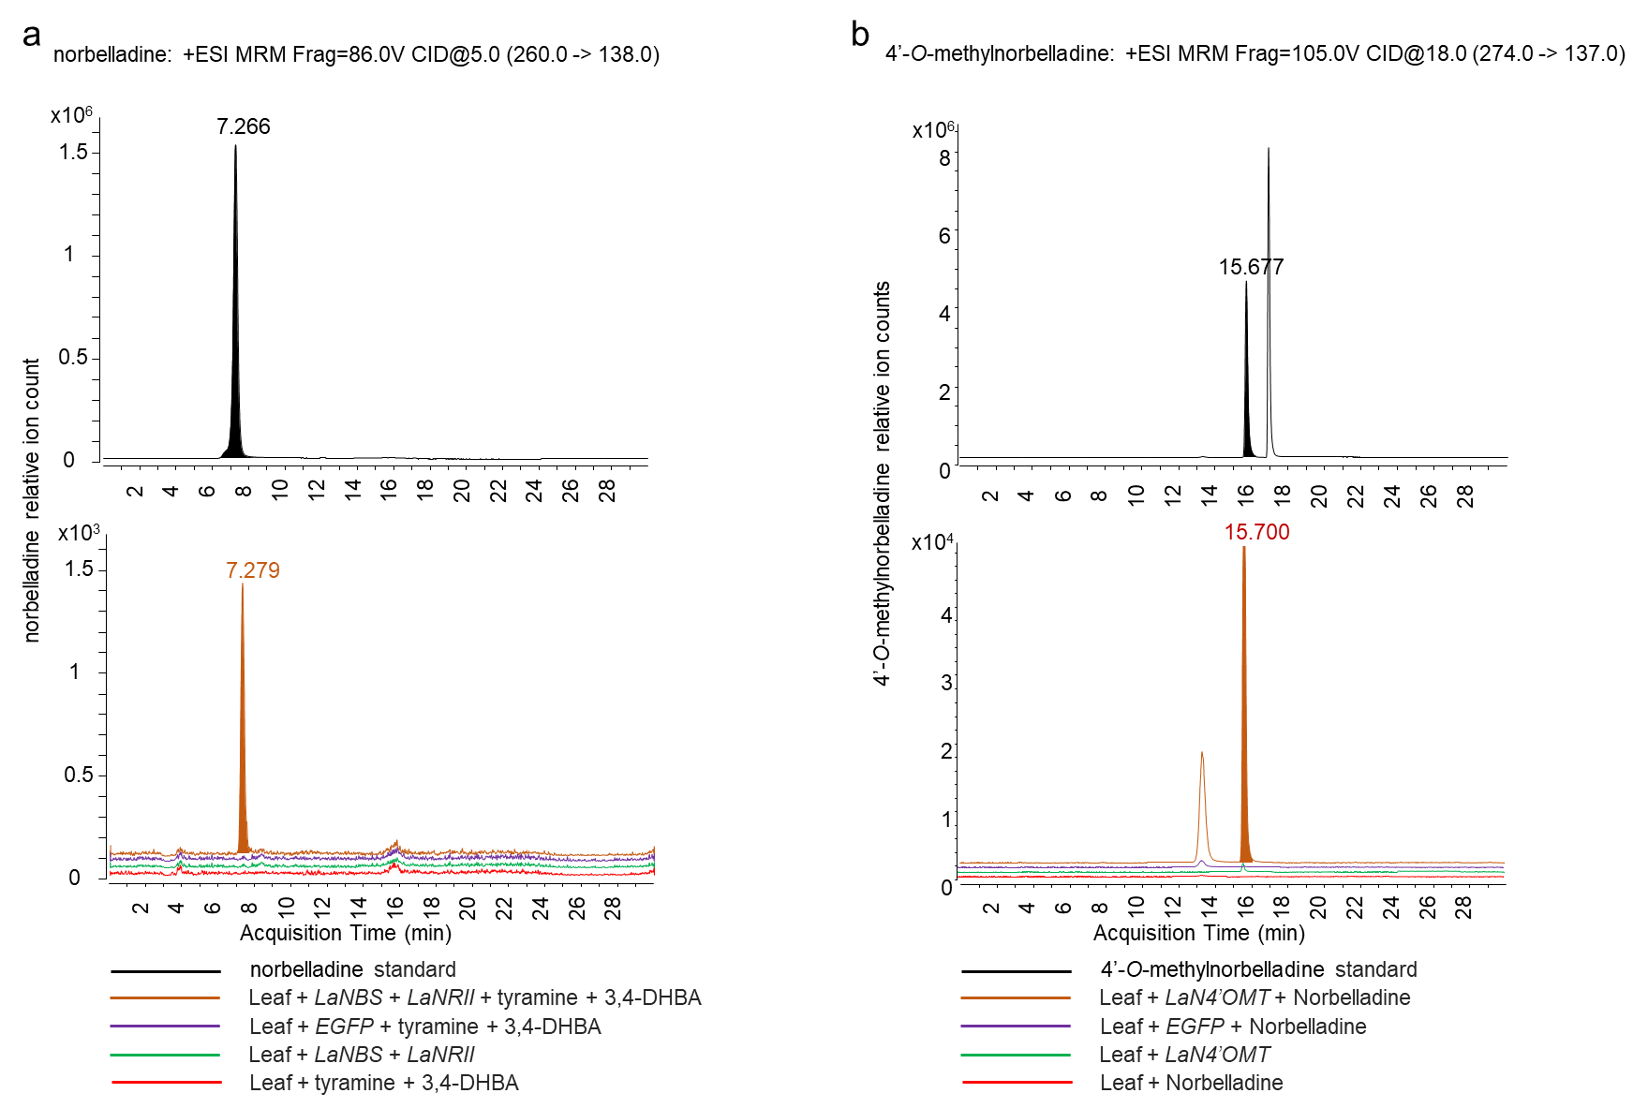

Supplementary Fig. 7: HPLC-MS/MS chromatograms of norbelladine and 4´-O-methylnorbelladine.
a HPLC-MS/MS chromatograms of norbelladine produced upon transient co-expression of LaNBS and LaNRII with tyramine and 3,4-DHBA as substrates. The color of each chromatogram indicates either authentic reference standard of norbelladine (black), the in vivo assay (brown), or different negative controls (purple, green, red). b HPLC-MS/MS chromatograms of 4´-O-methylnorbelladine, produced upon transient expression of LaN4´OMT with norbelladine as substrate. The color of each chromatogram indicates either authentic reference standard of 4´-O-methylnorbelladine (black), the in vivo assay (brown), or different negative controls (purple, green, red). The identity of those products were confirmed by comparing this compound’s retention time and other analytical parameters (Supplementary Table S4) to the ones of norbelladine and 4´-O-methylnorbelladine standard which were acquired in MRM analysis mode on the HPLC-MS/MS.

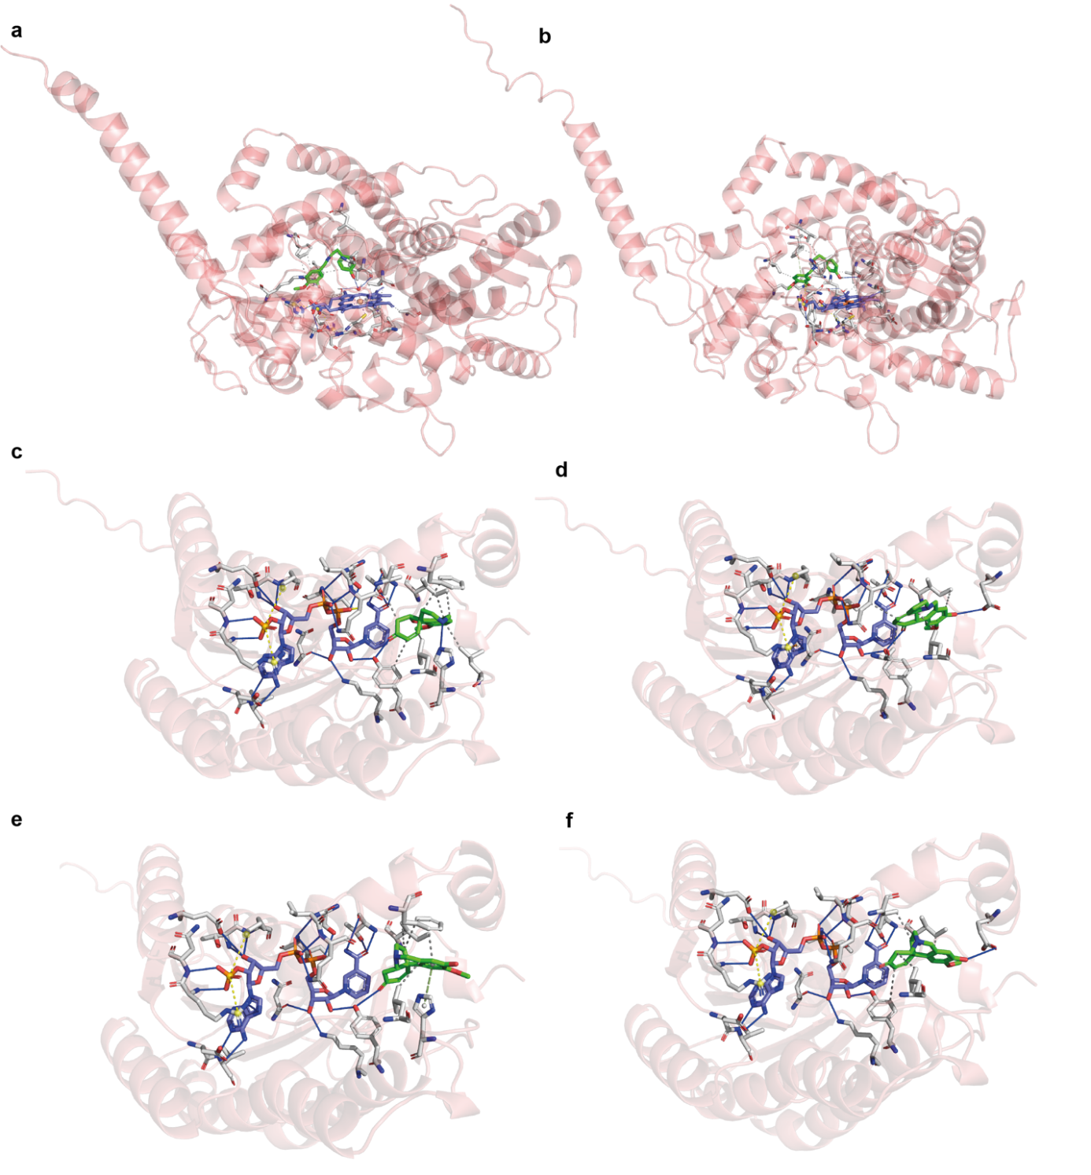

Supplementary Fig. 8. Docked structures of candidates CYP96T and NRII.
a Position of docked 4´-O-methylnorbelladine in the active site of CYP96T1 b Position of docked 4´-O-methylnorbelladine in the active site of CYP96T2. c Position of N-demethylnarwedine in the active site of LaNRII. d Position of noroxopluviine in the active site of LaNRII. e Position of noroxomaritidine to yield normaritidine in the active site of LaNRII. f Position of noroxomaritidine to yield oxomaritinamine in the active site of LaNRII.

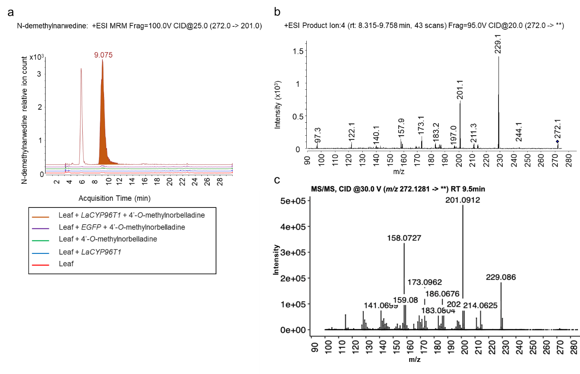

Supplementary Fig. 9: HPLC-MS/MS analysis of N-demethylnarwedine, produced upon transient expression of LaCYP96T1 with 4´-O-methylnorbelladine as substrate.
a HPLC-MS/MS chromatograms and the color of each chromatogram indicates the in vivo assay (brown), along with different negative controls (purple, blue, green, red). b MS/MS fragmentation pattern of the para- ortho’ product N-demethylnarwedine, that was produced upon transient expression of LaCYP96T1 with 4´-O-methylnorbelladine as substrate in N. benthamiana. c Published fragmentation pattern of N-demethylnarwedine (Mehta et al., 2023, Preprint). The identity of N-demethylnarwedine was confirmed by injecting these samples in MRM mode first (a), then in Product Ion mode to obtain the full collision-induced dissociation (CID) mass spectrum of this signal (b) and finally comparing it with previously published fragmentation pattern (c).

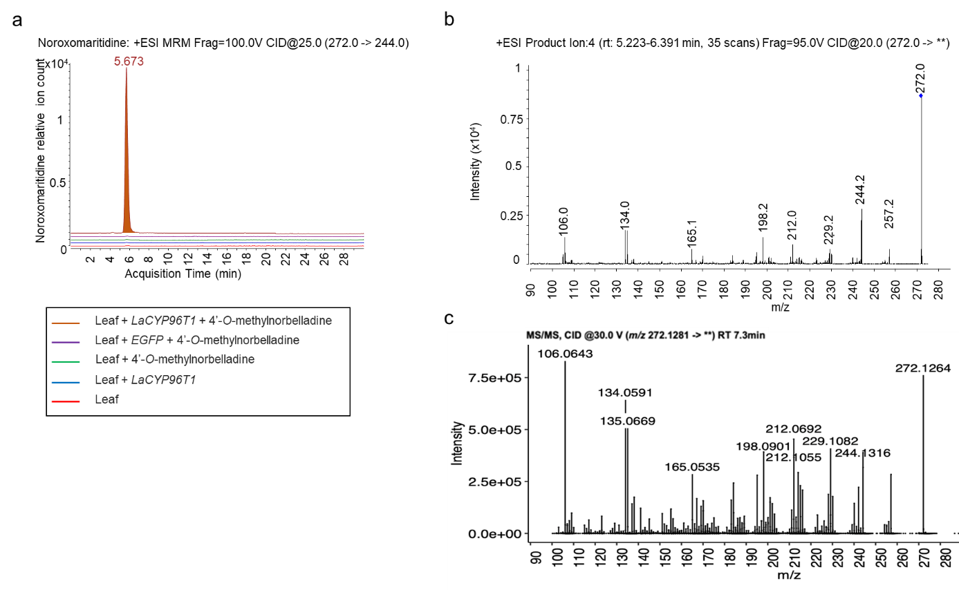

Supplementary Fig. 10: HPLC-MS/MS analysis of noroxomaritidine, produced upon transient expression of LaCYP96T1 with 4´-O-methylnorbelladine.
a HPLC-MS/MS chromatograms and the color of each chromatogram indicates the in vivo assay (brown), along with different negative controls (purple, blue, green, red). b MS/MS spectra of the para- para’ product noroxomaritidine, that was produced upon transient expression of LaCYP96T1 with 4´-O-methylnorbelladine in N. benthamiana. c Published fragmentation pattern of noroxomaritidine (Mehta et al., 2023, Preprint). The identity of noroxomaritidine was confirmed by injecting these samples in MRM mode first (a), then in Product Ion mode to obtain the full collision-induced dissociation (CID) mass spectrum of this signal (b) and finally comparing it with previously published fragmentation pattern (c).
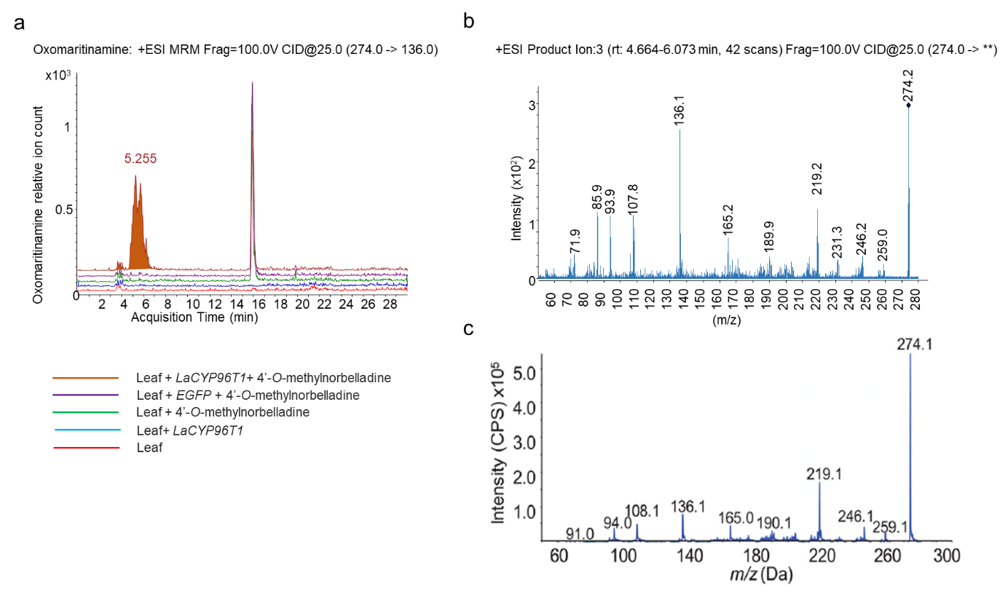

Supplementary Fig. 11: HPLC-MS/MS analysis of oxomaritinamine, produced upon transient expression of LaCYP96T1 with 4´-O-methylnorbelladine as substrates in N. benthamiana.
a HPLC-MS/MS chromatograms and the color of each chromatogram indicates the in vivo assay (brown), along with different negative controls (purple, blue, green, red). b MS/MS spectra of the para- para’ product oxomaritinamine, that was produced upon transient expression of LaCYP96T1 with 4´-O-methylnorbelladine in N. benthamiana. c Published fragmentation pattern of oxomaritinamine (Kilgore et al., 2016). The identity of oxomaritinamine was confirmed by injecting these samples in MRM mode first (a), then in Product Ion mode to obtain the full collision-induced dissociation (CID) mass spectrum of this signal (b) and finally comparing it with previously published fragmentation pattern (c).

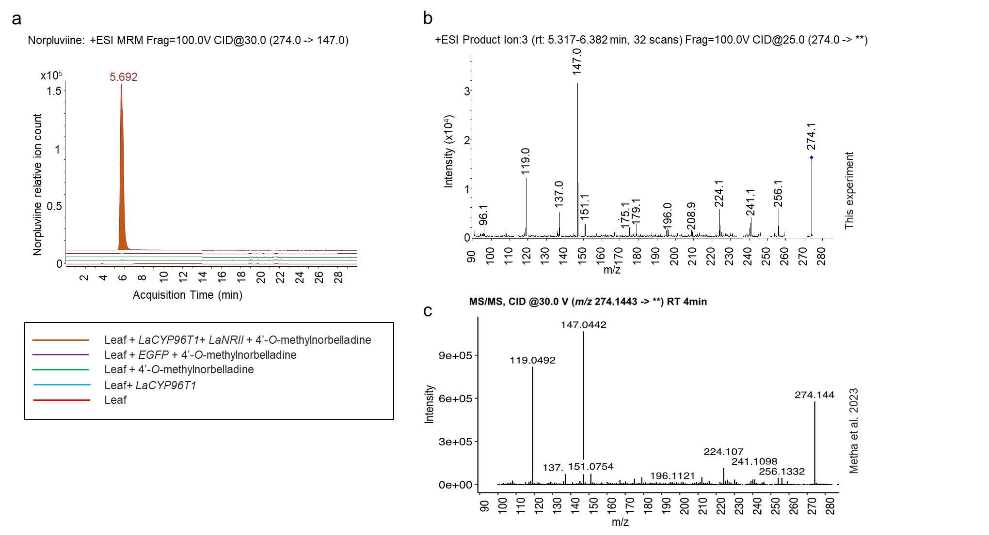
Supplementary Fig. 12: HPLC-MS/MS analysis of norpluviine produced upon transient co-expression of LaCYP96T1 and LaNRII with 4´-O-methylnorbelladine as substrates in N. benthamiana.
a HPLC-MS/MS chromatograms and the color of each chromatogram indicates the in vivo assay (brown), along with different negative controls (purple, blue, green, red). b MS/MS spectra of the ortho- para’ product norpluviine, that was produced upon transient expression of LaCYP96T1 and LaNRII with 4´-O-methylnorbelladine in N. benthamiana. c Published fragmentation pattern of norpluviine (Mehta et al., 2023, Preprint). The identity of norpluviine was confirmed by injecting these samples in MRM mode first (a), then in Product Ion mode to obtain the full collision-induced dissociation (CID) mass spectrum of this signal (b) and finally comparing it with previously published fragmentation pattern (c) (Mehta et al., 2023, Preprint).

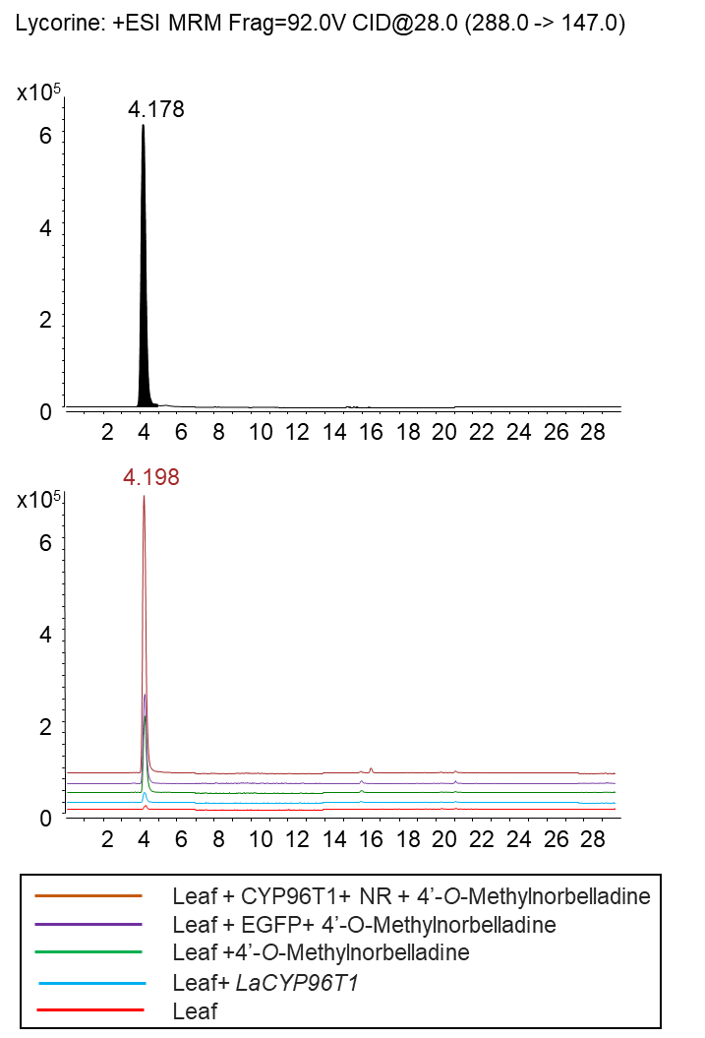
Supplementary Fig. 13: HPLC-MS/MS chromatograms of the ortho- para’ product lycorine, that was produced upon transient co-expression of LaCYP96T1 and LaNRII with 4´-O-methylnorbelladine in N. benthamiana.
The color of each chromatogram indicates the in vivo assay (brown), along with different negative controls (purple, blue, green, red). The identity of this product was confirmed by comparing this compound’s retention time and other analytical parameters (Supplementary Table S4) to the ones of lycorine standard which were acquired in MRM analysis mode on the HPLC-MS/MS.
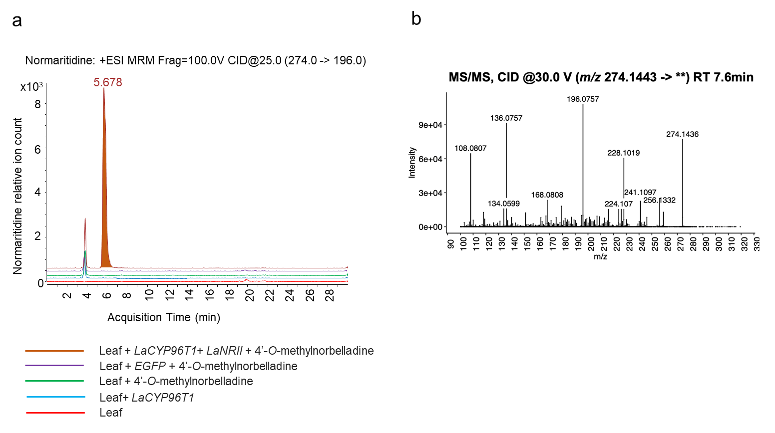
Supplementary Fig. 14: HPLC-MS/MS chromatograms of the para- para’ product normaritidine, that was produced upon transient co-expression of LaCYP96T1 and LaNRII with 4´-O-methylnorbelladine in N. benthamiana.
a The color of each chromatogram indicates the in vivo assay (brown), along with different negative controls (purple, blue, green, red). b Published fragmentation pattern of normaritidine. The identity of this product was confirmed by MRM analysis based on three characteristic product ions (i.e. m/z 196, 228 and 256) published in literature (Mehta et al., 2023, Preprint).

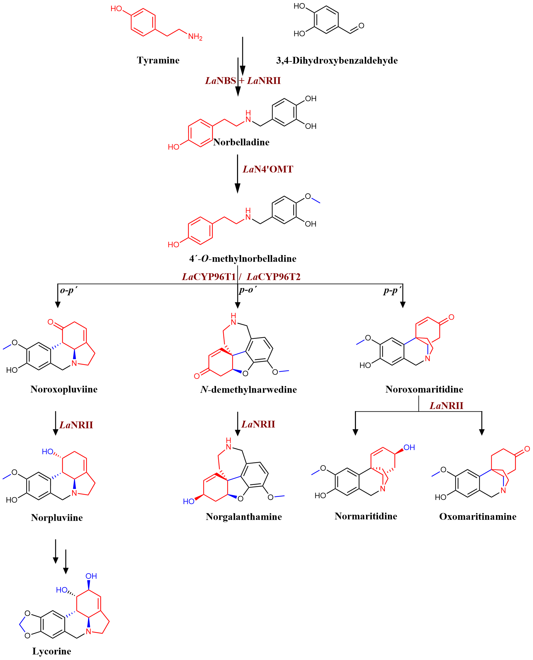
Supplementary Fig. 15: The elucidated alkaloid biosynthesis pathway in Leucojum aestivum in this study.
Red colored bonds are from tyramine, black from 3,4-dihydroxybenzaldehyde, blue colored bond or the atoms, are formed by respective enzymes in brown color.

