Fig. 1 DMTA parameters; a Storage modulus (G'), b Loss modulus (G") and c dissipation factor (tan δ) of all tested samples versus temperature at 1 Hz

Fig. 2 Specific heat capacity of pure sample (GE66-0.0) and its nanocomposites in respect to Polymer fraction, to determine heat of fusion; a after isothermal crystallization at 240 ºC; b during nonisothermal crystallization on cooling at 270 ºC and c the enthalpy of crystallization (ΔH), in respect to polymer mass, as a function of clay type. The dark yellow and navy lines represent reference data for reference curves from ATHAS database [23]

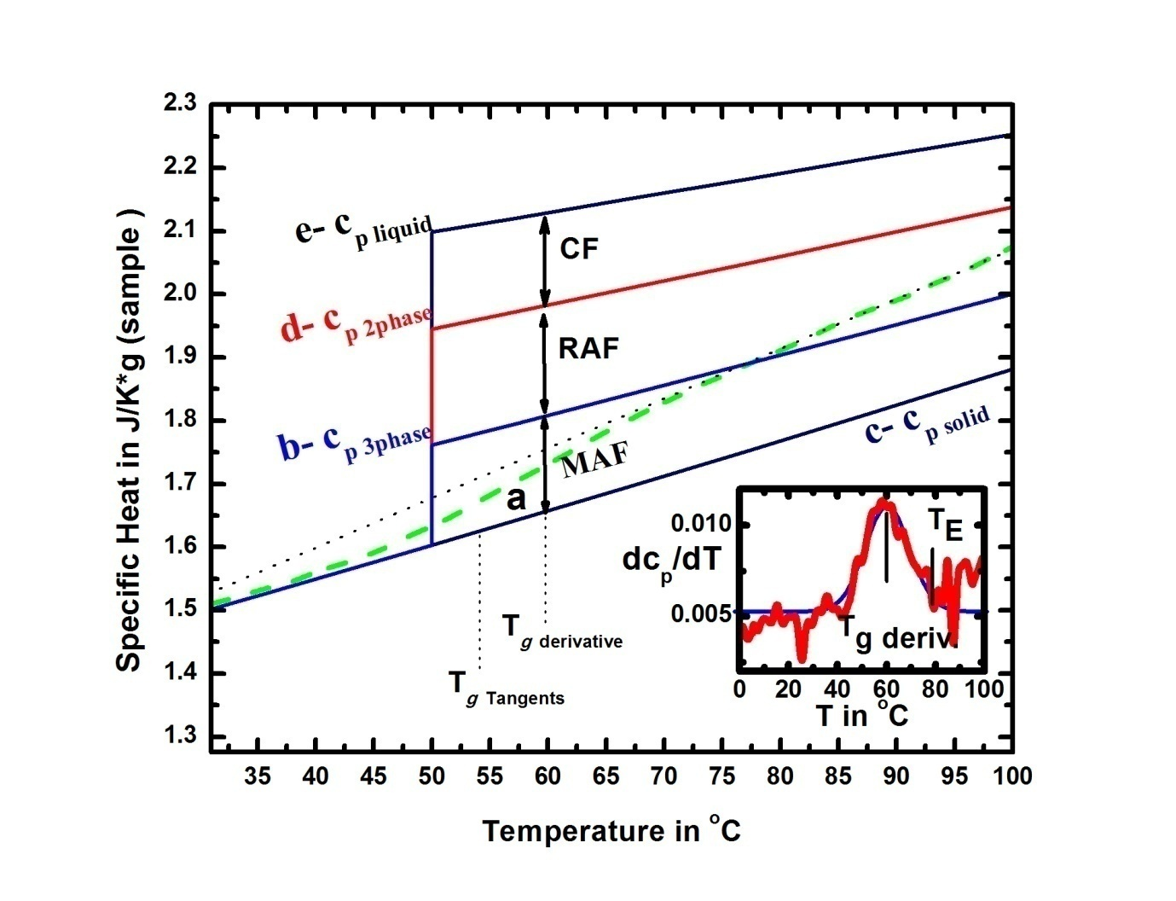
Fig. 3 Specific heat capacity of pure sample (GE66- 0.0); (a) sample curve for GE66- 0.0; (b) the
expected specific heat capacity above glass transition for 26% CF using a 2- phase-model of the
sample; (c) tangent line of measured curve (d) calculated specific heat capacity at 0.68 SF (e) solid
(c_{p} solid) and (f) liquid (c_{p} liquid) reference curves from ATHAS database [23]. The inset shows the
derivative curve in J/(g K²)
Fig. 4 Specific heat capacity of all samples in respect to sample mass as measured by Pyris
Diamond DSC, StepScanTM mode. The dark yellow and navy lines represent reference data
for (GE66- 0.0) from ATHAS data base

Fig. 5 Specific heat capacity in respect to polymer mass of pure GE66- 0.0 and its nanocomposites
from Step Scan TMDSC in the glass transition region

Fig. 6 Characteristic data of nonisothermal melt crystallization exotherms, the onset
crystallization temperature (T_{onset}) and peak temperature (T_{p}) for pure (GE66- 0.0) and its
nanocomposites

Fig. 7 Polymer fractions in GE66 based nanocomposites per polymer mass, Crystalline
Fraction (CF), mobile amorphous fraction (MAF), total rigid amorphous fraction (RAF), rigid
amorphous fraction due to the filler (RAF_{fi}) and rigid amorphous fraction at the crystals
(RAF_{cr})

Fig. 8 Dielectric constant (ε') of all tested samples versus frequency at different temperatures; a at -90 ºC; b at -15 ºC; c at room temperature and d at 100 ºC
Fig. 9 Dielectric loss (ε'') of all tested samples versus frequency at different temperatures; a at -90 ºC; b at -15 ºC; c at room temperature and d at 100 ºC

Fig. 10 Real component of the complex electric modulus (η′) versus log f of all tested samples at various fixed temperature; a at room temperature; b at 45 ºC; c at 60 ºC; d at 70 ºC and e at 100 ºC

Fig. 11 Imaginary component of the complex electric modulus (η′′) versus log f for neat GE66- 0.0 and its nanocomposites at various fixed temperature; a at room temperature; b at 45 ºC; c at 60 ºC; d at 70 ºC and e at 100 ºC

Fig. 12 Relaxation frequency versus the reciprocal temperature for all tested samples in a semi logarithmic scale. The inset shows the second peak for pure sample
Fig. 13 Relaxation time, ln (t _{relax.}), versus 1000/T for pure sample (GE66-0.0) and its nanocomposites. The inset shows the second peak for pure sample

Fig. 14 The electrical conductivity (σ′, σ′′) and the electrical Impedance (Z′, Z′′) for all samples as a function of frequency at room temperature

Fig. 15 The electrical conductivity (σ′, σ′′) and the electrical Impedance (Z′, Z′′) for all samples as a function of frequency at 100 ºC

Fig. 16 Electrical conductivity (σ') of pure sample GE66- 0.0 and loaded nanocomposites as a function of frequency at different fixed temperatures
Fig. 17 The exponent factor (m) as a function of frequency for all samples at different fixed temperatures

Fig. 18 The exponent factor (m) as a function of temperature for all samples (at constant frequency about 1000 Hz)

Fig. 19 The complex impedance Z′ versus Z′′ of neat polymer (GE66-0.0) and its nanocomposites at various fixed temperatures; a at room temperature; b at 70 ºC; c at 90 ºC; d at 130 ºC; e at 170 ºC; f at 2000 ºC and g at 235 ºC

Fig. 20 Loss tangent of all tested samples versus temperature at various fixed frequencies; a at 0.03 Hz; b at 0.1 Hz; c at 1 Hz; d at 10 Hz and e at 10² Hz
Fig. 21 Arrhenius plot for all samples, relaxation frequency versus temperature

