Supplementary Information

Supplementary Table 1. Demographics, clinical and laboratory data of individuals enrolled in the study and analyzed by mass cytometry.
Characteristics | Controls  n=9 | RA  n=11 | PsA  n=12
Age (years), median (range) | 48 (38-60) | 56 (33-65) | 51 (19-57)
Gender (female), n (%) | 5 (56%) | 11 (100%) | 9 (75%)
Smoking status (smoker), n (%) | 4 (44%) | 4 (36%) | 2 (17%)
Treatment
naïve, n (%) | N/A | 4 (36%) | 5 (42%)
csDMARDs-experienced, n (%) | N/A | 5 (46%) | 4 (33%)
b/tsDMARDs-experienced, n (%) | N/A | 2 (18%) | 3 (25%)
CRP (mg/l), mean (±SEM) | N/A | 32.9 (± 23.7) | 13.5 (± 5.1)
ESR (mm/h), mean (±SEM) | N/A | 39 (± 8) | 32 (± 8)
Disease activity score,  mean (±SEM) | N/A | DAS28,  5.24 (± 0.29) | DAPSA,  19.65 (± 1.30)
RF, n (%) | N/A | 9 (82%) | N/A
Anti-CCP, n (%) | N/A | 7 (64%) | N/A
Axial involvement, n (%) | N/A | N/A | 5 (42%)
Enthesitis, n (%) | N/A | N/A | 1 (8%)
Dactylitis, n (%) | N/A | N/A | 1 (8%)
BSA (≥ 3), n (%) | N/A | N/A | 6 (50%)
RA: rheumatoid arthritis; PsA: psoriatic arthritis; csDMARDs: conventional synthetic disease modifying antirheumatic drugs; b/tsDMARDs: biologic/targeted-synthetic disease modifying antirheumatic drugs; CRP: C-reactive protein; ESR: erythrocyte sedimentation rate; DAS28: Disease Activity Score-28; RF: rheumatoid factor; DAPSA: Disease Activity Index for Psoriatic Arthritis; anti-CCP: anti-cyclic citrullinated peptide; BSA: body surface area

Supplementary Table 2. The antibody panel used for mass cytometry. All antibodies were purchased from Standard BioTools Inc., San Francisco, CA, USA.
Metal | Target | Clone
89Y | CD45 | HI30
110Cd | CD34 | 581
141Pr | CD196/CCR6 | G034E3
142Nd | PDPN | NC-08
143Nd | CD123/IL-3R | 6H6
144Nd | CD19 | HIB19
145Nd | CD4 | RPA-T4
146Nd | CD8a | RPA-T8
147Sm | CD11c | Bu15
148Nd | CD16 | 3G8
149Sm | CD45RO | UCHL1
150Nd | CD45RA | HI100
151Eu | CD161 | HP-3G10
152Sm | CD194/CCR4 | L291H4
153Eu | CD25 | BC96
154Sm | CD27 | O323
155Gd | CD57 | HCD57
156Gd | CD183/CXCR3 | G025H7
158Gd | CD185/CXCR5 | J252D4
159Tb | CD90/Thy-1 | 5E10
160Gd | CD28 | CD28.2
161Dy | CD38 | HB-7
163Dy | CD56/NCAM | NCAM16.2
164Dy | TCRgd | B1
165 Ho | Notch3 | MHN3-21
166Er | CD294 | BM16
167Er | CD197/CCR7 | G043H7
168Er | CD14 | 63D3
169Tm | CDH11 | 16G5
170Er | CD3 | UCHT1
171Yb | CD20 | 2H7
172Yb | CD66b | G10F5
173Yb | HLA-DR | LN3
174Yb | IgD | IA6-2
176Yb | CD127/IL-7Ra | A019D5

Supplementary Table 3. Fibroblast phenotypes based on all possible combinations of CDH11, CD34, Notch3 and CD90.
Annotation | Phenotype
FB1 | CDH11⁻CD34⁻Notch3⁻CD90⁻
FB2 | CDH11⁺CD34⁻Notch3⁻CD90⁻
FB3 | CDH11⁻CD34⁺Notch3⁻CD90⁻
FB4 | CDH11⁻CD34⁻Notch3⁺CD90⁻
FB5 | CDH11⁻CD34⁻Notch3⁻CD90⁺
FB6 | CDH11⁺CD34⁺Notch3⁻CD90⁻
FB7 | CDH11⁺CD34⁻Notch3⁺CD90⁻
FB8 | CDH11⁺CD34⁻Notch3⁻CD90⁺
FB9 | CDH11⁻CD34⁺Notch3⁺CD90⁻
FB10 | CDH11⁻CD34⁺Notch3⁻CD90⁺
FB11 | CDH11⁻CD34⁻Notch3⁺CD90⁺
FB12 | CDH11⁺CD34⁺Notch3⁺CD90⁻
FB13 | CDH11⁺CD34⁺Notch3⁻CD90⁺
FB14 | CDH11⁺CD34⁻Notch3⁺CD90⁺
FB15 | CDH11⁻CD34⁺Notch3⁺CD90⁺
FB16 | CDH11⁺CD34⁺Notch3⁺CD90⁺
CDH11: cadherin-11

Supplementary Table 4. Fibrocyte phenotypes based on all possible combinations of CDH11, PDPN, CD90 and Notch3
Annotation | Phenotype
FC1 | CDH11⁻PDPN⁻Notch3⁻CD90⁻
FC2 | CDH11⁺PDPN⁻Notch3⁻CD90⁻
FC3 | CDH11⁻PDPN⁺Notch3⁻CD90⁻
FC4 | CDH11⁻PDPN⁻Notch3⁺CD90⁻
FC5 | CDH11⁻PDPN⁻Notch3⁻CD90⁺
FC6 | CDH11⁺PDPN⁺Notch3⁻CD90⁻
FC7 | CDH11⁺PDPN⁻Notch3⁺CD90⁻
FC8 | CDH11⁺PDPN⁻Notch3⁻CD90⁺
FC9 | CDH11⁻PDPN⁺Notch3⁺CD90⁻
FC10 | CDH11⁻PDPN⁺Notch3⁻CD90⁺
FC11 | CDH11⁻PDPN⁻Notch3⁺CD90⁺
FC12 | CDH11⁺PDPN⁺Notch3⁺CD90⁻
FC13 | CDH11⁺PDPN⁺Notch3⁻CD90⁺
FC14 | CDH11⁺PDPN⁻Notch3⁺CD90⁺
FC15 | CDH11⁻PDPN⁺Notch3⁺CD90⁺
FC16 | CDH11⁺PDPN⁺Notch3⁺CD90⁺
CDH11: cadherin-11; PDPN: podoplanin

Supplementary Table 5. Phenotypic definition of the 12 identified leukocyte subpopulations

Subpopulation | Phenotype
Neutrophils | CD45^{lo}CD66b⁺CD294⁻CD16⁺
Eosinophils | CD45^{lo}CD66b⁺CD294⁺CD16⁻
Basophils | CD45⁺CD66b⁻CD19⁻CD20⁻CD3⁻CD56⁻HLA-DR⁻CD11c⁻CD123⁺CD294⁺
Monocytes | CD45⁺CD66b⁻CD19⁻CD20⁻CD3⁻CD56⁻CD11c⁺HLA-DR⁺
NK cells | CD45⁺CD66b⁻CD19⁻CD20⁻CD3⁻CD14⁻CD45RA⁺CD123⁻CD56⁺
DC | CD45⁺CD66b⁻CD19⁻CD20⁻CD3⁻CD14⁻HLA-DR⁺
ILC | CD45⁺CD3⁻CD19⁻CD56⁻CD14⁻CD16⁻CD11c⁻TCRγδ⁻CD123⁻CD127⁺
MAIT/iNKT | CD45⁺CD66b⁻CD19⁻CD20⁻CD14⁻CD11c⁻CD3⁺CD4⁻CD28⁺CD161^{hi}
γδ T cells | CD45⁺CD66b⁻CD19⁻CD20⁻CD14⁻CD11c⁻CD3⁺CD4⁻CD8⁻TCRγδ⁺
CD4⁺ T cells | CD45⁺CD66b⁻CD19⁻CD20⁻CD14⁻CD11c⁻CD3⁺TCRγδ⁻CD4⁺CD8⁻
CD8⁺ T cells | CD45⁺CD66b⁻CD19⁻CD20⁻CD14⁻CD11c⁻CD3⁺TCRγδ⁻CD4⁻CD8⁺CD161^{lo/-}
B cells | CD45⁺CD66b⁻CD56⁻CD14⁻CD19⁺CD3⁻
NK: natural killer cells; DC: dendritic cells; MAIT: mucosal-associated invariant T cells; iNKT: invariant natural killer T cells; ILC: innate lymphoid cells

Supplementary Table 6. Clinical data and circulating fibroblast and fibrocyte counts and percentages,obtained from 270 μl peripheral blood, for each individual enrolled in the study

 | Baseline |  |  |  | Three months post-treatment
 | Circulating  Fibroblasts |  | Circulating  Fibrocytes |  | Disease activity | Circulating  Fibroblasts |  |  | Circulating  Fibrocytes
 | Counts (in 270 μl) | % in intact cells | Counts (in 270 μl) | % in intact cells |  | Counts (in 270 μl) |  | % in intact cells | Counts (in 270 μl) | % in intact cells
RA1 | 0 | 0.0000 | 6 | 0.0020 | L | 3 | 0.0011 |  | 45 | 0.0158
RA2 | 0 | 0.0000 | 8 | 0.0029 | L | 0 | 0.0000 |  | 4 | 0.0015
RA3 | 0 | 0.0000 | 86 | 0.0219 | L | 3 | 0.0007 |  | 268 | 0.0638
RA4 | 2 | 0.0003 | 8 | 0.0014 | H | 0 | 0.0000 |  | 29 | 0.0054
RA5 | 10 | 0.0021 | 8 | 0.0016 | L | 0 | 0.0000 |  | 12 | 0.0063
RA6 | 0 | 0.0000 | 21 | 0.0050 | M | 0 | 0.0000 |  | 4 | 0.0164
RA7 | 2 | 0.0004 | 14 | 0.0025 | M | 4 | 0.0011 |  | 181 | 0.0506
RA8 | 1 | 0.0002 | 12 | 0.0030 | H | 1 | 0.0002 |  | 15 | 0.0029
RA9 | 4 | 0.0007 | 41 | 0.0075 | L | 2 | 0.0004 |  | 93 | 0.0170
RA10 | 5 | 0.0012 | 7 | 0.0017 | H | 2 | 0.0006 |  | 25 | 0.0073
RA11 | 2 | 0.0005 | 42 | 0.0100 | H | 7 | 0.0019 |  | 251 | 0.0684
PsA1 | 1 | 0.0003 | 8 | 0.0024 | L | 0 | 0.0000 |  | 4 | 0.0007
PsA2 | 0 | 0.0000 | 21 | 0.0055 | M | 5 | 0.0014 |  | 76 | 0.0216
PsA3 | 7 | 0.0015 | 7 | 0.0015 | L | 0 | 0.0000 |  | 33 | 0.0015
PsA4 | 0 | 0.0000 | 18 | 0.0029 | L | 0 | 0.0000 |  | 149 | 0.0282
PsA5 | 2 | 0.0004 | 24 | 0.0045 | H | 0 | 0.0000 |  | 12 | 0.0022
PsA6 | 3 | 0.0010 | 89 | 0.0285 | L | 0 | 0.0000 |  | 120 | 0.0372
PsA7 | 4 | 0.0020 | 19 | 0.0093 | M | 8 | 0.0017 |  | 158 | 0.0330
PsA8 | 1 | 0.0002 | 55 | 0.0110 | L | 0 | 0.0000 |  | 73 | 0.0259
PsA9 | 2 | 0.0003 | 10 | 0.0016 | L | 2 | 0.0003 |  | 155 | 0.0254
PsA10 | 2 | 0.0004 | 20 | 0.0043 | H | 0 | 0.0000 |  | 54 | 0.0097
PsA11 | 1 | 0.0002 | 29 | 0.0066 | H | 0 | 0.0000 |  | 36 | 0.0069
PsA12 | 2 | 0.0003 | 22 | 0.0063 | N/A | N/A | N/A |  | N/A | N/A
HC1 | 0 | 0.0000 | 2 | 0.0011 | N/A | N/A | N/A |  | N/A | N/A
HC2 | 0 | 0.0000 | 11 | 0.0027 | N/A | N/A | N/A |  | N/A | N/A
HC3 | 1 | 0.0004 | 7 | 0.0025 | N/A | N/A | N/A |  | N/A | N/A
HC4 | 1 | 0.0003 | 30 | 0.0081 | N/A | N/A | N/A |  | N/A | N/A
HC5 | 0 | 0.0000 | 4 | 0.0019 | N/A | N/A | N/A |  | N/A | N/A
HC6 | 1 | 0.0003 | 52 | 0.0169 | N/A | N/A | N/A |  | N/A | N/A
HC7 | 0 | 0.0000 | 4 | 0.0013 | N/A | N/A | N/A |  | N/A | N/A
HC8 | 0 | 0.0000 | 7 | 0.0015 | N/A | N/A | N/A |  | N/A | N/A
HC9 | 1 | 0.0003 | 21 | 0.0064 | N/A | N/A | N/A |  | N/A | N/A
RA: rheumatoid arthritis; PsA: psoriatic arthritis; HC: healthy controls; CRP: C-reactive protein; ESR: erythrocyte sedimentation rate; for disease activity: L=low, M=moderate, H=high
Supplementary Table 7. Correlations of the numbers of circulating cadherin-11⁺ fibroblasts and CDH11⁺ fibrocytes with CDH11⁺CD90⁺ leukocyte subpopulations in patients. Correlation coefficients between the variables were calculated according to Spearman's rank correlation coefficient (r_{s}).

CDH11⁺CD90⁺ leukocyte subpopulations | CDH11⁺ fibroblasts |  | CDH11⁺ fibrocytes
CDH11⁺CD90⁺ leukocyte subpopulations | r_{s} | p value | r_{s} | p value
Neutrophils | 0.341 | 0.111 | 0.498 | 0.015
Eosinophils | -0.006 | 0.978 | -0.159 | 0.469
Basophils | -0.088 | 0.690 | 0.162 | 0.461
Monocytes | 0.203 | 0.353 | 0.698 | 0.001
NK cells | 0.180 | 0.410 | 0.548 | 0.007
DC | -0.026 | 0.908 | 0.765 | 0.001
ILC | 0.338 | 0.115 | 0.492 | 0.017
MAIT/iNKT | 0.234 | 0.283 | 0.268 | 0.216
γδ T cells | 0.026 | 0.905 | 0.607 | 0.014
CD4⁺ T cells | 0.150 | 0.495 | 0.407 | 0.054
CD8⁺ T cells | 0.382 | 0.072 | 0.238 | 0.275
B cells | 0.268 | 0.217 | 0.112 | 0.611
CDH11: cadherin-11; NK: natural killer cells; DC: dendritic cells; MAIT: mucosal-associated invariant T cells; iNKT: invariant natural killer T cells; ILC: innate lymphoid cells

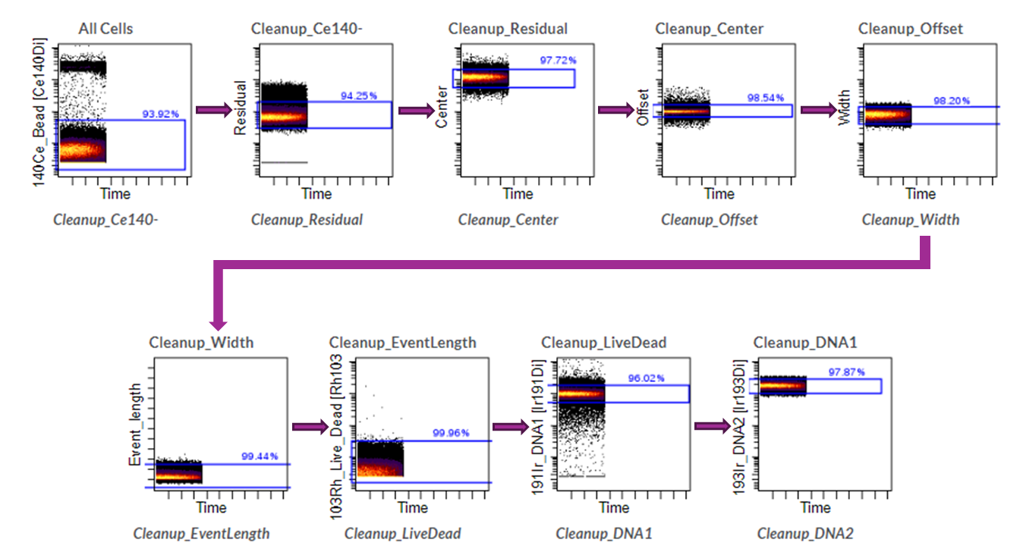
Supplementary Fig. 1. Representative dot plots showing the gating strategy for data cleanup to remove aggregates, debris, normalization beads, doublets, and dead cells from further analysis. Arrows indicate the gating sequence.

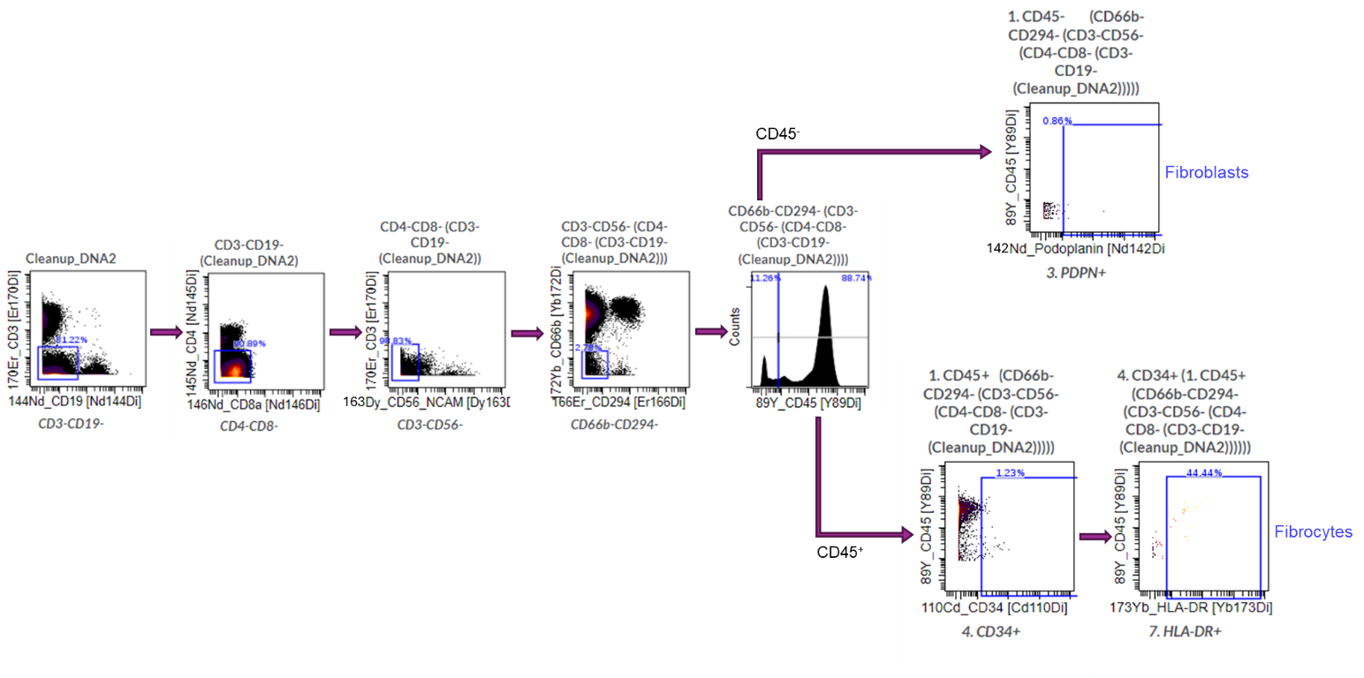

Supplementary Fig. 2. Representative dot plots showing the gating strategy for the identification of circulating fibroblasts and fibrocytes. Arrows indicate the gating sequence.
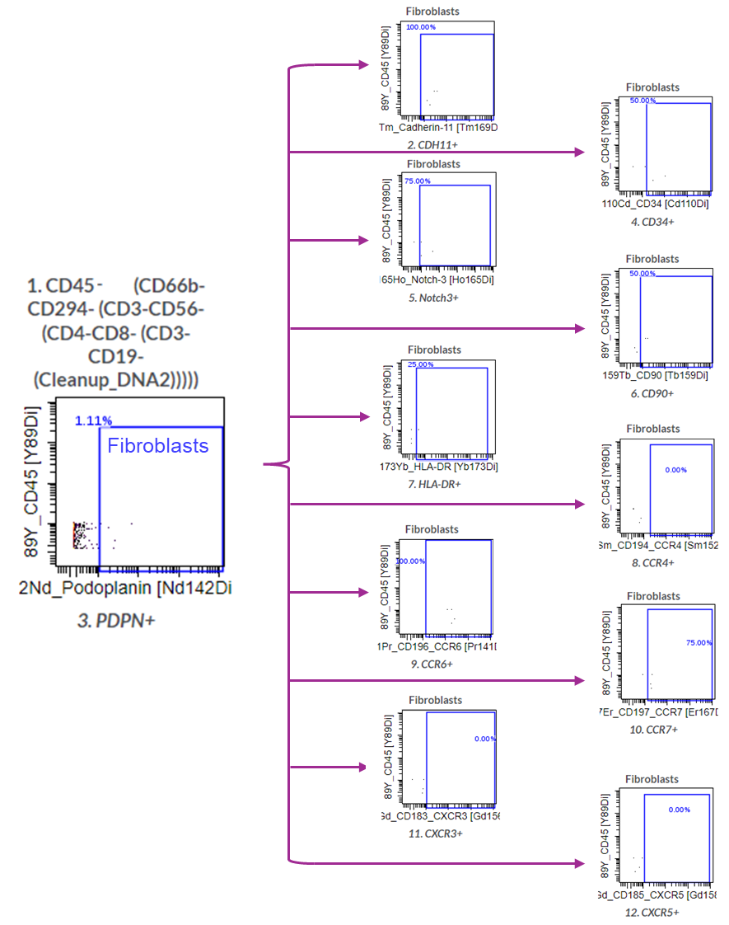

Supplementary Fig. 3. Representative dot plots showing the gating strategy for the phenotypic analysis of CDH11⁺, CD34⁺, Notch3⁺, CD90⁺, HLA-DR⁺, CCR4⁺, CCR6⁺, CCR7⁺, CXCR3⁺ and CXCR5⁺ circulating fibroblasts. Arrows indicate the gating sequence.

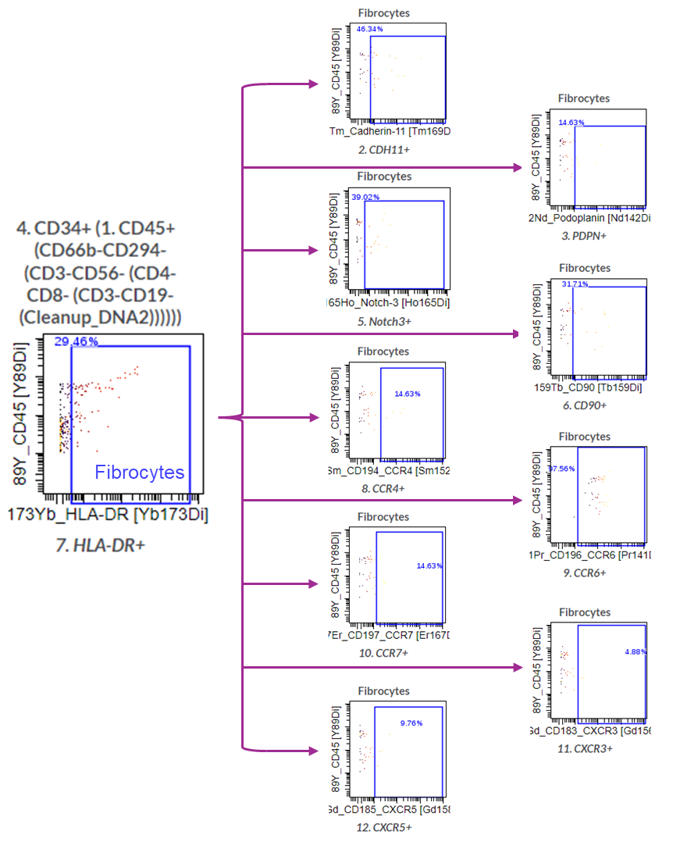

Supplementary Fig. 4. Representative dot plots showing the gating strategy for the phenotypic analysis of CDH11⁺, PDPN⁺, Notch3⁺, CD90⁺, CCR4⁺, CCR6⁺, CCR7⁺, CXCR3⁺ and CXCR5⁺ circulating fibrocytes. Arrows indicate the gating sequence.

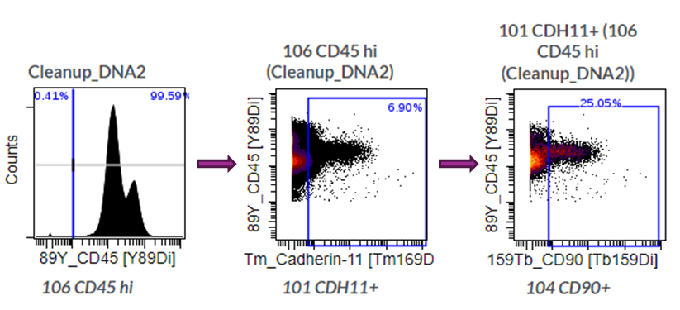
Supplementary Fig. 5. Representative dot plots showing the gating strategy for the phenotypic analysis of CD90⁺CDH11⁺ CD45⁺ cells. Arrows indicate the gating sequence.
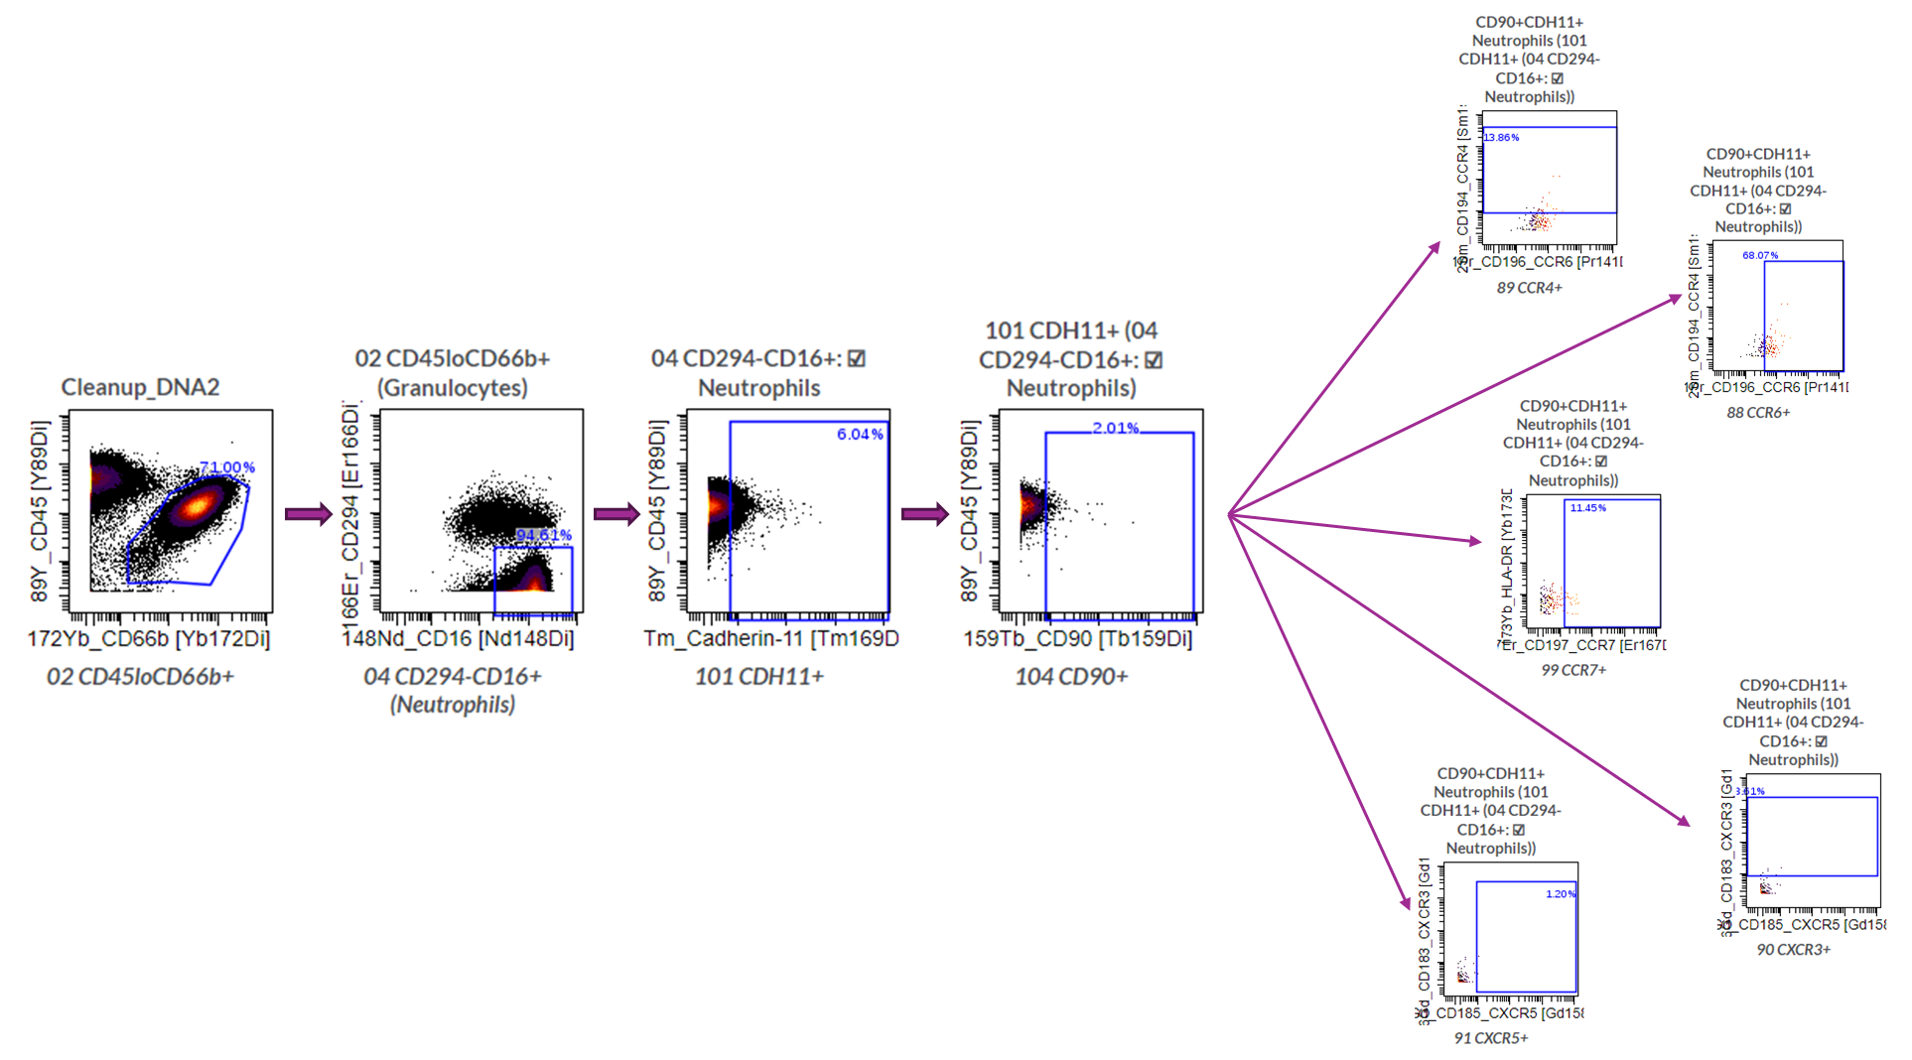

Supplementary Fig. 6. Representative dot plots showing the gating strategy for the phenotypic analysis of total CD90⁺CDH11⁺ neutrophils as well as CCR4⁺, CCR6⁺, CCR7⁺, CXCR3⁺ and CXCR5⁺ CD90⁺CDH11⁺ neutrophils. Arrows indicate the gating sequence.

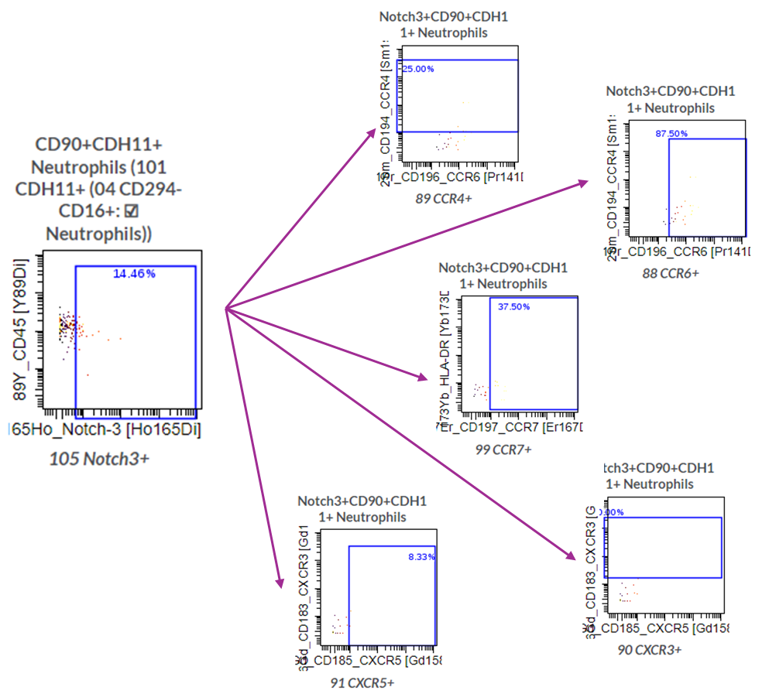

Supplementary Fig. 7. Representative dot plots showing the gating strategy for the phenotypic analysis of total Notch3⁺CD90⁺CDH11⁺ neutrophils as well as CCR4⁺, CCR6⁺, CCR7⁺, CXCR3⁺ and CXCR5⁺ Notch3⁺CD90⁺CDH11⁺ neutrophils. Arrows indicate the gating sequence.

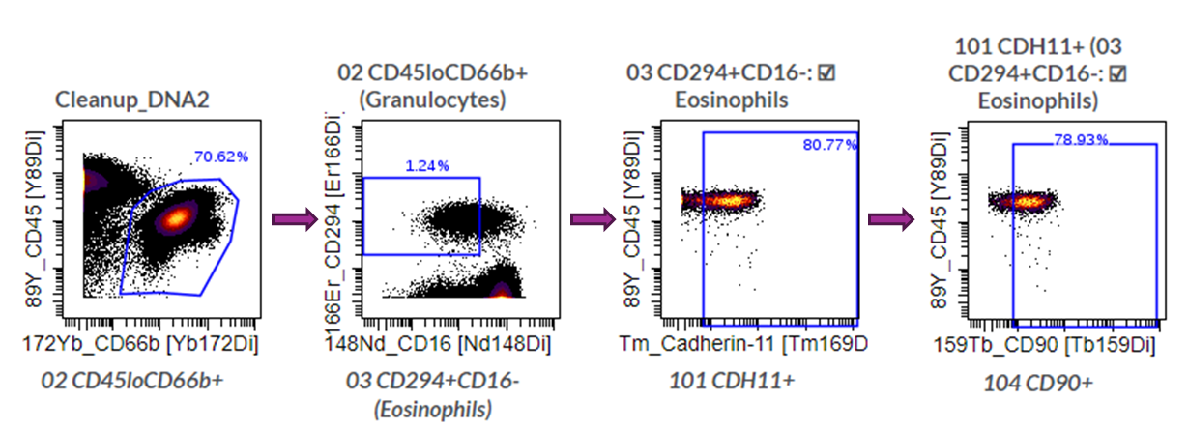

Supplementary Fig. 8. Representative dot plots showing the gating strategy for the phenotypic analysis of CD90⁺CDH11⁺ eosinophils. Arrows indicate the gating sequence.

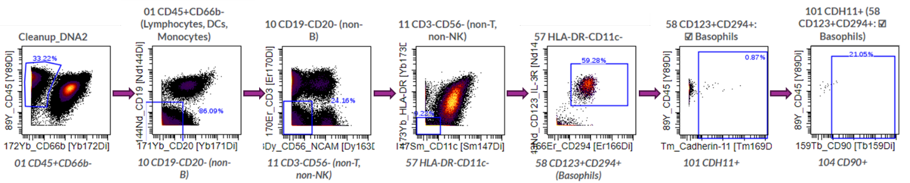
Supplementary Fig. 9. Representative dot plots showing the gating strategy for the phenotypic analysis of CD90⁺CDH11⁺ basophils. Arrows indicate the gating sequence.

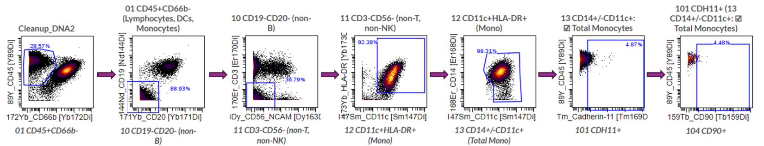

Supplementary Fig. 10. Representative dot plots showing the gating strategy for the phenotypic analysis of CD90⁺CDH11⁺ monocytes. Arrows indicate the gating sequence.

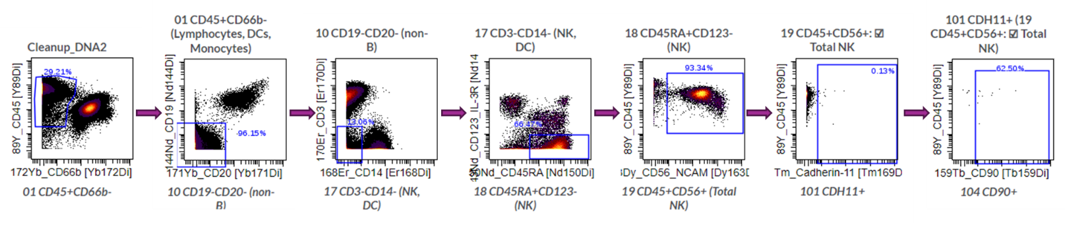
Supplementary Fig. 11. Representative dot plots showing the gating strategy for the phenotypic analysis of CD90⁺CDH11⁺ NK cells. Arrows indicate the gating sequence. (NK: natural killer)

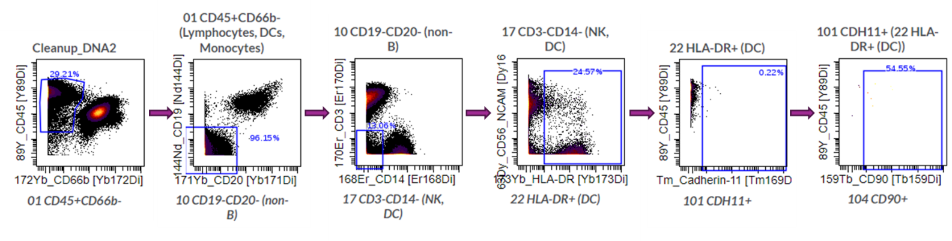
Supplementary Fig. 12. Representative dot plots showing the gating strategy for the phenotypic analysis of CD90⁺CDH11⁺ DC. Arrows indicate the gating sequence. (DC: dendritic cells)

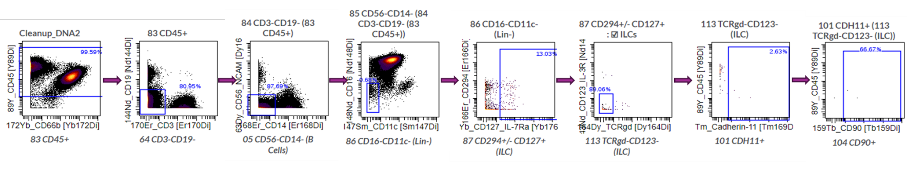
Supplementary Fig. 13. Representative dot plots showing the gating strategy for the phenotypic analysis of CD90⁺CDH11⁺ ILC. Arrows indicate the gating sequence. (ILC: innate lymphoid cells)

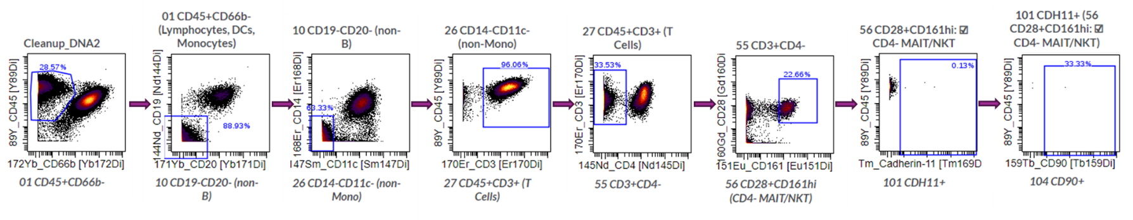
Supplementary Fig. 14. Representative dot plots showing the gating strategy for the phenotypic analysis of CD90⁺CDH11⁺ MAIT/iNKT. Arrows indicate the gating sequence. (MAIT: mucosal-associated invariant T cells; iNKT: invariant natural killer T)

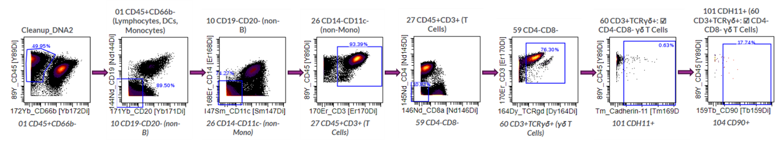
Supplementary Fig. 15. Representative dot plots showing the gating strategy for the phenotypic analysis of CD90⁺CDH11⁺ γδ T cells. Arrows indicate the gating sequence.

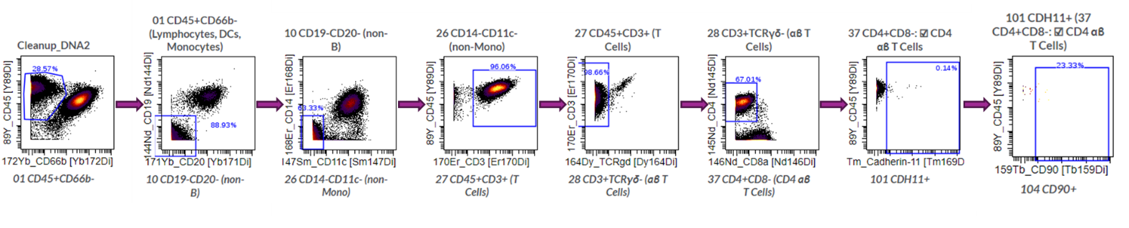
Supplementary Fig. 16. Representative dot plots showing the gating strategy for the phenotypic analysis of CD90⁺CDH11⁺ CD4⁺ T cells. Arrows indicate the gating sequence.

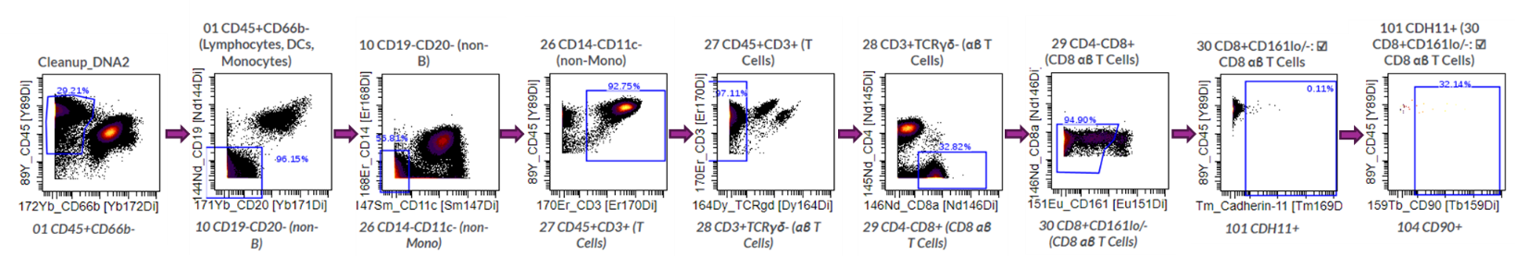

Supplementary Fig. 17. Representative dot plots showing the gating strategy for the phenotypic analysis of CD90⁺CDH11⁺ CD8⁺ T cells. Arrows indicate the gating sequence.

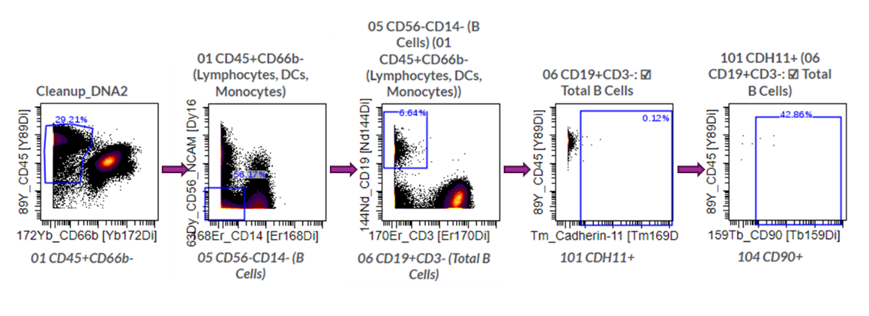Supplementary Fig. 18. Representative dot plots showing the gating strategy for the phenotypic analysis of CD90⁺CDH11⁺ B cells. Arrows indicate the gating sequence.
a) b)
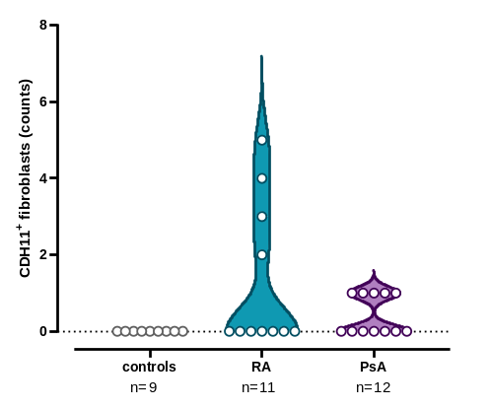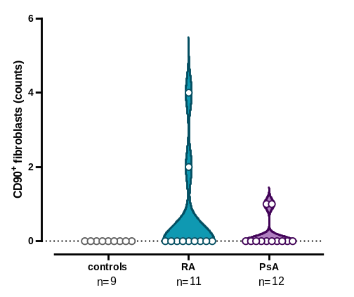

c) d)
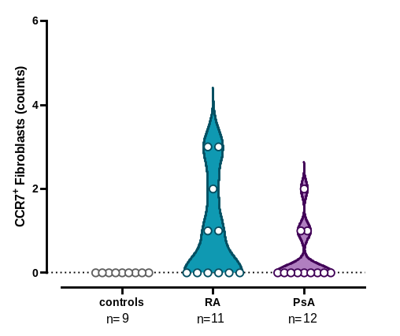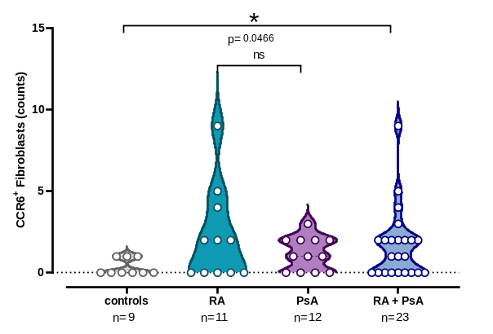

Supplementary Fig. 19. Fibroblasts expressing CDH11, CD90, CCR6 or CCR7 are increased in patients. Violin plots showing the counts of a) CDH11⁺ fibroblasts, b) CD90⁺ fibroblasts, c) CCR7⁺ fibroblasts, and d) CCR6⁺ fibroblasts, across the study groups. Each point corresponds to an individual (grey plot= controls, n= 9; cyan plot= RA, n= 11; purple plot= PsA, n= 12; blue plot= RA + PsA, n= 23) (n: number of individuals; RA: rheumatoid arthritis; PsA: psoriatic arthritis; CDH11: cadherin-11; ns: not significant; *, p< 0.050)

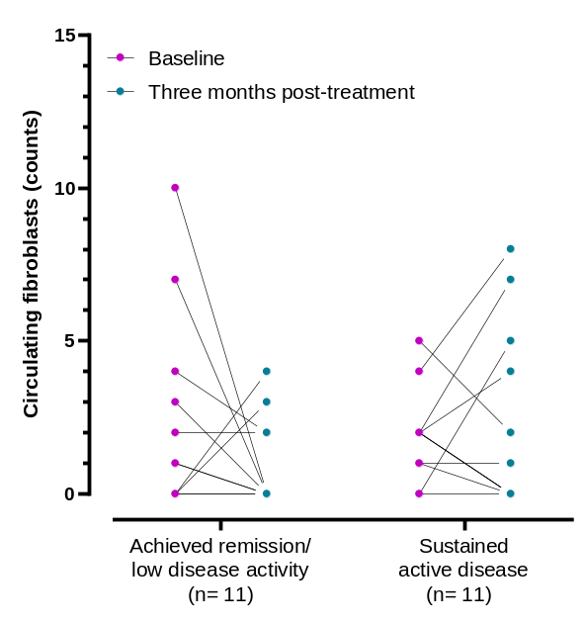

Supplementary Fig. 20. Fibroblast counts measured three-months post-treatment are comparable to baseline numbers. Total fibroblast counts in patients who achieved remission (n= 11) or remained clinically active (n= 11) post-treatment, measured at baseline and in their three-month follow-up. Each point corresponds to an individual patient (magenta points= baseline levels; cyan points= three months post-treatment levels). (n: number of individuals)

a)

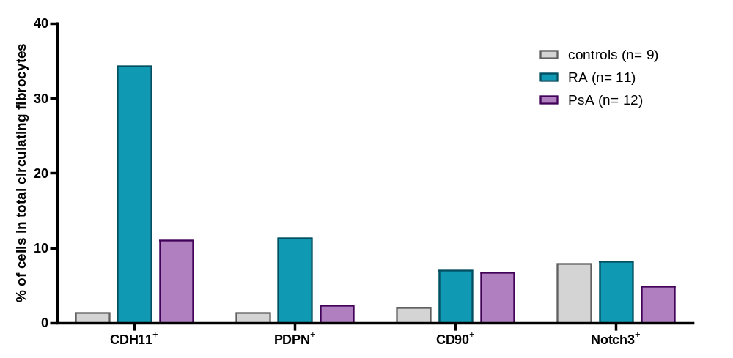

b)
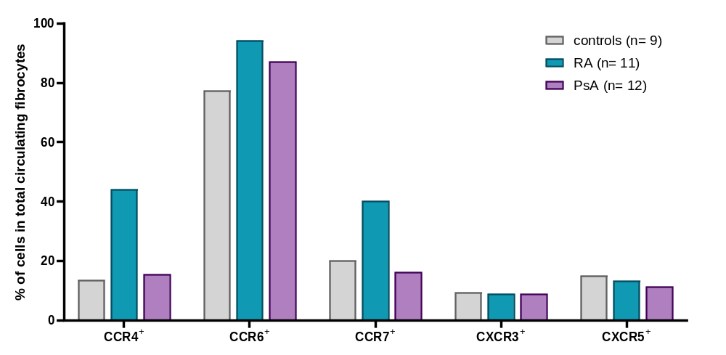

Supplementary Fig. 21. Phenotypic characterization of circulating fibrocytes in patients and controls. a) Bar plots depicting the percentages of CDH11⁺, PDPN⁺, CD34⁺ and Notch3⁺ fibrocytes within total detected fibroblasts per study group. b) Bar plots showing the percentages of CCR4⁺, CCR6⁺, CCR7⁺, CXCR3⁺ and CXCR5⁺ fibroblasts within total detected fibroblasts per study group (grey plot= controls, n= 9; cyan plot= RA, n= 11; purple plot= PsA, n= 12). (n: number of individuals; RA: rheumatoid arthritis; PsA: psoriatic arthritis)

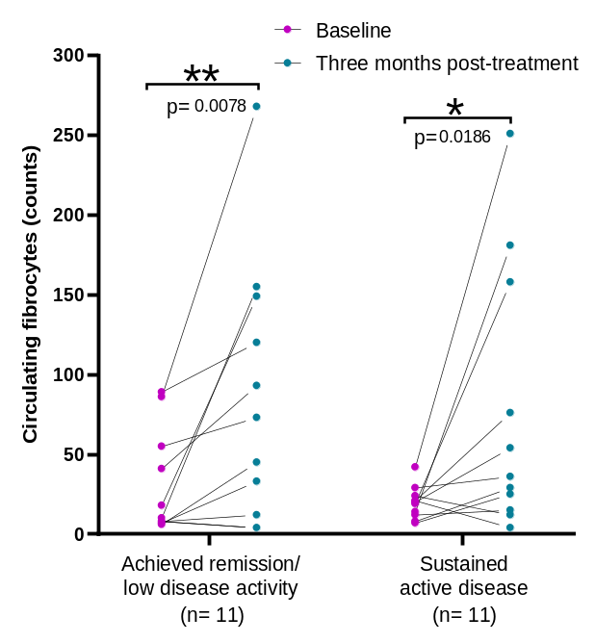

Supplementary Fig. 22. Fibrocyte counts are elevated three-months post-treatment, regardless of patients’ clinical status. Total fibrocyte counts in patients who became inactive (n= 11) or remained active (n= 11) post-treatment, measured at baseline and in their three-month follow-up. Each point corresponds to an individual patient (magenta points= baseline levels; cyan points= three months post-treatment levels). (n: number of individuals; *, p< 0.050; **, p≤ 0.010)

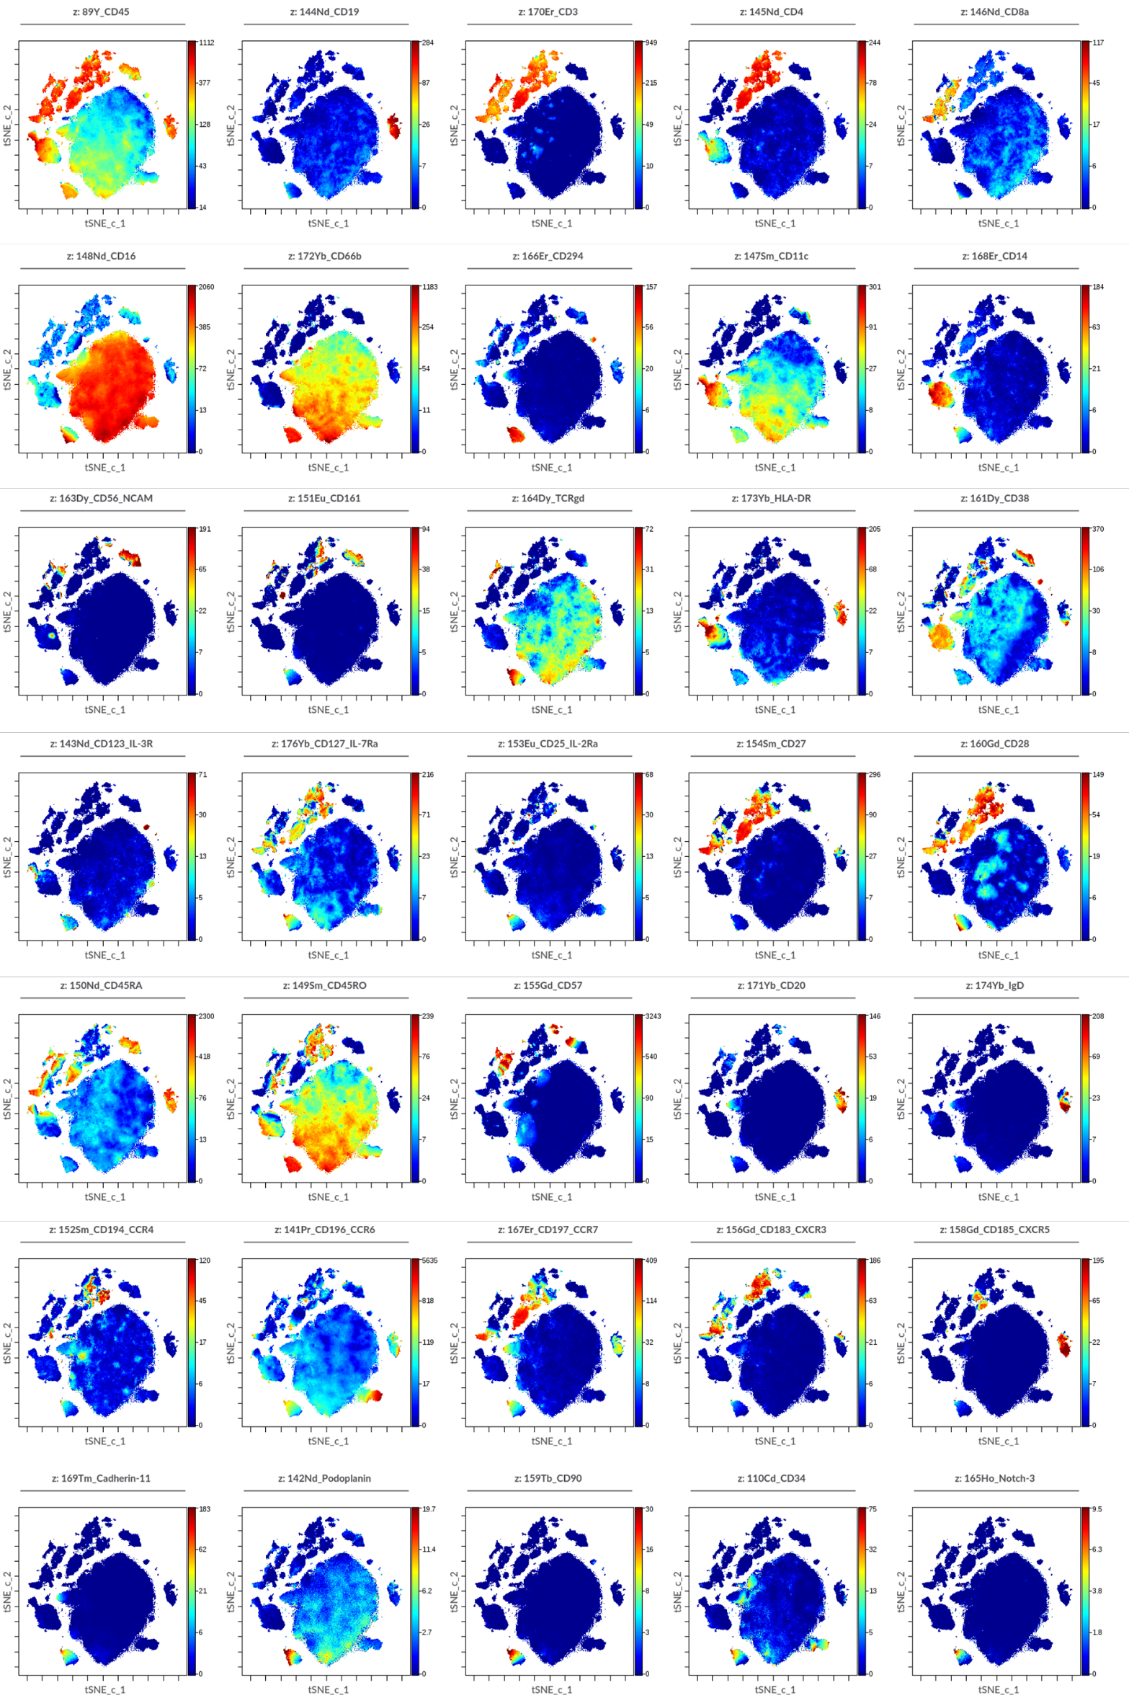

Supplementary Fig. 23. tSNE-CUDA plots showing the expression of the 36 markers used on the CyTOF analysis on 810,000 randomly selected cells. The 36 markers (CD45, CD19, CD3, CD4, CD8a, CD16, CD66b, CD294, CD11c, CD14, CD56, CD161, TCRgd, HLA-DR, CD38, CD123/IL-3R, CD127/IL-7Ra, CD25/IL-2Ra, CD27, CD28, CD45RA, CD45RO, CD57, CD20, IgD, CD194/CCR4, CD196/CCR6, CD197/CCR7, CD183/CXCR3, CD185/CXCR5, CDH11, PDPN, CD90, CD34, Notch3) are plotted separately in the 2-dimensional space. Each dot represents a cell and is colored according to marker’s intensity on a spectrum heat scale (red= high intensity; blue=low intensity). Arcsine-transformed color scales report the raw values of the marker’s intensity.

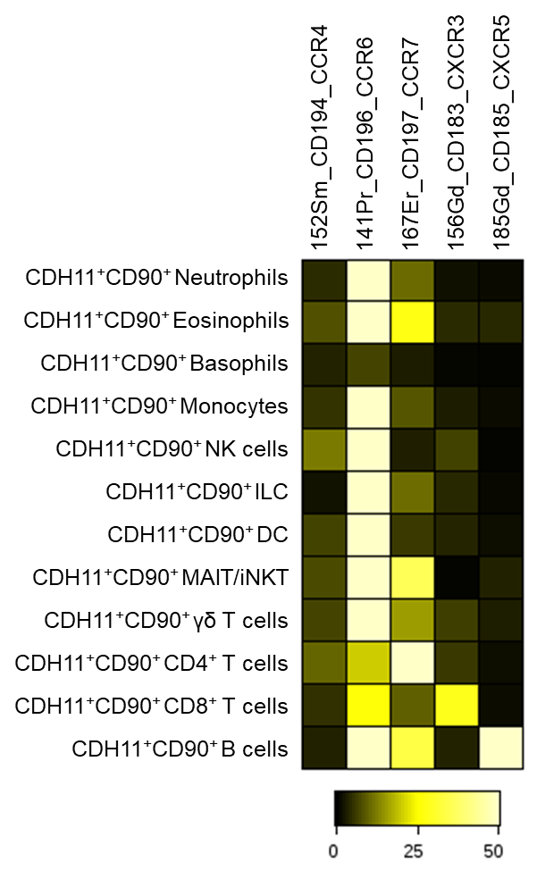
Supplementary Fig. 24. Expression of chemokine receptors by circulating leukocyte subpopulations co-expressing CDH11 and CD90. Heatmap showing the expression levels (median intensity) of CCR4, CCR6, CCR7, CXCR3 and CXCR5 within each CDH11⁺CD90⁺ leukocyte subpopulation.
a) b)
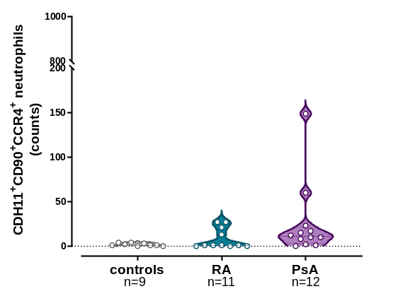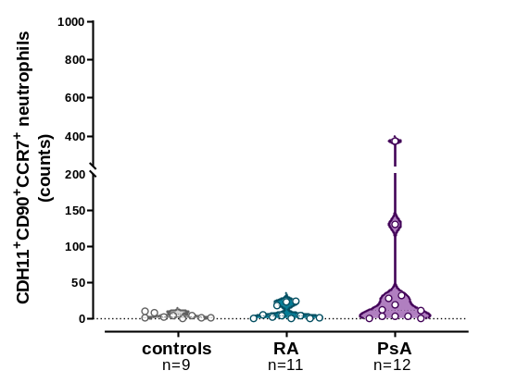
c) d)
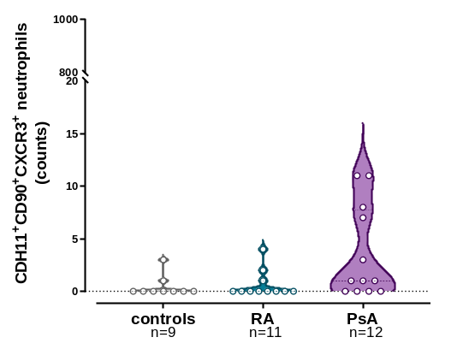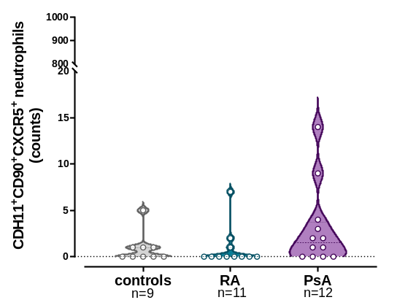

Supplementary Fig. 25. CD90⁺CDH11⁺ neutrophils expressing CCR4, CCR7, CXCR3 or CXCR5. Violin plots showing the counts of a) CCR4⁺, b) CCR7⁺, c) CXCR3⁺, and d) CXCR5⁺ CD90⁺CDH11⁺ neutrophils, across the study groups. Each point corresponds to an individual (grey plot= controls, n= 9; cyan plot= RA, n= 11; purple plot= PsA, n= 12). (n: number of individuals; RA: rheumatoid arthritis; PsA: psoriatic arthritis; CDH11: cadherin-11; PDPN: podoplanin)

a) b)
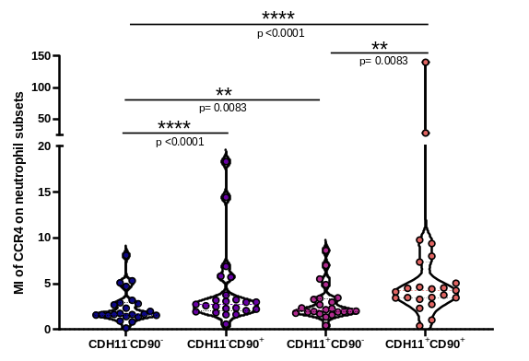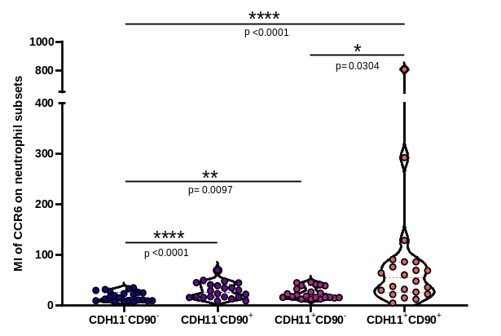
c) d)
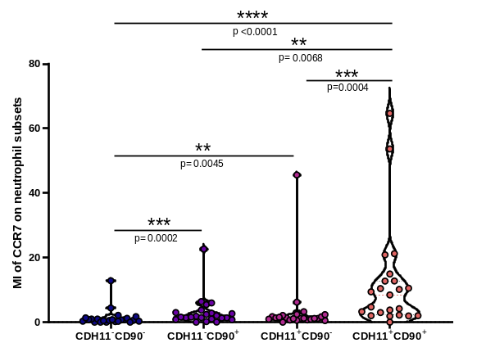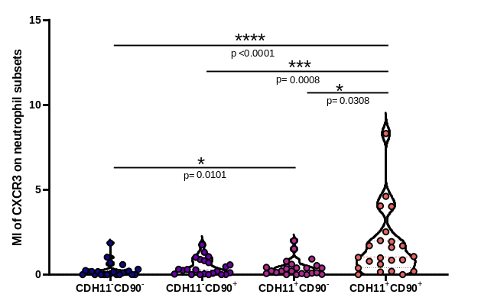

e)
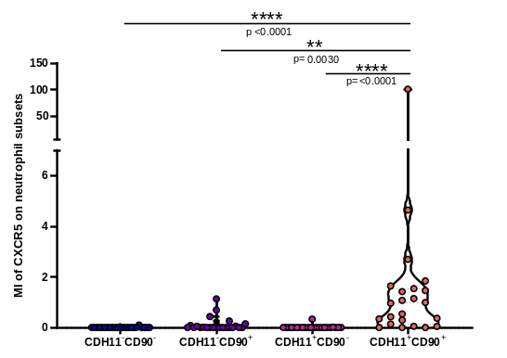

Supplementary Fig. 26. Chemokine receptors are preferentially overexpressed on CDH11⁺CD90⁺ neutrophils in patients. Violin plots showing the median expression (MI) of a) CCR4, b) CCR6, c) CCR7, d) CXCR3, and e) CXCR5 on CDH11⁻CD90⁻, CDH11⁻CD90⁺, cadherin-11⁺CD90⁻ and CDH11⁺CD90⁺ neutrophils, in patients with inflammatory arthritis (n= 23). Each point corresponds to an individual (CDH11: cadherin-11; *, p< 0.050; **, p≤ 0.010; ***, p≤ 0.001; ****, p≤ 0.0001)

a)
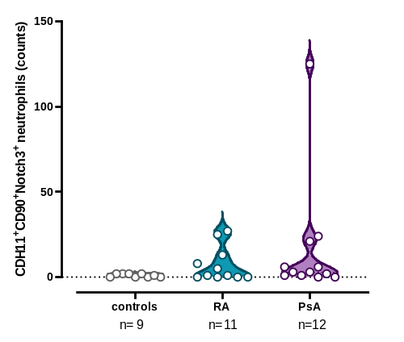

b) c)
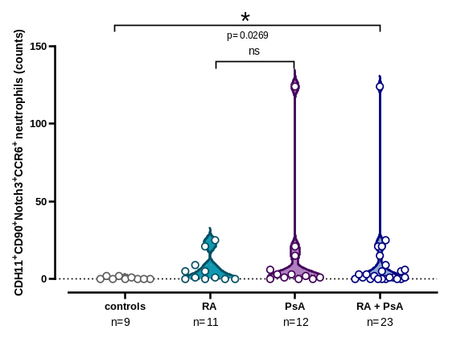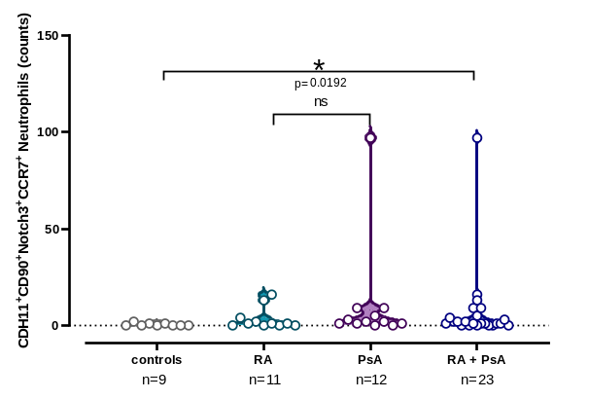

Supplementary Fig. 27. CCR6⁺ and CCR7⁺ CDH11⁺CD90⁺Notch3⁺ neutrophils are increased in patients. a) Violin plots showing the counts of CDH11⁺CD90⁺Notch3⁺ neutrophils, across the study groups. Each point corresponds to an individual. b) Violin plots showing the counts of CDH11⁺CD90⁺Notch3⁺CCR6⁺ neutrophils in patient groups and controls. Each point corresponds to an individual. c) Violin plots showing the counts of CDH11⁺CD90⁺Notch3⁺CCR7⁺ neutrophils in patient groups and controls. Each point corresponds to an individual (grey plot= controls, n= 9; cyan plot= RA, n= 11; purple plot= PsA, n= 12; blue plot= RA+PsA, n= 23). (n: number of individuals; RA: rheumatoid arthritis; PsA: psoriatic arthritis; CDH11: cadherin-11; ns: not significant; *, p< 0.050)

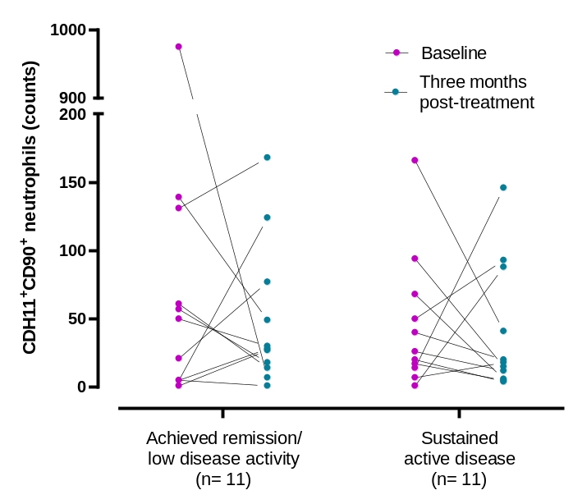

Supplementary Fig. 28. CDH11⁺CD90⁺ neutrophil counts in re-evaluated patients three months post-treatment are comparable to baseline, despite changes in disease activity. CDH11⁺CD90⁺ neutrophil counts in patients who became inactive (n= 11) or remained active (n= 11) post-treatment, measured at baseline and in their three-month follow-up. Each point corresponds to an individual patient (magenta points= baseline levels; cyan points= three months post-treatment levels). (CDH11: cadherin-11)

