Supplementary Materials

Supplementary Material 1. Description of the Outpatient Cardiac Rehabilitation Program
Supplementary Material 2. Protocol of the Visual-Approach/Avoidance-by-the-Self-Task
Supplementary Material 3. Measures of Additional Health-Related Variables
Supplementary Material 4. Self-Reported Physical Activity and Sedentary Behavior
Supplementary Material 5. Associations of Motivational and Health-Related Indicators with Daily Steps for One Week
Supplementary Material 6. Interaction Analyses
Supplementary Material 7. Sensitivity Analyses

Supplementary Material 1. Description of the Outpatient Cardiac Rehabilitation Program
The outpatient CR program adheres to the guidelines established by the Swiss Working Group for Cardiovascular Prevention, Rehabilitation, and Sports Cardiology (SCPRS), as outlined on www.SCPRS.ch. These guidelines are based on the core components of CR, which were recently updated by the European Association of Preventive Cardiology (Ambrosetti M et al., Eur J Prev Cardiol. 2020:2047487320913379). The ambulatory or outpatient cardiac rehabilitation (CR) program takes place over a period of six weeks, with sessions scheduled every morning of the 5 weekdays. The program comprises overall 78 training sessions of 45 minutes that emphasize endurance, strength, coordination/balance, outdoor activities, and relaxation techniques. In addition, there are also 12 educational sessions that provide information and material on disease comprehension, lifestyle modifications, medication information, dietary guidance, smoking cessation support, diabetic counseling, stress management, and psychological assessment when required. The outpatient CR program is not recommended for individuals dealing with complicated clinical or psychosocial situations, such as advanced age, reduced physical ability, impaired left ventricular function, comorbidities, or stressful home environments who are instead directed to an inpatient program.
Supplementary Material 2. Protocol of the Visual-Approach/Avoidance-by-the-Self-Task
The Visual-Approach/Avoidance-by-the-Self-Task (VAAST [1]) is a computerized reaction time task in which participants were asked to approach or avoid virtual stimuli displayed on the screen as quickly and accurately as possible . Specifically, participants were asked to react to the format (i.e., portrait vs landscape format) of the pictures depicting avatars in active (i.e., running position) and inactive (i.e., seating position) position using button press. Participants were instructed to approach the picture when it appears in a portrait format, and to avoid it when the picture appeared in a landscape format (the rule was counterbalanced between participants). Congruent with the participants’ approach or avoidance response, the whole visual environment zoomed in on the picture to simulate an approach movement and zoomed out to simulate an avoidance movement. A 30% change after the button press was used to give the impression of walking forward or backward as a consequence of the responses. See Cheval et al. [2] for more details about the task.

References
1. Rougier M, Muller D, Ric F, Alexopoulos T, Batailler C, Smeding A, et al. A new look at sensorimotor aspects in approach/avoidance tendencies: The role of visual whole-body movement information. Journal of Experimental Social Psychology. 2018;76:42–53.
2. Cheval B, Finckh A, Maltagliati S, Fessler L, Cullati S, Sander D, et al. Cognitive-bias modification intervention to improve physical activity in patients following a rehabilitation programme: protocol for the randomised controlled IMPACT trial. BMJ open. 2021;11(9):e053845.

Supplementary Material 3. Measures of Additional Health-Related Variables
Physical and mental health were evaluated through questionnaires for all participants and through objective indicators for outpatients exclusively.
Perceived global physical health was assessed using the PROMIS global physical health item: “In general, how would you rate your physical health?”, while global mental health was assessed using the following PROMIS item: “In general, how would you rate your mental health, including your mood and thinking skills?”. Participants responded on a scale from 1 (poor) to 5 (excellent).
Life satisfaction was assessed with the following PROMIS item: “In general, are you satisfied with your life?”. Participants responded on a scale ranging from 1 (very satisfied) to 7 (strongly dissatisfied). Scores were reversed in the analysis, so that higher scores indicated greater life satisfaction.
To measure functional dependence, we used the number of functional dependencies in 6 activities of daily living (ADL; dressing, walking, bathing, eating, getting in or out of bed, and using the toilet) and 7 instrumental activities of daily living (IADL; using a map, preparing a hot meal, shopping for groceries, using the telephone, taking medication, gardening or housework, and managing money) [2]. Higher scores indicated greater functional dependence.
Mobility was measured by the following three PROMIS items: “Do you have difficulty walking indoors?”, “Do you have difficulty walking outdoors?”, and “Do you have difficulty using the stairs?” Higher scores indicate less difficult mobility. The items were averaged (Cronbach's α =.80).
Abdominal circumference was assessed using a tape measure at end expiration to the nearest 0.1 cm at a horizontal level midway between the lower rib margin and the iliac crest.
Blood pressure was measured at the left arm using an automatic sphygmomanometer (Omron HEM-907, Kyoto, Japan) after 5 min of quite sitting position.
Glycated hemoglobin (HbA1c) was quantified by routine procedures at the Geneva University Hospitals’ laboratory.
Triglycerides and low-density lipoprotein-cholesterol concentration were measured using routine procedures at the Geneva University Hospitals’ laboratory.
Left ventricular ejection fraction was measured using routine procedures at the Geneva University Hospitals’ laboratory.
Cigarette consumption was self-reported using the following question “How many cigarettes do you smoke per day and for how many years?”
Indication for enrollment in the outpatient CR, presence of comorbidity was assessed using the patient’s electronic medical record from the Geneva University Hospitals’ laboratory.

Supplementary Materials 4. Self-Reported Physical Activity and Sedentary Behaviors
Table S1
Averaged Self-Reported Daily Physical Activity and Sedentary Levels During the First Week After the Rehabilitation Program and During a Usual Week for the Community-Dwelling Participants
Variable (min/day) | Outpatients  (N = 21*) | Controls  (N = 48*)
 | M (SD) | M (SD) | P value**
Sedentary | 275.83 (200.06) | 305 (200) | .577
Walking | 123.10 (85.99) | 131.80 (98.38) | .727
MVPA | 40.64 (37.47) | 62.62 (58.84) | .120
Meeting the weekly recommended level (150 min MVPA); n (%) | 14 (66.67%) | 33 (68.75%) | .310
Abbreviation. MVPA, moderate-to-vigorous physical activity; SD, standard deviation; min, minutes. *The sample size was reduced because some participants did not complete all the measures. **P value of the difference between the different participant types (outpatients vs. controls). Recommendation is of at least 150 minutes of MVPA aerobic physical activity a week.

Table S2. Associations of Motivational and Emotional Health-related Factors with Self-Reported Physical Activity and Sedentary Behaviors levels During the First Week After the Rehabilitation Program and During a Usual Week for the Community-Dwelling Participants
Outcome: MVPA |  | Univariate models  (N = 68) |  |  |  | Multivariate models  (N = 66)
 |  | b (95%CI) |  |  | P value | b (95%CI) |  |  | P value
Intercept |  |  |  |  |  | 60.67 (45.40; 75.94) |  |  | <.001
Participant type (ref. controls) |  |  |  |  |  | -9.38 (-39.77; 21.01) |  |  | .540
Outpatients |  | -21.97 (-49.81; 5.90) |  |  | .120
Age |  | - 3.63 (-19.96; 12.71) |  |  | .659
Sex (ref. female)
Male |  | 5.97 (-20.13; 32.07) |  |  | .649
Body mass index |  | -5.17 (-18.12; 7.77) |  |  | .428
Intention |  | -1.02 (-9.75; 7.71) |  |  | .816
Perceived capabilities |  | 16.01 (-0.31; 32.34) |  |  | .054
Instrumental attitudes |  | 11.41 (0.80; 23.62) |  |  | .067
Affective attitudes |  | 14.93 (2.09; 27.76) |  |  | .023 | 13.07 (-0.22; 26.37) |  |  | .054
R² adjusted |  | 0.06
Approach toward PA |  | -13.84 (-27.55; -0.11) |  |  | .048 | -10.82 (-24.57; 2.93) |  |  | .121
R² adjusted |  | .05
Approach toward SB |  | 4.94 (-9.69; 19.57) |  |  | .502
Depressive symptoms |  | -1.76 (-14.91; 11.39) |  |  | .790
Anxiety |  | -4.63 (-17.93; 8.67) |  |  | .489
Fatigue |  | -7.38 (-20.53; 5.79) |  |  | .267
Pain intensity |  | -1.44 (-14.44; 11.56) |  |  | .826
R² adjusted for the multivariate model |  |  |  |  |  | 0.09
Outcome: SB |  | Univariate models  (N = 68) |  |  |  | Multivariate models  (N = 66)
 |  |  | b (95%CI) | P value |  |  | b (95%CI) | P value
Intercept
Participant type (ref. controls)
Outpatients |  | -29.34 (-133.70; 75.03) |  |  | .577
Age |  | 0.47 (-59.83; 60.76) |  |  | .988
Sex (ref. female)
Male |  | 39.91 (-55.96; 135.78) |  |  | .409
Body mass index |  | 27.29 (-19.38; 73.95) |  |  | .247
Intention |  | 6.48 (-39.27; 52.22) |  |  | .779
Perceived capabilities |  | 46.31 (-14.67; 107.28) |  |  | .134
Instrumental attitudes |  | 17.23 (-28.85; 63.31) |  |  | .458
Affective attitudes |  | -9.88 (-59.13; 39.36) |  |  | .690
Approach toward PA |  | -15.86 (-67.35; 35.62) |  |  | .540
Approach toward SB |  | -48.75 (-100.90, 3.41) |  |  | .066
Depressive symptoms |  | 41.85 (-5.66; 89.36) |  |  | .083
Anxiety |  | 39.64 (-8.69; 87.96) |  |  | .106
Fatigue |  | 17.62 (-31.29; 66.53) |  |  | .475
Pain intensity |  | -44.39 (-91.18; 2.40) |  |  | .063
 |  |  |  |  |  |  |  |  | (continued)

Table S2. (continued)
Outcome: Meeting the recommended levels of MVPA |  | Univariate models  (N = 68) |  |  |  | Multivariate models  (N = 68)
 |  |  | b (95%CI) | P value |  |  | b (95%CI) | P value
Intercept |  |  |  |  |  | 1.95 (1.71; 2.22) |  |  | <.001
Participant type (ref. controls)
Outpatients |  | 0.98 (0.77; 1.25) |  |  | .867 | 1.01 (0.79; 1.29) |  |  | .931
Age |  | 1.08 (0.94; 1.24) |  |  | .299
Sex (ref. female)
Male |  | 0.31 (0.87; 1.36) |  |  | .493
Body mass index |  | 0.90 (0.81; 1.00) |  |  | .066
Intention |  | 1.02 (0.92; 1.14) |  |  | .689
Perceived capabilities |  | 1.11 (0.96; 1.28) |  |  | .156
Instrumental attitudes |  | 1.12 (1.01; 1.24) |  |  | .042 | 1.02 (0.89; 1.17) |  |  | .748
Affective attitudes |  | 1.17 (1.05; 1.30) |  |  | .005 | 1.15 (1.00; 1.33) |  |  | .060
Overall attitudes |  |  |  |  |  | 1.16 (1.04; 1.29) |  |  | .008
Approach toward PA |  | 0.93 (0.83; 1.04) |  |  | .224
Approach toward SB |  | 1.06 (0.94; 1.19) |  |  | .382
Depressive symptoms |  | 0.99 (0.88; 1.10) |  |  | .861
Anxiety |  | 1.03 (0.91; 1.15) |  |  | .768
Fatigue |  | 0.93 (0.83; 1.04) |  |  | .232
Pain intensity |  | 0.96 (0.86; 1.07) |  |  | .458
Abbreviation. MVPA, moderate-to-vigorous physical activity; PA, physical activity; 95%CI, Confidence interval at 95%. The adjusted model includes only the significant predictors of the univariate models, with the exception of the participants type (i.e., outpatients vs. controls) which was adjusted for. Because instrumental and affective attitudes exhibited a strong correlation (r = 0.66), we have created an overall of attitudes score that was used in the multivariate analyses.

Supplementary Materials 5. Associations of Motivational and Health-Related Indicators with Daily Steps for One Week
Table S3
Associations of Motivational and Emotional Health-Related Factors with Daily Steps During the First Week After the Rehabilitation Program and During a Usual Week for the Community-Dwelling Participants
Outcome: daily steps | Univariate models  (N = 58) |  | Multivariate model  (N = 58)
 | b (95% CI) | P value | b (95% CI) | P value
Intercept |  |  | 8339.76 (7168.24; 9511.27) | .435
Participant type (ref. controls)
Outpatients | 1297.98 (-875.22, 3471.18) | .237 | 1313.8 (-842.6; 3470.2) | .227
Age | -393.73 (-1681.76; 894.29) | .543
Sex (ref. female)
Male | -991.57 (-2982.28; 999.14) | .323
Body mass index | -511.84 (-1706.17; 682.49) | . 394
Intention | 824.61 (-135.70; 1784.91) | .091
Perceived capabilities | 1014.96 (-262.81; 2292.72) | .095
Instrumental attitudes | 456.26 (-466.57; 1379.10) | . 326
Affective attitudes | 1314.57 (190.65; 2438.49) | .023 | 1297.69 (177.96; 2417.42) | .024
R² adjusted | 0.07
Approach toward PA | 421.64 (-486.28; 1329.56) | .356
Approach toward SB | 245.32 (-643.83; 1134.47) | .582
Depressive symptoms | 175.10 (-894.52; 1244.73) | .744
Anxiety | 81.75 (-939.69; 1103.19) | .873
Fatigue | -155.53 (-1445.63; 1134.56) | .810
Pain intensity | -91.90 (-1084.46; 900.67) | .853
R² adjusted for the multivariate model |  |  | 0.08
Abbreviation. PA, physical activity; 95% CI, Confidence interval at 95%. The adjusted model includes only the significant predictors of the univariate models, with the exception of the participants sample (i.e., patients versus control) which was adjusted for. The R² adjusted were calculated only for statistically significant predictors.

Supplementary Material 6. Interaction Analyses
Table S4. Interaction Between Predictors of Physical Activity and Sedentary Behavior Levels and Participant Type (i.e., Outpatients vs. Controls)
Outcome: daily MVPA | b (95% CI) | P value
Affective attitudes | 10.32 (1.09; 19.55) | .029
Participant type (ref. control) | 18.43 (1.10; 35.77) | .038
Affective attitudes × Participant type | 4.96 (-23.63; 33.54) | .729
Outcome: daily SB | b (95% CI) | P value
Sex (ref. female) | 47.54 (11.41; 83.67) | .011
Pain intensity | -20.44 (-38.66; -2.22) | .029
Participant type (ref. control) | -3.57 (-45.75; 38.61) | .866
Sex × Participant type | 17.62 (-68.72; 103.96) | .684
Pain intensity × Participant type | 17.69 (-32.51; 67.88) | .483
Outcome: Meeting the PA recommendations | OR (95% CI) | P value
Perceived capabilities | 1.33 (1.03; 1.33) | .030
Instrumental attitudes | 1.11 (1.03; 1.19) | .006
Affective attitudes | 1.14 (1.07; 1.22) | <.001
Participant type (ref. control) | 1.18 (0.93; 1.50) | .175
Perceived capabilities × Participant type | 0.98 (0.74; 1.30) | .905
Instrumental attitudes × Participant type | 0.88 (0.66; 1.17) | .390
Affective attitudes × Participant type | 0.92 (0.75; 1.13) | .443
Abbreviation. MVPA, moderate-to-vigorous physical activity; SB, sedentary behavior; 95% CI, Confidence interval at 95%. The same interactions were computed for multivariate models and remained non-significant (p > .05, see https://doi.org/10.5281/zenodo.11072811 for the analyses).
Supplementary Material 7. Sensitivity Analyses
Figure S1. Sensitivity Analyses for Linear Regressions
A shows that with an alpha level of .05 and a sample size of 59 participants, the minimum effect size the present study can detect with 90% power is f² = 0.18 or R² = 0.16. B shows that, for univariate regression, the sensitivity curve showed that our study had between 33% and 90% power of detecting an effect size between f² = 0.04; or R² = 0.04 and f² = 0.18; or R² = 0.16, respectively. C shows that, for multivariate regression with two predictors (i.e., affective attitudes and participant type), the present study had between 33% and 90% power of detecting an effect size between f² = 0.06; or R² = 0.06 and f² = 0.25; or R² = 0.20, respectively. D shows that, for multivariate regression analyses with three predictors (i.e., sex, pain intensity, participant type), the present study had between 33% and 90% power of detecting an effect size between f² = 0.07; or R² = 0.06 and f² =.029; or R² = 0.23, respectively.

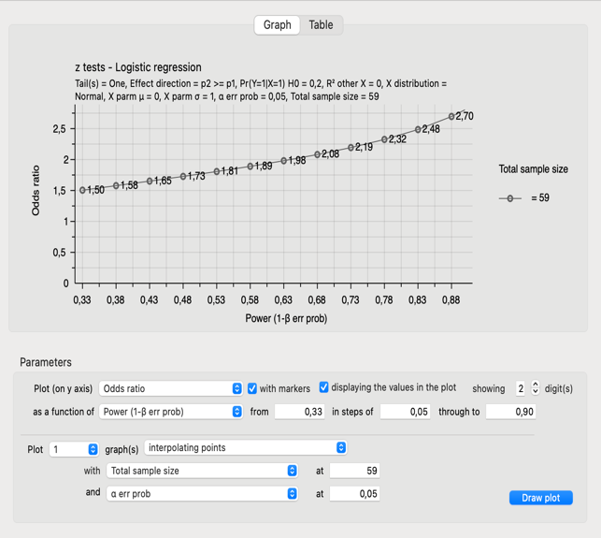
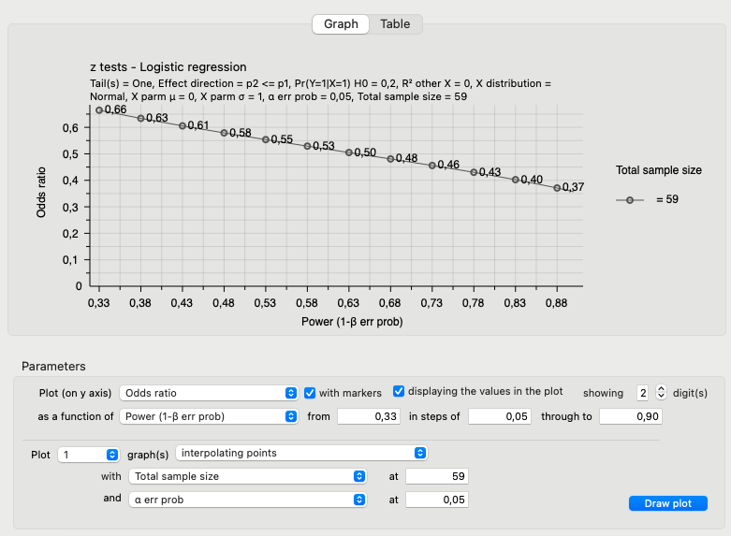
Figure S2. Sensitivity Analyses for Logistic Regressions
A shows that for a logistic regression, with an alpha level of .05 and a sample size of 59 participants (i.e., number of participants with complete device-based data), the present study had between 33% and 90% power of detecting an effect size between OR =1.50 and OR = 2.70, respectively. B shows that, for multivariate regression analyses with two predictors, the present study had 33% power of detecting an effect size of ~f² =.06 or R² = .06.

