Supplementary Materials for

Virome compositions indicate that viral spillover is a dead-end between the western honey bee (Apis mellifera) and the common eastern bumblebee (Bombus impatiens)
Dean McKeown et al.

*Corresponding author. Email: dcschroe@umn.edu

This PDF file includes:

Figs. S1 to S13
Tables S1 to S2

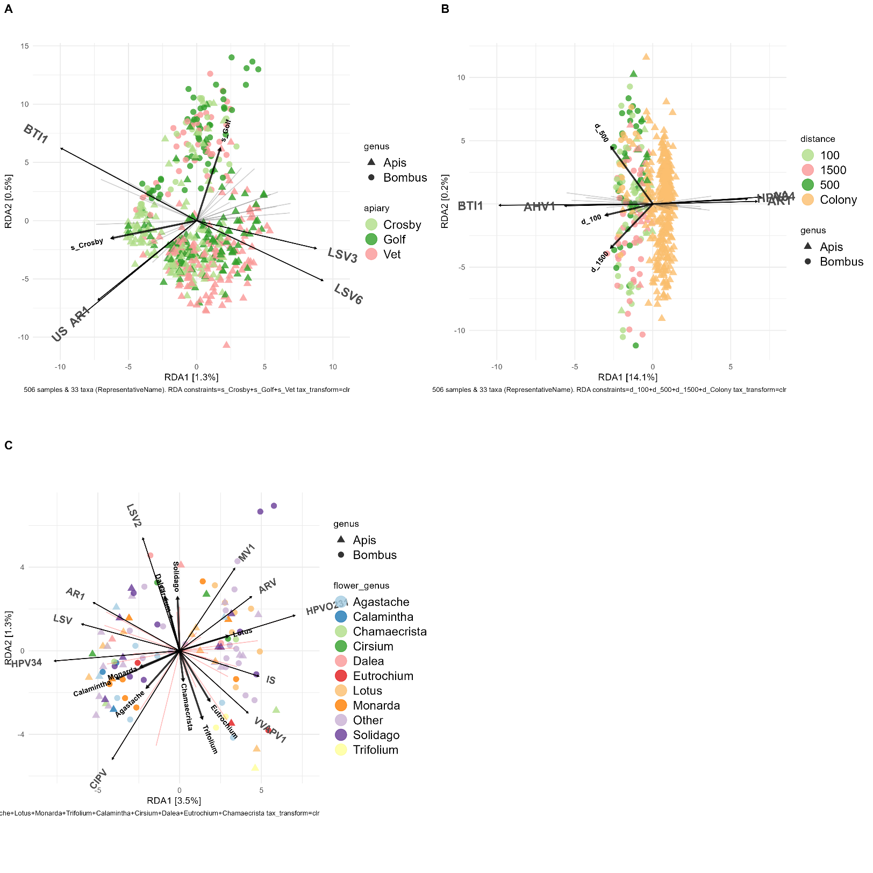
Fig. S1. PCA with redundancy analyses constraints of bee collection. Plots for apiary. (A), distance of collection from apiary (B), and flower genus collected from (C). Taxa influencing point distribution are labeled, as well as variables. AHV1 = allermuir hill virus 1, AR1 = apis rhabdovirus 1, BTI1 = bactrocera tryoni iflavirus 1, CIPV = cyclosorus interruptus picorna-like virus, HPV34 = hubei partiti-like virus 34, IS = Iflavirus sacbroodi, LSV = lake sinai virus, LSV2 = Lake Sinai virus 2, LSV3 = lake sinai virus 3, LSV6 = lake sinai virus 6, US = unclassified sinaivirus, VVAPV1 = vespa velutina associated permutotetra-like virus 1.
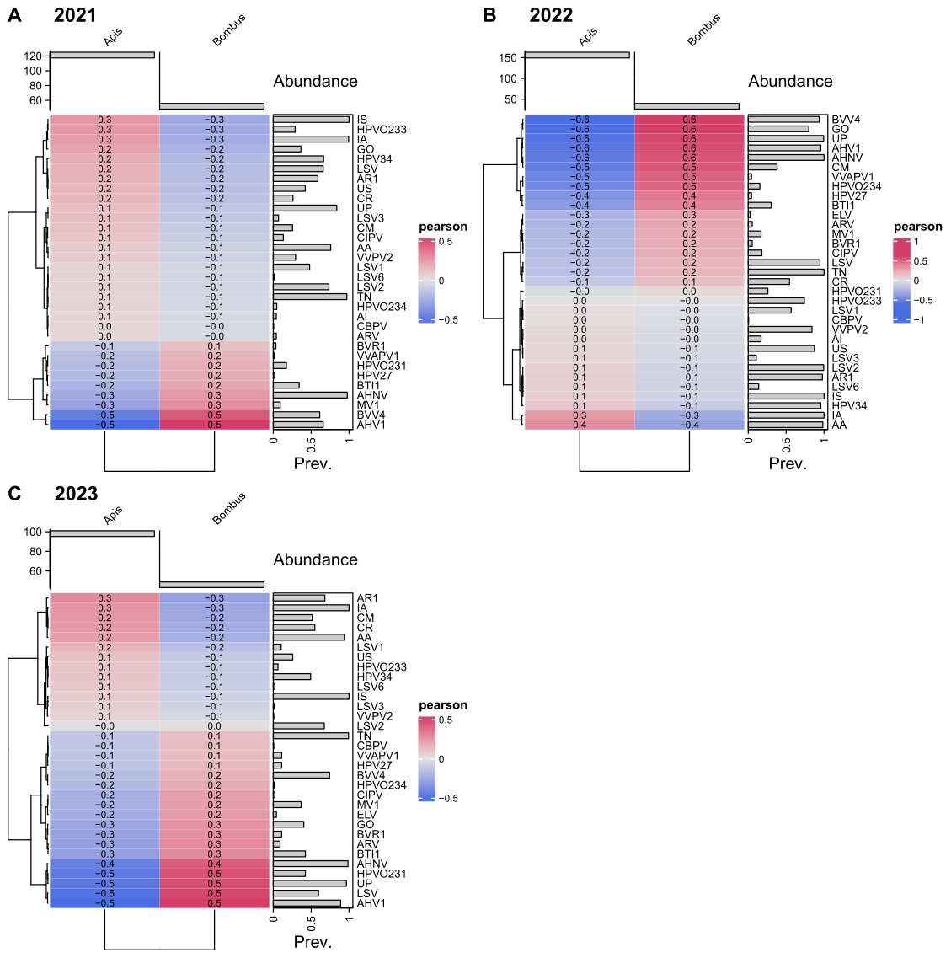
Fig. S2. Correlation heatmaps of viral reads mapped against classified viral contigs. Shown across collection years 2021 (A), 2022 (B), and 2023 (C) for A. mellifera (Apis) and B. impatiens (Bombus). Abundance refers to the number of samples sequenced. AA = Aparavirus apisacutum, AHNV = andrena haemorrhoa nege-like virus, AHV1 = allermuir hill virus 1, AI = Aparavirus israelense, AR1 = apis rhabdovirus 1, ARV = agassiz rock virus, BTI1 = bactrocera tryoni iflavirus 1, BVR1 = bombus-associated virus reo1, BVV4 = bombus-associated virus vir4, CBPV = chronic bee paralysis virus, CIPV = cyclosorus interruptus picorna-like virus, CM = Cripavirus mortiferum, CR = Cripavirus ropadi, ELV = elf loch virus, GO = ganda orthophasmavirus, HPV27 = hubei picorna-like virus 27, HPV34 = hubei partiti-like virus 34, HPVO231 = hymenopteran phasma-related virus OKIAV231, HPVO233 = hymenopteran phasma-related virus OKIAV233, HPVO234 = hymenopteran phasma-related virus OKIAV234, IA = Iflavirus aladeformis, IS = Iflavirus sacbroodi, LSV = lake sinai virus, LSV1 = Lake Sinai virus 1, LSV2 = Lake Sinai virus 2, LSV3 = lake sinai virus 3, LSV6 = lake sinai virus 6, MV1 = mayfield virus 1, TN = Triatovirus nigereginacellulae, UP = unclassified phasmaviridae, US = unclassified sinaivirus, VVAPV1 = vespa velutina associated permutotetra-like virus 1, VVPV2 = vespa velutina partiti-like virus 2.
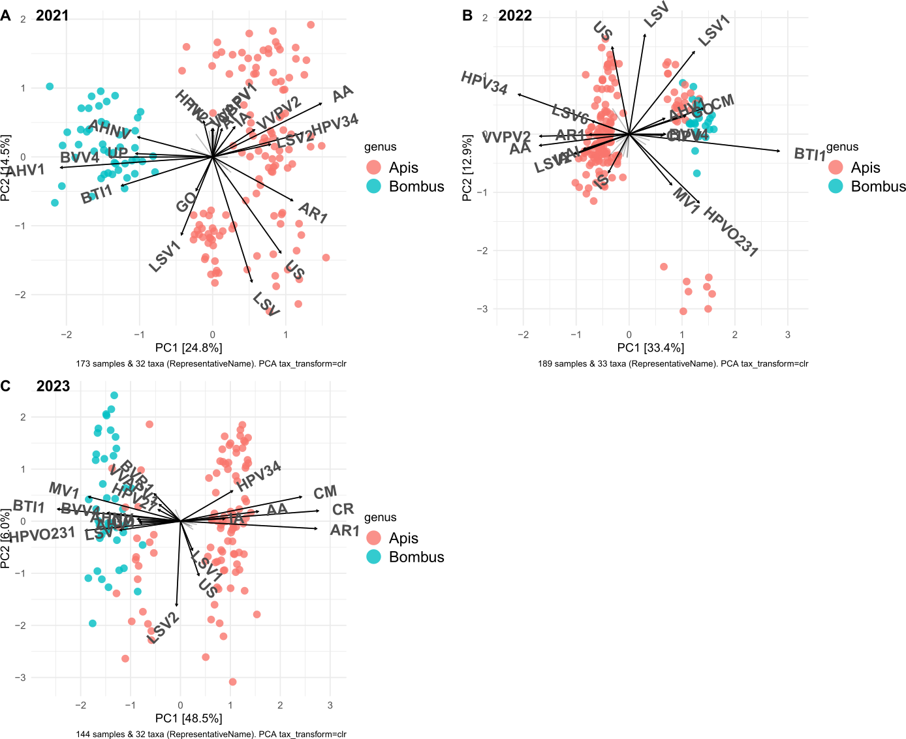

Fig. S3. PCA of bee collection year. Taxa influencing point distributions are labeled for 2021 (A), 2022 (B), and 2023 (C) for A. mellifera (Apis) and B. impatiens (Bombus). AA = Aparavirus apisacutum, AHNV = andrena haemorrhoa nege-like virus, AHV1 = allermuir hill virus 1, AI = Aparavirus israelense, AR1 = apis rhabdovirus 1, ARV = agassiz rock virus, BTI1 = bactrocera tryoni iflavirus 1, BVR1 = bombus-associated virus reo1, BVV4 = bombus-associated virus vir4, CM = Cripavirus mortiferum, CR = Cripavirus ropadi, GO = ganda orthophasmavirus, HPV27 = hubei picorna-like virus 27, HPV34 = hubei partiti-like virus 34, HPVO231 = hymenopteran phasma-related virus OKIAV231, HPVO233 = hymenopteran phasma-related virus OKIAV233, IA = Iflavirus aladeformis, IS = Iflavirus sacbroodi, LSV = lake sinai virus, LSV1 = Lake Sinai virus 1, LSV2 = Lake Sinai virus 2, MV1 = mayfield virus 1, VVAPV1 = vespa velutina associated permutotetra-like virus 1, VVPV2 = vespa velutina partiti-like virus 2.
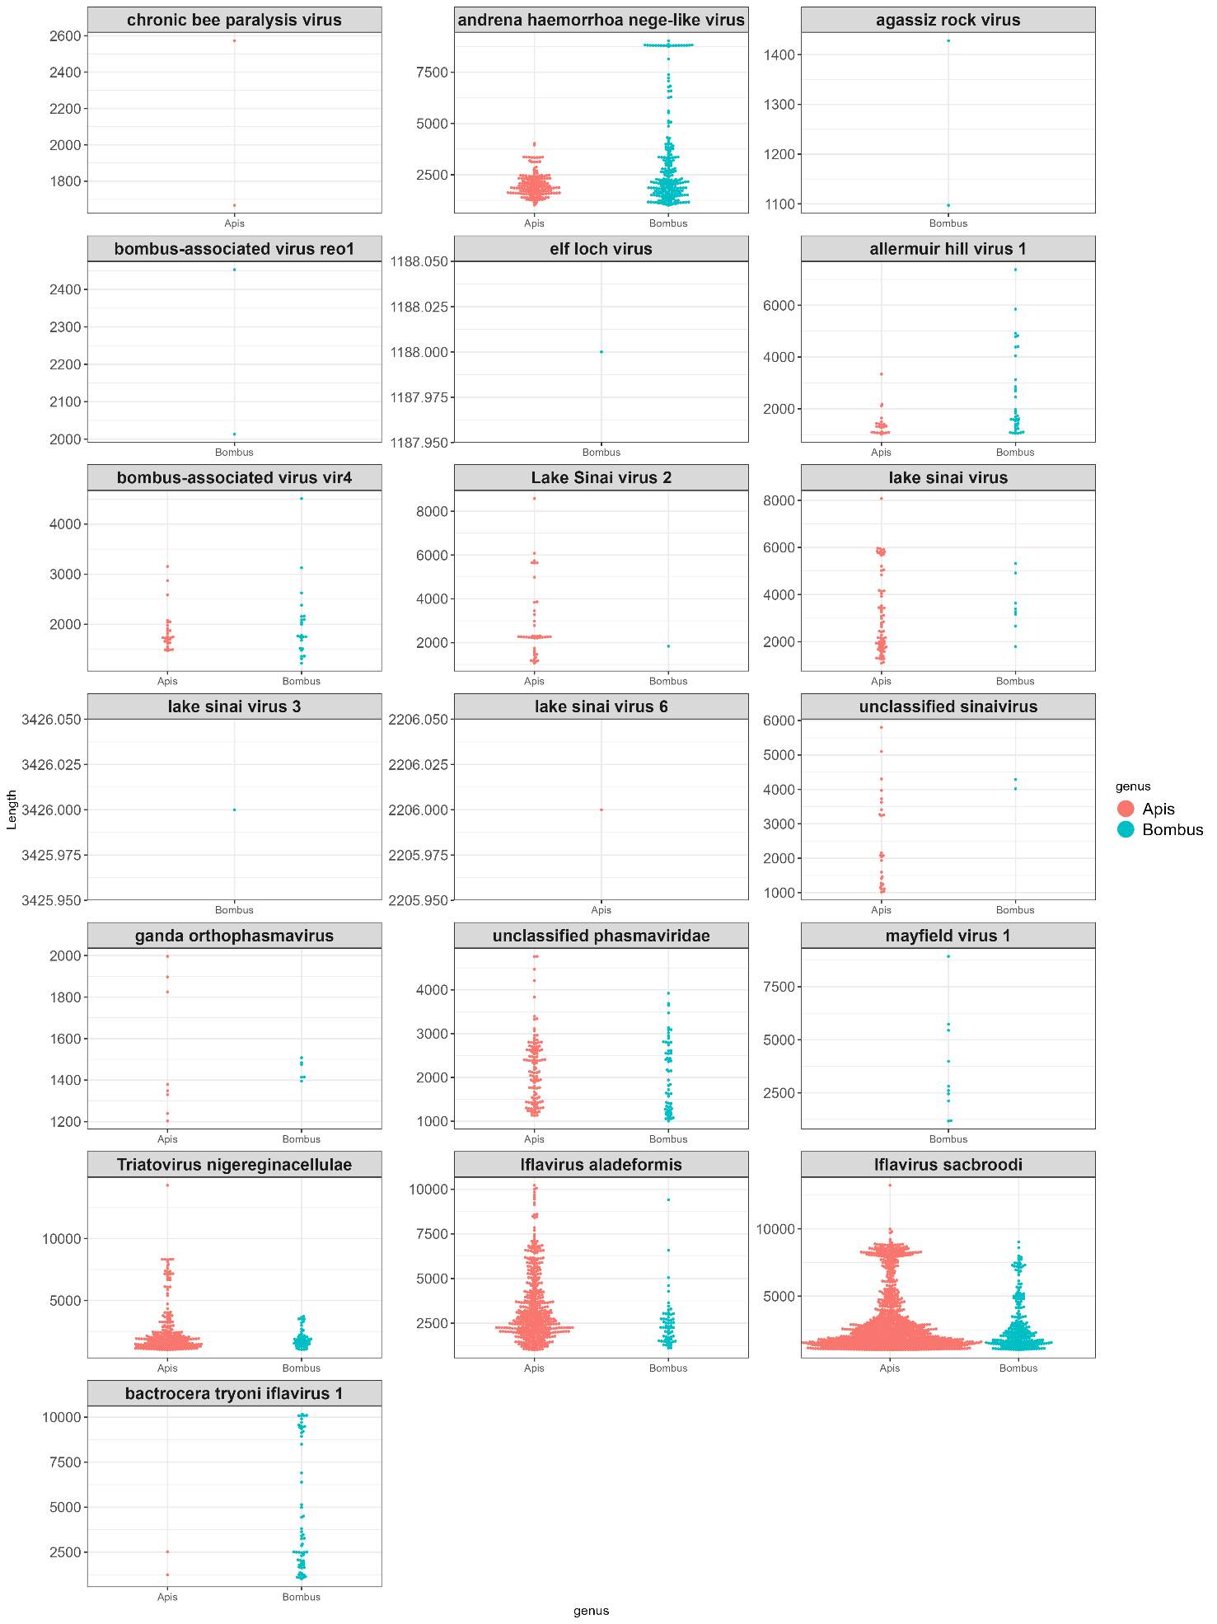
Fig. S4. Viral contig size distribution. Contig length (y axis) is shown in bp for A. mellifera (Apis) and B. impatiens (Bombus).
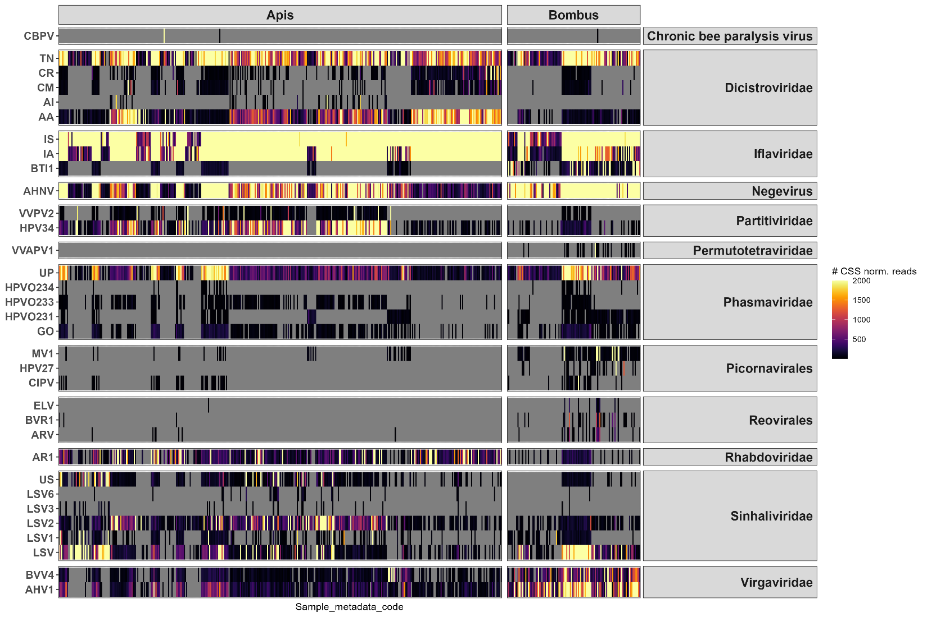
Fig. S5. Reads mapped to classified viral contigs. 389 Apis mellifera (Apis) samples, 117 Bombus impatiens (Bombus) samples. Read counts are (scaled to library size by cumulative sum scale normalisation). Individual samples occupy the x axis (labels not shown). AA = Aparavirus apisacutum, AHNV = andrena haemorrhoa nege-like virus, AHV1 = allermuir hill virus 1, AI = Aparavirus israelense, AR1 = apis rhabdovirus 1, ARV = agassiz rock virus, BTI1 = bactrocera tryoni iflavirus 1, BVR1 = bombus-associated virus reo1, BVV4 = bombus-associated virus vir4, CBPV = chronic bee paralysis virus, CIPV = cyclosorus interruptus picorna-like virus, CM = Cripavirus mortiferum, CR = Cripavirus ropadi, ELV = elf loch virus, GO = ganda orthophasmavirus, HPV27 = hubei picorna-like virus 27, HPV34 = hubei partiti-like virus 34, HPVO231 = hymenopteran phasma-related virus OKIAV231, HPVO233 = hymenopteran phasma-related virus OKIAV233, HPVO234 = hymenopteran phasma-related virus OKIAV234, IA = Iflavirus aladeformis, IS = Iflavirus sacbroodi, LSV = lake sinai virus, LSV1 = Lake Sinai virus 1, LSV2 = Lake Sinai virus 2, LSV3 = lake sinai virus 3, LSV6 = lake sinai virus 6, MV1 = mayfield virus 1, TN = Triatovirus nigereginacellulae, UP = unclassified phasmaviridae, US = unclassified sinaivirus, VVAPV1 = vespa velutina associated permutotetra-like virus 1, VVPV2 = vespa velutina partiti-like virus 2.
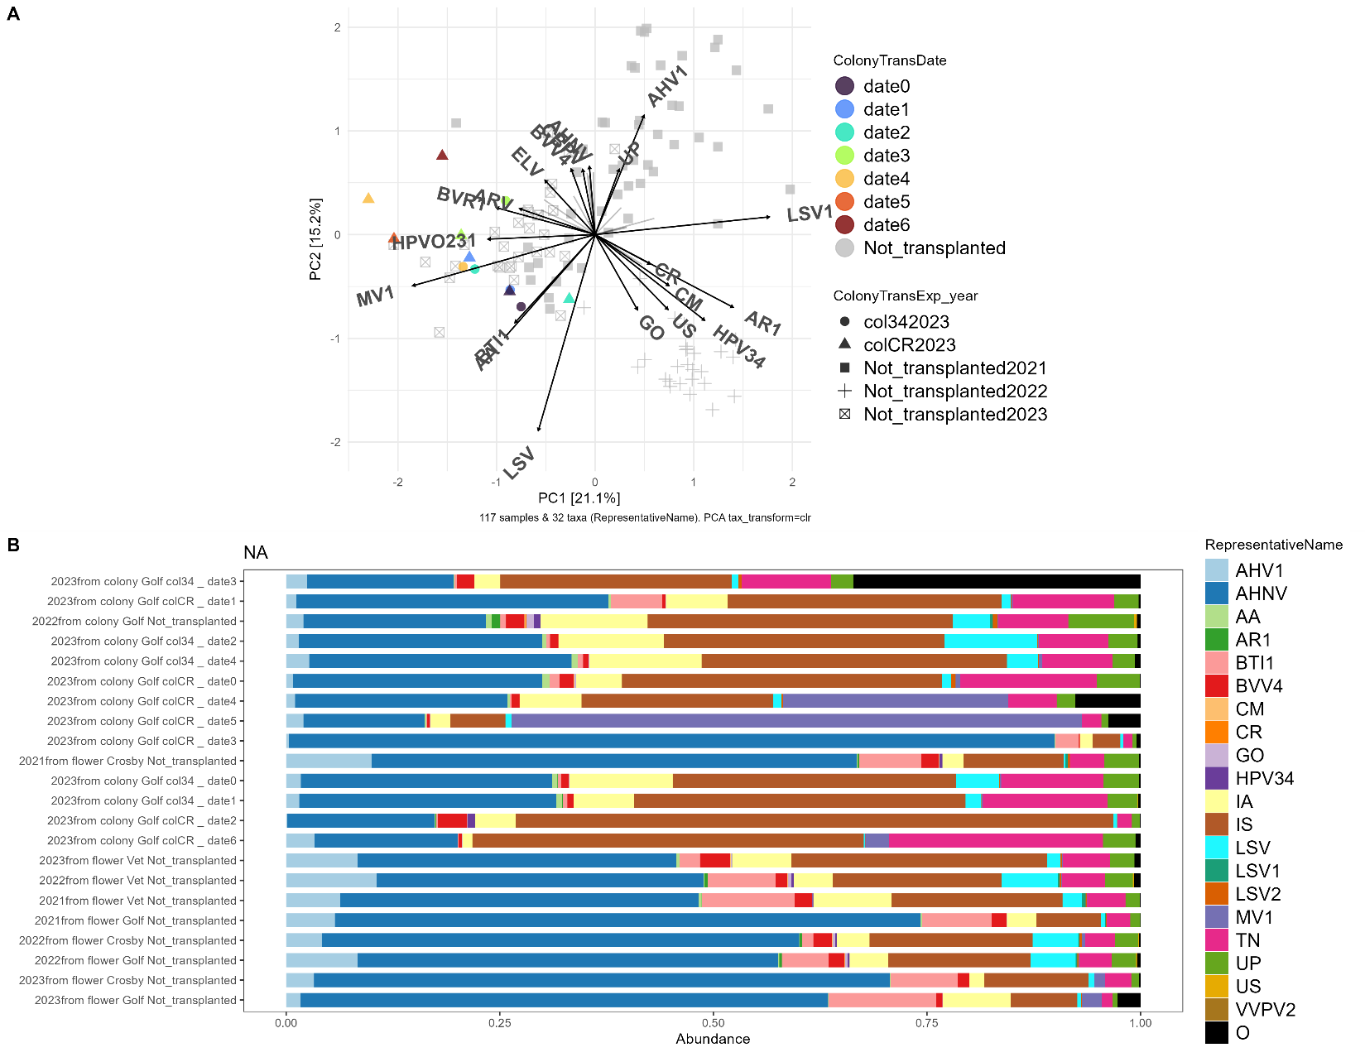
Fig. S6. Analyses of transplanted B. impatiens colonies. (A) Unconstrained PCA of samples coloured by the transplantation time point (ColonyTransDate) and treatment (col34 and colCR are the two transplanted colonies, Not_transplanted are samples collected from flowers). Taxa influencing point distribution are labelled, as well as variables. AA = Aparavirus apisacutum, AHNV = andrena haemorrhoa nege-like virus, AHV1 = allermuir hill virus 1, AI = Aparavirus israelense, AR1 = apis rhabdovirus 1, ARV = agassiz rock virus, BTI1 = bactrocera tryoni iflavirus 1, BVR1 = bombus-associated virus reo1, BVV4 = bombus-associated virus vir4, CBPV = chronic bee paralysis virus, CIPV = cyclosorus interruptus picorna-like virus, CM = Cripavirus mortiferum, CR = Cripavirus ropadi, ELV = elf loch virus, GO = ganda orthophasmavirus, HPV27 = hubei picorna-like virus 27, HPV34 = hubei partiti-like virus 34, HPVO231 = hymenopteran phasma-related virus OKIAV231, HPVO233 = hymenopteran phasma-related virus OKIAV233, HPVO234 = hymenopteran phasma-related virus OKIAV234, IA = Iflavirus aladeformis, IS = Iflavirus sacbroodi, LSV = lake sinai virus, LSV1 = Lake Sinai virus 1, LSV2 = Lake Sinai virus 2, LSV3 = lake sinai virus 3, LSV6 = lake sinai virus 6, MV1 = mayfield virus 1, TN = Triatovirus nigereginacellulae, UP = unclassified phasmaviridae, US = unclassified sinaivirus, VVAPV1 = vespa velutina associated permutotetra-like virus 1, VVPV2 = vespa velutina partiti-like virus 2, O = Others. (B) Compositions of viral communities in Bombus from flowers (Not_transplanted) and transplanted colonies (colCR and col34). Relative abundances of viruses are merged by experimental treatment.
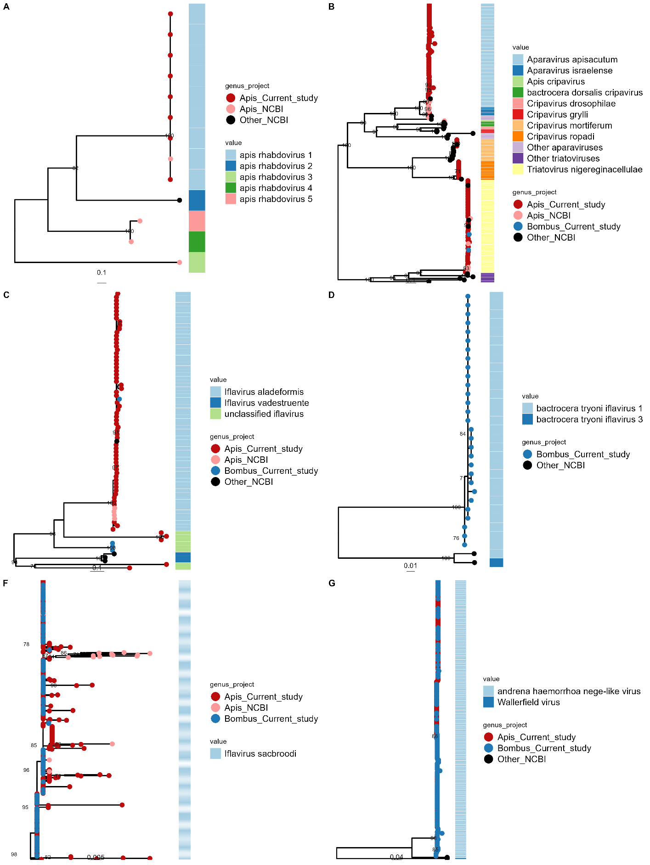
Fig. S7. Maximum likelihood phylogeny of viral RNA dependent RNA polymerases recovered from A. mellifera (Apis) and B. impatiens (Bombus). Tree constructed using amino acid sequence in IQTREE with 1000 bootstrap replications. Only bootstrap node values >70 are shown. Trees include (A) (Pfam PF00946) of apis rhabdovirus, (B) Dicistroviridae (Pfam PF00680), (C) Iflavirus aladeformis (Pfam PF00680), (D) bactrocera tryoni iflaviruses (Pfam PF00680), (E) Iflavirus sacbroodi (Pfam PF00680), (F) nege-like virus (Pfam PF00978).
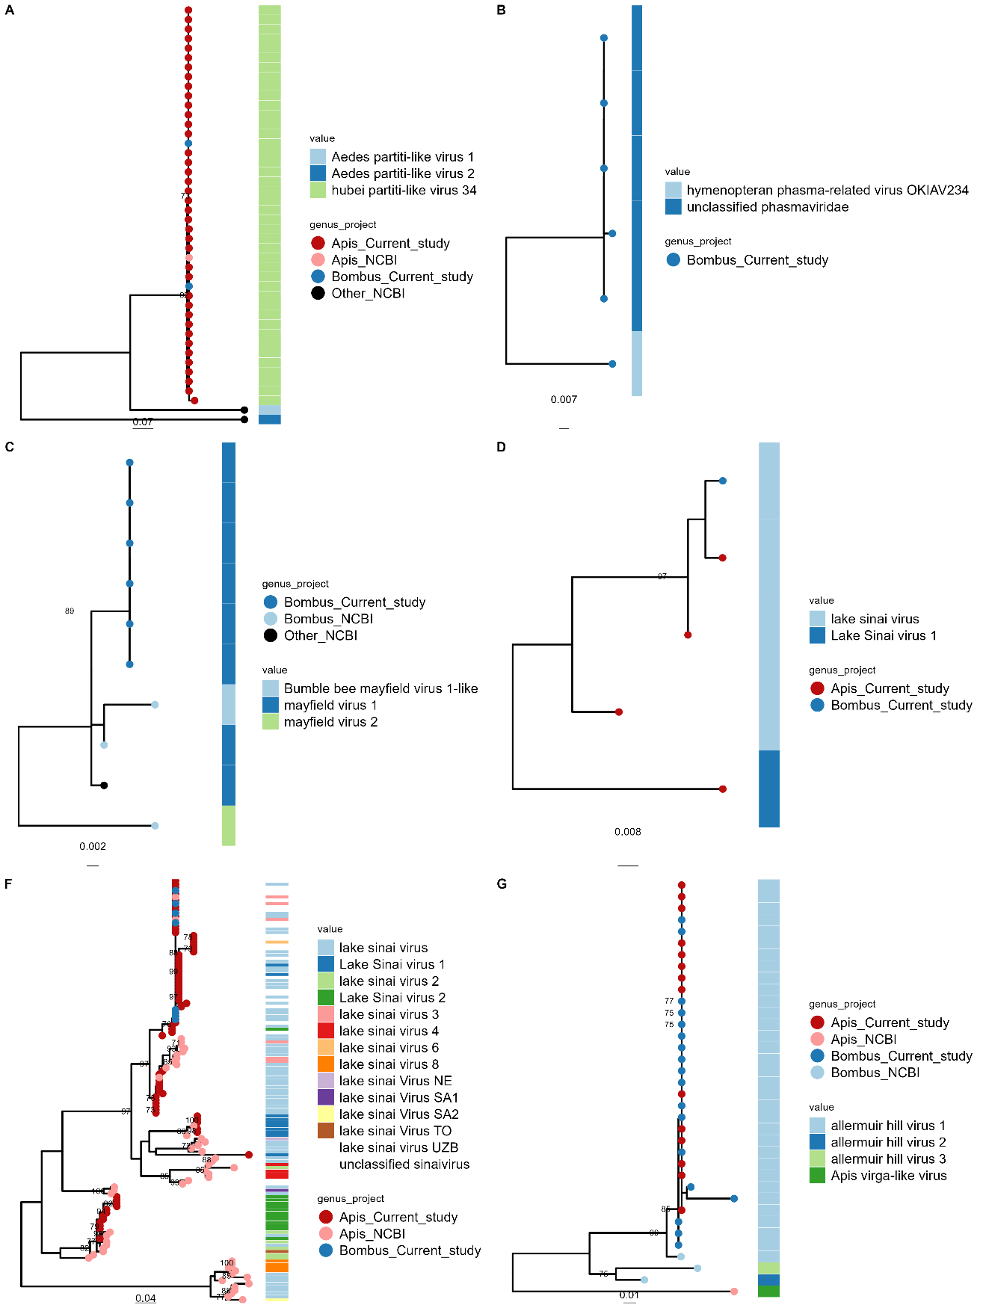
Fig. S8. Maximum likelihood phylogeny of viral RNA dependent RNA polymerases recovered from A. mellifera (Apis) and B. impatiens (Bombus). Tree constructed using amino acid sequence in IQTREE with 1000 bootstrap replications. Only bootstrap node values >70 are shown. Trees include (A) partiti-like virus (Pfam PF00978), (B) unclassified phasmaviridae (Pfam PF04196), (C) picorna-like (Pfam PF00680), (D) Sinaivirus (Pfam PF00978), (E) Sinaivirus (Pfam PF00998), (F) virga-like (Pfam PF00978).

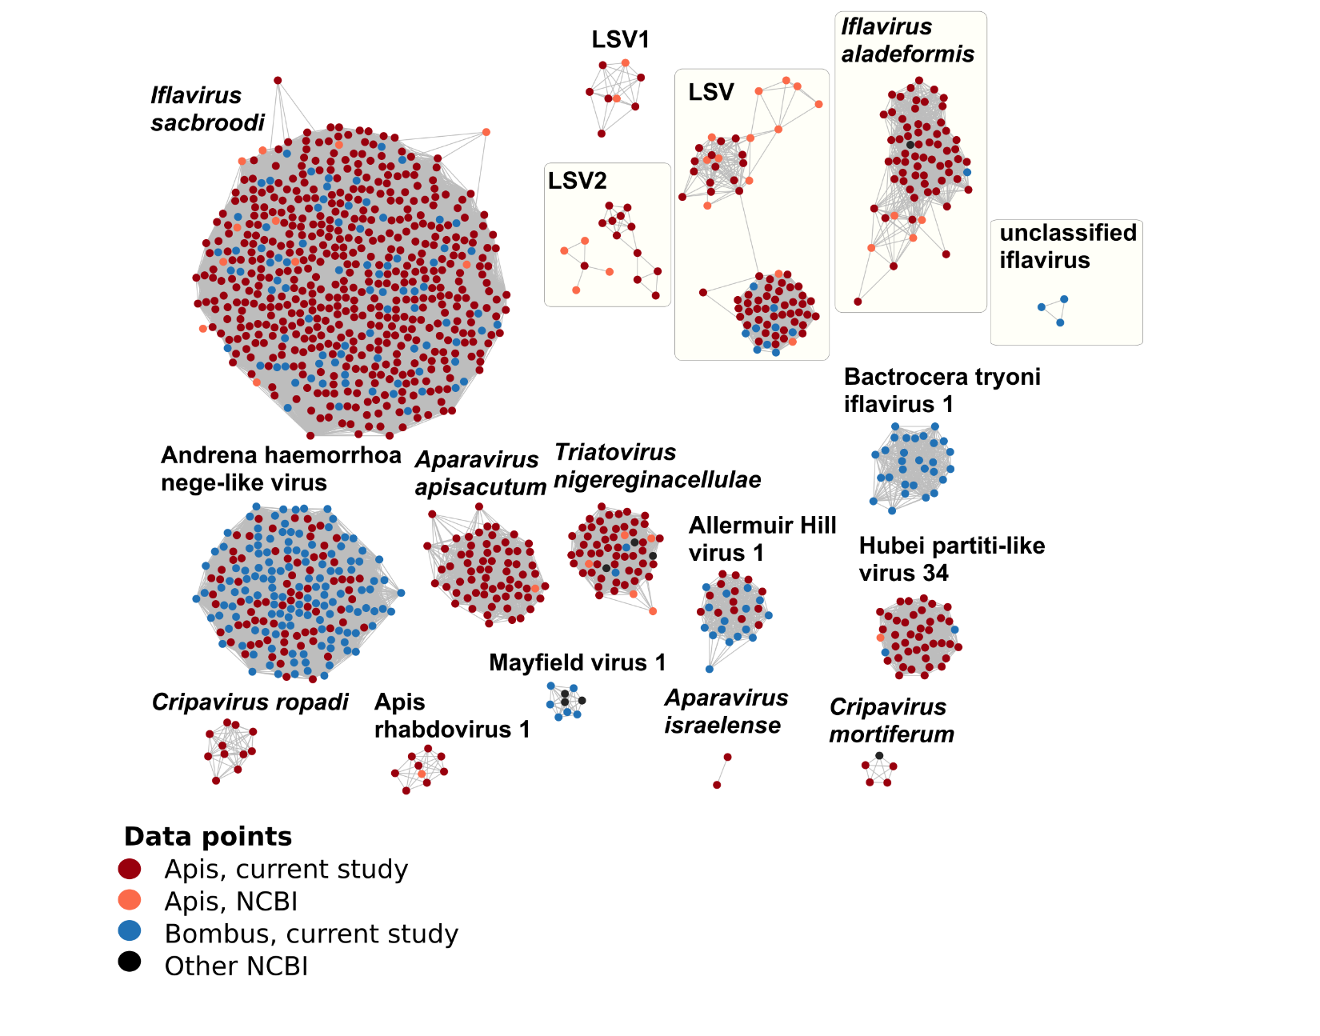
Fig. S9. Similarity network of viral RNA dependent RNA polymerase recovered from A. mellifera (Apis) and B. impatiens (Bombus). Only edges over 98 % BLASTp identity similarity are shown.

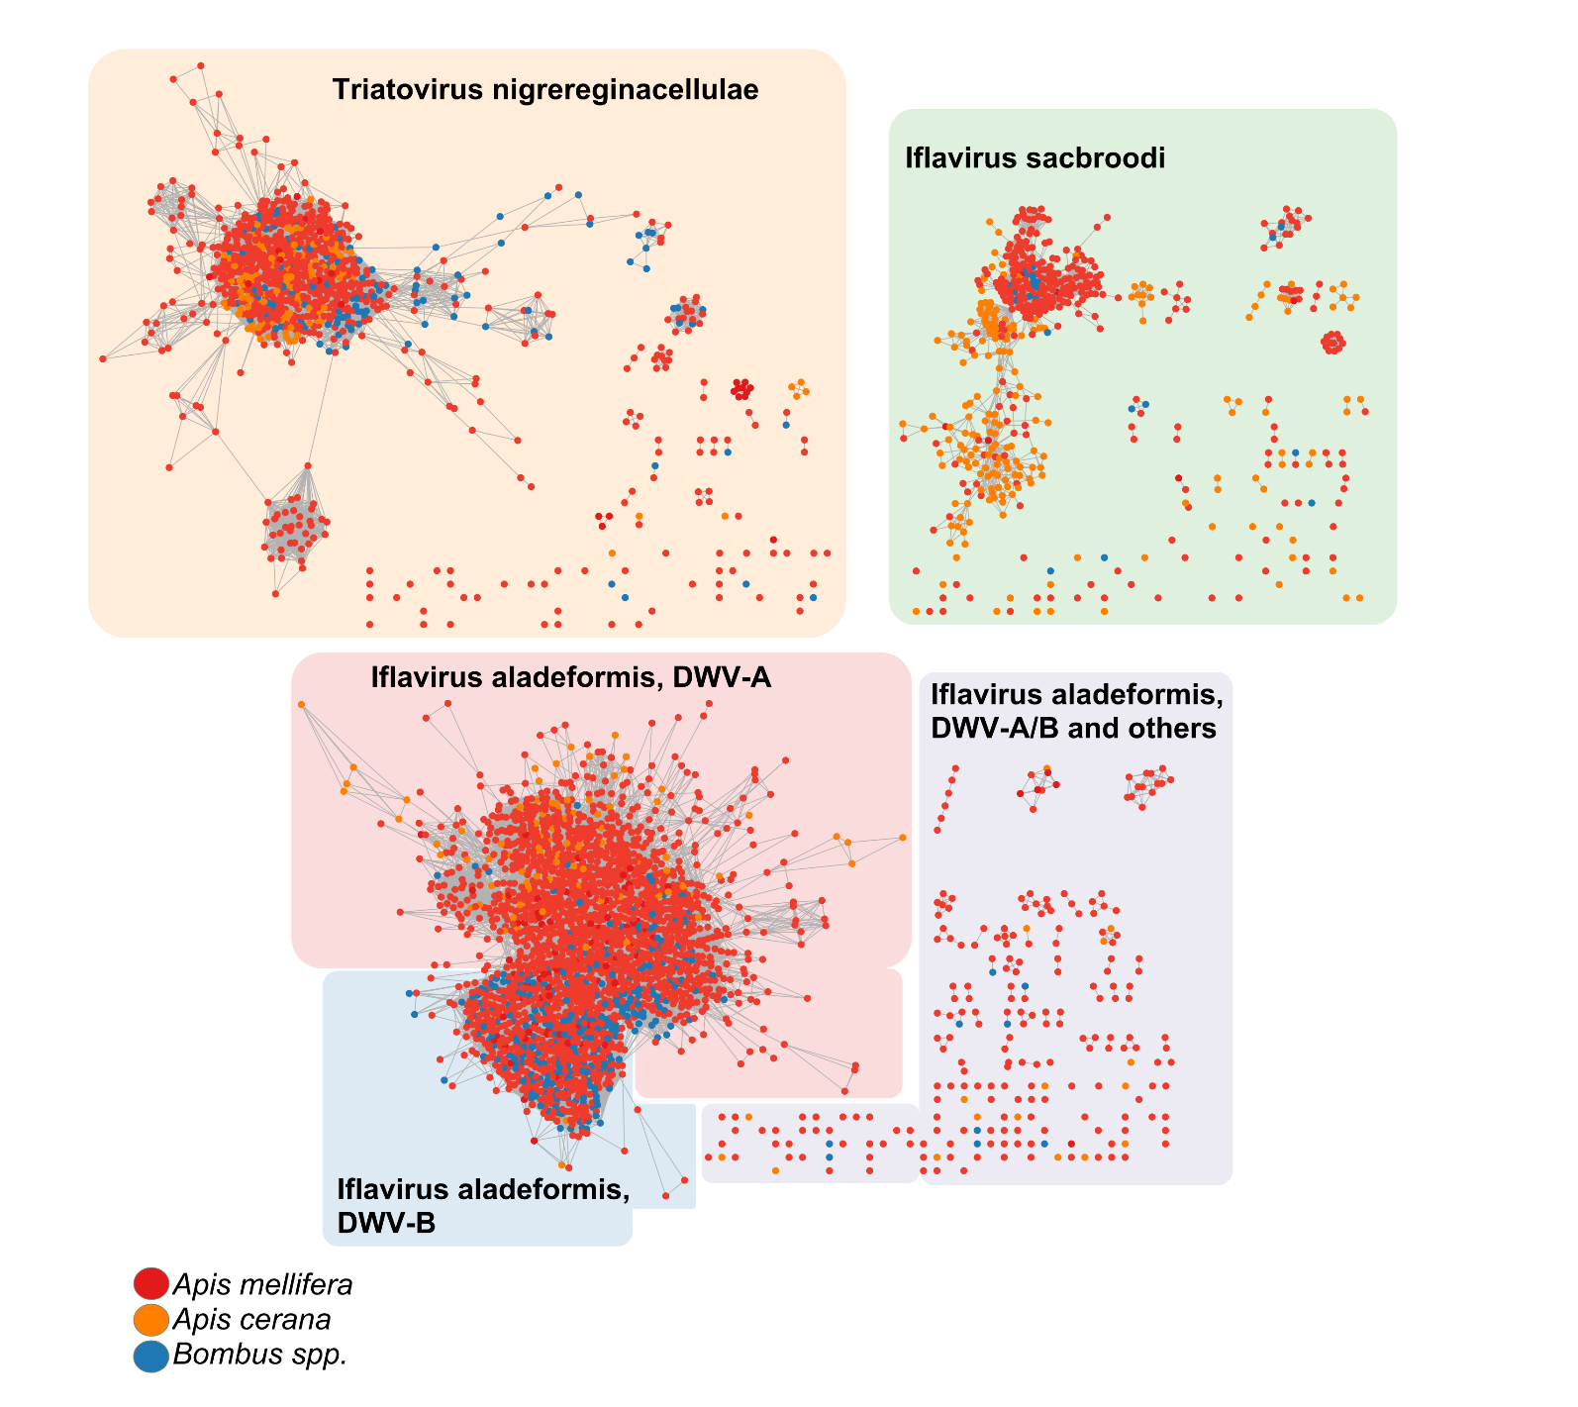
Fig. S10. Similarity networks of NCBI reference nucleotide sequences of Iflavirus aladeformis (deformed wing virus, DWV), Ifavirus sacbroodi (sacbrood virus, SBV), and Triatovirus nigereginacellulae (black queen cell virus, BQCV), only for sequences over 200 bp length and recovered from Bombus spp., Apis mellifera, and Apis cerana. Only edges over 98 % percent identity are shown. Network is based on fastANI percent identity of whole contigs. Datapoints coloured by host origin of viral sequence as in key.

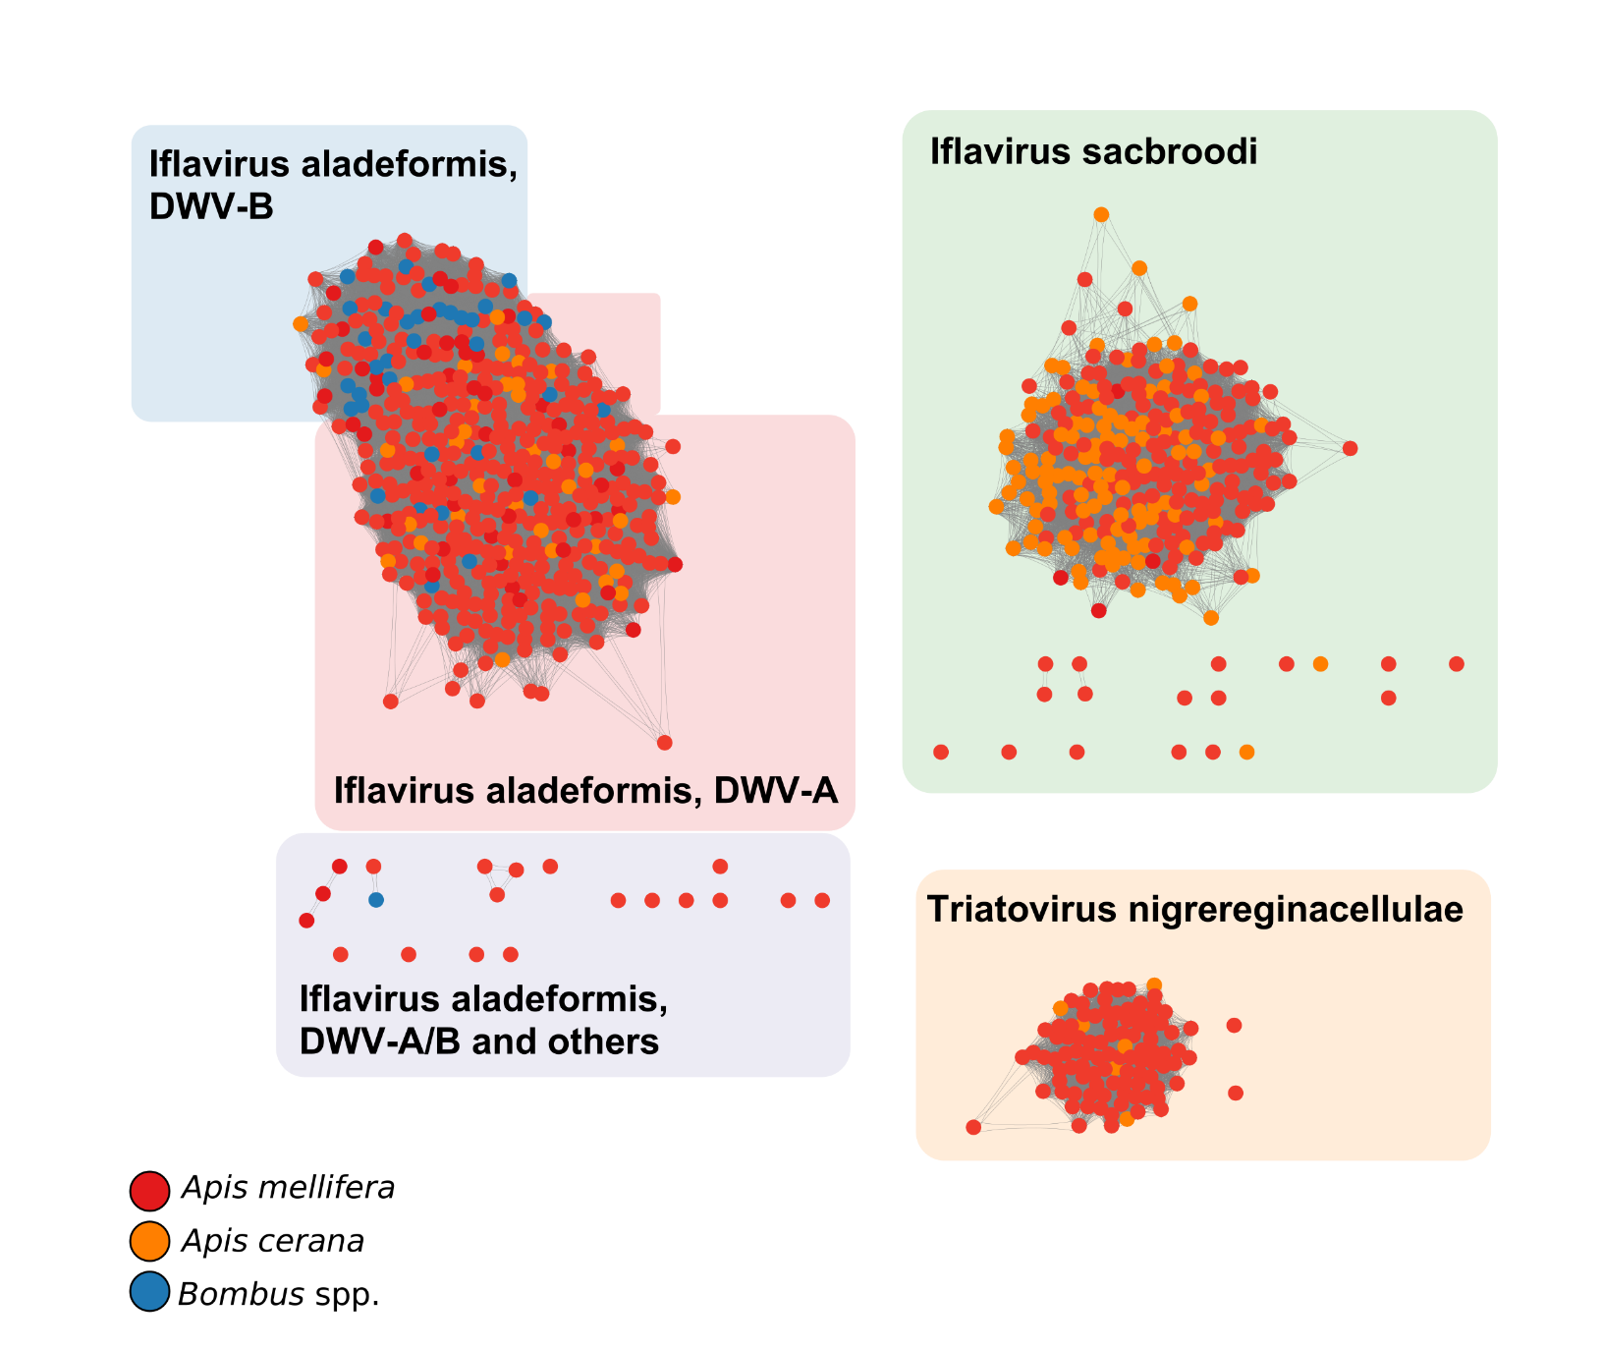
Fig. S11. Similarity networks of NCBI reference sequences of viral RNA dependent RNA polymerase of Iflavirus aladeformis (deformed wing virus, DWV), Iflavirus sacbroodi (sacbrood virus, SBV), and Triatovirus nigereginacellulae (black queen cell virus, BQCV) using protein sequences predicted from the nucleotide sequences in (Fig. S10) which were derived from Bombus spp., Apis mellifera, and Apis cerana. Only edges over 98 % percent identity are shown. Network is based on BLAST (blastp) percent identity of RNA dependent polymerase (Pfam PF00680). Datapoints coloured by host origin of viral sequence as in key.

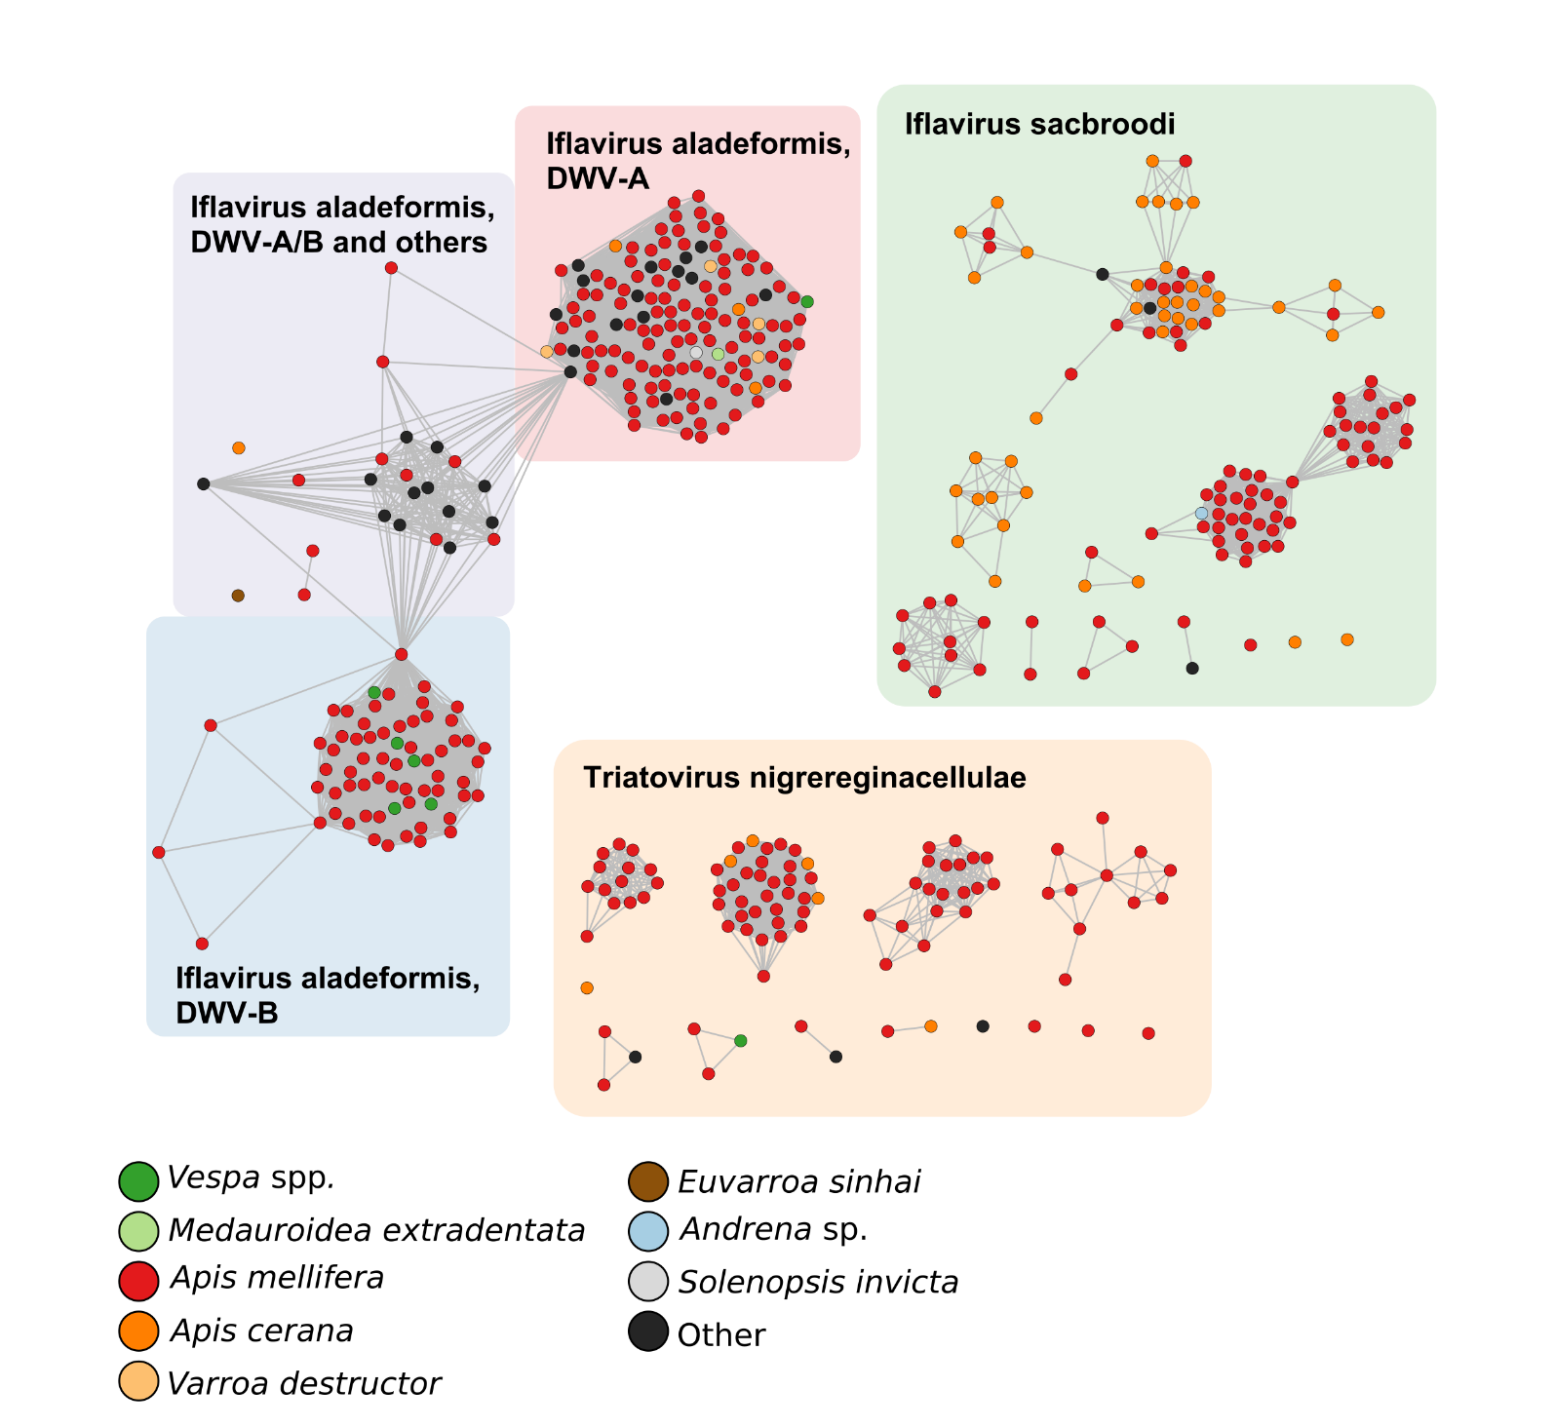
Fig. S12. Similarity networks of NCBI reference nucleotide sequences of Iflavirus aladeformis (deformed wing virus, DWV), Iflavirus sacbroodi (sacbrood virus, SBV), and Triatovirus nigereginacellulae (black queen cell virus, BQCV), only for sequences over 4000 bp recovered from various insects. Only edges over 98 % percent identity are shown. Network is based on fastANI percent identity of whole contigs. Datapoints coloured by host origin of viral sequence as in key.

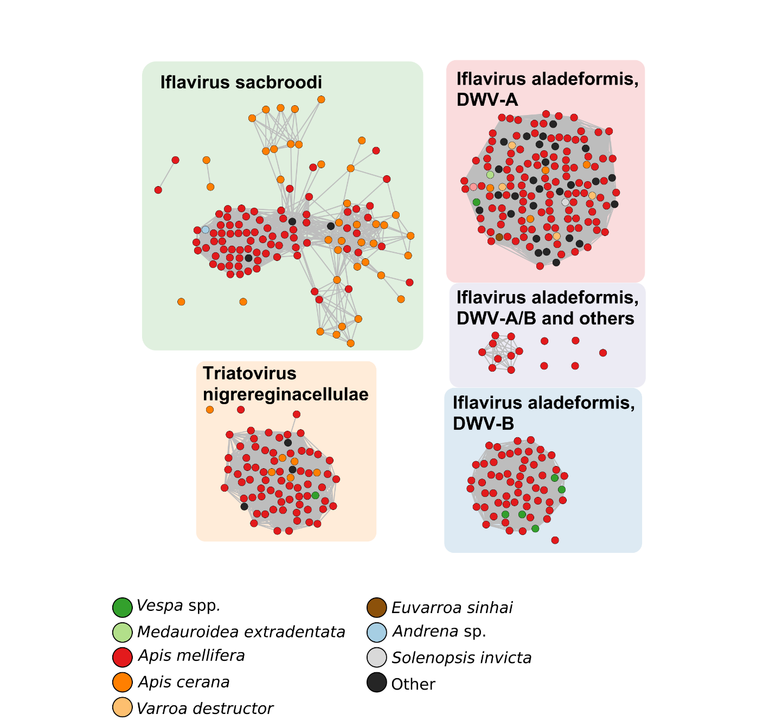
Fig. S13. Similarity networks of NCBI reference sequences of viral RNA dependent RNA polymerase of Iflavirus aladeformis (deformed wing virus, DWV), Iflavirus sacbroodi (sacbrood virus, SBV), and Triatovirus nigereginacellulae (black queen cell virus, BQCV), using protein sequences predicted from the nucleotide sequences in (Fig. S12) which were derived from various insects. Only edges over 98 % percent identity are shown. Network is based on BLAST (blastp) percent identity of RNA dependent polymerase (Pfam PF00680). Datapoints coloured by host origin of viral sequence as in key.

Table S1.
PERMANOVA results of viral community composition.

Variables | Df | SumOfSqs | R2 | F | Pr(>F) | Significance
genus | 1 | 1.106160493 | 0.00911690632 | 6.606483044 | 0.0010 | ***
collection_year | 2 | 4.153893516 | 0.03423613329 | 12.40445092 | 0.0010 | ***
genus:collection_year | 2 | 1.379682194 | 0.01137125526 | 4.120038222 | 0.0010 | ***
genus:distance | 3 | 0.756000270 | 0.00623090744 | 1.505056757 | 0.0550
genus:apiary | 2 | 0.383925768 | 0.00316429242 | 1.146487828 | 0.3030
genus:apiary:distance | 3 | 0.526707492 | 0.00434109055 | 1.04857723 | 0.3800
genus:flower_genus | 10 | 1.558469067 | 0.0128448056 | 0.930787126 | 0.6600
flower_shape | 4 | 3.56903479 | 0.02941576387 | 3.853088412 | 0.001 | ***
flower_depth_cat | 2 | 0.292052971 | 0.00240708251 | 0.630593976 | 0.887
proportion_of_BBs_to_HBs | 22 | 8.105820221 | 0.06680766863 | 1.591081664 | 0.001 | ***
genus:flower_shape | 3 | 0.522952282 | 0.00431014034 | 0.752764261 | 0.822
genus:flower_depth_cat | 2 | 0.149628591 | 0.00123322959 | 0.323074571 | 0.993
genus:proportion_of_BBs_to_HBs | 15 | 2.513895472 | 0.02071937091 | 0.723725943 | 0.975

Table S2.
Wilcox test of contig length, Apis versus Bombus

Virus | W | p | Significance
Iflavirus aladeformis | 20926 | 5.2e-05 | ***
allermuir hill virus 1 | 233.5 | 0.003595517 | ***
andrena haemorrhoa nege-like virus | 17680.5 | 0.001678183 | ***
Iflavirus sacbroodi | 159522 | 0.06133123 | **
Triatovirus nigereginacellulae | 7266 | 0.4929103
lake sinai virus | 221 | 0.2644197
unclassified phasmaviridae | 4241.5 | 0.1500736

