Supplementary materials for ‘Bias and negative values of vaccine effectiveness estimates from a test-negative design without controlling for prior infection’
Ryan E. Wiegand, Bruce Fireman, Morgan Najdowski, Mark W. Tenforde, Ruth Link-Gelles, Jill M. Ferdinands
Contents
Simulation methods 2
Part 1: historical period 2
Probability of cases 2
Probability of vaccination 4
Protection 6
Generation of infection and vaccination 11
Example plot of protection 12
Part 2: analytic period 13
Probability of cases 14
Probability of vaccination 15
Symptoms 16
Test Characteristics 17
Symptomatic infection outcome 18
Severe disease outcome 18
Analytic methods 20
Models 20
Bias 21
Unstable estimates 21
Supplemental Results 23
Supplemental Tables 23
Supplemental Figures 26
VE against symptomatic infection 27
VE against severe disease 40
Bibliography 53

Simulation methods
The simulation process was split into two parts. The goals of part one were to
- create a vaccination and infection history for each person aged 18-49 years up to the week of 2023-05-07 to be used as covariates in modeling and
- generate each person’s protection level since a majority of people have existing protection against SARS-CoV-2 infection.
Part two then utilized the historical and protection information and applied those to a test-negative design (TND) to estimate vaccine effectiveness (VE) against symptomatic infection or severe disease.

Part 1: historical period

Probability of cases
Case count data from 60 U.S. jurisdictions [1] were summed by week to create weekly, national case counts. Weekly case counts were then divided by the 2020 U.S. population estimates to create provisional weekly probabilities of infection (Figure S1).
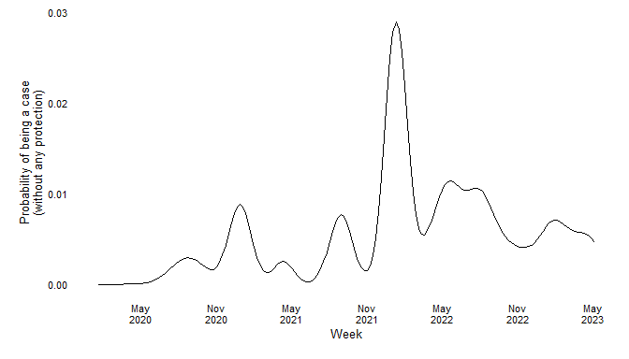
Figure S1: Weekly probability of infection based on U.S. jurisdictional case counts and 2020 U.S. population estimates.

Since case count data suffered from underreporting of infections that varied by time [2], we adjusted the distribution to be in line with seroprevalence studies that explored the underreporting [2] and found approximately 95%-98% of the population possessed at least one infection by the week of 2023-05-07 [3]. For each realized population, the adjustment factor was varied allowing for some randomness in that factor. The distribution for the adjustment factor was $N\left(μ=4,σ=0.5\right)$ (Figure S2).
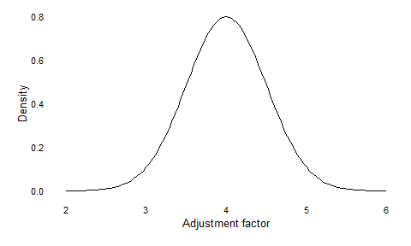
Figure S2: Distribution of the case distribution adjustment factor.

After accounting for the adjustment factor, the distribution became the weekly probability of infection without any protection. We used $Pr\left(c_{k}\right)$ to denote the probability of infection in week $k$ and plotted this below with the mean adjustment factor of 4 (Figure S3)
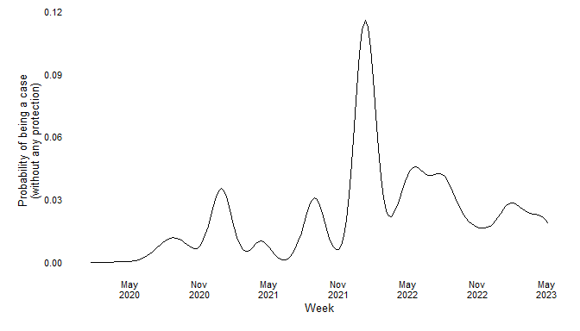
Figure S3: Weekly probability of infection with an adjustment factor of 4, the expected value of the adjustment factor distribution.

Probability of vaccination
The probability that person $j$ got an additional vaccination dose in week $k$ was conditional on their current dose. If $D_{j,k}$ was person $j$’s number of vaccination doses at the beginning of week $k$ and $D_{j,k}^{'}$ the next dose for person $j$ in week $k$, then $Pr\left(D_{j,k}^{'}∣D_{j,k}\right)$ was the likelihood of person $j$ obtaining an additional vaccination dose in week $k$. In our simulations, we considered three distributions: $Pr\left(D_{j,k}^{'}=2∣D_{j,k}=0\right)$; $Pr\left(D_{j,k}^{'}=3∣D_{j,k}=2\right)$; and $Pr\left(D_{j,k}^{'}=4∣D_{j,k}=3\right)$
We used publicly available data of vaccination distributions for people aged 18-49 years by day [4] and converted them to weekly probabilities (Figure S4) for the vaccination distributions.
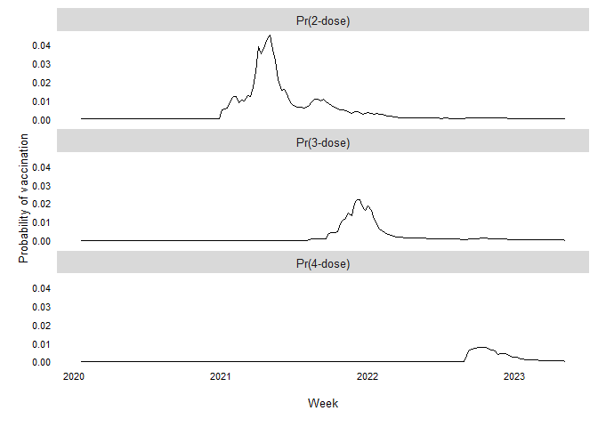
Figure S4: Weekly probabilities of a vaccination dose receipt based on daily vaccination data and U.S. population estimates.

The curves were standardized so that the cumulative probability of vaccination equaled 1 and then fit to a Beta distribution to find an estimated, smoothed curve of vaccination probability by week (Figure S5).
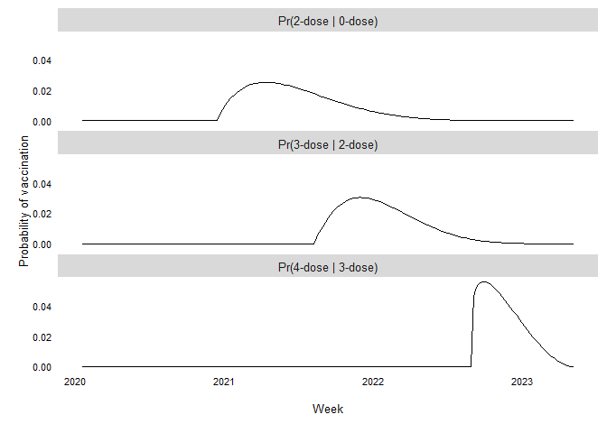
Figure S5: Beta distributions of weekly probability of an additional vaccination dose conditional on a person having had the prior vaccination dose.

In addition, research suggests that people have been less likely to obtain a COVID-19 vaccination after a known SARS-CoV-2 infection. Multiple studies explored whether people with prior infection were less likely to get vaccinated than people without a known prior infection, each with slightly different questions posed to participants. In our search of the literature, we found the following odds ratios (ORs) with the specific comparison estimated:
- Probably/definitely will not get a vaccine: OR=0.63757. [5]
- Reachable vs. reluctant: OR=0.62361. [6]
- Plans to receive vaccination: OR=0.55. [7]
- Intention to receive vaccine: OR=0.40. [8]
- Self-reported past vaccination: OR=0.50. [9]
- Receiving or planning to receive vaccination: OR=0.45833. [10]
Please note our search may not have been exhaustive. From those studies, the median OR was 0.525 which was used in simulations. In our simulations, the ratios did not depend on the dose, e.g., an unvaccinated person was treated the same as someone with three vaccination doses
In an attempt to realize the median OR at each week $k$, the expected marginal totals were calculated for each combination of $D_{j,k}^{'}$ and $D_{j,k}$. Those marginal totals were naive people ($n_{1,k}$), people with a prior infection ($n_{2,k}$), expected number of people with a vaccination in week $k$ ($n_{3,k}$), and expected number of people without a vaccination in week $k$ ($n_{4,k}$). The marginal totals were used to calculate the probabilities of vaccination in people with prior infection and naive people are determined. That was done by solving the formula
$$\frac{ω_{k}*\left(n_{1,k}-n_{3,k}+ω_{k}\right)}{\left(n_{3,k}-ω_{k}\right)\left(n_{2,k}-ω_{k}\right)}-η=0,$$
where $η=$ 0.525 and $ω_{k}$ was the number of vaccinations in prior infected people in week $k$. Then
$$Pr\left(D_{j,k}^{'}∣D_{j,k},I_{j,k}^{*}\right)=\left\{\begin{matrix}\frac{n_{3,k}-ω_{k}}{n_{1,k}} & \text{if }I_{j,k}^{*}=0, \\ \frac{ω_{k}}{n_{2,k}} & \text{if }I_{j,k}^{*}=1.\end{matrix}\right.$$

Protection
Protection in week $k$ was defined based a person’s vaccine-induced protection (VP) and infection-induced protection (IP) in week $k-1$. Each used the same basic function: for VP, the function is as follows:
$${\text{VP}}_{j,k}=f_{v}\left(k-1,t_{j,k-1}^{v},κ_{v},θ_{v}\right)=max\left[0,κ_{v}+\frac{κ_{v}}{-θ_{v}}*\left(k-1-t_{j,k-1}^{v}\right)\right],$$
where $t_{j,k-1}^{v}$ was the week of the most recent vaccination in week $k-1$, $κ_{v}$ was the maximum protection conferred by vaccination, and $θ_{v}$ was the number of weeks before protection from vaccination reaches zero.
Two definitions were used for vaccination-induced protection waning with different curves for pre-Omicron and Omicron/post-Omicron (Figure S6).
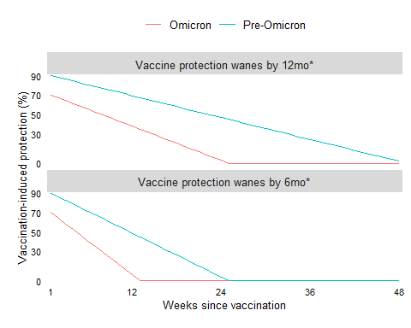
Figure S6: Vaccine protection waning curves.

An individual’s vaccination-induced protection level was varied via a multiplier. That multiplier was generated from a Gamma distribution with $Γ\left(α,β\right)$ where $α$ was the shape parameter and $β$ the scale. For this distribution, $α=$ 100 and $β=$ 0.01 (Figure S7).
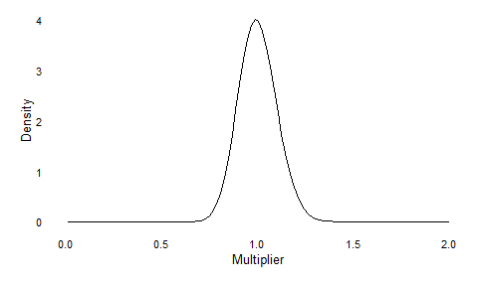
Figure S7: Distribution of vaccine-induced protection multipler.

A similar function to VP was used for IP:
$${\text{IP}}_{j,k}=f_{p}\left(k-1,t_{j,k-1}^{p},κ_{p},θ_{p}\right)=max\left[0,κ_{p}+\frac{κ_{p}}{-θ_{p}}*\left(k-1-t_{j,k-1}^{p}\right)\right],$$
where $t_{j,k-1}^{p}$ was the week of the most recent infection in week $k-1$, $κ_{p}$ was the maximum protection conferred by prior infection, and $θ_{p}$ was the number of weeks before protection from a prior infection reaches zero.
Two definitions were used for infection-induced protection with the same curves regardless of variant (Figure S8).
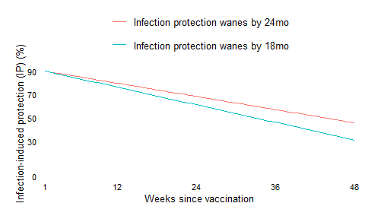
Figure S8: Infection protection waning curves.

As with vaccination-induced protection, we included a multiplier for each individual’s infection-induced protection. The distribution was the same as for infection-induced protection, specifically, a $Γ\left(α,β\right)$ with $α=$ 100 and $β=$ 0.01 (Figure S9).
Figure S9: Distribution of infection-induced protection multipler.

For people with both vaccine-induced protection and infection-induced protection, hybrid protection (or hybrid immunity) was determined by one of two definitions and used for ${\text{HP}}_{j,k}$.
One scenario was to have the larger of the vaccine-induced and infection-induced protection boosted by 30% of the other protection up to a maximum of 0.99 (or 99%) (Figure S10):
$${\text{HP}}_{j,k}=\left\{\begin{matrix}min\left[0.99, {\text{IP}}_{j,k}+0.3*{\text{VP}}_{j,k}\right] & \text{if} {\text{IP}}_{j,k}≥{\text{VP}}_{j,k} \\ min\left[0.99, {\text{VP}}_{j,k}+0.3*{\text{IP}}_{j,k}\right] & \text{if} {\text{IP}}_{j,k}<{\text{VP}}_{j,k}.\end{matrix}\right.$$
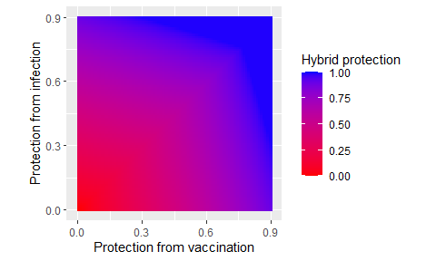
Figure S10: Hybrid protection that is a maximum of 30% percent boost (either IP + 0.3 * VP or VP + 0.3 * IP).

The other scenario boosted protection but unequally based on which type of protection was larger, i.e.,
$${\text{HP}}_{j,k}=\left\{\begin{matrix}min\left[0.99, {\text{VP}}_{j,k}+0.3*{\text{IP}}_{j,k}\right] & \text{if} {\text{VP}}_{j,k}≥{\text{IP}}_{j,k} \\ min\left[0.99, {\text{IP}}_{j,k}+0.1*{\text{VP}}_{j,k}\right] & \text{if} {\text{VP}}_{j,k}<{\text{IP}}_{j,k}.\end{matrix}\right.$$
In this scenario, a person’s vaccine-induced protection was again boosted by 30% of that person’s infection-induced protection up to a maximum of 0.99. On the other hand, infection-induced protection was only boosted by 10% of vaccine-induced protection up to a maximum of 0.99 (Figure S11).
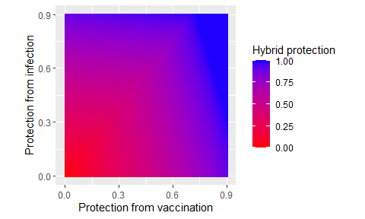
Figure S11: Hybrid protection that is a maximum of unequal percent boost (either IP + 0.1 * VP or VP + 0.3 * IP).

Once ${\text{HP}}_{j,k}$ was determined, person $j$’s protection that week ($ψ_{j,k}$) was
$$ψ_{j,k}=\left\{\begin{matrix}0 & \text{if} {\text{IP}}_{j,k}=0 \text{and} {\text{VP}}_{j,k}=0 \\ {\text{IP}}_{j,k} & \text{if} {\text{IP}}_{j,k}>0 \text{and} {\text{VP}}_{j,k}=0 \\ {\text{VP}}_{j,k} & \text{if} {\text{IP}}_{j,k}=0 \text{and} {\text{VP}}_{j,k}>0 \\ {\text{HP}}_{j,k} & \text{if} {\text{IP}}_{j,k}>0 \text{and} {\text{VP}}_{j,k}>0.\end{matrix}\right.$$

Generation of infection and vaccination
The probability of infection for person $j$ in week $k$ was
$$Pr\left(I_{j,k}\right)=Pr\left(c_{k}\right)*\left(1-ψ_{j,k-1}\right)$$
and $I_{j,k}∼Bern\left(Pr\left(I_{j,k}\right)\right)$ where $I_{j,k}$ was the infection status for person $j$ in week $k$ where $I_{j,k}=1$ if infected and $I_{j,k}=0$ if uninfected.
The additional vaccination dose for person $j$ in week $k$, denoted by $V_{j,k}$, was $V_{j,k}∼Bern\left(Pr\left(D_{j,k}^{'}\right)\right)$. An additional vaccination dose does not impact protection until the following week, thus
$$D_{j,k+1}=\left\{\begin{matrix}D_{j,k} & \text{if} V_{j,k}=0 \\ D_{j,k}^{'} & \text{if} V_{j,k}=1.\end{matrix}\right.$$
Sixteen different parameter sets were used to generate historical data. These consisted of all combinations of two definitions of VP waning, two definitions of IP waning, and four definitions of hybrid protection.
A total of 200 populations were created for each of the four parameter sets.

Example plot of protection
The image below is an example from a simulation of 100 people to show the changing immunity over time prior to the TND (Figure S12).
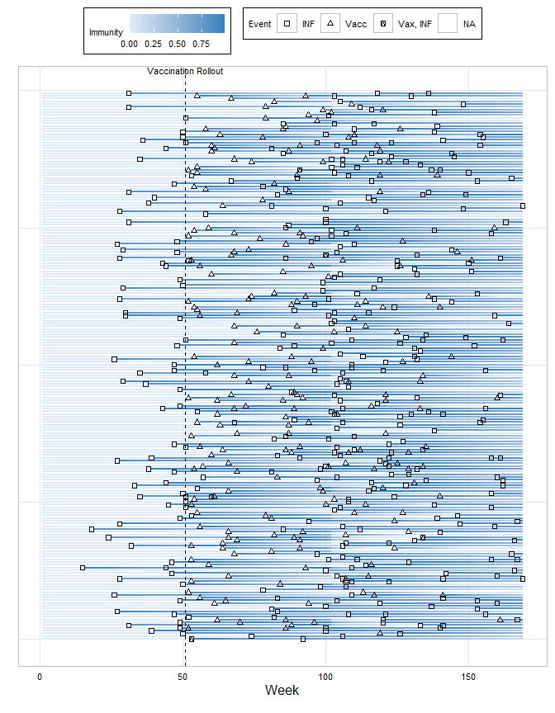
Figure S12: Example of protection trajectories during the historical period for 100 people.

Part 2: analytic period
For the analytic period, eight parameters were varied:
- two definitions of infection-induced protection;
- two definitions of vaccination-induced protection;
- two definitions of hybrid protection;
- four case distributions presented (constant 2%, constant 4%, 2% with a 4% peak, 2% with a 6% peak);
- two outcomes (symptomatic infection or severe disease);
- two vaccination percentages for the population (10%, 25%);
- three time intervals for the vaccination rollout (weeks 1-12 [before the case peak], weeks 11-22 [during the case peak], or weeks 21-32 [after the case peak]); and
- three time intervals for the TND against symptomatic infection (weeks 1-12 [before the case peak], weeks 11-22 [during the case peak], or weeks 21-32 [after the case peak]; TND against severe disease only one time interval of weeks 13-32).
The formulas for $Pr\left(I_{j,k}\right)$ and $Pr\left(D_{j,k}^{'}∣D_{j,k},I_{j,k}^{*}\right)$ remained the same. Simulations were run for each combination for a total of 768 combinations. Each simulated population was used five times for each parameter set.

Probability of cases
Four case distributions were simulated (Figure S13). As before, the probabilities assumed no existing protection.
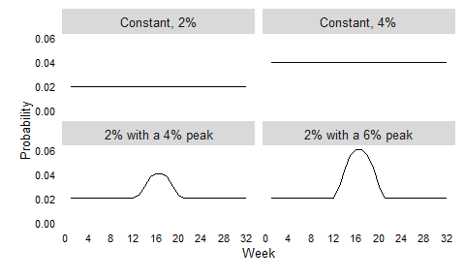
Figure S13: Case distributions during the analytic period.

Probability of vaccination
The vaccination rollout distribution was generated from a lognormal distribution with a mean of 1.5 and a standard deviation of 0.5 and could occur before the mode in the case distribution (weeks 1-12), during the mode in the case distribution (weeks 11-22), or after the mode in the case distribution (weeks 21-32) (Figure S14).
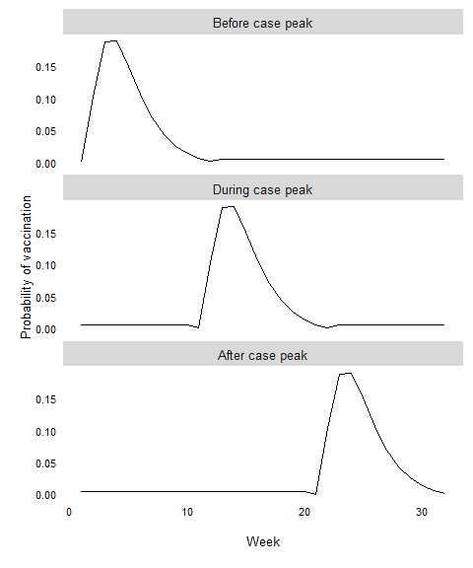
Figure S14: Distributions of vaccination coverage used in simulations.

The total probability of vaccination over the 32-week period was set at 10% or 25% and the above curve was scaled to match (Figure S15).
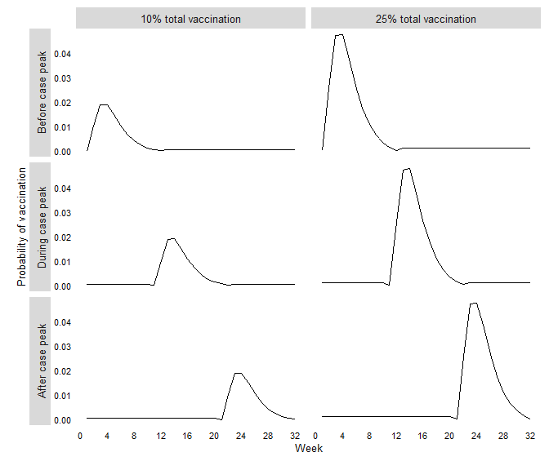
Figure S15: Final weekly distributions of seasonal vaccination coverage used in simulations.

Symptoms
For infected people, the expected probability of symptoms was 0.8 and for uninfected people, the probability of symptoms was 0.2. This parameter was varied by individual to introduce some randomness to an infected person’s (Figure S16) or uninfected person’s (Figure S17) proclivity to develop symptoms after an infection. Of note, for uninfected people, the likelihood of symptoms is defined as the probability of symptoms over the analytic period instead of the probability of symptoms for an infection event.
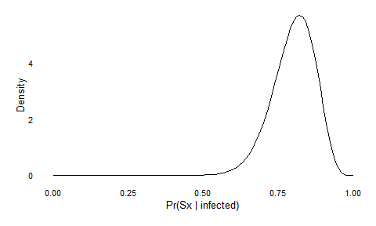
Figure S16: Distribution of the probabilty of symptoms for an infected person during the week of infection.

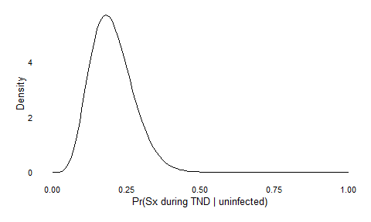
Figure S17: Distribution of the probabilty of symptoms for an uninfected person during the entire analytic period.

Test Characteristics
For the symptomatic infection outcome, testing positive depended on the weeks since the infection. Sensitivity values were dependent on the weeks since infection based on the results in Miller et al. [11]

Table S1: Test characteristics by week where week=0 indicates the week of infection.
days | week | Sensitivity | Specificity
0-7 | 0 | 90 | 100
8-14 | 1 | 70 | 100
15-21 | 2 | 50 | 100
22-28 | 3 | 20 | 100
29-35 | 4 | 5 | 100
36+ | 5+ | 0 | 100

Symptomatic infection outcome
For the symptomatic infection outcome, whether a person was symptomatic in the week of data collection was included in the simulations. Once a person was symptomatic, they are automatically included in the TND at that week. Symptomatic people were then tested and, as covered above, the sensitivity of the test depends on how many weeks since a person’s last infection. A positive test was randomly generated from a Bernoulli distribution with probability equal to the test sensitivity divided by 100.

Severe disease outcome
Vaccination-induced protection against severe disease started at 0.9 and took 192 weeks to wane to zero. Infection-induced protection against severe disease starts slightly higher at 0.95 and takes longer, specifically 384 weeks, to wane to zero (Figure S18).
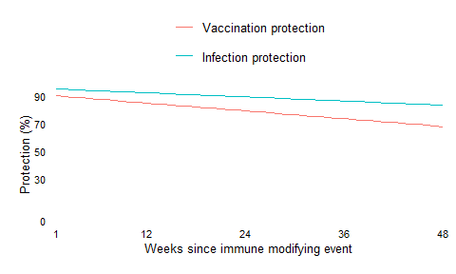
Figure S18: Waning curves for protection against severe disease.

Hybrid protection against severe disease was determined using the same function as hybrid protection against infection.
To generate severe disease, $Pr\left(I_{j,k}\right)$ was simulated to create an infection outcome. Those infected in that week ($I_{j,k}=1$) were determined to have a severe outcome by
$$S_{j,k}∼Bern\left(Pr\left(S_{j,k}∣I_{j,k}=1\right)\right)$$
where
$$Pr\left(S_{j,k}∣I_{j,k}=1\right)=\frac{\left(1-ψ_{j,k-1}^{s}\right)}{\left(1-ψ_{j,k-1}\right)}$$
where $ψ_{j,k-1}^{s}$ was person $j$’s protection against severe disease calculated after week $k-1$.
For uninfected people, i.e., $I_{j,k}=0$, we set
$$Pr\left(S_{j,k}∣I_{j,k}=0\right)=\frac{0.02}{20},$$
where $S_{j,k}$ was a severe disease event, 0.02 was chosen so the expectation would be that 2% of people would experience a severe disease event, and 20 is the number of weeks in the severe disease TND.
Testing was considered perfect (sensitivity=specificity=1) as we assumed a patient with severe respiratory disease would be diagnosed correctly.

Analytic methods

Models
Exposures fit in the models were:
- vaccination at any time during the analytic period;
- vaccination in the previous 2 months;
- vaccination in the previous 3 months;
- vaccination in the previous 4 months;
- vaccination in the previous 5 months;
- vaccination in the previous 6 months;
- the number of doses received (unvaccinated as the reference group, 2-dose, 3-dose, 4-dose, or 5-dose); and
- the time since vaccination (unvaccinated as the reference group, 0-2 months, 3-4 months, 5-11 months, and 12 or more months).
Each exposure was included in a model with either
- no other covariates (uncontrolled or unadjusted model) or
- the months since the last infection (categorical with $\text{months}=\{1,2,…,11,12 \text{or more}\}$) and the number of prior infections as a continuous variable (controlled or adjusted model).
For each logistic regression, we modeled $Pr\left(I_{j,k}^{*}\right)$, such that
$$Pr\left(I_{j,k}^{*}\right)=\frac{exp\left(ζ\right)}{1+exp\left(ζ\right)}.$$
Corresponding to each of the exposure definitions, the unadjusted models were parameterized as follows:
- $ζ=β_{0}+β_{1}{\text{AP}}_{j,k}$, where ${\text{AP}}_{j,k}=1$ if person $j$ got a vaccination in the simulated roll out by week $k$ and ${\text{AP}}_{j,k}=0$ if not;
- $ζ=β_{0}+β_{1}{\text{R}}_{j,k}^{2M}$, where ${\text{R}}_{j,k}^{2M}=1$ if person $j$ got a vaccination in the 2 months prior to week $k$ and ${\text{R}}_{j,k}^{2M}=0$ if not;
- $ζ=β_{0}+β_{1}{\text{R}}_{j,k}^{3M}$, where ${\text{R}}_{j,k}^{3M}=1$ if person $j$ got a vaccination in the 3 months prior to week $k$ and ${\text{R}}_{j,k}^{3M}=0$ if not;
- $ζ=β_{0}+β_{1}{\text{R}}_{j,k}^{4M}$, where ${\text{R}}_{j,k}^{4M}=1$ if person $j$ got a vaccination in the 4 months prior to week $k$ and ${\text{R}}_{j,k}^{4M}=0$ if not;
- $ζ=β_{0}+β_{1}{\text{R}}_{j,k}^{5M}$, where ${\text{R}}_{j,k}^{5M}=1$ if person $j$ got a vaccination in the 5 months prior to week $k$ and ${\text{R}}_{j,k}^{5M}=0$ if not;
- $ζ=β_{0}+β_{1}{\text{R}}_{j,k}^{6M}$, where ${\text{R}}_{j,k}^{6M}=1$ if person $j$ got a vaccination in the 6 months prior to week $k$ and ${\text{R}}_{j,k}^{6M}=0$ if not;
- $ζ=β_{0}+β_{1}{\text{R}}_{j,k}^{2\text{-dose}}+β_{2}{\text{R}}_{j,k}^{3\text{-dose}}+β_{3}{\text{R}}_{j,k}^{4\text{-dose}}+β_{4}{\text{R}}_{j,k}^{5\text{-dose}}$, where ${\text{R}}_{j,k}^{n\text{-dose}}=1$ if person $j$ had $n$ doses in week $k$ and ${\text{R}}_{j,k}^{n\text{-dose}}=0$ if not; and
- $ζ=β_{0}+β_{1}{\text{R}}_{j,k}^{0-2\text{ months}}+β_{2}{\text{R}}_{j,k}^{3-4\text{ months}}+β_{3}{\text{R}}_{j,k}^{5-11\text{ months}}+β_{4}{\text{R}}_{j,k}^{12\text{+ months}}$, where ${\text{R}}_{j,k}^{n\text{ months}}=1$ if person $j$ had her or his most recent vaccination $n$ months in week $k$ and ${\text{R}}_{j,k}^{n\text{ months}}=0$ if not.
In all models, VE was calculated as $\left(1-OR\right)*100$ where $OR$ was the odds ratio from the logistic model.

Bias
Bias in simulation studies is typically defined as the deviation from truth. In these simulations, true VE is challenging to determine since true VE depends the distribution of vaccination dissemination, the waning protection of vaccinations, the distribution of infections, and the waning protection of infections. Thus, a true VE will depend on each individual’s time since vaccination and, if applicable, time since last infection, meaning the true VE will be different for each simulation.
Though, the purpose of these simulations is to present a real-world, policy-relevant evaluation of ignoring the effect of prior infection in an evaluation of vaccine effectiveness. To do this, we felt it was important to generate individual people’s histories across a relevant range of scenarios. As a result, these simulations differ from typical simulation studies because we do not compare our results to a true parameter value. Thus, our definition of bias is
$$Bias\left(VE\right)=E\left[{VE}^{\text{unadjusted}}-{VE}^{\text{adjusted}}\right]$$
where ${VE}^{\text{unadjusted}}$ was the vaccine effectiveness estimate from models without controlling for participants’ prior infection status and ${VE}^{\text{adjusted}}$ was the vaccine effectiveness estimate from models that adjust for participants’ prior infection.
We retain the use of “bias” to describe our comparison. Although we do not compare our simulated VE estimates to a true VE, we feel bias is a reasonable term to use since that conveys the deviation from an established measurement.

Unstable estimates
A total of 21,504,000 VE estimates were produced from these simulations.
Of those, 260 estimates had a log odds above 1 (corresponding to an odds ratio of 2.72 or greater). Two of those were from the 5-11 months since vaccination category and the other 258 were from the 5-dose exposure group. The odds ratios were large in these simulations since a very small number of people were sampled (median=11; range=4, 23) and a high percentage were positive. For these simulations, an odds ratio of 1.00 was used, which corresponds to a VE of $\left(1-e^{1}\right)*100=-171.83$.
A total of 4,178 estimates had a large standard error (defined as a standard error of 2 or greater). Two of these estimates were from the vaccination at any time during the analytic period exposure group, 26 were from the 5-11 months since vaccination category, and the remaining 4,150 were from the 5-dose exposure group. These simulations usually had a large standard error because no exposed people were positive for SARS-CoV-2. For these simulations with a large sample size, a standard error of five was used.
Two simulations fell into both categories, meaning a total of 4,436 estimates (or 0.02%) were unstable.

Supplemental Results

Supplemental Tables
Table S2. Median, minimum, and maximum per simulation of protection against infection, protection against severe disease, weeks since vaccination, and weeks since infection across 200 simulated populations for each of the 8 combinations of vaccine protection, infection protection, and hybrid protection definitions.
Vaccine protection  defintion (VP) | Infection protection  defintion (IP) | Hybrid protection  defintion (HP) | Median protection  against infection  per simulation  median (min, max) | Median protection  against severe disease  per simulation  median (min, max) | Median weeks  since vaccination  per simulation  median(min, max) | Median weeks  since infection  per simulation  median(min, max)
VP wanes by 48(24) wks | IP wanes by 96 wks | Additional 30% either | 0.46 (0.33, 0.51) | 0.94 (0.90, 0.96) | 68.0 (68.0, 69.0) | 45.0 (41.0, 52.0)
VP wanes by 24(12) wks | IP wanes by 96 wks | Additional 30% either | 0.46 (0.31, 0.51) | 0.95 (0.89, 0.97) | 68.0 (68.0, 69.0) | 46.0 (41.0, 53.0)
VP wanes by 48(24) wks | IP wanes by 72 wks | Additional 30% either | 0.37 (0.26, 0.44) | 0.95 (0.92, 0.97) | 68.0 (67.0, 69.0) | 42.0 (36.0, 47.0)
VP wanes by 24(12) wks | IP wanes by 72 wks | Additional 30% either | 0.36 (0.26, 0.43) | 0.96 (0.93, 0.97) | 68.0 (68.0, 69.0) | 42.0 (37.0, 47.0)
VP wanes by 48(24) wks | IP wanes by 96 wks | Additional 10% VP or 30% IP | 0.46 (0.40, 0.50) | 0.89 (0.87, 0.91) | 68.0 (68.0, 69.0) | 45.0 (41.0, 49.0)
VP wanes by 24(12) wks | IP wanes by 96 wks | Additional 10% VP or 30% IP | 0.46 (0.35, 0.50) | 0.90 (0.87, 0.91) | 68.0 (68.0, 69.0) | 46.0 (41.0, 51.0)
VP wanes by 48(24) wks | IP wanes by 72 wks | Additional 10% VP or 30% IP | 0.36 (0.26, 0.44) | 0.90 (0.87, 0.92) | 68.0 (67.0, 69.0) | 42.0 (36.0, 47.0)
VP wanes by 24(12) wks | IP wanes by 72 wks | Additional 10% VP or 30% IP | 0.36 (0.24, 0.43) | 0.90 (0.87, 0.92) | 68.0 (68.0, 69.0) | 42.0 (37.0, 48.0)

Table S3. Median, minimum, and maximum per simulation for protection against infection, protection against severe disease, weeks since vaccination, and weeks since infection across 1,600 simulated populations broken down by number of vaccinations.
Number of vaccinations | N | Median protection  against infection  per simulation  median(min, max) | Median protection  against severe disease  per simulation  median(min, max) | Median weeks  since vaccination  per simulation  median(min, max) | N with prior  infection  per simulation | Median weeks  since infection  per simulation  median(min, max)
0 | 36454 (35996, 36929) | 0.42 (0.24, 0.52) | 0.83 (0.79, 0.86) | - | 35904 (32348, 36687) | 44.0 (35.0, 56.0)
2 | 24820 (24392, 25285) | 0.41 (0.24, 0.52) | 0.91 (0.85, 0.99) | 104.0 (103.0, 104.0) | 24306 (21823, 25179) | 44.0 (36.0, 56.0)
3 | 14011 (13600, 14358) | 0.43 (0.27, 0.52) | 0.95 (0.88, 0.99) | 72.0 (72.0, 73.0) | 13649 (12194, 14107) | 43.0 (35.0, 51.0)
4 | 24725 (24348, 25147) | 0.40 (0.21, 0.50) | 0.99 (0.99, 0.99) | 28.0 (28.0, 29.0) | 22708 (17249, 24462) | 44.0 (38.0, 49.0)

Table S4. Median, minimum, and maximum protection against infection, protection against severe disease, weeks since vaccination, and weeks since infection across 1,600 simulated populations broken down by number of number of infections
Number of infections | N | Median protection  against infection  per simulation  median(min, max) | Median protection  against severe disease  per simulation  median(min, max) | N vaccinated | Median weeks  since vaccination  per simulation  median(min, max) | Median weeks  since infection  per simulation  median(min, max)
0 | 3414 (794, 15379) | 0.00 (0.00, 0.00) | 0.70 (0.60, 0.73) | 2859 (679, 11885) | 32.0 (31.0, 33.0) | -
1 | 27370 (13460, 48763) | 0.18 (0.05, 0.29) | 0.92 (0.87, 0.98) | 20260 (10397, 32447) | 61.0 (35.0, 70.0) | 67.0 (65.0, 69.0)
2 | 39506 (28711, 42006) | 0.43 (0.35, 0.51) | 0.93 (0.90, 0.99) | 24788 (16167, 26657) | 71.0 (67.0, 78.0) | 43.0 (41.0, 46.0)
3 | 21685 (6267, 32009) | 0.61 (0.55, 0.65) | 0.93 (0.90, 0.98) | 11824 (3159, 18847) | 75.0 (71.0, 82.0) | 26.0 (23.0, 28.0)
4 | 5914 (813, 14218) | 0.67 (0.64, 0.70) | 0.92 (0.89, 0.97) | 2918 (391, 7516) | 77.0 (72.0, 88.0) | 17.0 (16.0, 18.0)
>=5 | 1292 (67, 5236) | 0.69 (0.65, 0.72) | 0.89 (0.85, 0.94) | 586 (30, 2444) | 80.0 (68.0, 100.0) | 14.0 (12.0, 16.0)

Supplemental Figures
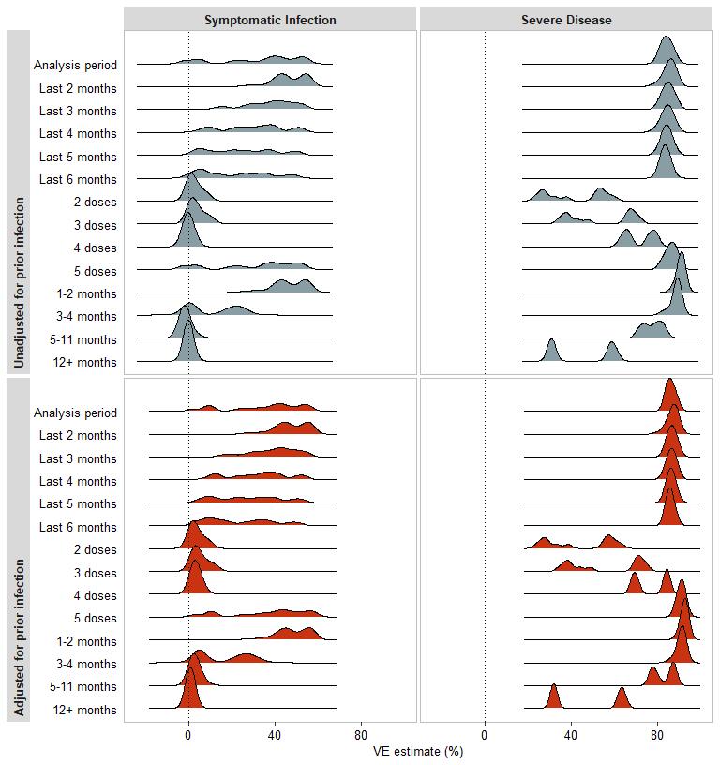
Figure S19: Distribution of simulated VE estimates for VE against symptomatic infection and VE against severe disease. Estimates are for each exposure definition stratifed by estimates unadjusted for prior infection and adjusted for prior infection.

VE against symptomatic infection
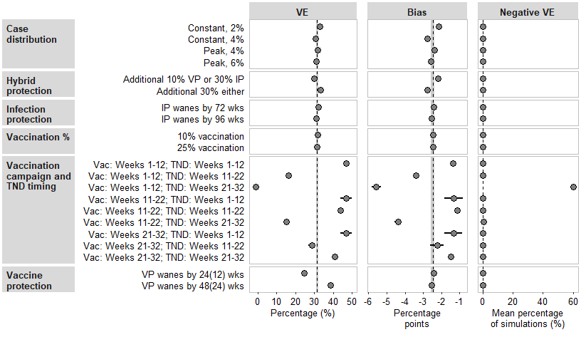
Figure S20: Unadjusted vaccine effectiveness (VE) against symptomatic infection, bias compared to adjusted VE estimates, and percentage of simulations with unadjusted VE less than zero (negative VE) for vaccination at any time during the analytic period.

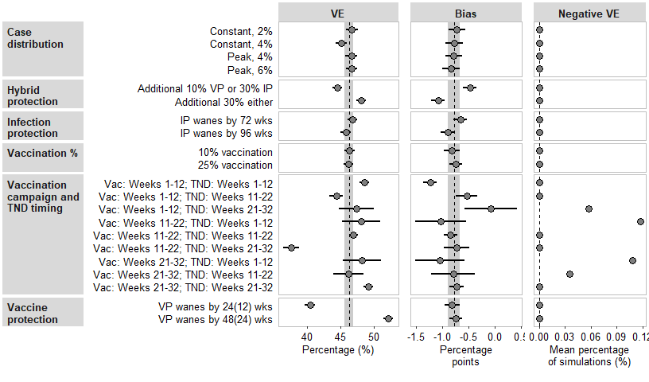
Figure S21: Unadjusted vaccine effectiveness (VE) against symptomatic infection, bias compared to adjusted VE estimates, and percentage of simulations with unadjusted VE less than zero (negative VE) for vaccination in the previous 2 months.

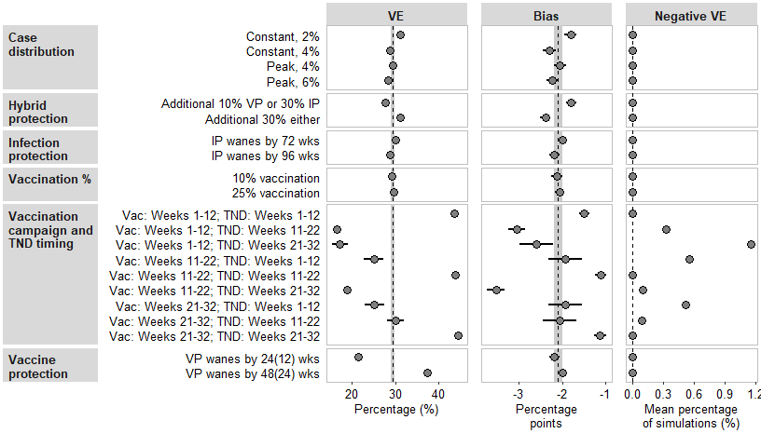
Figure S22: Unadjusted vaccine effectiveness (VE) against symptomatic infection, bias compared to adjusted VE estimates, and percentage of simulations with unadjusted VE less than zero (negative VE) for vaccination in the previous 4 months.

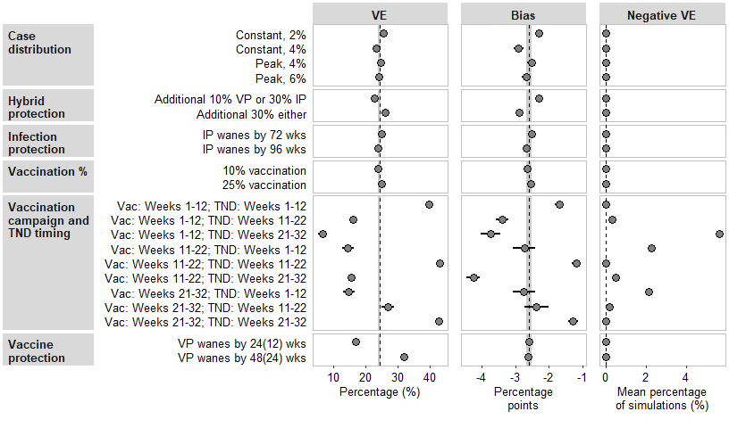
Figure S23: Unadjusted vaccine effectiveness (VE) against symptomatic infection, bias compared to adjusted VE estimates, and percentage of simulations with unadjusted VE less than zero (negative VE) for vaccination in the previous 5 months.

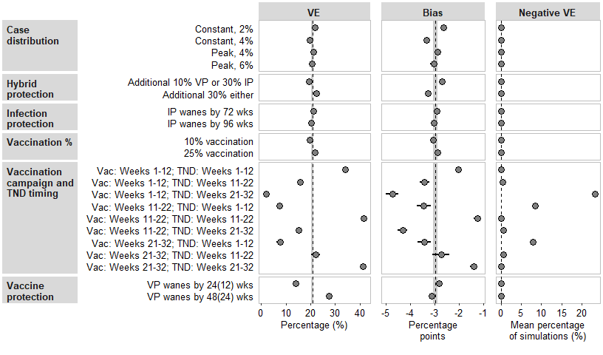
Figure S24: Unadjusted vaccine effectiveness (VE) against symptomatic infection, bias compared to adjusted VE estimates, and percentage of simulations with unadjusted VE less than zero (negative VE) for vaccination in the previous 6 months.

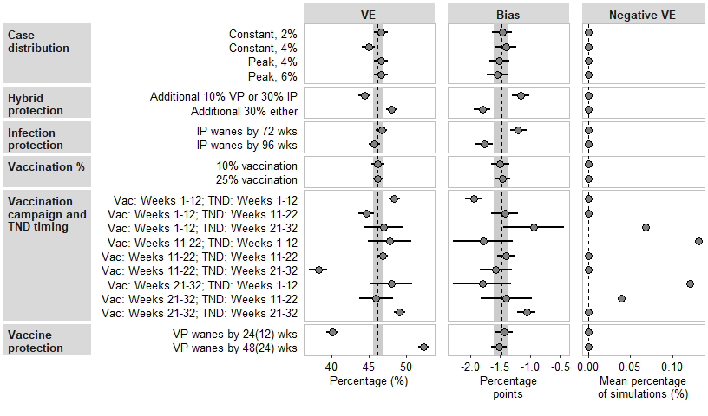
Figure S25: Unadjusted vaccine effectiveness (VE) against symptomatic infection, bias compared to adjusted VE estimates, and percentage of simulations with unadjusted VE less than zero (negative VE) for 1-2 months since the last vaccination.

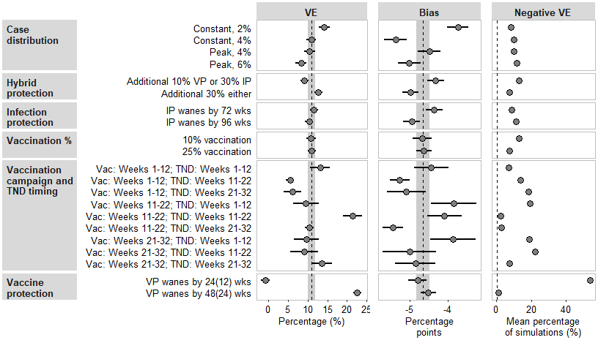
Figure S26: Unadjusted vaccine effectiveness (VE) against symptomatic infection, bias compared to adjusted VE estimates, and percentage of simulations with unadjusted VE less than zero (negative VE) for 3-4 months since the last vaccination.

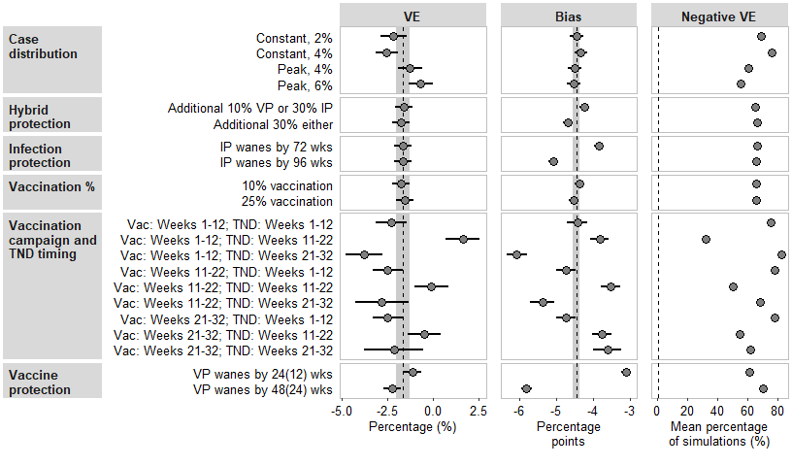
Figure S27: Unadjusted vaccine effectiveness (VE) against symptomatic infection, bias compared to adjusted VE estimates, and percentage of simulations with unadjusted VE less than zero (negative VE) for 5-11 months since the last vaccination.

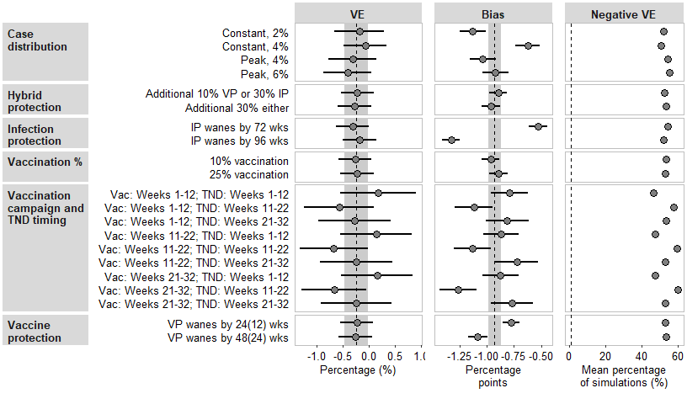
Figure S28: Unadjusted vaccine effectiveness (VE) against symptomatic infection, bias compared to adjusted VE estimates, and percentage of simulations with unadjusted VE less than zero (negative VE) for 12 or more months since the last vaccination.

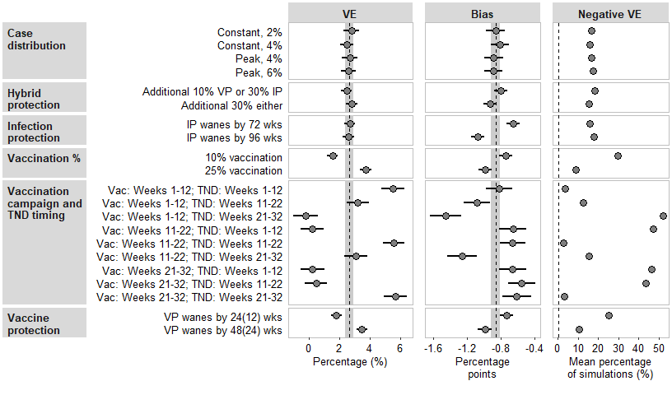
Figure S29: Unadjusted vaccine effectiveness (VE) against symptomatic infection, bias compared to adjusted VE estimates, and percentage of simulations with unadjusted VE less than zero (negative VE) for 2 vaccination doses.

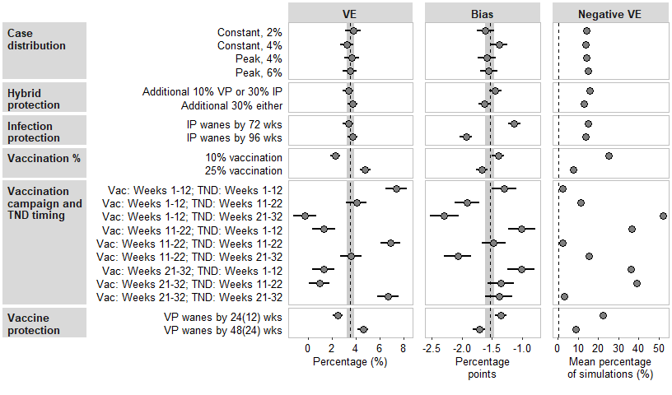
Figure S30: Unadjusted vaccine effectiveness (VE) against symptomatic infection, bias compared to adjusted VE estimates, and percentage of simulations with unadjusted VE less than zero (negative VE) for 3 vaccination doses.

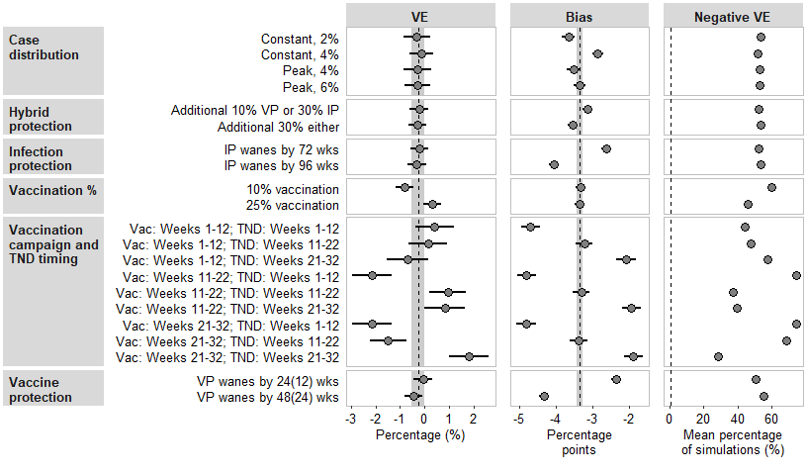
Figure S31: Unadjusted vaccine effectiveness (VE) against symptomatic infection, bias compared to adjusted VE estimates, and percentage of simulations with unadjusted VE less than zero (negative VE) for 4 vaccination doses.

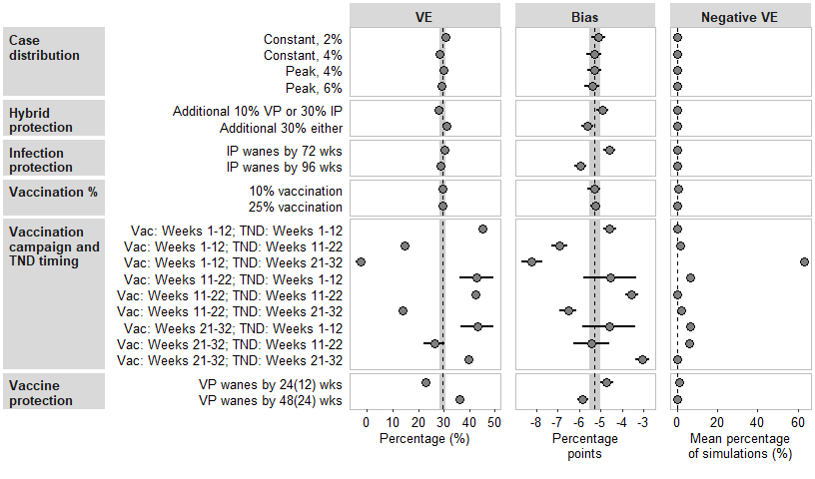
Figure S32: Unadjusted vaccine effectiveness (VE) against symptomatic infection, bias compared to adjusted VE estimates, and percentage of simulations with unadjusted VE less than zero (negative VE) for 5 vaccination doses.

VE against severe disease
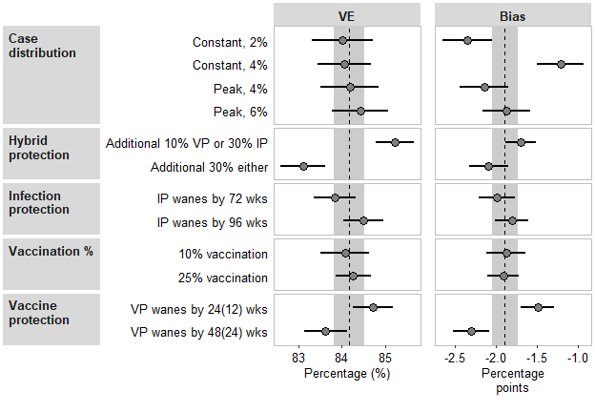
Figure S33: Unadjusted vaccine effectiveness (VE) against severe disease and bias compared to adjusted VE estimates for vaccination at any time during the analytic period.

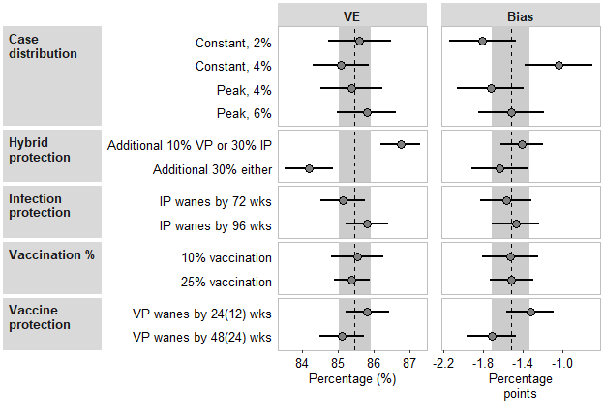
Figure S34: Unadjusted vaccine effectiveness (VE) against severe disease and bias compared to adjusted VE estimates for vaccination in the previous 2 months.

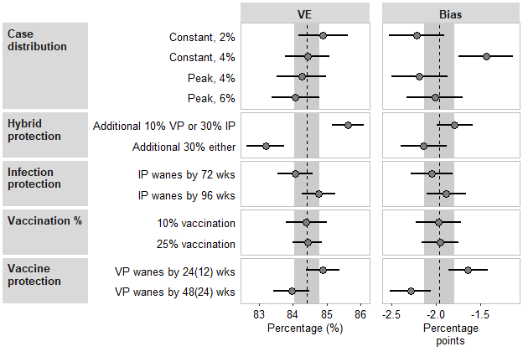
Figure S35: Unadjusted vaccine effectiveness (VE) against severe disease and bias compared to adjusted VE estimates for vaccination in the previous 4 months.

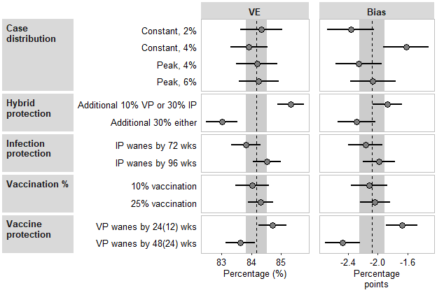
Figure S36: Unadjusted vaccine effectiveness (VE) against severe disease and bias compared to adjusted VE estimates for vaccination in the previous 5 months.

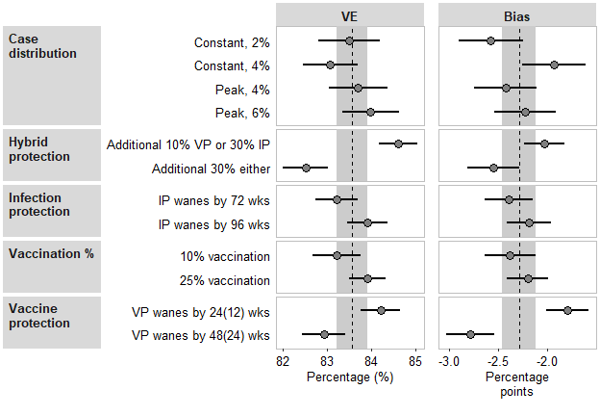
Figure S37: Unadjusted vaccine effectiveness (VE) against severe disease and bias compared to adjusted VE estimates for vaccination in the previous 6 months.

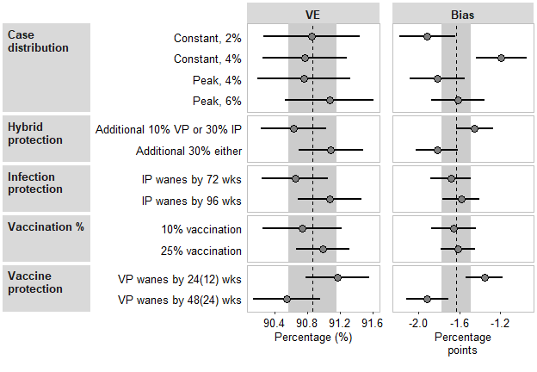
Figure S38: Unadjusted vaccine effectiveness (VE) against severe disease and bias compared to adjusted VE estimates for 1-2 months since the last vaccination.

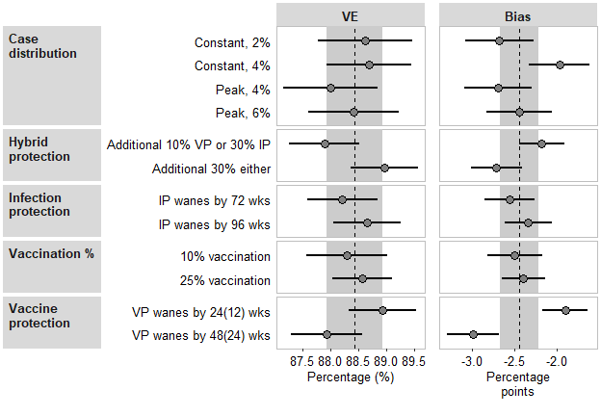
Figure S39: Unadjusted vaccine effectiveness (VE) against severe disease and bias compared to adjusted VE estimates for 3-4 months since the last vaccination.

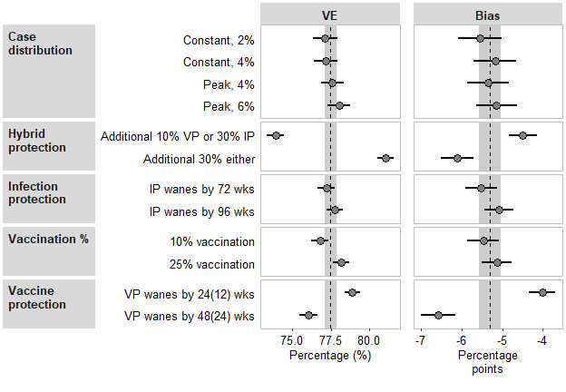
Figure S40: Unadjusted vaccine effectiveness (VE) against severe disease and bias compared to adjusted VE estimates for 5-11 months since the last vaccination.

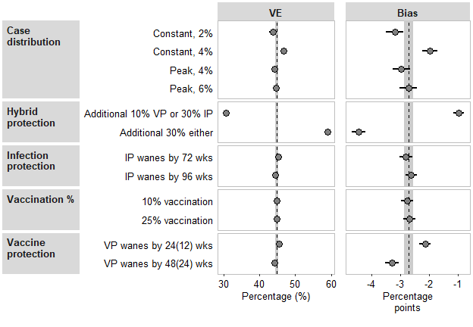
Figure S41: Unadjusted vaccine effectiveness (VE) against severe disease and bias compared to adjusted VE estimates for 12 or more months since the last vaccination.

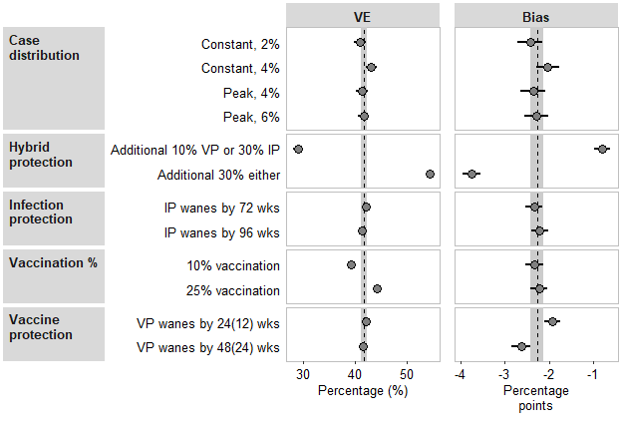
Figure S42: Unadjusted vaccine effectiveness (VE) against severe disease and bias compared to adjusted VE estimates for 2 vaccination doses.

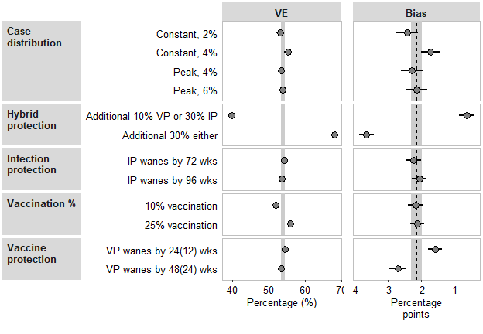
Figure S43: Unadjusted vaccine effectiveness (VE) against severe disease and bias compared to adjusted VE estimates for 3 vaccination doses.

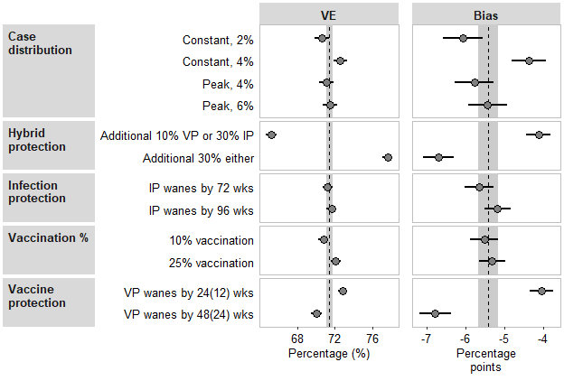
Figure S44: Unadjusted vaccine effectiveness (VE) against severe disease and bias compared to adjusted VE estimates for 4 vaccination doses.

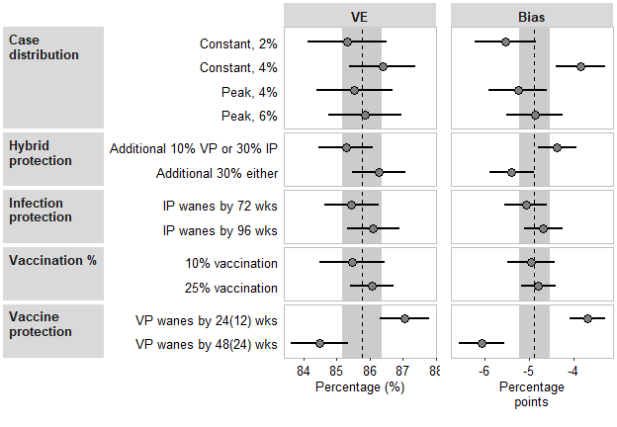
Figure S45: Unadjusted vaccine effectiveness (VE) against severe disease and bias compared to adjusted VE estimates for 5 vaccination doses.

Bibliography
1. Centers for Disease Control and Prevention COVID-19 Response. Weekly united states COVID-19 cases and deaths by state. 2023; Available at: \url{https://data.cdc.gov/Case-Surveillance/Weekly-United-States-COVID-19-Cases-and-Deaths-by-/pwn4-m3yp}.
2. Wiegand RE, Deng Y, Deng X, et al. Estimated SARS-CoV-2 antibody seroprevalence trends and relationship to reported case prevalence from a repeated, cross-sectional study in the 50 states and the District of Columbia, United States—October 25, 2020–February 26, 2022. The Lancet Regional Health–Americas 2023; 18.
3. Centers for Disease Control and Prevention. 2022 nationwide COVID-19 infection- and vaccination-induced antibody seroprevalence (blood donations). 2023; Available at: \url{https://covid.cdc.gov/covid-data-tracker/#nationwide-blood-donor-seroprevalence-2022}.
4. Centers for Disease Control and Prevention COVID-19 Response. COVID-19 vaccination age and sex trends in the united states, national and jurisdictional. 2023; Available at: \url{https://data.cdc.gov/Vaccinations/COVID-19-Vaccination-Age-and-Sex-Trends-in-the-Uni/5i5k-6cmh}.
5. Nguyen KH, Huang J, Mansfield K, Corlin L, Allen JD. COVID-19 vaccination coverage, behaviors, and intentions among adults with previous diagnosis, united states. Emerging Infectious Diseases 2022; 28:631.
6. Lutrick K, Groom H, Fowlkes AL, et al. COVID-19 vaccine perceptions and uptake in a national prospective cohort of essential workers. Vaccine 2022; 40:494–502. Available at: https://www.sciencedirect.com/science/article/pii/S0264410X21015930.
7. Pacella-LaBarbara ML, Park YL, Patterson PD, et al. COVID-19 vaccine uptake and intent among emergency healthcare workers: A cross-sectional survey. Journal of Occupational and Environmental Medicine 2021; 63:852–856.
8. Moniz MH, Townsel C, Wagner AL, et al. COVID-19 vaccine acceptance among healthcare workers in a united states medical center. medRxiv 2021; Available at: https://www.medrxiv.org/content/early/2021/04/30/2021.04.29.21256186.
9. Do DP, Frank R. Prior COVID-19 infection: an underappreciated factor in vaccine hesitancy in the USA. Journal of Public Health 2022; 44:471–474. Available at: https://doi.org/10.1093/pubmed/fdab404.
10. Nguyen V-TT, Huang Y, Huang M, Tsai J. Factors related to COVID-19 vaccine hesitancy among middle-income and low-income adults in the USA. Journal of Epidemiology & Community Health 2023; 77:328–335. Available at: https://jech.bmj.com/content/77/5/328.
11. Miller TE, Garcia Beltran WF, Bard AZ, et al. Clinical sensitivity and interpretation of PCR and serological COVID-19 diagnostics for patients presenting to the hospital. The FASEB Journal 2020; 34:13877–13884. Available at: https://faseb.onlinelibrary.wiley.com/doi/abs/10.1096/fj.202001700RR.

