Table I: Basic characteristics of the study population
 |  | Group
 |  | Treatment |  | Control
 |  | Count | % | Count | %
Sex | M | 56 | 62,9% | 45 | 56,3%
Sex | F | 33 | 37,1% | 35 | 43,8%
Fracture type | Trimalleolar fracture | 26 | 29,2% | 19 | 23,8%
Fracture type | Bimalleolar fracture | 29 | 32,6% | 36 | 45,0%
Fracture type | Tibial malleolus only | 0 | 0,0% | 0 | 0,0%
Fracture type | Malleolar fracture only | 17 | 19,1% | 15 | 18,8%
Fracture type | Trimalleolar fracture with syndesmotic disruption | 17 | 19,1% | 10 | 12,5%
Skin injuries | No | 85 | 95,5% | 57 | 71,3%
Skin injuries | Yes | 4 | 4,5% | 23 | 28,7%
Diabetes | No | 73 | 82,0% | 70 | 87,5%
Diabetes | Yes | 16 | 18,0% | 10 | 12,5%
Hypercholesterolemia | No | 73 | 82,0% | 67 | 83,8%
Hypercholesterolemia | Yes | 16 | 18,0% | 13 | 16,3%
Venous insufficiency | No | 82 | 92,1% | 76 | 95,0%
Venous insufficiency | Yes | 7 | 7,9% | 4 | 5,0%
BMI | Underweight | 0 | 0,0% | 0 | 0,0%
BMI | Normal | 42 | 47,2% | 46 | 57,5%
BMI | Overweight | 35 | 39,3% | 23 | 28,7%
BMI | Obesity I stage | 12 | 13,5% | 7 | 8,8%
BMI | Obesity II stage | 0 | 0,0% | 3 | 3,8%
BMI | Obesity III stage | 0 | 0,0% | 1 | 1,3%

Table II: The mean time to surgery is reported for treatment and control group
 |  | Group | N | Mean (hs.) | Median | S.D. | Mean Std. Error
Time to surgery |  | Treatment | 89 | 34,78 | 36.00 | 12,316 | 1,305
 |  | Control | 80 | 91,44 | 78.5 | 42,253 | 4,724

Table III: Time to surgery

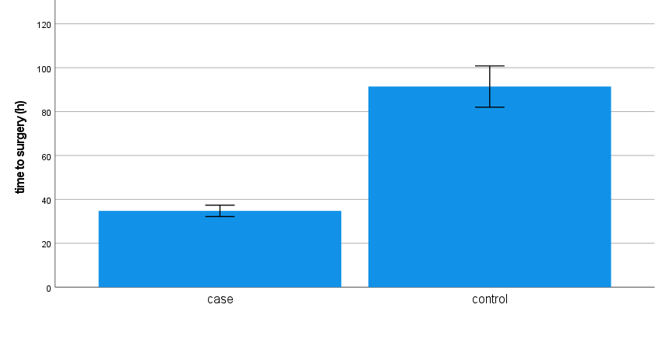
Table III: the time to surgery is significantly shorter in patient treated with third cryotherapy device compare with control group.
Table IV:

 |  | Group
 |  | Treatment |  |  | Control
 |  | Time to surgery (h) |  |  | Time to surgery (h)
 |  | Mean | Median | Standard Deviation | Mean | Median | Standard Deviation | p-value°
Type of fracture | Trimalleolar | 36,23 | 39,00 | 8,66 | 102,26 | 90,00 | 42,73 | <0.001
Type of fracture | Bimalleolar | 33,79 | 30,00 | 11,94 | 79,94 | 75,00 | 24,60 | <0.001
Type of fracture | Medial malleolus | . | . | . | . | . | .
Type of fracture | Lateral malleolus | 31,65 | 24,00 | 11,32 | 93,33 | 72,00 | 63,43 | <0.001
Type of fracture | Trimalleolar with TPA dislocation | 37,35 | 28,00 | 17,79 | 109,40 | 111,50 | 47,61 | <0.001

Table IV: Cryotherapy reduces time to surgery of all type of ankle fractures compared to controls.

Table V:
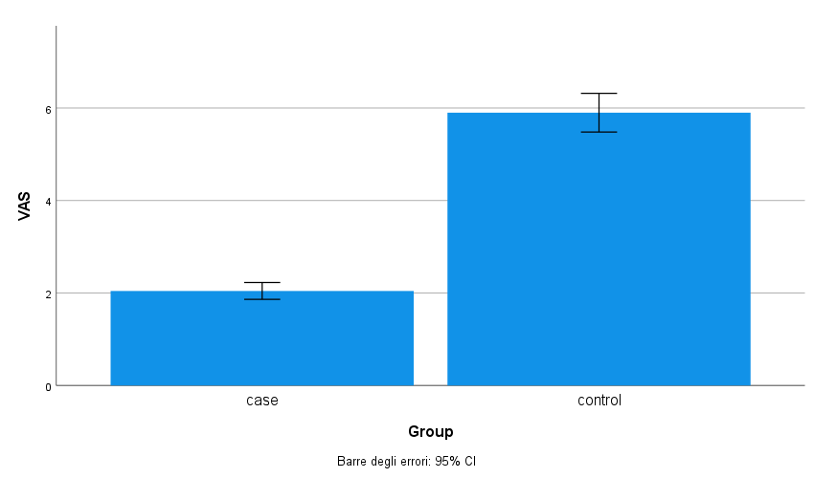
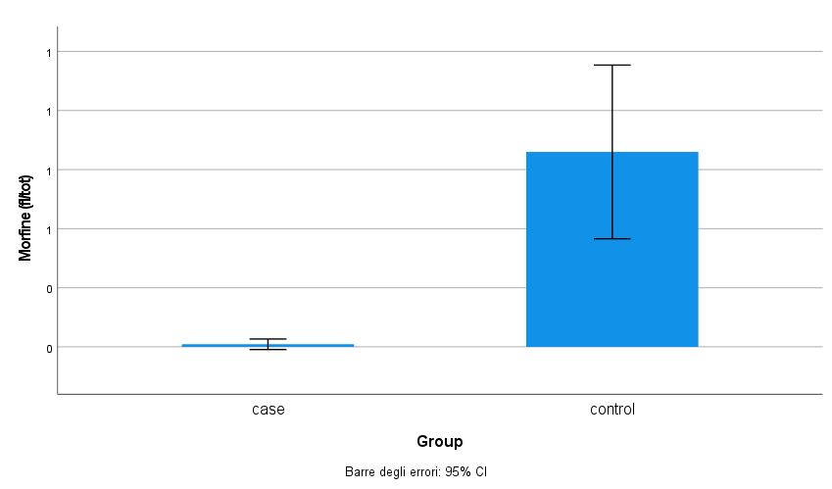

Table V: The mean pre-operatory VAS (A) and morphine consumption (Number of vails - B) were significantly lower (p-value<0.001) in the cryotherapy group compared to the control group.

Table VI
Cutaneous Complications Crosstabulation
 |  |  | Skin lesions |  | Total
 |  |  | No | Yes | Total
Group | Treatment | Count | 85 | 4 | 89
Group | Treatment | % within Group | 95,5% | 4,5% | 100,0%
Group | Treatment | % within skin lesions | 59,9% | 14,8% | 52,7%
Group | Controls | Count | 57 | 23 | 80
Group | Controls | % within Group | 71,3% | 28,7% | 100,0%
Group | Controls | % within skin lesions | 40,1% | 85,2% | 47,3%
Total |  | Count | 142 | 27 | 169
 |  | % within Group | 84,0% | 16,0% | 100,0%
 |  | % within skin lesions | 100,0% | 100,0% | 100,0%

Table VI: 95.5% of the treatment group did not report skin complications with respect to 28.7% of the controls. Among all skin lesions reported, 85.2% belong to the control group.

Table VII
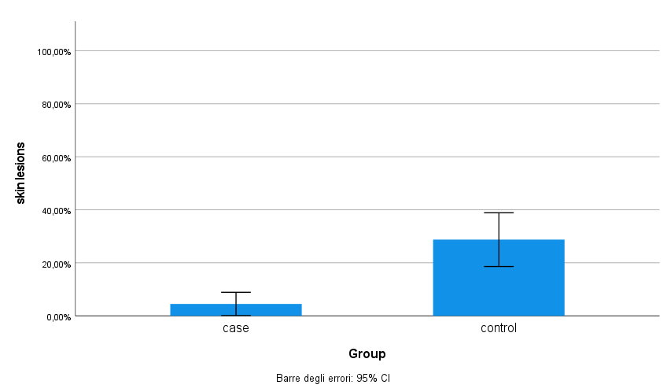
Table VII: To relate the presence of skin complications and the group to which they belong, the chi-square test is used since they are two nominal variables. The test is statistically significant (p-value<0.001) therefore there is a significant association between the group and the presence of skin lesions. Cramer's V index is calculated to quantify the strength of the association. The index is equal to 0.331, i.e. there is a moderate association.

