Extended data figure/table legends
B | A
D | C
F | E
H | G
J | I
L | K
Extended Data Fig. 1. Association between educational achievements and pre-sleep exposure to ALAN (left) and to noise (right panel) analysed separately. Note. A and B – average grades in Arabic; C and D – average grades in Hebrew; E and F – average grades in English; G and H – average grades in mathematics; I and J – average grades in humanities; K and L – average grades in sciences. Each dot represents an individual student differentiated by the colour of the dot.

A | B
C | D
E | F
G | H
I | J
K | L
Extended Data Fig. 2. The association between educational achievements and exposure during sleep to ALAN (left) and noise (right) analysed separately. Note. A and B – average grades in Arabic; C and D – average grades in Hebrew; E and F – average grades in English; G and H – average grades in mathematics; I and J – average grades in humanities; K and L – average grades in sciences
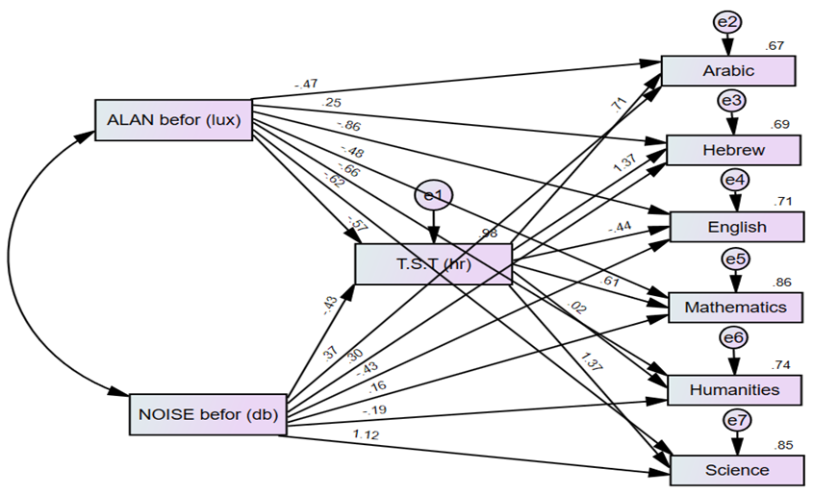
A
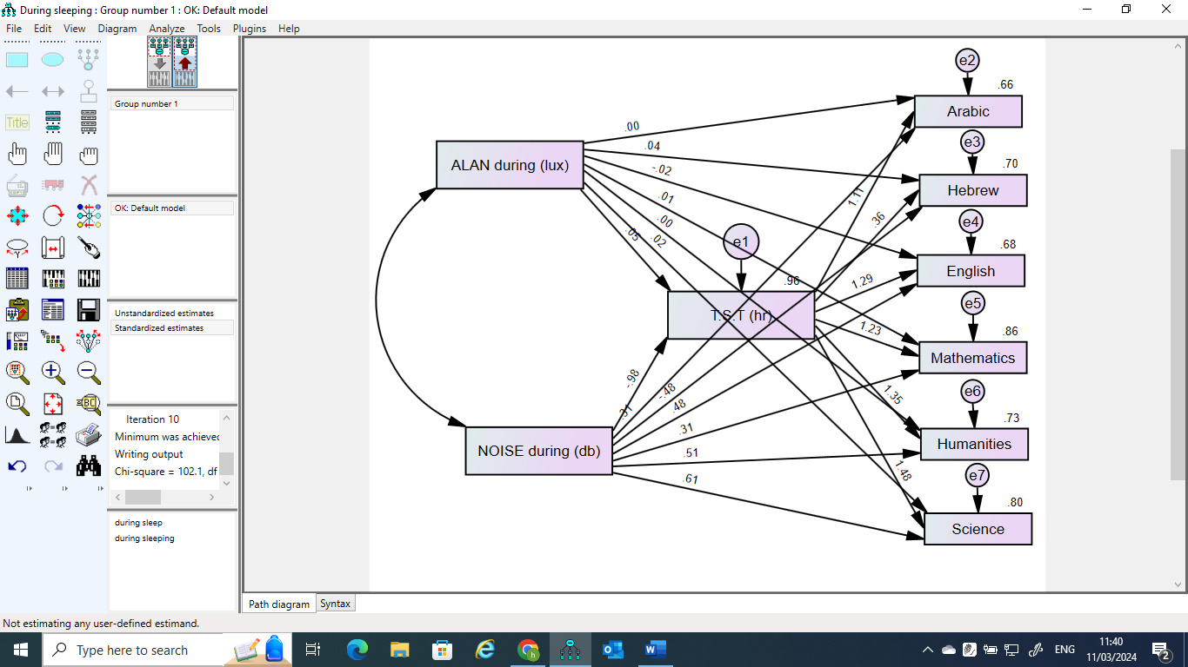
B
Extended Data Fig. 3. Mediation effect of TST on educational achievements: A = pre-sleep exposure; B = sleep-time exposure. Note. The analysis was performed using SPSS AMOS software²². The graphs illustrate the complexity of the impact of ALAN and noise on educational achievements with TST as a mediator.

Extended Data Table 1. Descriptive statistics of the study cohort
Attribute | Min | Max | Mean | SD
Age (years) | 13 | 18 | 15.7 | 1.588
Total sleep time (hours) | 4.06 | 11.56 | 7.79 | 1.82
Average room temperature (ºC) | 15.18 | 18.95 | 16.67 | 0.71
Average room humidity (%) | 41.74 | 73.39 | 67.15 | 5.71
Average ALAN exposure before sleep (lx) | 51.22 | 134.46 | 89.99 | 20.34
Average ALAN exposure during sleep (lx) | 0.0 | 1.5 | 0.40 | 0.28
Average noise exposure before sleep (dB) | 30.42 | 59.79 | 43.69 | 6.83
Average noise exposure during sleep (dB) | 29.00 | 47.00 | 38.85 | 4.57
Average grade in Arabic (0 to 100) | 65 | 100 | 85.00 | 9.284
Average grade in Hebrew (0 to 100) | 66 | 100 | 86.73 | 8.724
Average grade in English (0 to 100) | 50 | 100 | 85.45 | 10.435
Average grade in mathematics (0 to 100) | 41 | 98 | 72.94 | 13.747
Average grade in humanities (0 to 100) | 68 | 100 | 89.78 | 8.098
Average grade in sciences (0 to 100) | 55 | 100 | 76.11 | 11.294

Extended Data Table 2. Comparison between the control and study groups
Variable and study/control group |  | Min | Max | Mean | t-stat | SD | Sign.
Exposure to ALAN and noise
Average exposure to ALAN before sleep (lx) | Control group | 51.2 | 72.7 | 61.9 | 27.2 | 9.09 | <.001
Average exposure to ALAN before sleep (lx) | Study group | 105.0 | 134.5 | 120.2 | 41.1 | 11.70 | <.001
Average exposure to ALAN during sleep (lx) | Control group | 0 | 0.8 | 0.3 | 5.0 | 0.24 | <.001
Average exposure to ALAN during sleep (lx) | Study group | 0.0 | 0.8 | 0.3 | 5.8 | 0.24 | <.001
Average exposure to noise before sleep (dB) | Control group | 30.4 | 40.0 | 34.6 | 43.3 | 3.20 | <.001
Average exposure to noise before sleep (dB) | Study group | 47.6 | 59.8 | 53.8 | 52.3 | 4.11 | <.001
Average exposure to noise during sleep time (dB) | Control group | 29.0 | 36.0 | 32.2 | 48.5 | 2.65 | <.001
Average exposure to noise during sleep time (dB) | Study group | 41.0 | 47.0 | 44.8 | 83.5 | 2.15 | <.001
Subject grades (0-100)
Arabic | Control group | 88.0 | 100.0 | 94.9 | 93.8 | 4.05 | <.001
Arabic | Study group | 65.0 | 90.0 | 74.5 | 37.41 | 7.96 | <.001
Hebrew | Control group | 87.0 | 100.0 | 97.36 | 106.0 | 3.67 | <.001
Hebrew | Study group | 66.0 | 86.0 | 76.4 | 57.2 | 5.34 | <.001
English | Control group | 87.4 | 100.0 | 94.6 | 92.4 | 4.1 | <.001
English | Study group | 50.0 | 86.0 | 70.5 | 29.9 | 9.44 | <.001
Mathematics | Control group | 80.1 | 98.0 | 90.3 | 65.2 | 5.54 | <.001
Mathematics | Study group | 41.0 | 67.0 | 53.5 | 25.8 | 8.31 | <.001
Humanities | Control group | 90.0 | 100.0 | 96.8 | 116.9 | 3.31 | <.001
Humanities | Study group | 68.0 | 89.0 | 77.4 | 44.7 | 6.92 | <.001
Sciences | Control group | 79.0 | 100.0 | 91.9 | 50.1 | 7.33 | <.001
Sciences | Study group | 55.0 | 73.0 | 62.6 | 58.3 | 4.29 | <.001

