Supplementary Figures
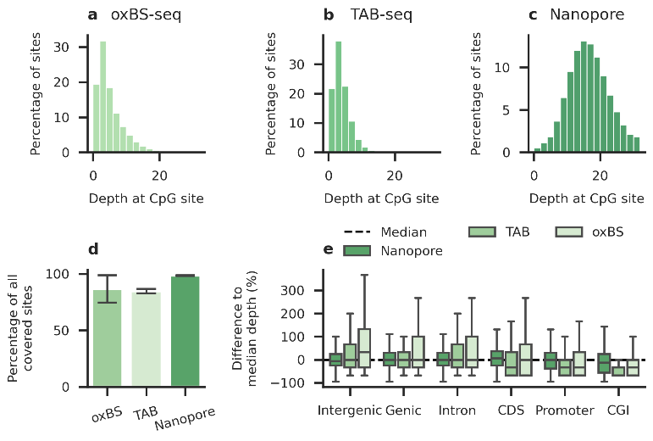
Supplementary Figure 1: Coverage and read depth across each dataset. Coverage depth distribution for the a) oxBS-seq, b) TAB-seq, and c) nanopore sequencing datasets. d) Completeness of coverage for technical replicates of each sequencing method. Expressed as a percentage of all CpG sites covered by all methods. e) Genomic context dependent differences in CpG read depth, relative to the median depth of each method.
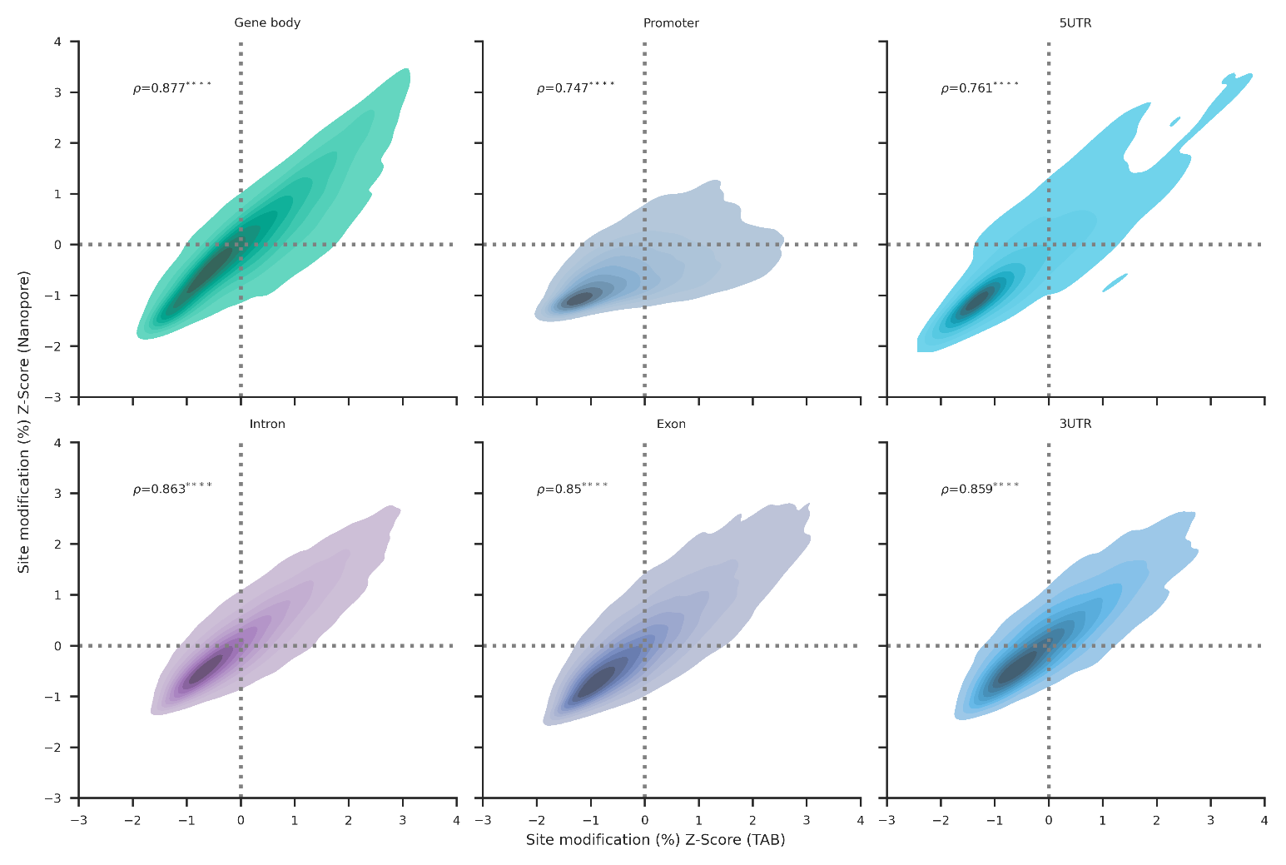
Supplementary Figure 2: 5hmC enrichment in matched genomic features as detected by nanopore sequencing (y) and TAB-seq (x). CpG-context base-calls from both datasets are aggregated across matched genomic features. The proportion of all base-calls within each feature comprised of 5hmC is arsine transformed, with the transformed value used to calculate a Z-score.
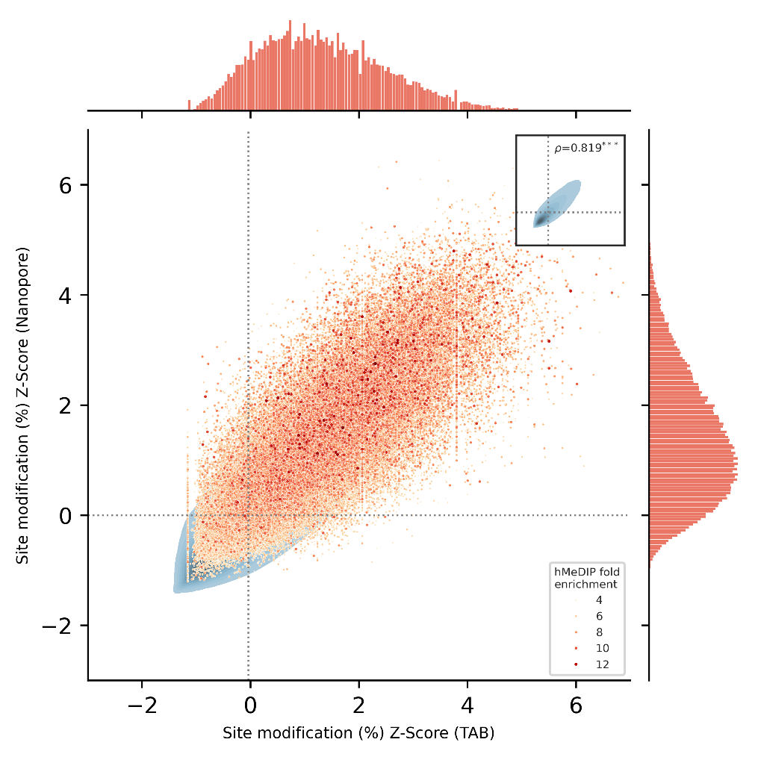
Supplementary Figure 3: Comparison of conventional PCR-based hMeDIP-seq peaks (scatter) and 5hmC detection enrichment from nanopore and TAB-seq (density). CpG-context base-calls from each dataset are aggregated across matched 500bp windows of the genome. The proportion of all base-calls in each window comprised of 5hmC is first arcsine transformed, and then a Z-score is calculated from the transformed values for both nanopore and TAB-seq 5hmC calls. Background plot shows density of those windows, with a scatterplot overlay indicating overlaps with hMeDIP-seq peaks from a public hMeDIP-seq dataset (Song et al., 2011). Inset plot (top-right) shows background density without scatterplot overlay. Histograms along margins count hMeDIP-seq peaks relative to (top) TAB-seq and (bottom) nanopore sequencing.
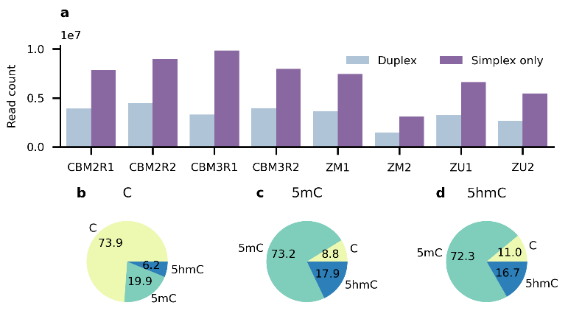
Supplementary Figure 4: Duplex modified base detection in nanopore sequence data. a) Count of all duplex and simplex-only reads across 8 nanopore PromethION sequencing runs, using mouse cerebellum and all methylation controls. b-d) Pie charts show CpG dyad partners as a percentage of all CpG dyad pairs containing a) unmodified C, b) 5mC, or c) 5hmC.
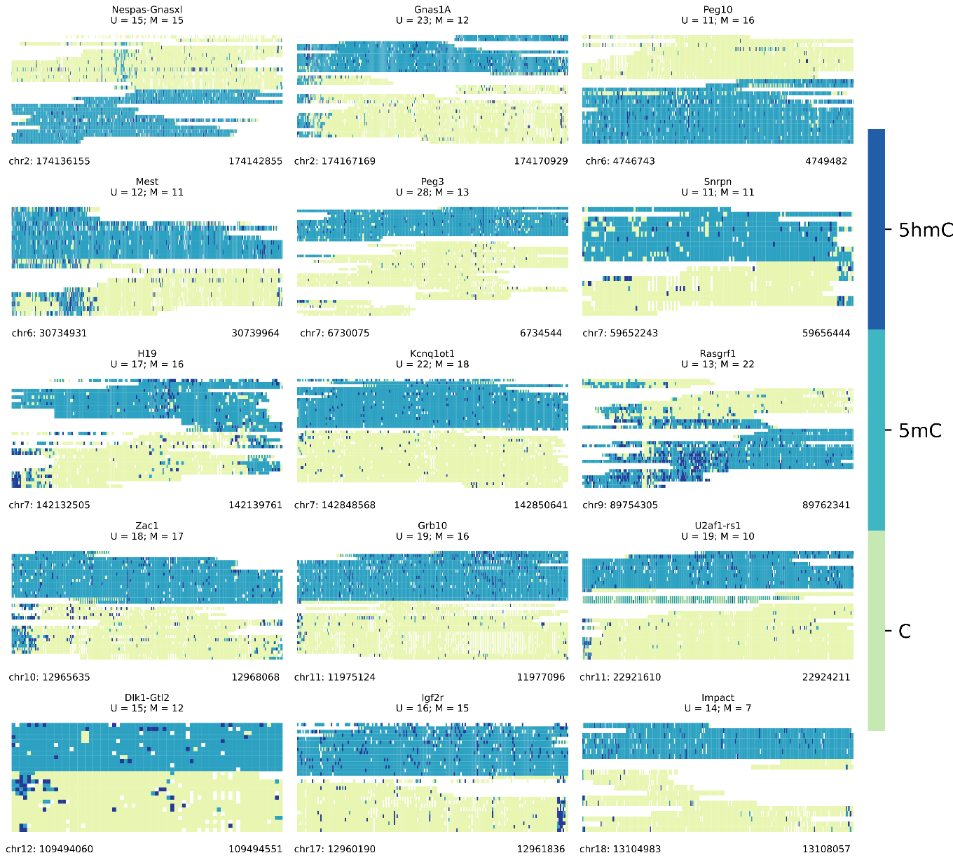
Supplementary Figure 5: Differentially methylated regions from imprinted gene and imprinting clusters in mouse cerebellum, sorted by allele. Heatmap titles contain the official gene symble, count of reads assigned to the unmethylated allele (U), and count of methylated reads (M).
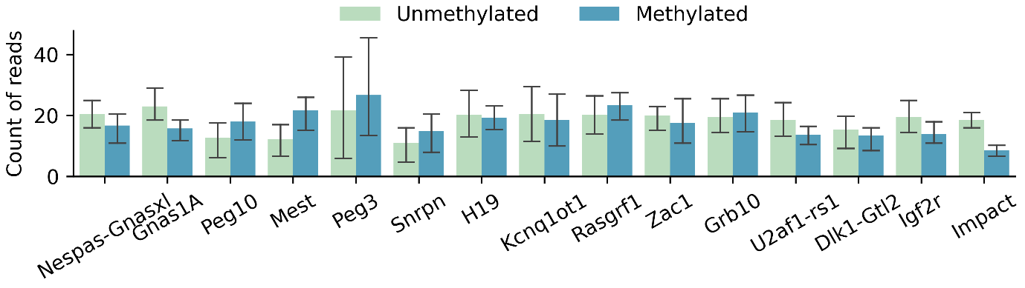
Supplementary Figure 6: Count of reads by allele for imprinted gene and imprinting clusters.
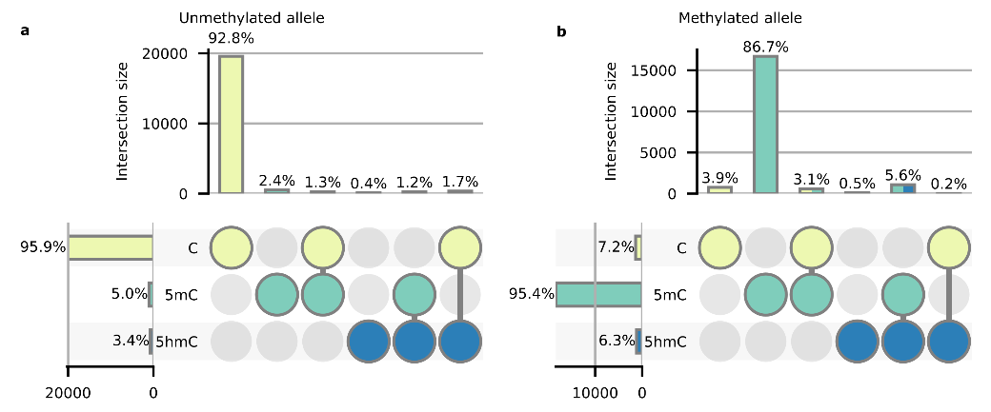
Supplementary Figure 7: Duplex base-calls at the differentially methylated regions of imprinted genes separated by allele. a-b) Upset plots of duplex modification states on the a) unmethylated and b) methylated allele.

Supplementary Tables
Supplementary Table 1: Spearman correlation of 5hmC Z-score between matched genomic features in nanopore and TAB-seq data. Z-scores are calculated from the arcsine transformed proportion of all base-calls contained in a feature comrpised of 5hmC.
Feature type | Spearman correlation ρ | Number of features compared (n)
Intron | 0.863 | 91,415
Exon | 0.85 | 28,742
Promoter | 0.747 | 8,371
3UTR | 0.859 | 8,243
5UTR | 0.761 | 877
Whole gene body | 0.977 | 19,190

Supplementary Table 2: Coordinates used for ICR analysis. Derived from Tomizawa et al. (2011). Coordinates were lifted over to mm39 (GRCm39) from mm10 (GRCm38) using UCSC LiftOver.
Chromosome | Start | End | ICR Cluster | Expressed allele
chr2 | 174135847 | 174142870 | Nespas-Gnasxl | M
chr2 | 174167880 | 174171044 | Gnas1A | M
chr6 | 4745996 | 4749542 | Peg10 | M
chr6 | 30733719 | 30740906 | Mest | M
chr7 | 6730075 | 6734545 | Peg3 | M
chr7 | 59649823 | 59657730 | Snrpn | M
chr7 | 142130545 | 142137800 | H19 | P
chr7 | 142848568 | 142850642 | Kcnq1ot1 | M
chr9 | 89756317 | 89765880 | Rasgrf1 | P
chr10 | 12965635 | 12968069 | Zac1 | M
chr11 | 11975032 | 11980194 | Grb10 | M
chr11 | 22921532 | 22924921 | U2af1-rs1 | M
chr12 | 109494035 | 109494599 | Dlk1-Gtl2 | P
chr17 | 12959887 | 12962154 | Igf2r | M
chr18 | 13104910 | 13108093 | Impact | M

Supplementary Table 3: Point-Biserial Correlation between CpG dyad modification state and absolute distance from CTCF ChIP-seq peak summits. Positive correlations imply further distance from binding summits, whereas negative correlations imply proximity. CpG dyads greater than 500bp from a peak summit are excluded from calculations.
Dyad pattern | Point-Biserial Correlation ($r_{pb}$) | Number of dyads compared (n)
C:C | -0.32 | 5,167,962
5mC:5mC | 0.25 | 1,945,330
5hmC:5hmC | 0.04 | 256,189
C:5mC | 0.06 | 341,956
C:5hmC | 0.01 | 201,858
5mC:5hmC | 0.11 | 806,327

Works cited

Song, C.-X., Szulwach, K.E., Fu, Y., Dai, Q., Yi, C., Li, X., Li, Y., Chen, C.-H., Zhang, W., Jian, X., Wang, J., Zhang, L., Looney, T.J., Zhang, B., Godley, L.A., Hicks, L.M., Lahn, B.T., Jin, P. and He, C., 2011. Selective chemical labeling reveals the genome-wide distribution of 5-hydroxymethylcytosine. Nature Biotechnology, 29(1), pp. 68-72.
Tomizawa, S.-i., Kobayashi, H., Watanabe, T., Andrews, S., Hata, K., Kelsey, G. and Sasaki, H., 2011. Dynamic stage-specific changes in imprinted differentially methylated regions during early mammalian development and prevalence of non-CpG methylation in oocytes. Development, 138(5), pp. 811-820.

