Supplementary materials

8q24 Clear Cell Renal Cell Carcinoma Germline Variant is Associated with VHL Mutation Status and Clinical Aggressiveness

Jeanette E. Eckel-Passow^{1,*}, Huihuang Yan¹, Matthew L. Kosel¹, Daniel Serie², Paul A. Decker¹, Robert B. Jenkins³, Brian Costello⁴, Bradley Leibovich⁴, Thai H. Ho⁵, Alexander Parker²

Supplementary Figure S1: Hi-C interactions for each of the 14 known RCC germline variants.

Chromosome 1: rs4381241

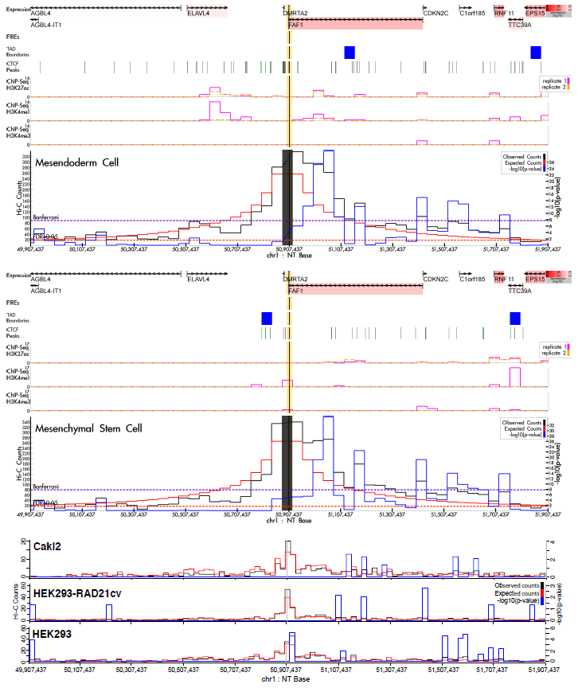
Chromosome 2: rs7579899

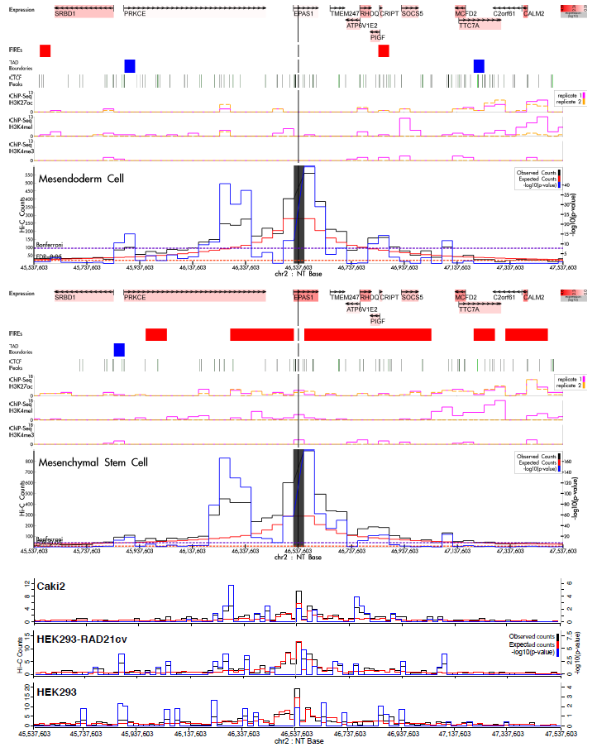

Chromosome 2: rs12105918

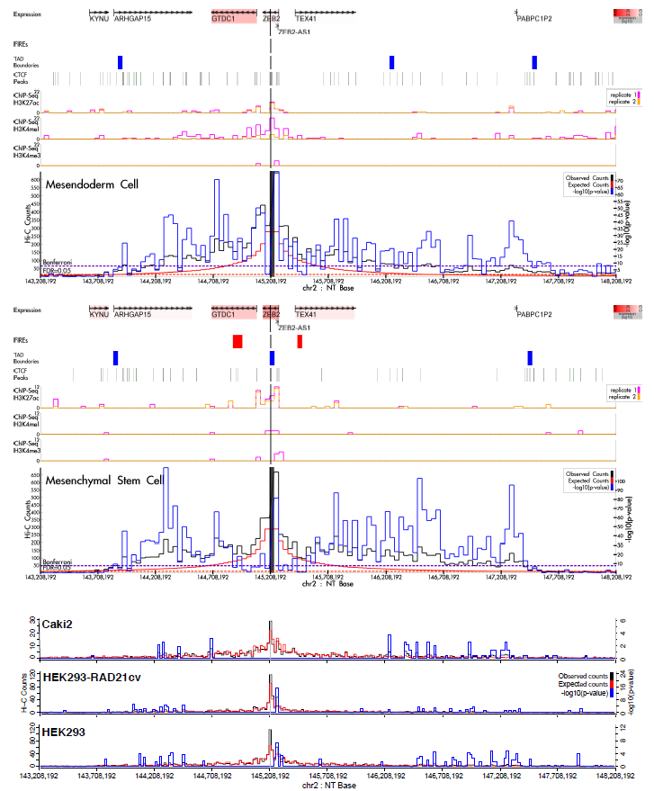

Chromosome 3: rs10936602

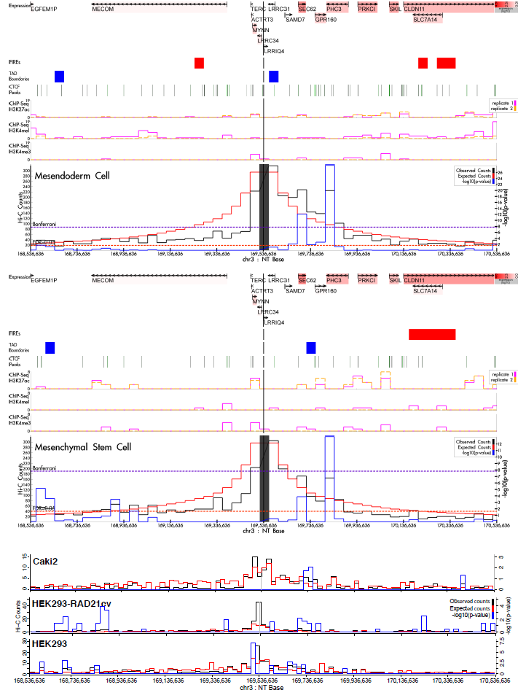

Chromosome 3: rs67311347

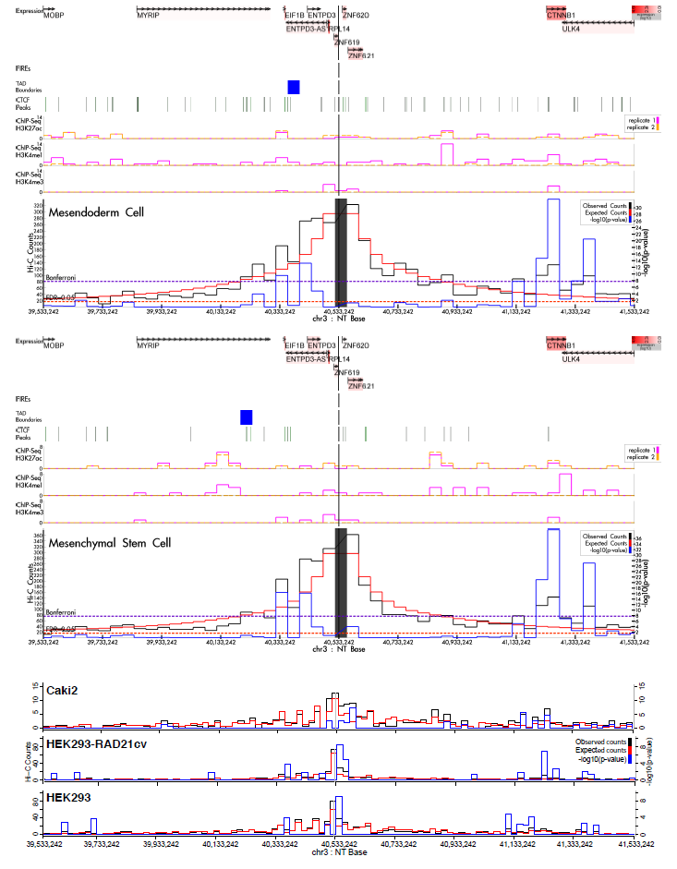

Chromosome 8: rs2241261

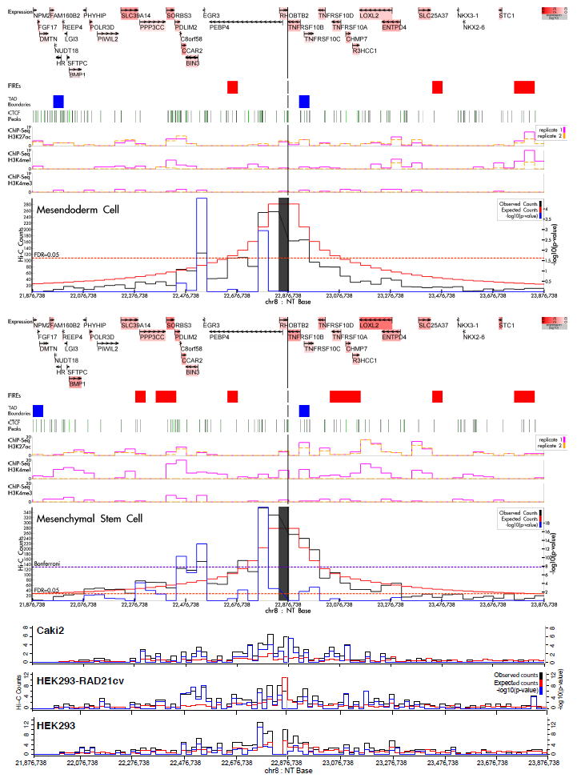

Chromosome 8: rs35252396

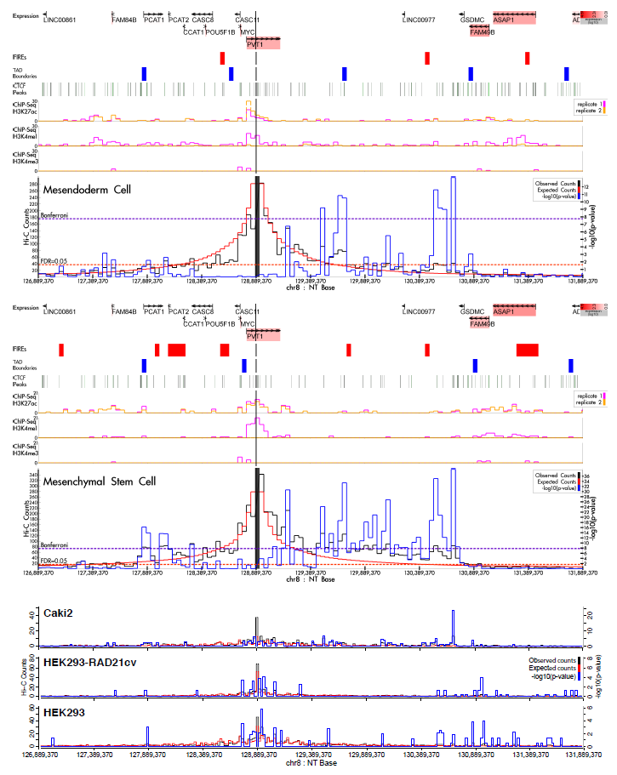

Chromosome 10: rs11813268

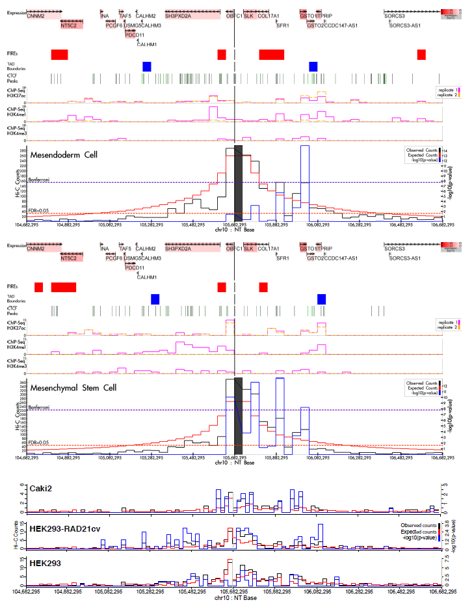

Chromosome 11: rs1800057

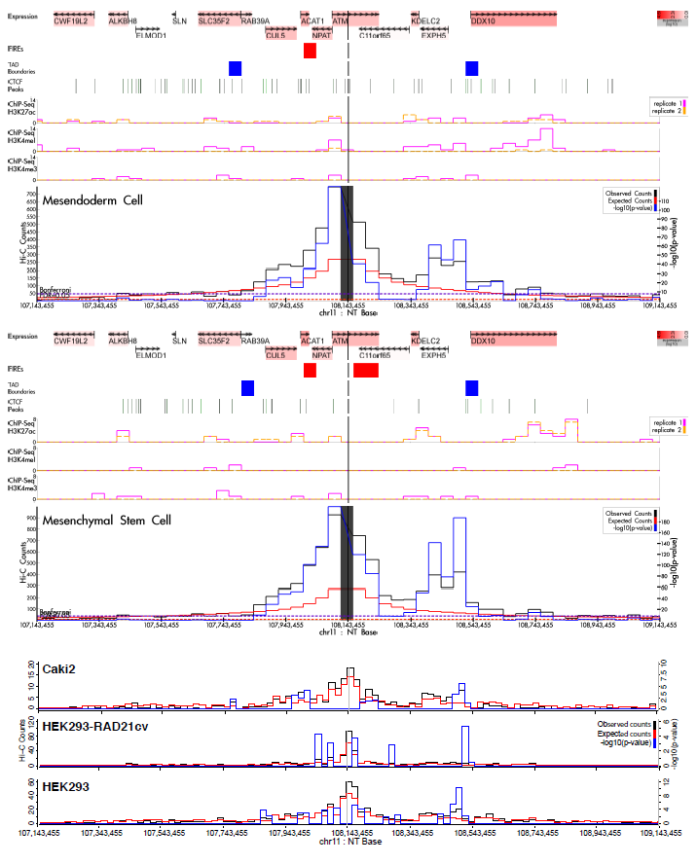

Chromosome 11: rs7105934

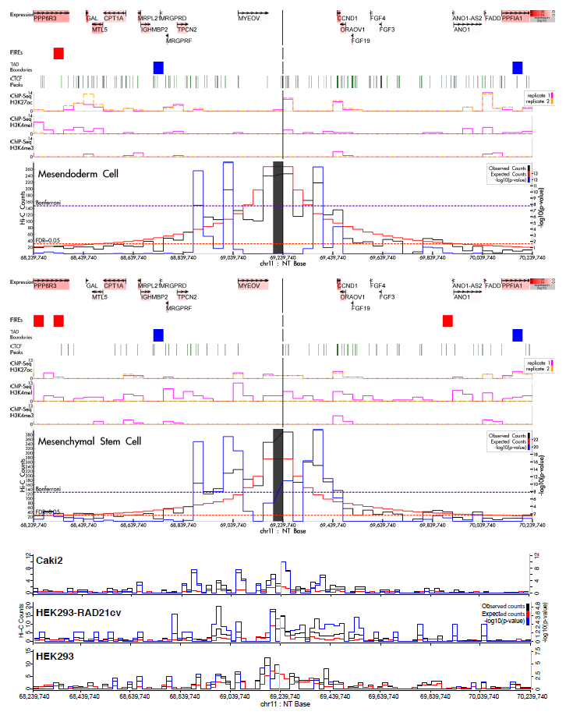

Chromosome 11: rs74911261

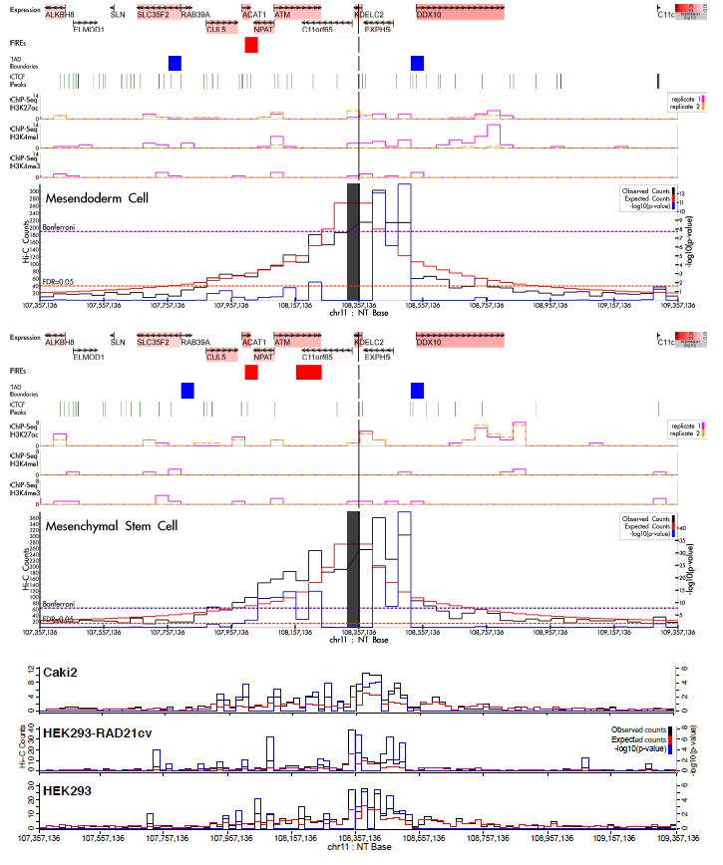

Chromosome 12: rs718314

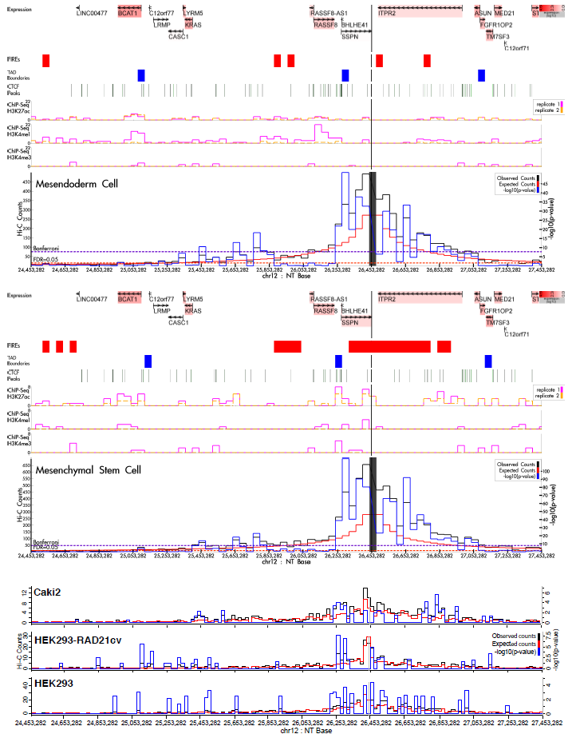

Chromosome 12: rs4765623

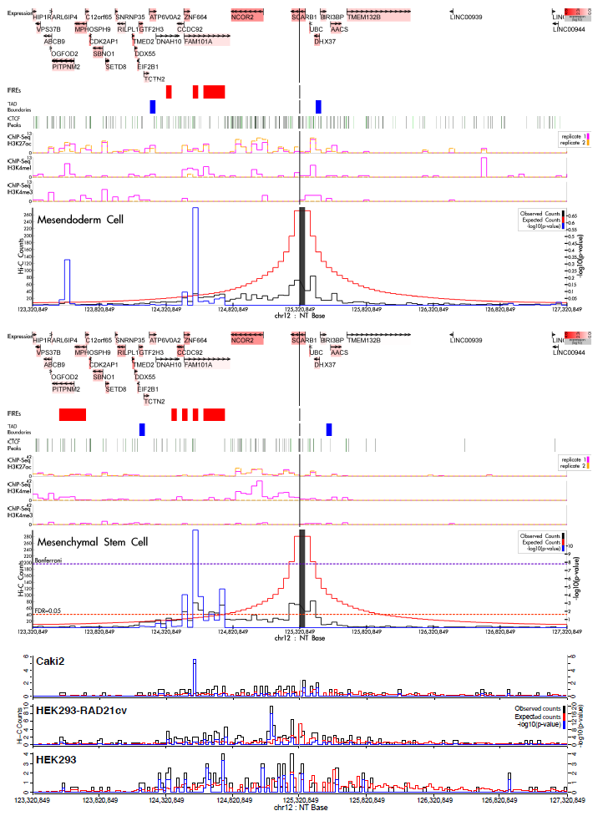

Chromosome 14: rs4903064

