Supplemental information

Supplemental methods
Brain imaging
Magnetic resonance imaging (MRI) and resting state functional MRI (rs-fMRI) data were acquired with a 3.0 T UMR790 MRI scanner (United Imaging, Shanghai) at KIZ. The anesthesia and scanning procedures adhered to the guidelines outlined in the US National Institutes of Health Guide for the Care and Use of Laboratory Animals and were approved by the Institutional Animal Care and Use Committee of the Kunming Institute of Zoology, CAS. Prior to scanning, the animals were premedicated with atropine (0.05 mg/kg, intramuscular) followed by ketamine (10 mg/kg, intramuscular). Anesthesia was maintained throughout the scanning procedure with continuous intravenous propofol at 15 mg/kg/h. To ensure optimal anesthesia, the levels of End-tidal carbon dioxide (ETCO₂) and respiratory rate were monitored using a magnetic-resonance compatible monitoring system. Additionally, to prevent hypothermia, animals were carefully covered with a blanket during the scanning procedure.

Structural MRI data acquisition and analyses
T1-weighted images were acquired using a 3D T1-weighted fast spoiled gradient echo (gre_fsp) sequence (voxel size = 0.5 mm isotropic, TE = 5.6 ms, TR = 13.01 ms, flip angle: 8°), while T2-weighted images were acquired using a fse_mx sequence (voxel size = 0.5 mm isotropic, TE = 396.48 ms, TR = 3400 ms, flip angle: 59°) by using a 12-channel head coil. The structural data were processed using Analysis of Functional NeuroImages software (AFNI)¹, FMRIB Software Library (FSL)², Advanced Normalization Tools (ANTs)³ and FreeSurfer⁴.

Firstly, the T1 image of each animal was nonlinearly registered to the NIMH Macaque Template (NMT, version 2.0)⁵. Then, the initial skull stripping mask and white matter mask were generated using an in-house neural network model. The T2 image was co-registered with the T1 image using a rigid-body transformation. A bias correction procedure was applied to enhance contrast by combining the T1 and T2 images. Subsequently, a customized pipeline primarily based on FreeSurfer was employed to process the T1 image, and produced white matter and gray matter surfaces. Manual examination and editing of the skull stripping and white matter masks were performed slice-by-slice along axial and coronal planes by an expert to ensure accuracy. The revised versions were used to generate the final white matter and gray matter surfaces.

The brain surfaces were further segmented into four lobes (i.e., frontal, parietal, temporal, and occipital lobes) and 88 regions per hemisphere, according to the CHARM1 and CHARM5 atlas respectively⁵. FreeSurfer was utilized to extract the gray matter thickness, volume, and surface area (gray matter/CSF boundary) of each lobe and region. Subcortical regions were parcellated using a SARM atlas⁶, encompassing 13 main nuclei and structures such as the amygdala, thalamus, and hippocampal formation (Table S11). The segmentation of subcortical regions was achieved by inversely applying the abovementioned registration matrix to the SARM atlas mentioned above. The segmentation of white matter was based on the CHARM1 and CHARM5 atlas⁵ for gray matter. The segmentation of the ventricle was conducted using the identical procedure to that employed for subcortical regions, followed by manual examination and editing if necessary. Note that the volume of each region, including ventricles, white matter, and subcortical regions, was calculated based on the voxel count in the native space atlas.

Rs-fMRI data acquisition and analyses
Rs-fMRI images were collected using an echo planar imaging (EPI) sequence (voxel size = 1.5 mm isotropic, TE = 29 ms, TR = 1700 ms, flip angle: 80°). Each session comprised 505 EPI volumes. The first 5 volumes from each fMRI data were removed to allow the signal to reach a steady state. The reverse phase encoding data was acquired for EPI image correction. The rs-fMRI data preprocessing was performed using AFNI following a workflow as outlined in previous studies⁷.

For FC analyses, the data were divided into five segments, each consisting of 100 volumes. The brain was parcellated using the CHARM5 atlas and SARM atlas following the same procedure as the structural data analysis. Then, the FC network was calculated for each individual. The edges of the FC network were defined as Pearson’s correlation coefficients between the mean time series of all pairs of brain regions, resulting in a 202 × 202 matrix. The diagonal line of the matrix was set to zero. Next, FC matrices were transformed into z-score matrices using Fisher’s z-transformation to improve normality.

Group Analyses
To evaluate the structural difference between DISC1 p.Arg517Trp carriers and non-carriers, we conducted Generalized Linear Mixed Models (GLMMs) on measures at the global, lobe, and region levels, with Hemisphere as the random factor. Notably, all structural data were corrected with the intracranial volume of the corresponding hemisphere.

The present study employed the network-based statistic (NBS), as described by Zalesky et al.⁸, to identify subnetworks or clusters of regions exhibiting differential connectivity within the intra-hemisphere network between two groups. This non-parametric statistical approach was specifically designed to control for family-wise error resulting from multiple comparisons. Connected components of the graph were identified based on edges that surpassed a primary threshold (a series of extent values, e.g., ranging from 3.0 to 3.4), and the statistical significance of these connected components was assessed by comparing their topological extension against a null distribution generated through non-parametric permutation testing. It is important to note that in the NBS analysis, the rejection of the null hypothesis occurs at the component level rather than at the individual edge level. This characteristic allows for superior statistical power compared to mass-univariate approaches. The NBS analysis was conducted using the NBS toolbox (https://www.nitrc.org/projects/nbs/), with all statistical analyses carried out in MATLAB R2021b. To account for potential confounding effects, Segment and Hemisphere were included as nuisance covariates. Brain results were visualized using a network surface representation based on BrainNet Viewer⁹.
Supplementary references
1. Cox, R.W. AFNI: software for analysis and visualization of functional magnetic resonance neuroimages. Comput. Biomed. Res. 29, 162-73 (1996).
2. Jenkinson, M., Beckmann, C.F., Behrens, T.E., Woolrich, M.W. & Smith, S.M. Fsl. Neuroimage 62, 782-90 (2012).
3. Avants, B.B., Tustison, N. & Song, G. Advanced normalization tools (ANTS). Insight j 2, 1-35 (2009).
4. Fischl, B. FreeSurfer. Neuroimage 62, 774-81 (2012).
5. Jung, B. et al. A comprehensive macaque fMRI pipeline and hierarchical atlas. Neuroimage 235, 117997 (2021).
6. Hartig, R. et al. The subcortical atlas of the rhesus macaque (SARM) for neuroimaging. Neuroimage 235, 117996 (2021).
7. Jo, H.J. et al. Effective preprocessing procedures virtually eliminate distance-dependent motion artifacts in resting state FMRI. Journal of applied mathematics 2013(2013).
8. Zalesky, A., Fornito, A. & Bullmore, E.T. Network-based statistic: identifying differences in brain networks. Neuroimage 53, 1197-207 (2010).
9. Xia, M., Wang, J. & He, Y. BrainNet Viewer: a network visualization tool for human brain connectomics. PLoS One 8, e68910 (2013).
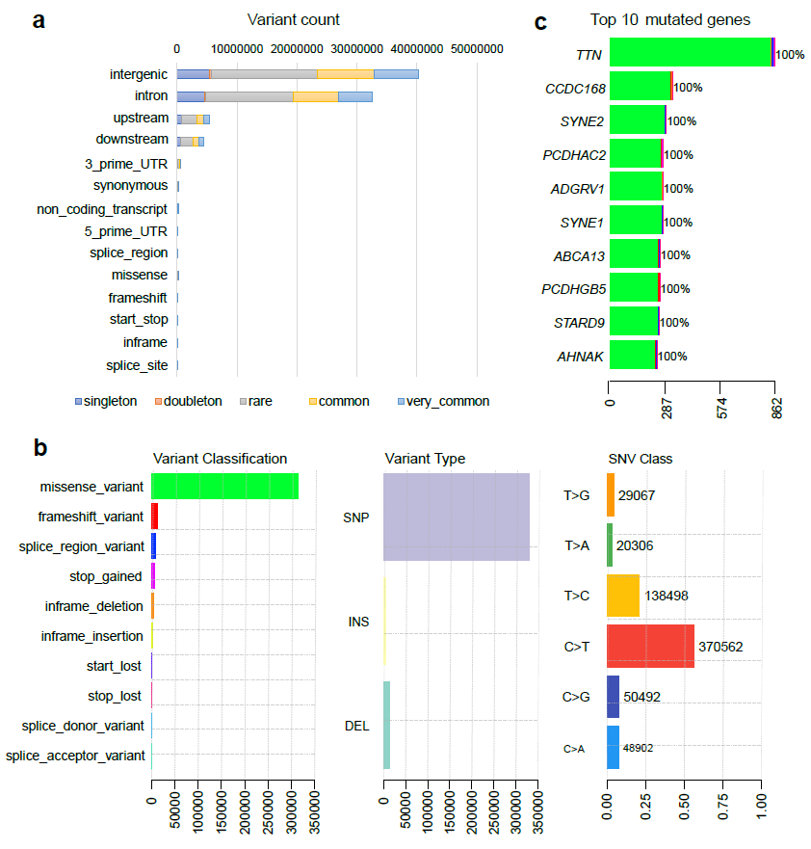

Extended Data Fig. 1: Summary of the mutations of CRM cohort. a, Variant count on the basis of variant type and allele frequency (AF). Singleton, allele count = 1; doubleton, allele count = 2; rare, allele count > 2 and AF ≤ 0.01; common, AF > 0.01 and AF ≤ 0.05; and very common, AF > 0.05. b, Left: histogram of the different mutation types in coding and splicing regions. Middle: frequency of three variant categories: SNP, insertion (INS), and deletion (DEL) in coding and splicing regions. Right: frequency of SNV classes. c, Stacked histogram of different types of mutation in the top 10 mutated genes with the highest mutation frequency.

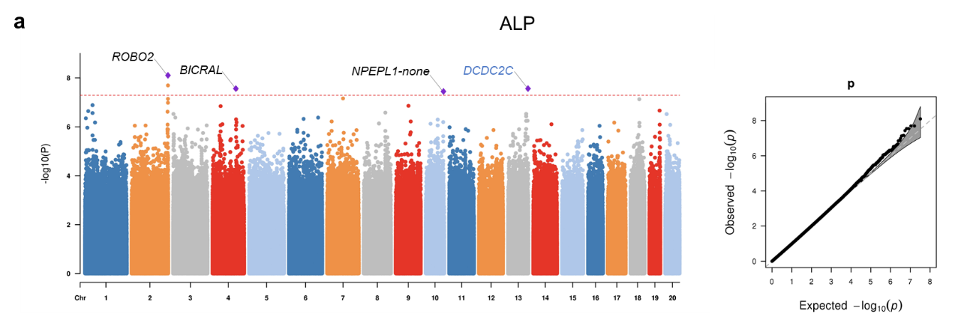
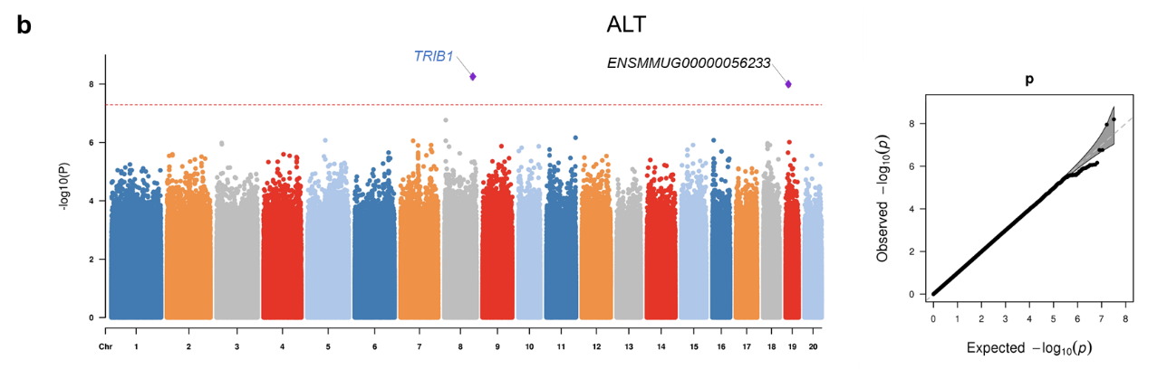
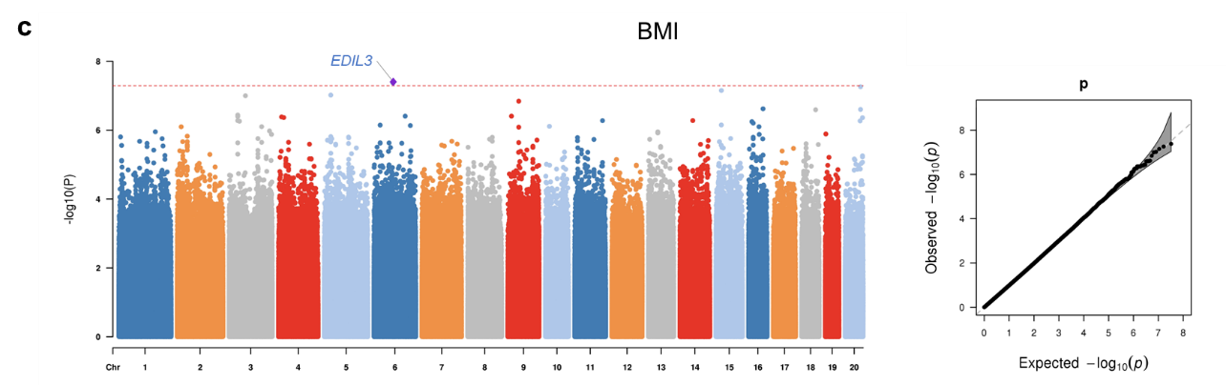
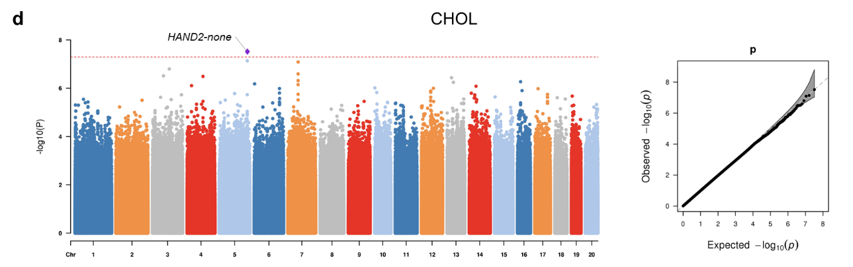
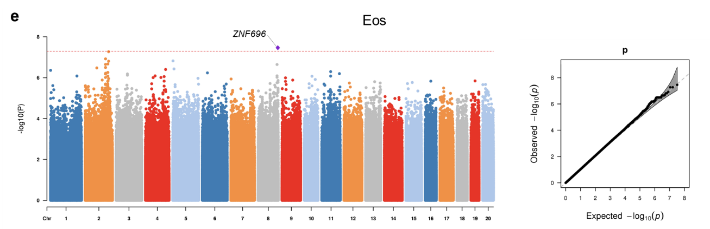
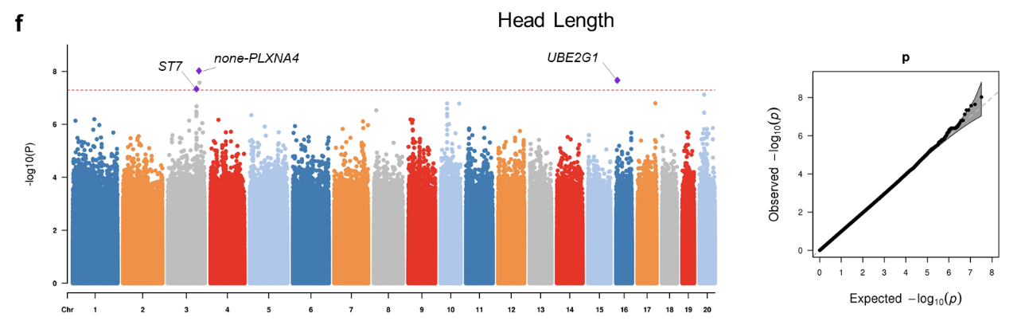
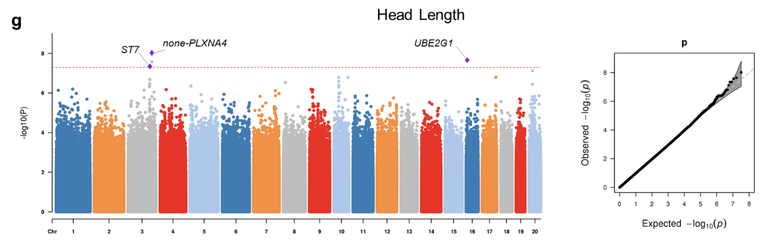
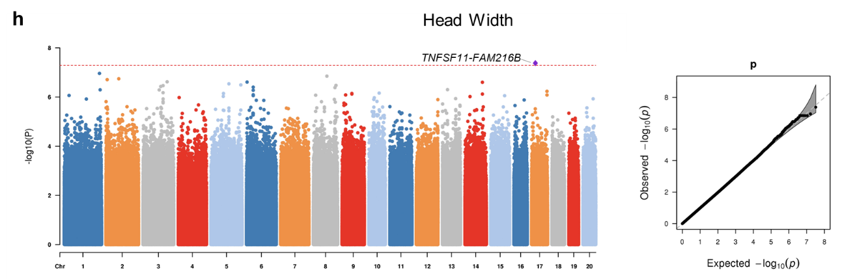
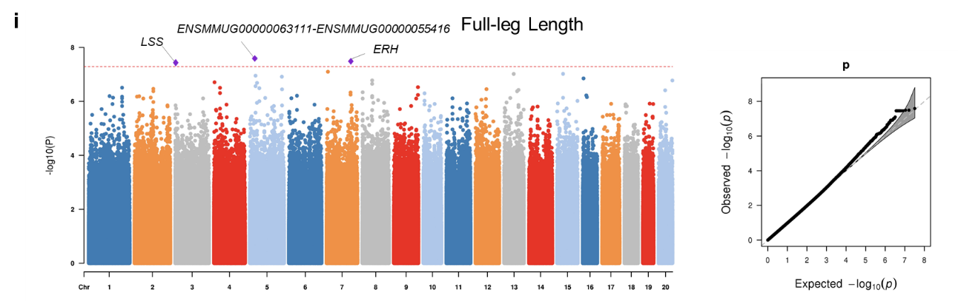
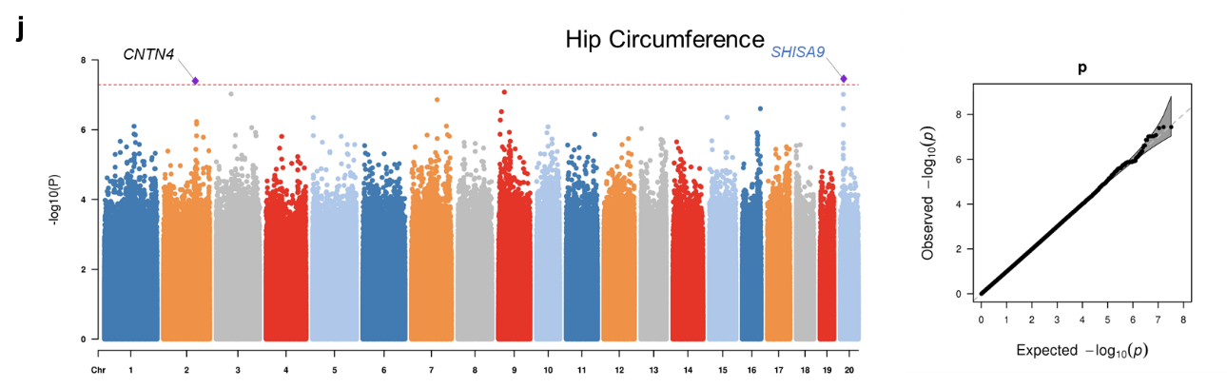
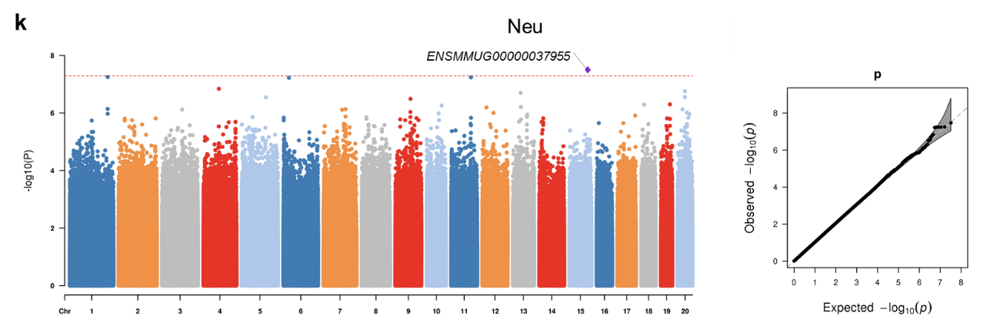
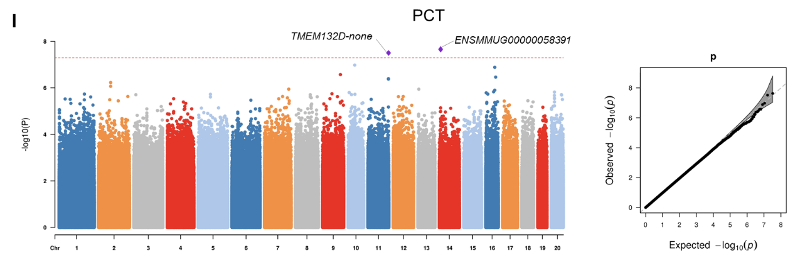
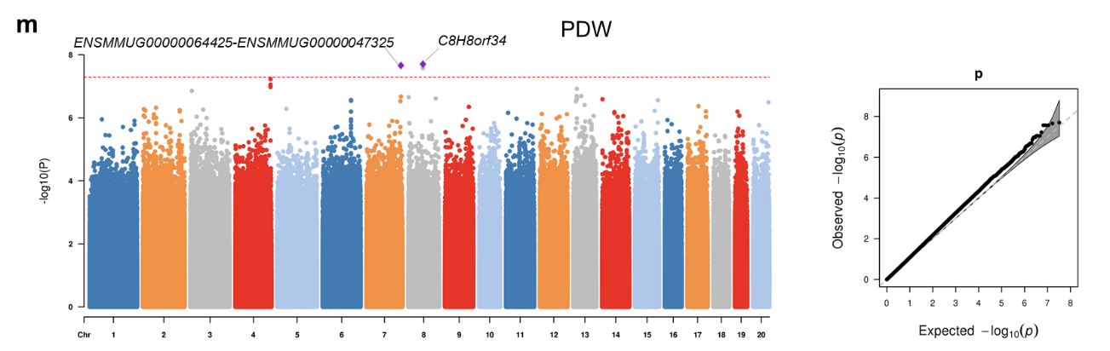
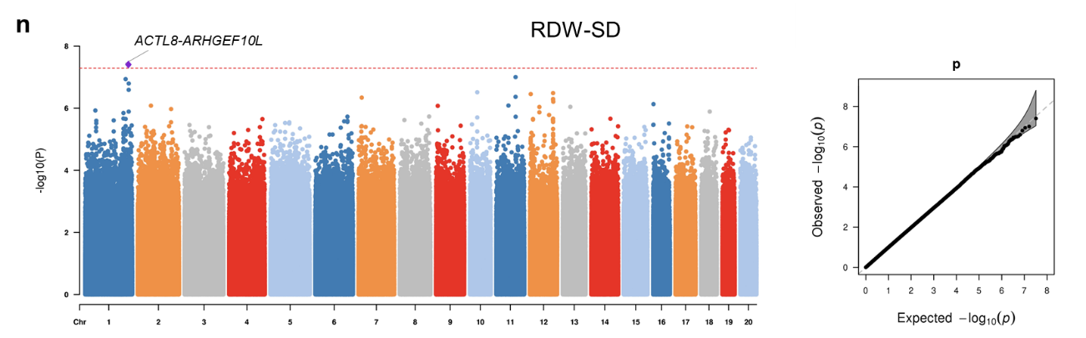
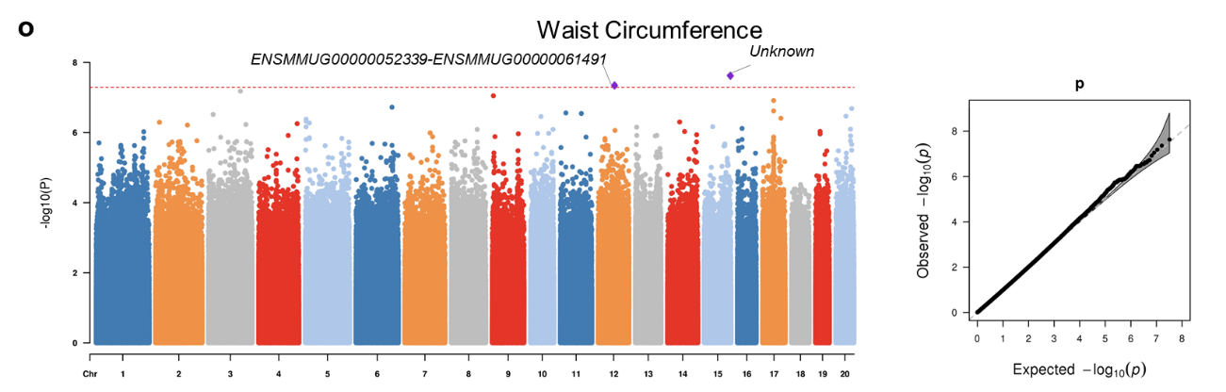
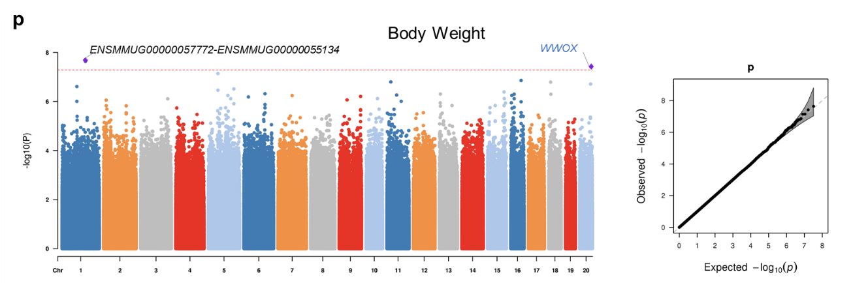
Extended Data Fig. 2: The variants that satisfied the genome-wide significance threshold in GWAS analyses. The purple diamond in each Manhattan plot (left) represents the independent loci that associate to the phenotype trait. Abbreviation of the hematological and biochemical traits were given in Table S6. The red dashed-line represents the genome-wide significance threshold of p-value < 5.13 × 10⁻⁸. Genes have been reported to associate with relevant human traits were highlighted in blue color. QQplots for the corresponding GWAS result were presented on the right. X-axis indicates expected -log10 p-value. Y-axis indicates observed -log10 p-value. Gray shaded areas show 95% confidence intervals for the expected distributions.

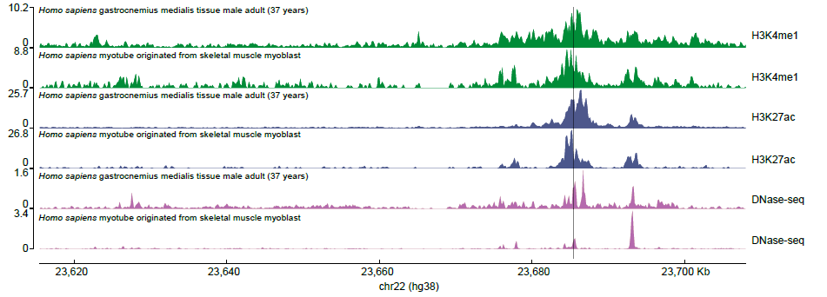
Extended Data Fig. 3. Position of chr10:28504973 in Mmul_10 genome exhibits distinct active enhancer signatures in several type of human cells. The position of chr10:28504973 in Mmul_10 genome that liftover to human coordinate (chr22:23685460) was indicated by a gray dash line. Active enhancer signatures in different cell types were defined by epigenetic marks, such as H3K4me1, H3K27ac, and DNase hypersensitivity.

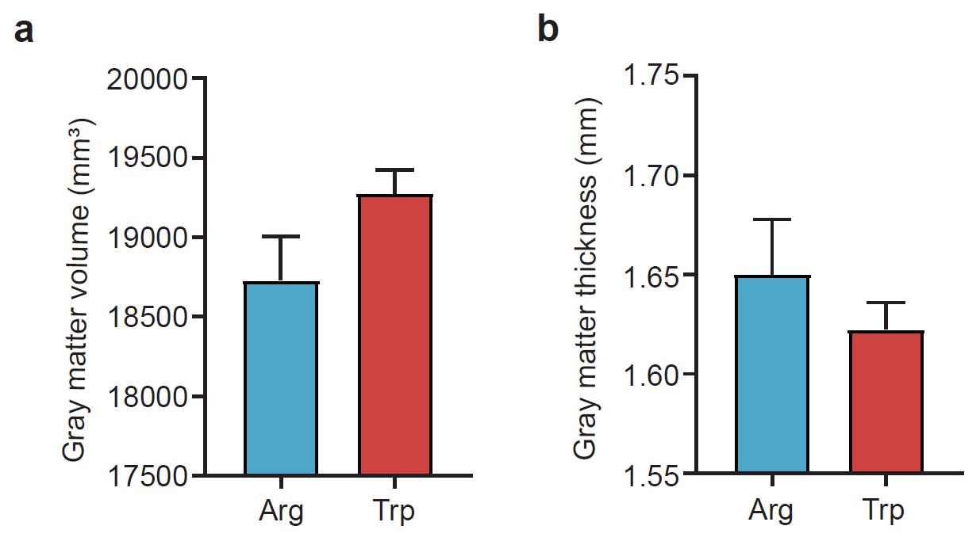
Extended Data Fig. 4. Differences in the whole-brain gray matter. a, Gray matter volume; and (b) Gray matter thickness in Trp-bearing macaques and Arg controls.

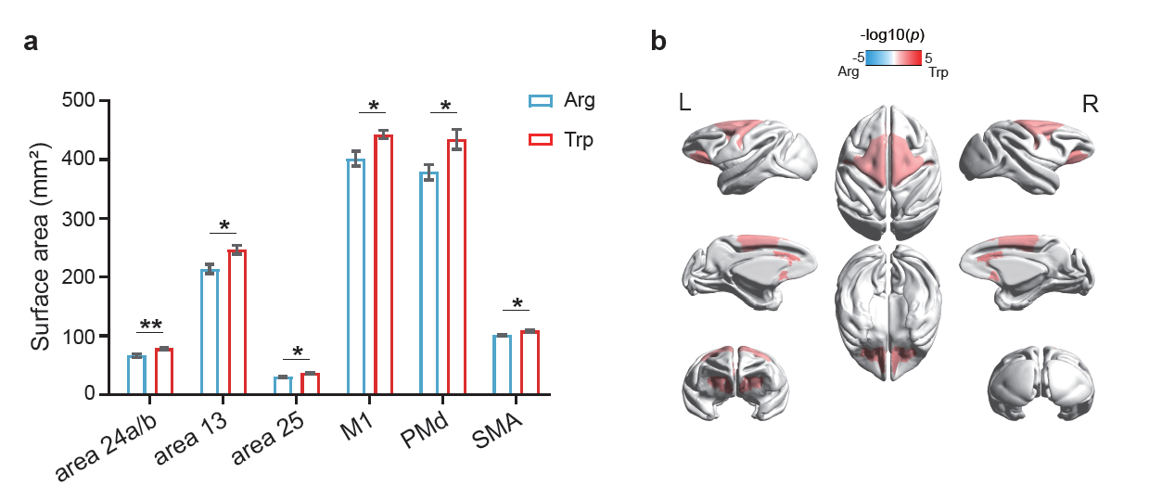
Extended Data Fig. 5: Surface area differences in frontal regions. a, Bar plot of detail frontal brain regions exhibiting significant differences in surface area between Trp-bearing macaques (red) and Arg controls (blue). b, Visualization of frontal brain regions showing significant differences between Trp-bearing macaques and Arg controls on the mid-gray surfaces of the macaque template. Red indicates where the surface area in Trp-bearing macaques was larger than Arg controls, while blue denotes the opposite. The significance of structural difference at region level were measured using Generalized Linear Mixed Models (GLMMs) and all structural data were corrected with the intracranial volume of the corresponding hemisphere. SMA: supplementary motor area; PMd: dorsal premotor cortex. *: p<0.05; **: p<0.01.

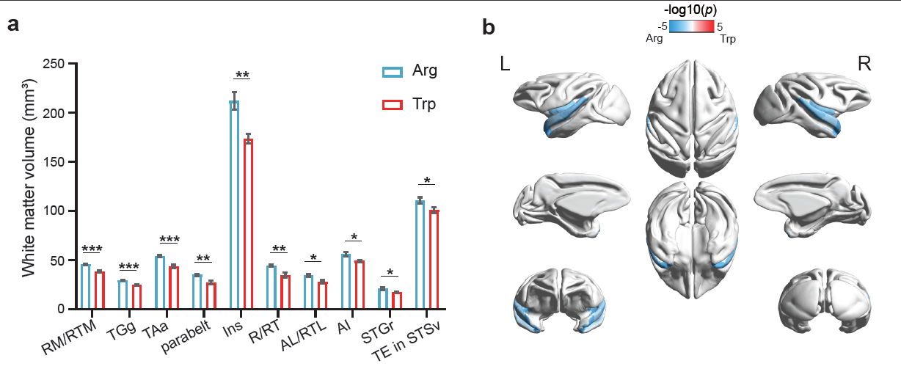

Extended Data Fig. 6: White matter volume differences in temporal regions. a, Bar plot of detail temporal brain regions exhibiting significant differences in white matter volume between Trp-bearing macaques and Arg controls. b, Visualization of temporal brain regions showing significant differences between Trp-bearing macaques and Arg controls on the mid-gray surfaces of the macaque template. Red indicates the surface area of Trp-bearing macaques is larger than Arg controls, while blue denotes the opposite. RM/RTM: rostral areas of the medial belt; TGg: granular temporal pole; TAa: area TAa; parabelt: parabelt areas of auditory cortex; Ins: insula; R/RT: rostral areas of the core; AL/RTL: rostral areas of the lateral belt; AI: primary auditory cortex; STGr: rostral superior temporal gyrus; TE in STSv: area TE in the ventral STS. The significance of structural difference at region level were measured using GLMMs and all structural data were corrected with the intracranial volume of the corresponding hemisphere. *: p<0.05; **: p<0.01; ***: p<0.001.

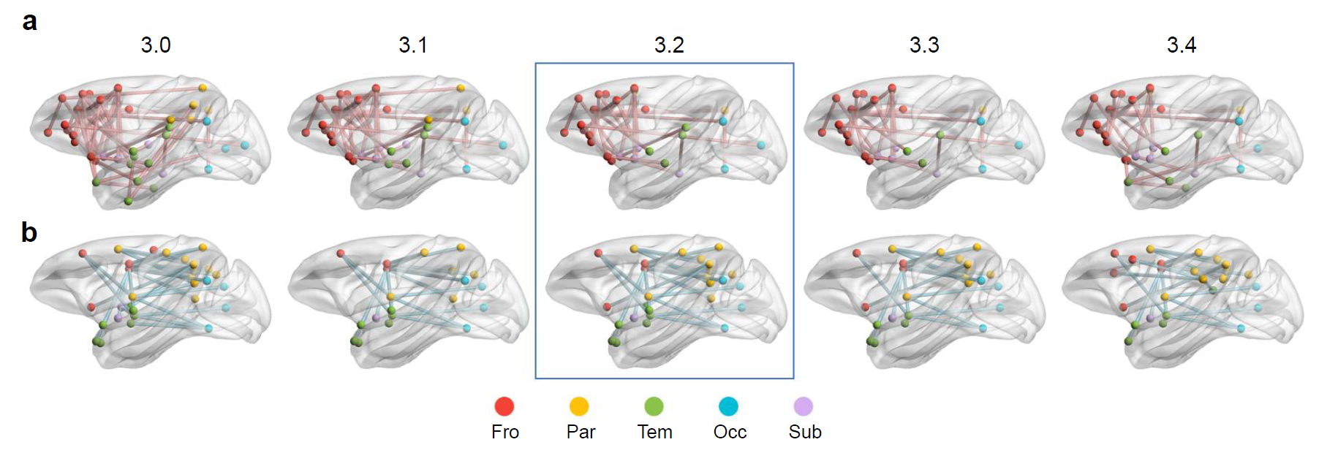
Extended Data Fig. 7: Comparisons of NBS results. a, Increased functional connectivity observed in Trp-bearing macaques compared to Arg controls across a threshold range from t = 3.0 to t = 3.4. b, Decreased functional connectivity observed in Trp-bearing macaques compared to Arg controls across a threshold range from t = 3.0 to t = 3.4. The results at the median threshold (t = 3.2) were highlighted. Fro: frontal lobe; Par: parietal lobe; Tem: temporal lobe; Occ: occipital lobe; Sub: subcortical area.

