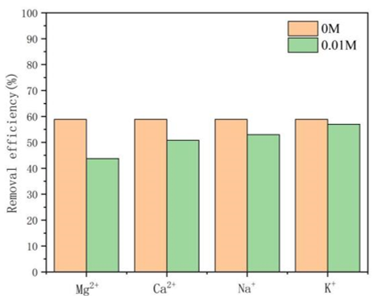
Figure S1 Effect of coexisting cations on the adsorption of Sb(III) by Fe₃O₄@MIL-100(Fe).
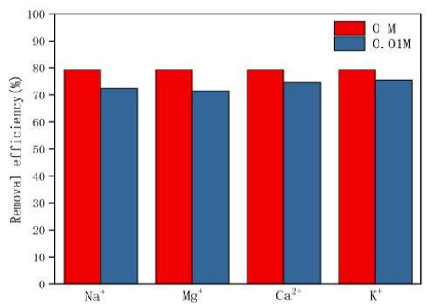
Figure S2 Effect of coexisting cations on the adsorption of Sb(III) by Fe₃O₄@MIL-101(Fe).

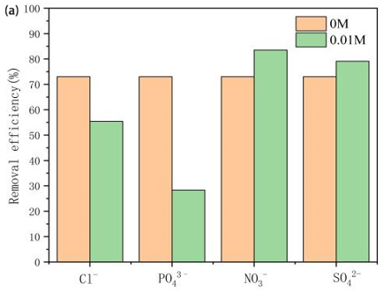
Figure S3 Effect of coexisting anions on the adsorption of Sb(III) by Fe₃O₄@MIL-101(Fe).

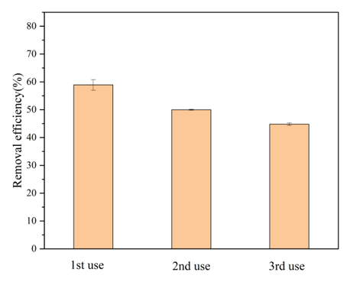
Figure S4 Reusability of Fe₃O₄@MIL-100(Fe) for Sb(Ⅲ) adsorption.

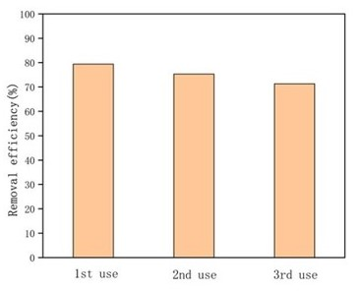
Figure S5 Reusability of Fe₃O₄@MIL-101(Fe) for Sb(Ⅲ) adsorption.

