SARS-CoV-2 Infection Reduces Human Nasopharyngeal Commensal Microbiome with Inclusion of Pathobionts

Figures with Legends

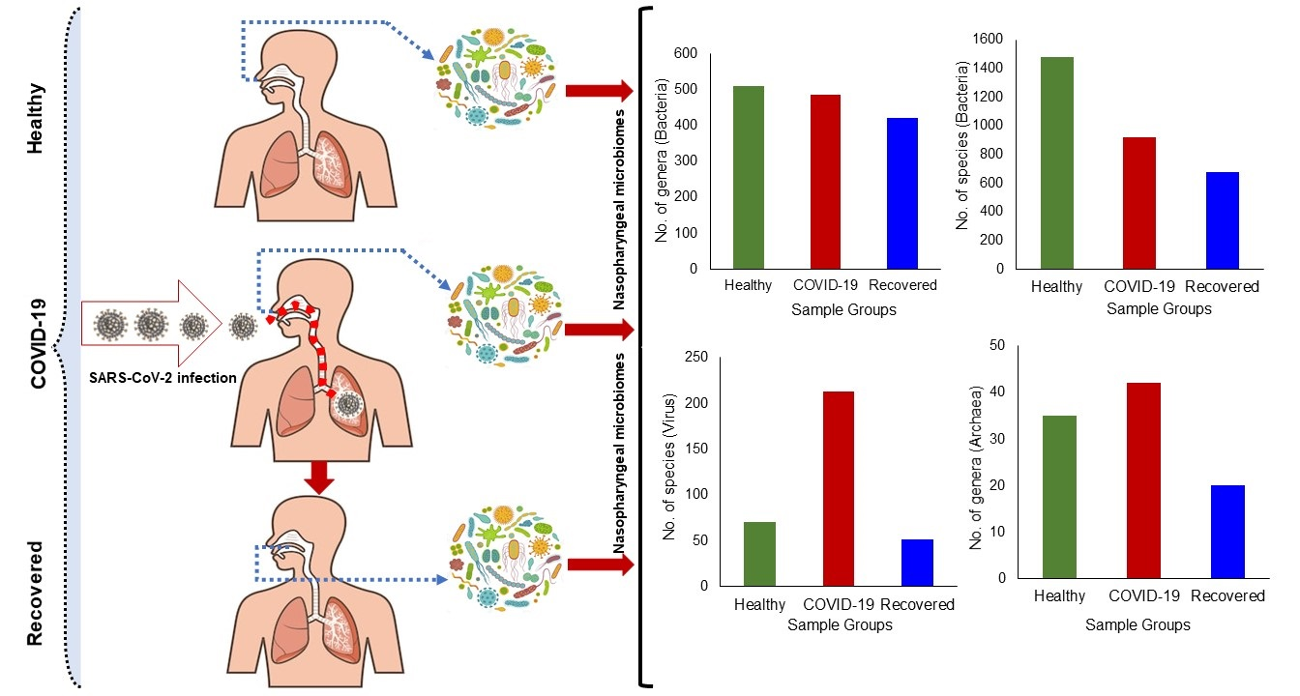

Graphical abstact. Differences in microbiome composition and diversities in COVID-19, Recovered and Healthy metagenomes.

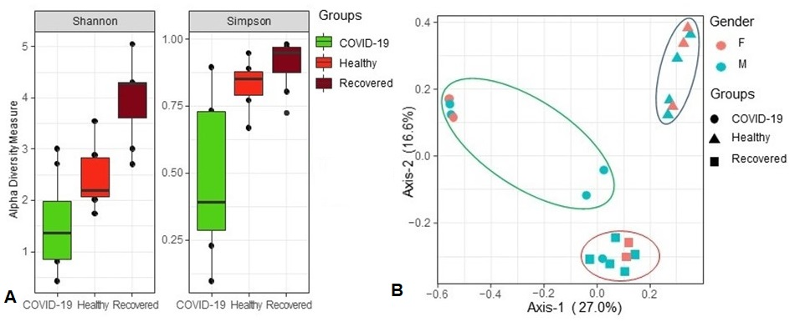
Fig. 1. Differences in microbiome diversity and community structure in COVID-19, Recovered and Healthy nasopharyngeal sample metagenomes. A Box plots showing significantly higher microbial species richness in COVID-19 compared to Recovered and Healthy control samples (COVID-19, p = 0.0065; Recovered, p = 0.0105; Healthy, p = 0.0401; Wilcoxon rank sum test) (P=0.036, Kruskal-Wallis test) in both Shannon and Simpson estimated alpha diversity calculation. B Principal coordinates analysis (PCoA) measured on the Bray-Curtis distance method separated samples by microbial population structure. Each color represents an individual, and shapes indicate the population in three metagenomes. Statistical analysis using Kruskal–Wallis tests showed significant microbial diversity variations across the three metagenomes (p = 0.0059, Kruskal-Wallis test).

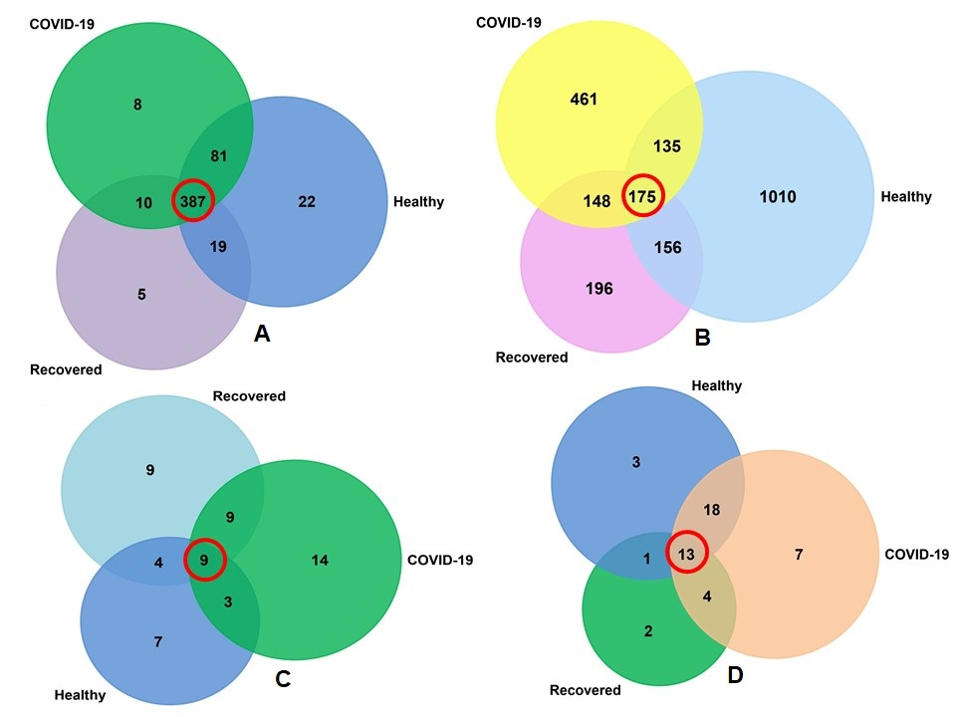
Fig. 2. Taxonomic composition of COVID-19, Recovered and Healthy control metagenomes. Venn diagrams representing the core unique and shared microbiomes in COVID-19, Recovered and Healthy nasopharyngeal samples. A Venn diagram showing unique and shared bacterial genera. Out of 532 detected genera, only 387 genera (highlighted in red) were found to be shared across the given conditions. B Venn diagram comparison of unique and shared bacterial species where only 175 (highlighted in red) species shared among the conditions. C Venn diagrams representing unique and shared viral genera identified in three metagenomes. Of the detected archaeal genera (n=55), 14,9 and 7 genera had unique association with COVID-19, Recovered and Healthy samples, respectively, and 9 genera (highlighted in red) were found to be shared across three metagenomes. D Venn diagrams representing unique and shared archaeal genera identified in three metagenomes. Of the detected archaeal genera (n=48), 7, 2 and 3 genera had unique association with COVID-19, Recovered and Healthy samples, respectively, and 13 genera (highlighted in red) were found to be shared across three metagenomes. More information on the taxonomic result is also available in Data S1.

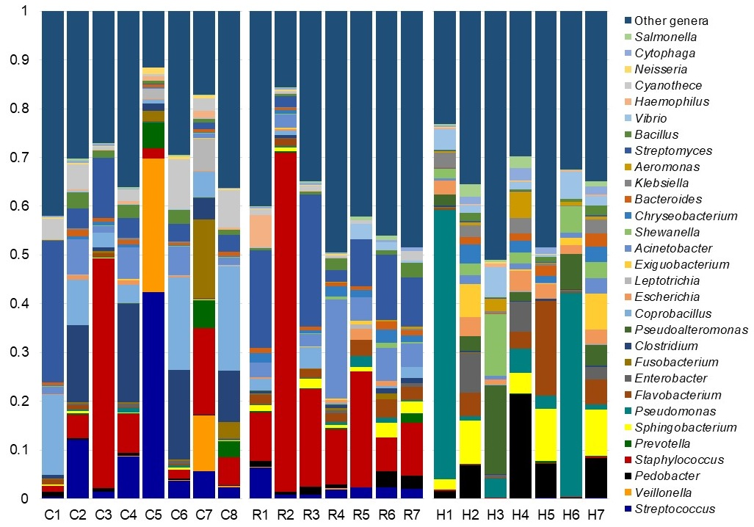
Fig. 3. The genus level taxonomic profile of bacteria in COVID-19 (C1-C8), Recovered (R1-R7) and Healthy (H1-H7) nasopharyngeal samples. The relative abundance of 30 most abundant bacterial genera are sorted from bottom to top by their deceasing proportion, with the remaining genera keeping as ‘Other genera’. Each stacked bar plot represents the abundance of bacterial genera in each sample of the corresponding category. Notable differences in bacterial populations are those where the taxon is abundant in COVID-19 and Recovered samples, and effectively undetected in the Healthy controls. The distribution and relative abundance of the bacterial genera in the study metagenomes are also available in Data S1 and S2.

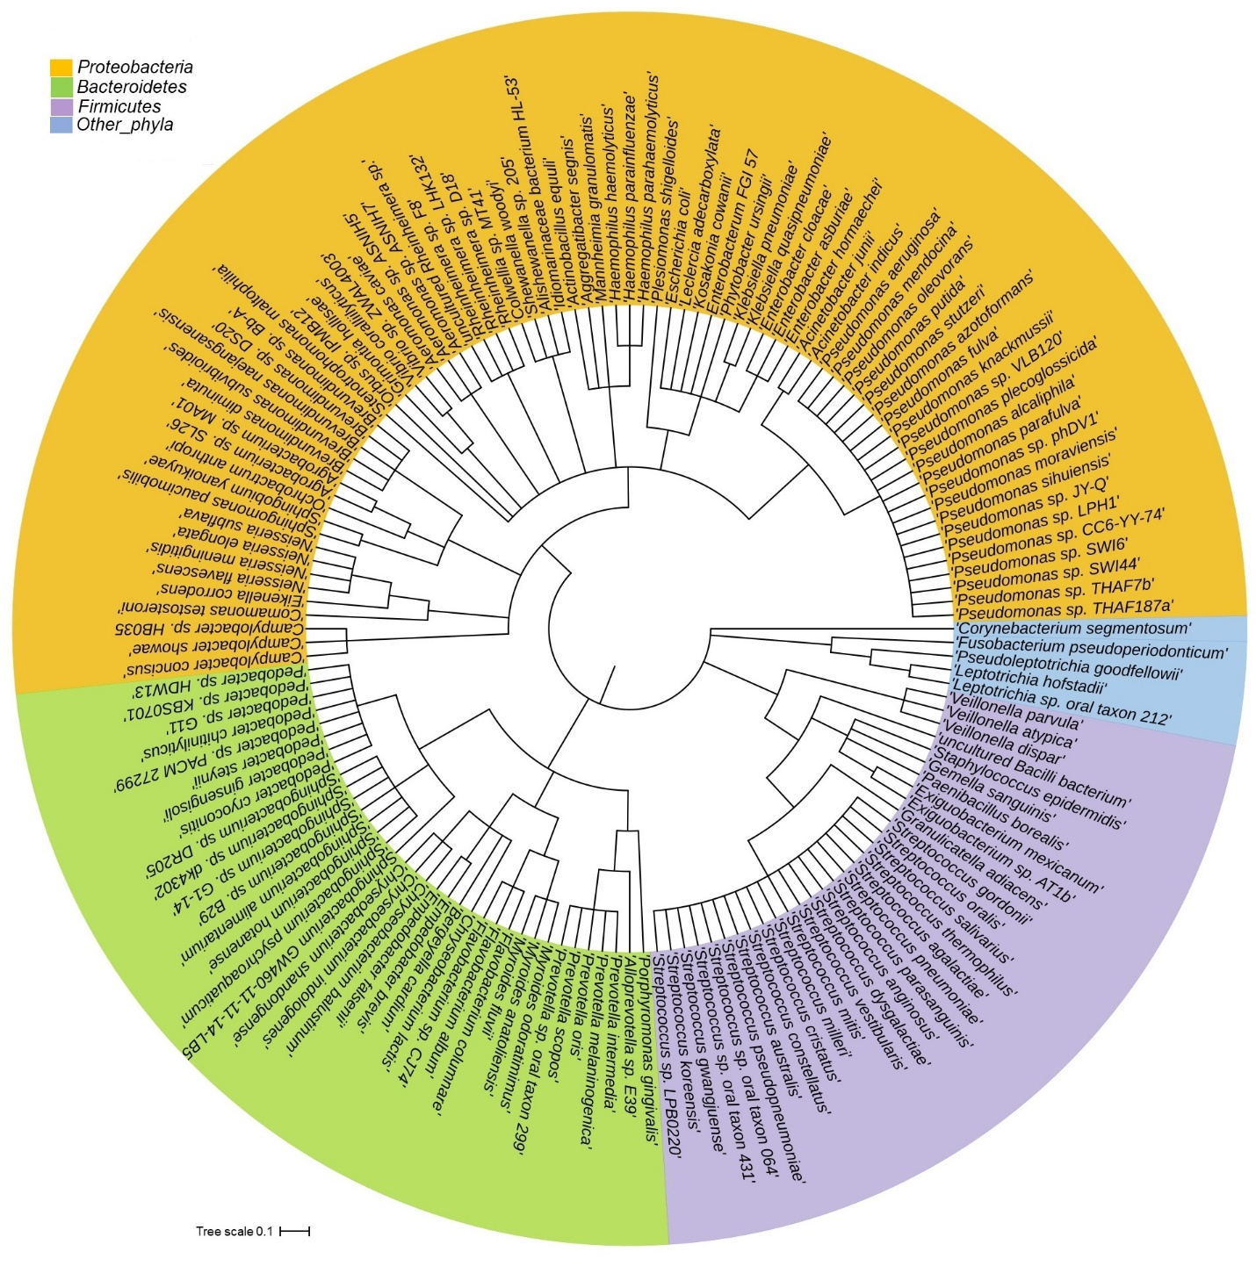
Fig. 4. The species and/or strain level taxonomic representation of microbiome in COVID-19, Recovered and Healthy metagenomes. Taxonomic dendrogram in the midpoint rooted phylogenetic tree was generated with top abundant 200 species of bacteria found in three metagenomes. The tree was made based on the maximum likelihood method in Clustal W and displayed with iTOL (interactive Tree Of Life). Color ranges identify different strains within the tree. Strains and/or species are color-coded by different phyla of bacteria present in > 95% of samples. The strains in the phylogenetic tree are also available in Data S1 and S2.

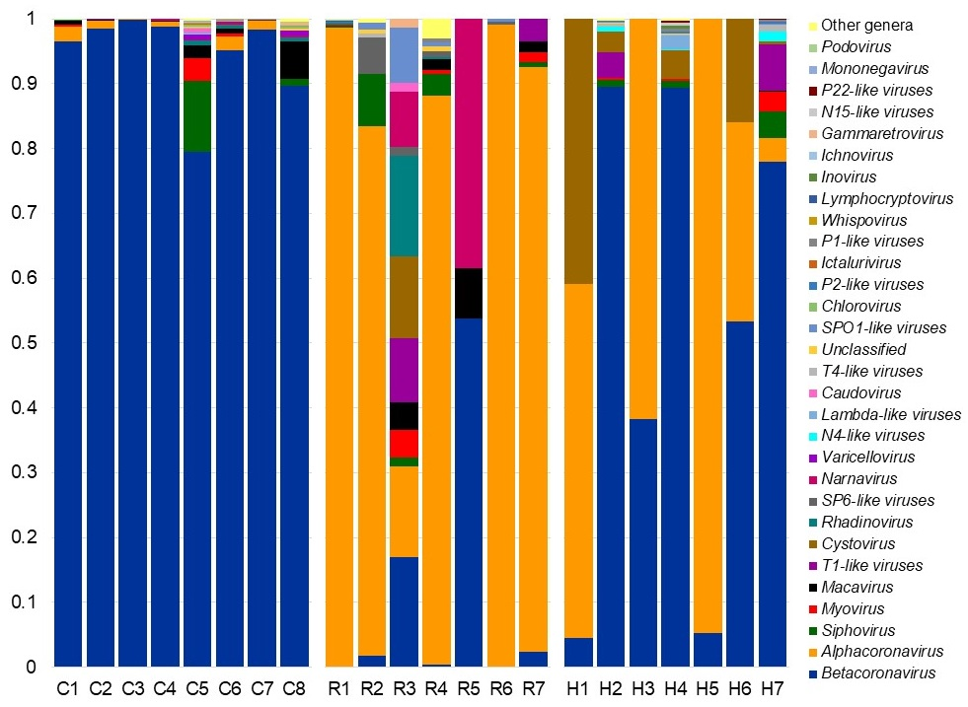
Fig. 5. The genus level taxonomic profile of viruses in COVID-19 (C1-C8), Recovered (R1-R7) and Healthy (H1-H7) nasopharyngeal samples. Stacked bar plots showing the relative abundance and distribution of the 30 most top abundant viral genera, with ranks ordered from bottom to top by their decreasing proportion, with the remaining genera keeping as ‘Other genera’. Each stacked bar plot represents the abundance of viral genera in each sample of the corresponding category. Notable differences in viral populations are those where the taxon is abundant in COVID-19 and Recovered samples, and effectively undetected in the Healthy controls. The distribution and relative abundance of the archaeal genera in the study metagenomes are also available in Data S1 and S2.

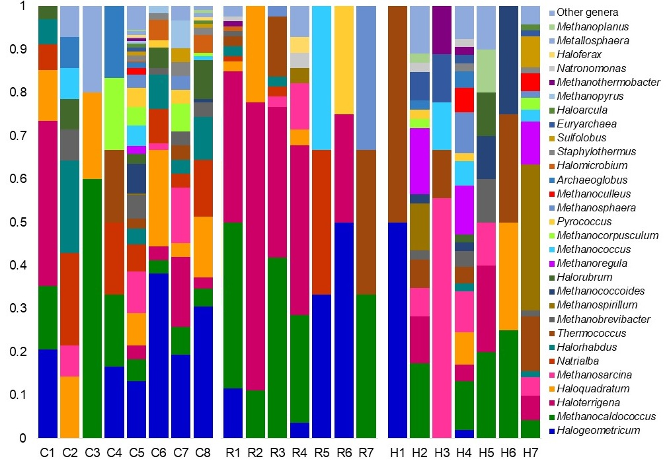
Fig. 6. The genus level taxonomic profile of archaea in COVID-19 (C1-C8), Recovered (R1-R7) and Healthy (H1-H7) nasopharyngeal samples. Stacked bar plots showing the relative abundance and distribution of the 30 most top abundant archaeal genera, with ranks ordered from bottom to top by their decreasing proportion, with the remaining genera keeping as ‘Other genera’. Each stacked bar plot represents the abundance of archaeal genera in each sample of the corresponding category. Notable differences in archaeal populations are those where the taxon is abundant in COVID-19 and Recovered samples, and effectively undetected in the Healthy controls. The distribution and relative abundance of the archaeal genera in the study metagenomes are also available in Data S1 and S2.

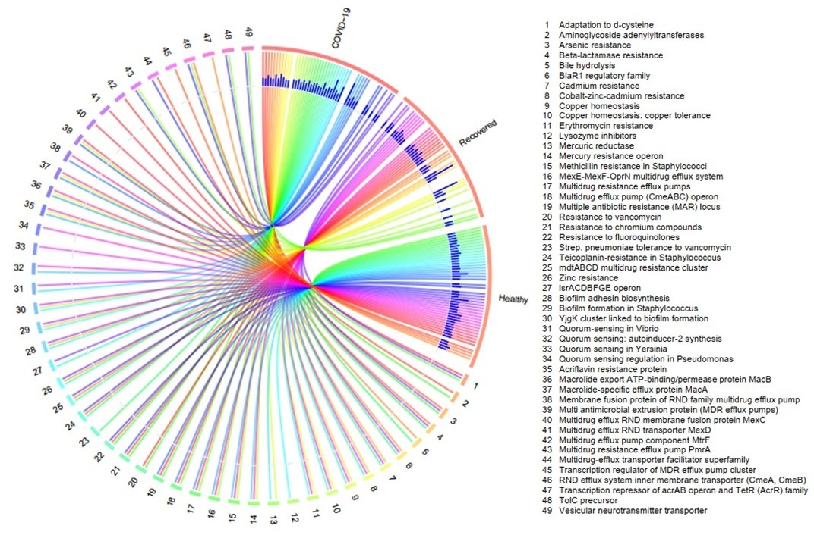
Fig. 7. Distribution of the resistance to antibiotic and toxic compounds (RATC) genes in COVID-19, Recovered and Healthy metagenomes. The circular plot illustrates the diversity and relative abundance of the RATC genes detected among the microbiomes of the three metagenomes through SEED subsystems analysis. The association of the RATC genes according to metagenome is shown by different colored ribbons and the relative abundances these genes are represented by inner blue colored bars. Some of the RATC functional groups shared among microbes of the three metagenomes (COVID-19, Recovered and Healthy), and rest are effectively undetected in the microbiomes of the other metagenomes. The numerical values 1 to 49 represent different RATC functional groups found across the study metagenomes. More data on RATC functional groups and their relative abundances are also available in Data S3.

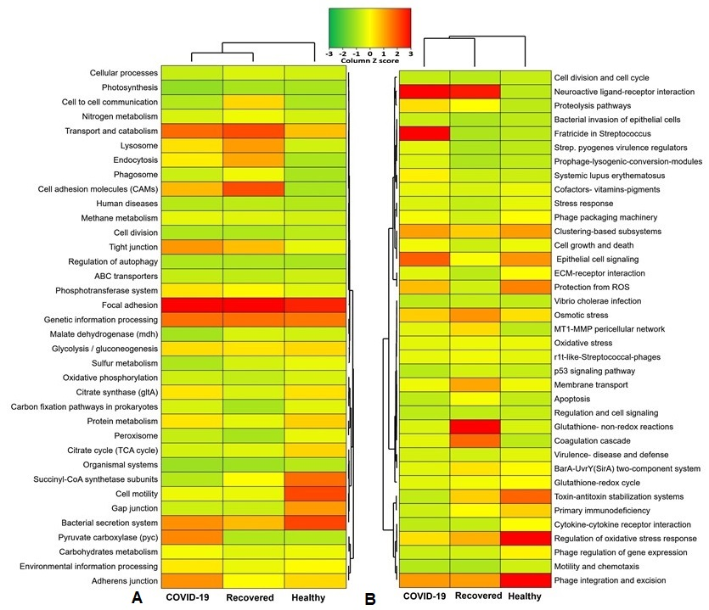

Fig. 8. Functional annotation of the COVID-19, Recovered and Healthy nasopharyngeal sample related sequences. A Heatmap representing the average relative abundance hierarchical clustering of the predicted KEGG Orthologs (KOs) functional pathways of the microbiome across four metagenome groups. B Heatmap showing the average relative abundance hierarchical clustering of the predicted SEED functions in different levels among the microbiomes of four metagenomes. The color bars (column Z score) at the top represent the relative abundance of putative genes. The color codes indicate the presence and completeness of each KEGG and SEED module, expressed as a value between -3 (lowest abundance) and 3 (highest abundance). The red color indicates the more abundant patterns, whilst green cells account for less abundant putative genes in that particular metagenome.

